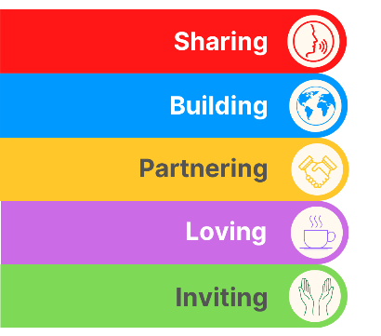
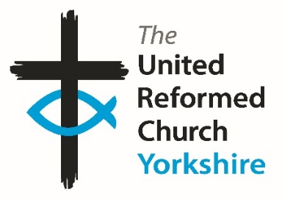
Yorkshire Synod Briefing
Number 162

23rd October 2025

Where has October gone!
Well, what a three weeks that was!!

It has been full on at Synod this past few weeks. I knew that we were going to be busy, but I didn’t expect the levels of activity in Synod to be so vibrant. We have had an induction in Sheffield, a double header Synod meeting; both online and in person at Roundhay as well as a huge number of activities across the Synod ranging from Ceilidhs in Skipton to Big Sing in Saltaire to MacMillan Coffee Mornings in Idle and Joined Up Thinking in York. And there is more to come as you’ll see in the pages of this Briefing. I must admit I am looking forward to a bit of a half-term break this coming week, but once we get into November the wheels keep on turning as we begin the preparations for Advent and (dare I say it) Christmas.
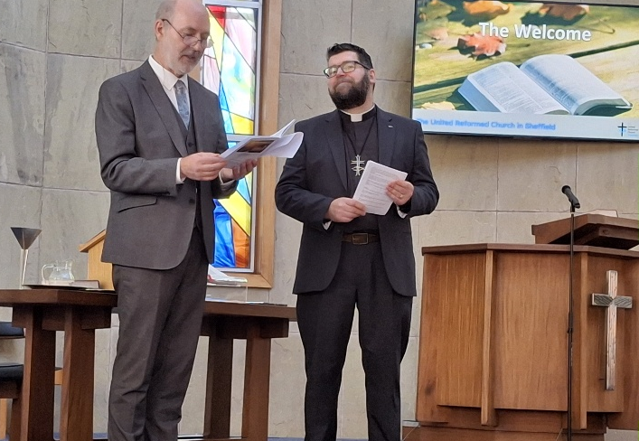
As was mentioned last time, the Sheffield Partnership welcomed Revd Johnny O’Hanlon at Central URC on Saturday 4th October. The church was packed with those from the Sheffield area, from Synod and from wider afield and it was a great privelege to take part in just a bit of the service. Here we see the Synod Moderator Revd Jamie Kissack offering that welcome to Johnny and I offer that same welcome here from all at the Synod Office.

At the Synod meetings the following week we were able to look at finance and safeguarding at an online gathering on the evening of Thursday 9th October and to be part of a series of workshops in person on Saturday 11th at St Andrew’s, Roundhay. The work Synod completed on the Thursday evening included the adoption of the Synod’s budget for 2026 with the news that belts will need to be tightened and that Synod will be looking to be more discerning in its gifting. Much of this is in relation to offering to support the Reparations of Slavery fund set up by the URC denominationally as well as offering a contribution to the Church Life Fund which is being discussed in even greater depth at the forthcoming extra General Assembly being held next month. Our Treasurer, Revd Simon Copley noted that the way in which Synod provides funding to churches for various things has been on the radar for some time now and that the various streams and processes that are offered need rationalising into a single, unified process and this will be considered in 2026.
The Saturday meeting of Synod was a much lighter, missional and affirming experience for all of us. There was some business as Synod was unanimous in adopting the Yorkshire Synod Missional Strategy (more of that in a later edition of the Briefing) and the creation of a Synod Compliance group which has a role in helping churches navigate the uncharted areas of rules and regulations which crop up in the life of our Christian witness every now and then.
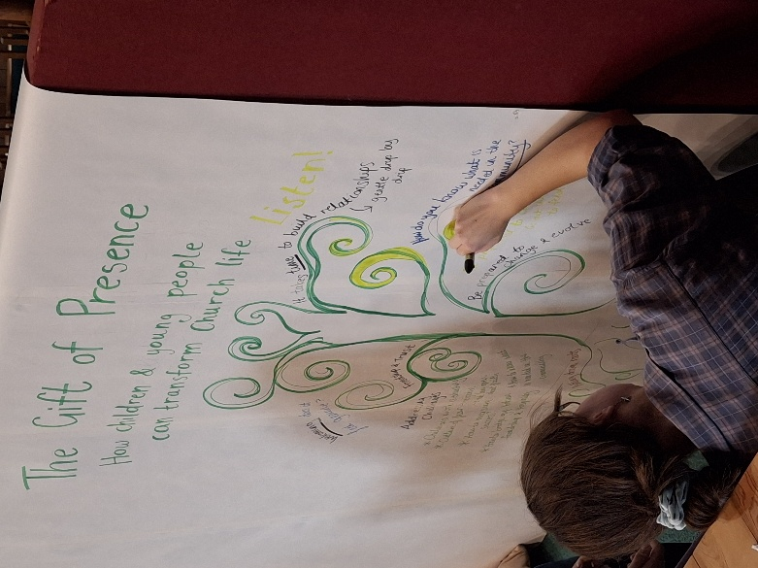
Through their expert curating of the three workshops on offer the younger adults in the Synod were able to generate discussion points around the three themes of “Exploring Life, Love and Faith with Gen Z”, “Discipleship in Divided Times” and “The Gift of Presence: How children and young people can transform church life”. Thanks must be given to Matthew Wilmott of the Frontier Youth Trust, Roo Stewart of JPIT and Tony Harris & Tracy Winfrow of Synod & Shiregreen who led the workshops and more importantly to Emily whose interpretive artwork from the notes she received from the three workshops made it very clear that the discussions generated reached deeper and further than if these subjects had been presented in a more formal manner.
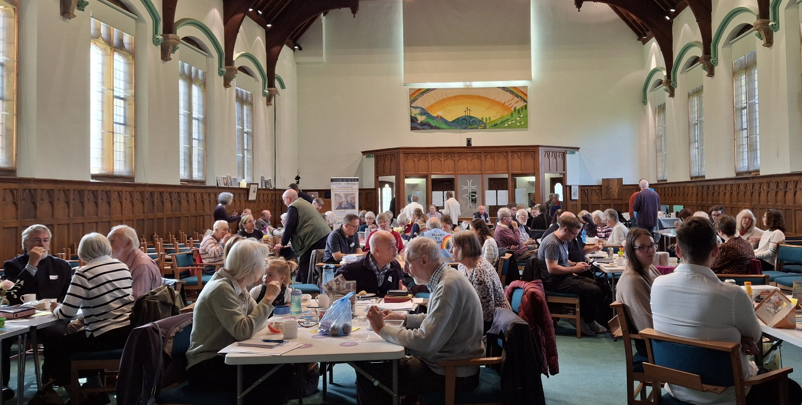
One of the key elements of feedback which will be reflected upon is what we use our Synod meetings for. It was quite clear that through a non-scientific exercise carried out by our Children and Youth Development Officer, Megan Tillbrook, that the majority of those attending appreciated the more relaxed style to the day and that their reasons for attending centre on faith and fellowship rather than on rules and regulations.
Finally on the subject of the Synod meeting, I have to thank the good folk at St Andrew’s Roundhay for their hospitality, their warmth of welcome and their inordinate ability to be there with help and support wherenever we needed it. Thank you Roundhay and I hope you were as equally touched by the enthusiasm for the themes and topics as were those who attended.

If you have any news of welcoming people into Church, stories of celebration and hope or even notices of future events, please let me know by dropping me a line at clerk@urcyorkshire.org.uk and I’ll showcase it in the next edition, due out on Thursday 13th November 2025.
Thank you
Tim Crossley
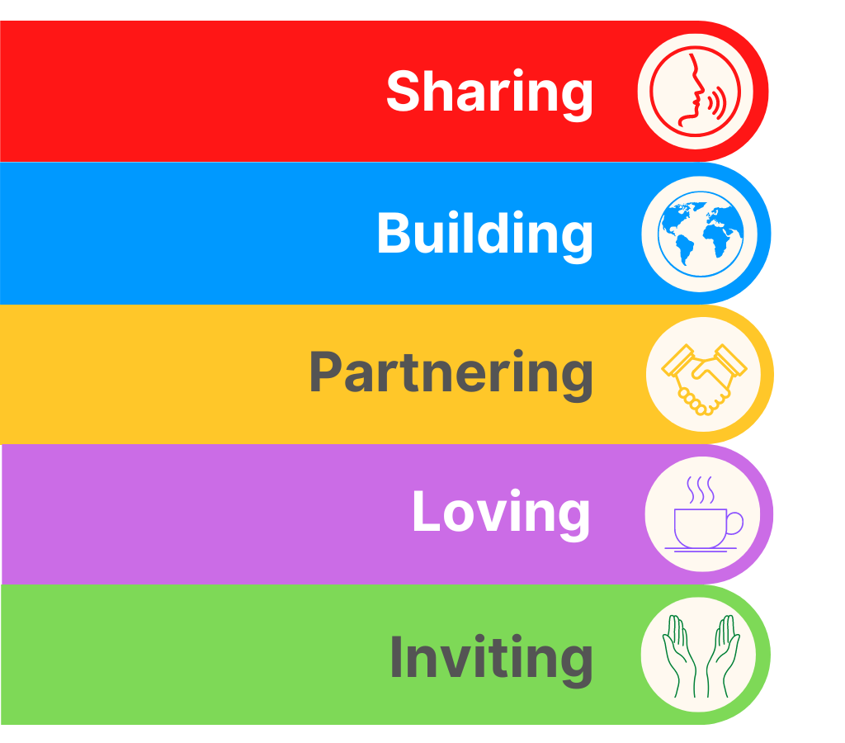
YOUTH ASSEMBLY 2026
Bookings have opened for next year’s URC Youth Assembly which will be happening between 27th February and 1st March 2026. Visit www.bit.ly/3TkqSfn for more details and to see a taster video of Youth Assembly 2025 or contact Megan at the Synod Office at megancyp@urcyorkshire.org.uk.

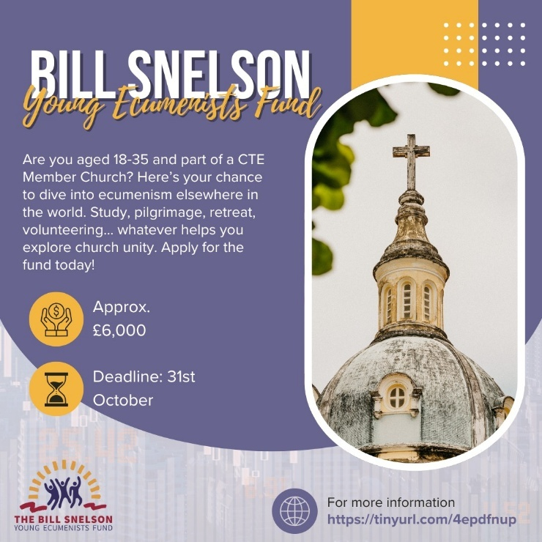
ECUMENICAL OPPORTUNITIES
Explore Ecumenism Abroad with the Bill Snelson Fund!
Are you aged 18–35 and part of a CTE Member Church? This is your chance to travel, learn, and grow in faith through ecumenical experiences around the world. Whether it’s study, pilgrimage, retreat, volunteering, or reconciliation work—this fund can help you go further in your journey toward church unity.
🕊️ Approx. £6,000 available to grant
🗓️ Next deadline: 31st October 2025
Apply now at tinyurl.com/4epdfnup
If you have any questions or you would like to book, please contact the Synod Office (office@urcyorkshire.org.uk or moderatorpa@urcyorkshire.org.uk) to inform us, who will be coming from your church, so we can advise West Park URC of numbers expected.
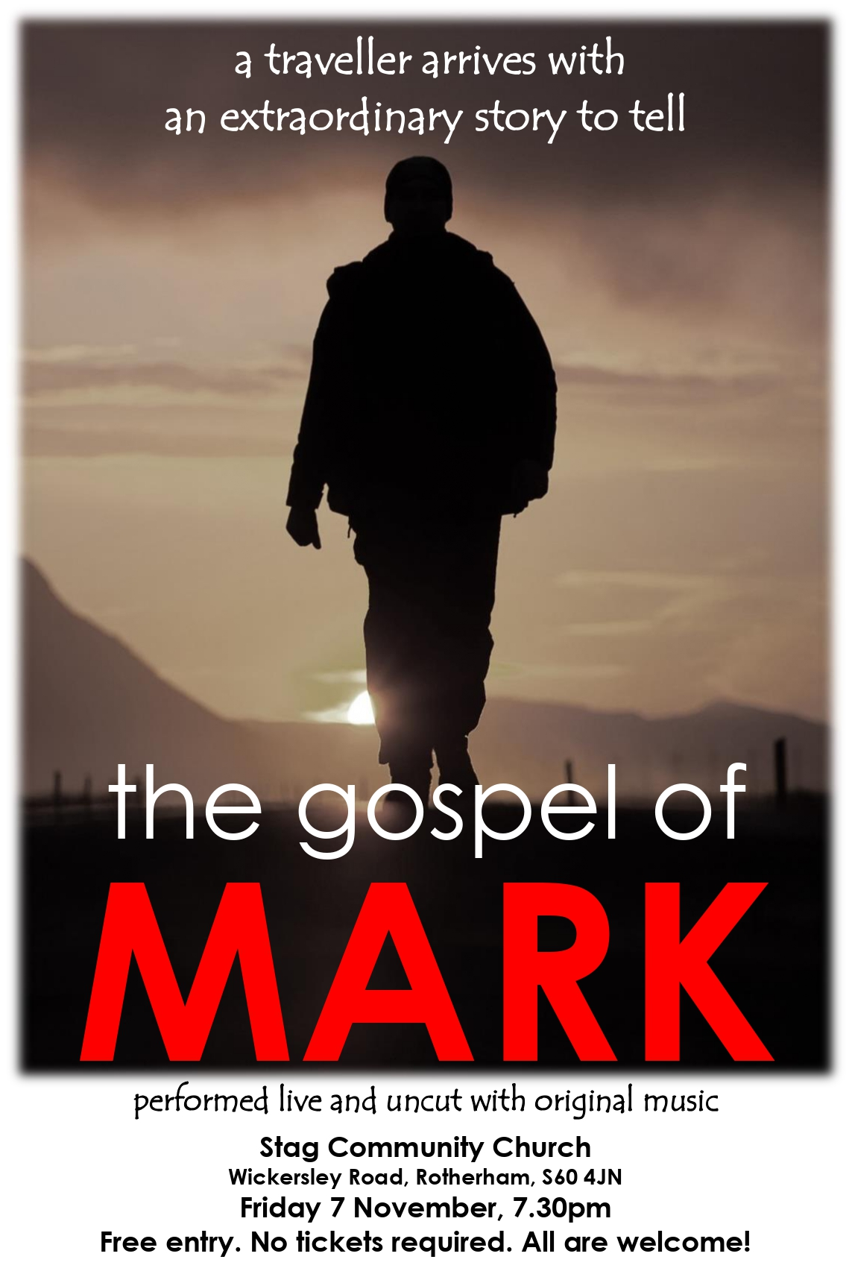
Lay Preachers and Worship Leaders lectionary planning zoom sessions

The Lay Preachers and Worship Leaders Planning Group are pleased to let you know that we are facilitating these sessions again after interest was expressed at the July 2025 conference.

We invite you to Explore the Advent lectionary readings together firstly on Tuesday 11th November There will be two identical sessions, the first session being at 10.30am with a second repeated session at 7.30pm.

Facilitated by Rod Morrison in the morning and Anne Dale in the evening, this will be a time for participants to look together at the lectionary readings for 30th November & 7th December in preparation for leading worship on those Sundays.

Please register your interest
with Rod Morrison rodmorrison1946@btinternet.com
by Friday 7th November,

indicating whether you will join in the morning or evening or if you are available for either, so if necessary, we can balance the groups so both sessions are viable.

Both events will be held on Zoom and the link for the sessions will be sent by Monday 10th November to all who register.

Secondly on Thursday 20th November 10.30am and repeated 7.30pm for looking at 14th & 21st December lectionary readings, facilitated by Jill Fletcher in the morning and Rod Morrison in the evening. Register with Rod by Friday 14th November and the link will be sent to those registered by Wednesday 19th November.

Please share this opportunity with anyone who leads worship in your church, whether on their own or part of a worship team, especially if they are new to this calling, to help us reach those who are not on our circulation list.

Yours in Christ’s service
Kath Lonsdale, Rod Morrison, Jill Fletcher and Anne Dale
Yorkshire Synod Lay Preachers and Worship Leaders Planning Group.



Yorkshire Synod Discipleship Development Small Grant Fund 2025
The Ministries Committee have so far approved 21 applications to this fund since 2022 and we encourage all lay church members to consider applying in 2025. Please use the new application form available through the Synod Office as the amount which you can ask for resources or has increased to up to £300. This fund exists to help you on your Christian journey including the costs of attending a course or to offset the costs of buying resources for personal development or sharing with others. If anyone wants to discuss an application before submitting it please contact the Convenor of the Yorkshire Ministries Committee, Kath Lonsdale at kathlonsdale@talktalk.net.
Remember this is for any age of lay person in our churches to apply for so please discuss with your young people as well as adults.

LEEDS PARTNERSHIP PRAYERS
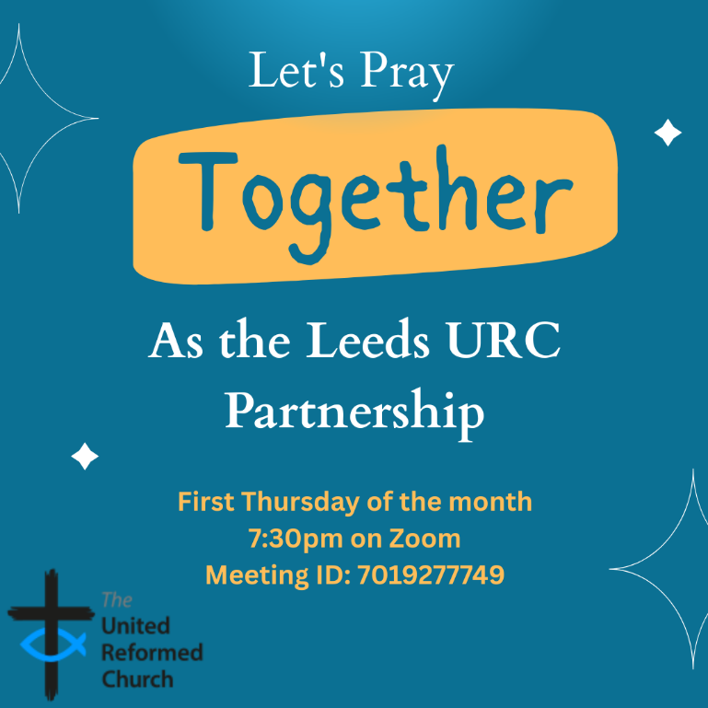
Although this is primarily aimed at those of us who are linked with the churches of the Leeds URC Partnership, this invitation is open to everyone from around the Synod and beyond.
It will be happening on the first Thursday of the month on Zoom at 7:30pm. The next one will be on Thursday 6th November and the link is here: https://us02web.zoom.us/j/7019277749

There will be a time to pray together, a time to share in reading the Bible and a time to share the joys and challenges in our lives, churches, communities and world.

Looking forward to seeing you there.



UNITE, RESPECT, CONNECT
Many of you will know that the Synod has a thriving and active community based in the Moldgreen area of Huddersfield. It is headed by Community Related Church Worker (CRCW) Helen Snashall, and she has kindly allowed the annual report which is sent into the Synod Mission Fund (which helps resource the project).

A Message from the Synod’s New Racial Justice Advocate
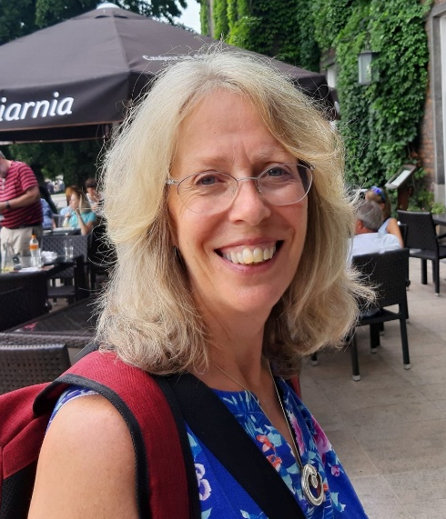
I just want to introduce myself as your new Racial Justice Advocate. Firstly, a huge thank you to Rev Zadie Orr who did this work in the past. Hers are big shoes to fill.
My name is Judy Rogers, and I am a member of Trinity St Andrews in Skipton. As a daughter of the manse, we had lots of overseas visitors staying with us in Bradford when I was young. No surprise I ended up working for CWM in the Pacific and later as Education Adviser for Christian Aid. For the last 20 years I have worked on an outreach project bringing diverse and disadvantaged groups out from the cities into the beautiful Yorkshire Dales where I live. This has fostered my passion for breaking down barriers, inclusion and diversity. I have introduced many of our Muslim communities and asylum seekers and refugees to the English countryside and have made many friends along the way. Most recently at the beginning of October we ran our 9th annual Muslim / Christian women’s weekend with friends from all over Yorkshire.
It would be great to hear from you:-
- What is your church doing in the field of Racial Justice/Interfaith/Diversity and Inclusion?
- In particular do you have refugees and asylum seekers within your church community?
- Do you have links with refugees and asylum-seeking groups or run a project yourself?
- What would you like your new Racial Justice Advocate to support you with in your church?
So please do get in touch via the Synod office – office@urcyorkshire.org.uk or clerk@urcyorkshire.org.uk to help us in Yorkshire be known as the welcoming Synod we already know we are.
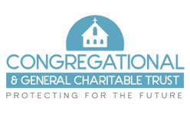
Do you need financial support for your church building project or significant repairs?

The Congregational & General Charitable Trust may be able to help

The C&G Trust is an independent grant-making charity which aims to support churches, particularly those of the United Reformed and Congregational denominations, in the provision and repair of suitable buildings. They make grants towards the overall care, upkeep and extension of churches and also offer grant funding toward the capital cost of church community projects.
The trust began as the charitable arm of the Congregational & General Insurance Company but became a separate charity and now is completely independent of the insurance company and distributes grants from the investment of the proceeds of the sale of that company in 2016.

What grants are available?
The level of grants available to churches range from £1,000 to a maximum of £25,000. Grants are usually capped at 25% of the total project cost. Grants are awarded for church or related community capital projects involving building work, repairs, improvements or extensions. Any project costing less than £1m in total will be considered. Consideration will also be given to smaller clearly defined and discrete project phases. There are a few exclusions including organ or bell restoration, stand-alone environmental projects such as solar panels or heat source pumps, manse works, conservation/restoration of works of art, graveyard or garden maintenance, parking provision and the running costs of the church.

How do I apply?
Applications should be made in advance of starting any work (apart from obtaining professional design and project planning advice) and be submitted when planning has proceeded to the point where clear details of the planned works and their expected cost can be provided.
Applications are considered quarterly (March, June, September and December of each calendar year) The upcoming application date for each quarter is published on the website at https://www.candgtrust.org.uk/how-to-apply-funding-church-projects/ with further details and an application form available to download. The website also has a useful Q & A section as well as a sample completed application form for you to view. If you are unable to find all the answers to your questions, please contact us at admin@candgtrust.org.uk.
Applications must be supported by copies of your church accounts and documentation supporting the estimated cost of the project, such as Contractor quotes. There is an expectation that the church will contribute, so far as it is practicable, to the project from its own funds and from local fundraising.

The charity exists to help churches like yours – so please do not hesitate to apply if you feel we can be of help.


Put the date in your diary – Monday 24th November 2025.

Rod Morrison, of the Synod’s Eco Group asks “Do you remember the old days, when your mum darned your socks, or put patches on the elbows of your school blazer? When you took your shoes to the cobblers to be re-heeled, or unravelled that now-too-small jumper to knit a new one in a bigger size? It was repair, reuse, share, and upcycle – practices that we need to return to as we face the consequences of global warming; practices which we now call “circular consumption” - keeping resources in use and preventing waste. That’s what “Circular Monday” is all about. Forget Black Friday, and celebrate Circular Monday instead, when we focus on keeping resources in use and preventing waste. Of course, we should be keeping resources in use and preventing waste all the time. But Monday 24th November is when there is a main event to promote “circular consumption””.

So why not join the Main Event for this year – on Circular Monday 24th November
It’s just one hour – with big impact. It’s online, and showcases how circular solutions are reshaping the world. Expect inspiration, global perspectives, and engaging voices leading the way towards a more sustainable future. If you want to take part, simply post a photo of yourself or your group on social media with #CircularMonday, showing something linked to reuse, repair, or renting.

For more information use this link : https://www.eventbrite.com/e/circularmonday-2025-official-main-event-tickets-1607228065409?aff=oddtdtcreator

But “Circular Monday” is more than just one day in a year.
Circular Monday began in 2017 in Malmö, Sweden, as a counter-movement to Black Friday. It is now an on-line campaigning community which highlights and celebrates businesses, organisations, and individuals that keep resources in use and prevent waste, making it easier for people everywhere to choose circular solutions. (see www.circularmonday.com )

The Circular Monday community aims to promote circular consumption by:
- ‍Hosting an annual global action day (the main event - Circular Monday - the Monday before Black Friday)
- Building the world’s largest database of circular businesses and changemakers
- Inspiring people to repair, reuse, rent, share, and upcycle instead of buying new.
At their main event, always the Monday before Black Friday, the year’s campaign results are revealed. The goal is to make circular solutions visible, accessible, and the new normal.

As a guide, the Circular Monday community use the 12R strategies, including: Refuse, Reduce, Rethink, Redesign, Reuse, Repair, Refurbish, Remanufacture, Repurpose, Recycle, Re-earth, and (as a last resort) Recover. Recycling is considered baseline, not leadership so we encourage higher-value practices like reuse, repair, and redesign.

Anyone can join the Circular Monday community, both online and through local in-person activities or digital events. You can explore the Circular Monday database of circular businesses, or join as a volunteer. For ideas, check out @circularmonday on Instagram.

Why not join the online community yourself and start to consume circular – or at least think about which of the 12 Rs you can put into practice?

And an after-thought : If you want to calculate your carbon footprint so that you can monitor your progress towards zero carbon, go to https://climate-calculator.climatehero.org/?source=MicrosoftKeywords&msclkid=e14c76185f8b1f0a5a4c1ec4154a8c61
It takes just 5 minutes!
Important information from the Synod Safeguarding Team
Due to changes in the insurance industry, insurers are now adding a new safeguarding endorsement for churches to complete when their insurance is due for renewal. What this means is that insurance companies will now place conditions on all policies, that it these conditions must be adhered to for the policies to be valid.
What this means is that you will need to answer yes to the following questions –
- Have you a complete and comprehensive written safeguarding policy that is reviewed at least annually?
- Do you have a church safeguarding coordinator for your church?
- Do you as a church, provide safeguarding training to everyone who needs it due to their role within the church?
- Do you know how to respond to a safeguarding incident, know who to report it to and how to deal with it correctly?
- Has everyone who needs them, due to their role, had the correct level of DBS checks and has this been completed in the past three years?
- Have you and do you have a system to securely retain records of any abuse allegations and the action you took in relation to these allegations?
You would also need to make the insurance company aware if there have been any allegations of abuse which have been reported at your church.
The above relates to anybody involved in the church who works unsupervised with children or vulnerable adults or has unsupervised access to children or vulnerable adults. This means that everybody who falls under the guidance of Good Practice 6, which includes Elders etc need to make sure everything is up to date and in order, to be able to confirm this with the insurance company when the renewal is submitted.
If the answer is no, or the disclosure is incorrectly completed, insurance may be withheld or be made void in any claims. If this is the case and a claim is made it will be made against the church itself and the Trustees.
Many of you may already be able to answer yes to all the questions posed.
However, many of you may not be able to answer yes to all the questions and this is where action needs to be taken at the church.
The Elders/Trustees are responsible for ensuring that the church is a safe place for everyone and therefore responsible for making sure that you can answer all the questions posed by an insurance company to provide insurance cover for the church and everyone who attends.
If you need help making sure your church can answer yes to all the questions you will be asked please contact the Synod Safeguarding Team by email (click here) and we will assist you in making sure your church can be insured correctly.

The Safeguarding team are available 24 hours a day, seven days a week and 365 days a year (and even 366 days in Leap Years!!). Details can be found on the Yorkshire website at https://urcyorkshire.org.uk/safeguarding/ and any query, either by phone or by e-mail at safeguarding.1and4@urc.org.uk will be answered within 24 hours.
FIRE SAFETY
Jane Bunyan, our Synod Property Officer property@urcyorkshire.org.uk has asked that I remind churches that fire regulations for small non-domestic premises have changed in light of the Grenfell Tower Enquiry outcomes. The advice Synod is giving is that all churches should make themselves aware of the new regulations and advice updated in 2024 at Making your small non-domestic premises safe from fire - GOV.UK or https://www.gov.uk/government/publications/making-your-small-non-domestic-premises-safe-from-fire but if you would like a pdf copy then please email Jane at the above e-mail address.


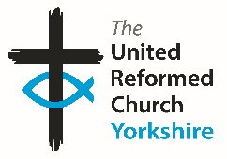

Somebody is missing
Is it you?

Synod is looking for volunteers to fill
several posts across it’s committees.
Please contact the Synod Moderator or
Clerk if you, or someone you know,
would like more information
on how to help.

clerk@urcyorkshire.org.uk moderator@urcyorkshire.org.uk

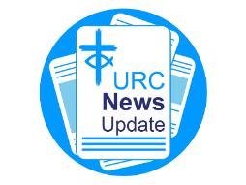
NEWS FROM THE DENOMINATION
The URC’s News Update is a monthly e-newsletter that keeps you informed about the latest news and events.
To receive this popular newsletter, please visit the https://urc.org.uk/news-updates-sign-up-form/ page on the URC website and follow the links. If you just want to dip in and catch up on what is going one, that’s fine and you can
read and print recent editions of our e-newsletter by visiting the URC News Update page at https://urc.org.uk/urc-news-update/ .

And Finally
Barry’s Birthday

In a quiet corner of Sheffield, on a Saturday afternoon when most of us were sipping our cups of tea and swapping stories of chapel fayre through the ages, our attention was drawn to what looked like a fire breathing caterpillar. However, it turned out that not only were the gathered congregation who had earlier welcomed Rev Johnny O’Hanlon into the Sheffield Team, but they were unwittingly witnesses to the birthday of Johnny’s new colleague, Rev Barry Welch.
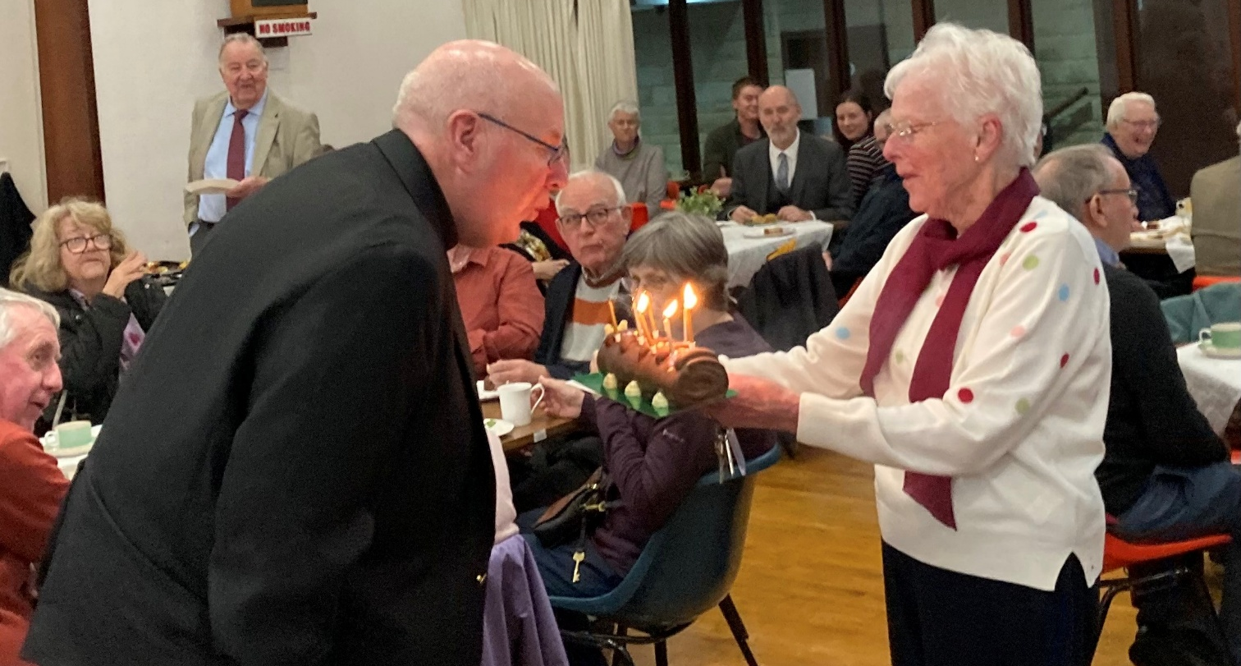
The fire breathing caterpillar was called Colin (or Cecil, or Cuthbert or Ciara, depending on where it came from), the gathered crowd were in good voice as they sang Happy Birthday, and I hope that Barry enjoyed the day. A belated Happy Birthday from all of us at Synod and we wish you many more to come in the future.

If you have a good news story from your part of the Synod or something that you feel would enhance the work of Synod in 2025 and into 2026, drop me a line at clerk@urcyorkshire.org.uk and I’ll make sure it hits the back page!!

You can also keep an eye on all our social media platforms for news; on the website at Home - URC Yorkshire Synod, at United Reformed Church in Yorkshire - Home | Facebook and Wilderness URC Yorkshire - Home | Facebook, the YouTube page at URC Yorkshire - YouTube and the Twitter (X) page at URC in Yorkshire (@URCYorkshire) / Twitter.

