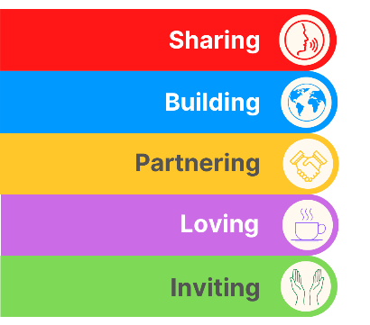
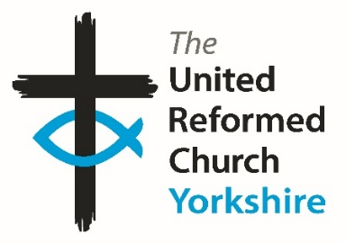
Yorkshire Synod Briefing
Number 163

13th November 2025

November Musings.
The last three weeks have been a bit of a blur. I was fortunate to take a week off at half term at the end of October and was able to finally immerse myself culturally – visits to Haworth, Lister Park in Bradford for the Turner Prize exhibition and Saltaire were the order of the week. These three places are all on my doorstep (I have worked in Haworth, I went to school across the road from Lister Park and I can walk down to Saltaire with ease), but rarely see them through a cultural lens. Of the three, two for me were well worth the visit (especially as one has a magnificent URC building housing a warm and friendly congregation), but the third, well let me paraphrase somewhat: “I may not know art but I know what I like” - I’ll leave you to guess which one I’m refering to. Just like our own tastes in how we worship and serve God, there are many ways, all valid and all varied. We are a broad and accommodating denomination and I hope that what I bring in the Briefings reflect that so that we can work together to bring God’s Kingdom closer.
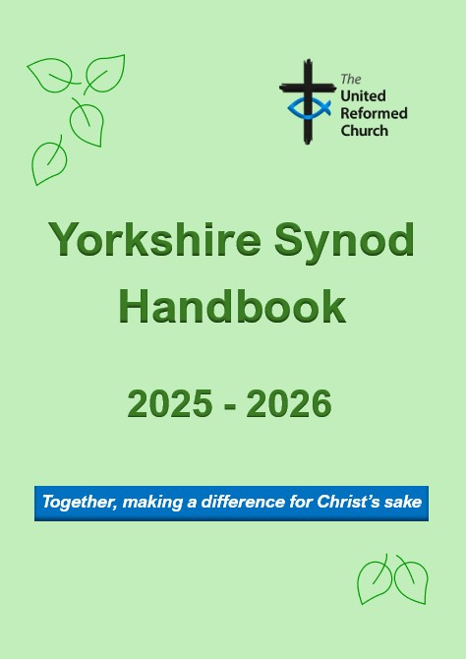
As in previous Briefings, this time sees several invitations to events and courses, as well as pointers to how you may help bring God’s Kingdom closer. There are also requests: from me at Synod in that we are in desparate need of willing volunteers to fill our Synod committees (and even to convene one of them); from our Safeguarding team to ensure that all your churches are fully compliant; from the new Eco team to be mindful of recycling and reusing things under the Circular Monday banner; and from our Property Officer who has asked that both fire safety and church security are not overlooked.
Finally, at Somerset House there has been a great deal of work going on to keep all our records up to date, and every so often this manifests itself in the YORKSHIRE SYNOD HANDBOOK. This is readily available from the Synod office, either in booklet form or as a free fully searchable pdf. Prices start at £3.50 per copy if collected from the Synod office or at £4.50 a piece if posted out.
For more information and for an order form, please conact the Synod office at office@urcyorkshire.org.uk.

If you have any news of welcoming people into Church, stories of celebration, Advent and hope or notices of Christmas 2025 and future events in 2026, please let me know by dropping me a line at clerk@urcyorkshire.org.uk and I’ll showcase it in the next edition, due out on Thursday 27th November 2025.
Thank you
Tim Crossley
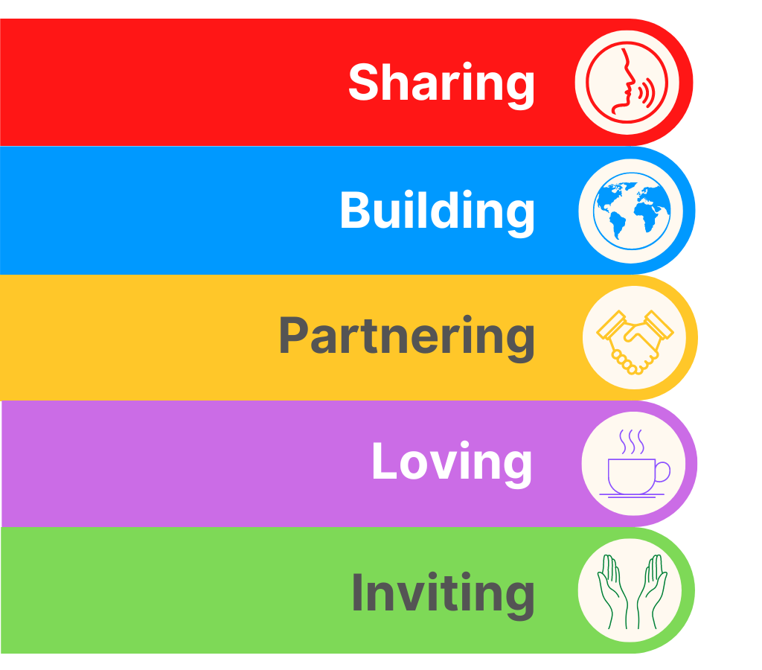
YOUTH ASSEMBLY 2026
Bookings have opened for next year’s URC Youth Assembly which will be happening between 27th February and 1st March 2026. Visit www.bit.ly/3TkqSfn for more details and to see a taster video of Youth Assembly 2025 or contact Megan at the Synod Office at megancyp@urcyorkshire.org.uk.

Lay Preachers and Worship Leaders lectionary planning zoom sessions
The Lay Preachers and Worship Leaders Planning Group are pleased to let you know that we are facilitating these sessions again after interest was expressed at the July 2025 conference.
We invite you to Explore the Advent lectionary readings together on Thursday 20th November 10.30am and repeated 7.30pm for looking at 14th & 21st December lectionary readings, facilitated by Jill Fletcher in the morning and Rod Morrison in the evening. Register with Rod by Friday 14th November and the link will be sent to those registered by Wednesday 19th November.
Please share this opportunity with anyone who leads worship in your church, whether on their own or part of a worship team, especially if they are new to this calling, to help us reach those who are not on our circulation list.
Yours in Christ’s service
Kath Lonsdale, Rod Morrison, Jill Fletcher and Anne Dale
Yorkshire Synod Lay Preachers and Worship Leaders Planning Group.
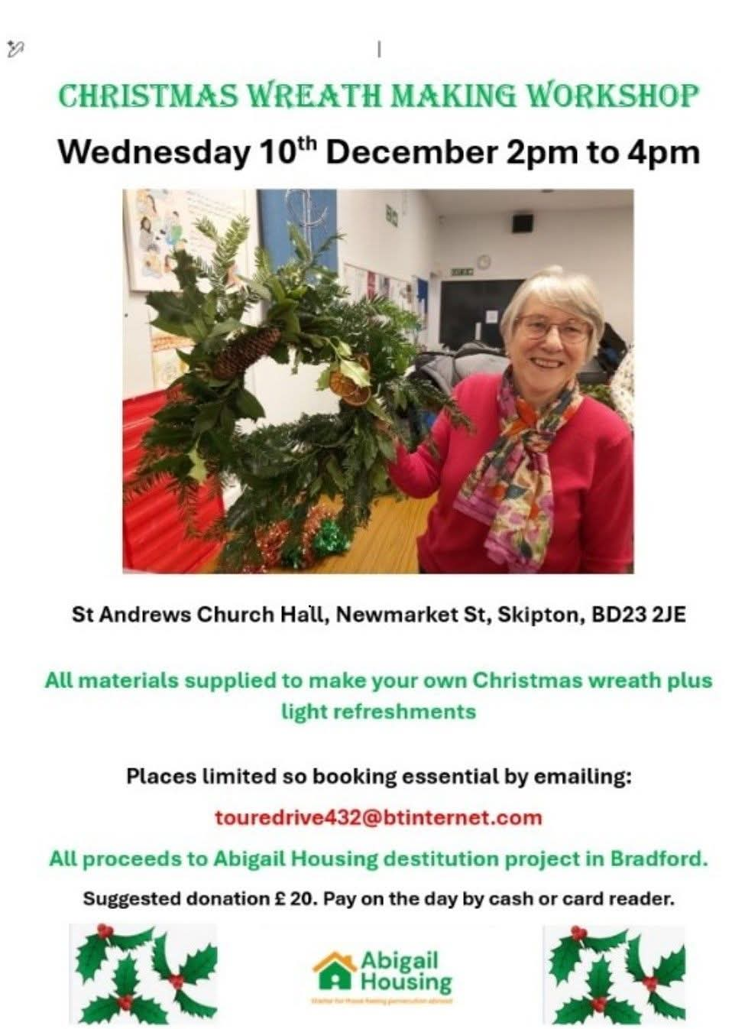

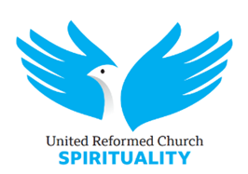
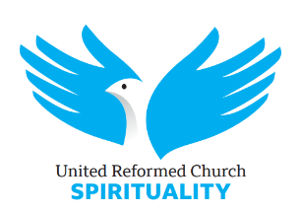
Waiting for the light: advent online retreat
2 December 2025 07:30 to 6 December 2025 21:00

Venue: Online
Ticket: Free

There will be three sessions each day:
7.30-8.00am: a portion of a psalm, leading into silence
12.00-13.00pm: a shared slow reading of one of the readings of the day (lectio divina) followed by a little sharing
7.30-9.00pm: sessions led by a variety of people, to include Neil Thorogood, Andrew Brown and Jacob Bali
For previous online retreats some people have attended all the sessions, weaving the rhythm of the retreat into their week, and others have dipped in as they are able. Sessions will be sufficiently self-contained for this to work as a “retreat in daily life” for whatever sessions people can make.
All the sessions will be on the same Zoom link.
Please book at: https://urc-spirituality.org.uk/urcsp_event/advent-online-retreat-2/
after which you will be sent the zoom link for all the sessions.



Yorkshire Synod Discipleship Development Small Grant Fund 2026
The Ministries Committee have so far approved 21 applications to this fund since 2022 and we encourage all lay church members to consider applying in 2026. Please use the new application form available through the Synod Office as the amount which you can ask for resources or has increased to up to £300. This fund exists to help you on your Christian journey including the costs of attending a course or to offset the costs of buying resources for personal development or sharing with others. If anyone wants to discuss an application before submitting it please contact the Convenor of the Yorkshire Ministries Committee, Kath Lonsdale at kathlonsdale@talktalk.net.
Remember this is for any age of lay person in our churches to apply for so please discuss with your young people as well as adults.

LEEDS PARTNERSHIP PRAYERS
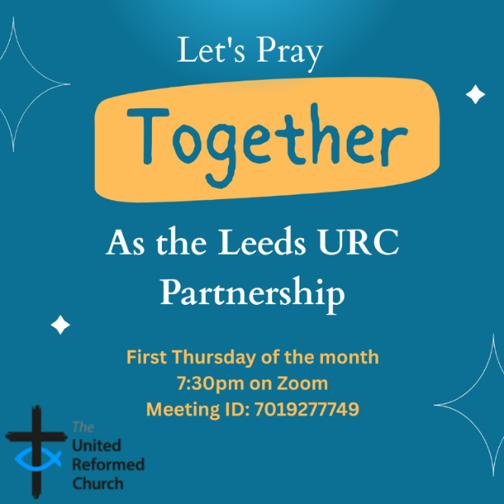
Although this is primarily aimed at those of us who are linked with the churches of the Leeds URC Partnership, this invitation is open to everyone from around the Synod and beyond.
It will be happening on the first Thursday of the month on Zoom at 7:30pm. The next one will be on Thursday 4th December and the link is here: https://us02web.zoom.us/j/7019277749

There will be a time to pray together, a time to share in reading the Bible and a time to share the joys and challenges in our lives, churches, communities and world.

Looking forward to seeing you there.

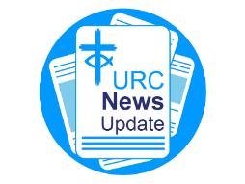
NEWS FROM THE DENOMINATION
The URC’s News Update is a monthly e-newsletter that keeps you informed about the latest news and events.
To receive this popular newsletter, please visit the https://urc.org.uk/news-updates-sign-up-form/ page on the URC website and follow the links. If you just want to dip in and catch up on what is going one, that’s fine and you can
read and print recent editions of our e-newsletter by visiting the URC News Update page at https://urc.org.uk/urc-news-update/ .

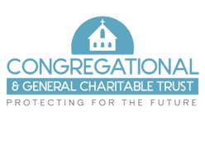
Do you need financial support for your church building project or significant repairs?

The Congregational & General Charitable Trust may be able to help

The C&G Trust is an independent grant-making charity which aims to support churches, particularly those of the United Reformed and Congregational denominations, in the provision and repair of suitable buildings. They make grants towards the overall care, upkeep and extension of churches and also offer grant funding toward the capital cost of church community projects.
The trust began as the charitable arm of the Congregational & General Insurance Company but became a separate charity and now is completely independent of the insurance company and distributes grants from the investment of the proceeds of the sale of that company in 2016.

What grants are available?
The level of grants available to churches range from £1,000 to a maximum of £25,000. Grants are usually capped at 25% of the total project cost. Grants are awarded for church or related community capital projects involving building work, repairs, improvements or extensions. Any project costing less than £1m in total will be considered. Consideration will also be given to smaller clearly defined and discrete project phases. There are a few exclusions including organ or bell restoration, stand-alone environmental projects such as solar panels or heat source pumps, manse works, conservation/restoration of works of art, graveyard or garden maintenance, parking provision and the running costs of the church.

How do I apply?
Applications should be made in advance of starting any work (apart from obtaining professional design and project planning advice) and be submitted when planning has proceeded to the point where clear details of the planned works and their expected cost can be provided.
Applications are considered quarterly (March, June, September and December of each calendar year) The upcoming application date for each quarter is published on the website at https://www.candgtrust.org.uk/how-to-apply-funding-church-projects/ with further details and an application form available to download. The website also has a useful Q & A section as well as a sample completed application form for you to view. If you are unable to find all the answers to your questions, please contact us at admin@candgtrust.org.uk.
Applications must be supported by copies of your church accounts and documentation supporting the estimated cost of the project, such as Contractor quotes. There is an expectation that the church will contribute, so far as it is practicable, to the project from its own funds and from local fundraising.

The charity exists to help churches like yours – so please do not hesitate to apply if you feel we can be of help.


Put the date in your diary – Monday 24th November 2025.

Rod Morrison, of the Synod’s Eco Group asks “Do you remember the old days, when your mum darned your socks, or put patches on the elbows of your school blazer? When you took your shoes to the cobblers to be re-heeled, or unravelled that now-too-small jumper to knit a new one in a bigger size? It was repair, reuse, share, and upcycle – practices that we need to return to as we face the consequences of global warming; practices which we now call “circular consumption” - keeping resources in use and preventing waste. That’s what “Circular Monday” is all about. Forget Black Friday, and celebrate Circular Monday instead, when we focus on keeping resources in use and preventing waste. Of course, we should be keeping resources in use and preventing waste all the time. But Monday 24th November is when there is a main event to promote “circular consumption””.

So why not join the Main Event for this year – on Circular Monday 24th November
It’s just one hour – with big impact. It’s online, and showcases how circular solutions are reshaping the world. Expect inspiration, global perspectives, and engaging voices leading the way towards a more sustainable future. If you want to take part, simply post a photo of yourself or your group on social media with #CircularMonday, showing something linked to reuse, repair, or renting.

For more information use this link : https://www.eventbrite.com/e/circularmonday-2025-official-main-event-tickets-1607228065409?aff=oddtdtcreator

But “Circular Monday” is more than just one day in a year.
Circular Monday began in 2017 in Malmö, Sweden, as a counter-movement to Black Friday. It is now an on-line campaigning community which highlights and celebrates businesses, organisations, and individuals that keep resources in use and prevent waste, making it easier for people everywhere to choose circular solutions. (see www.circularmonday.com )

The Circular Monday community aims to promote circular consumption by:
- ‍Hosting an annual global action day (the main event - Circular Monday - the Monday before Black Friday)
- Building the world’s largest database of circular businesses and changemakers
- Inspiring people to repair, reuse, rent, share, and upcycle instead of buying new.
At their main event, always the Monday before Black Friday, the year’s campaign results are revealed. The goal is to make circular solutions visible, accessible, and the new normal.

As a guide, the Circular Monday community use the 12R strategies, including: Refuse, Reduce, Rethink, Redesign, Reuse, Repair, Refurbish, Remanufacture, Repurpose, Recycle, Re-earth, and (as a last resort) Recover. Recycling is considered baseline, not leadership so we encourage higher-value practices like reuse, repair, and redesign.

Anyone can join the Circular Monday community, both online and through local in-person activities or digital events. You can explore the Circular Monday database of circular businesses, or join as a volunteer. For ideas, check out @circularmonday on Instagram.

Why not join the online community yourself and start to consume circular – or at least think about which of the 12 Rs you can put into practice?

And an after-thought : If you want to calculate your carbon footprint so that you can monitor your progress towards zero carbon, go to https://climate-calculator.climatehero.org/?source=MicrosoftKeywords&msclkid=e14c76185f8b1f0a5a4c1ec4154a8c61
It takes just 5 minutes!
Important information from the Synod Safeguarding Team
Due to changes in the insurance industry, insurers are now adding a new safeguarding endorsement for churches to complete when their insurance is due for renewal. What this means is that insurance companies will now place conditions on all policies, that it these conditions must be adhered to for the policies to be valid.
What this means is that you will need to answer yes to the following questions –
- Have you a complete and comprehensive written safeguarding policy that is reviewed at least annually?
- Do you have a church safeguarding coordinator for your church?
- Do you as a church, provide safeguarding training to everyone who needs it due to their role within the church?
- Do you know how to respond to a safeguarding incident, know who to report it to and how to deal with it correctly?
- Has everyone who needs them, due to their role, had the correct level of DBS checks and has this been completed in the past three years?
- Have you and do you have a system to securely retain records of any abuse allegations and the action you took in relation to these allegations?
You would also need to make the insurance company aware if there have been any allegations of abuse which have been reported at your church.
The above relates to anybody involved in the church who works unsupervised with children or vulnerable adults or has unsupervised access to children or vulnerable adults. This means that everybody who falls under the guidance of Good Practice 6, which includes Elders etc need to make sure everything is up to date and in order, to be able to confirm this with the insurance company when the renewal is submitted.
If the answer is no, or the disclosure is incorrectly completed, insurance may be withheld or be made void in any claims. If this is the case and a claim is made it will be made against the church itself and the Trustees.
Many of you may already be able to answer yes to all the questions posed.
However, many of you may not be able to answer yes to all the questions and this is where action needs to be taken at the church.
The Elders/Trustees are responsible for ensuring that the church is a safe place for everyone and therefore responsible for making sure that you can answer all the questions posed by an insurance company to provide insurance cover for the church and everyone who attends.
If you need help making sure your church can answer yes to all the questions you will be asked please contact the Synod Safeguarding Team by email (click here) and we will assist you in making sure your church can be insured correctly.

The Safeguarding team are available 24 hours a day, seven days a week and 365 days a year (and even 366 days in Leap Years!!). Details can be found on the Yorkshire website at https://urcyorkshire.org.uk/safeguarding/ and any query, either by phone or by e-mail at safeguarding.1and4@urc.org.uk will be answered within 24 hours.

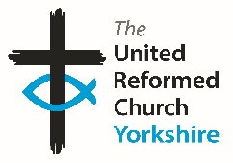

Somebody is missing
Is it you?

Synod is looking for volunteers to fill
several posts across it’s committees.
Please contact the Synod Moderator or
Clerk if you, or someone you know,
would like more information
on how to help.

clerk@urcyorkshire.org.uk moderator@urcyorkshire.org.uk

WANTED!!
The Children’s and Youth Work Committee of the Yorkshire Synod is in need of a new Convenor, to succeed Mr Dan Morrell who has filled this role for a good few years now. He steps down from the role at our next Synod meeting, to be held on March 14th 2026 at West Park URC in Harrogate.
This means we are looking for a successor to Dan, so if you are interested in this role, or you may know of someone who would be ideal to help guide the Children’s and Youth Work side of our Synod life, please contact the Synod Clerk at clerk@urcyorkshire.org.uk for more details and for a more detailed job description.

FIRE SAFETY
Jane Bunyan, our Synod Property Officer property@urcyorkshire.org.uk has asked that I remind churches that fire regulations for small non-domestic premises have changed in light of the Grenfell Tower Enquiry outcomes. The advice Synod is giving is that all churches should make themselves aware of the new regulations and advice updated in 2024 at Making your small non-domestic premises safe from fire - GOV.UK or https://www.gov.uk/government/publications/making-your-small-non-domestic-premises-safe-from-fire but if you would like a pdf copy then please email Jane at the above e-mail address.




Places of Worship Protective Security Scheme (Home Office)
The Home Office is offering funded security measures (like CCTV, alarms, and secure doors) to places of worship and faith community centres in England and Wales that are at risk of hate crime. The scheme covers installation and one year of maintenance.

Through this scheme, eligible sites can apply for fully funded physical security measures such as CCTV, Secure fencing/gates, Stronger doors and locks, Window protection, Intruder alarms, Entry systems (keypad, fob, intercom), External lighting and Secure mailboxes

The application portal is now open and will close on 8th December 2025. If you are interested in applying, please visit:
https://www.homeofficesurveys.homeoffice.gov.uk/s/placesofworshipscheme/

For more information, including eligibility, further details on the application process, and supporting guidance, please visit GOV.uk.:
https://www.gov.uk/guidance/places-of-worship-protective-security-scheme

The Home Office will be hosting drop-in sessions and workshops. These sessions will talk through the process, explain what successful applications look like, and offer a useful Q&A to applicants.

These sessions will be hosted on:
16:00-17:00 – 26th November and 14:00-15:00 – 2nd December

If you are interested in attending, please email psvc@homeoffice.gov.uk , and a member of the team will be happy to register you.

Buildings for Mission Forum webinar
The Church Family and Sustainability
Join us on Thursday 20 November 2025 at 11.30am for a quick update on how the resolutions taken at the Extraordinary General Assembly will impact the use of our churches’ buildings for mission, and to hear from experts Cliff and Sacha on sustainability for our church families. There will also be plenty of time for exchanging ideas and sharing experiences.
Register for the webinar here:
https://www.eventbrite.co.uk/e/buildings-for-mission-forum-tickets-1785304346359?aff=oddtdtcreator .

For more information about this webinar please contact Lindsey Brown,
Head of Ecumenical Relations and Evangelism, United Reformed Church,
86 Tavistock Place, London WC1H 9RT
lindsey.brown@urc.org.uk
And Finally
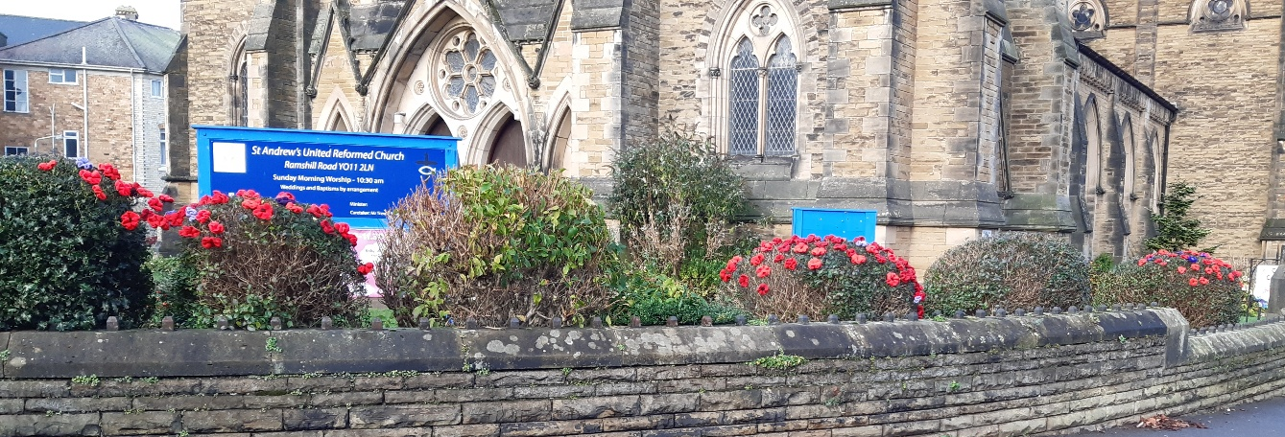
Remembering in Scarborough
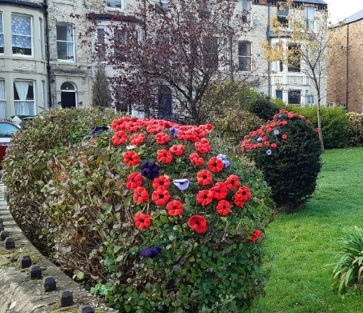
Sid Hambridge, the Church Secretary at St Andrew’s URC in Scarborough contacted us at Synod office with how they recently commemorated the Remembrance season this November. They were able to adorn the bushes in the church grounds with poppies, knitted by their ladies. As well as being an outward sign of St Andrew’s appreciation of the sacrifices made by those who served their country it also represented a more personal remebrance as a special dedication was made to Trish McNaughton, a member of St. Andrew's who died earlier this year.
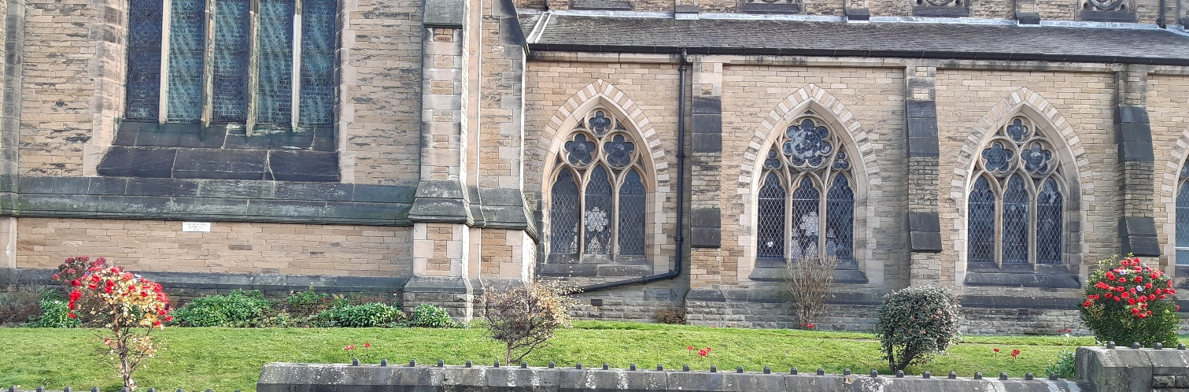

If you have a good news story from your part of the Synod or something that you feel would enhance the work of Synod in 2025 and into 2026, drop me a line at clerk@urcyorkshire.org.uk and I’ll make sure it hits the back page!!

You can also keep an eye on all our social media platforms for news; on the website at Home - URC Yorkshire Synod, at United Reformed Church in Yorkshire - Home | Facebook and Wilderness URC Yorkshire - Home | Facebook, the YouTube page at URC Yorkshire - YouTube and the Twitter (X) page at URC in Yorkshire (@URCYorkshire) / Twitter.

