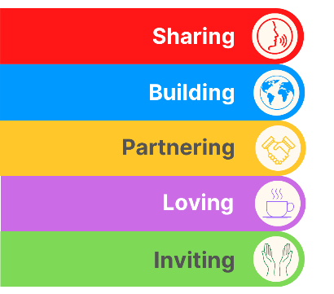
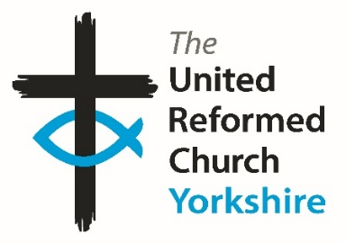
Yorkshire Synod Briefing
Number 164

27th November 2025

ADVENT IS HERE
Advent is nearly here; it starts this Sunday on 30th November and many of the new invitations and events which are in this issue of the Briefing are related to just that or to the Christmas celebrations that Advent leads us into. There are a wide variety of events, ranging from the celebratory to the creative to the contemplatative. Each has its place in our preparation and each has a side which strengthens our understanding of just what we celebrate at Christmas as Christians. As you will see there are special Advent Carol Services, Workshops to help make the decorations for your own celebrations, Christmas Tree Festivals as well as new notices of traditional Carol concerts and services across the Synod.
As well as the Synod churches being active during Advent, so are some of the national interest groups. URC Spirituality is inviting us to Wait For The Light in a more measured and contemplatative manner, whilst URC’s online church, yoURChurch is hosting the annual joint service with our friends and colleagues in the Evangelische Kirche der Pfalz. Nationally the denomination is working with our free church colleagues through JPIT, with aid being sent to Jamaica in the aftermath of the recent hurricane and on matters of migration. These stories can be found here https://urc.org.uk/our-news-stories/latest-news/ with an opportunity to sign up for the URC’s news update service.
It has been a rather busy time as well in the Synod office, and for those who have the privilege to represent the Synod in the national arena. The Yorkshire Synod’s General Assembly Representatives were again called upon at the beginning of the month to consider the progress and continuation of the Church Life Review. This was done over a three day period and for all the relevant papers and resolutions please visit the URC website at https://urc.org.uk/general-assembly-assembly-executive-assembly-committees/general-assembly/general-assembly-papers/ . Here you can find what plans lay in store for the denomination as we enter 2026 and I hope that you can add to the many prayers that are offered so that this all come to fruition as we seek the mind of God and find the direction His church will take in the future.

Finally to let you know that after this one there is just one more Briefings to go this year!! The next one is due out on Wednesday 17th December, which allows me to report on how your many Advent events have gone and (I hope) to showcase the Christmas Events you are all planning. Please don’t be shy; send in your stories, news of your events and anything your church would love to share with the Synod and beyond.

If you have any news of welcoming people into Church, stories of celebration, Advent and hope or notices of Christmas 2025 and future events in 2026, please let me know by dropping me a line at clerk@urcyorkshire.org.uk and I’ll showcase it in the next edition, due out on Wednesday 17th December 2025. Yes, I know, a Wednesday, but it means that I can still showcase those pre-Christmas events that I know you are itching to get me to advertise.
Thank you
Tim Crossley
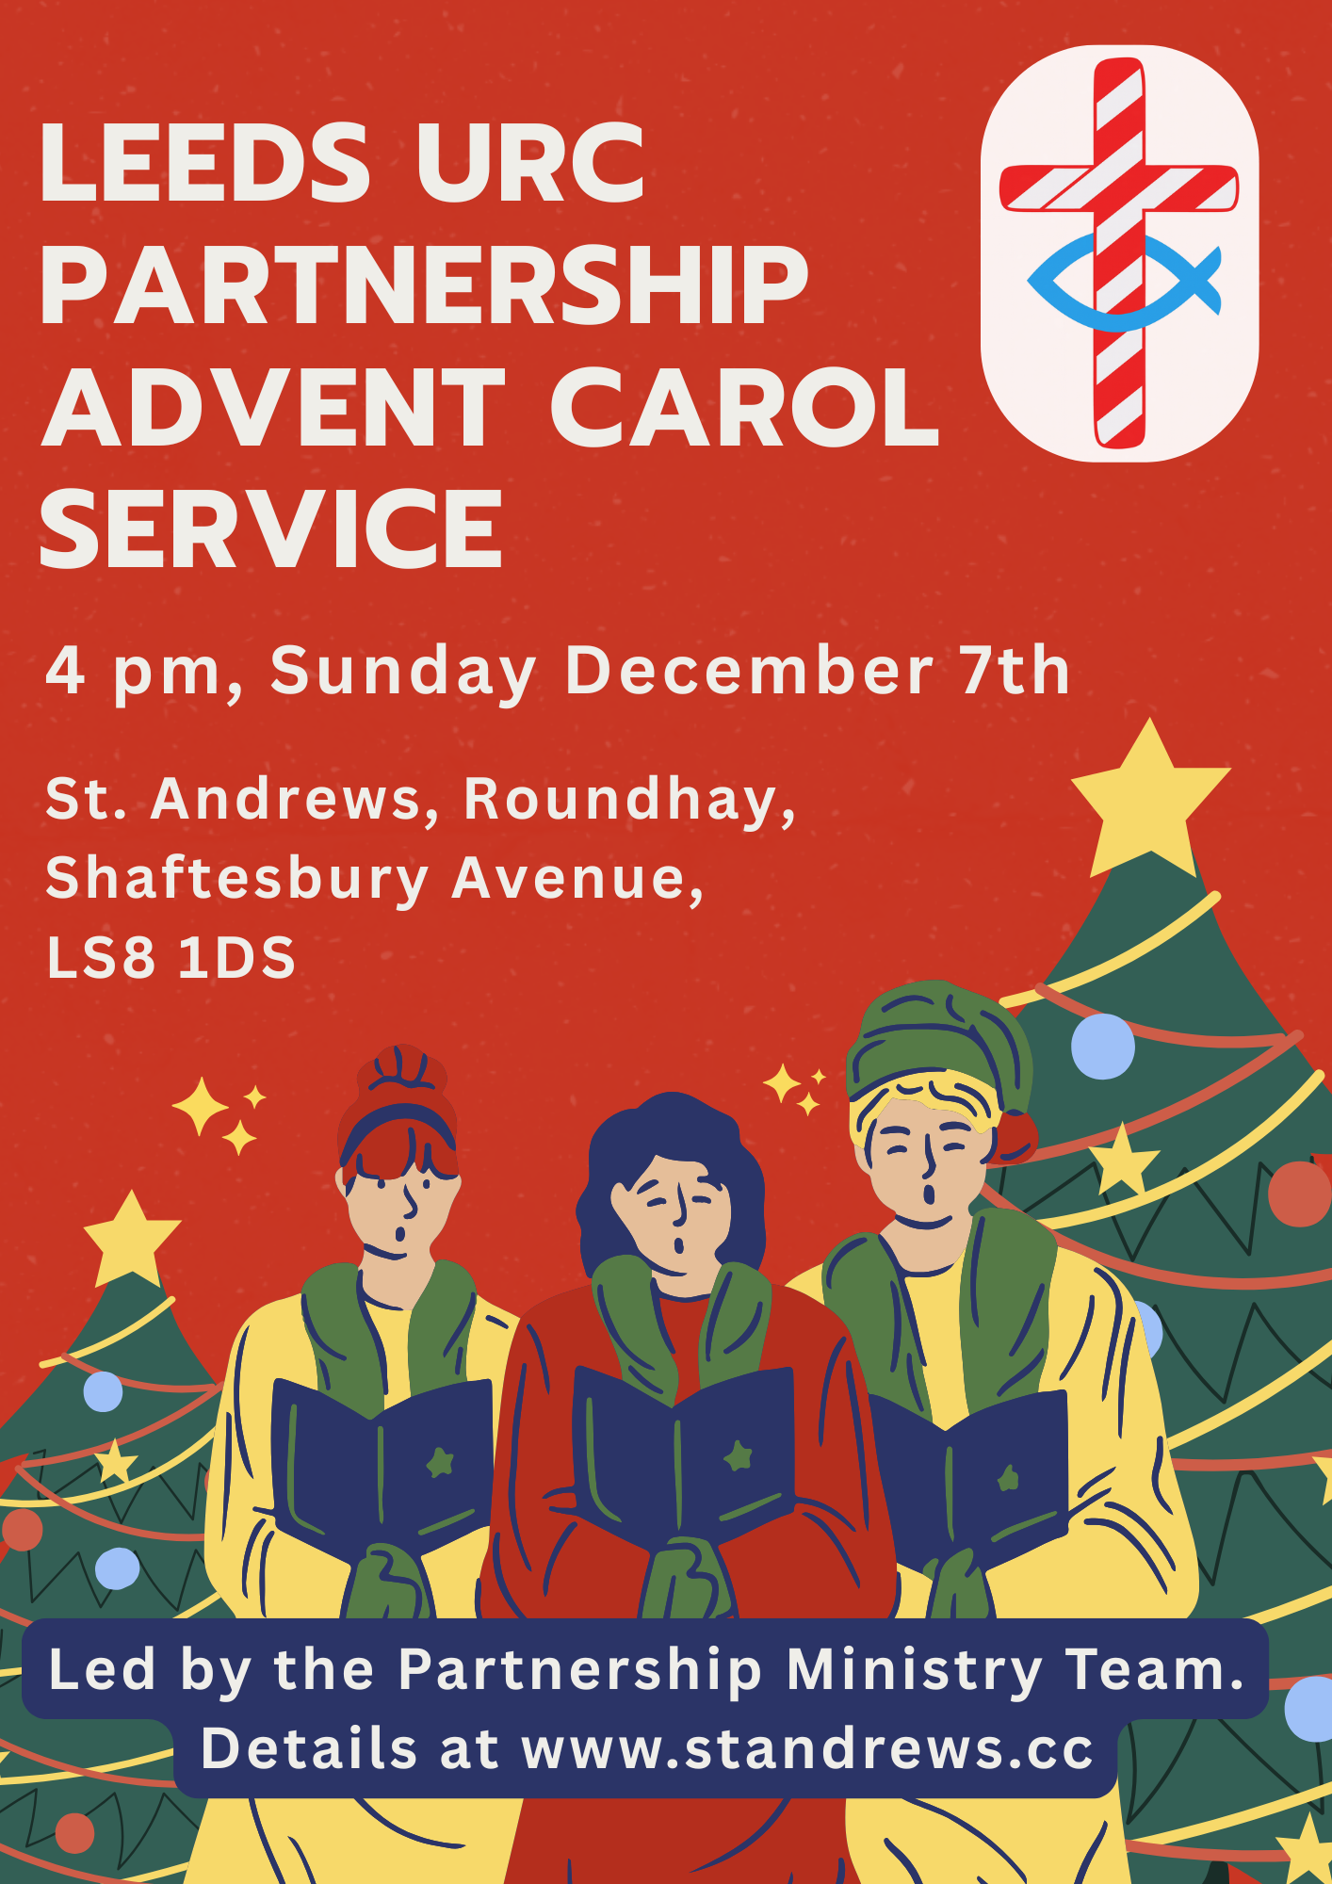
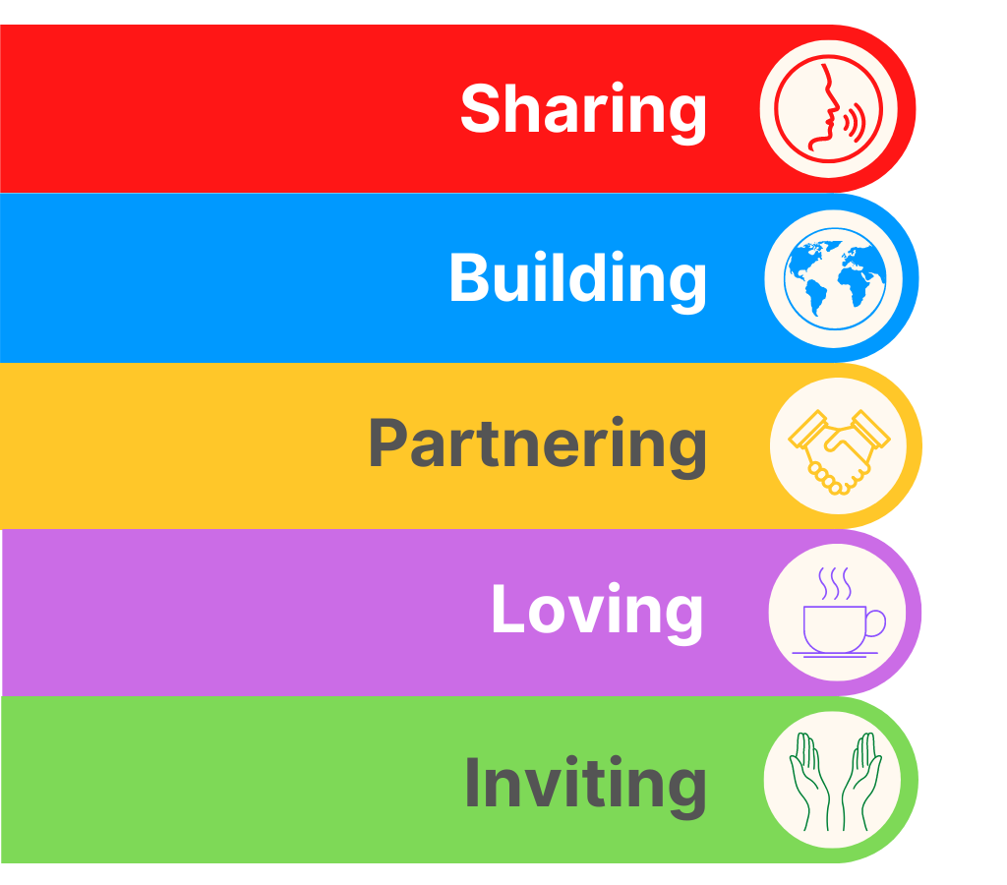
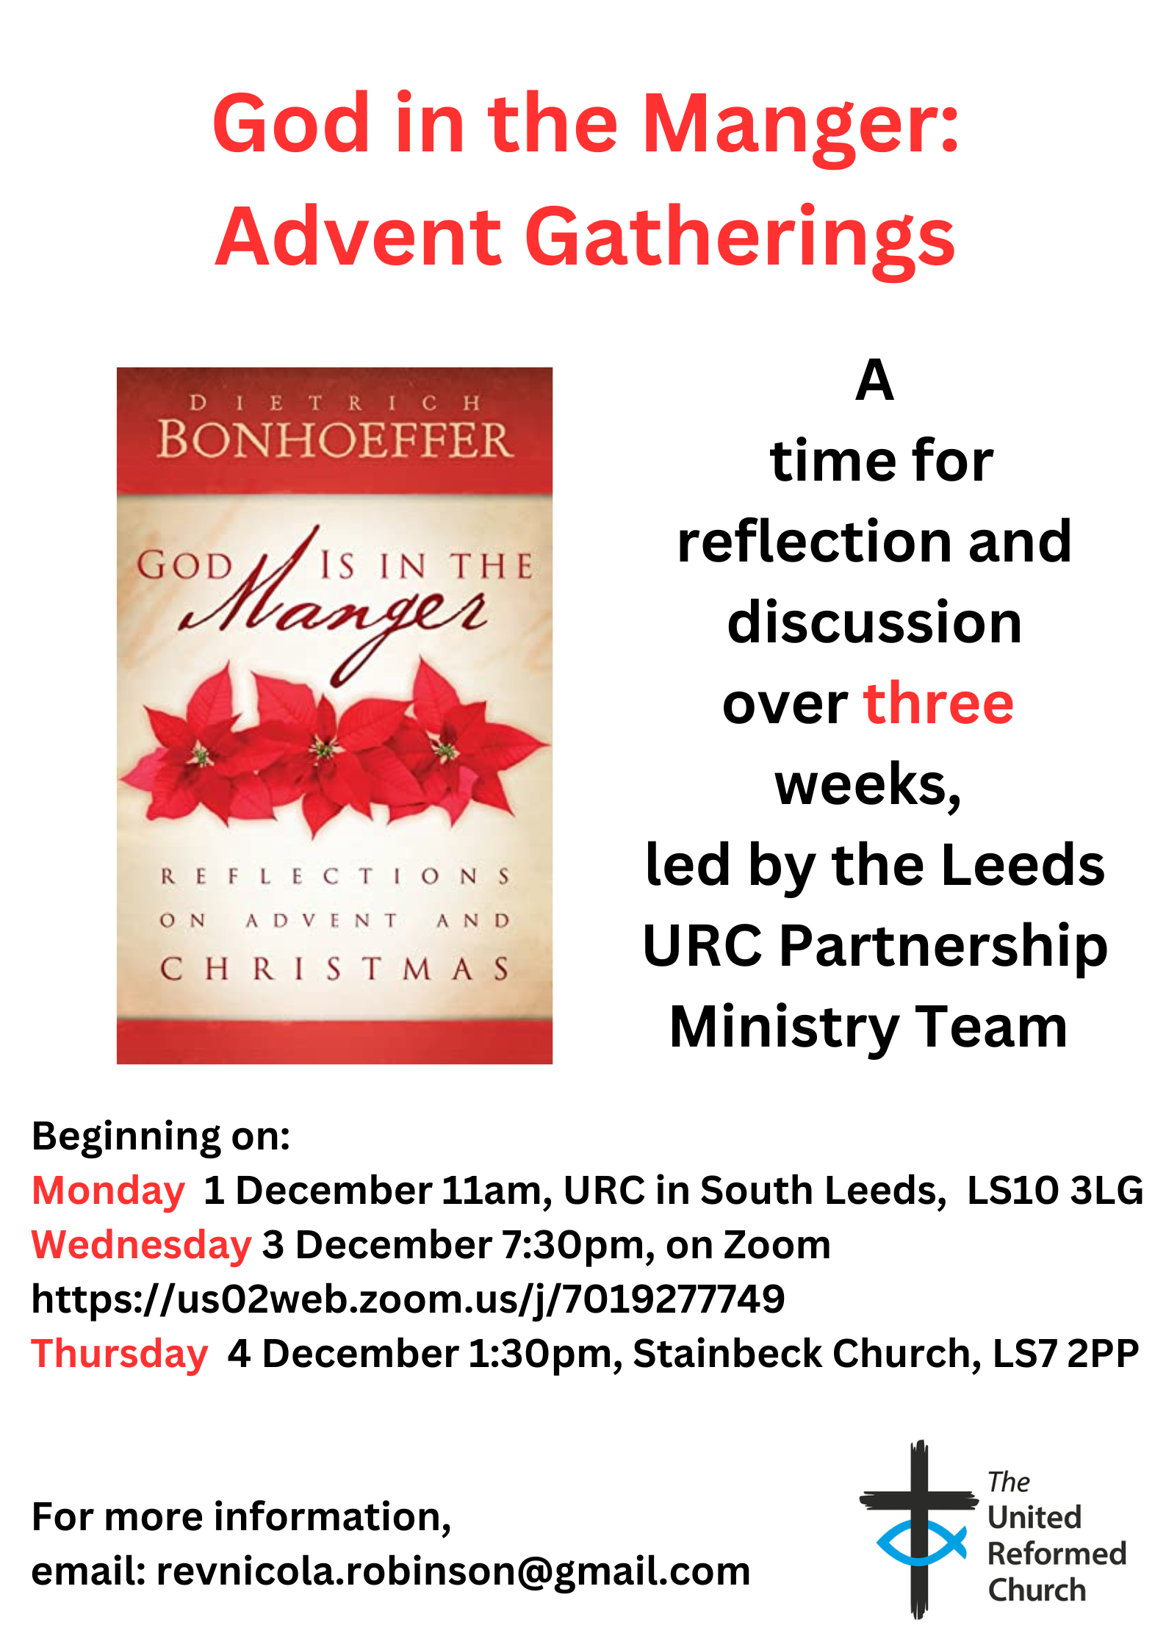
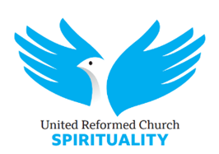
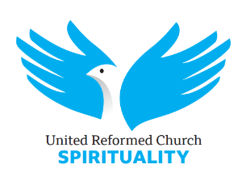
Waiting for the light: advent online retreat
2 December 2025 07:30 to 6 December 2025 21:00

Venue: Online
Ticket: Free
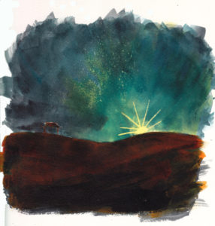
There will be three sessions each day:
7.30-8.00am: a portion of a psalm, leading into silence
12.00-13.00pm: a shared slow reading of one of the readings of the day (lectio divina) followed by a little sharing
7.30-9.00pm: sessions led by a variety of people, to include Neil Thorogood, Andrew Brown and Jacob Bali
For previous online retreats some people have attended all the sessions, weaving the rhythm of the retreat into their week, and others have dipped in as they are able. Sessions will be sufficiently self-contained for this to work as a “retreat in daily life” for whatever sessions people can make.
All the sessions will be on the same Zoom link.
Please book at: https://urc-spirituality.org.uk/urcsp_event/advent-online-retreat-2/
after which you will be sent the zoom link for all the sessions.

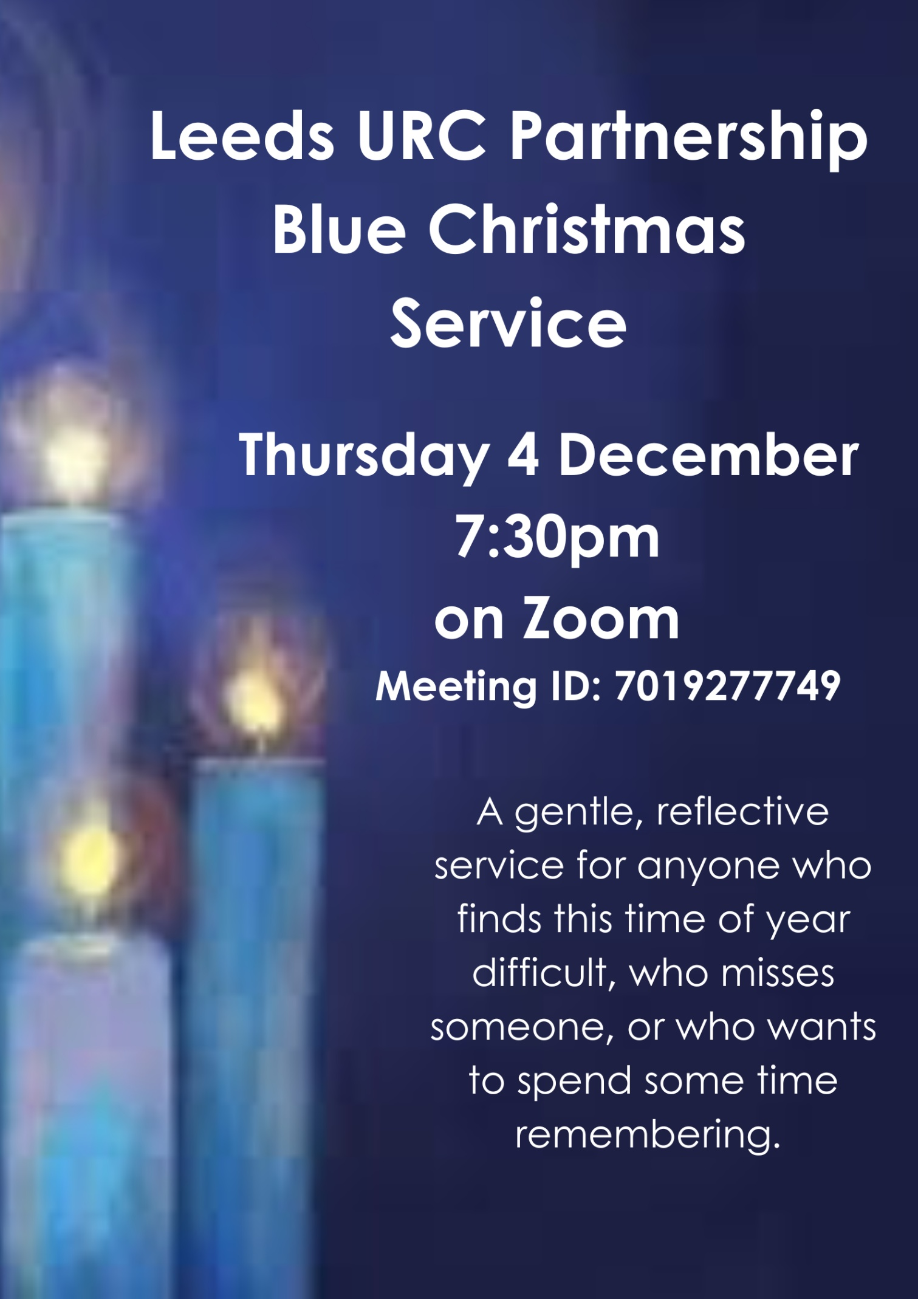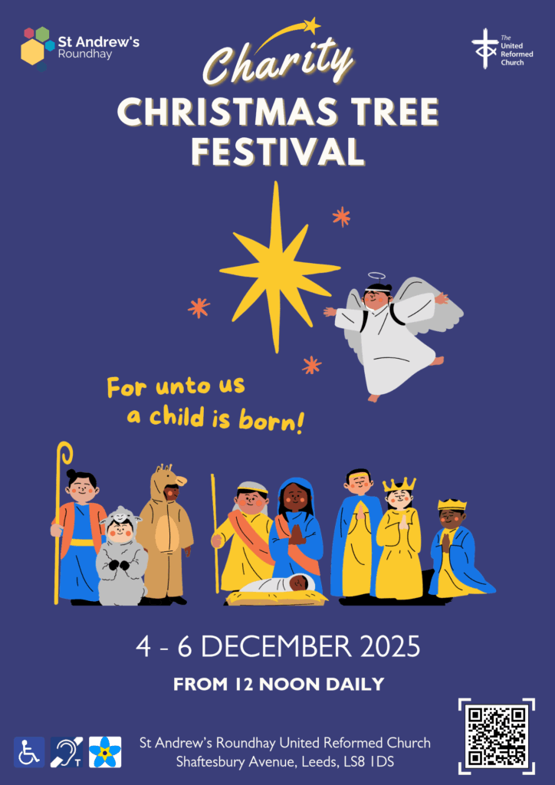
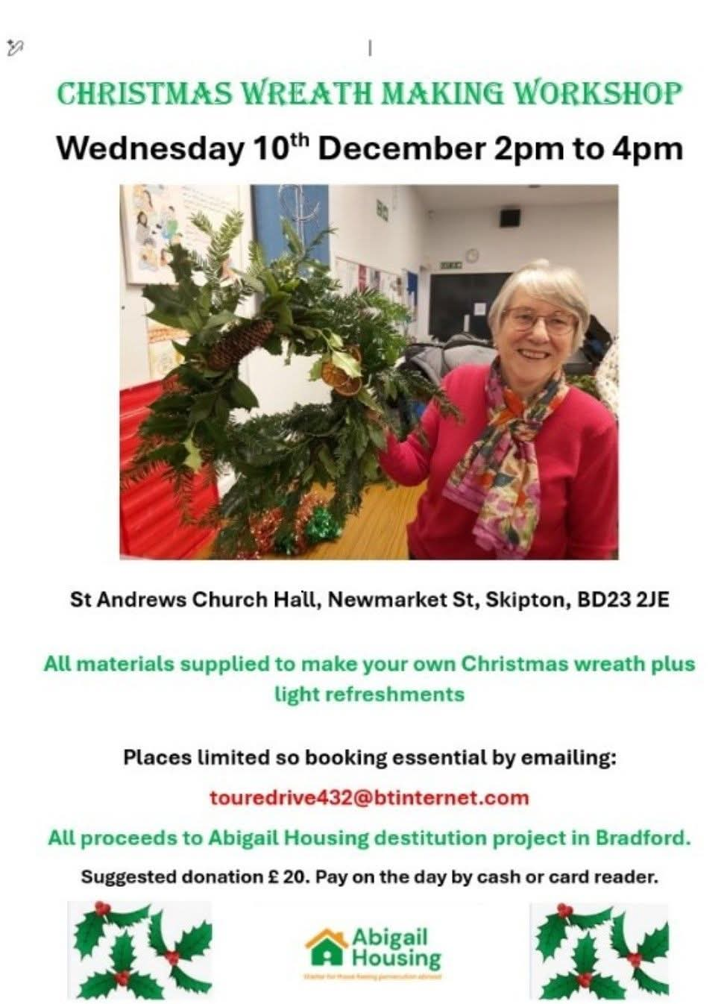

Annual Online Evangelische Kirche der Pfalz Advent Service
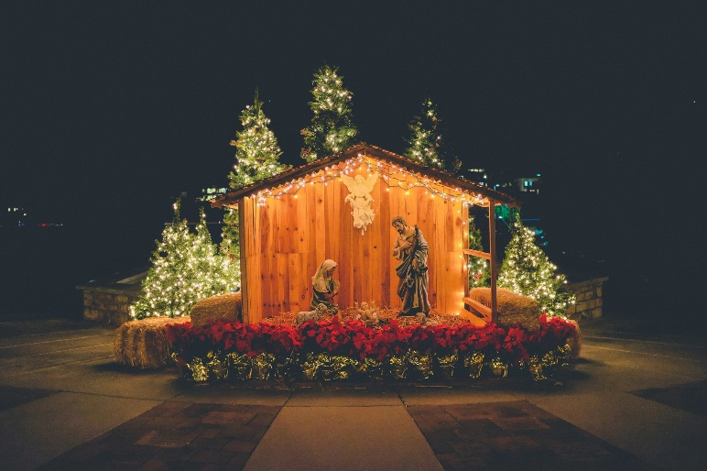
The annual online Advent service with the URC’s partner churches in the Pfalz region of Germany will be on Sunday evening, 14th December, 6.00pm to 7.00 pm. The service will be in English and German (with subtitles).
This is an excellent opportunity to meet with our German friends, with the facility for conversations during the service in break-out rooms. It will be hosted by the URC’s online church, yoURChurch.

All are welcome and to join please use Meeting ID 965 1457 5443 and Passcode YourChurch, or click on the link https://bit.ly/2Tf1EUk

YOUTH ASSEMBLY 2026
Bookings have opened for next year’s URC Youth Assembly which will be happening between 27th February and 1st March 2026. Visit www.bit.ly/3TkqSfn for more details and to see a taster video of Youth Assembly 2025 or contact Megan at the Synod Office at megancyp@urcyorkshire.org.uk.

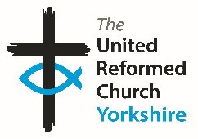


Somebody is missing
Is it you?

Synod is looking for volunteers to fill
several posts across it’s committees.
Please contact the Synod Moderator or
Clerk if you, or someone you know,
would like more information
on how to help.

clerk@urcyorkshire.org.uk moderator@urcyorkshire.org.uk



Yorkshire Synod Discipleship Development Small Grant Fund 2026
The Ministries Committee have so far approved 21 applications to this fund since 2022 and we encourage all lay church members to consider applying in 2026. Please use the new application form available through the Synod Office as the amount which you can ask for resources or has increased to up to £300. This fund exists to help you on your Christian journey including the costs of attending a course or to offset the costs of buying resources for personal development or sharing with others. If anyone wants to discuss an application before submitting it please contact the Convenor of the Yorkshire Ministries Committee, Kath Lonsdale at kathlonsdale@talktalk.net.
Remember this is for any age of lay person in our churches to apply for so please discuss with your young people as well as adults.

LEEDS PARTNERSHIP PRAYERS
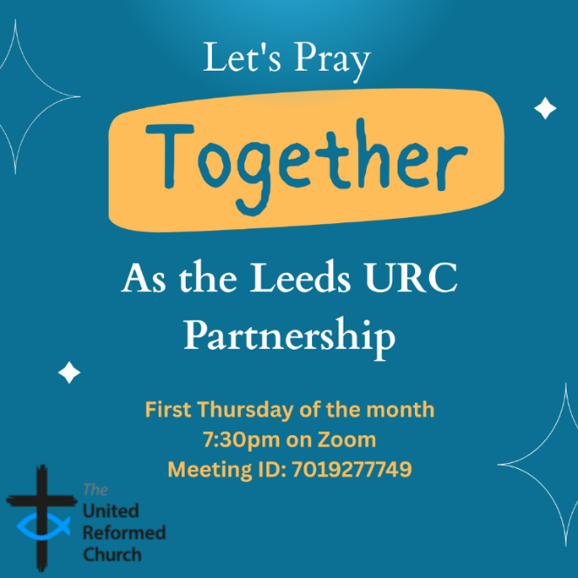
Although this is primarily aimed at those of us who are linked with the churches of the Leeds URC Partnership, this invitation is open to everyone from around the Synod and beyond.
It will be happening on the first Thursday of the month on Zoom at 7:30pm. The next one will be on Thursday 4th December and the link is here: https://us02web.zoom.us/j/7019277749

There will be a time to pray together, a time to share in reading the Bible and a time to share the joys and challenges in our lives, churches, communities and world.

Looking forward to seeing you there.

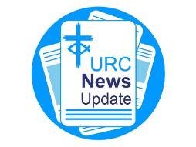
NEWS FROM THE DENOMINATION
The URC’s News Update is a monthly e-newsletter that keeps you informed about the latest news and events.
To receive this popular newsletter, please visit the https://urc.org.uk/news-updates-sign-up-form/ page on the URC website and follow the links. If you just want to dip in and catch up on what is going one, that’s fine and you can
read and print recent editions of our e-newsletter by visiting the URC News Update page at https://urc.org.uk/urc-news-update/ .

Important information from the Synod Safeguarding Team
Due to changes in the insurance industry, insurers are now adding a new safeguarding endorsement for churches to complete when their insurance is due for renewal. What this means is that insurance companies will now place conditions on all policies, that it these conditions must be adhered to for the policies to be valid.
What this means is that you will need to answer yes to the following questions –
- Have you a complete and comprehensive written safeguarding policy that is reviewed at least annually?
- Do you have a church safeguarding coordinator for your church?
- Do you as a church, provide safeguarding training to everyone who needs it due to their role within the church?
- Do you know how to respond to a safeguarding incident, know who to report it to and how to deal with it correctly?
- Has everyone who needs them, due to their role, had the correct level of DBS checks and has this been completed in the past three years?
- Have you and do you have a system to securely retain records of any abuse allegations and the action you took in relation to these allegations?
You would also need to make the insurance company aware if there have been any allegations of abuse which have been reported at your church.
The above relates to anybody involved in the church who works unsupervised with children or vulnerable adults or has unsupervised access to children or vulnerable adults. This means that everybody who falls under the guidance of Good Practice 6, which includes Elders etc need to make sure everything is up to date and in order, to be able to confirm this with the insurance company when the renewal is submitted.
If the answer is no, or the disclosure is incorrectly completed, insurance may be withheld or be made void in any claims. If this is the case and a claim is made it will be made against the church itself and the Trustees.
Many of you may already be able to answer yes to all the questions posed.
However, many of you may not be able to answer yes to all the questions and this is where action needs to be taken at the church.
The Elders/Trustees are responsible for ensuring that the church is a safe place for everyone and therefore responsible for making sure that you can answer all the questions posed by an insurance company to provide insurance cover for the church and everyone who attends.
If you need help making sure your church can answer yes to all the questions you will be asked please contact the Synod Safeguarding Team by email (click here) and we will assist you in making sure your church can be insured correctly.

The Safeguarding team are available 24 hours a day, seven days a week and 365 days a year (and even 366 days in Leap Years!!). Details can be found on the Yorkshire website at https://urcyorkshire.org.uk/safeguarding/ and any query, either by phone or by e-mail at safeguarding.1and4@urc.org.uk will be answered within 24 hours.
WANTED!!
The Children’s and Youth Work Committee of the Yorkshire Synod is in need of a new Convenor, to succeed Mr Dan Morrell who has filled this role for a good few years now. He steps down from the role at our next Synod meeting, to be held on March 14th 2026 at West Park URC in Harrogate.
This means we are looking for a successor to Dan, so if you are interested in this role, or you may know of someone who would be ideal to help guide the Children’s and Youth Work side of our Synod life, please contact the Synod Clerk at clerk@urcyorkshire.org.uk for more details and for a more detailed job description.

FIRE SAFETY
Jane Bunyan, our Synod Property Officer property@urcyorkshire.org.uk has asked that I remind churches that fire regulations for small non-domestic premises have changed in light of the Grenfell Tower Enquiry outcomes. The advice Synod is giving is that all churches should make themselves aware of the new regulations and advice updated in 2024 at Making your small non-domestic premises safe from fire - GOV.UK or https://www.gov.uk/government/publications/making-your-small-non-domestic-premises-safe-from-fire but if you would like a pdf copy then please email Jane at the above e-mail address.

Nurturing Creation: A Small Act with Growing Roots in Knottingley
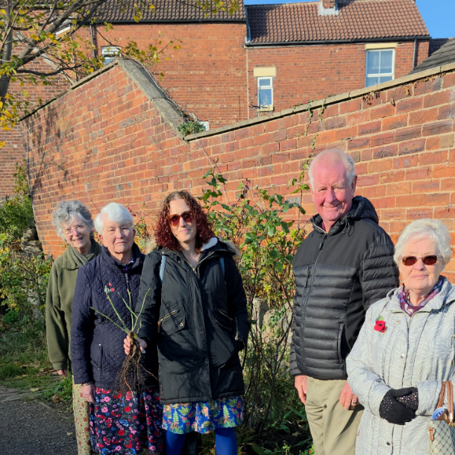
As part of their ongoing Green Agenda, Knottingley URC recently reached out to the Friends of Freda’s Garden—a group dedicated to caring for a beautiful stretch of the canal path in the town lovingly planted by the late Freda, a local woman whose vision transformed an ordinary space into a sanctuary of colour, peace, and welcome.
Today, the Friends continue her legacy, tending the garden so that it remains a place of beauty for everyone who passes by.
As a church, Knottingley URC asked if there was anything they needed and they were delighted to donate two climbing roses, aptly named “Pilgrim” and “Bathsheba.” A small group of the Knottingley membership visited the canal, met with Mark, who now manages the garden, and shared a simple blessing by the water as the roses were planted -symbols of growth, hope, and ongoing care for God’s creation.
Here we see (from left to right) Margaret Lyons, Pat Mee, Claire Nutt, Ian Nutt and Judith Wadsworth at the spot where those climbing roses have been planted.
And Finally
A Peaceful time in Denholme
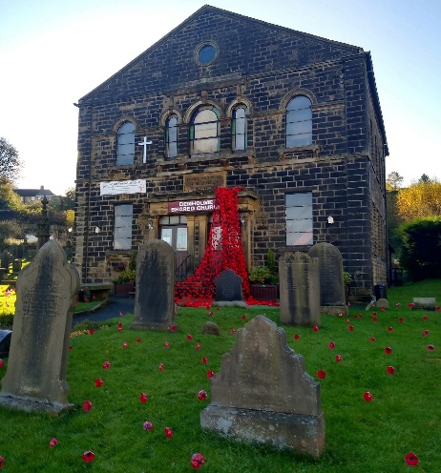
Last time I highlighted the Remembrance poppies knitted by the dextrous fingers of the members of St Andrew’s Scarborough. This time I am pleased to highlight the Doves for Peace project at one of our most westerly (if not highest at 290 m above sea level) churches at Denholme. Janice Le Blancq, one of Denholme’s Elders, writes:
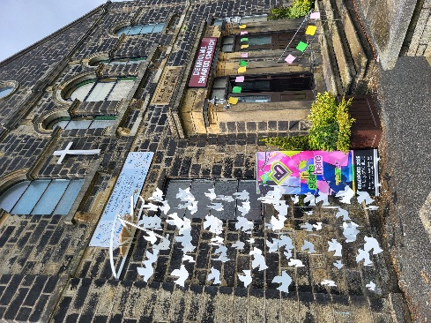
Peace is a significant word in the Christian vocabulary. We refer to Jesus Christ as the Prince of Peace; we refer to the Peace that passes all understanding; we share The Peace, there is an Advent candle for Peace. The list goes on …
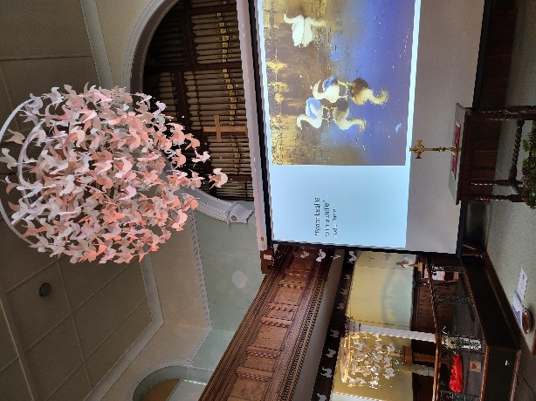
At a time when there is so much conflict and the world is crying out for Peace, Denholme Shared Church decided to focus on Peace this year. From the end of May throughout June, we joined in with the Bradford City of Culture 2025 celebrations. We were fortunate to receive a small grant and a stunning display of Peace doves was created both inside and outside the church in collaboration with local community groups and individuals. There were paper doves, knitted doves, wooden doves, tatted doves and more besides!
Individuals were asked to consider what Peace meant to them as individuals. It is common to despair and sigh when faced with the troubles of the world but, sometimes, so much more difficult to be at Peace within ourselves and with others.
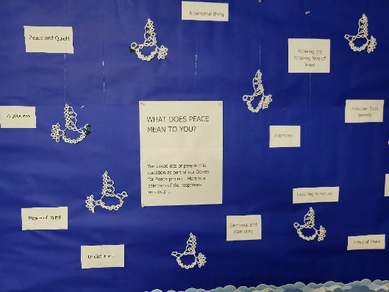
A rolling slideshow of images with famous quotes on peace was produced and many people commented on how restful and calm they felt for having experienced the exhibition.
The magnificent indoor display will remain in place until at least the New Year but the outdoor doves have now been removed.
Remembrance Sunday has just been observed and we are rapidly drawing towards Advent. Let us hope that the Spirit of Peace will be with us all and the memories of our Doves for Peace Exhibition remain in the hearts of all those who took part.

If you have a good news story from your part of the Synod or something that you feel reflects the work of Synod in 2025 and inspire others as we move into 2026, drop me a line at clerk@urcyorkshire.org.uk and I’ll make sure it hits the back page!!

You can also keep an eye on all our social media platforms for news; on the website at Home - URC Yorkshire Synod, at United Reformed Church in Yorkshire - Home | Facebook and Wilderness URC Yorkshire - Home | Facebook, the YouTube page at URC Yorkshire - YouTube and the Twitter (X) page at URC in Yorkshire (@URCYorkshire) / Twitter.

