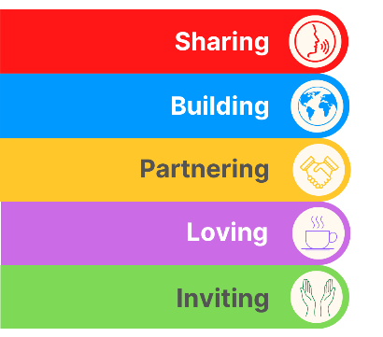
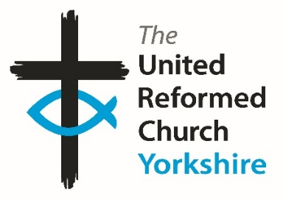
Yorkshire Synod Briefing
Number 165

17th December 2025

WISHING YOU ALL A VERY HAPPY CHRISTMAS AND A PEACEFUL AND PROSPEROUS NEW YEAR
I would like to take this opportunity to wish you all a very happy Christmas and a peaceful, prosperous and fulfilling New Year from all of us here at the Synod Office to all of you, wherever you may be. May the Christ-child whose coming we celebrate at this time of year be our guide and inspiration in all we do in 2026 and beyond.
This time we have quite a few stories of what has been going on, not only in the first two weeks of advent, but before that, especially at Denholme Shared Church, Norristhorpe URC, Zion URC Cottingham, Westfield URC Wyke and at The Bridge URC Otley, where the emphasis has been on those at the younger end of our church community. I hope that their activities can inspire similar activities across the Synod. I know other churches have similar outreach programmes to different demographics, and I would love to be able to showcase these as well. Send in your stories and pictures and I’ll share them in 2026, either here in The Briefing or on the Synod website at https://urcyorkshire.org.uk/. They may even end up in https://urc.org.uk/our-news-stories/latest-news/ which is always worth a read and has the opportunity to sign up for regular URC’s news updates.
As well as letting you know what has happened, there are a few events which are open to us all in the few days left before Christmas itself, in particular the Saltaire Carol service on the afternoon of Sunday 21st December and an invitiation to the YourChurch Christmas Eve Communion service, which is being led by our own Moderator, Revd Jamie Kissack. There are invitations to events beyond the Christmas season as well as notices that the Synod is looking for a Training and Mission Enabler, that the Hull Churches are recruiting a Wilderness worker and that there are plenty of other roles in the Synod and throughout the URC that need filling.
So, if you have any news of welcoming people into Church, stories of celebration and mission, please let me know by dropping me a line at clerk@urcyorkshire.org.uk and I’ll showcase it in the first edition of 2026, due out on Thursday 15th January 2026.
Thank you and every blessing to you all this Christmas season

Tim Crossley
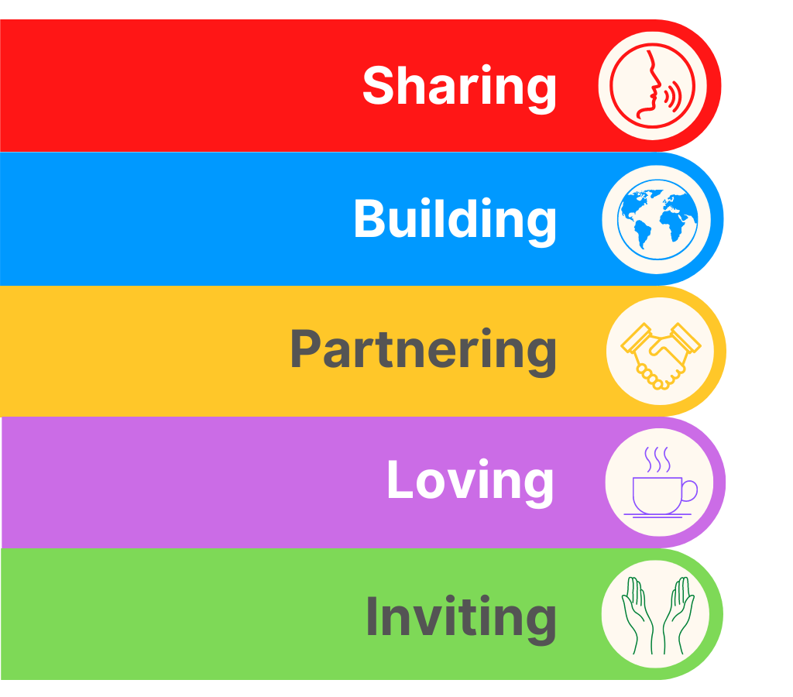
LIGHT NIGHTS IN HORNSEA
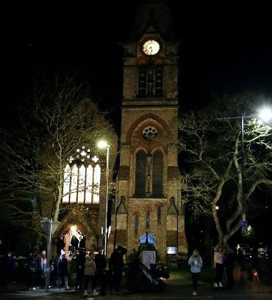
Back on the evening of Saturday 29th November, Hornsea URC was central to the town’s switching on of their Christmas Lights.
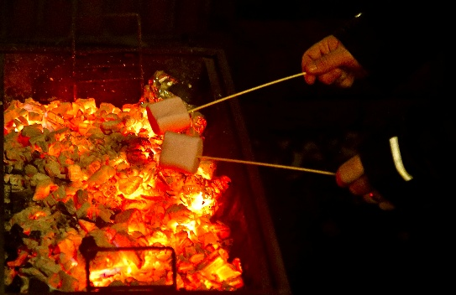
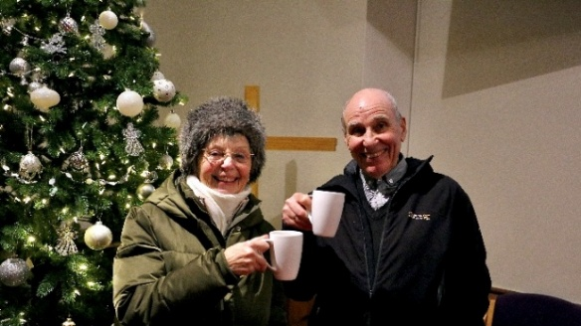
This annual event is now one of Hornsea’s big events and as usual Hornsea URC opened the church up for Teas, Coffees and other Refreshments. They also had a craft stall and a toy stall (to raise monies for transportation of their shoeboxes). It was hard to say how many came into the church, but their best guess is that there must have been 400 to 500 people of all ages. Some came for a drink (as Tony and Denise Greenway are seen here doing), some came in to get warm, some for a chat, and some just to sit and take everything in.
The church also had a BBQ outside where they gave away over 200 marshmallow smores, mainly to children, but also to adults. This went down a storm and opened the door for many conversations.
The church is always decorated for the lights nights and looks lovely; and they also took the opportunity to advertise their Christmas services on their screens.
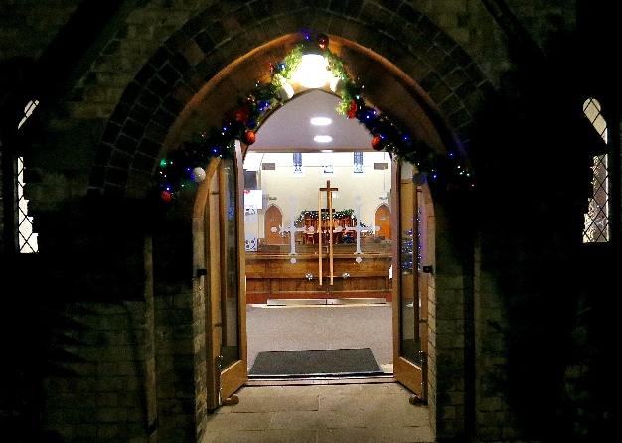
For more information on what is happening at Hornsea URC over the Christmas period and beyond, please visit their website at https://hornseaurc.org.uk/
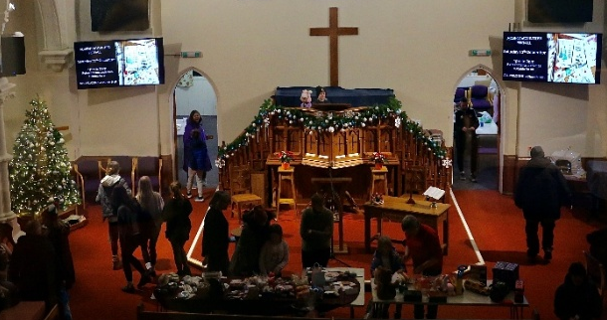

Racial Justice Sunday on 8th February 2026
Plans are being put in place for next year and the sooner it get’s into people’s diaries the better.
The theme for 2026 is Love Your Neighbour. Given the current narratives of hostility, fear, suspicion and hatred of the ‘other’, particularly asylum seekers, refugees and anyone who is not British or Irish ‘enough’, this theme is more important than ever.
Resources are available here:
https://ctbi.org.uk/resources/racial-justice-sunday-8-february-2026/'
and more information will be available in January 2026.

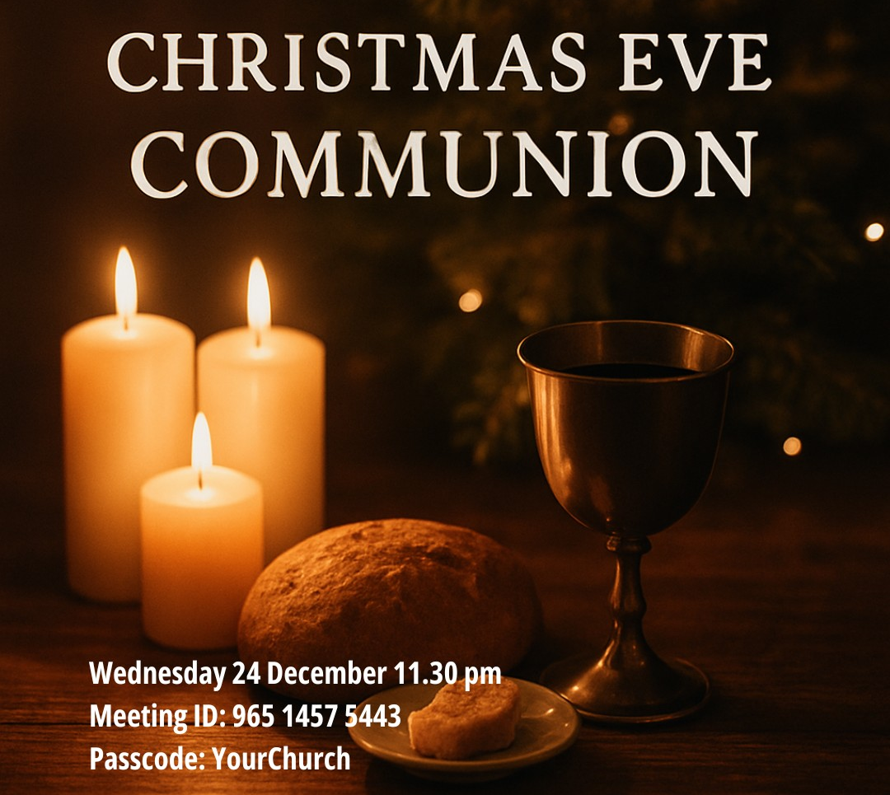
CHRISTMAS EVE COMMUNION
Our own Yorkshire Synod Moderator, Revd Jamie Kissack, will be leading the online YourChurch Christmas Eve Communion Service on 24th December at 11.30pm. You will be most welcome to join them to celebrate with members and friends of YourChurch.
Please bring bread & wine or their equivalents.
Join us using:
Meeting ID: 965 1457 5443
Passcode: YourChurch
or click on this link: https://bit.ly/2Tf1EUk

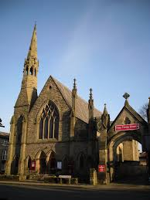
The fellowship of Knaresborough United Reformed Church would love to invite you to a celebration of our recent renovations and redecoration.

Pease join us at our coffee morning/afternoon between 10am and 2pm on Saturday 10th January 2026 or come and worship with us at 10am on Sunday 11th January 2026.
We look forward to seeing you and showing you around.

YOUTH ASSEMBLY 2026
Bookings have opened for next year’s URC Youth Assembly which will be happening between 27th February and 1st March 2026. Visit www.bit.ly/3TkqSfn for more details and to see a taster video of Youth Assembly 2025 or contact Megan at the Synod Office at megancyp@urcyorkshire.org.uk.
NORRISTHORPE URC GETTING READY FOR CHRISTMAS.
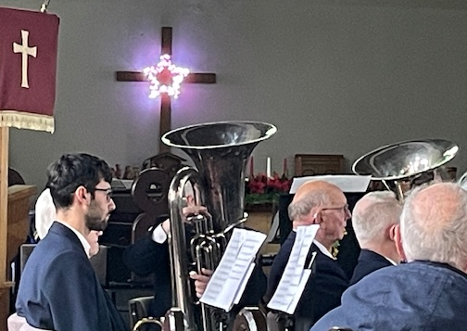
One of our SPACE (Spen and Calder Enterprise) churches has had a busy time getting ready for Christmas Celebration this month. Janet McDonald writes to tell us that “The Hills of Norristhorpe were alive with Christmas music on Saturday 6th December with a great brass band concert provided by the Clifton and Lightcliffe Brass Band. The church was full and a great afternoon was had by all. Following the concert we finished the afternoon with tea/coffee mince pies, shortbread and Christmas cake with of course Wensleydale cheese.
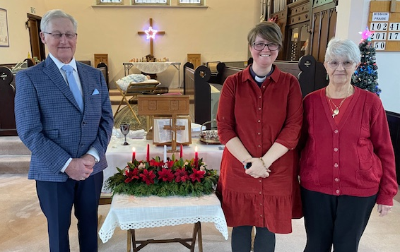
“Sunday 7th December, we welcomed and celebrated the Ordination of John Cresswell as our new elder. At the same time Christine Whitaker remade her commitment to continue her role as an elder of the church. The service and ordination were carried out by our new minister Rev. Samantha Sheehan.
“Sunday 14th December saw the church windowsills already decorated with nativity scenes from around the world. We had a great afternoon holding our Christingle service for playgroup that meets in the church building and it was wonderful to have the place once again full of children, their families and our own church family.
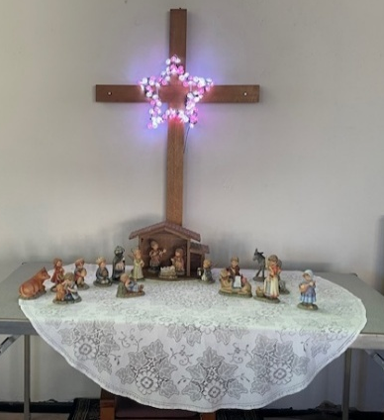

The service started with the children singing the 12 Days of Christmas and then the story of Jesus was told by members of the church. Carols were sung and Rev. Samantha explained about the Christingle orange and made an extra large one for the children to see. Christingles were given out and we all joined in and sang as our final song ‘He’s got the whole world in his hands’”.

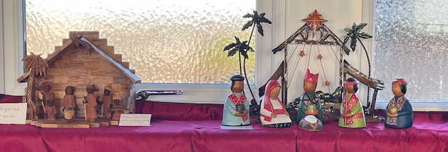
Janet also would like you all to know that coming up on 17th December there is a planned visit from Norristhorpe Junior and Infant school to look around church, that on 18th December is the last coffee morning before Christmas and that on 24th December there will be a Midnight watch Service at 11.30pm where all are welcomed to join them.
N.O.W. THAT’S WHAT I CALL CHRISTMAS, 2025
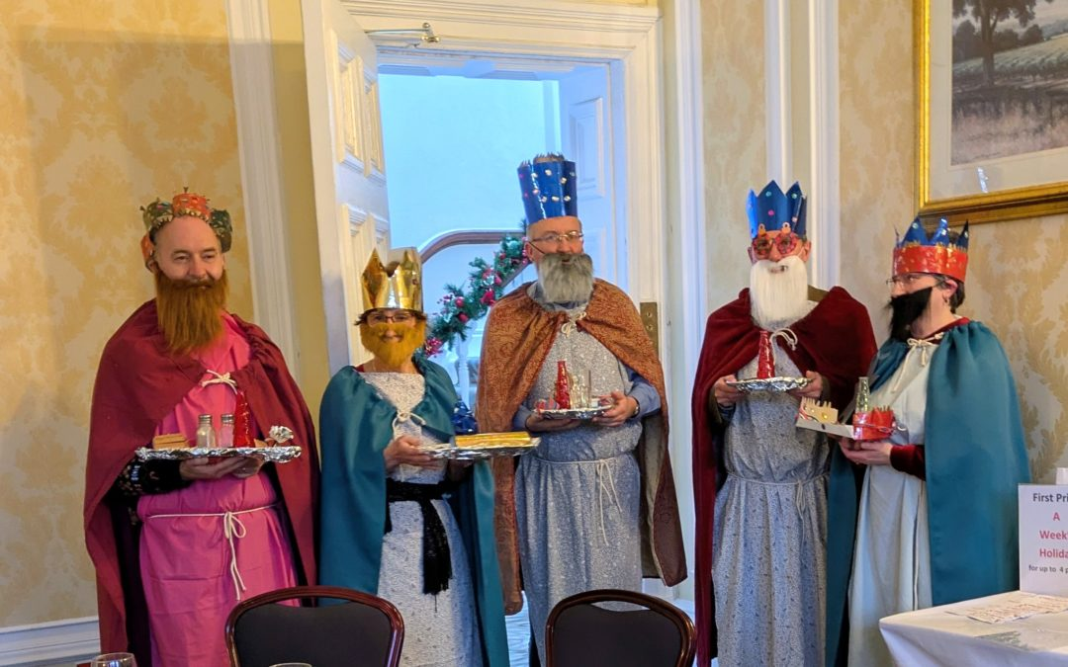

The Nidd, Ouse and Wharfe (NOW) Mission and Care Group, had their Christmas lunch recently at the Old Swan, Harrogate, and sent in a photo of the festivities!
Rev Helga Cornell, retired minister said the image shows the result of a party game called The Best Dressed Wise Man. Each table had to earn money by completing tasks to buy items to dress up their King. It looks like much fun was had by all.
You may be able to spot the Moderator, Rev Jamie Kissack, in there amongst others.

SANTA’S BREAKFAST DATE IN DENHOLME
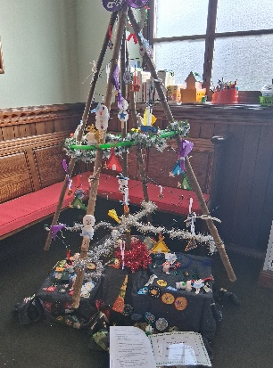
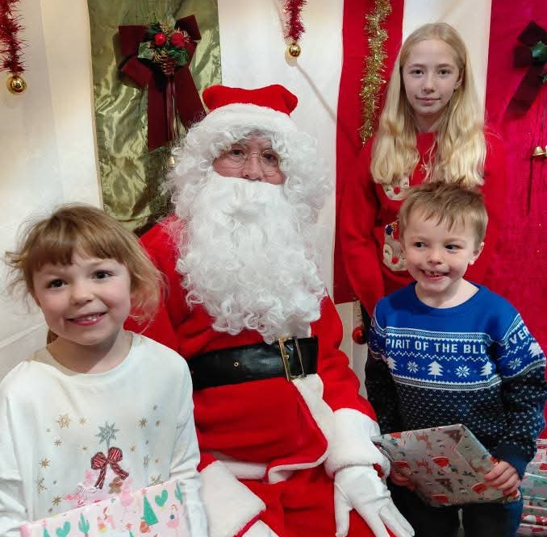
On 6th December Denholme Shared Church were able to have 'Breakfast with Santa'. They were able to welcome 40 children to meet with Santa over tea and toast (and a bit of chocolate by the look of things).

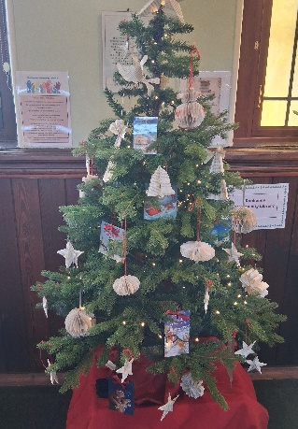
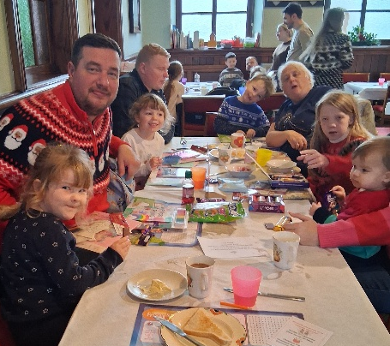
Over this past weekend and on Monday, Tuesday and Wednesday 13-16th December Denholme Shared Church has held their 'Christmas Tree Festival' with various trees created by local groups from the village.

In the run up to Christmas they will be hosting their Carol Service at 10.30am on Sunday 21st December, a Christmas Eve Christingle Service at 4.00pm and later on Christmas Eve a Midnight in Bethlehem Communion Service at 9.00pm. All are most welcome and for more information, visit
https://www.denholmechurch.org.uk/


Yorkshire Synod Discipleship Development Small Grant Fund 2026
The Ministries Committee have so far approved 21 applications to this fund since 2022 and we encourage all lay church members to consider applying in 2026. Please use the new application form available through the Synod Office as the amount which you can ask for resources or has increased to up to £300. This fund exists to help you on your Christian journey including the costs of attending a course or to offset the costs of buying resources for personal development or sharing with others. If anyone wants to discuss an application before submitting it please contact the Convenor of the Yorkshire Ministries Committee, Kath Lonsdale at kathlonsdale@talktalk.net.
Remember this is for any age of lay person in our churches to apply for so please discuss with your young people as well as adults.

ANOTHER YORKSHIRE LUNDIE AWARD WINNER
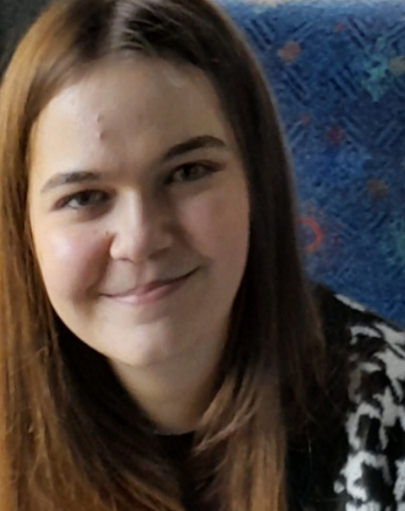
The most recent Lundie winner is Lydia Raddings, from the URC’s Yorkshire Synod. Lydia volunteered with the URC team hosting young people at Greenbelt Festival from 2021 to 2025.

Judy Harris, Children’s and Youth Development Officer for the National Synod of Wales, says Lydia’s work was integral to helping create a welcoming and safe space for the 12-17-year-olds during the festival. “She has a wonderful way of coming alongside the young people, especially the ones who may be feeling overwhelmed in what is a busy and sometimes noisy festival”.
Judy spoke of Lydia’s “gentle way” of interacting with the young people, which calms them. “Her faith is shown in her actions, and she shows and shares this in a uniquely personable way.”
For details of how to nominate young people under the age of 26 for a Lundie Award, see bit.ly/URCLundie

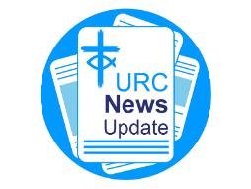
NEWS FROM THE DENOMINATION
The URC’s News Update is a monthly e-newsletter that keeps you informed about the latest news and events.
To receive this popular newsletter, please visit the https://urc.org.uk/news-updates-sign-up-form/ page on the URC website and follow the links. If you just want to dip in and catch up on what is going one, that’s fine and you can
read and print recent editions of our e-newsletter by visiting the URC News Update page at https://urc.org.uk/urc-news-update/ .

Worship Day for the Bradford & Aire Valley Churches held at Saltaire URC.
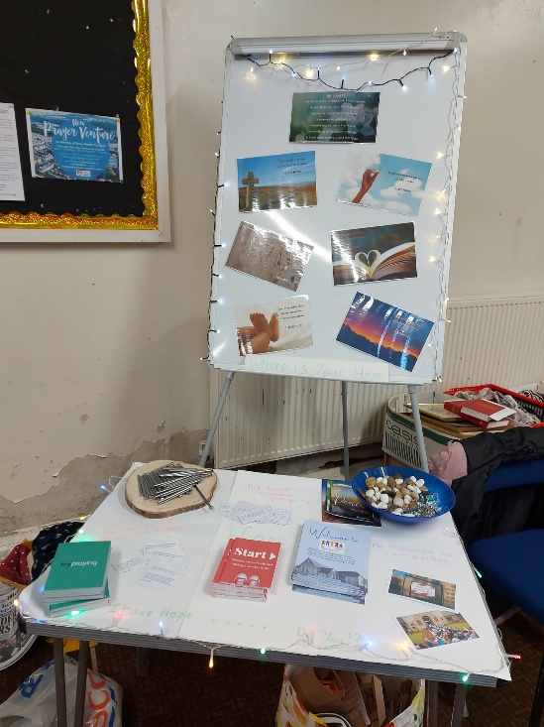
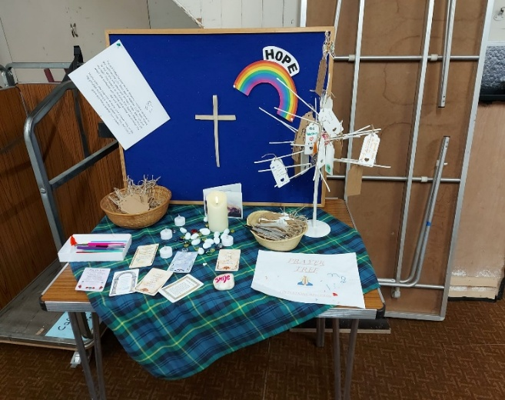
Back on Saturday October 25th, the Bradford and Aire Valley churches came together for a Worship Day. The theme for the day was ‘Hope in the Making’ and they were blessed to have been led on their Worship Day by the Reverend Sarah Fitton.
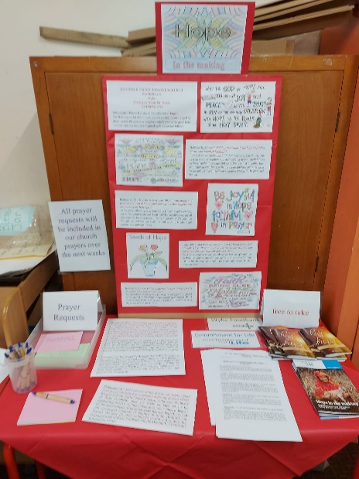
Six churches in the Bradford and Aire Valley were represented with 38 people taking part throughout the day.
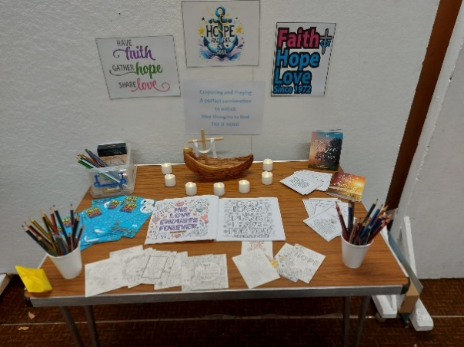
Saltaire URC hosted the day for us with their warm hospitality and many people took the opportunity to explore this historic church with excellent information provided by the members of Saltaire. It brought home to us the rich diversity and heritage of the URC.
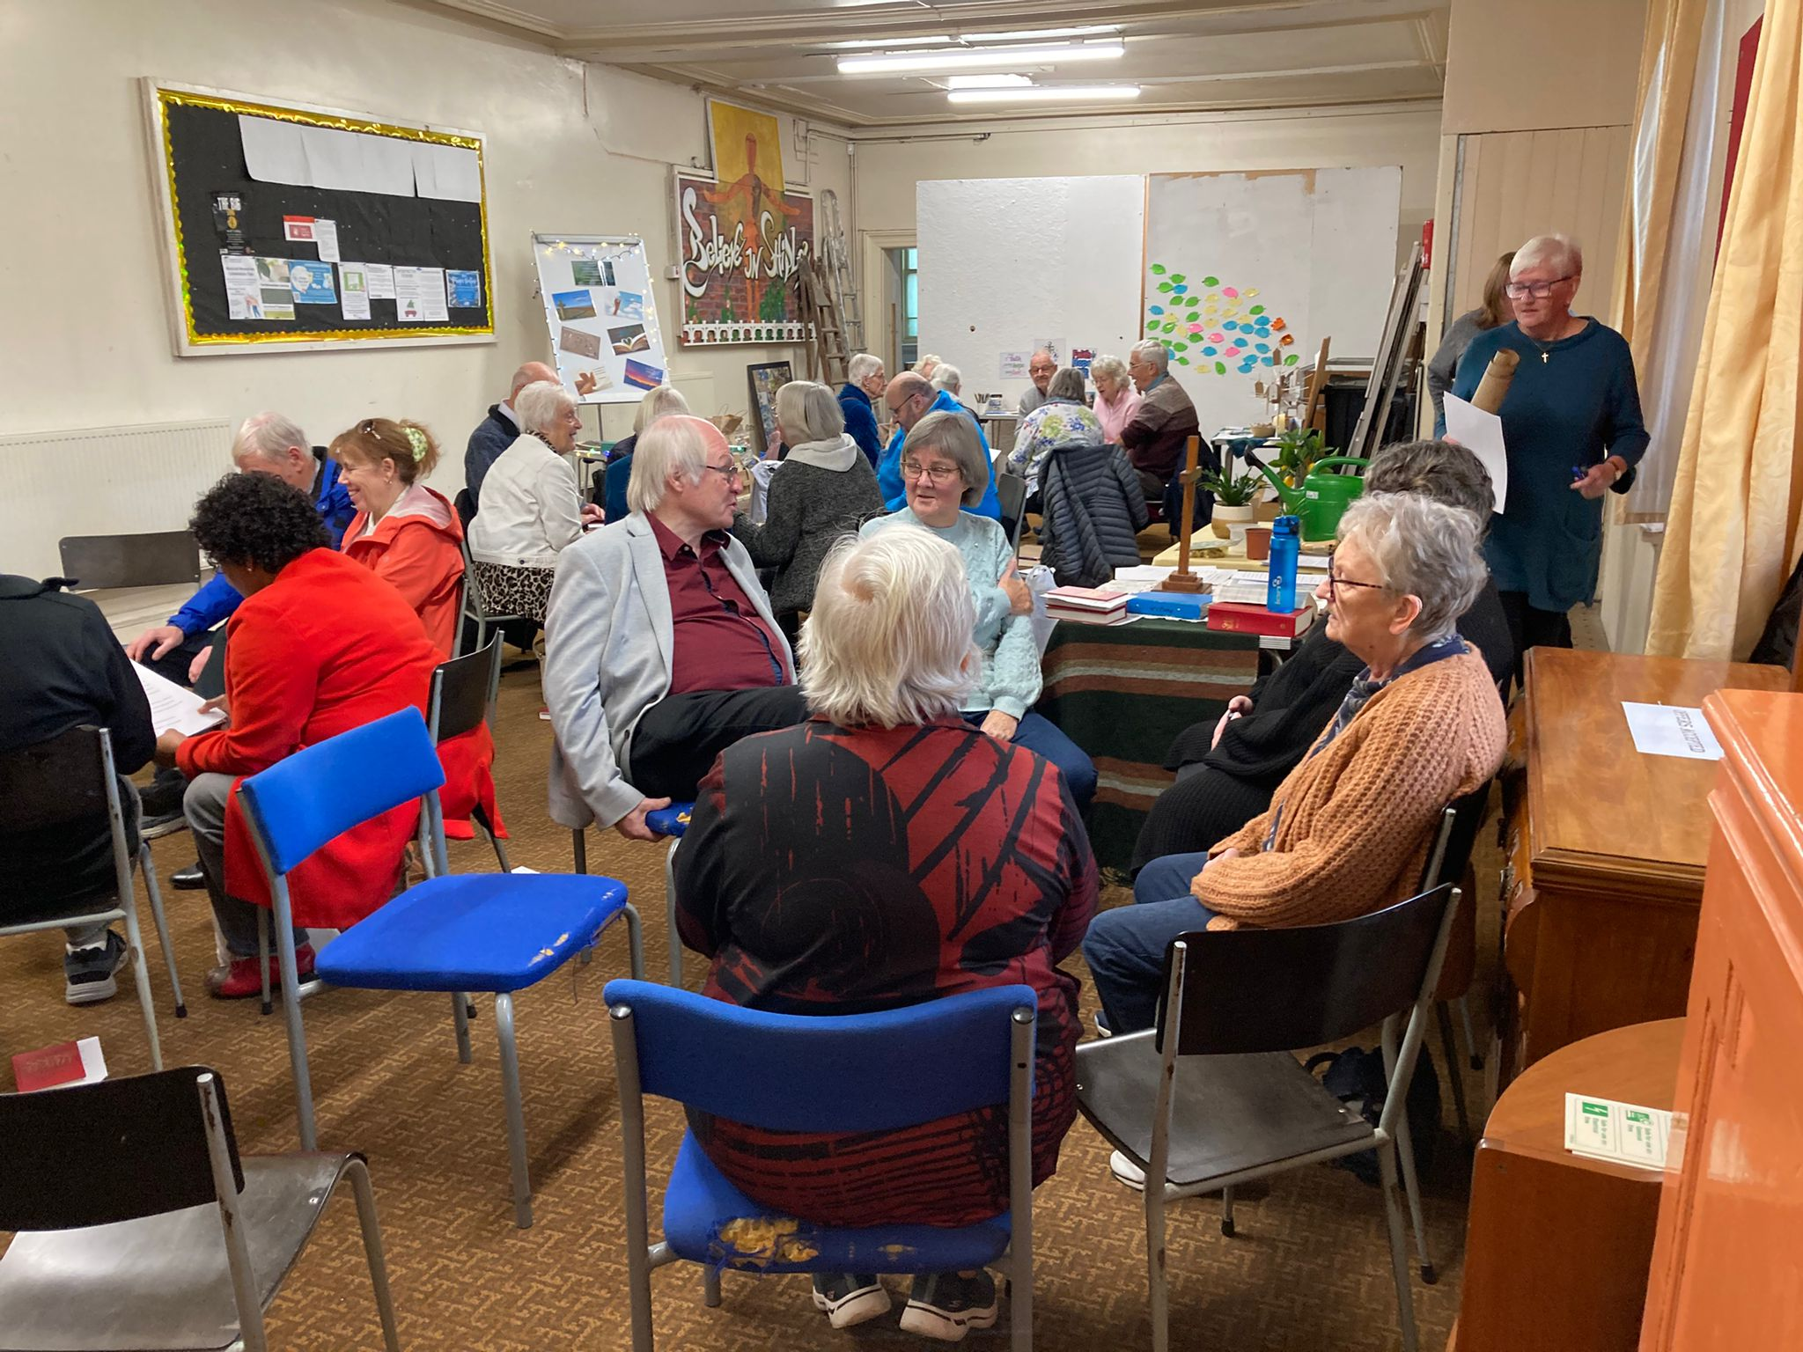
There were a series of prayer tables set out by members from Bolton Villas Family Church, Holme URC, Pudsey URC, Saltaire URC and Westfield URC, each on the theme of ‘Hope in the Making’. They were exciting, interactive and uplifting. Time was allocated to make sure these resources were fully appreciated!

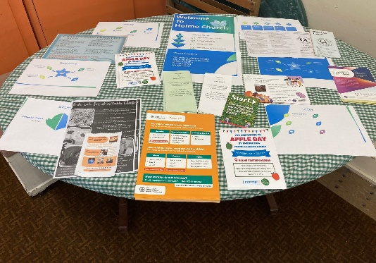
The day had prayer, singing and three sessions:
- Hope in the Making: Growth;
- Hope in the Making: Floating, in which the bible study was based on Matthew 14: v22 – 33;
- Hope in the Making: Taking Shape
This was the first of what is hoped to be many events where the Bradford and Aire Valley churches can come together to worship, study our Bible, pray together and enjoy fellowship. It was a great day for the Working for God Group based in the churches in the Bradford Area & Aire Valley!

CHILDREN’S WORK BLOSSOMING AT THE BRIDGE CHURCH
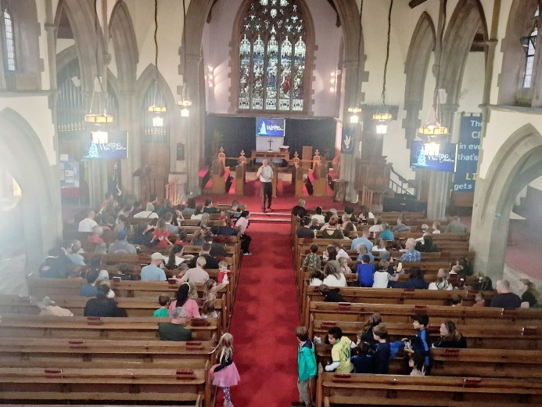
Some amazing news from the Bridge Church in Otley, West Yorkshire, where their work amongst children is showing real signs of bearing fruit….
On Saturday 29th November the church broke all its previous records when about 85 children from around 50 families attended their Messy Church. Pictured here is the short popular ‘story-time’ section of the Messy Church programme, which follows a time, in the church hall, where various craft activities take place. The session concluded with a meal, and this time extra provisions had to be sent for, so popular was the event!

The Bridge Church also hosts two midweek Parents and Toddlers sessions, known as Toddlers@theBridge. Such is the reputation of these two sessions that they both run at full capacity. The church has been delighted that two of the families recently took the momentous step to have their children baptised. One of these occurred on Advent Sunday, and one is coming up in the run-up to Christmas.
The Church also is home to a number of different uniformed organisations (Beavers, Cubs, Scouts, Explorers, Rainbows, Brownies and Guides) and hosts Youth Drop-In, an after-school club for Year 7 to Year 9 pupils which is run ecumenically.
In more good news for the church, the Bridge Church recently appointed a Children and Families Worker, thanks to a grant provided by the Yorkshire Synod. Their new worker commences on 5th January.
Isobel Evans, who is the Bridge Church’s elder responsible for children’s and young people’s work, and who also is the Leader of Toddlers@theBridge, and its Messy Church co-ordinator, said ‘we are so pleased that our work among children is bearing fruit, we have a very committed team who ensure that everyone is made to feel welcome, as we try to build relationships with young families.’
You can find out lots more of The Bridge Church’s outreach by visiting their website at https://www.otleybridgechurch.org.uk/
The Safeguarding team are available 24 hours a day, seven days a week and 365 days a year (and even 366 days in Leap Years!!). Details can be found on the Yorkshire website at https://urcyorkshire.org.uk/safeguarding/ and any query, either by phone or by e-mail at safeguarding.1and4@urc.org.uk will be answered within 24 hours.

ADVENT PACKS AND NATIVITY STICKERS AT WESTFIELD WYKE
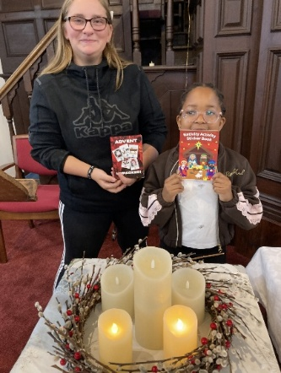
We have received a great story from Westfield URC, Wyke, where Imogen (here pictured with Leilani), successfully applied for a Discipleship Development Small Grant to enable her to help with the Wyke Churches Together Christmas outreach. With the grant funding, Imogen was able to buy 150 of the URC’s Advent Packs which she added to the hampers the Wyke Churches Together were sending out via the local foodbank.
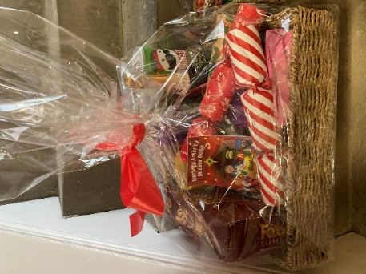
Imogen said “I am a 15 year old worshipper at Westfield URC and part of SHINE ( Serve Him In Everything ). I joined with others from Westfield in the Wyke churches together outreach during November and December. Using the Advent Packs and Nativity Activity sticker books I had bought using the with a grant from Synod it was great to put the advent packs in the daily foodbank parcels and also to put Church invitations, greetings and nativity activity sticker books in Christmas hampers which members from each of the Wyke churches delivered to local families in need. I was also able to give Advent packs and nativity Stickers to our youngest member of SHINE and to a youngster who comes to our coffee morning."

Awards at Zion URC, Cottingham
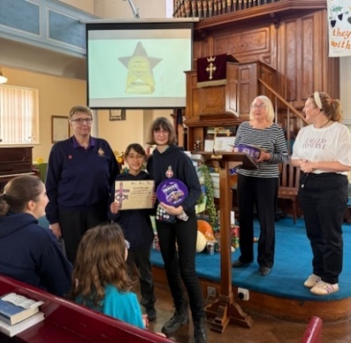
Megan Tillbrook, our Children and Young People Development Practitioner recently visited Zion URC, Cottingham to present 2 awards as part of their Harvest Celebration which was led by Katie Brooke, a life-long member of the church and serving elder as well as captain of the Girls Brigade that meet at Zion. Katie ensured that there were opportunities for the girls to shine throughout the service, from leading prayers, to doing readings, dramas and playing music.
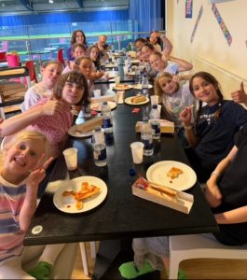
The first award was presented to the 1st Cottingham Girls Brigade for their resilience and determination in rebuilding from scratch in recent years when numbers dropped to just 2! Katie tells an inspiring story about praying to God for a sign about whether the time had come to close the Girls’ Brigade unit. That prayer has led to the group growing and now it takes an active role in church life, bringing wonderful energy and new life into the church.
The second award was presented to the church family on behalf of the team that run the Toddler Group. This year they have raised funds for Christian aid, Barnardo’s, Children in Need and Comic Relief. The group plays a vital role in the church’s outreach and they relished the chance to share in the day’s special worship service.
For the full story of how the Girls Brigade reinvigorated and of the wider work of the Toddler group visit the Yorkshire Synod website at https://urcyorkshire.org.uk/award-presentations-at-zion-urc-cottingham/
If you have a group in your local church who you would like to nominate to receive the group award to recognise and celebrate the wonderful ministry and mission that is happening locally, please contact Megan Tillbrook megancyp@urcyorkshire.org.uk
A NEW FACE IN THE WILDERNESS!!

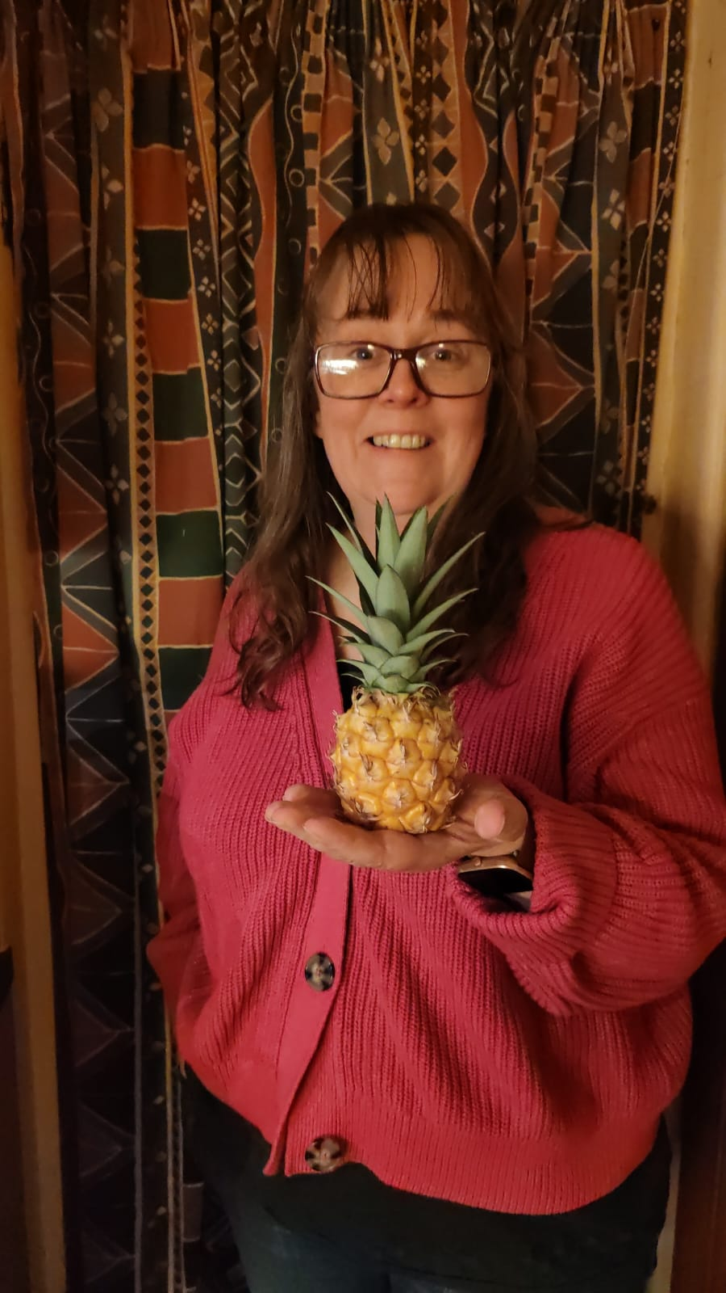
The Wilderness team has increase in number with the appointment recently of Mell Cameratas as the new Children, Youth and Families worker in Sheffield.
This is Mell, and I’ll let her introduce herself on her own words:
I'm thrilled to be joining the Wilderness Team as Children, Youth and Families Work Enabler in Sheffield. I grew up in Shropshire and became a Christian through the local church youth club, an experience which has shaped my calling and given me a passion to work with children and young people.
I left home to work in outdoor education in Christian outdoor centres around the country, which eventually lead me to Sheffield where I met my husband. I have spent the last 10 years overseeing a growing children’s and youth team in an Anglican church as well as working for an ecumenical youth charity running youth groups and supporting young people’s spiritual development and mental health.
I have always loved being around children and young people, not least my own two, now young adults, both living at home along with our two rabbits. I enjoy starting craft projects, (sometimes I finish them too) and finding adventure in everyday life. I’m excited to be beginning this new chapter and looking forward to seeing how God will use me.

Mell Cam
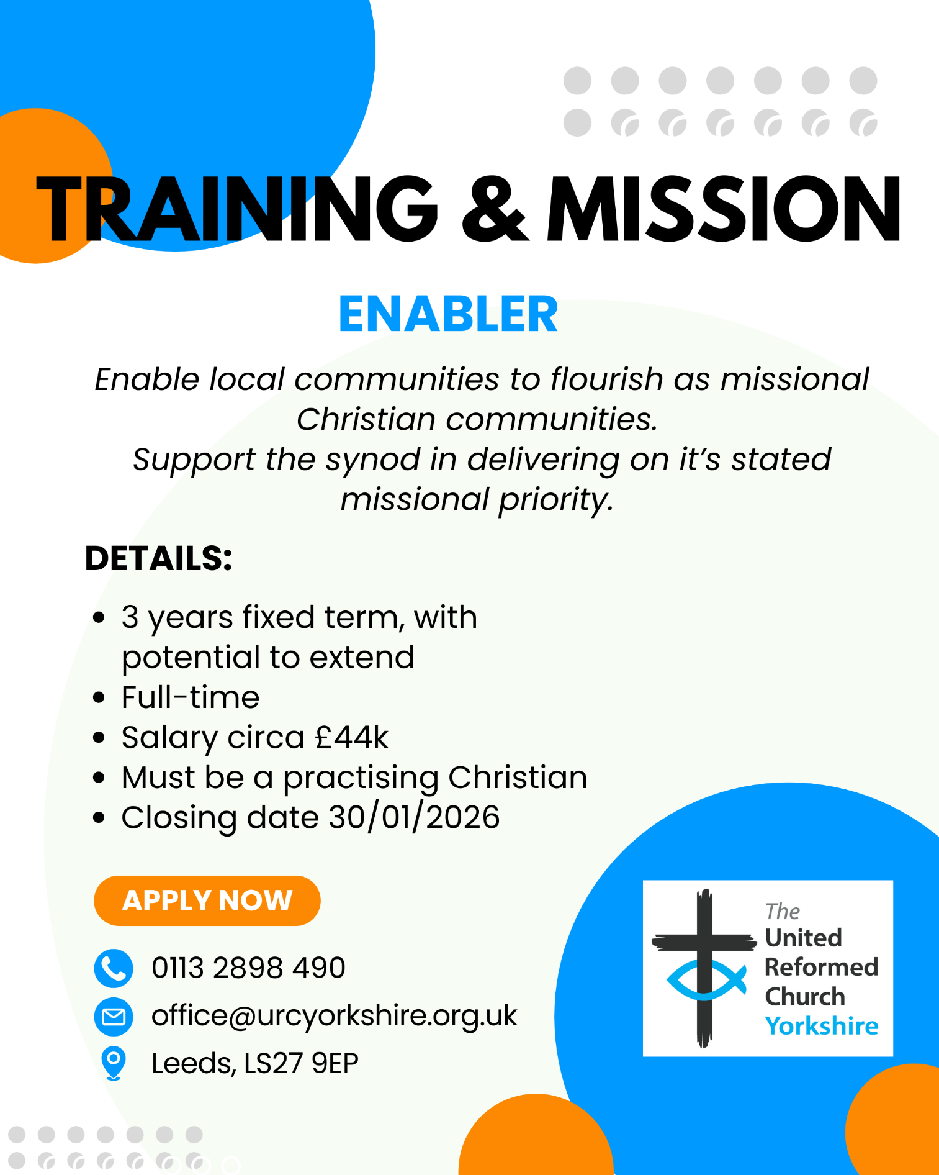

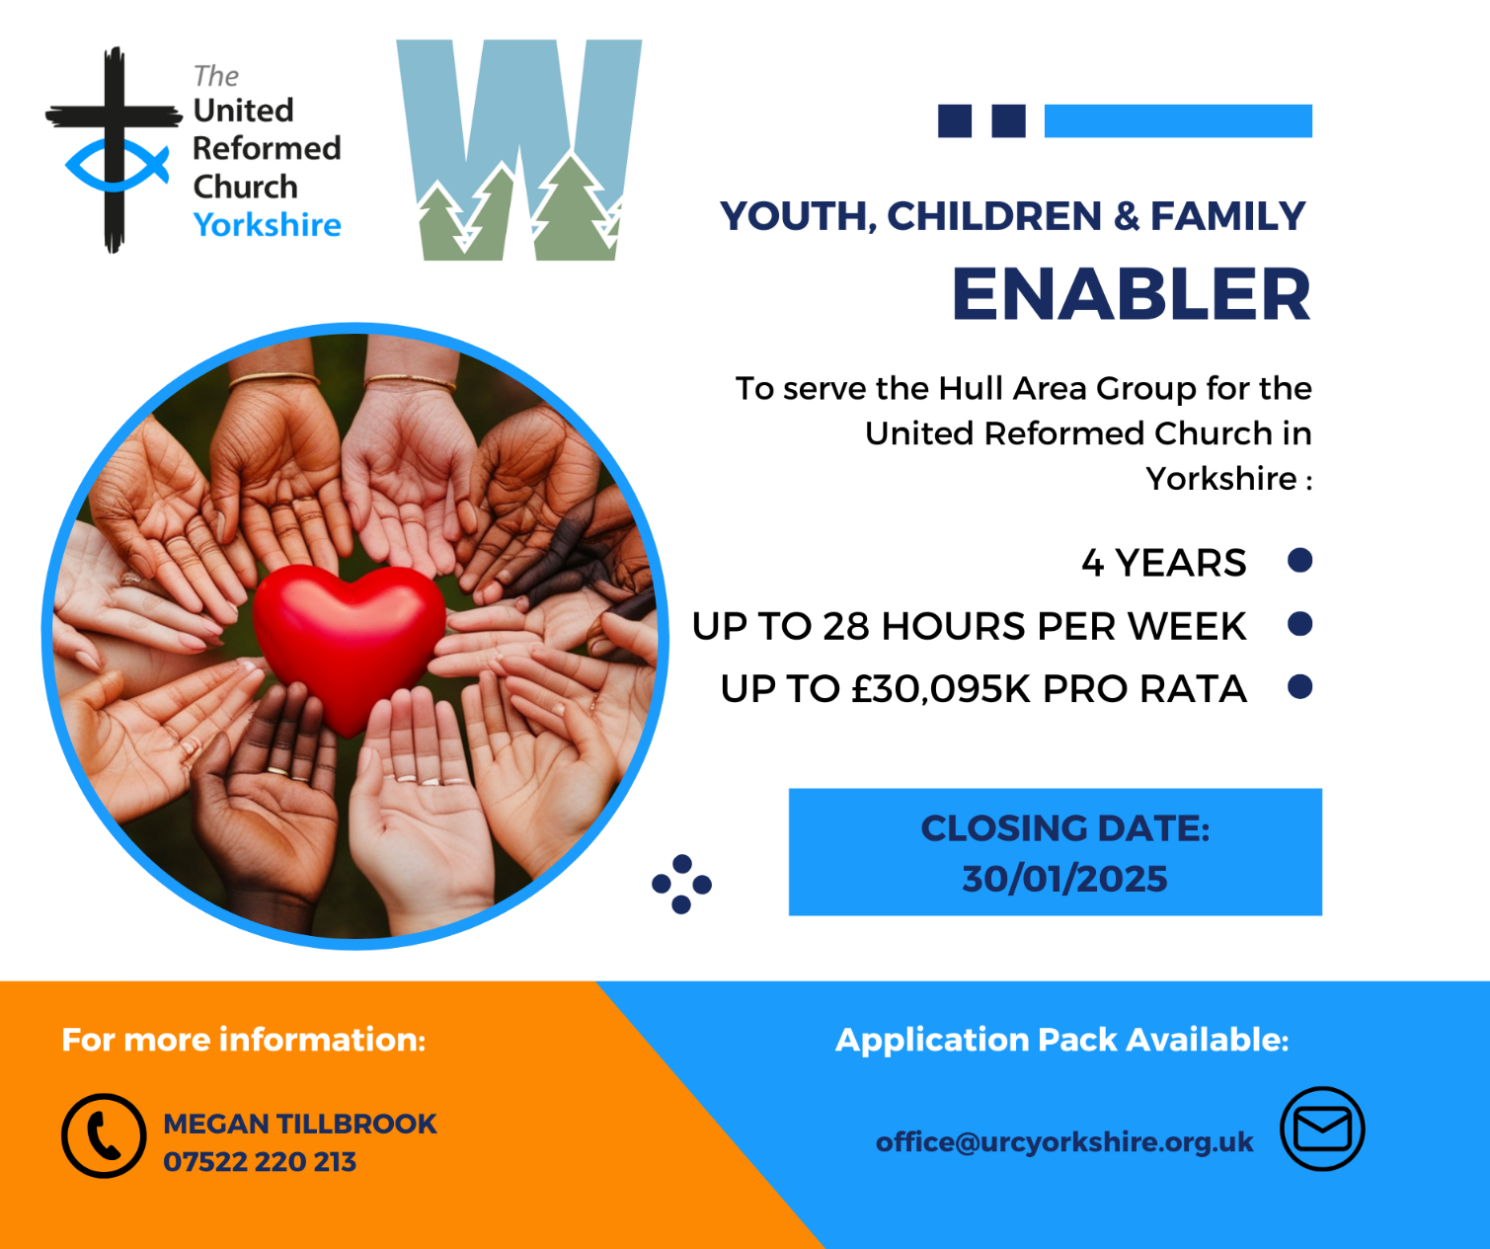

WANTED!!
The Children’s and Youth Work Committee of the Yorkshire Synod is in need of a new Convenor, to succeed Mr Dan Morrell who has filled this role for a good few years now. He steps down from the role at our next Synod meeting, to be held on March 14th 2026 at West Park URC in Harrogate.
This means we are looking for a successor to Dan, so if you are interested in this role, or you may know of someone who would be ideal to help guide the Children’s and Youth Work side of our Synod life, please contact the Synod Clerk at clerk@urcyorkshire.org.uk for more details and for a more detailed job description.

FIRE SAFETY
Jane Bunyan, our Synod Property Officer property@urcyorkshire.org.uk has asked that I remind churches that fire regulations for small non-domestic premises have changed in light of the Grenfell Tower Enquiry outcomes. The advice Synod is giving is that all churches should make themselves aware of the new regulations and advice updated in 2024 at Making your small non-domestic premises safe from fire - GOV.UK or https://www.gov.uk/government/publications/making-your-small-non-domestic-premises-safe-from-fire but if you would like a pdf copy then please email Jane at the above e-mail address.

Treasurer – The Milton Mount Foundation

The Milton Mount Foundation is a Trust Fund that offers grants to children of Ministers. The Fund arises from the sale of the Milton Mount College in 1962.
For more information: https://www.miltonmountfoundation.org.uk/

The Treasurer oversees the financial matters of the charity in line with good practice and in accordance with the governing document and legal requirements and reports to the Board of trustees at each meeting about the financial health of the organisation.
Closing date for applications: 31 January
Informal interview for role: 26 February pm or 27 February am
For more information and application form, please contact: The Secretary at miltonmountfoundation@gmail.com

This can also be found on the URC Jobs page of the website: https://urc.org.uk/jobs/


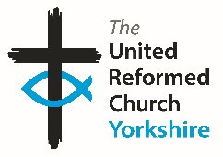

Somebody is missing
Is it you?

Synod is looking for volunteers to fill
several posts across it’s committees.
Please contact the Synod Moderator or
Clerk if you, or someone you know,
would like more information
on how to help.

clerk@urcyorkshire.org.uk moderator@urcyorkshire.org.uk

And Finally
A Celebration of Lay Preaching
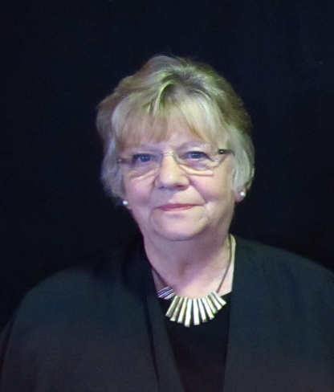
On October 26th, Bingley URC held a special celebratory service on the 70th Anniversary of the first service one of our Elders, Valerie Jenkins, preached on October 23rd 1955. Valerie’s family and many old friends joined us for the service and a number of them contributed to recalling Church events over the years.
In the 1960’s Valerie had formed a youth Drama group, the Berith Players, who performed Christian plays in place of the ‘Preacher’s Slot’ at Sunday worship. At first treated by the clergy with some uncertainty, the positive work the group were doing causing young people to come to church was soon recognised and the group frequently had more bookings than Sundays and often performed mid-week all over the Yorkshire and Cheshire area. Sometimes they went even further afield, including tours to Somerset, Lincolnshire and Cambridgeshire. Three members of the group were at the service to tell some of the tales of those eventful years (though sadly others are now infirm or deceased).
After ten years based in Lancashire, Valerie’s husband, John, was ordained and the family moved initially to live in Wisbech where John served in the Spalding group of churches. He moved later to Stainbeck and finally to Saltaire.
After the celebratory service, the congregation moved on to Saltaire to enjoy lunch together and a time to continue sharing stories from the past. All agree it had been a good day!

Over the years, Valerie has continued as a Local Preacher and as a much-appreciated Elder at Bingley URC.

If you have a good news story from your part of the Synod or something that you feel reflected the work of Synod in 2025 and which inspires others as we move into 2026, drop me a line at clerk@urcyorkshire.org.uk and I’ll make sure it hits the back page!!

You can also keep an eye on all our social media platforms for news; on the website at Home - URC Yorkshire Synod, at United Reformed Church in Yorkshire - Home | Facebook and Wilderness URC Yorkshire - Home | Facebook, the YouTube page at URC Yorkshire - YouTube and the Twitter (X) page at URC in Yorkshire (@URCYorkshire) / Twitter.



