
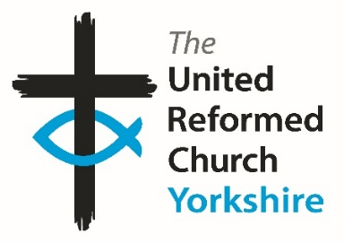
Yorkshire Synod Briefing
Number 166

15th January 2026

WELCOME TO 2026!!
A Happy New Year to you all and I’m still happy to say this, even through we are half way through January. I pray that your New Years are as peaceful and prosperous and fulfilling as they can be and that is lasts until the year is old in November and December.
Much of what I have here has been carried over from the last issue of 2025, but we have some new events and invitations which are of interest to all of us. One of the new items is a direct response to our call to be good neighbours with the invitation to Come Dine with Palestine. This is the second Come Dine event being held at Trinity St Andrew’s, Newmarket Street site and like before everyone is welcome to come along. The full details are on page 3 and I hope that it is as successful as last times in raising much needed resources for Medical Aid Palestine. The Love Your Neighbour theme is repeated in that Racial Justice Sunday is taking place on 8th February. Churches Together in Britain and Ireland have resources available – the link is on page 2.
A welcome invitation has been extended by Revd Neil Thorogood, the Moderator Elect of the URC’s General Assembly. On page 5 is a request for churches to invite him to their services in the year he serves as General Assembly Moderator (July 2026 – June 2027). You’ll need to be quick about it as the deadline for invitations is 28th February!!
Don’t forget that there is an opportunity next weekend to learn how to host Good Meetings and that there is the opportunity to apply for Discipleship Development grants to help individuals on their Christian journeys. There is a final call for the Lay Preachers and Worship Leaders’ weekend – I hear that spaces are running out fast, as are the spaces available for Youth Assembly which is happening on 27th February to 1st March.
There are invitations to events beyond this month as well as notices that the Synod is looking for a Training and Mission Enabler, that the Hull Churches are recruiting a Wilderness worker and that there are plenty of other roles in the Synod and throughout the URC that need filling.

Finally, please send in your stories and pictures and I’ll share them throughout 2026, either here in The Briefing or on the Synod website at https://urcyorkshire.org.uk/. They may even end up in https://urc.org.uk/our-news-stories/latest-news/ which is always worth a read and has the opportunity to sign up for regular URC’s news updates.

So, if you have any news of welcoming people into Church, stories of celebration and mission, please let me know by dropping me a line at clerk@urcyorkshire.org.uk and I’ll showcase it in the next edition of 2026, due out on Thursday 29th January 2026.
Thank you and every blessing to you all as we progress into 2026.
Tim Crossley


Positively Rural – Being Present in Schools
The Sheffield Methodist District are inviting interested parties to join them on Tuesday 3 February 2026 at 1:00pm for their Positively Rural webinar.
In this session, they will be sharing how local rural practitioners have developed presence in rural schools with stories of lived experiences and good practice. They will cover both Primary and Secondary Schools, as well as having opportunities for those attending to share their own stories. As always, there will also be opportunities to share your own experiences in smaller break-out groups. As far as we know it is not and exclusively Sheffield experience, so anyone from around the Synod is welcome to sign up.
The deadline to register is 31 January 2026 at mid-day.
Book your place here: https://www.eventbrite.co.uk/e/positively-rural-being-present-in-schools-tickets-1977605549434?aff=oddtdtcreator or scan the QR code above.

If you have any questions, please contact thee Sheffield Methodist District Administrator, Katrin Hackett at katrin@sheffieldmethodist.org

Racial Justice Sunday on 8th February 2026
Plans are being put in place for next year and the sooner it get’s into people’s diaries the better.
The theme for 2026 is Love Your Neighbour. Given the current narratives of hostility, fear, suspicion and hatred of the ‘other’, particularly asylum seekers, refugees and anyone who is not British or Irish ‘enough’, this theme is more important than ever.
Resources are available here:
https://ctbi.org.uk/resources/racial-justice-sunday-8-february-2026/'
and more information will be available in January 2026.
Come Dine with Palestine Saturday 7th February 6.00pm to 8.00pm
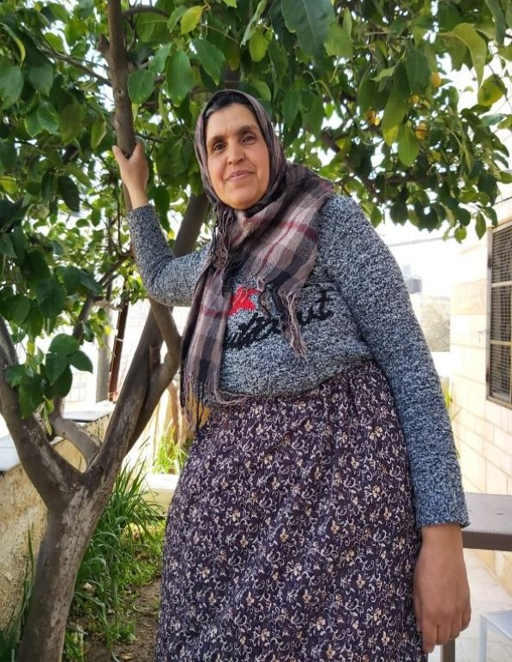

Enjoy a beautifully cooked Palestinian meal
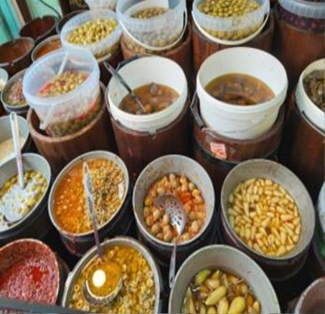
Hear from Tina Brocklebank Director of Bradford City of Sanctuary
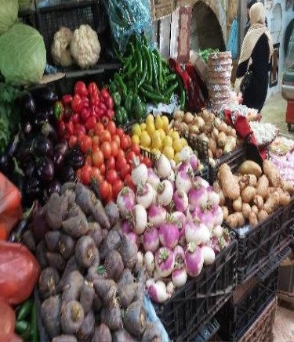

At: St Andrews Church Hall, Newmarket St, Skipton, BD23 2JE Booking essential please book by emailing: touredrive432@btinternet.com
All proceeds to Medical Aid for Palestinians. Pay on night by cash or via card reader.


YOUTH ASSEMBLY 2026
Bookings have opened for next year’s URC Youth Assembly which will be happening between 27th February and 1st March 2026. Visit www.bit.ly/3TkqSfn for more details and to see a taster video of Youth Assembly 2025 or contact Megan at the Synod Office at megancyp@urcyorkshire.org.uk.

Lay Preachers’ and Worship Leaders’ Weekend

" Choosing and Using the Psalms in Worship "

at the Wydale Conference Centre, Brompton by Sawdon near Scarbrough
https://www.wydale.org
We are pleased to say that registration for our fifth Lay Preachers’ and Worship Leaders’ weekend at Wydale Conference Centre is NOW OPEN.
This will be 17th – 19th July 2026 (Friday teatime to Sunday lunch).
We are very pleased that Dr Alison Gray, Director of Studies, Tutor in Old Testament Language, Literature & Theology at Westminster College, will be our main speaker at the conference.
This weekend will again be paid for by synod and grants so you will only need to cover your travel costs.
There are 30 places available and you are now invited to register with the office at
office@urcyorkshire.org.uk or 0113 289 8490.

Yours in Christ’s service
Kath Lonsdale, Anne Dale, Jill Fletcher, Rod Morrison,
Lay Preachers and Worship Leaders Planning Group
For any queries, please contact Kath at kathlonsdale@talktalk.net 01274 315203 or 07759525936

GENERAL ASSEMBLY MODERATOR INVITATION
An invitation from Revd Neil Thorogood, our General Assembly Moderator Elect. Many of you will remember that Neil served in the Halifax group between 1992 and 1999, so it would be great to invite him to revisit God’s Own Country.

Greetings and good wishes for the New Year!
The start of 2026 has me looking ahead to taking on the role of Moderator to the General Assembly as Catriona Wheeler completes her term at the Assembly in July 2026. You may have spotted a piece in the last copy of Reform in which Rachel Fitzgerald introduced herself as the PA to the Assembly Moderator and Moderator Elect. Rachel and I would now welcome any invitations from local churches, synods and other groups within the URC who might like me to visit.
If you would like to invite me to visit your church or community, please can you fill in this Google form by Saturday 28th February 2026: https://docs.google.com/forms/d/e/1FAIpQLSec5SZYp5vmd9ClDk3pNtvJxCvxhtxKPPZneK9ZF8dKOlVnUA/viewform?usp=header
If you have any technical issues with the form or wish to seek clarification about anything, you can contact Rachel on rachel.fitzgerald@urc.org.uk
My hope is to continue the practice of previous moderators in being able to offer to share in ways that you feel would be most appropriate in your context. More than anything, I look forward to the amazing opportunity to simply listen across the URC to the stories of our life and the heights and depths we are living through. Perhaps part of my role can be to help us tell our story well and to discover more together of the riches of the Spirit we treasure and share with the world. You might want me to share with your congregation in Sunday worship or preaching at special services. A visit might include sharing in Bible study or wider reflections on matters of faith and the life of the URC in general. I also have a particular interest in the visual arts and poetry as avenues for reflection, spirituality and theology if that was of any interest. The possibilities are genuinely endless and up to you.
With my deep thanks for their generosity in letting me have the space, my two congregations have enabled us to draft a calendar of potential weekends from July 2026 to June 2027 ready to fill with your invitations. If it were possible for me to do several things each weekend, alongside Sunday preaching engagements, which allowed me to meet more people and see more things that would be wonderful. If there were mid-week events you wanted me to share in, they can be included in your invitations.
After the 28th February deadline, Rachel and I will be meeting to see how best to fulfil as many of your invitations as possible. We will want to ensure that I travel widely to all parts of the URC and have as broad a range of visits as possible. Thank you in advance for taking time to consider this letter, and every blessing in all you do.
Yours in Christ,
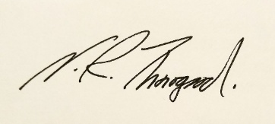
Neil



Yorkshire Synod Discipleship Development Small Grant Fund 2026
The Synod is pleased to let you all know that it has received confirmation that it has a pot of £4000 to grant to those wishing to apply to the Yorkshire Synod Discipleship Development 2026.

1. Who is eligible to apply? Committed members or adherents, including children and young people, of a congregation within the United Reformed Church who are exercising, or want to exercise, a form of lay ministry or community service whether expressed within or beyond their local church. The DDF is not open to Ministers of Word and Sacraments and CRCWs, as there are other designated funds available for those groups.

2. How much is available? Up to £300 per applicant per calendar year, although the Synod may agree to more than this according to the local context and circumstances.

3. What can this money be used for? The purposes for which the funding is provided are defined by creativity and vocation, in line with the URC's discipleship development strategy. Be bold, take risks. The funding exists to help you to follow Jesus. You might be helped in this by courses (at any level) at any of the URC Resource Centres for Learning or from other learning providers, or you may have ideas on resourcing discipleship development in other people. You may need funds to cover the costs of travel, materials or books. All you have to do is make a case to your local church meeting and submit the application form to the Synod Convenor of Ministries for consideration and, if appropriate, authorisation.

4. How are applications made? Having gained your church meeting's endorsement, applications are to be made on the designated form, well before the spending is due to start. Backdated applications will not normally be accepted. Application forms are obtainable from the Synod Convenor of Ministries via the Synod Office at office@urcyorkshire.org.uk and should be sent back for authorisation before being passed to the synod finance office.

5. How are grants paid? Grants authorised by the Convenor of Synod Ministries
are paid by a Synod finance officer by reimbursement to you when you have given proof of what you've spent. Contact your Synod Convenor of Ministries for discussion if you need something funded directly on your behalf, rather than waiting for re-imbursement.

If anyone wants to discuss an application before submitting it please contact the Convenor of the Yorkshire Ministries Committee, Kath Lonsdale at kathlonsdale@talktalk.net.
Remember this is for any age of lay person in our churches to apply for so please discuss with your young people as well as adults.

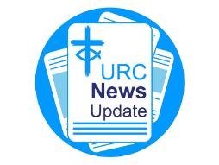
NEWS FROM THE DENOMINATION
The URC’s News Update is a monthly e-newsletter that keeps you informed about the latest news and events.
To receive this popular newsletter, please visit the https://urc.org.uk/news-updates-sign-up-form/ page on the URC website and follow the links. If you just want to dip in and catch up on what is going one, that’s fine and you can
read and print recent editions of our e-newsletter by visiting the URC News Update page at https://urc.org.uk/urc-news-update/ .

UPCOMING DATA PROTECTION TRAINING
Mary Fallah, the URC’s Head of Compliance & Services, will be hosting a series of data protection training sessions during the last week of January and the first week of February for Synod staff and local church workers.
Each session will run for 1 hour and 45 minutes, and evening options are available starting at 7:00pm.

Why this training matters
Understanding and complying with GDPR is essential to protect personal data and maintain trust within our church communities. This training will also reinforce safeguarding responsibilities, ensuring that we handle sensitive information with care and integrity.

Register now to secure your preferred date and time:
Click here to register
Or copy and paste this link into your browser
https://forms.office.com/pages/responsepage.aspx?id=4WjTP9fxHkqOQEWoQ7VeiWjXyjeHh09LsW2IxliilqpUQk9OQjFWUE9KS1hKN1FBQjhYTlFJWFk3RS4u&route=shorturl

If you require more details, please contact Mary at mary.fallah@urc.org.uk

The Safeguarding team are available 24 hours a day, seven days a week and 365 days a year (and even 366 days in Leap Years!!). Details can be found on the Yorkshire website at https://urcyorkshire.org.uk/safeguarding/ and any query, either by phone or by e-mail at safeguarding.1and4@urc.org.uk will be answered within 24 hours.

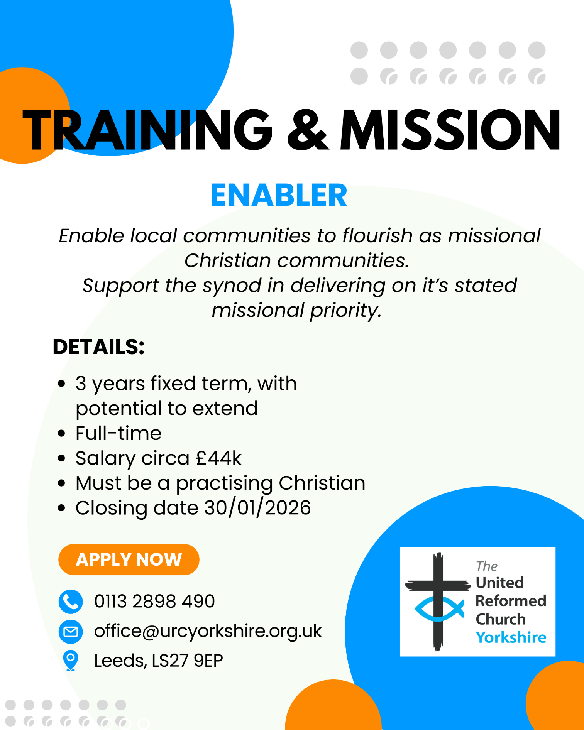



WANTED!!
The Children’s and Youth Work Committee of the Yorkshire Synod is in need of a new Convenor, to succeed Mr Dan Morrell who has filled this role for a good few years now. He steps down from the role at our next Synod meeting, to be held on March 14th 2026 at West Park URC in Harrogate.
This means we are looking for a successor to Dan, so if you are interested in this role, or you may know of someone who would be ideal to help guide the Children’s and Youth Work side of our Synod life, please contact the Synod Clerk at clerk@urcyorkshire.org.uk for more details and for a more detailed job description.

FIRE SAFETY
Jane Bunyan, our Synod Property Officer property@urcyorkshire.org.uk has asked that I remind churches that fire regulations for small non-domestic premises have changed in light of the Grenfell Tower Enquiry outcomes. The advice Synod is giving is that all churches should make themselves aware of the new regulations and advice updated in 2024 at Making your small non-domestic premises safe from fire - GOV.UK or https://www.gov.uk/government/publications/making-your-small-non-domestic-premises-safe-from-fire but if you would like a pdf copy then please email Jane at the above e-mail address.

Treasurer – The Milton Mount Foundation

The Milton Mount Foundation is a Trust Fund that offers grants to children of Ministers. The Fund arises from the sale of the Milton Mount College in 1962.
For more information: https://www.miltonmountfoundation.org.uk/

The Treasurer oversees the financial matters of the charity in line with good practice and in accordance with the governing document and legal requirements and reports to the Board of trustees at each meeting about the financial health of the organisation.
Closing date for applications: 31 January
Informal interview for role: 26 February pm or 27 February am
For more information and application form, please contact: The Secretary at miltonmountfoundation@gmail.com

This can also be found on the URC Jobs page of the website: https://urc.org.uk/jobs/


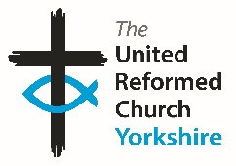

Somebody is missing
Is it you?

Synod is looking for volunteers to fill
several posts across it’s committees.
Please contact the Synod Moderator or
Clerk if you, or someone you know,
would like more information
on how to help.

clerk@urcyorkshire.org.uk moderator@urcyorkshire.org.uk

And Finally
CHRISTMAS CELEBRATIONS AND NEW YEAR PREPARATIONS AT NORRISTHORPE

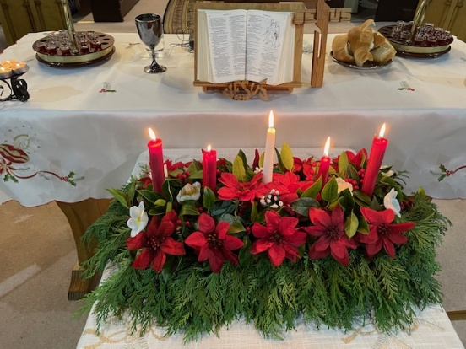
The folk over at Norristhorpe URC have been in touch to let us know that their Christmas and New Year week was full of joy and celebration.
They held a midnight Holy Communion service on Christmas Eve, led by their minister, Revd Samantha Sheehan with the central candle in their Advent wreath being lit as Christmas Day arrived.

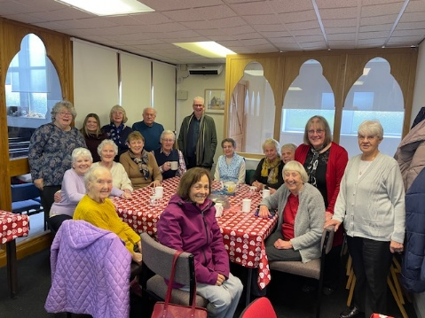
The following week saw the regulars who attend their Coffee mornings meet to celebrate the passing of the old year and to prepare for the coming of 2026 (admittedly on a Tuesday rather than a Thursday, and a day or two early as they met on the 30th).

Now that the New Year is with us their coffee mornings are back to being from 10.30am on a Thursday and they welcome everyone to their Sunday services which start at 10.45am.
For more information, visit their webpage at https://spaceurc.org.uk/?page_id=124

If you have a good news story from your part of the Synod or something that you feel reflected the work of Synod in 2025 and which inspires others as we move into 2026, drop me a line at clerk@urcyorkshire.org.uk and I’ll make sure it hits the back page!!

You can also keep an eye on all our social media platforms for news; on the website at Home - URC Yorkshire Synod, at United Reformed Church in Yorkshire - Home | Facebook and Wilderness URC Yorkshire - Home | Facebook, the YouTube page at URC Yorkshire - YouTube and the Twitter (X) page at URC in Yorkshire (@URCYorkshire) / Twitter.

