
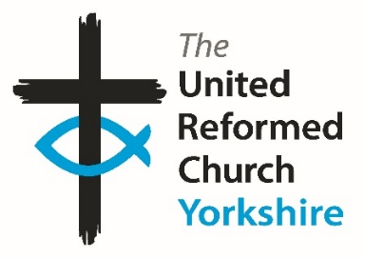
Yorkshire Synod Briefing
Number 167

29th January 2026

WELCOME TO 2026!!
Well, where has January gone. I went to a meeting yesterday at which it was the first time that I had seen some of the attendees since 2025 and I was greeted with a “Happy New Year”. I thought nothing of it and responded in kind, then stopped, looked at my watch, realised we were four weeks into the year and thought – where does time go. I’m sure you have all done this as well and to make the year go even quicker this issue has lots of offerings to help you and your churches participate and celebrate the Christian life we lead as well as enabling you all to develop and grow in Christ both individually and as active members of your communities. There is a time for everything and that it is the gift of God, so I pray that what we do for Him as time goes by will, as the writer of Ecclesiastes assures us, endure forever.
As ever, there are invitations to events beyond this month. There is even one asking for bookings to one in August, but there are also events happening around the Synod in February. We have the final calls for applications to our prospective Training and Mission Enabler and for the Hull Churches’ Wilderness worker although the search for a new Children and Young People Committee convenor continues. Whilst that is in mind we are still short of volunteers to fill key roles in our Synod committees, especially on the financial and property side of things. If you know of someone who you think would be suitable, let me know and we will approach them.
Finally, please send in your stories and pictures and I’ll share them throughout 2026, either here in The Briefing or on the Synod website at https://urcyorkshire.org.uk/. They may even end up in https://urc.org.uk/our-news-stories/latest-news/ which is always worth a read and has the opportunity to sign up for regular URC’s news updates.
Finally, a message from the denomination regarding the 2027 Prayer Handbook. The deadline for submitting prayers for the 2027 Prayer Handbook is Friday 27 February 2026. The theme for the next edition is: A larger belonging.
Prayers are invited that draw us beyond tribe, nation and ideology towards God’s new creation. A belonging wider than our differences and deeper than our divisions. All submissions to phb@urc.org.uk.
Full information at URC Prayer Handbook - United Reformed Church or https://urc.org.uk/your-faith/prayer-and-worship/urc-prayer-handbook/

So, if you have any news of welcoming people into Church, stories of celebration and mission, please let me know by dropping me a line at clerk@urcyorkshire.org.uk and I’ll showcase it in the first edition of 2026, due out on Thursday 12th February 2026.
Thank you and every blessing to you all as we progress into 2026.
Tim Crossley



Positively Rural – Being Present in Schools
The Sheffield Methodist District are inviting interested parties to join them on Tuesday 3 February 2026 at 1:00pm for their Positively Rural webinar.
In this session, they will be sharing how local rural practitioners have developed presence in rural schools with stories of lived experiences and good practice. They will cover both Primary and Secondary Schools, as well as having opportunities for those attending to share their own stories. As always, there will also be opportunities to share your own experiences in smaller break-out groups. As far as we know it is not and exclusively Sheffield experience, so anyone from around the Synod is welcome to sign up.
The deadline to register is 31 January 2026 at mid-day.
Book your place here: https://www.eventbrite.co.uk/e/positively-rural-being-present-in-schools-tickets-1977605549434?aff=oddtdtcreator or scan the QR code above.

If you have any questions, please contact thee Sheffield Methodist District Administrator, Katrin Hackett at katrin@sheffieldmethodist.org

Racial Justice Sunday on 8th February 2026
Plans are being put in place for next year and the sooner it get’s into people’s diaries the better.
The theme for 2026 is Love Your Neighbour. Given the current narratives of hostility, fear, suspicion and hatred of the ‘other’, particularly asylum seekers, refugees and anyone who is not British or Irish ‘enough’, this theme is more important than ever.
Resources are available here:
https://ctbi.org.uk/resources/racial-justice-sunday-8-february-2026/'
and more information will be available in January 2026.
Come Dine with Palestine Saturday 7th February 6.00pm to 8.00pm
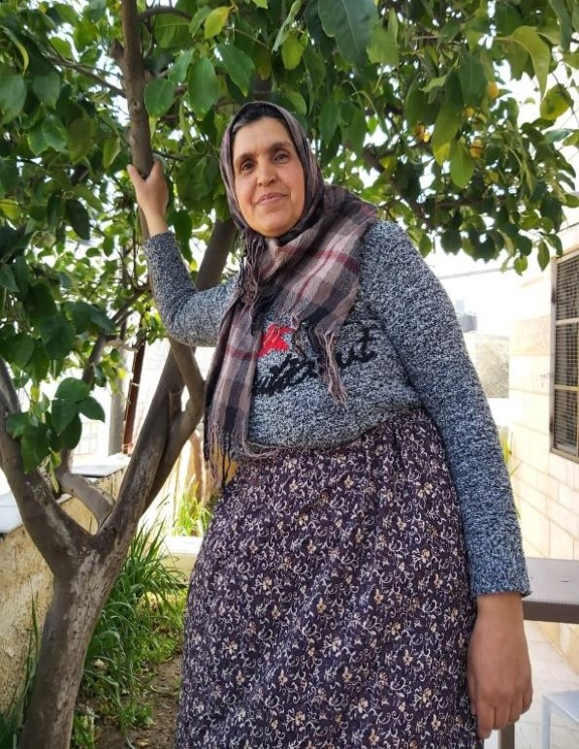

Enjoy a beautifully cooked Palestinian meal
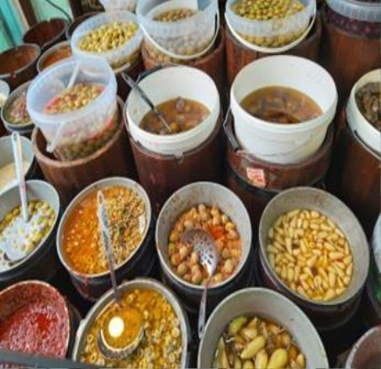
Hear from Tina Brocklebank Director of Bradford City of Sanctuary
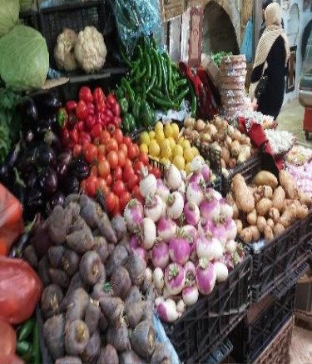

At: St Andrews Church Hall, Newmarket St, Skipton, BD23 2JE Booking essential please book by emailing: touredrive432@btinternet.com
All proceeds to Medical Aid for Palestinians. Pay on night by cash or via card reader.


YOUTH ASSEMBLY 2026
Bookings have opened for next year’s URC Youth Assembly which will be happening between 27th February and 1st March 2026. Visit www.bit.ly/3TkqSfn for more details and to see a taster video of Youth Assembly 2025 or contact Megan at the Synod Office at megancyp@urcyorkshire.org.uk.

Lay Preachers’ and Worship Leaders’ Weekend

" Choosing and Using the Psalms in Worship "

at the Wydale Conference Centre, Brompton by Sawdon near Scarbrough
https://www.wydale.org
We are pleased to say that registration for our fifth Lay Preachers’ and Worship Leaders’ weekend at Wydale Conference Centre is NOW OPEN.
This will be 17th – 19th July 2026 (Friday teatime to Sunday lunch).
We are very pleased that Dr Alison Gray, Director of Studies, Tutor in Old Testament Language, Literature & Theology at Westminster College, will be our main speaker at the conference.
This weekend will again be paid for by synod and grants so you will only need to cover your travel costs.
There are 30 places available and you are now invited to register with the office at
office@urcyorkshire.org.uk or 0113 289 8490.

Yours in Christ’s service
Kath Lonsdale, Anne Dale, Jill Fletcher, Rod Morrison,
Lay Preachers and Worship Leaders Planning Group
For any queries, please contact Kath at kathlonsdale@talktalk.net 01274 315203 or 07759525936

GENERAL ASSEMBLY MODERATOR INVITATION
An invitation from Revd Neil Thorogood, our General Assembly Moderator Elect. Many of you will remember that Neil served in the Halifax group between 1992 and 1999, so it would be great to invite him to revisit God’s Own Country.

Greetings and good wishes for the New Year!
The start of 2026 has me looking ahead to taking on the role of Moderator to the General Assembly as Catriona Wheeler completes her term at the Assembly in July 2026. You may have spotted a piece in the last copy of Reform in which Rachel Fitzgerald introduced herself as the PA to the Assembly Moderator and Moderator Elect. Rachel and I would now welcome any invitations from local churches, synods and other groups within the URC who might like me to visit.
If you would like to invite me to visit your church or community, please can you fill in this Google form by Saturday 28th February 2026: https://docs.google.com/forms/d/e/1FAIpQLSec5SZYp5vmd9ClDk3pNtvJxCvxhtxKPPZneK9ZF8dKOlVnUA/viewform?usp=header
If you have any technical issues with the form or wish to seek clarification about anything, you can contact Rachel on rachel.fitzgerald@urc.org.uk
My hope is to continue the practice of previous moderators in being able to offer to share in ways that you feel would be most appropriate in your context. More than anything, I look forward to the amazing opportunity to simply listen across the URC to the stories of our life and the heights and depths we are living through. Perhaps part of my role can be to help us tell our story well and to discover more together of the riches of the Spirit we treasure and share with the world. You might want me to share with your congregation in Sunday worship or preaching at special services. A visit might include sharing in Bible study or wider reflections on matters of faith and the life of the URC in general. I also have a particular interest in the visual arts and poetry as avenues for reflection, spirituality and theology if that was of any interest. The possibilities are genuinely endless and up to you.
With my deep thanks for their generosity in letting me have the space, my two congregations have enabled us to draft a calendar of potential weekends from July 2026 to June 2027 ready to fill with your invitations. If it were possible for me to do several things each weekend, alongside Sunday preaching engagements, which allowed me to meet more people and see more things that would be wonderful. If there were mid-week events you wanted me to share in, they can be included in your invitations.
After the 28th February deadline, Rachel and I will be meeting to see how best to fulfil as many of your invitations as possible. We will want to ensure that I travel widely to all parts of the URC and have as broad a range of visits as possible. Thank you in advance for taking time to consider this letter, and every blessing in all you do.
Yours in Christ,
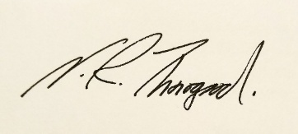
Neil

World
Day of Prayer

“I will give you rest, come”
Prepared by
Christian women from Nigeria
At 2 pm.
On Friday 6th March 2026
at
Westfield
United Reformed Church
Followed by refreshments
All welcome

Transport Request
Over the past few years Yorkshire Synod had been blessed as being the home of Revd Dr Elizabeth (Liz) Brown, whose life and mission was celebrated recently at her funeral at Stainbeck URC. Since that service we have been asked by David Thompson (on behalf of the URC History Society Council) whether we could send various artefacts that we have from Liz, including her dissertation on the history of the Presbyterian Church in Taiwan, to Westminster College in Cambridge where they can be assessed in the hope that they become a part of the URC’s archives or even that of SOAS (The School of Oriental and African Studies) in London.

At the moment they are in a large plastic packing box and we currently have no way of readily getting these things to Westminster College. So, this is the request; is there anybody due to have a meeting or the like at Westminster College who could take them there?

If you are able to help, please contact Revd Angela Hughes at angela.hughes1@icloud.com so that the box can be sent across to you, or if you are local to Leeds for you to collect and they will be really grateful to those who are able to offer.


Above is an invitation to either participate or contribute to the March for Mercy Pyjama Walk. Quite a few folk from the Stag Community Church, Rotherham (Herringthorpe URC) are participating, so either join them or sponsor them as they walk for this worthy cause.
In you need more information, contact Revd Matt Stone at matt.stone@cantab.net.


Yorkshire Synod Discipleship Development Small Grant Fund 2026
The Synod is pleased to let you all know that it has received confirmation that it has a pot of £4000 to grant to those wishing to apply to the Yorkshire Synod Discipleship Development 2026.

1. Who is eligible to apply? Committed members or adherents, including children and young people, of a congregation within the United Reformed Church who are exercising, or want to exercise, a form of lay ministry or community service whether expressed within or beyond their local church. The DDF is not open to Ministers of Word and Sacraments and CRCWs, as there are other designated funds available for those groups.

2. How much is available? Up to £300 per applicant per calendar year, although the Synod may agree to more than this according to the local context and circumstances.

3. What can this money be used for? The purposes for which the funding is provided are defined by creativity and vocation, in line with the URC's discipleship development strategy. Be bold, take risks. The funding exists to help you to follow Jesus. You might be helped in this by courses (at any level) at any of the URC Resource Centres for Learning or from other learning providers, or you may have ideas on resourcing discipleship development in other people. You may need funds to cover the costs of travel, materials or books. All you have to do is make a case to your local church meeting and submit the application form to the Synod Convenor of Ministries for consideration and, if appropriate, authorisation.

4. How are applications made? Having gained your church meeting's endorsement, applications are to be made on the designated form, well before the spending is due to start. Backdated applications will not normally be accepted. Application forms are obtainable from the Synod Convenor of Ministries via the Synod Office at office@urcyorkshire.org.uk and should be sent back for authorisation before being passed to the synod finance office.

5. How are grants paid? Grants authorised by the Convenor of Synod Ministries
are paid by a Synod finance officer by reimbursement to you when you have given proof of what you've spent. Contact your Synod Convenor of Ministries for discussion if you need something funded directly on your behalf, rather than waiting for re-imbursement.

If anyone wants to discuss an application before submitting it please contact the Convenor of the Yorkshire Ministries Committee, Kath Lonsdale at kathlonsdale@talktalk.net.
Remember this is for any age of lay person in our churches to apply for so please discuss with your young people as well as adults.

Community Project Awards
For 28 years, the United Reformed Church’s (URC) Community Project Awards have recognised outstanding community projects in local URCs and churches in ecumenical partnerships, that demonstrate the love of God and the mission of the Church by reaching out in many different ways to help the local communities in which they serve.
The partner of the awards for the past 17 years has been https://www.congregational.co.uk/. Since the awards began, more than 80 churches have received £150,000 in support. From 2025, the total amount offered to church projects was increased to £10,000.
2026 Community Project Awards
Entries are now open for the 2026 Community Project Awards. The winning entries will be awarded at the General Assembly on Saturday 4 July, 2026.
Please use the downloadable Word document for your entry, which includes the rules of the competition and this is the link to it https://urc.org.uk/wp-content/uploads/2025/12/Community-Project-Awards-entry-form-2026.docx
The deadline for entries is Friday 20 February, 2026, and here is a picture of some of last years winners, which included Yorkshire’s own Trinity Church, Wilsden and St Andrew’s Roundhay.
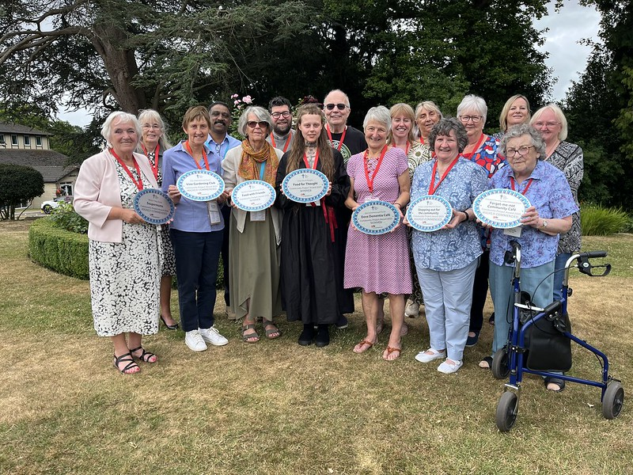



Revd Dr Simon Cross, who serves in the Hull URC Partnership, is instrumental in organising this event due to take place at Westminster College, Cambridge (and online) on the 21st of March called:

The Quiet Revival: Myth, memory or movement?

Simon writes: I dare say that you will have either read or at least heard about the report from the Bible Society, last year, which talked about a ‘Quiet Revival’ in church attendance amongst young people. You may also have seen, read, or heard some of the discussion about that report – maybe even the British Social Attitudes Survey which offered a starkly ‘alternative’ picture.
In order to shed some light on this confused and confusing picture I’ve asked some clever and well-informed people to take part in a ‘symposium’ – each of them will present a short paper and there will be room for discussion after each one. As well as some leading social scientists and international researchers I’ve invited some well-placed church figures, and a resident expert in the history of British revivals. We will also hear, directly, from one of the authors of the original Bible Society report.
I’m not saying we’re definitely going to get to the bottom of whether there really is a ‘quiet revival’ going on, or not, (and if there is – whether that’s good, bad, or… something else) but we will, at least, have a better sense of what that might mean… I hope.
Look at it this way: if nothing else you can have a day with some very clever and interesting people… and me.
I’d love you to be able to join us for the event, either in person or – indeed – online (nothing to stop you organising a watch party, by the way). Thanks to a generous grant we’ve kept the prices as low as possible – the in person ticketing is tiered too, so if you’re feeling flush you can chip in a little more to help us make sure we cover the costs. There are only a limited number of ‘in person’ tickets available (if everyone receiving this email got a ticket, we’d be full) – so if you’re keen to be in the room, then my advice is to book early.
(And if you’re fortunate enough to have a ‘training budget’ or similar – then this will, I’m sure, qualify. I mean, it might not… I don’t really know. To be fair - it’s a guess.)

If you are interested in joining Simon on 21st March, between 10am and 6pm there’s a booking link here: Quiet Revival - Westminster College or https://www.westminster.cam.ac.uk/quiet-revival and you can read the original Quiet Revival report here: The Quiet Revival: Gen Z leads rise in church attendance or https://www.biblesociety.org.uk/research/quiet-revival

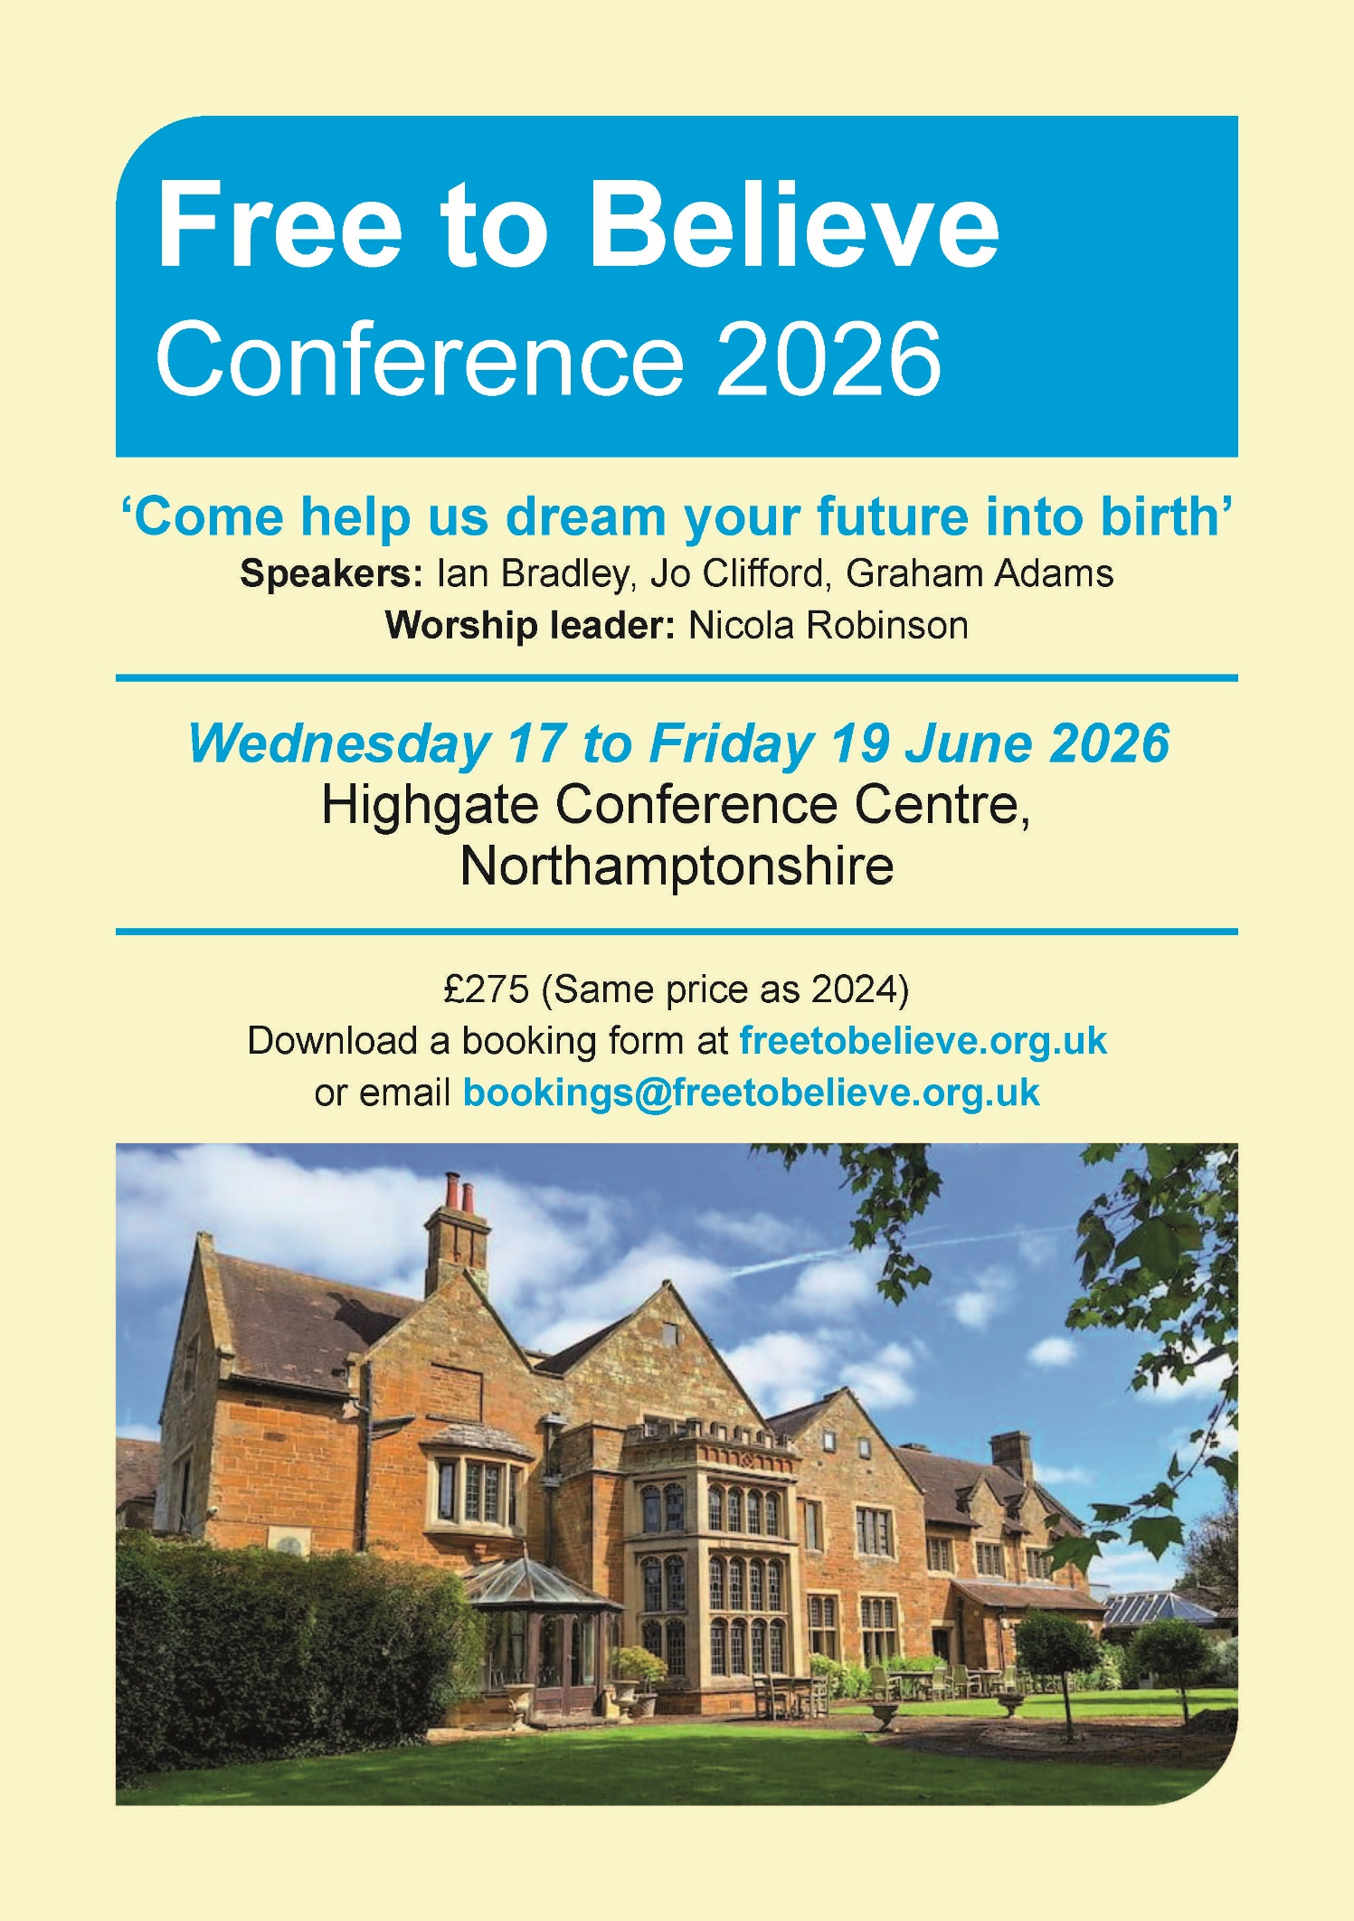
For more information, please visit the Free to Believe website at https://freetobelieve.org.uk/conferences.html
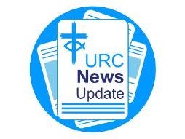
NEWS FROM THE DENOMINATION
The URC’s News Update is a regular e-newsletter that keeps you informed about the latest news and events.
To receive this popular newsletter, please visit the https://urc.org.uk/news-updates-sign-up-form/ page on the URC website and follow the links. If you just want to dip in and catch up on what is going one, that’s fine and you can
read and print recent editions of our e-newsletter by visiting the URC News Update page at https://urc.org.uk/urc-news-update/ .
The Safeguarding team are available 24 hours a day, seven days a week and 365 days a year (and even 366 days in Leap Years!!). Details can be found on the Yorkshire website at https://urcyorkshire.org.uk/safeguarding/ and any query, either by phone or by e-mail at safeguarding.1and4@urc.org.uk will be answered within 24 hours.

LISTED BUILDINGS NEWS
We have a message from the Synod’s Property Officer, Jane Bunyan, which is of interest to all of you who worship in and care for the Synod’s Listed Buildings.

Dear Friends
Firstly, thank you for everything that you do to maintain the buildings you care for and I need to remind everyone that ALL buildings within the curtilage of your grounds are listed, not just the bits that appear on the listing with Historic England! This includes church halls and any outbuildings etc. If you are not sure please check with me in the office, especially as the Synod Property committee should always be advised of works to Listed buildings.
Secondly, if you have done any works on your buildings (including architects fees etc) in 2025, you can claim the VAT back on these up to a value of £25,000. This needs claimed before the end of March 2026, and I suggest doing so sooner rather than later, in case the pot runs out. The link to start that claim is this one https://listed-places-of-worship-grant.dcms.gov.uk/ . Several United Reformed Churches in our synod would have been eligible for more in 2025 if the cap had not been in place, as would major historic buildings such as York Minister, or St Michael–le–Belfry in York, Ripon Cathedral and Leeds Minster.
Thirdly and most importantly, this scheme is NOT being renewed in 2026. It is being replaced with a new grant funding system and some detail on it can be found here https://questions-statements.parliament.uk/written-statements/detail/2026-01-22/hlws1266.
It is called the PLACES OF WORSHIP RENEWAL FUND and is the result of successful lobbying by many heritage organisations who feared the loss of relief on the work done to historic buildings and it does indicate that the government acknowledges the importance of these listed buildings.

Please do get in touch if I can offer any more help or support.
With best wishes
Jane Bunyan
Synod Property Officer


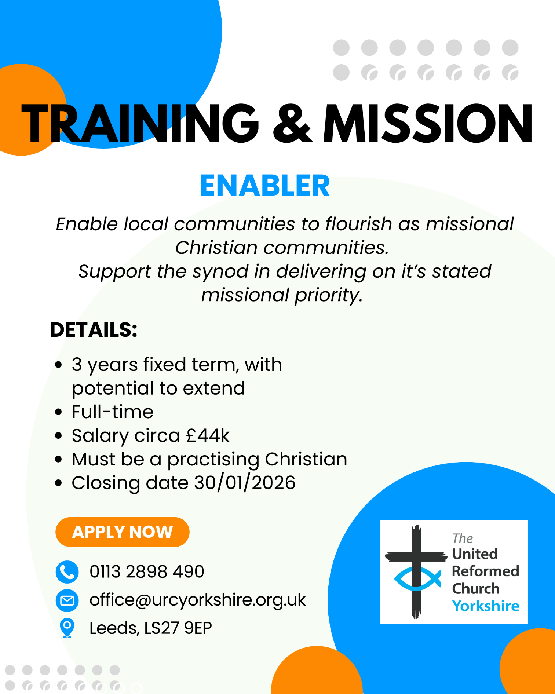

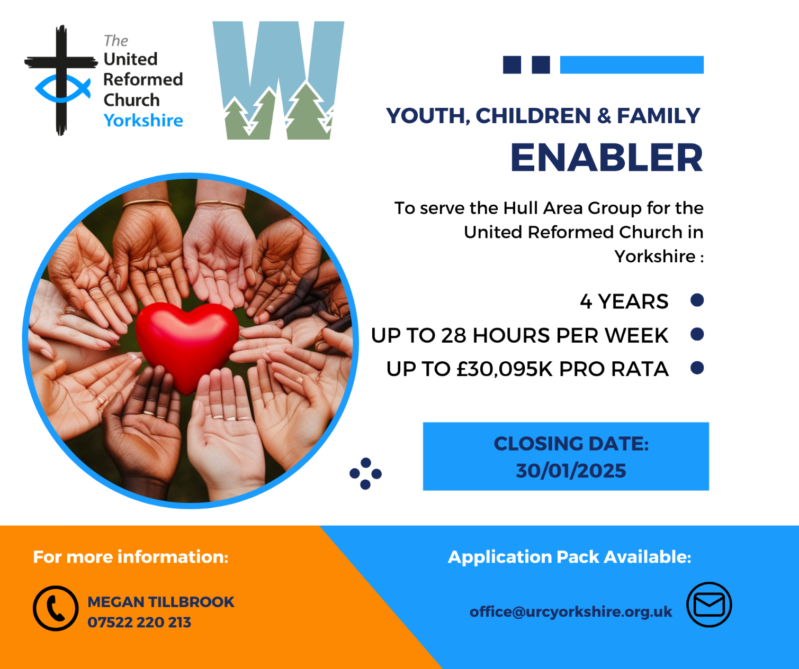

WANTED!!
The Children’s and Youth Work Committee of the Yorkshire Synod is in need of a new Convenor, to succeed Mr Dan Morrell who has filled this role for a good few years now. He steps down from the role at our next Synod meeting, to be held on March 14th 2026 at West Park URC in Harrogate.
This means we are looking for a successor to Dan, so if you are interested in this role, or you may know of someone who would be ideal to help guide the Children’s and Youth Work side of our Synod life, please contact the Synod Clerk at clerk@urcyorkshire.org.uk for more details and for a more detailed job description.

FIRE SAFETY
Jane Bunyan, our Synod Property Officer property@urcyorkshire.org.uk has asked that I remind churches that fire regulations for small non-domestic premises have changed in light of the Grenfell Tower Enquiry outcomes. The advice Synod is giving is that all churches should make themselves aware of the new regulations and advice updated in 2024 at Making your small non-domestic premises safe from fire - GOV.UK or https://www.gov.uk/government/publications/making-your-small-non-domestic-premises-safe-from-fire but if you would like a pdf copy then please email Jane at the above e-mail address.

Treasurer – The Milton Mount Foundation

The Milton Mount Foundation is a Trust Fund that offers grants to children of Ministers. The Fund arises from the sale of the Milton Mount College in 1962.
For more information: https://www.miltonmountfoundation.org.uk/

The Treasurer oversees the financial matters of the charity in line with good practice and in accordance with the governing document and legal requirements and reports to the Board of trustees at each meeting about the financial health of the organisation.
Closing date for applications: 31 January
Informal interview for role: 26 February pm or 27 February am
For more information and application form, please contact: The Secretary at miltonmountfoundation@gmail.com

This can also be found on the URC Jobs page of the website: https://urc.org.uk/jobs/


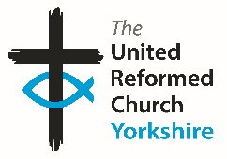

Somebody is missing
Is it you?

Synod is looking for volunteers to fill
several posts across it’s committees.
Please contact the Synod Moderator or
Clerk if you, or someone you know,
would like more information
on how to help.

clerk@urcyorkshire.org.uk moderator@urcyorkshire.org.uk

And Finally
World Day of Prayer Preparation
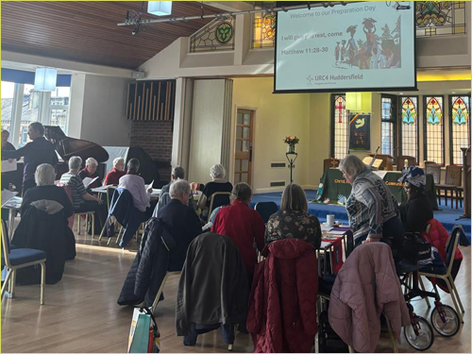
Back at the beginning of November last year – the first of November in fact – there took place an inspiring, spiritual and fun day at Moldgreen URC in Huddersfield. The day was centred on preparing for the World Day of Prayer, which will be happening this year on Friday 6th March.
As you’ll see from the photographs kindly supplied by Kath Lonsdale of Westfield Wyke URC, there was wide URC participation as well as an even wider ecumenical participation with folk attending from the Moravian church and the Church of England.
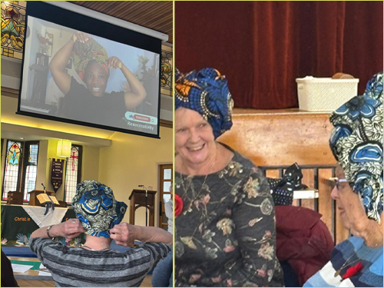
There are other preparation days being planned, so please visit the World Day of Prayer website to find one near to your church and also to find a service dedicated to the World Day of Prayer over that first weekend in March.

If you have a good news story from your part of the Synod or something that you feel reflects the work of Synod and which inspires others as we move into 2026, drop me a line at clerk@urcyorkshire.org.uk and I’ll make sure it hits the back page!!

You can also keep an eye on all our social media platforms for news; on the website at Home - URC Yorkshire Synod, at United Reformed Church in Yorkshire - Home | Facebook and Wilderness URC Yorkshire - Home | Facebook, the YouTube page at URC Yorkshire - YouTube and the Twitter (X) page at URC in Yorkshire (@URCYorkshire) / Twitter.

