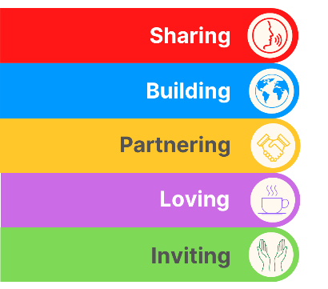
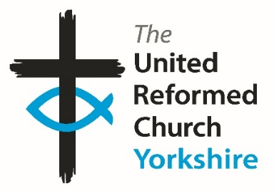
Yorkshire Synod Briefing
Number 169

5th March 2026

Spring Meetings Special
This February and the first half of March have seen a flurry of meetings. Nothing unusual about that as it has always seemed to me that the URC is built on a foundation of meetings, but this past few weeks’ meetings will hopefully go a long way to improving how we do things at Synod and across the denomination. A key meeting recently was that one held at Hinsley Hall in Leeds, where members of Synod Council with staff and office holders gathered to build on the work initiated at the first “Hinsley Hall” meeting back in 2024. Much was discussed and there will hopefully be some feedback at the Synod meeting later this month, but one thing which came from it was how effective the Briefing is, and is the way in which it is distributed suitable for the messgae it is trying to get out. So, after discussion, this will be (for a while until the feedback comes in) the last Briefing that will be sent out via e-mail. From the next issue – due out on 19th March - the plan is to only upload it to the Synod website. This is to try and cut down the amount of e-mail traffic we at Synod send out to church sectretaries, ministers and others on our mailing lists as we respond to comments along the lines of there being far too many things coming from Synod blocking up in-boxes.
The next big meeting, and one which perhaps book ends the early Spring meetings season as it arrives only three weeks before Easter, is our March Synod meeting. We are blessed with an invitation to join with our fellow Yorkshire churches at West Park URC, Harrogate on Saturday 14th March. This is the first time Synod has met at West Park and with the theme of the Synod meeting being “Worship”, I hope we can use their flexible space to the best advantage as Synod looks to see how we can make worship a more vibrant and relevent part of our witness. Not only that but we welcome Revd Neil Thorogood, General Assembly Moderator-Elect, who will be exploring worship themes with us during the morning session.
You will notice that some of our churches are engaging with the World Day of Prayer on March 6th. I know that there are events at Westfield Wyke URC and at Portholme Church Selby. I’m sure that their experiences of uniting with fellow Christians in prayer at a time when feelings of uncertainty are on the rise will be reassuring and I hope to be able to report back on how those World Day of Prayer were able to bring a sense of positivity in future issues.
Please continue to send invitations to your events, your stories and pictures in to me, and I’ll continue to advertise and share them throughout 2026, either here in The Briefing or on the Synod website at https://urcyorkshire.org.uk/. They may even end up in https://urc.org.uk/our-news-stories/latest-news/ which is always worth a read and has the opportunity to sign up for regular URC’s news updates.

So, if you have any news of welcoming people into Church, stories of celebration and mission, please let me know by dropping me a line at clerk@urcyorkshire.org.uk and I’ll showcase it in the next edition, due out on Thursday 19th March 2026.
Tim Crossley
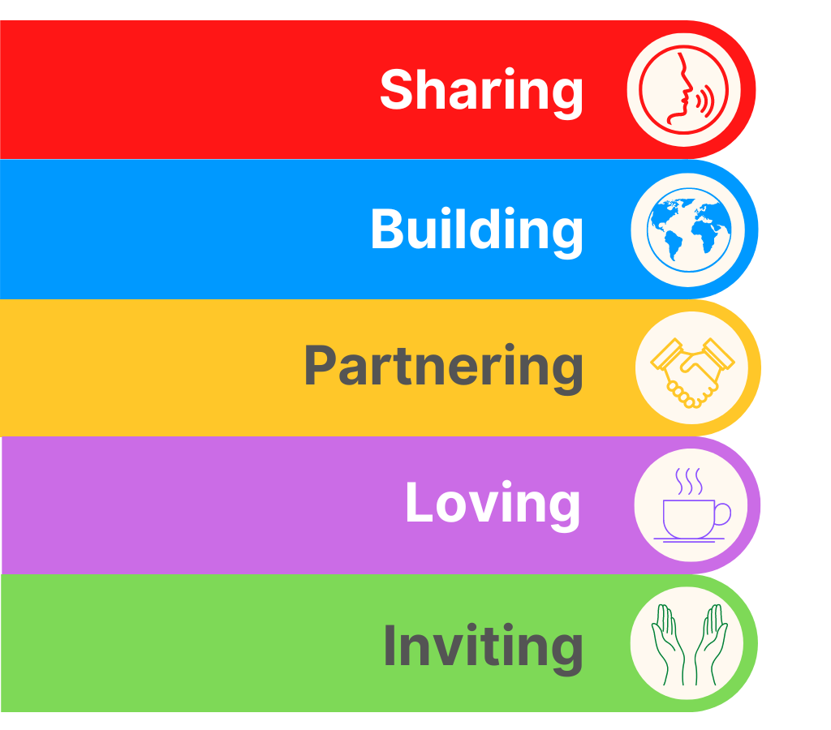
SYNOD FORUMS 2026
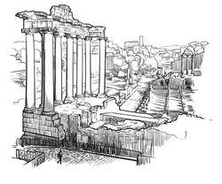
During the Spring of 2026 the Synod Team will be bringing the Synod Forums to three new venues so that those who couldn’t make it to previous venues have the opportunity to travel to somewhere potentially closer to home.
- Saturday 9th May at Pudsey URC
- Saturday 30th May at Portholme Church, Selby
- Saturday 6th June at St Andrew’s URC, Sheffield
Each forum will commence at 10am and each are brilliant opportunities for fellowship and good conversation; the place to have your voice heard, and to help shape the priorities of the Synod.
All are welcome and the Synod team looks forward to seeing you there..

THE KING’S WAY CHURCH. WESLEY ST. OSSETT
LENT LUNCHES
We shall again be having lunches on Mondays during Lent. These will take the form of a modest meal of soup and a roll, followed by a talk given by a visiting speaker.
There is no charge, but there will be a retiring collection for the speaker’s charity.
Mon. 23rd Feb THE CONE EXCHANGE (the original re purposing)
Mon. 2nd March THE SHANNON TRUST (literacy in HMP’s)
Mon. 9th March SHARED HARMONIES (music for dementia)
Mon. 16th March CHAPLAINCY at FOUNTAINS ABBEY
Mon. 23rd March. ABIGAIL HOUSING (homeless refugees & asylum seekers)
All at 12.30pm until approx. 1.45pm at the King’s Way Church Hall.
Some indication of numbers attending would be helpful for catering purposes. If possible, please notify Christine Whitworth. Tel.01924 271554, E Mail Christine_whitworth@hotmail.co.uk, but please feel free just to come at the last minute – everyone will be very welcome.

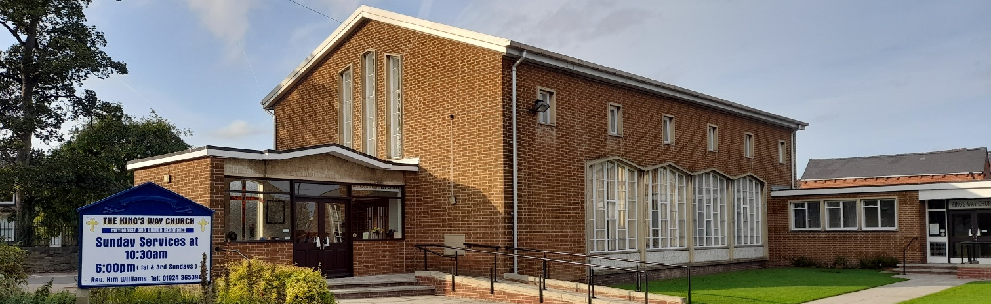

ONLY TWO PLACES LEFT FOR
Lay Preachers’ and Worship Leaders’ Weekend
"Choosing and Using the Psalms in Worship"
at the Wydale Conference Centre, Brompton by Sawdon near Scarbrough
https://www.wydale.org
We are pleased to say that registration for our fifth Lay Preachers’ and Worship Leaders’ weekend at Wydale Conference Centre is NOW OPEN.
This will be 17th – 19th July 2026 (Friday teatime to Sunday lunch).
We are very pleased that Dr Alison Gray, Director of Studies, Tutor in Old Testament Language, Literature & Theology at Westminster College, will be our main speaker at the conference.
This weekend will again be paid for by synod and grants so you will only need to cover your travel costs.
There are 30 places available and you are now invited to register with the office at
office@urcyorkshire.org.uk or 0113 289 8490.

Yours in Christ’s service
Kath Lonsdale, Anne Dale, Jill Fletcher, Rod Morrison,
Lay Preachers and Worship Leaders Planning Group
For any queries, please contact Kath at kathlonsdale@talktalk.net 01274 315203 or 07759525936



“I will give you rest, come”

Prepared by Christian women from Nigeria
At 2 pm.
On Friday 6th March 2026
at
Westfield United Reformed Church
Westfield Lane, Wyke, BD12 9DB
Followed by refreshments
All welcome
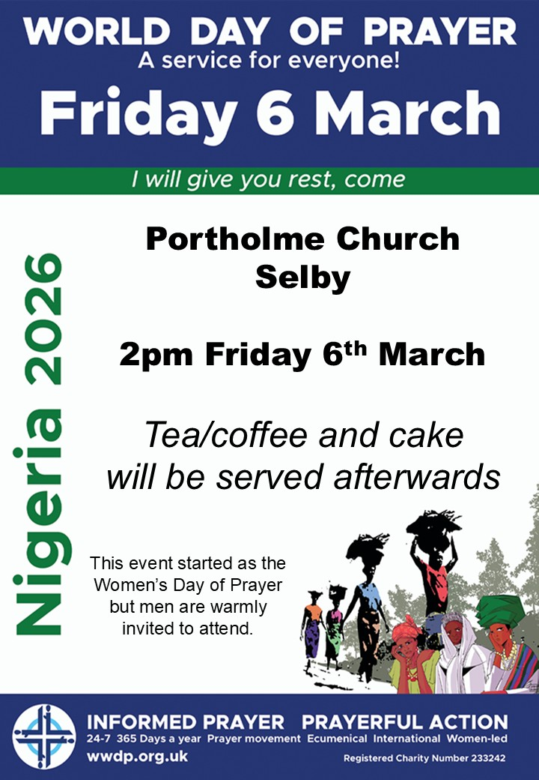
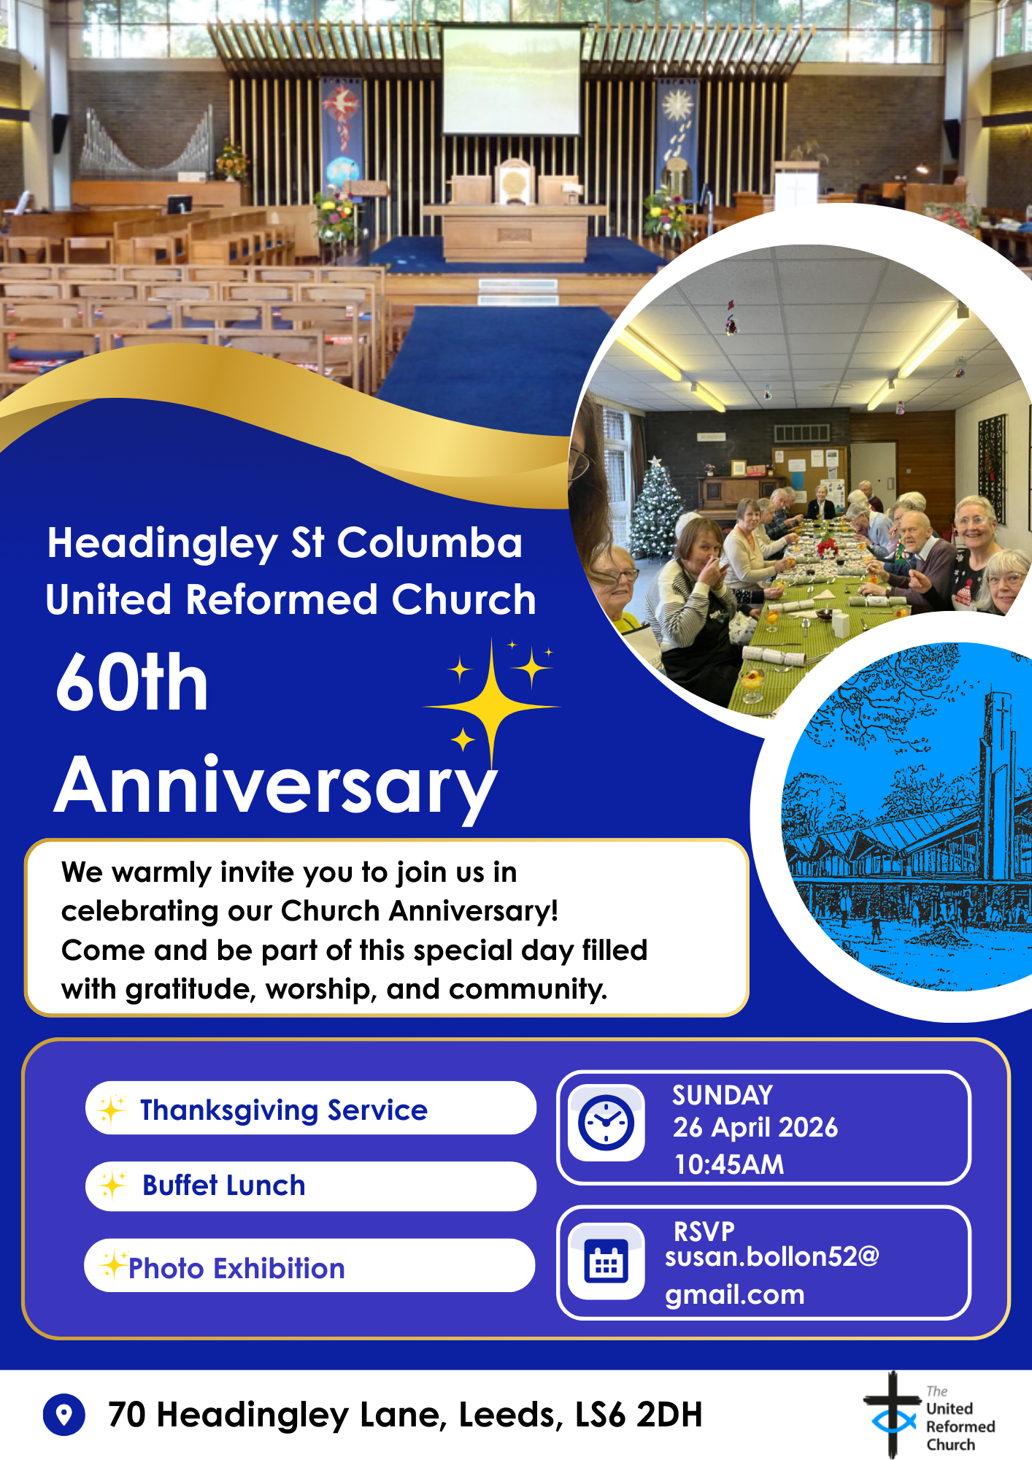
More details to follow in the next issue of the Briefing – and keep your eyes on the Synod website as that information will soon be there as well as there will be the opportunity to apply for grants to help subsidise transport to THE BIG DAY OUT.
News from the Charity Commissioners.
I’ve been asked to bring this to your attention so that you may take up the offer from the Commissioners to take part in their Faith Security Training. Please have a read and follow the instructions as to how to sign up.

Free Faith Security Training – Offered by the Home Office
The Home Office is pleased to announce the launch of Faith Security Training (FST) – a free security awareness scheme designed specifically for faith communities across England and Wales, which will be delivered on behalf of the Home Office by CDS Support.
This training will help you strengthen security practices, mitigate threats, and ensure your places of worship remain safe and secure.
Why take part?
- Gain practical knowledge to protect your congregation and premises.
- Learn how to identify and reduce risks before they become threats.
- Access expert-led training, developed with input from faith and security specialists, designed to ensure all faith communities achieve a foundational level of security knowledge and principles.
- Be part of the government’s Plan for Change, creating safer streets and stronger communities.
Who should attend?
- Faith leaders, trustees, facilities managers, volunteers, and anyone with responsibility for security at your place of worship. The training is also suitable for any member of a congregation with an interest in improving security at places of worship.
- How is training delivered?
- Face-to-face or virtual classroom sessions with direct access to security experts.
- E-learning modules available soon via ProtectUK for flexible learning.
The scheme is intended as an additional, fully optional resource that participants may draw on if helpful. It is designed to complement any existing security training that individuals or organisations have already undertaken.
Don’t miss this opportunity to upskill your community and safeguard your place of worship. Register now and take the first step towards a safer future. Together, we can support faith communities to stay safe and secure.
If you are interested in participating, please register here - https://email.cdsds.uk/en-gb/faith-security-training
For further information, please visit the FST webpage, or email contact@cdssupport.uk.

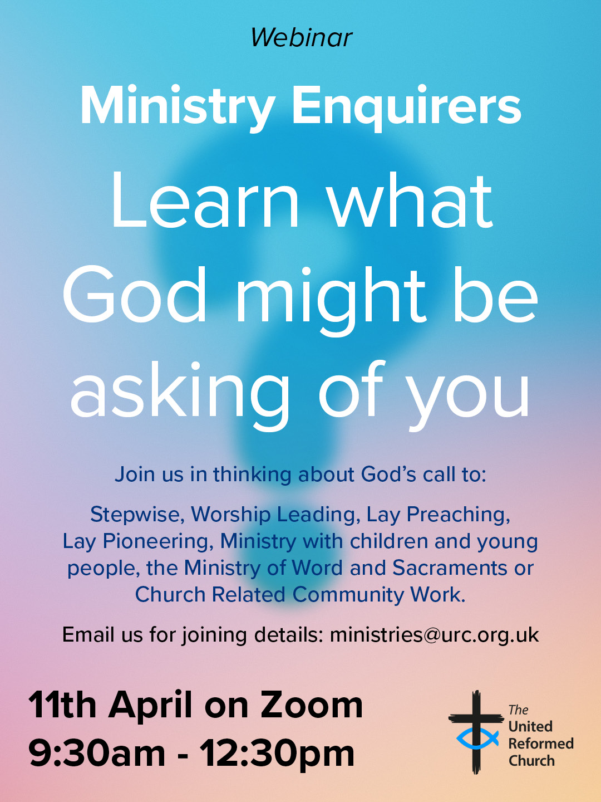
FAITH, HOPE AND VISION
ST PAUL’S URC, HARROGATE - 150 YEARS

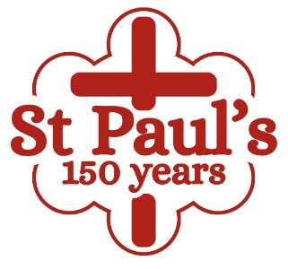
2026 is a special year of celebration at St Paul’s, Harrogate. The congregation is celebrating its 150th anniversary, leading up to a weekend of special events on 13th and 14th June. Throughout the year the congregation will be looking back with gratitude to the faith, hope and vision of those who planted the original seeds in 1876 as well as continuing to look upward in worship and look forward in hope. The church’s prayer is that this anniversary will help them to renew their commitment to Christ’s mission so that the next 150 years will bear even greater fruit for the Kingdom, as they seek to remain true to their vision of St Paul’s as somewhere where everybody is somebody and Jesus is Lord.
Back in 1876 a small group of individuals started to worship in an iron or tin church (named after the original roof) in Victoria Avenue, Harrogate. Over the next 21 years this dedicated group expanded and raised funds until they were able to achieve their vision of becoming “self-supporting” in a stone building in February 1897. In 1972 St Paul’s Presbyterian Church became St Paul’s United Reformed Church and part of Leeds District and the Yorkshire Synod. Situated in the town centre St Paul’s has always been a gathered congregation, drawing on a wide geographical area.
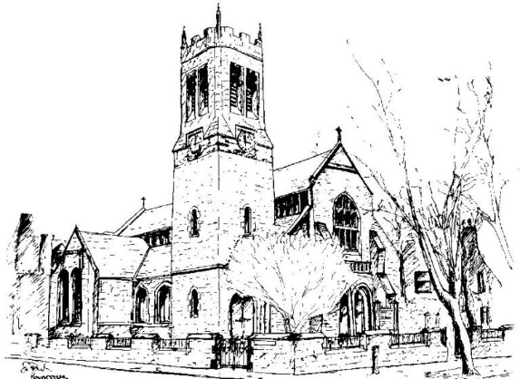
Although 2026 is primarily a year of celebration we shall also be aiming to raise funds towards replacing the church roof. Special visiting preachers has been invited throughout the year and the Synod Treasurer, Revd Simon Copley was our preacher on 8 February. Events planned include a coffee morning and gift day on 4 April, a Ceilidh on 18 April, and a movie and pizza evening for the young people on 4 June. Commemorative mugs have been produced as well as a booklet describing the early struggles to establish and build St Paul’s, which included some fascinating insights into those early days including the sacking of the lady playing the harmonium for impropriety in 1879! Perhaps she showed her ankles!

WANTED!!
The Children’s and Youth Work Committee of the Yorkshire Synod is in need of a new Convenor, to succeed Mr Dan Morrell who has filled this role for a good few years now. He steps down from the role at our next Synod meeting, to be held on March 14th 2026 at West Park URC in Harrogate.
This means we are looking for a successor to Dan, so if you are interested in this role, or you may know of someone who would be ideal to help guide the Children’s and Youth Work side of our Synod life, please contact the Synod Clerk at clerk@urcyorkshire.org.uk for more details and for a more detailed job description.



Yorkshire Synod Discipleship Development Small Grant Fund 2026
The Synod is pleased to let you all know that it has received confirmation that it has a pot of £4000 to grant to those wishing to apply to the Yorkshire Synod Discipleship Development 2026.

1. Who is eligible to apply? Committed members or adherents, including children and young people, of a congregation within the United Reformed Church who are exercising, or want to exercise, a form of lay ministry or community service whether expressed within or beyond their local church. The DDF is not open to Ministers of Word and Sacraments and CRCWs, as there are other designated funds available for those groups.

2. How much is available? Up to £300 per applicant per calendar year, although the Synod may agree to more than this according to the local context and circumstances.

3. What can this money be used for? The purposes for which the funding is provided are defined by creativity and vocation, in line with the URC's discipleship development strategy. Be bold, take risks. The funding exists to help you to follow Jesus. You might be helped in this by courses (at any level) at any of the URC Resource Centres for Learning or from other learning providers, or you may have ideas on resourcing discipleship development in other people. You may need funds to cover the costs of travel, materials or books. All you have to do is make a case to your local church meeting and submit the application form to the Synod Convenor of Ministries for consideration and, if appropriate, authorisation.

4. How are applications made? Having gained your church meeting's endorsement, applications are to be made on the designated form, well before the spending is due to start. Backdated applications will not normally be accepted. Application forms are obtainable from the Synod Convenor of Ministries via the Synod Office at office@urcyorkshire.org.uk and should be sent back for authorisation before being passed to the synod finance office.

5. How are grants paid? Grants authorised by the Convenor of Synod Ministries
are paid by a Synod finance officer by reimbursement to you when you have given proof of what you've spent. Contact your Synod Convenor of Ministries for discussion if you need something funded directly on your behalf, rather than waiting for re-imbursement.

If anyone wants to discuss an application before submitting it please contact the Convenor of the Yorkshire Ministries Committee, Kath Lonsdale at kathlonsdale@talktalk.net.
Remember this is for any age of lay person in our churches to apply for so please discuss with your young people as well as adults.


Revd Dr Simon Cross, who serves in the Hull URC Partnership, is instrumental in organising this event due to take place at Westminster College, Cambridge (and online) on the 21st of March called:

The Quiet Revival: Myth, memory or movement?
Simon writes: I dare say that you will have either read or at least heard about the report from the Bible Society, last year, which talked about a ‘Quiet Revival’ in church attendance amongst young people. You may also have seen, read, or heard some of the discussion about that report – maybe even the British Social Attitudes Survey which offered a starkly ‘alternative’ picture.
In order to shed some light on this confused and confusing picture I’ve asked some clever and well-informed people to take part in a ‘symposium’ – each of them will present a short paper and there will be room for discussion after each one. As well as some leading social scientists and international researchers I’ve invited some well-placed church figures, and a resident expert in the history of British revivals. We will also hear, directly, from one of the authors of the original Bible Society report.
I’m not saying we’re definitely going to get to the bottom of whether there really is a ‘quiet revival’ going on, or not, (and if there is – whether that’s good, bad, or… something else) but we will, at least, have a better sense of what that might mean… I hope.
Look at it this way: if nothing else you can have a day with some very clever and interesting people… and me.
I’d love you to be able to join us for the event, either in person or – indeed – online (nothing to stop you organising a watch party, by the way). Thanks to a generous grant we’ve kept the prices as low as possible – the in person ticketing is tiered too, so if you’re feeling flush you can chip in a little more to help us make sure we cover the costs. There are only a limited number of ‘in person’ tickets available (if everyone receiving this email got a ticket, we’d be full) – so if you’re keen to be in the room, then my advice is to book early.
(And if you’re fortunate enough to have a ‘training budget’ or similar – then this will, I’m sure, qualify. I mean, it might not… I don’t really know. To be fair - it’s a guess.)

If you are interested in joining Simon on 21st March, between 10am and 6pm there’s a booking link here: Quiet Revival - Westminster College or https://www.westminster.cam.ac.uk/quiet-revival and you can read the original Quiet Revival report here: The Quiet Revival: Gen Z leads rise in church attendance or https://www.biblesociety.org.uk/research/quiet-revival

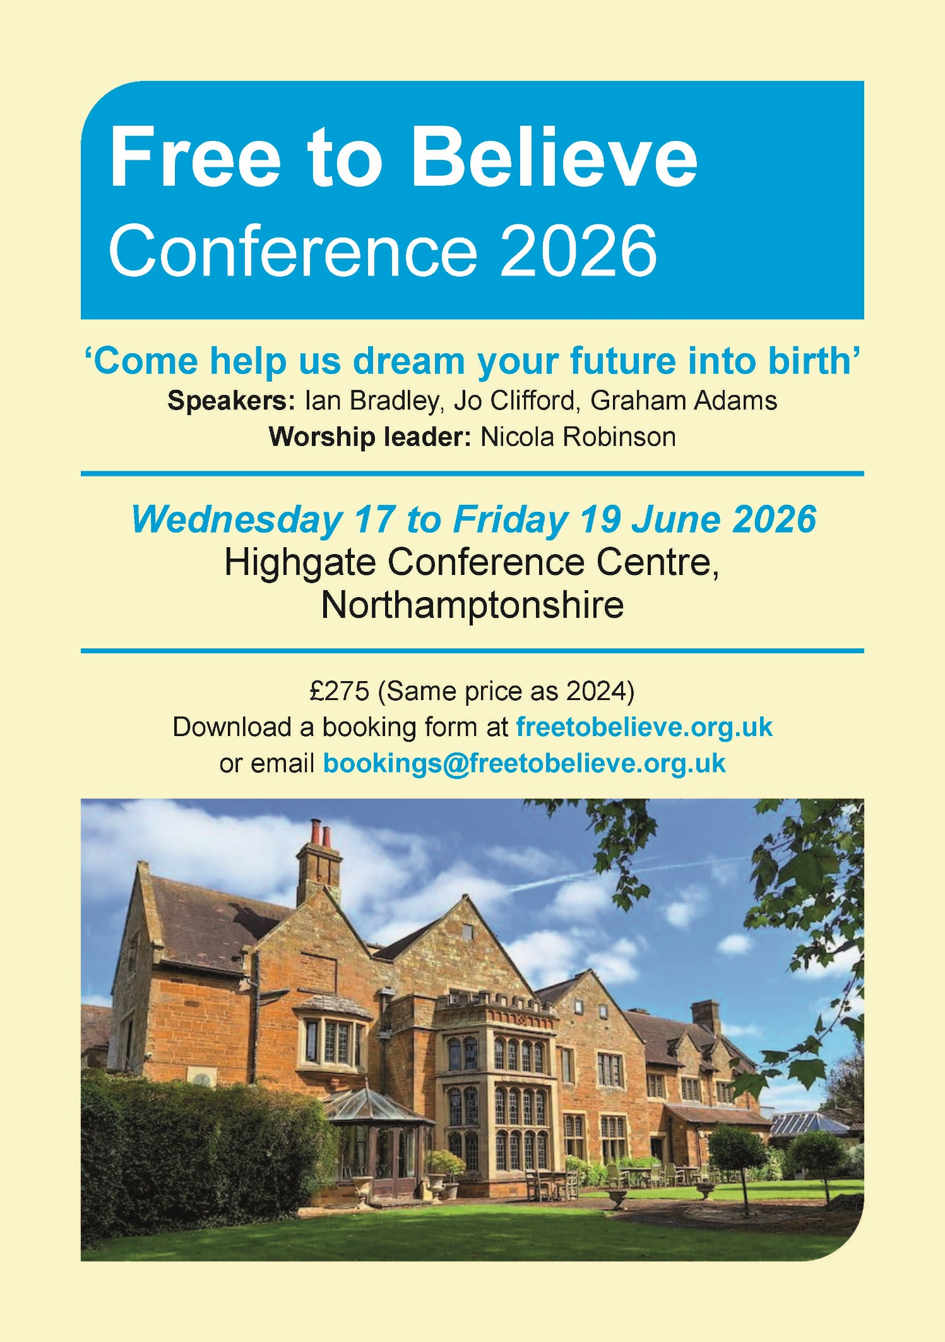
For more information, please visit the Free to Believe website at https://freetobelieve.org.uk/conferences.html
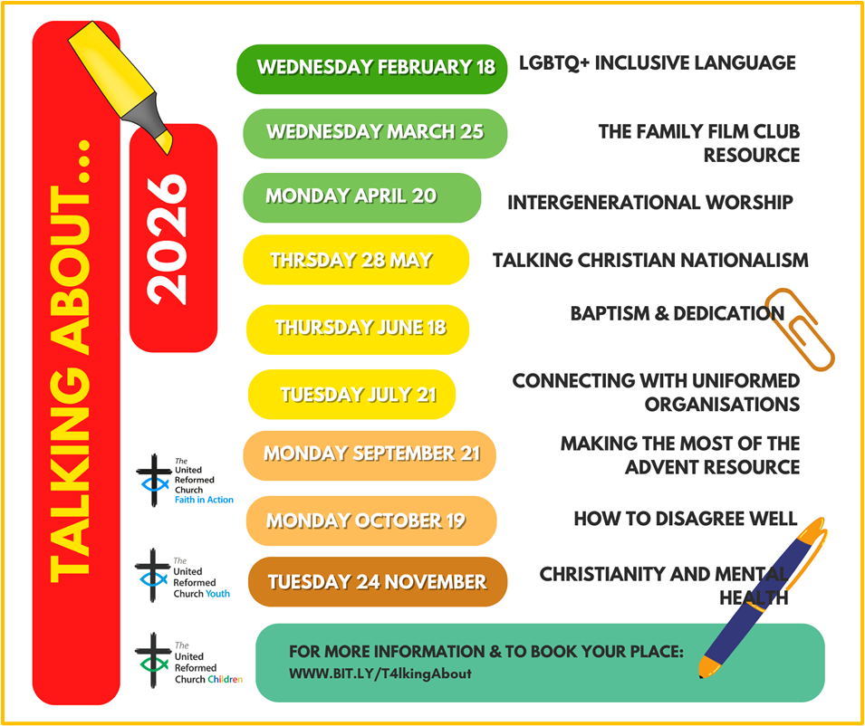

FIRE SAFETY
Jane Bunyan, our Synod Property Officer property@urcyorkshire.org.uk has asked that I remind churches that fire regulations for small non-domestic premises have changed in light of the Grenfell Tower Enquiry outcomes. The advice Synod is giving is that all churches should make themselves aware of the new regulations and advice updated in 2024 at Making your small non-domestic premises safe from fire - GOV.UK or https://www.gov.uk/government/publications/making-your-small-non-domestic-premises-safe-from-fire but if you would like a pdf copy then please email Jane at the above e-mail address.

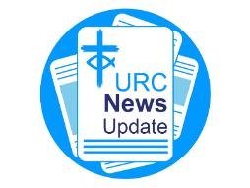
NEWS FROM THE DENOMINATION
The URC’s News Update is a regular e-newsletter that keeps you informed about the latest news and events.
To receive this popular newsletter, please visit the https://urc.org.uk/news-updates-sign-up-form/ page on the URC website and follow the links. If you just want to dip in and catch up on what is going one, that’s fine and you can
read and print recent editions of our e-newsletter by visiting the URC News Update page at https://urc.org.uk/urc-news-update/ .

Submit your photographs for the 2027 URC Calendar

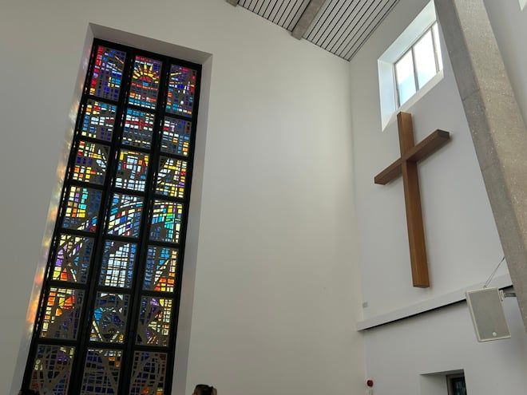
The 2027 United Reformed Church Calendar is titled ‘Transparent as glass’ and will feature stained glass windows and glass sculptures from our churches and Local Ecumenical Partnerships.

Glass has been used in churches since the 7th century for visual storytelling and religious education, acting as colourful “picture books” for congregations to learn Bible stories and for Christian teaching. Stained glass also creates a sacred atmosphere by focussing light for worship and enhancing our churches’ architectural beauty.

We invite you to send in your photos of large and small windows, as well as any sculptures made from, or including, glass. Please include the name of the church and the photographer. You can email your image(s) to the URC Press Office, pressoffice@urc.org.uk.

Please note that for all photos submitted, the photographer is granting the URC permission to use the photographs in print and digitally. The deadline for submitting your photos is June 5 2026.

The calendar will be available on the URC Bookshop from August and is once again generously supported by Edwards Insurance.

The Safeguarding team are available 24 hours a day, seven days a week and 365 days a year (and even 366 days in Leap Years!!). Details can be found on the Yorkshire website at https://urcyorkshire.org.uk/safeguarding/ and any query, either by phone or by e-mail at safeguarding.1and4@urc.org.uk will be answered within 24 hours.

LEEDS PARTNERSHIP PRAYERS
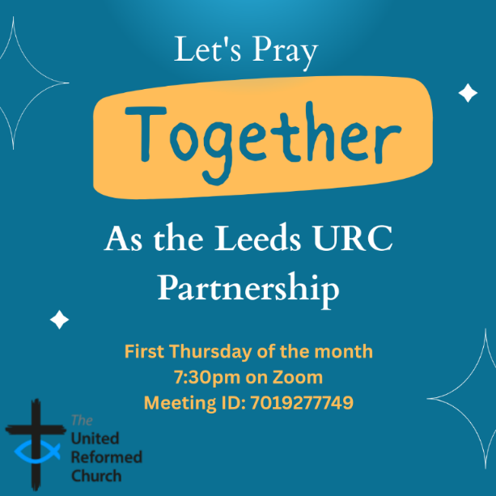
Although this is primarily aimed at those of us who are linked with the churches of the Leeds URC Partnership, this invitation is open to everyone from around the Synod and beyond.
It will be happening on the first Thursday of the month on Zoom at 7:30pm. The next one will be on tonight, Thursday 5th March and the link is here: https://us02web.zoom.us/j/7019277749

There will be a time to pray together, a time to share in reading the Bible and a time to share the joys and challenges in our lives, churches, communities and world.
Looking forward to seeing you there.
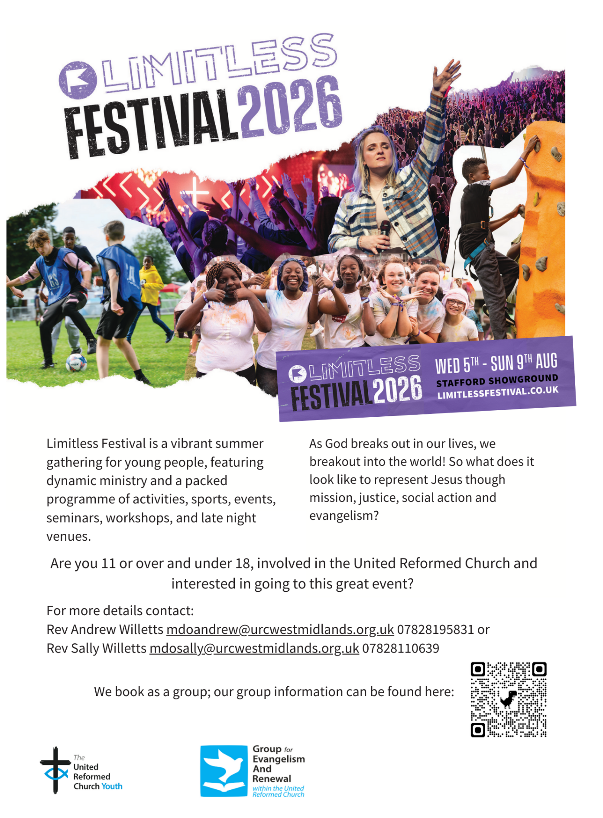

LISTED BUILDINGS NEWS
We have a message from the Synod’s Property Officer, Jane Bunyan, which is of interest to all of you who worship in and care for the Synod’s Listed Buildings.

Dear Friends
Firstly, thank you for everything that you do to maintain the buildings you care for and I need to remind everyone that ALL buildings within the curtilage of your grounds are listed, not just the bits that appear on the listing with Historic England! This includes church halls and any outbuildings etc. If you are not sure please check with me in the office, especially as the Synod Property committee should always be advised of works to Listed buildings.
Secondly, if you have done any works on your buildings (including architects fees etc) in 2025, you can claim the VAT back on these up to a value of £25,000. This needs claimed before 31st March 2026, and I suggest doing so sooner rather than later, in case the pot runs out. The link to start that claim is this one https://listed-places-of-worship-grant.dcms.gov.uk/ . Several United Reformed Churches in our synod would have been eligible for more in 2025 if the cap had not been in place, as would major historic buildings such as York Minister, or St Michael–le–Belfry in York, Ripon Cathedral and Leeds Minster.
Thirdly and most importantly, this scheme is NOT being renewed in 2026. It is being replaced with a new grant funding system and some detail on it can be found here https://questions-statements.parliament.uk/written-statements/detail/2026-01-22/hlws1266.
It is called the PLACES OF WORSHIP RENEWAL FUND and is the result of successful lobbying by many heritage organisations who feared the loss of relief on the work done to historic buildings and it does indicate that the government acknowledges the importance of these listed buildings.

Please do get in touch if I can offer any more help or support.
With best wishes
Jane Bunyan
Synod Property Officer

Sadly, this time I don’t have a “And Finally” story for the back page. However, if you have a good news story from your part of the Synod or something that you feel reflects the work of Synod and which inspires others as we move into 2026, drop me a line at clerk@urcyorkshire.org.uk and I’ll make sure it hits the back page!!

You can also keep an eye on all our social media platforms for news; on the website at Home - URC Yorkshire Synod, at United Reformed Church in Yorkshire - Home | Facebook and Wilderness URC Yorkshire - Home | Facebook, the YouTube page at URC Yorkshire - YouTube and the Twitter (X) page at URC in Yorkshire (@URCYorkshire) / Twitter.

