
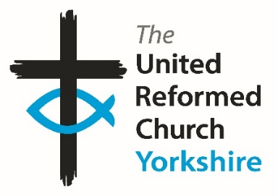
Yorkshire Synod Briefing
Number 170

19th March 2026

Spring Synod Meeting
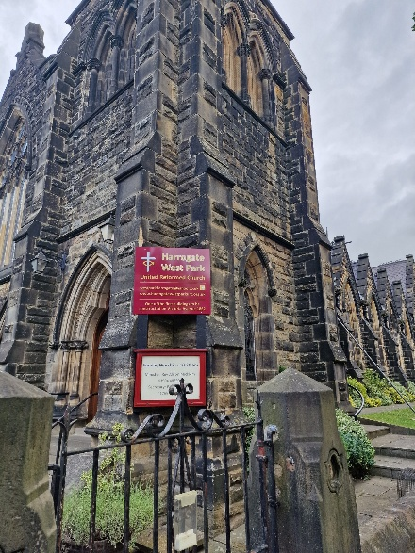
The Yorkshire Synod met in Harrogate on Saturday 14th March for its Spring 2026 meeting and couldn’t have asked for a much warmer welcoming than the hosts, West Park URC, offered. On a glorious spring day, just over 80 people from over half the churches in Synod filled the room to learn, listen and discern how the Synod is moving forward into 2026.
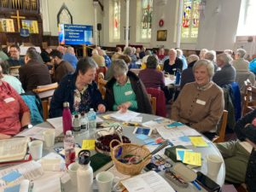
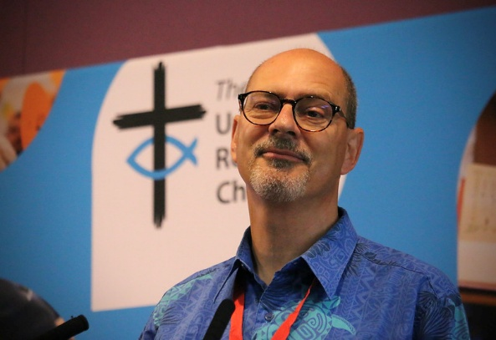
Synod was joined by General Assembly Moderator-elect, Revd Neil Thorogood, who led the morning session on Worship, the ways, the wherefores and the hows. This was an exploration of how to make worship a more relevant part of the Church’s life, how to make it be at the heart of the day to day life of our constituent churches and how it has a relevance to the wider world. The session incorporated group work, input from the Children and Youth team as well as our Racial Justice Advocate, Judy Rogers and cumulated in Synod sharing in Holy Communion. Synod was also kept up to speed with the ongoing Church Life Review being conducted by the Offices of General Assembly and offered thanks to those who have served Synod as well as welcoming those who have taken up roles and positions in our various committees. It is hoped the draft minutes will be distributed to Synod reps before Easter so that they can pass on a fuller picture to their own churches.
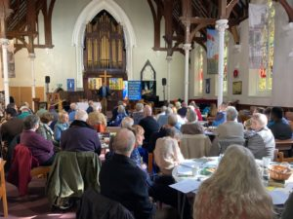
The meeting was also an opportunity to introduce some new and some familiar faces. Jason Raddings was introduced as the new Yorkshire Synod Youth Representative and it was great to hear that Yorkshire’s own Kacie Hodgson is now serving as Moderator of URC Youth. Synod also greeted Jon Steel, who begins work as the Synod’s Training and Mission Enabler at Easter.

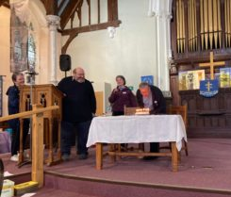
Synod was also able to wish one of it’s own a very happy birthday. As pictured, Revd Jason McCullagh’s special day was marked with him being presented with a specially baked cake topped with an indeterminate number of candles. Happily he was able to blow them all out before it became a fire hazard😊. Hopefully there was enough cake to go round.

Synod will meet again on 10th October 2026 at Moldgreen URC in Huddersfield and it is hoped that the work done in Harrogate can continue apace in Huddersfield later in the year (and if there is an opportunity to celebrate a birthday – that’s fine…………..

Another area where Synod would love to hear from you is how Synod communicates with you. Communication is always a two-way process and to find out more as to how you would like to hear from Synod, and perhaps how you would like to be able to contact Synod, Daniel Raddings has set up a QR code through which you can access a simple questionnaire. All that is being asked is what do you want to hear from us and what format of media would you prefer?
As a Synod we want to share information that benefits your mission. So we’ve devised this simple survey/questionnaire to help us help you.

If you struggle to access the questions via the QR Code you can click the following link https://forms.gle/c4XFZ3kaqUvRoJa26 or if you find it easier to contact Daniel directly his e-mail is daniel.raddings@outlook.com.

Please continue to send invitations to your events, your stories and pictures in to me, and I’ll continue to advertise and share them throughout 2026, either here in The Briefing or on the Synod website at https://urcyorkshire.org.uk/. They may even end up in https://urc.org.uk/our-news-stories/latest-news/ which is always worth a read and has the opportunity to sign up for regular URC’s news updates.

So, if you have any news of welcoming people into Church, stories of celebration and mission, please let me know by dropping me a line at clerk@urcyorkshire.org.uk and I’ll showcase it in the next edition, due out on the website only on 2nd April 2026, just in time for Easter.
Tim Crossley

SYNOD FORUMS 2026
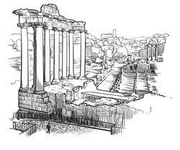
During the Spring of 2026 the Synod Team will be bringing the Synod Forums to three new venues so that those who couldn’t make it to previous venues have the opportunity to travel to somewhere potentially closer to home.
- Saturday 9th May at Pudsey URC
- Saturday 30th May at Portholme Church, Selby
- Saturday 6th June at St Andrew’s URC, Sheffield
Each forum will commence at 10am and each are brilliant opportunities for fellowship and good conversation; the place to have your voice heard, and to help shape the priorities of the Synod.
All are welcome and the Synod team looks forward to seeing you there.

TALKING ABOUT…
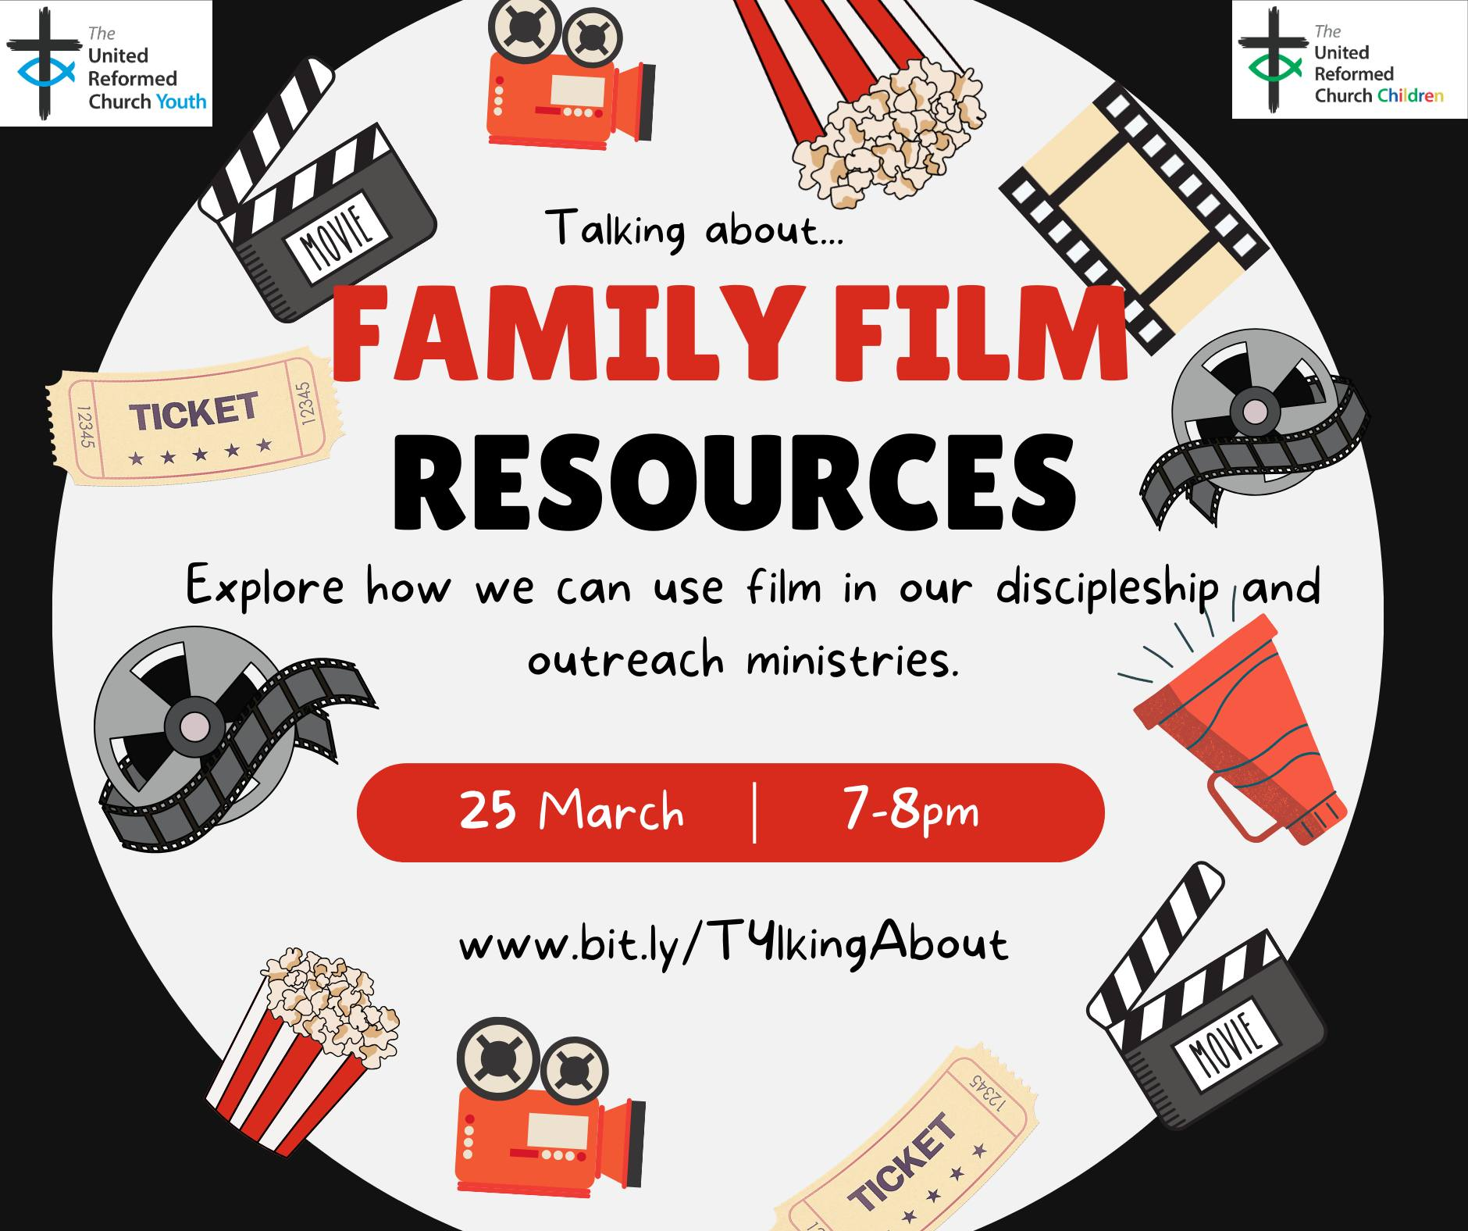
Are you looking for something different to engage families in your church?
On Wednesday 25th March at 7pm come and hear about the fabulous FAMILY FILM RESOURCES written by 2 of the CYDO+ team. Explore how film can be used in our discipleship and outreach ministries. The session will break into 2 rooms, one for those who are already using the resource and want to develop further and one for those who would like to explore how to get something started.
You could also check out the resource in advance by clicking here https://www.urcscotland.org.uk/childrens-ministry
Book your place: www.bit.ly/T4lkingAbout
THE KING’S WAY CHURCH. WESLEY ST. OSSETT
LENT LUNCHES
We shall again be having lunches on Mondays during Lent. These will take the form of a modest meal of soup and a roll, followed by a talk given by a visiting speaker.
There is no charge, but there will be a retiring collection for the speaker’s charity.
Mon. 23rd Feb THE CONE EXCHANGE (the original re purposing)
Mon. 2nd March THE SHANNON TRUST (literacy in HMP’s)
Mon. 9th March SHARED HARMONIES (music for dementia)
Mon. 16th March CHAPLAINCY at FOUNTAINS ABBEY
Mon. 23rd March. ABIGAIL HOUSING (homeless refugees & asylum seekers)
All at 12.30pm until approx. 1.45pm at the King’s Way Church Hall.
Some indication of numbers attending would be helpful for catering purposes. If possible, please notify Christine Whitworth. Tel.01924 271554, E Mail Christine_whitworth@hotmail.co.uk, but please feel free just to come at the last minute – everyone will be very welcome.

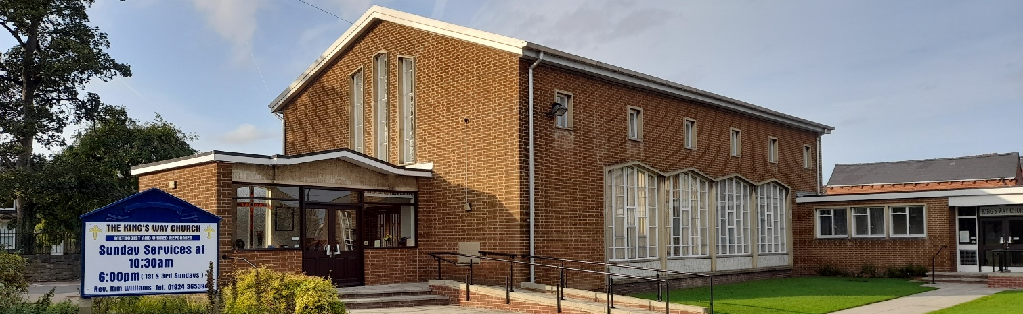

An Invitation to Pray

One of the Street Pastors in Doncaster sent this to one of our Ecumenical Officers, Rod Morrison, last weekend, and Rod has asked that it be shared.

During the Second World War, a group of people stopped whatever they were doing at a specific time every night to pray for peace and safety for everyone. They did this every day, and it was as if the whole city paused — such was the power of prayer. The result was so overwhelming that the bombing stopped shortly afterward!
Now once again some people are organizing. A group of people around the world has agreed to spend one minute praying for the safety of our countries, for the end of the problems that oppress us, and for God to guide the decisions of our leaders.

This body of people will gather at the following times:

India – 9:00pm.
Germany – 4:00pm.
Austria – 4:00pm.
Spain – 4:00pm.
Portugal – 3:00pm.
Canary Isles – 3:00pm.
Costa Rica – 8:00pm.
Colombia – 7:00pm.
Nicaragua – 8:00pm.
Ecuador – 7:00pm.
Guatemala – 8:00pm.
Mexico – 8:00pm.
Panama – 7:00pm.
Honduras – 6:00pm.
El Salvador – 8:00pm.
Venezuela – 6:00pm.
Uruguay – 5:00pm.
Paraguay – 5:00pm.
Brazil – 6:00pm.
Argentina – 5:00pm.
Peru – 6:00pm.
Chile – 5:00pm.
Italy – 4:00pm.
Australia – 2:00pm.
USA – 1:00pm.
Canada – 12 noon
Singapore – 9:00pm.
Thailand – 9:00pm.
Korea – 9:00pm.
Hong Kong / Taiwan – 10:00pm.
Philippines – 11:00pm.
UAE- 7.00pm.
Sierra Leone- 3.00pm.
Switzerland – 4:00pm.
UK - 3.00pm.

Every day we will pause for one minute at the designated time to pray for world peace, for the end of conflict, and for the restoration of calm and security for all people on earth. We will also pray that families may seek their security, protection, and salvation in God. If we truly understood the immense power of prayer, we would be amazed.
🙏🙏🙏🙏
If you can, please forward this request to your contacts so that together we can work a miracle through our prayers.

Set an alarm on your phone every day at the time designated for your country and pray for one minute for peace. 🙏🙏🙏🙏
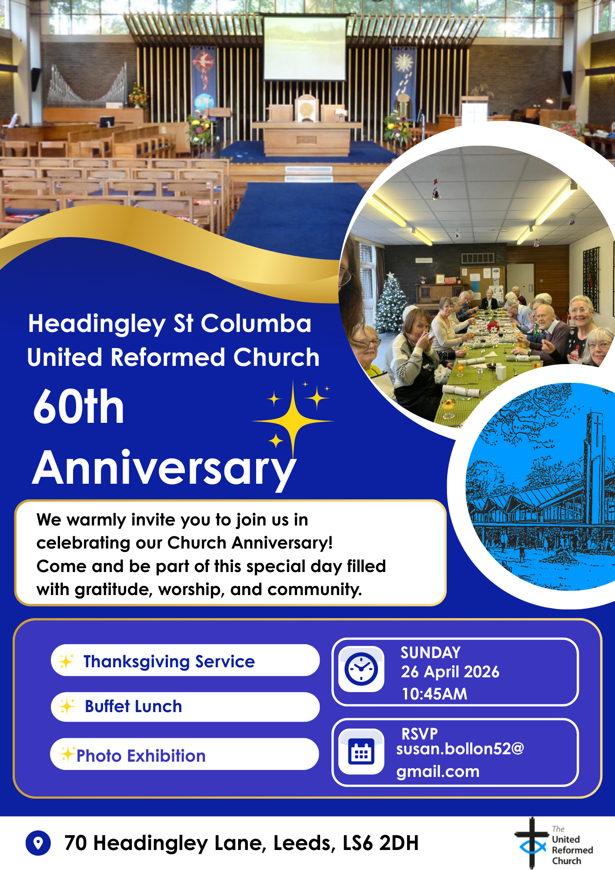
More details to follow in subsequent issues of the Briefing – and keep your eyes on the Synod website as that information will soon be there as well as there will be the opportunity to apply for grants to help subsidise transport to THE BIG DAY OUT.

Westfield, Wyke’s, World Day of Prayer
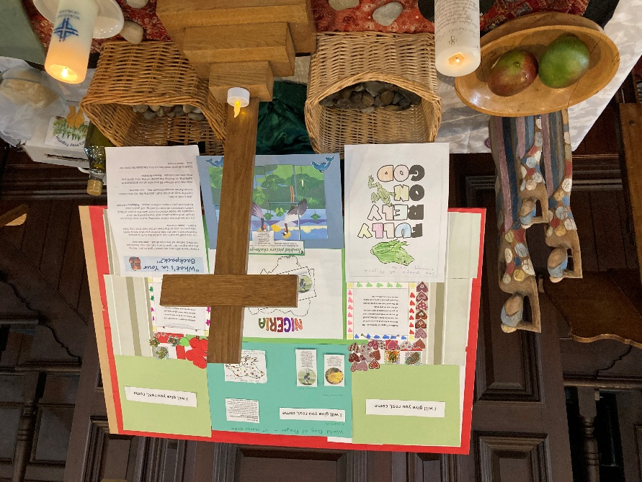
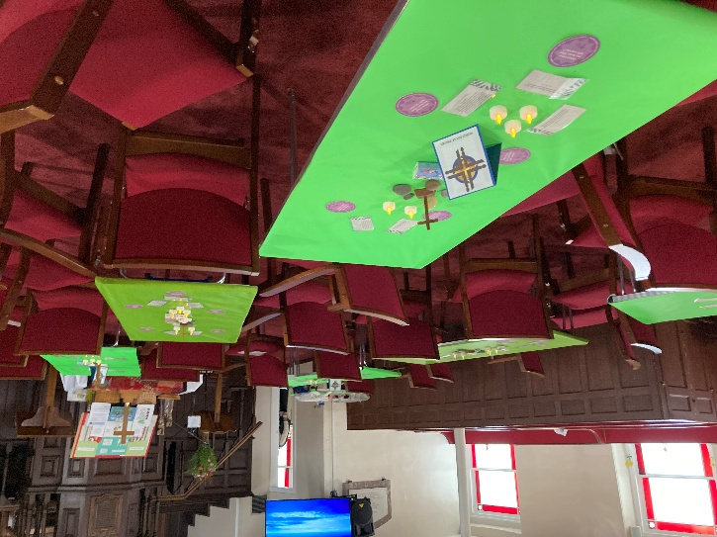
The World Day of Prayer, written by the ladies of Nigeria, took place on Friday 6th March at Westfield URC, Wyke and they were joined by their sisters and brothers from Lower Wyke Moravians and St Mary's Anglican Church, Wyke. 27 people attended with representatives from all 3 churches.

During the service one of the Westfield elders, Glynis Fletcher, updated the congregation on the current situation in Nigeria. Glynis knows people in Nigeria and has visited there. She shared that even though there is much persecution and poverty the Christians there dance down to the front of their churches to give their offerings and are always singing and full of joy. What a witness!

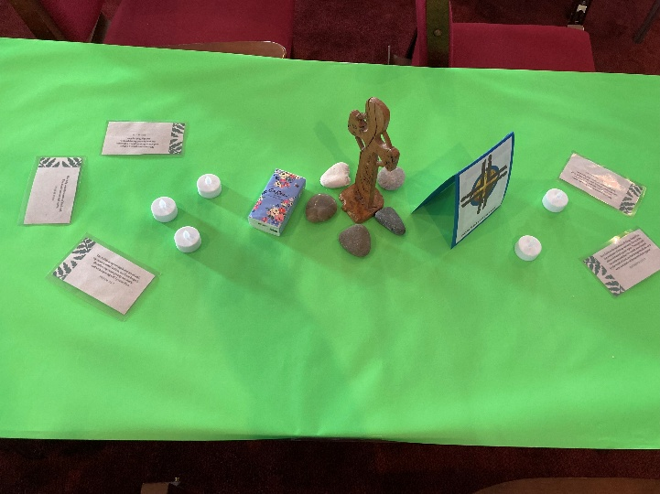
The communion table display was put together by our SHINE (serve him in everything) Sunday morning young people's group and 2 of the leaders of that group."

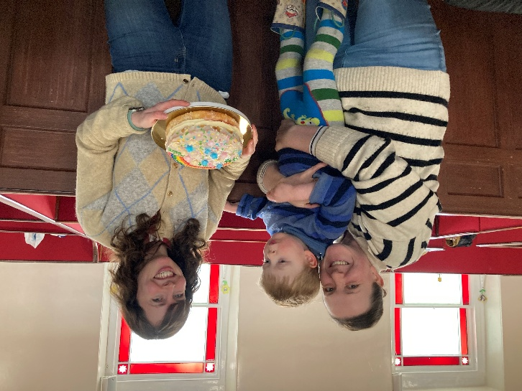
It was also a joy to be able to say Happy Birthday to the Moravian minister, Revd Claire Maxwell, after the service. The Anglican vicar, Revd Lucy Wormsley, had made her a birthday cake with her son Toby for us all to share alongside our Nigerian biscuits at refreshments time

St Andrew’s Roundhay Clock Appeal – success!

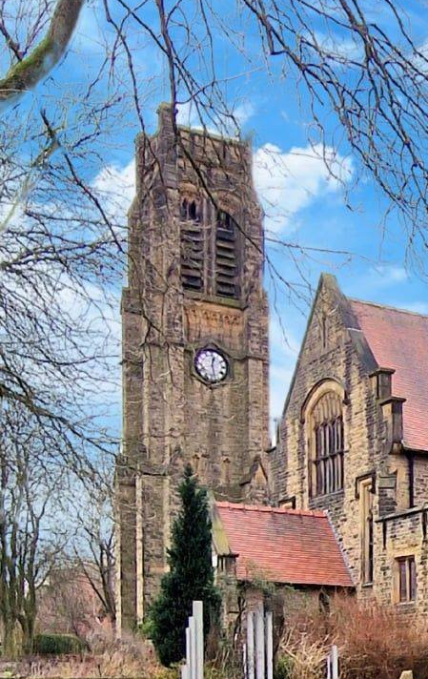
Heather Thompson, the treasurer at St Andrew’s URC, Roundhay has been in touch to let us know that they are delighted to announce that they have reached their fundraising target to repair their Clocktower Clock!

When the clock stopped working a few months ago St Andrew’s were told that it would take over £15,000 to both repair the clock and fit a suppressor to the clock bell allowing us to silence the chimes at night. This is of course a huge amount of money, so they decided to ask their amazing local community to help them get the clock going again.

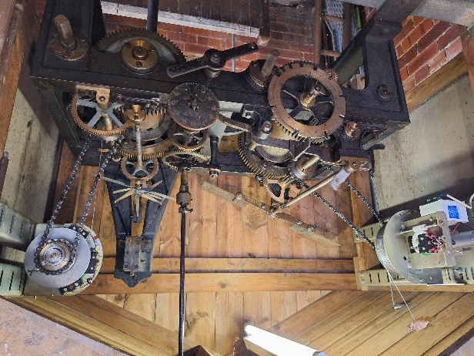
On 11th February 2026 they launched their ‘St Andrew’s Roundhay Clock Appeal’ with a special fundraising café at the weekly Clocktower Community Café (open every Wednesday morning between 10am and noon). They delivered leaflets telling people a bit about the history and significance of our 118 year old Clocktower Clock and set up a JustGiving page asking for donations.

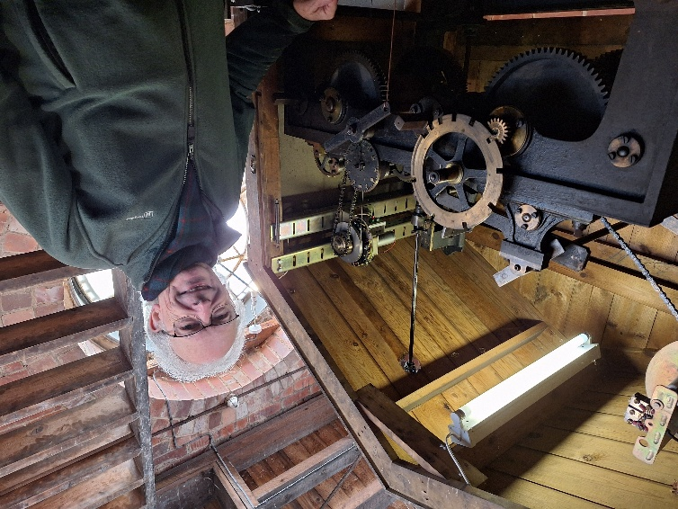
The Clock Appeal launch was a spectacular success - the community rallied round and they were supported by their local councillors and even BBC Radio Leeds! St Andrew’s are so grateful to all their members, friends and neighbours for donating so generously. In addition, it has been heartwarming to hear people’s stories and discover how much the clock means to those within St Andrew’s local community. The church feels incredibly blessed to have reached the fundraising target of £15,800 and they hope to get the clock ticking again soon.
Church elder, Lewis Murray, seen here with the soon
to be repaired winding gear.



FAITH, HOPE AND VISION
ST PAUL’S URC, HARROGATE - 150 YEARS

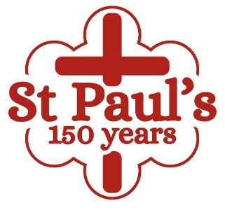
2026 is a special year of celebration at St Paul’s, Harrogate. The congregation is celebrating its 150th anniversary, leading up to a weekend of special events on 13th and 14th June. Throughout the year the congregation will be looking back with gratitude to the faith, hope and vision of those who planted the original seeds in 1876 as well as continuing to look upward in worship and look forward in hope. The church’s prayer is that this anniversary will help them to renew their commitment to Christ’s mission so that the next 150 years will bear even greater fruit for the Kingdom, as they seek to remain true to their vision of St Paul’s as somewhere where everybody is somebody and Jesus is Lord.
Back in 1876 a small group of individuals started to worship in an iron or tin church (named after the original roof) in Victoria Avenue, Harrogate. Over the next 21 years this dedicated group expanded and raised funds until they were able to achieve their vision of becoming “self-supporting” in a stone building in February 1897. In 1972 St Paul’s Presbyterian Church became St Paul’s United Reformed Church and part of Leeds District and the Yorkshire Synod. Situated in the town centre St Paul’s has always been a gathered congregation, drawing on a wide geographical area.
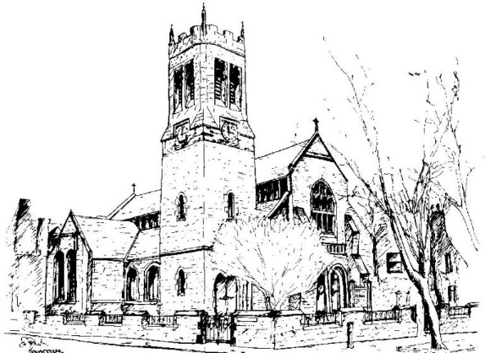
Although 2026 is primarily a year of celebration we shall also be aiming to raise funds towards replacing the church roof. Special visiting preachers has been invited throughout the year and the Synod Treasurer, Revd Simon Copley was our preacher on 8 February. Events planned include a coffee morning and gift day on 4 April, a Ceilidh on 18 April, and a movie and pizza evening for the young people on 4 June. Commemorative mugs have been produced as well as a booklet describing the early struggles to establish and build St Paul’s, which included some fascinating insights into those early days including the sacking of the lady playing the harmonium for impropriety in 1879! Perhaps she showed her ankles!

WANTED!!
The Children’s and Youth Work Committee of the Yorkshire Synod is in need of a new Convenor, to succeed Mr Dan Morrell who has filled this role for a good few years now. He stepped down from the role at our last Synod meeting, held on March 14th 2026 at West Park URC in Harrogate.
This means we are looking for a successor to Dan, so if you are interested in this role, or you may know of someone who would be ideal to help guide the Children’s and Youth Work side of our Synod life, please contact the Synod Clerk at clerk@urcyorkshire.org.uk for more details and for a more detailed job description.



Yorkshire Synod Discipleship Development Small Grant Fund 2026
The Synod is pleased to let you all know that it has received confirmation that it has a pot of £4000 to grant to those wishing to apply to the Yorkshire Synod Discipleship Development 2026.

1. Who is eligible to apply? Committed members or adherents, including children and young people, of a congregation within the United Reformed Church who are exercising, or want to exercise, a form of lay ministry or community service whether expressed within or beyond their local church. The DDF is not open to Ministers of Word and Sacraments and CRCWs, as there are other designated funds available for those groups.

2. How much is available? Up to £300 per applicant per calendar year, although the Synod may agree to more than this according to the local context and circumstances.

3. What can this money be used for? The purposes for which the funding is provided are defined by creativity and vocation, in line with the URC's discipleship development strategy. Be bold, take risks. The funding exists to help you to follow Jesus. You might be helped in this by courses (at any level) at any of the URC Resource Centres for Learning or from other learning providers, or you may have ideas on resourcing discipleship development in other people. You may need funds to cover the costs of travel, materials or books. All you have to do is make a case to your local church meeting and submit the application form to the Synod Convenor of Ministries for consideration and, if appropriate, authorisation.

4. How are applications made? Having gained your church meeting's endorsement, applications are to be made on the designated form, well before the spending is due to start. Backdated applications will not normally be accepted. Application forms are obtainable from the Synod Convenor of Ministries via the Synod Office at office@urcyorkshire.org.uk and should be sent back for authorisation before being passed to the synod finance office.

5. How are grants paid? Grants authorised by the Convenor of Synod Ministries
are paid by a Synod finance officer by reimbursement to you when you have given proof of what you've spent. Contact your Synod Convenor of Ministries for discussion if you need something funded directly on your behalf, rather than waiting for re-imbursement.

If anyone wants to discuss an application before submitting it please contact the Convenor of the Yorkshire Ministries Committee, Kath Lonsdale at kathlonsdale@talktalk.net.
Remember this is for any age of lay person in our churches to apply for so please discuss with your young people as well as adults.


Revd Dr Simon Cross, who serves in the Hull URC Partnership, is instrumental in organising this event due to take place at Westminster College, Cambridge (and online) on the 21st of March called:

The Quiet Revival: Myth, memory or movement?
Simon writes: I dare say that you will have either read or at least heard about the report from the Bible Society, last year, which talked about a ‘Quiet Revival’ in church attendance amongst young people. You may also have seen, read, or heard some of the discussion about that report – maybe even the British Social Attitudes Survey which offered a starkly ‘alternative’ picture.
In order to shed some light on this confused and confusing picture I’ve asked some clever and well-informed people to take part in a ‘symposium’ – each of them will present a short paper and there will be room for discussion after each one. As well as some leading social scientists and international researchers I’ve invited some well-placed church figures, and a resident expert in the history of British revivals. We will also hear, directly, from one of the authors of the original Bible Society report.
I’m not saying we’re definitely going to get to the bottom of whether there really is a ‘quiet revival’ going on, or not, (and if there is – whether that’s good, bad, or… something else) but we will, at least, have a better sense of what that might mean… I hope.
Look at it this way: if nothing else you can have a day with some very clever and interesting people… and me.
I’d love you to be able to join us for the event, either in person or – indeed – online (nothing to stop you organising a watch party, by the way). Thanks to a generous grant we’ve kept the prices as low as possible – the in person ticketing is tiered too, so if you’re feeling flush you can chip in a little more to help us make sure we cover the costs. There are only a limited number of ‘in person’ tickets available (if everyone receiving this email got a ticket, we’d be full) – so if you’re keen to be in the room, then my advice is to book early.
(And if you’re fortunate enough to have a ‘training budget’ or similar – then this will, I’m sure, qualify. I mean, it might not… I don’t really know. To be fair - it’s a guess.)

If you are interested in joining Simon on 21st March, between 10am and 6pm there’s a booking link here: Quiet Revival - Westminster College or https://www.westminster.cam.ac.uk/quiet-revival and you can read the original Quiet Revival report here: The Quiet Revival: Gen Z leads rise in church attendance or https://www.biblesociety.org.uk/research/quiet-revival

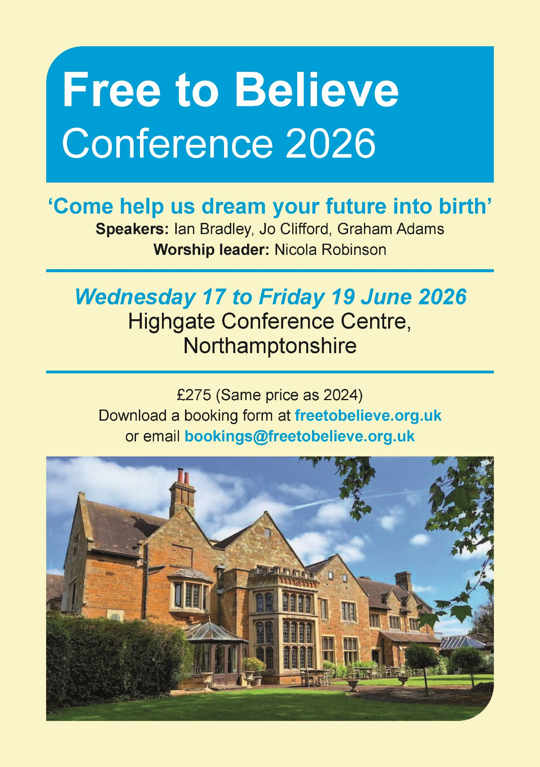
For more information, please visit the Free to Believe website at https://freetobelieve.org.uk/conferences.html
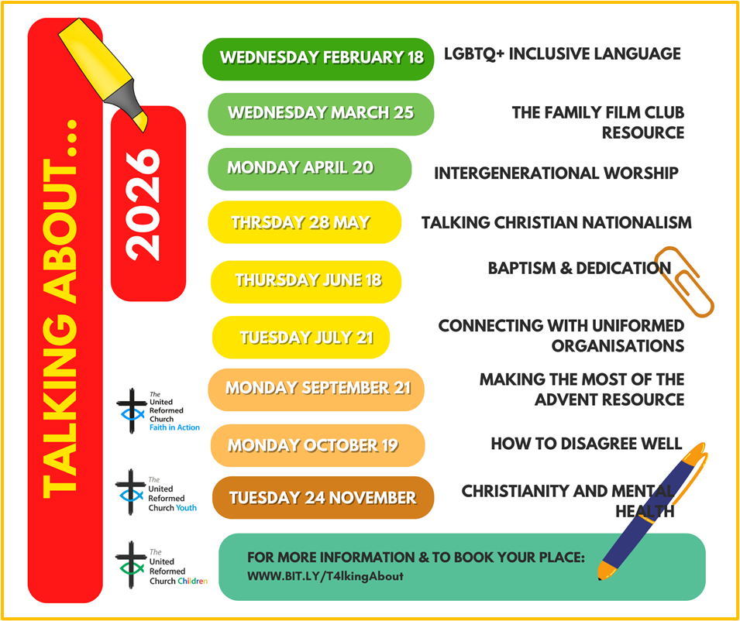

FIRE SAFETY
Jane Bunyan, our Synod Property Officer property@urcyorkshire.org.uk has asked that I remind churches that fire regulations for small non-domestic premises have changed in light of the Grenfell Tower Enquiry outcomes. The advice Synod is giving is that all churches should make themselves aware of the new regulations and advice updated in 2024 at Making your small non-domestic premises safe from fire - GOV.UK or https://www.gov.uk/government/publications/making-your-small-non-domestic-premises-safe-from-fire but if you would like a pdf copy then please email Jane at the above e-mail address.

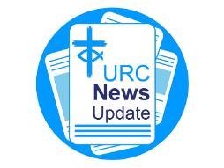
NEWS FROM THE DENOMINATION
The URC’s News Update is a regular e-newsletter that keeps you informed about the latest news and events.
To receive this popular newsletter, please visit the https://urc.org.uk/news-updates-sign-up-form/ page on the URC website and follow the links. If you just want to dip in and catch up on what is going one, that’s fine and you can
read and print recent editions of our e-newsletter by visiting the URC News Update page at https://urc.org.uk/urc-news-update/ .

Submit your photographs for the 2027 URC Calendar

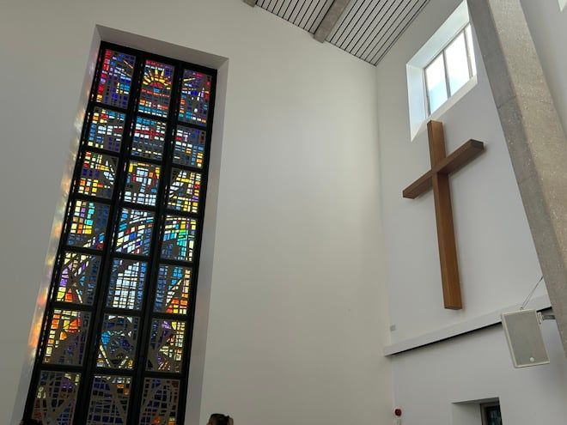
The 2027 United Reformed Church Calendar is titled ‘Transparent as glass’ and will feature stained glass windows and glass sculptures from our churches and Local Ecumenical Partnerships.

Glass has been used in churches since the 7th century for visual storytelling and religious education, acting as colourful “picture books” for congregations to learn Bible stories and for Christian teaching. Stained glass also creates a sacred atmosphere by focussing light for worship and enhancing our churches’ architectural beauty.

We invite you to send in your photos of large and small windows, as well as any sculptures made from, or including, glass. Please include the name of the church and the photographer. You can email your image(s) to the URC Press Office, pressoffice@urc.org.uk.

Please note that for all photos submitted, the photographer is granting the URC permission to use the photographs in print and digitally. The deadline for submitting your photos is June 5 2026.

The calendar will be available on the URC Bookshop from August and is once again generously supported by Edwards Insurance.

The Safeguarding team are available seven days a week and 365 days a year as the inbox is monitored at weekends. This inbox is not monitored continually but concerns will be responded to within 24 hours. If you need immediate support, please contact the Police or your Local Authority Duty Safeguarding Team. All contact details for these services MUST be displayed in your churches.
Further details can be found on the Yorkshire website at https://urcyorkshire.org.uk/safeguarding/ or email your query to safeguarding.1and4@urc.org.uk.
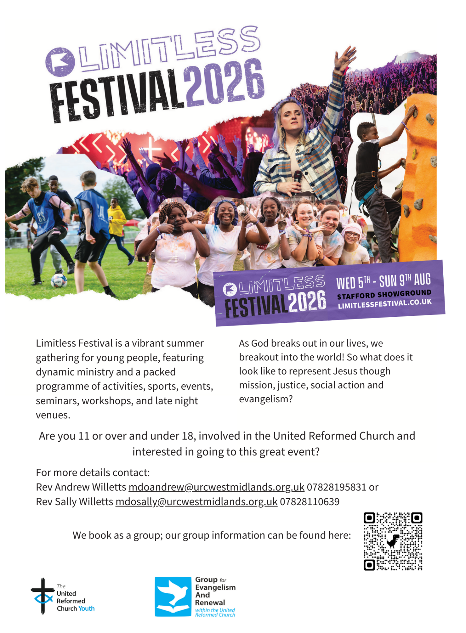

LISTED BUILDINGS NEWS
We have a message from the Synod’s Property Officer, Jane Bunyan, which is of interest to all of you who worship in and care for the Synod’s Listed Buildings.

Dear Friends
Firstly, thank you for everything that you do to maintain the buildings you care for and I need to remind everyone that ALL buildings within the curtilage of your grounds are listed, not just the bits that appear on the listing with Historic England! This includes church halls and any outbuildings etc. If you are not sure please check with me in the office, especially as the Synod Property committee should always be advised of works to Listed buildings.
Secondly, if you have done any works on your buildings (including architects fees etc) in 2025, you can claim the VAT back on these up to a value of £25,000. This needs claimed before 31st March 2026, and I suggest doing so sooner rather than later, in case the pot runs out. The link to start that claim is this one https://listed-places-of-worship-grant.dcms.gov.uk/. Several United Reformed Churches in our synod would have been eligible for more in 2025 if the cap had not been in place, as would major historic buildings such as York Minister, or St Michael–le–Belfry in York, Ripon Cathedral and Leeds Minster.
Thirdly and most importantly, this scheme is NOT being renewed in 2026. It is being replaced with a new grant funding system and some detail on it can be found here https://questions-statements.parliament.uk/written-statements/detail/2026-01-22/hlws1266.
It is called the PLACES OF WORSHIP RENEWAL FUND and is the result of successful lobbying by many heritage organisations who feared the loss of relief on the work done to historic buildings and it does indicate that the government acknowledges the importance of these listed buildings.

Please do get in touch if I can offer any more help or support.
With best wishes
Jane Bunyan
Synod Property Officer

AND FINALLY
I’m happy to say that we do have an “And Finally” story this time, and it comes from Shiregreen in Sheffield. Back in January 2025 they applied for and were successful in obtaining a Synod Mission Capacity Fund grant for a “Plant Enabler”. This role did perplex the panel to begin with, but once the role was explained and broadened to take in some of the other Sheffield Team churches, it all made sense.
I’ll leave the first year’s story in the words of Martin Lambourne of Shiregreen URC:
Andrew Winfrow was appointed to this post thanks to the grant from the Yorkshire Synod Mission and Capacity Fund. He quickly made an impact on the work at Shiregreen as well as offering help with maintenance projects at Dore and Totley and Gleadless churches.
Andy soon made great improvements to the general state of cleanliness of the church premises and the repairs to the fabric of the building. He also addressed the state of the grounds, making sure that the grass, hedges and large planters were brought into good order.
Andrew also made some innovative features to the work with children and parents who attended both the Toddler group and the social café. He encouraged children in particular to help him with potting plants and other gardening chores in the safe area at the rear of the church. This was extended to the children who came to the after-school club and the Summer Holiday Club days. This could be said to have given another facet to the word “plant” as it is the plural noun in Welsh for “children”!
Andy also has a passion for environmental issues and soon had us putting our coffee grounds and potato peelings in the newly created compost area. He has now created a new plot for the growing of flowers and vegetables in the Spring as well as bringing a greenhouse to be installed.
Another innovation has been his creation of a Wild Wednesday group aimed at dads and their children
(mums are included) which took place on Wednesday evenings during the lighter months and included local walks as well as ventures out into the Peaks.
Andy works well with our Children and Families Worker (Tracey) and helps with both the Toddler Group and the After-school club. He has also been an invaluable minibus driver for our Seniors Lunch Club. All in all, he has been a huge asset, and we look forward to further developments in the coming year.
On the wider front, Andy has helped the churches at Dore and Totley and at Gleadless with some of their internal and external tasks. However, the other churches have been slow to take up the offers of help, and we hope others will become involved in the near future.
We are grateful for the Synod’s funding of this work and hope it may become a trailblazer for other churches in Yorkshire and beyond.
Martin Lambourne (Secretary, Shiregreen URC).

If you have a good news story from your part of the Synod or something that you feel reflects the work of Synod and which inspires others as we move into 2026, drop me a line at clerk@urcyorkshire.org.uk and I’ll make sure it hits the back page!!

You can also keep an eye on all our social media platforms for news; on the website at Home - URC Yorkshire Synod, at United Reformed Church in Yorkshire - Home | Facebook and Wilderness URC Yorkshire - Home | Facebook, the YouTube page at URC Yorkshire - YouTube and the Twitter (X) page at URC in Yorkshire (@URCYorkshire) / Twitter.

