
Synod Mission Fund
Grant Application Form

The Synod has three streams of grant support that can be accessed:

Mission Projects - for any projects/posts/equipment that help your congregation carry out any aspect of mission in your local community.

Mission Capacity - for any measure (including back-room, support, organisational changes and administration tasks) that will help your congregation position itself better and/or release energy to engage in mission.

Vision and Opportunity Property Grants - to fund any alteration to church buildings that help congregations engage more effectively in mission

All the criteria below must be fulfilled, to be eligible for a grant:
Please tick where applicable
The church has a Living Document
The project fits into the 5 threads of mission
The church meeting have approved the application
The church has office holders
The church is up to date with mission and ministry payments at the requested rate
The church is up to date with loan repayments (if applicable)
The church is up to date with Safeguarding training and returns
The church is funding part of the project
If request is over £2,500, the church has applied to other sources of funding
If an LEP, the other denominations have been approached for funding
The church does not have adequate funds to finance the project
The church accounts for the last 3 years have been submitted

Preferred criteria:
Please tick where applicable
A Synod grant (any of the above) has not been awarded in the last 3 years
The church is not in the spending cycle of an existing grant
The church has engaged in LYCIG training or similar initiatives/courses
The church has engaged in stewardship programs
The church is taking steps to become an ECO congregation
The church is undertaking recommendations of Quinquennial Inspections

Section A - The Applicant

1. Name

2. Address

3. Contact Name and Correspondence Address

4. Position in church (if applicable)
__________________________________________________
5. Contact phone number

6. Contact email address
__________________________________________________

7. Please indicate whether you are a Church or LEP/Pastorate/other group? Please state the names of the churches/organisations

8. Is your application for a project/initiative in partnership with any other church or group outside the URC or Yorkshire Synod? Please describe your partnership, naming the partner organisations

9. Describe the history of your partnership

10. Membership and attendance of your church/organisation. Please give details of the number of
Members
Adherents
Average adult attendance
Children

11. Please provide the names of the office holders

Section B - Your Vision for Mission
URC General Assembly encourages all congregations of the URC to produce a Living Document to describe their life and mission.
Please enclose this document with your application together with any other documents that will help us understand the aims of your project.
If your Living Document does not answer questions 1 to 8, please answer them below as much as you are able.
If your Living Document answers any of the following questions, please leave them blank
1. Please indicate which of the Synod’s Five Threads of Mission (see diagram on page 13) is your project/initiative working towards - Indicate more than one if applicable)
- Building
- Loving
- Inviting
- Partnering
- Sharing
2. Please describe your project/initiative briefly and how it addresses the Threads of Mission you have indicated
3. Briefly describe your current mission activity and plans and how your project/Initiative will support these. Please show evidence you have researched the needs of the community
4. Describe the area where your project/initiative will take place?

5. Who are the people who will benefit from your project/initiative and how will they benefit? How many people will benefit?
6. What measures has the church taken to becoming an ECO congregation?
7. Has the church engaged in LYCIG training or similar initiatives/courses. Please provide details
8. Has the church engaged in stewardship programs? Please provide details
Section C - Mission Capacity Grants
Nb: Only answer this question if you are applying for funding to support any measure (including back-room, support, organisational changes and administration tasks) that will help your congregation position itself better and/or release energy to engage in mission

(eg do not answer if you are applying for work on a property, a project/post that is directly addressing a mission need or any initiative costing less than £2,500)

1. How will your scheme/project release capacity in your congregations to engage in mission and support your mission aims?

2. Please quantify how much capacity will be released

3. Provide any other evidence of the how the capacity will be released
Section D – Property
Nb: Only answer this section if you are applying for a Vision and Opportunity Property Grant
1. Describe your project or proposed works

2. When were your last two quinquennial inspections?
3. What action was taken following these inspections?
4. Did these inspections identify any major causes for concern, over the short, medium and longer term? Please state the time scales that apply

5. Are there outstanding high cost issues which need addressing? Please outline your plans for dealing with them or explain why they are not being addressed

6. Is the property listed or in a conservation area?

7. Please provide the dates the following were prepared/reviewed by your church:
Asbestos Management Plan
Fire risk Assessment
Health and safety
Gas Safety Inspection
Electrical Safety Inspection

Please note, if the total cost of the project is in excess of £20,000 it will require the approval of both the Property Committee and the Financial Resources Committee. This application will automatically be sent to those committees for approval.
If the application is in or on any part of a listed building, then it needs a Listed Building Advisory Committee application. Please ask our Synod Property Officer, Jane Bunyan (property@urcyorkshire.org.uk) for more information.
Section E - Costs
1. What is the total cost of the project? Please attach a detailed budget breaking down by years as appropriate. If property related, please attach 3 quotes
£

2. How much will the church contribute and how will these funds be secured?
£
3. What funds have been secured from other sources? Please provide details
£

4. If you are an LEP, have funds been requested from the other denominations?
5. What funds have been requested from other sources? Please give details of the status of these requests
£

6. How much is being requested from the Synod?
£

Section E – Costs (continued)
7. What amount of unrestricted funds do you have?

£

8. Please state the amount required to run your operations for a six month period

£

9. If you have unrestricted funds above 6 months of operating costs, please state why these are not being used
10. Outline your plans to secure funding in the event of any shortfall?
11. How will the project be sustained/continued or ended after this period of funding?

- Please provide details of any grants (mission fund, capacity fund or property) you have received from Synod in the last 3 years
- If you are in the spending cycle of an existing Synod grant (mission fund, capacity fund or property), please give details
Section F - Management
Do not answer this question if you are applying for any initiative costing less than £2,500
1. How will the project be managed? (e.g. Steering group, company trustees etc.)
2. What is the relationship of the management structure to your church and how will any participants be appointed?
3. Please give names, and roles, of any key personnel, their expertise and qualifications and their relationship with your church e.g. elder, member, employee

4. If staff or volunteers are not yet appointed, please describe the jobs they will be doing and how you will recruit and train them, and what safeguarding procedures you will follow (please provide job descriptions and person specifications as appropriate)

5. What personnel/human resources support do you think may be needed from the Synod?
6. If you need other experience and expertise, where do you expect this to come from?

7. What risks do you see in the scheme/project and how will you manage them?

8. How do you intend to evaluate the scheme/project?
Section G - Sign Off
Church Meeting resolution dated …………………………...
Please attach any relevant Church Meeting minutes showing the correctly worded resolution to authorise both your project/initiative and this application
We submit our application to the Synod for support and agree to abide by the terms of any grant

Signed by: ..................................................................
Church Secretary

Date: .....................................

Section H – Checklist for Applicant
In order, to prevent a delay in processing your application, please ensure the form is completed in full and the following are included within your application. Please provide attachments where necessary
Please tick to indicate the information is included in the application
Living Document
Minutes of the Church meeting, with the resolution
Financial Statement for the past 3 years
Proof of secured funding
Detailed budget of the total costs of the project
Job Descriptions (if applicable)
If Property application, provide 3 quotes for the work
Provide details of stewardship programs attended (if applicable)
Provide details of LYCIG training or similar initiatives / courses attended (if applicable)
Details of plans for further grant applications

Section I – Notes
Criteria
Grant applications must be for initiatives that further the Yorkshire Synod’s Five Threads of Mission (Building, Loving, Inviting, Partnering, Sharing - see above).
Although the Application Form makes reference to ‘the church’, applications are welcome from groups of churches or pastorates.
As Synod are trying to use money to support the mission of the church. It may not always be possible to make a grant.
Please abide by any requests from the Synod Mission Support Fund Panel for reporting and any other feedback on how you have used any grant. For multi year applications, it is a requirement of the grant that a report is submitted 12 months after the grant payment has been made, showing how the money was spent and what difference it has made to your mission.

If there is unspent grant funding, it must be returned to the Synod.

Completing your Application Form
Please read the application form and these notes carefully and answer all questions as directed.
Nb: the boxes on the form will expand so please use as much space as required (if writing by hand or typing please append additional sheets indicating, clearly, which questions are being answered)
Sending your Application
Please email the completed form and accompanying papers to
Tim Crossley (clerk@urcyorkshire.org.uk)
with a copy to Hayley Brook (accounts@urcyorkshire.org.uk)

Alternatively, if posting send all forms and documentation to the Clerk at:

The United Reformed Church Yorkshire Synod,

Somerset House,

St Paul’s Street,

Morley,

Leeds

LS27 9EP.

Applications must include all the requested supporting documentation

Decisions about your application
Applicants will be notified of the outcome of their application as soon as is practicable after the relevant meetings, normally in writing on Synod headed paper by the Synod Clerk or the Property Officer.
Section I – Notes (continued)
What if Synod requires more information?
Please try and give as much information as possible.
The relevant Synod panel may not be able to make a decision at their meeting and they may contact you for further detail or clarification.
Other Synod officials such as our Finance Manager, Trust Secretary, Property Officer or Synod Treasurer may need to contact the applicant.
Feedback
We welcome comments on the use of this form so that we may learn and improve our practice in the future - many thanks!

URC Yorkshire Synod’s Five Threads of Mission
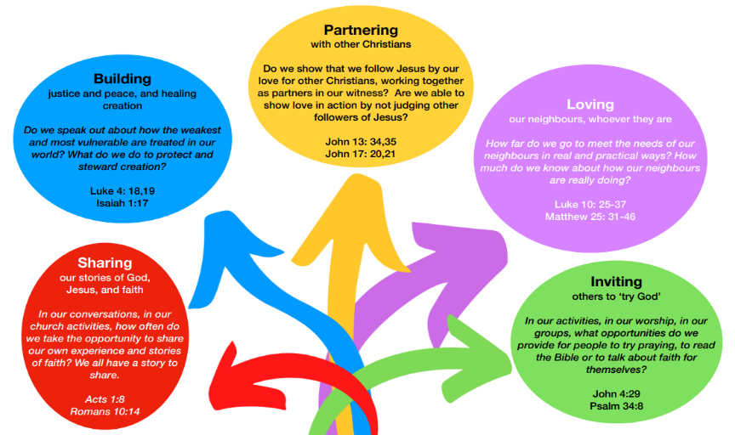

Section J – Office Use Only
1. Checklist
 | Please indicate Yes or No for each of the points below | Yes/No
 | Financial Statements for the last 3 years
 | Loan repayments (if applicable) are up to date
 | M&M payments are up to date (at the requested amount)
 | Living Document provided
 | Minutes of the Church meeting approving the application
 | Does the church have office holders?
 | Proof of secured funding
 | Have applications been made to other sources of funding?
 | If LEP, has finance been secured/sourced from the other denominations?
 | Does the church have adequate unrestricted funds to finance the project?
 | Fully up to date with safeguarding training and returns
 | Recommendations of quinquennials are being implemented
 | Report received from Synod Finance Manager
 | Is the life of the congregation sustainable?
 | Does the project fit into the 5 threads of mission?
 | Visit made to the applicant?
 | Has a Synod grant been awarded in the last 3 years?
 | Is the church in the spending cycle of an existing grant?
 | The church is funding part of the project
 | The church has engaged in LYCIG training or similar initiatives/courses
 | The church has engaged in stewardship programs
 | The church is taking steps to become an ECO congregation

Section J – Office Use Only (continued)
2. Decisions
Funding Stream Applicable (please circle):
Mission
Mission Capacity
Property

Grant Approved / Declined (Please circle)
Amount agreed £
Date offered: ………………………
Approved by (state committee name): ……………………………….

If project is property related and in excess of £20,000, approval of the work must be sought from the Property Committee and the Financial Resources Committee

Property Committee (date approved): ………………………….
Financial Resources Committee (date approved): ……………………………….

Church/organisation informed of decision by (name): ……………………………….
on (date): …………………………

