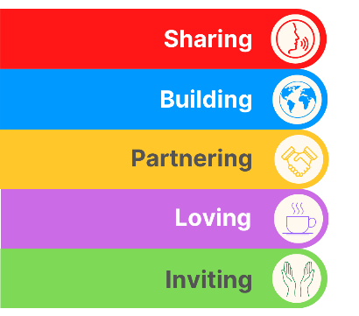
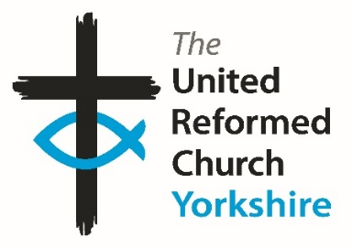
Yorkshire Synod Briefing
Number 171

2nd April 2026

Easter Greetings from URC Yorkshire Synod
From the Moderator

Dear friends,
I send you my greetings as we immerse ourselves in the many and various services and activities of this Holy Week and Easter. As we journey together through this season - against a background of war - we are reminded that the risen Christ comes among us with words both simple and profound: “Peace be with you.”
In a world often marked by uncertainty and division, the message of Easter speaks afresh into our lives. It is not a distant or fragile peace, but a living, active gift—rooted in hope, shaped by love, and sustained by the presence of the risen Lord. This peace meets us where we are: in our communities, our churches, and our daily lives.

As the Yorkshire Synod, we are called not only to receive this peace, but to share it—to be peacemakers in our neighbourhoods, to offer reconciliation where there is brokenness, to be an expression of the unity Christ wills for his church, and to embody Christ’s compassion in all we do.
From all of us at the Synod office to all of you reading this Briefing may you have a fulfilling and uplifting Easter.
With every blessing this Easter,

Jamie

Revd Jamie Kissack
Yorkshire Synod Moderator

From the Clerk
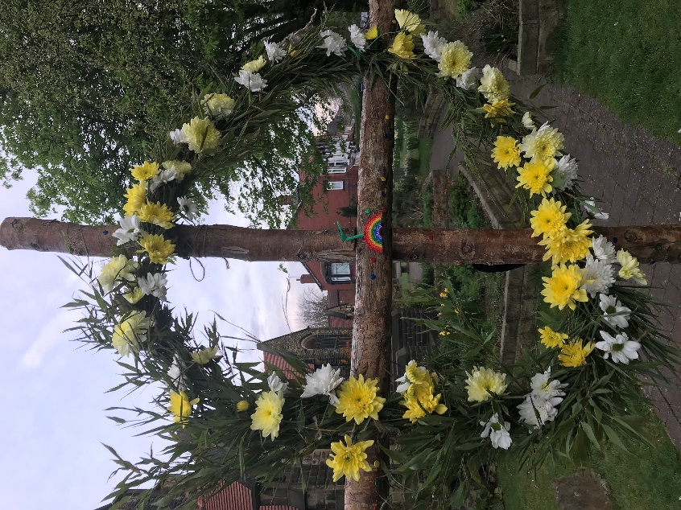
The lead up to Easter is a period where a greeting such as happy or merry may not be particularly appropriate. With this Briefing being uploaded to the website on Maundy Thursday it comes between two of the high points in our Christian calendar, but the week in which we are in, Holy Week, pulls at our emotions in every which way. We have readily joined in the Hosannas of Palm Sunday and we will enthusiastically shout out the Alleluias on Easter Sunday. Yet during the week we watch and listen to Jesus in the Temple overturning tables and stalls; debating with the theologians and academics of the time; explaining the Kingdom to his followers; and initiating the sacrament of Holy Communion which we still celebrate today. We will read those stories and try to understand and learn from them, then we will read the narrative of Jesus’ betrayal, trial, abandonment, death and burial which can never be regarded as happy or merry. So, by Saturday we are in theological maelstrom. There is so much to take in that to try and do it in a week is nigh on impossible.
Image courtesy of St Andrew's Roundhay URC
But we do take it in, and on Easter Sunday it all comes together where we do shout out Alleluia, we can greet each other with a “Christ is Risen, He is risen indeed!” and we can celebrate that the words of Jesus related in John 12:46 do ring true for us all:
“I have come into the world as light, so that no one who has faith in me should remain in darkness.”

Please continue to send invitations to your events, your stories and pictures in to me, and I’ll continue to advertise and share them throughout 2026, either here in The Briefing or on the Synod website at https://urcyorkshire.org.uk/. They may even end up in https://urc.org.uk/our-news-stories/latest-news/ which is always worth a read and has the opportunity to sign up for regular URC’s news updates.

So, if you have any news of welcoming people into Church, stories of celebration and mission, please let me know by dropping me a line at clerk@urcyorkshire.org.uk and I’ll showcase it in the next edition, due out on the website only on 16th April 2026.
Tim
Tim Crossley
Yorkshire Synod Clerk

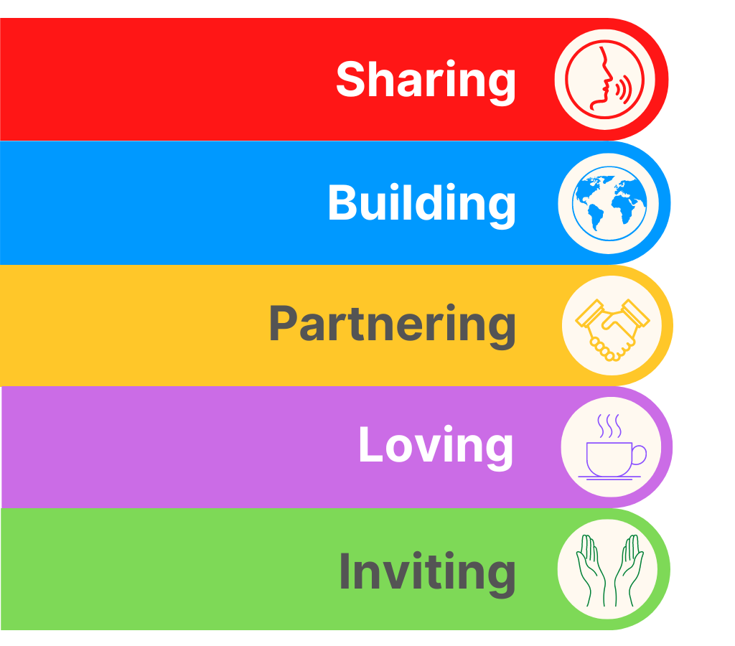
SYNOD FORUMS 2026
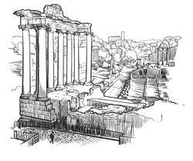
During the Spring of 2026 the Synod Team will be bringing the Synod Forums to three new venues so that those who couldn’t make it to previous venues have the opportunity to travel to somewhere potentially closer to home.
- Saturday 9th May at Pudsey URC
- Saturday 30th May at Portholme Church, Selby
- Saturday 6th June at St Andrew’s URC, Sheffield
Each forum will commence at 10am and each are brilliant opportunities for fellowship and good conversation; the place to have your voice heard, and to help shape the priorities of the Synod.
All are welcome and the Synod team looks forward to seeing you there.

TALKING ABOUT…

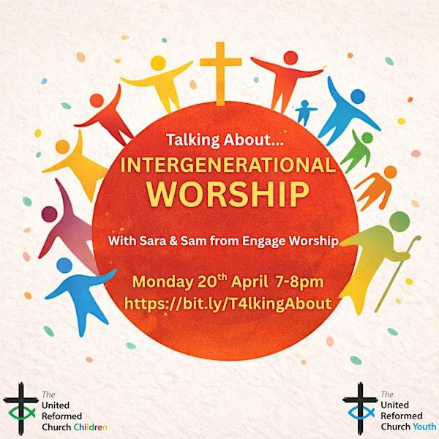
Are you looking for something different to engage families in your church?
On Monday 20th April at 7pm come and hear how Sara & Sam will explore what intergenerational worship can look like in your context. Based on their Whole Church Worship resource, they will share principles and usable ideas for bringing all kinds of people together before God. Ideas will include prayers, songs, Bible readings and more.
To book your place
visit:
www.bit.ly/T4lkingAbout

Big Questions from URC Youth that Challenge Us All
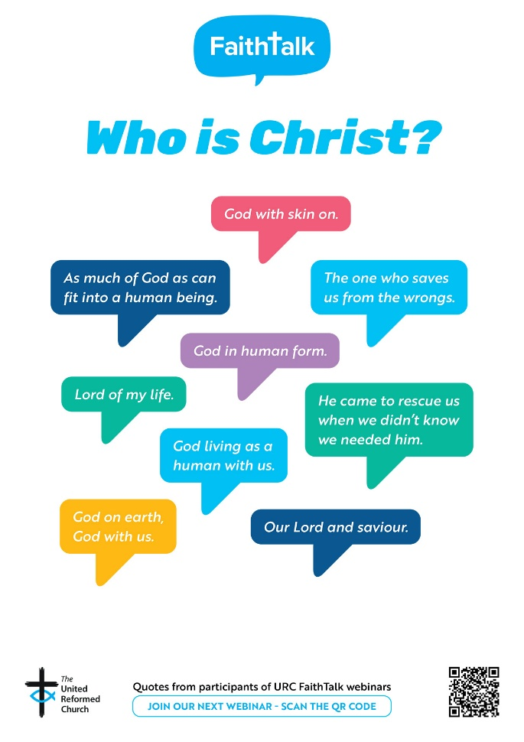
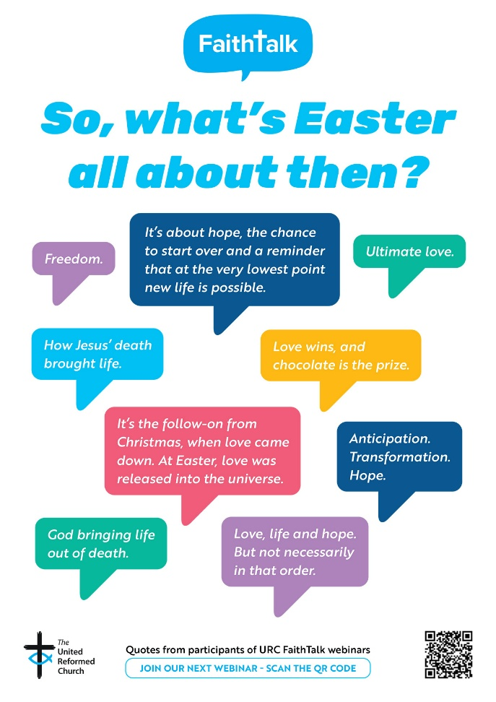

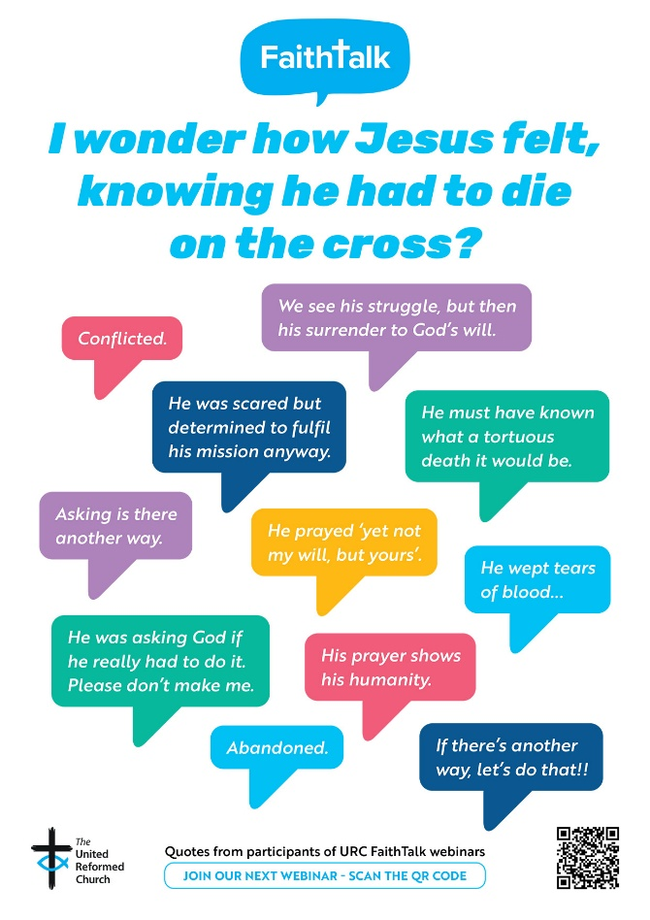
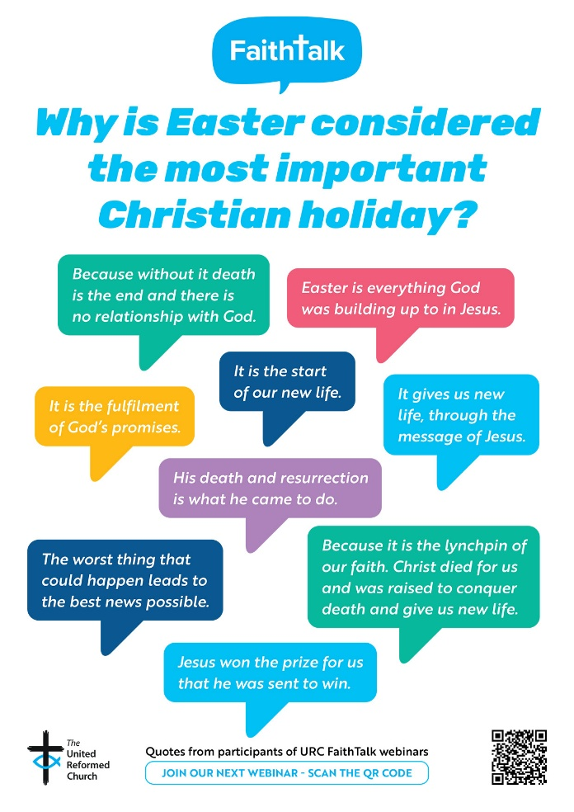
Our next webinar will take place on Tuesday 21 April at 7pm: “Big Questions from URC Youth that Challenge Us All”. Delegates at the recent URC Youth Assembly were asked what their Big Questions are, and we will be tackling a selection during our time together.
To receive a link please register here: https://www.eventbrite.co.uk/e/faith-talk-webinar-tickets-1982502880483?aff=odcleoeventsincollection#organizer-card
An Invitation to Pray

One of the Street Pastors in Doncaster sent this to one of our Ecumenical Officers, Rod Morrison, and Rod has asked that it be shared.

During the Second World War, a group of people stopped whatever they were doing at a specific time every night to pray for peace and safety for everyone. They did this every day, and it was as if the whole city paused — such was the power of prayer. The result was so overwhelming that the bombing stopped shortly afterward!
Now once again some people are organizing. A group of people around the world has agreed to spend one minute praying for the safety of our countries, for the end of the problems that oppress us, and for God to guide the decisions of our leaders.

This body of people will gather at the following times:

India – 9:00pm.
Germany – 4:00pm.
Austria – 4:00pm.
Spain – 4:00pm.
Portugal – 3:00pm.
Canary Isles – 3:00pm.
Costa Rica – 8:00pm.
Colombia – 7:00pm.
Nicaragua – 8:00pm.
Ecuador – 7:00pm.
Guatemala – 8:00pm.
Mexico – 8:00pm.
Panama – 7:00pm.
Honduras – 6:00pm.
El Salvador – 8:00pm.
Venezuela – 6:00pm.
Uruguay – 5:00pm.
Paraguay – 5:00pm.
Brazil – 6:00pm.
Argentina – 5:00pm.
Peru – 6:00pm.
Chile – 5:00pm.
Italy – 4:00pm.
Australia – 2:00pm.
USA – 1:00pm.
Canada – 12 noon
Singapore – 9:00pm.
Thailand – 9:00pm.
Korea – 9:00pm.
Hong Kong / Taiwan – 10:00pm.
Philippines – 11:00pm.
UAE- 7.00pm.
Sierra Leone- 3.00pm.
Switzerland – 4:00pm.
UK - 3.00pm.

Every day we will pause for one minute at the designated time to pray for world peace, for the end of conflict, and for the restoration of calm and security for all people on earth. We will also pray that families may seek their security, protection, and salvation in God. If we truly understood the immense power of prayer, we would be amazed.
🙏🙏🙏🙏
If you can, please forward this request to your contacts so that together we can work a miracle through our prayers.

Set an alarm on your phone every day at the time designated for your country and pray for one minute for peace. 🙏🙏🙏🙏
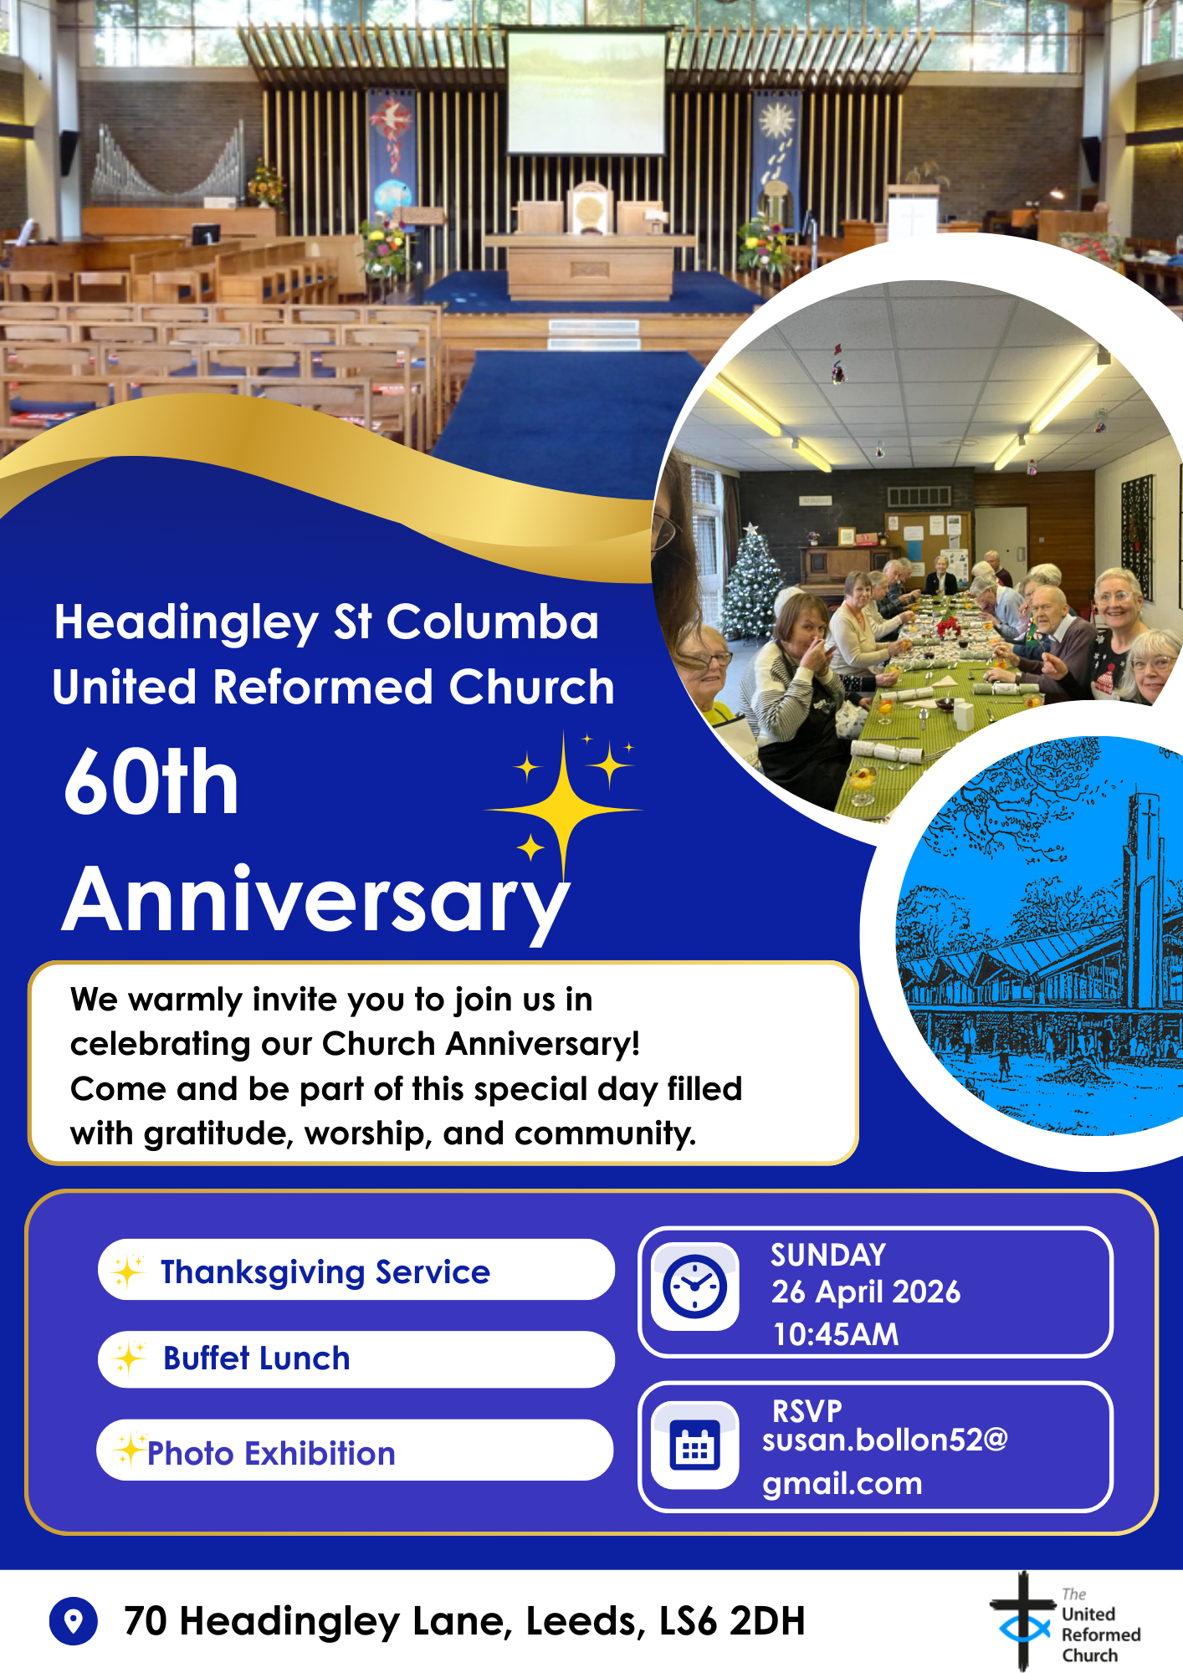
More details to follow in subsequent issues of the Briefing – and keep your eyes on the Synod website as that information will soon be there as well as there will be the opportunity to apply for grants to help subsidise transport to THE BIG DAY OUT.
New Head of Children, Youth and Intergenerational Discipleship
The URC’s Faith in Action Team is pleased to announce the appointment of Dr Jo Griffiths as the new Head of Children, Youth and Intergenerational Discipleship (CYID).
Jo, who will begin her new role on 1 July, joins the United Reformed Church from Ridley Hall, Cambridge, where she served as Director of Studies and Children's and Family Ministry Tutor. She brings more than 30 years’ experience in youth work to her new role.
The Revd Jenny Mills, Deputy General Secretary (Faith in Action), said: “We are delighted to welcome Jo into the team. She brings a wealth of experience to the role, working with children and young people and those that work with them.”
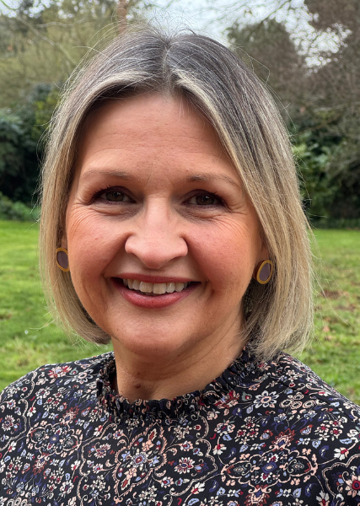
Jo holds a PHD is from Brunel University, where her research explored the professional identity formation of newly graduated Christian youth workers. Her MA, also from Brunel University, was in Youth and Community Studies. Jo has a BA (Hons) in Youth and Community Work with Applied Theology from Oxford Brookes University. She is also JNC-qualified (Joint Negotiating Committee for Youth and Community Workers).
Before joining Ridley, Jo worked in churches as a children and youth worker, with a particular passion for developing intergenerational worship and community-focused initiatives. She also worked within local authority youth services, managing teams and creating programmes that supported young people facing adversity. Across all her roles, her heart has remained the same: helping people flourish and building communities where children, young people and adults genuinely belong.
Jo first joined Ridley Hall in 2005 as Assistant Centre Director at what was then the Centre for Youth Ministry (CYM), becoming Centre Director in 2010. She later served as Director of a children, youth and families project based at St Andrew’s Church, Enfield, before returning to Ridley in 2020.
Jo said: “I am absolutely thrilled to be stepping into this new role, and I am really looking forward to meeting everyone.”
In her free time, enjoys spending time holidays in Somerset and walking across Exmoor. Jo has three grown-up children and lives in North London with her husband Steve, a vicar, and their dog, Jess.
During the vacancy period, the CYID and the CYDO+ teams will work together to oversee the ongoing work.

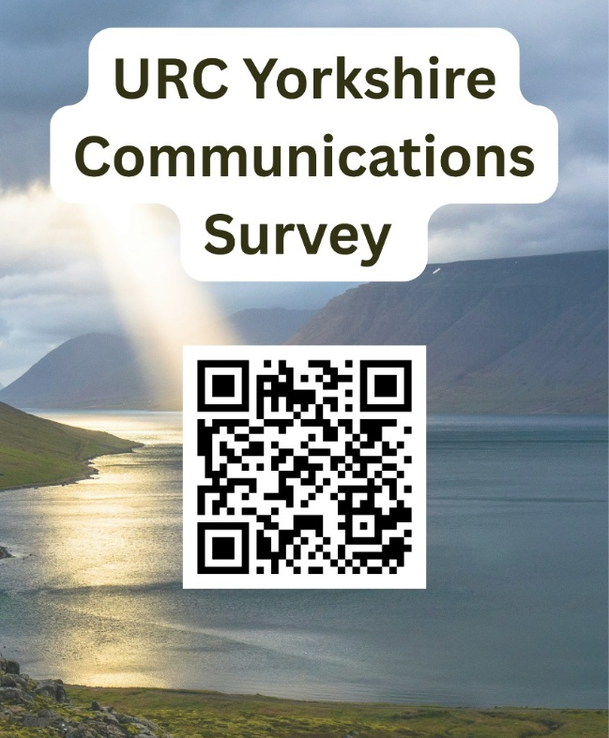
Communications Survey
Communication is always a two-way process and to find out more as to how you would like to hear from Synod, and perhaps how you would like to be able to contact Synod, Daniel Raddings has set up a QR code through which you can access a simple questionnaire. All that is being asked is what do you want to hear from us and what format of media would you prefer?
As a synod we want to share information that benefits your mission. So we’ve devised this simple survey/questionnaire to help us help you.

If you struggle to access the questions via the QR Code you can click the following link https://forms.gle/c4XFZ3kaqUvRoJa26 or if you find it easier to contact Daniel directly his e-mail is daniel.raddings@outlook.com.

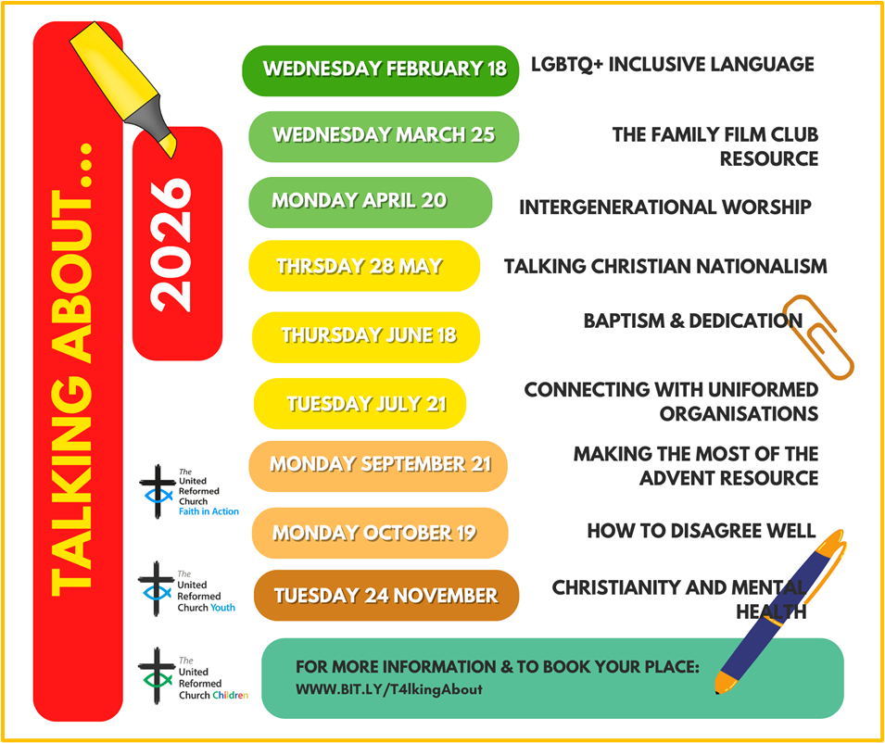
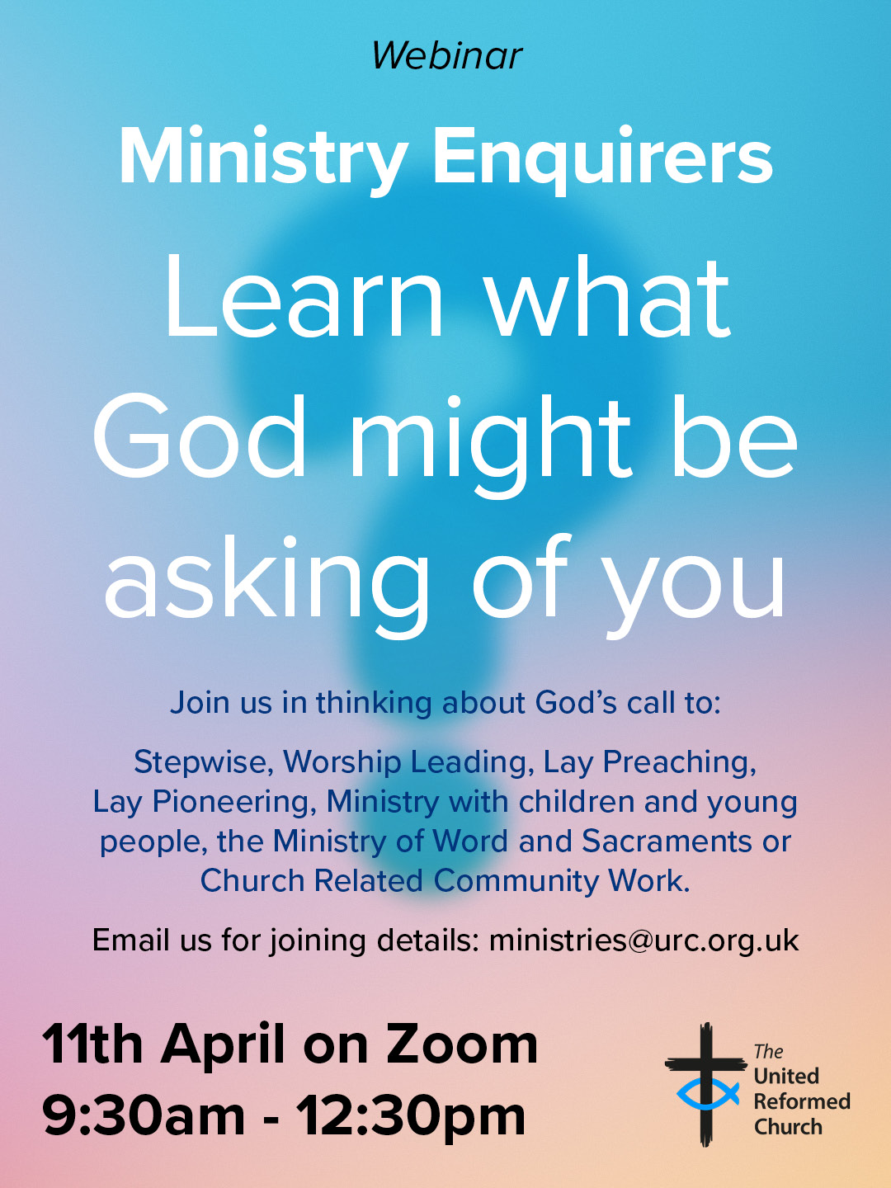



Yorkshire Synod Discipleship Development Small Grant Fund 2026
The Synod is pleased to let you all know that it has received confirmation that it has a pot of £4000 to grant to those wishing to apply to the Yorkshire Synod Discipleship Development 2026.

1. Who is eligible to apply? Committed members or adherents, including children and young people, of a congregation within the United Reformed Church who are exercising, or want to exercise, a form of lay ministry or community service whether expressed within or beyond their local church. The DDF is not open to Ministers of Word and Sacraments and CRCWs, as there are other designated funds available for those groups.

2. How much is available? Up to £300 per applicant per calendar year, although the Synod may agree to more than this according to the local context and circumstances.

3. What can this money be used for? The purposes for which the funding is provided are defined by creativity and vocation, in line with the URC's discipleship development strategy. Be bold, take risks. The funding exists to help you to follow Jesus. You might be helped in this by courses (at any level) at any of the URC Resource Centres for Learning or from other learning providers, or you may have ideas on resourcing discipleship development in other people. You may need funds to cover the costs of travel, materials or books. All you have to do is make a case to your local church meeting and submit the application form to the Synod Convenor of Ministries for consideration and, if appropriate, authorisation.

4. How are applications made? Having gained your church meeting's endorsement, applications are to be made on the designated form, well before the spending is due to start. Backdated applications will not normally be accepted. Application forms are obtainable from the Synod Convenor of Ministries via the Synod Office at office@urcyorkshire.org.uk and should be sent back for authorisation before being passed to the synod finance office.

5. How are grants paid? Grants authorised by the Convenor of Synod Ministries
are paid by a Synod finance officer by reimbursement to you when you have given proof of what you've spent. Contact your Synod Convenor of Ministries for discussion if you need something funded directly on your behalf, rather than waiting for re-imbursement.

If anyone wants to discuss an application before submitting it please contact the Convenor of the Yorkshire Ministries Committee, Kath Lonsdale at kathlonsdale@talktalk.net.
Remember this is for any age of lay person in our churches to apply for so please discuss with your young people as well as adults.

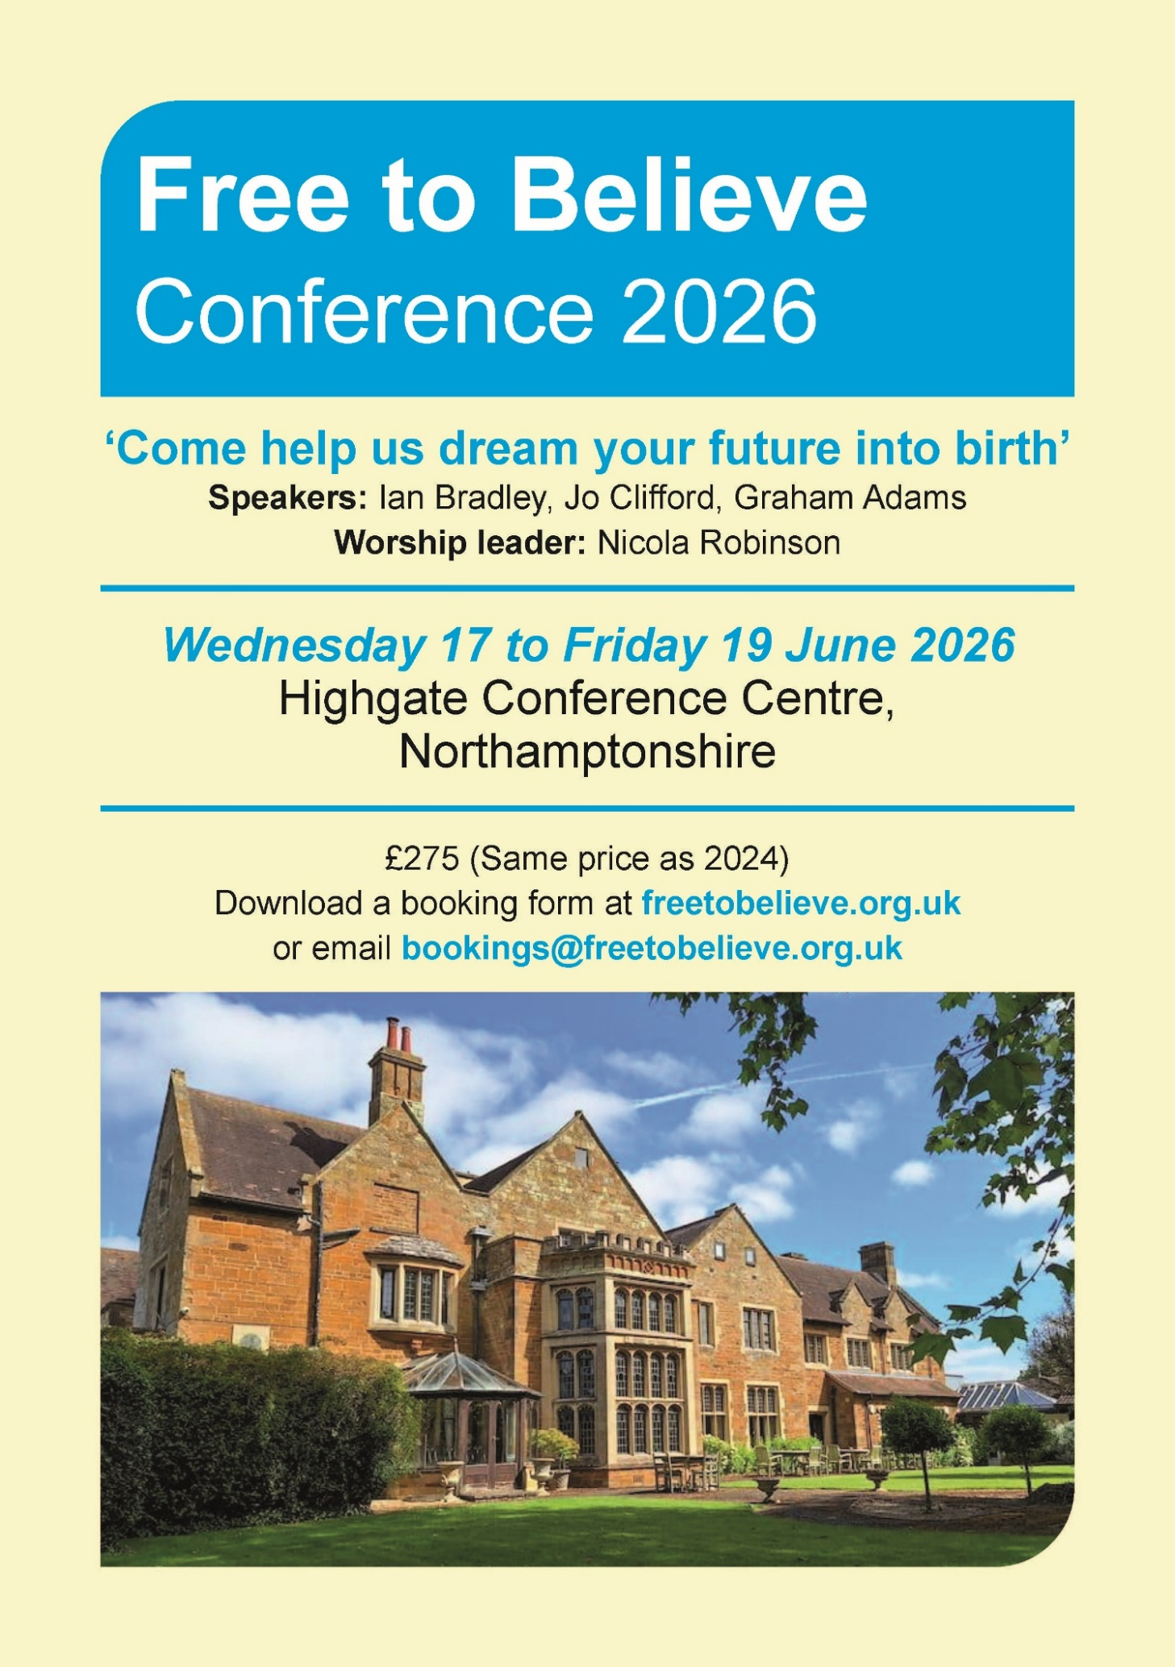
For more information, please visit the Free to Believe website at https://freetobelieve.org.uk/conferences.html
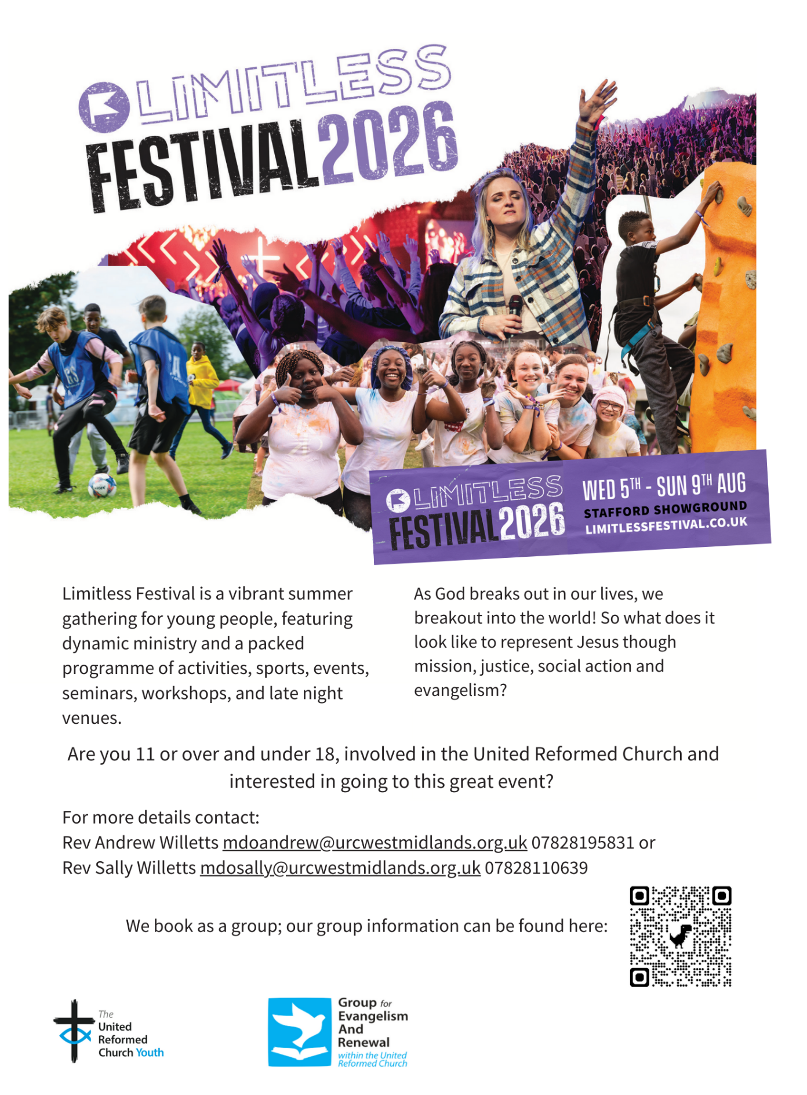

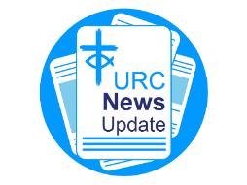
NEWS FROM THE DENOMINATION
The URC’s News Update is a regular e-newsletter that keeps you informed about the latest news and events.
To receive this popular newsletter, please visit the https://urc.org.uk/news-updates-sign-up-form/ page on the URC website and follow the links. If you just want to dip in and catch up on what is going one, that’s fine and you can
read and print recent editions of our e-newsletter by visiting the URC News Update page at https://urc.org.uk/urc-news-update/ .

JPIT IS RECRUITING
Applications for the Joint Public Issues Team’s 2026-27 internship programme are closing soon.

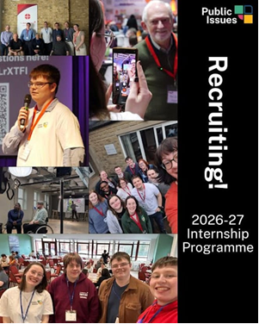
If you are a young Christian (aged 21-30) who is passionate about issues of justice and peace, please apply. If you know a young adult who may be interested, please share.
Each year, there are opportunities to work with the Joint Public Issues Team for a year as an intern. The internships open for applications in the spring, for roles which usually run from September to the following August.
These popular internships provide opportunities to:
• Explore the intersection of faith and politics
• Develop skills in campaigning, communications, research, and policy
• Receive training, mentoring and networking opportunities

Full-time, paid roles from September 2026-August 2027
Deadline: Friday 10 April
Interviews: Wednesday 6 May

For more information visit the JPIT website at: https://jpit.uk/internship?utm_source=JPIT&utm_medium=email&utm_campaign=15422667_JPIT%20Newsletter%20Apr%2026&dm_i=1MV9,96K7F,MT4T0M,12HRSF,1,0,0,0
And to apply follow the link on that page or click here:
https://methodist.current-vacancies.com/Jobs/Advert/4123583?cid=1885&t=Joint-Public-Issues-Team-Internships---------

Submit your photographs for the 2027 URC Calendar

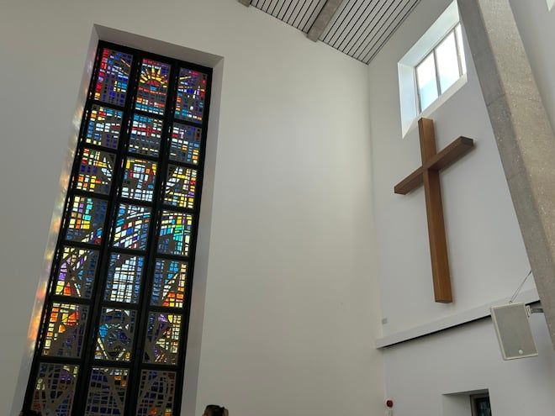
The 2027 United Reformed Church Calendar is titled ‘Transparent as glass’ and will feature stained glass windows and glass sculptures from our churches and Local Ecumenical Partnerships.

Glass has been used in churches since the 7th century for visual storytelling and religious education, acting as colourful “picture books” for congregations to learn Bible stories and for Christian teaching. Stained glass also creates a sacred atmosphere by focussing light for worship and enhancing our churches’ architectural beauty.

We invite you to send in your photos of large and small windows, as well as any sculptures made from, or including, glass. Please include the name of the church and the photographer. You can email your image(s) to the URC Press Office, pressoffice@urc.org.uk.

Please note that for all photos submitted, the photographer is granting the URC permission to use the photographs in print and digitally. The deadline for submitting your photos is June 5 2026.

The calendar will be available on the URC Bookshop from August and is once again generously supported by Edwards Insurance.

Safeguarding News

The Safeguarding team are available seven days a week and 365 days a year as the inbox is monitored at weekends. This inbox is not monitored continually but concerns will be responded to within 24 hours. If you need immediate support, please contact the Police or your Local Authority Duty Safeguarding Team. All contact details for these services MUST be displayed in your churches.
Further details can be found on the Yorkshire website at https://urcyorkshire.org.uk/safeguarding/ or email your query to safeguarding.1and4@urc.org.uk.

For more details please contact either Emma Pearce at emma.pearce@urc.org.uk or our own Carrie Kaunda at carrie.kaunda@urc.org.uk
AND FINALLY
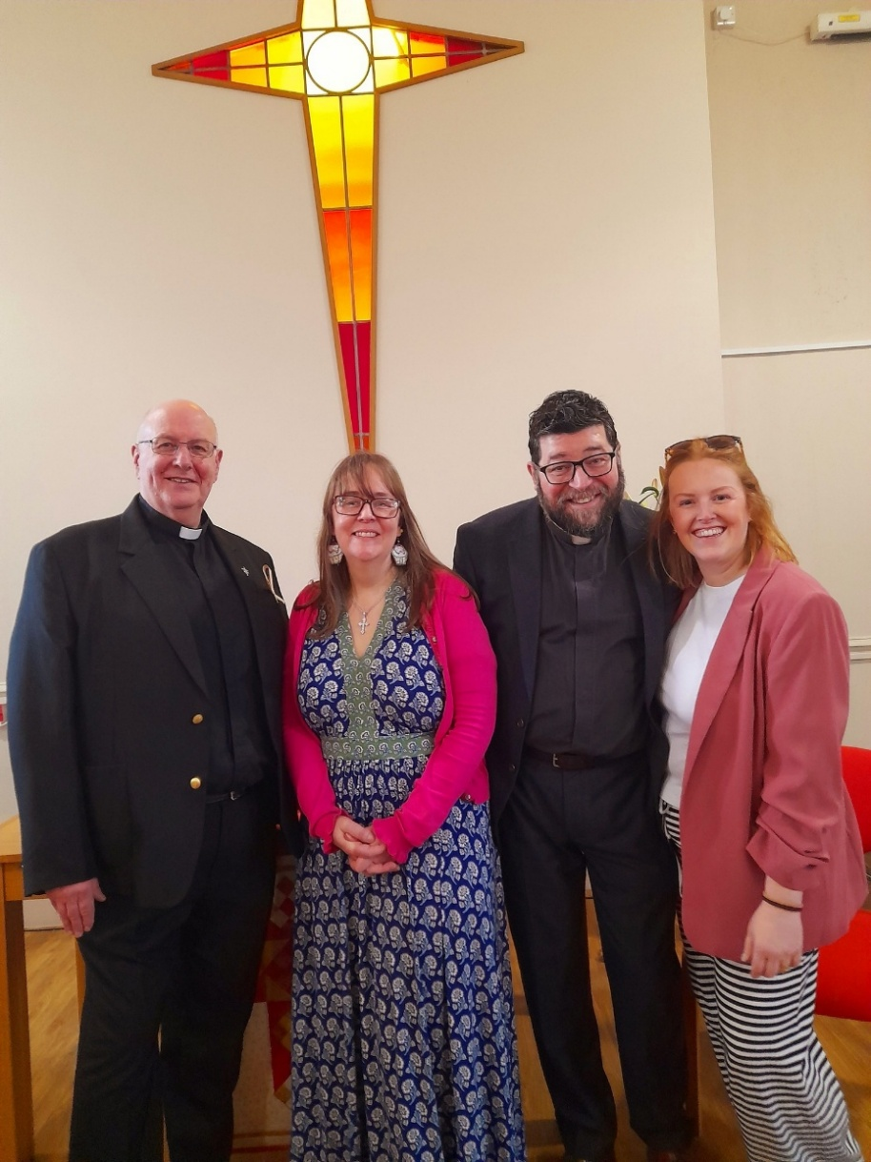
We have another great story from Sheffield – this time from the Yorkshire Synod Wilderness team.

On Palm Sunday the churches in the Sheffield Ministry Team came together at Dore & Totley URC for their joint service
Part of this service was given to formally induct and welcome Mell Camerata into her role as the Children, Youth and Family Enabler. Mell will work alongside Revd Johnny O'Hanlon and Revd Barry Welch in Sheffield and also be part of the Yorkshire Synod WILDERNESS Hub Team
Please pray for Mell as she continues this ministry with and for children and young people in our Sheffield churches and communities

Here are the team, from left to right, Revd Barry Welch, Mell Camerata, Revd Johnny O’Hanlon and Megan Tillbrook.

If you have a good news story from your part of the Synod or something that you feel reflects the work of Synod and which inspires others as we move into 2026, drop me a line at clerk@urcyorkshire.org.uk and I’ll make sure it hits the back page!!

You can also keep an eye on all our social media platforms for news; on the website at Home - URC Yorkshire Synod, at United Reformed Church in Yorkshire - Home | Facebook and Wilderness URC Yorkshire - Home | Facebook, the YouTube page at URC Yorkshire - YouTube and the Twitter (X) page at URC in Yorkshire (@URCYorkshire) / Twitter.

