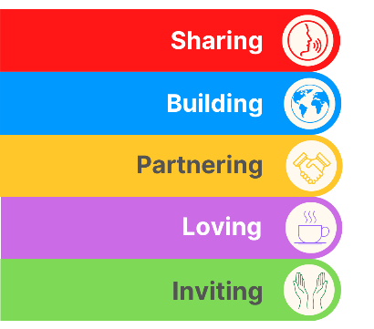
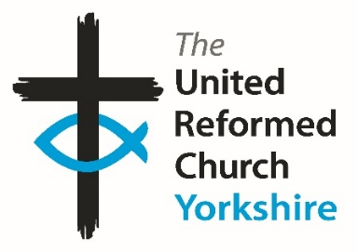
Yorkshire Synod Briefing
Number 172

16th April 2026

I hope that you all had a fulfilling and blessed Easter, and that you are all singing Alleluia as we journey through the next few weeks. It was also good to hear of the stories of how our Churches across the Synod celebrated Easter, with their local community and with other churches in their areas.
For some churches the momentum that they had generated in the weeks leading up to Easter continues apace, as you will see from our friends at St Paul’s URC, Harrogate, Bilton Grange and Saltaire, and you will also see that the invitations to events and courses over the summer are still open.
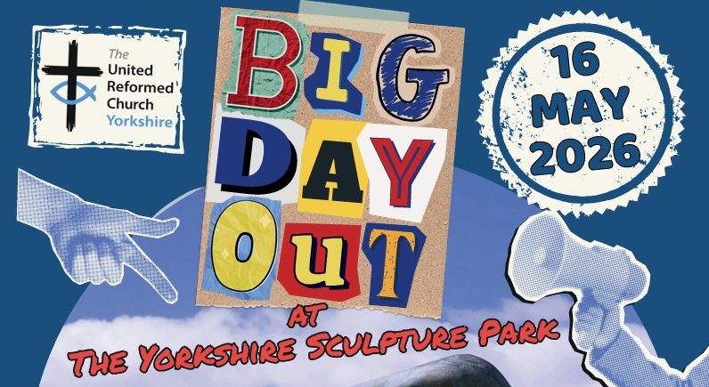
At Synod we are now gearing up to hosting this year’s BIG DAY OUT being held at the Yorkshire Sculpture Park. For more information on how to get tickets, please contact office@urcyorkshire.org.uk and don’t forget that the Synod Mission Fund is offering a helping hand for those organising group transport. More information can be found below, so make a note in your diaries!!
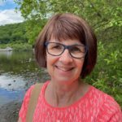
This is also the last issue of the Briefing which will be checked over by Sally Duxbury, our erstwhile Moderator’s PA. Sally is retiring on Thursday 23rd April after over 25 years of service with the Synod. We will really miss her steady hand in the weeks, months and years to come and I know that she will be a hard act to follow. I hope you can join me in wishing Sally a full, fruitful and happy retirement as we wish her well for the future.

Please continue to send invitations to your events, your stories and pictures in to me, and I’ll continue to advertise and share them throughout 2026, either here in The Briefing or on the Synod website at https://urcyorkshire.org.uk/. They may even end up in https://urc.org.uk/our-news-stories/latest-news/ which is always worth a read and has the opportunity to sign up for regular URC’s news updates.

So, if you have any news of welcoming people into Church, stories of celebration and mission, please let me know by dropping me a line at clerk@urcyorkshire.org.uk and I’ll showcase it in the next edition, due out on the website only on 30th April 2026.
Tim
Tim Crossley
Yorkshire Synod Clerk
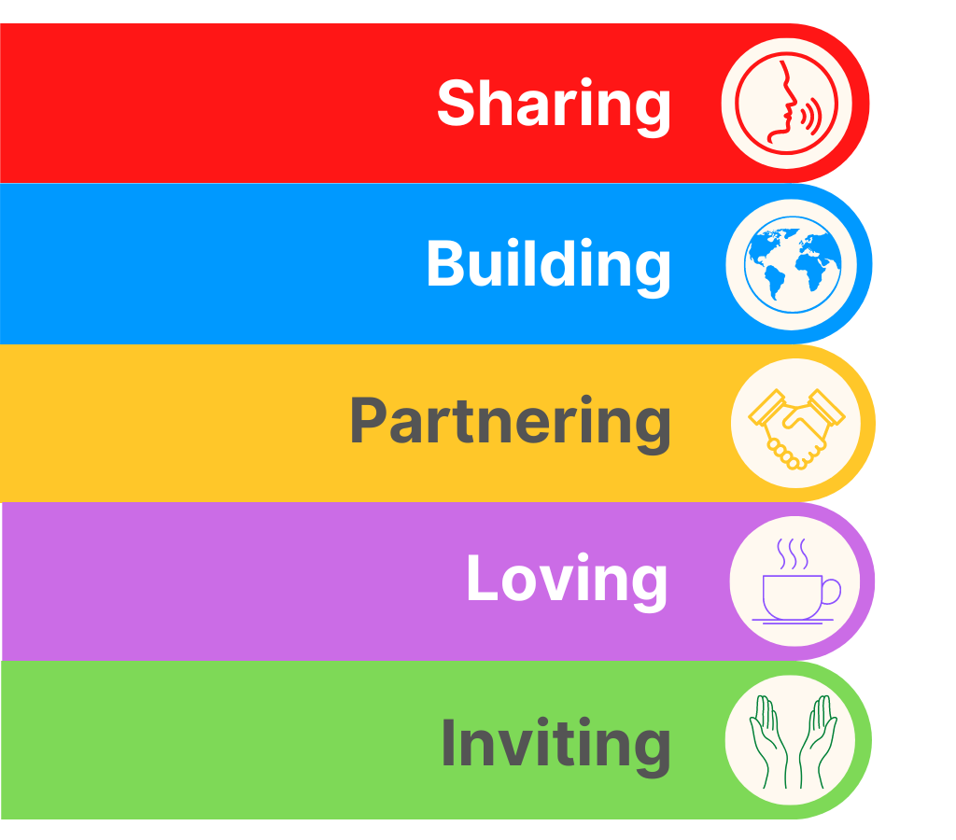
SYNOD FORUMS 2026
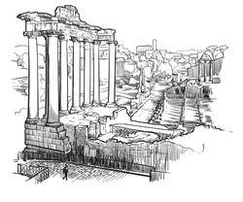
During the Spring of 2026 the Synod Team will be bringing the Synod Forums to three new venues so that those who couldn’t make it to previous venues have the opportunity to travel to somewhere potentially closer to home.
- Saturday 9th May at Pudsey URC
- Saturday 30th May at Portholme Church, Selby
- Saturday 6th June at St Andrew’s URC, Sheffield
Each forum will commence at 10am and each are brilliant opportunities for fellowship and good conversation; the place to have your voice heard, and to help shape the priorities of the Synod.
All are welcome and the Synod team looks forward to seeing you there.

TALKING ABOUT…

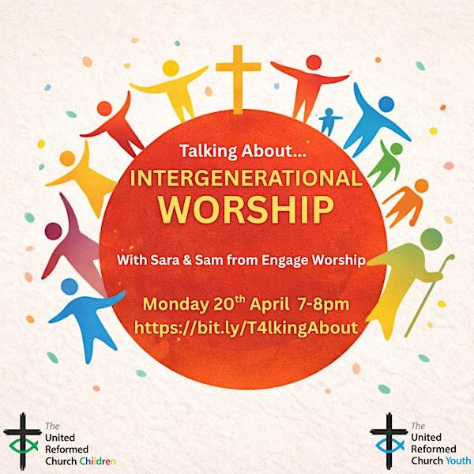
Are you looking for something different to engage families in your church?
On Monday 20th April at 7pm come and hear how Sara & Sam will explore what intergenerational worship can look like in your context. Based on their Whole Church Worship resource, they will share principles and usable ideas for bringing all kinds of people together before God. Ideas will include prayers, songs, Bible readings and more.
To book your place
visit:
www.bit.ly/T4lkingAbout

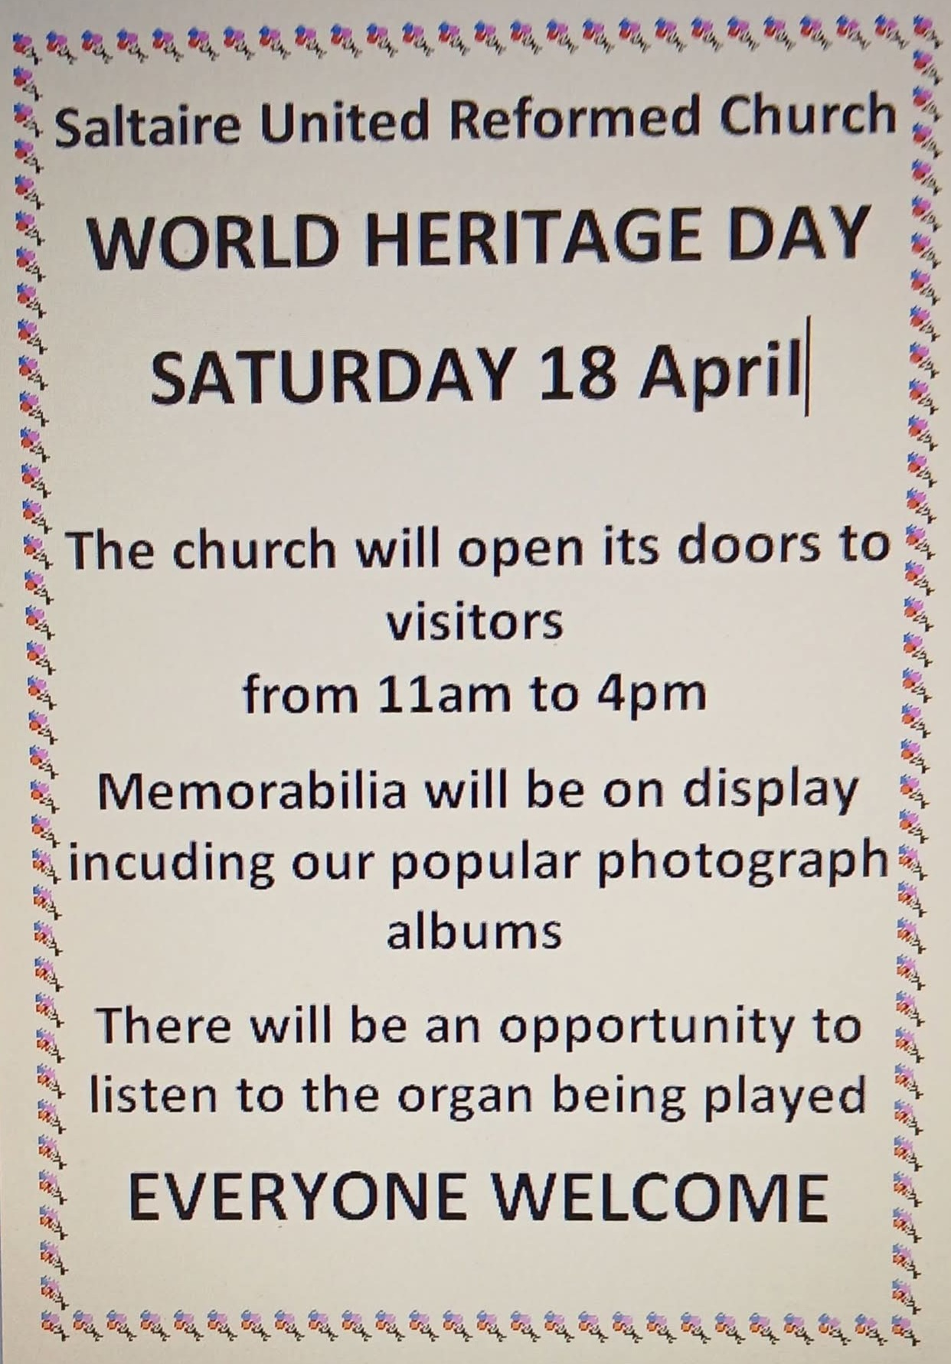
For more information and a guide to other activities, please visit https://saltairefestival.co.uk/events/
Big Questions from URC Youth that Challenge Us All
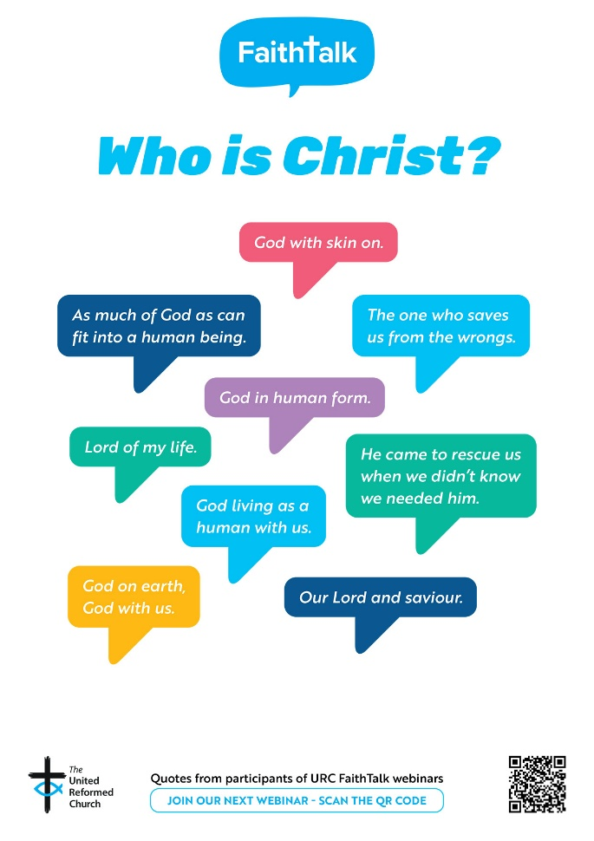
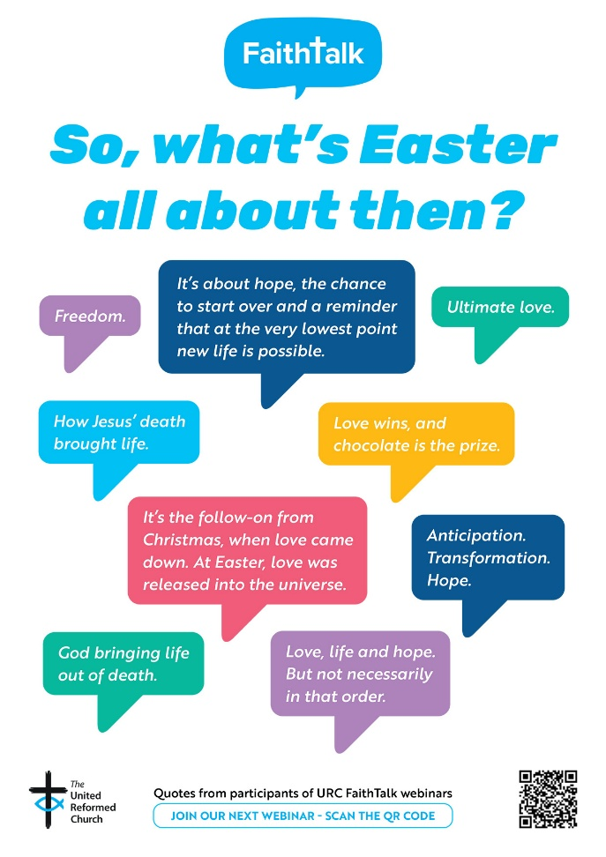

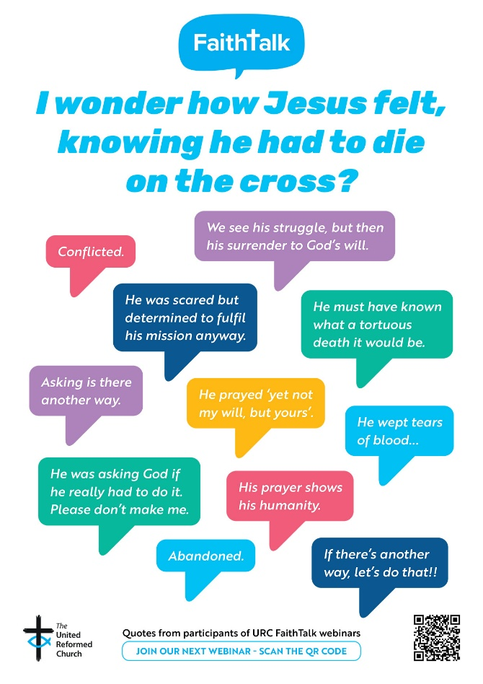
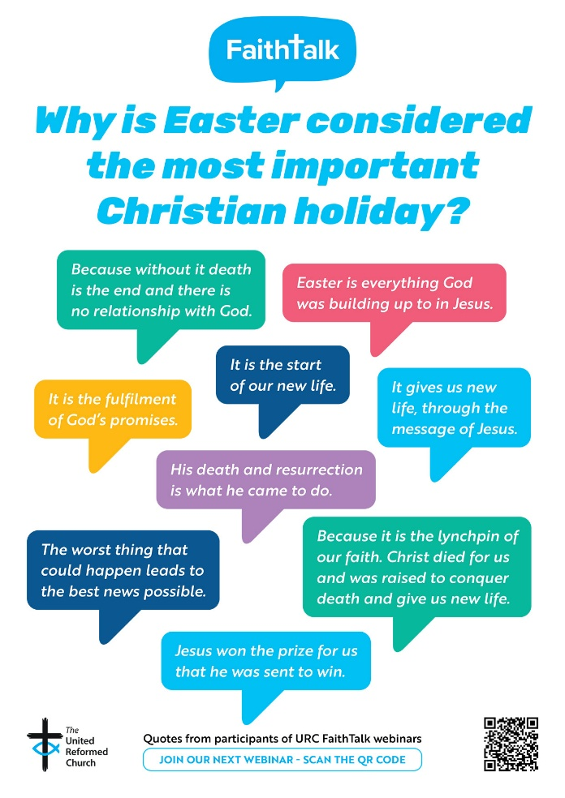
Our next webinar will take place on Tuesday 21 April at 7pm: “Big Questions from URC Youth that Challenge Us All”. Delegates at the recent URC Youth Assembly were asked what their Big Questions are, and we will be tackling a selection during our time together.
To receive a link please register here: https://www.eventbrite.co.uk/e/faith-talk-webinar-tickets-1982502880483?aff=odcleoeventsincollection#organizer-card
An Invitation to Pray

One of the Street Pastors in Doncaster sent this to one of our Ecumenical Officers, Rod Morrison, and Rod has asked that it be shared.

During the Second World War, a group of people stopped whatever they were doing at a specific time every night to pray for peace and safety for everyone. They did this every day, and it was as if the whole city paused — such was the power of prayer. The result was so overwhelming that the bombing stopped shortly afterward!
Now once again some people are organizing. A group of people around the world has agreed to spend one minute praying for the safety of our countries, for the end of the problems that oppress us, and for God to guide the decisions of our leaders.

This body of people will gather at the following times:

India – 9:00pm.
Germany – 4:00pm.
Austria – 4:00pm.
Spain – 4:00pm.
Portugal – 3:00pm.
Canary Isles – 3:00pm.
Costa Rica – 8:00pm.
Colombia – 7:00pm.
Nicaragua – 8:00pm.
Ecuador – 7:00pm.
Guatemala – 8:00pm.
Mexico – 8:00pm.
Panama – 7:00pm.
Honduras – 6:00pm.
El Salvador – 8:00pm.
Venezuela – 6:00pm.
Uruguay – 5:00pm.
Paraguay – 5:00pm.
Brazil – 6:00pm.
Argentina – 5:00pm.
Peru – 6:00pm.
Chile – 5:00pm.
Italy – 4:00pm.
Australia – 2:00pm.
USA – 1:00pm.
Canada – 12 noon
Singapore – 9:00pm.
Thailand – 9:00pm.
Korea – 9:00pm.
Hong Kong / Taiwan – 10:00pm.
Philippines – 11:00pm.
UAE- 7.00pm.
Sierra Leone- 3.00pm.
Switzerland – 4:00pm.
UK - 3.00pm.

Every day we will pause for one minute at the designated time to pray for world peace, for the end of conflict, and for the restoration of calm and security for all people on earth. We will also pray that families may seek their security, protection, and salvation in God. If we truly understood the immense power of prayer, we would be amazed.
🙏🙏🙏🙏
If you can, please forward this request to your contacts so that together we can work a miracle through our prayers.

Set an alarm on your phone every day at the time designated for your country and pray for one minute for peace. 🙏🙏🙏🙏
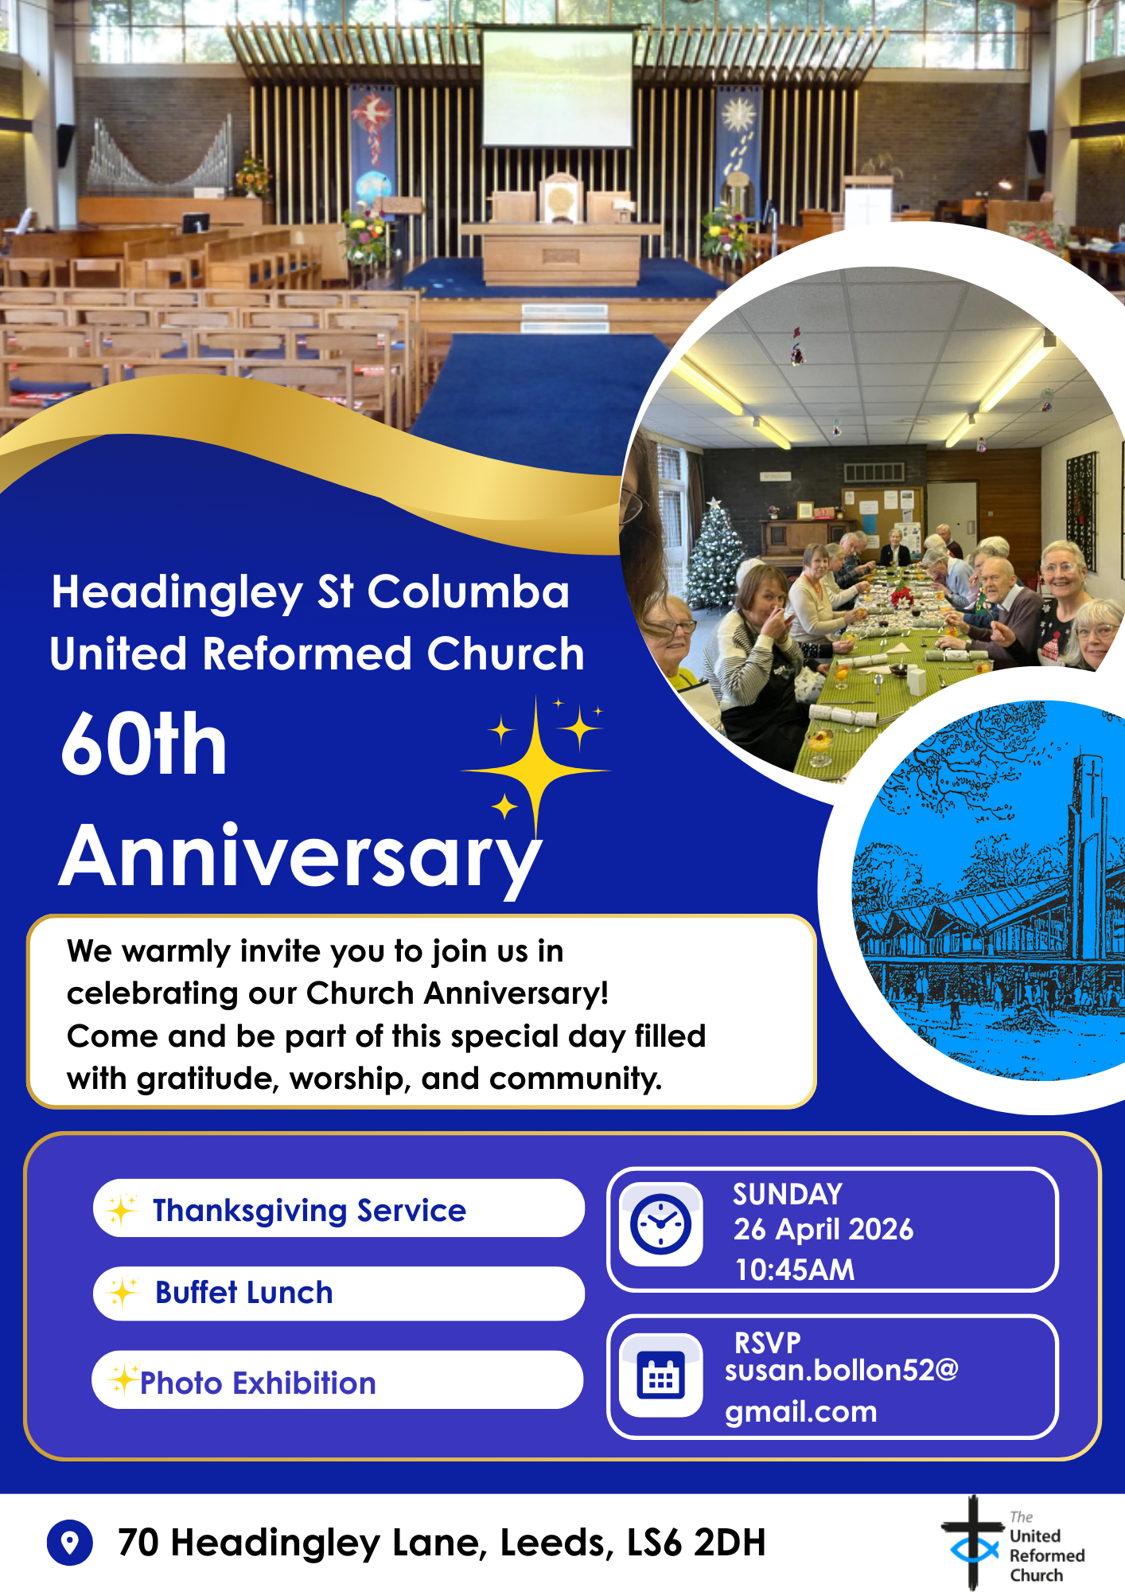

BIG DAY OUT ACTIVITIES
As promised, here are some of the activities that will be happening on the Big Day Out:

The Fisherman’s Tale from 4Front Theatre


We are delighted that 4Front Theatre are returning to the Yorkshire Sculpture Park to perform another of their truly magnificent shows. Last year they had us all laughing and singing, from the toddlers to the teenagers to the old-timers, everyone got caught up in the show about Jesus’ timeless parable tales. This year they will bring us The Fisherman’s Tale. ‘The Fisherman’s Tail is a show not to be missed. It is a hearty all-age musical; about four humble fishermen whose everyday lives are blown out of the water when they are caught up in the whirlwind of Jesus’ life and miracles. With lots of catchy original tunes, this new take on the life and miracles of Jesus will guarantee to put the wind in your sails.’


BIG Praise & Sing

Alex Walker will lead us in this experiment to blend karaoke and open mic! Come along and request some of your favourite songs and pray that Alex knows the tunes.
Have a go at singing, playing and dancing along to a mixture of worship songs and hymns.

Tickets available here: https://www.tickettailor.com/events/theunitedreformedchurchyorkshireprovincetrustltd/2067409
Booking closes at 9am on Tuesday 5th May 2026.
Keep your eyes on the Synod website as that information will soon be there as well as there will be the opportunity to apply for grants to help subsidise transport to THE BIG DAY OUT.


A Trinity of New Elders at Dacre URC
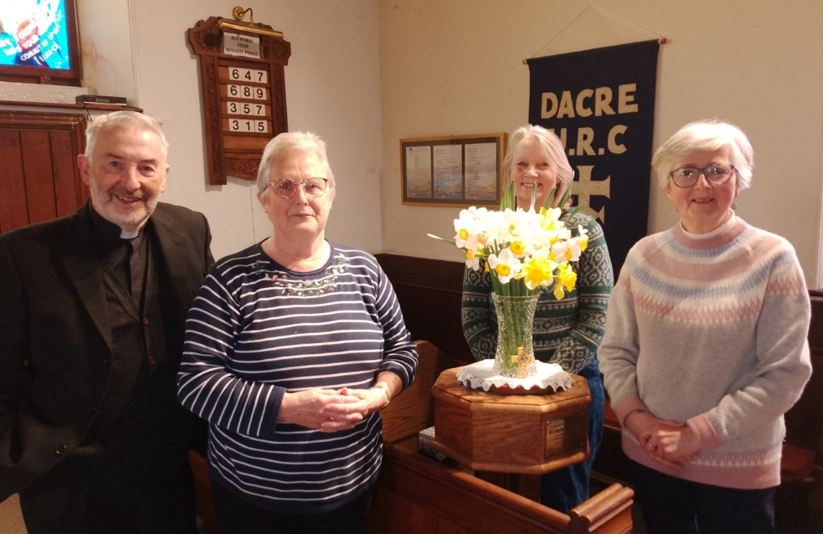
The Eldership at Dacre URC, a rural church in Nidderdale and a member of the N.O.W. (Nidd, Ouse, Wharfe) Mission and Care Group multiplied 150% on Easter Sunday when The Rev. John Campbell officiated at the ordination and induction of three new Elders, (from left to right) Jane Simpson, Carol Rowe and Lucy Tiffany.

St Paul’s Celebration Build Up
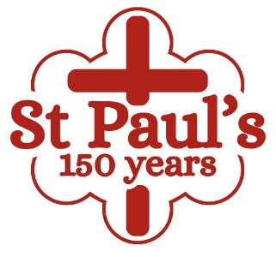
I hear that there are many things happening and/or planned at St Paul’s Harrogate in the build up to their 150th year celebrations and that the celebration banner on the church tower attracts a lot of attention from passers-by.
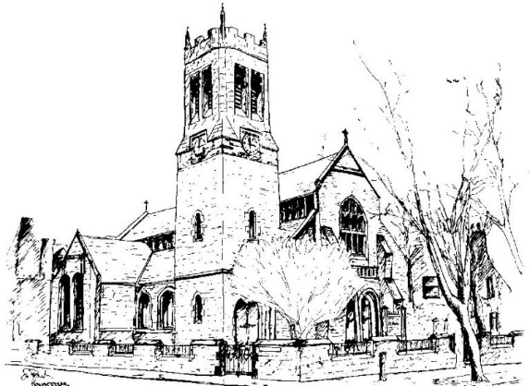
This Saturday evening (18th April) they have a ceilidh which happily for them is sold out, but perhaps for us a missed opportunity. However, it doesn’t stop you from joining with St Paul’s in their anniversary year: there is a limerick competition (for those with Edward Lear tendencies), an art competition (pictures of the church) and book marks to be handed out in Harrogate Library. The church is also inviting lots of people who have links with the church (including people who were married in St Paul's as well as former members) to join them in their celebrations. Looking ahead the church’s uniformed organisations are planning several fundraising events, such as pizza/movie night for young people, so keep an eye open for those.
Finally, St Paul’s are happy to announce that through the generosity of the Synod through the Synod Mission Capacity Fund, they have been able to engage a Church Administrator. Amanda Freak started in the role this past Monday and I hope I join you all in wishing Amanda well in her new role.

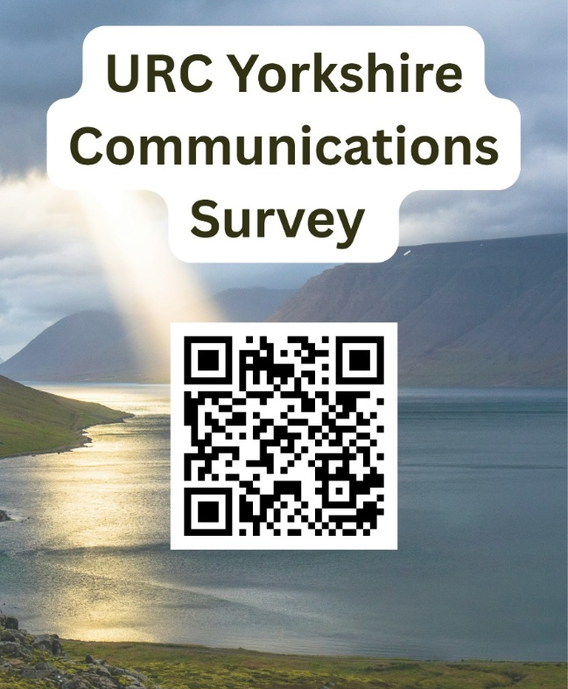
Communications Survey
Communication is always a two-way process and to find out more as to how you would like to hear from Synod, and perhaps how you would like to be able to contact Synod, Daniel Raddings has set up a QR code through which you can access a simple questionnaire. All that is being asked is what do you want to hear from us and what format of media would you prefer?
As a synod we want to share information that benefits your mission. So we’ve devised this simple survey/questionnaire to help us help you.

If you struggle to access the questions via the QR Code you can click the following link https://forms.gle/c4XFZ3kaqUvRoJa26 or if you find it easier to contact Daniel directly his e-mail is daniel.raddings@outlook.com.

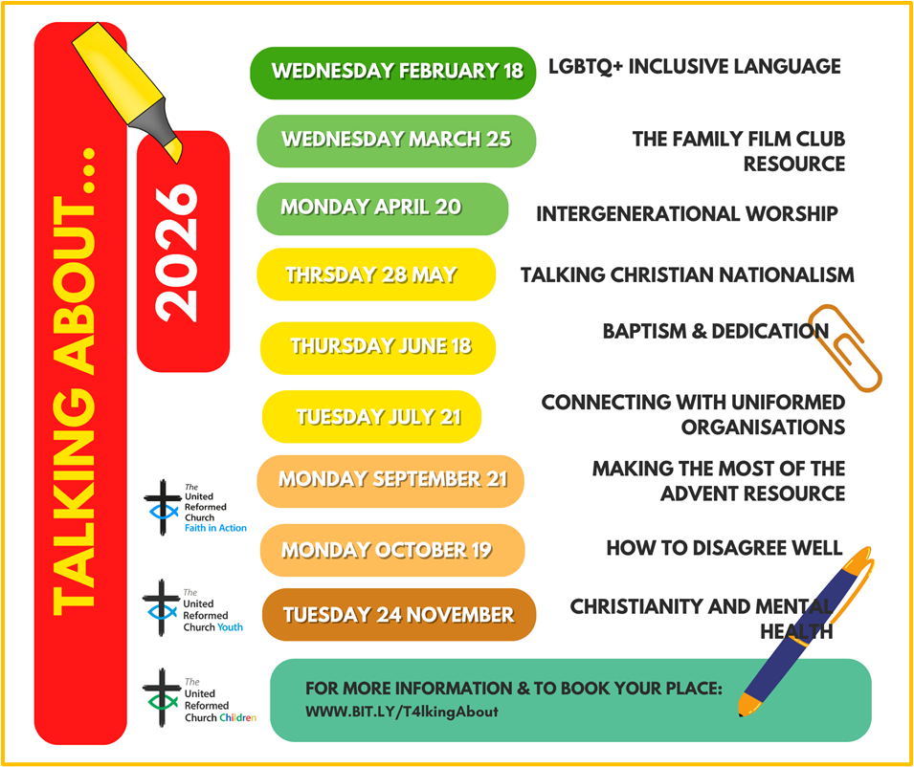


Yorkshire Synod Discipleship Development Small Grant Fund 2026
The Synod is pleased to let you all know that it has received confirmation that it has a pot of £4000 to grant to those wishing to apply to the Yorkshire Synod Discipleship Development 2026.

1. Who is eligible to apply? Committed members or adherents, including children and young people, of a congregation within the United Reformed Church who are exercising, or want to exercise, a form of lay ministry or community service whether expressed within or beyond their local church. The DDF is not open to Ministers of Word and Sacraments and CRCWs, as there are other designated funds available for those groups.

2. How much is available? Up to £300 per applicant per calendar year, although the Synod may agree to more than this according to the local context and circumstances.

3. What can this money be used for? The purposes for which the funding is provided are defined by creativity and vocation, in line with the URC's discipleship development strategy. Be bold, take risks. The funding exists to help you to follow Jesus. You might be helped in this by courses (at any level) at any of the URC Resource Centres for Learning or from other learning providers, or you may have ideas on resourcing discipleship development in other people. You may need funds to cover the costs of travel, materials or books. All you have to do is make a case to your local church meeting and submit the application form to the Synod Convenor of Ministries for consideration and, if appropriate, authorisation.

4. How are applications made? Having gained your church meeting's endorsement, applications are to be made on the designated form, well before the spending is due to start. Backdated applications will not normally be accepted. Application forms are obtainable from the Synod Convenor of Ministries via the Synod Office at office@urcyorkshire.org.uk and should be sent back for authorisation before being passed to the synod finance office.

5. How are grants paid? Grants authorised by the Convenor of Synod Ministries
are paid by a Synod finance officer by reimbursement to you when you have given proof of what you've spent. Contact your Synod Convenor of Ministries for discussion if you need something funded directly on your behalf, rather than waiting for re-imbursement.

If anyone wants to discuss an application before submitting it please contact the Convenor of the Yorkshire Ministries Committee, Kath Lonsdale at kathlonsdale@talktalk.net.
Remember this is for any age of lay person in our churches to apply for so please discuss with your young people as well as adults.

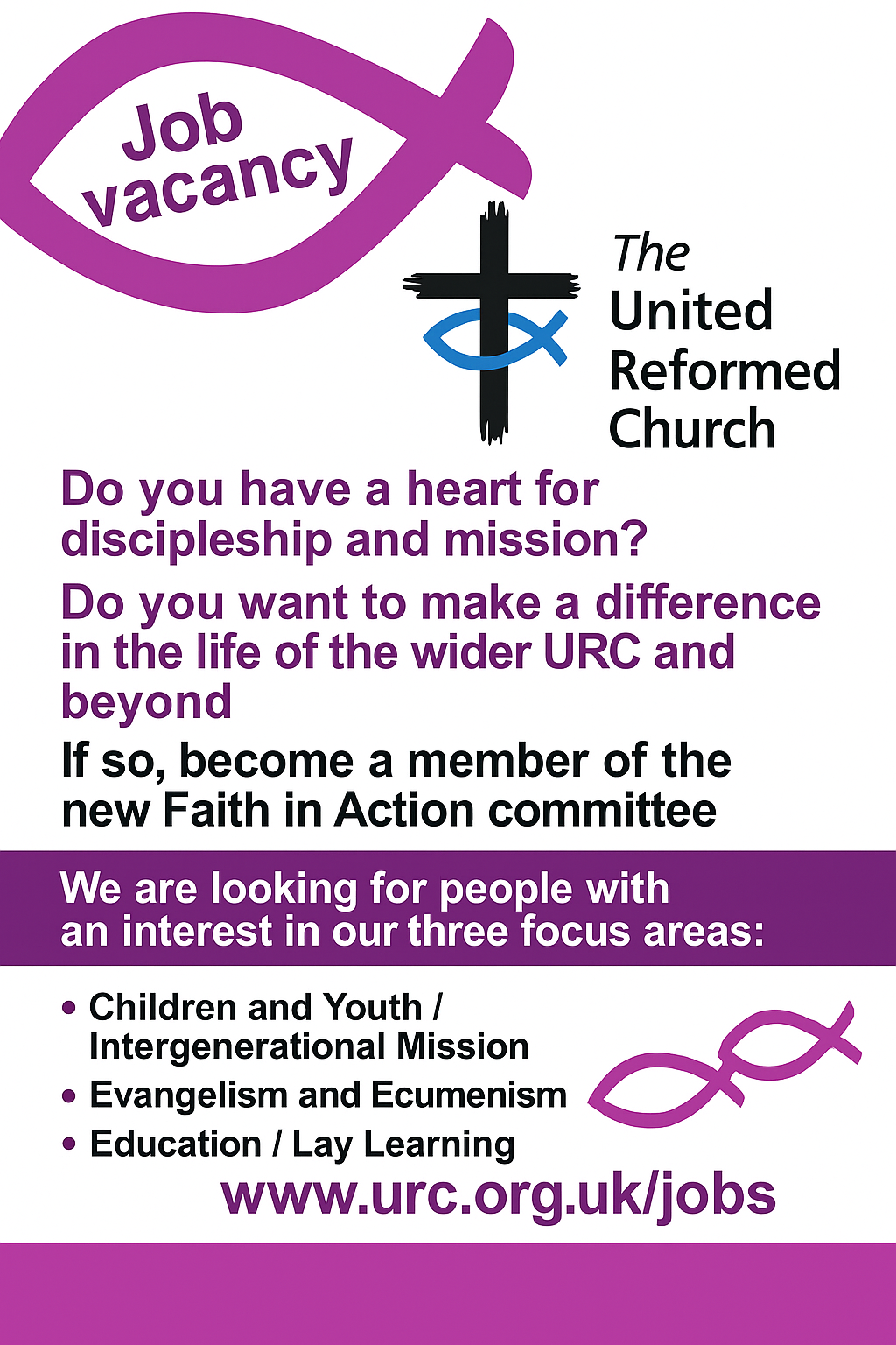

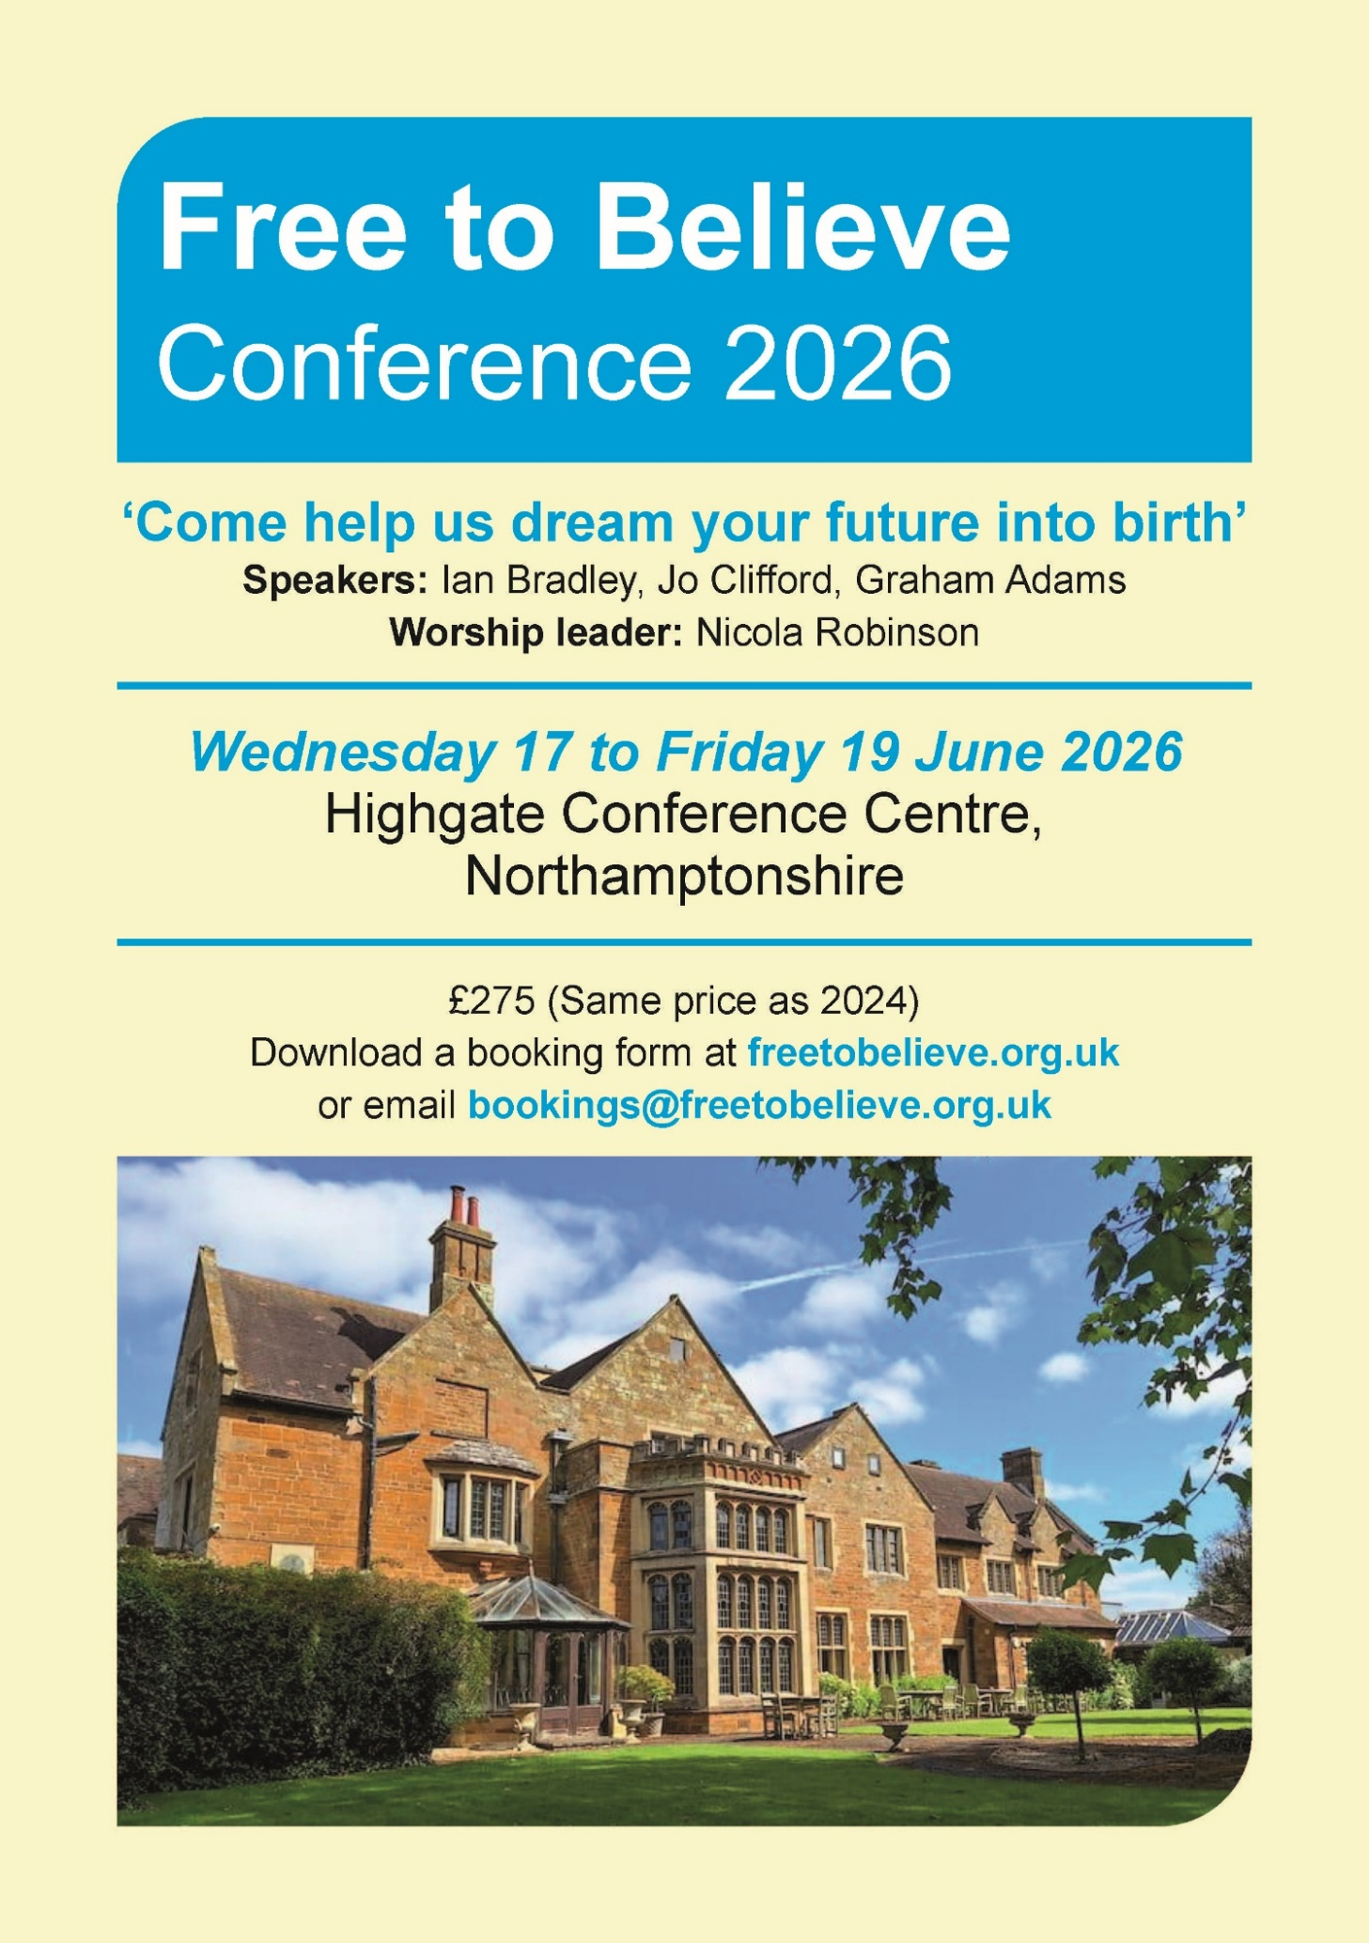
For more information, please visit the Free to Believe website at https://freetobelieve.org.uk/conferences.html
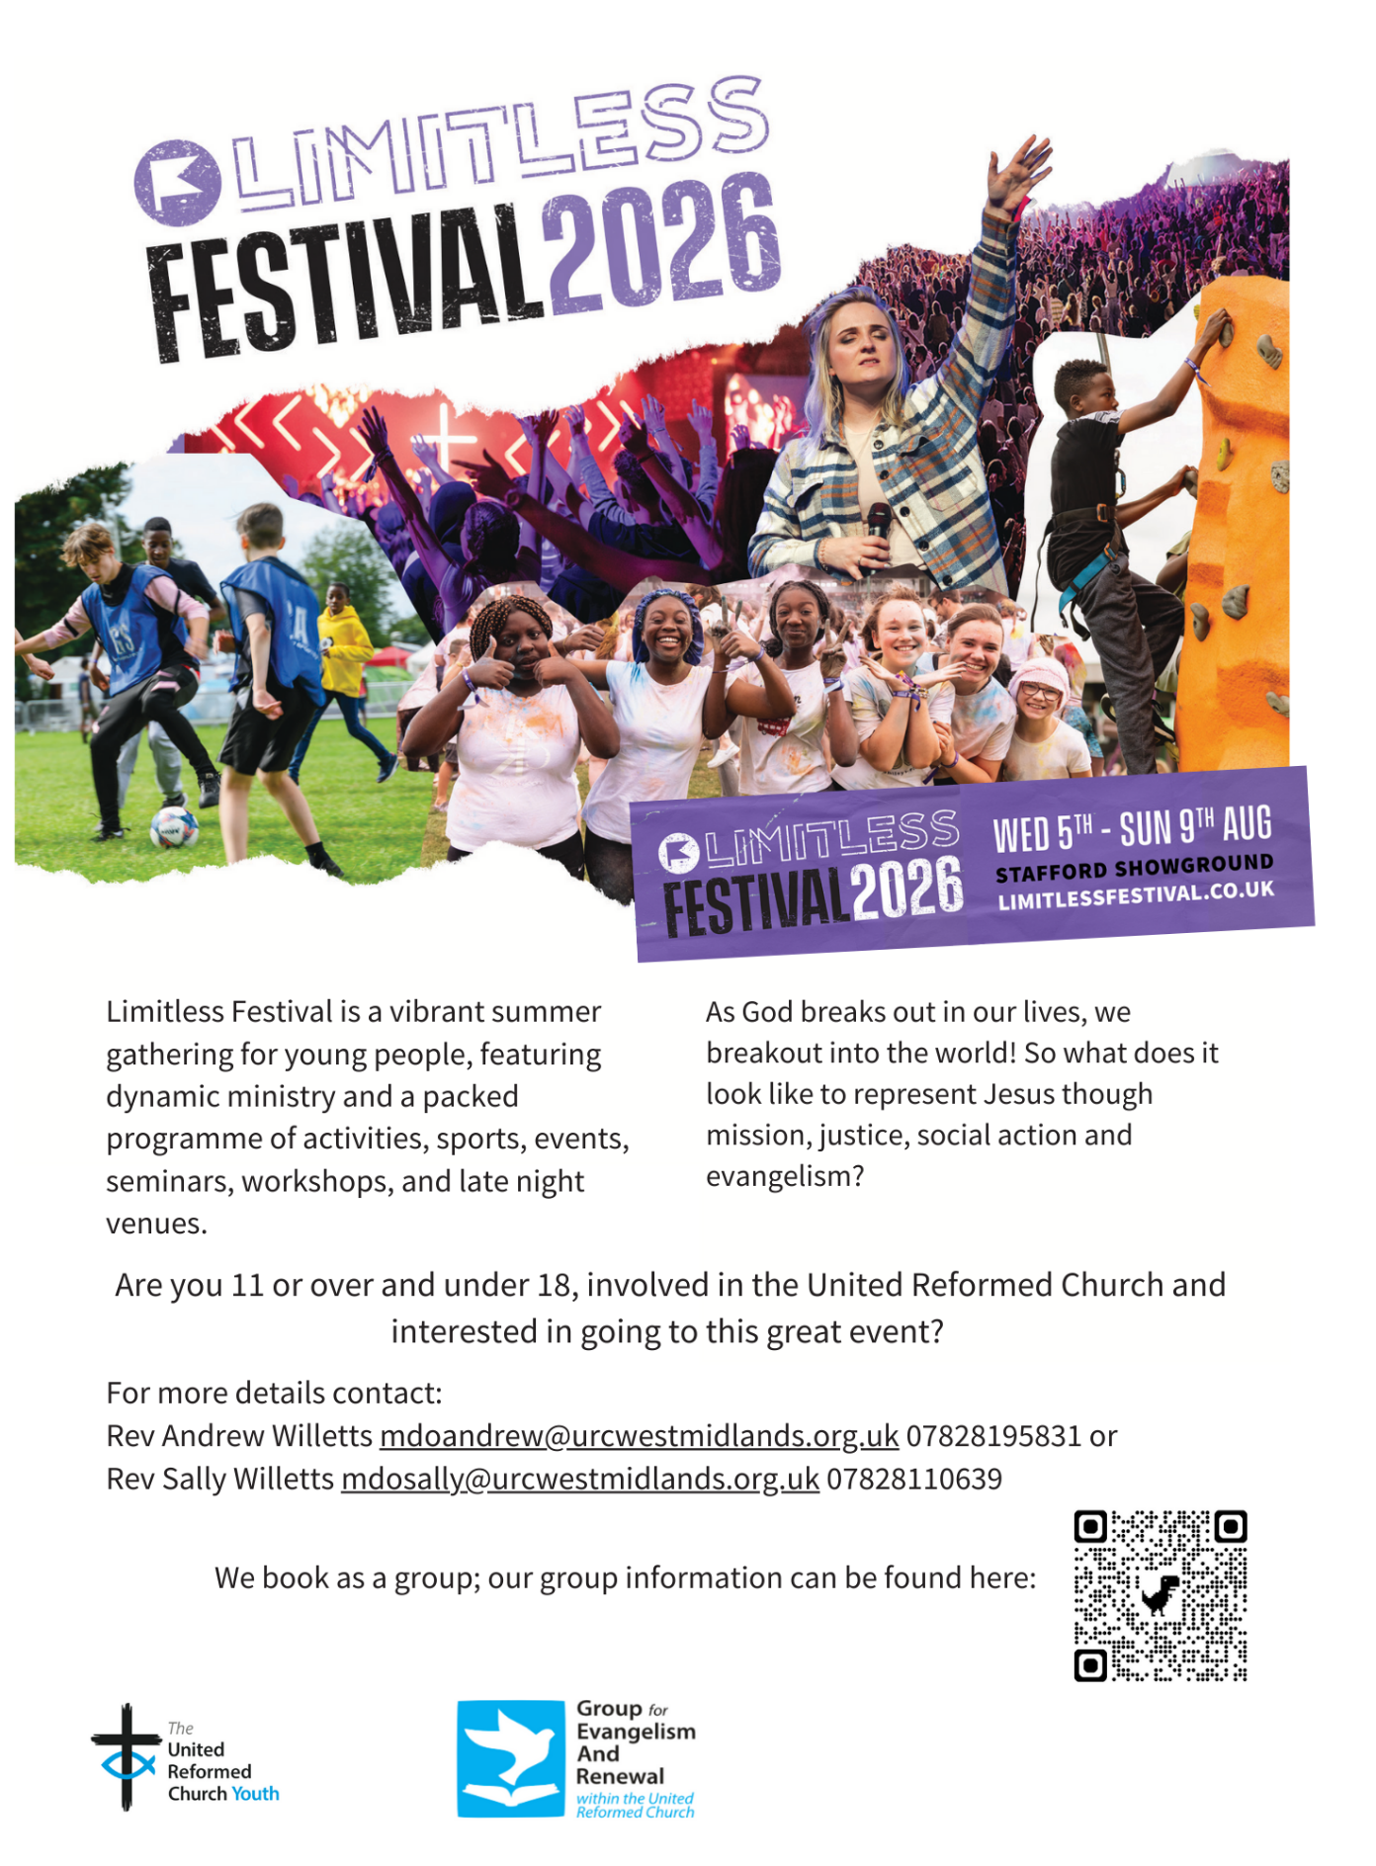

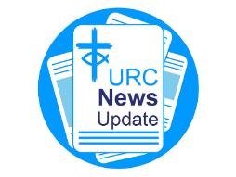
NEWS FROM THE DENOMINATION
The URC’s News Update is a regular e-newsletter that keeps you informed about the latest news and events.
To receive this popular newsletter, please visit the https://urc.org.uk/news-updates-sign-up-form/ page on the URC website and follow the links. If you just want to dip in and catch up on what is going one, that’s fine and you can
read and print recent editions of our e-newsletter by visiting the URC News Update page at https://urc.org.uk/urc-news-update/ .

Submit your photographs for the 2027 URC Calendar

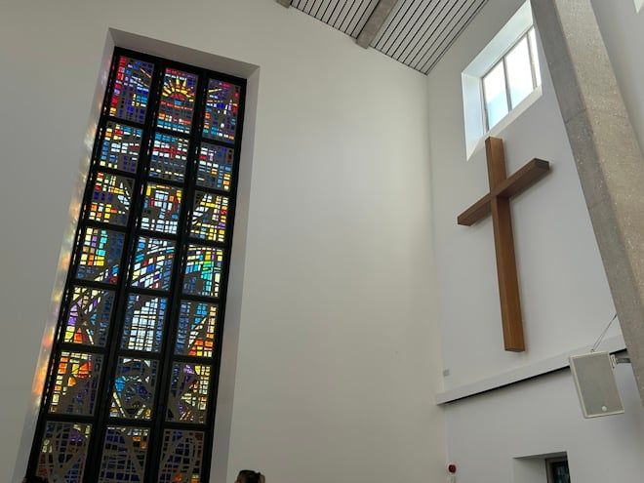
The 2027 United Reformed Church Calendar is titled ‘Transparent as glass’ and will feature stained glass windows and glass sculptures from our churches and Local Ecumenical Partnerships.

Glass has been used in churches since the 7th century for visual storytelling and religious education, acting as colourful “picture books” for congregations to learn Bible stories and for Christian teaching. Stained glass also creates a sacred atmosphere by focussing light for worship and enhancing our churches’ architectural beauty.

We invite you to send in your photos of large and small windows, as well as any sculptures made from, or including, glass. Please include the name of the church and the photographer. You can email your image(s) to the URC Press Office, pressoffice@urc.org.uk.

Please note that for all photos submitted, the photographer is granting the URC permission to use the photographs in print and digitally. The deadline for submitting your photos is June 5 2026.

The calendar will be available on the URC Bookshop from August and is once again generously supported by Edwards Insurance.

Safeguarding News

For more details please contact either Emma Pearce at emma.pearce@urc.org.uk or our own Carrie Kaunda at carrie.kaunda@urc.org.uk

The Safeguarding team are available seven days a week and 365 days a year as the inbox is monitored at weekends. This inbox is not monitored continually but concerns will be responded to within 24 hours. If you need immediate support, please contact the Police or your Local Authority Duty Safeguarding Team. All contact details for these services MUST be displayed in your churches.
Further details can be found on the Yorkshire website at https://urcyorkshire.org.uk/safeguarding/ or email your query to safeguarding.1and4@urc.org.uk.

AND FINALLY
The Wyke Easter Eggs – have they been found?

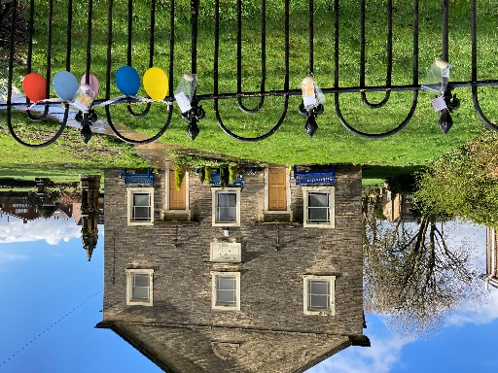
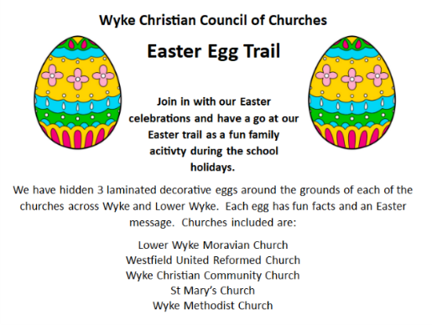
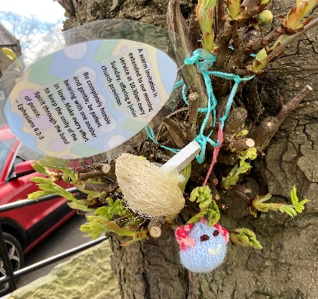
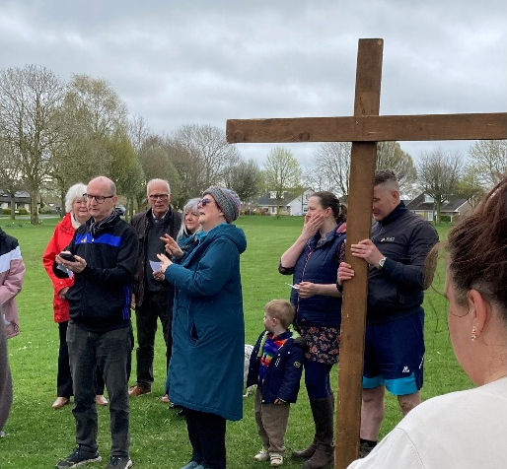
I’ve been told by a very reliable witness that in Wyke, just south of Bradford, there were a few missing Easter Eggs. Happily though, in conjunction with the Wyke Christian Council of Churches they were all found. The weekend started with their Good Friday walk of witness and outside service and was followed by an invitation to look for three laminated decorative eggs hidden in the grounds of the participating churches.
The event covered the whole of the Easter weekend and was able to coincide with my reliable witness’s own Easter Day service at Westfield URC.

If you have a good news story from your part of the Synod or something that you feel reflects the work of Synod and which inspires others as we move into 2026, drop me a line at clerk@urcyorkshire.org.uk and I’ll make sure it hits the back page!!

You can also keep an eye on all our social media platforms for news; on the website at Home - URC Yorkshire Synod, at United Reformed Church in Yorkshire - Home | Facebook and Wilderness URC Yorkshire - Home | Facebook, the YouTube page at URC Yorkshire - YouTube and the Twitter (X) page at URC in Yorkshire (@URCYorkshire) / Twitter.

