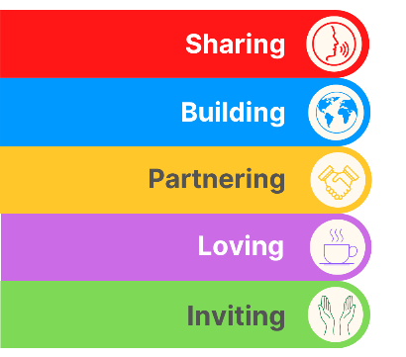
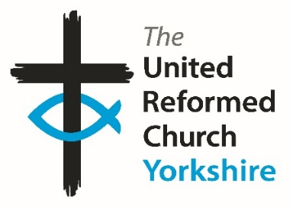
Yorkshire Synod Briefing
Number 173

30th April 2026

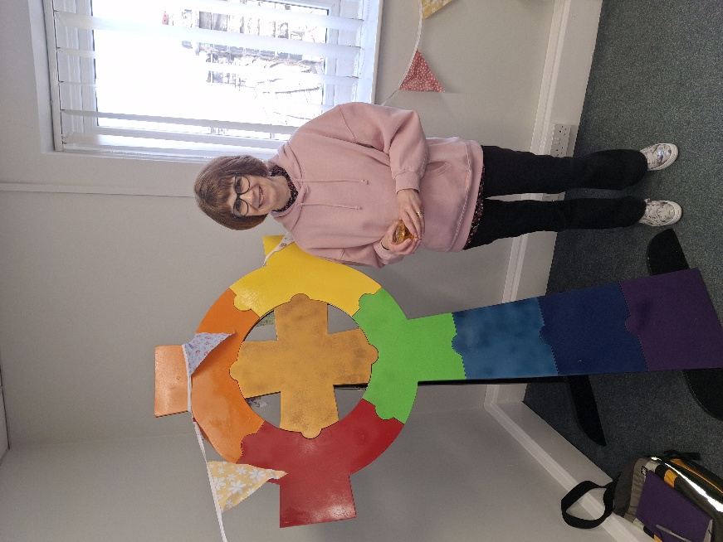
A Farewell to Sally
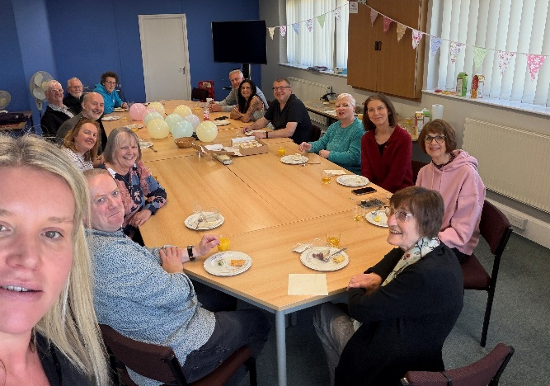
We said a very fond farewell to Sally Duxbury last week. Sally has hung her “Moderator’s P.A.” hat up to enjoy retirement and the Synod team were able to come together on Tuesday 21st for a special lunch to wish her well and to thank her for her work for the Synod over the past 25 years or so. Sally started with Synod in the summer of 2000 when the office was still based at Salem Chapel in Leeds. Over her 25 years she became a truly dependable and faithful member of the Synod team and we at Synod cannot thank her enough. I’m sure you join us all at the Synod Office in wishing her well in her retirement.

On a practical note, Synod is not yet in a position to recruit for a replacement, so the plan in the short term is that the existing office staff have agreed to provide cover for the Moderator, Revd Jamie Kissack. Anne Ward and Claire Preest will be covering the Moderator’s PA role between them: Anne will be overseeing the paperwork for Moderators’ Meetings and Introductions etc, whilst Claire will be supporting Jamie in arranging his diary. Both Anne and Claire will have access to the email accounts of moderator@urcyorkshire.org.uk and moderatorpa@urcyorkshire.org.uk. However, during Jamie’s impending Sabbatical (which begins on 8th June), the moderator@urcyorkshire.org.uk will have an out-of-office message and will not be responded to. Therefore, if you have any enquiries relating to Jamie’s role before or during his Sabbatical, please use the moderatorpa@urcyorkshire.org.uk (Sally’s old e-mail address) before the end of May. Further details of cover will be in the next issue of the Briefing.

Please continue to send invitations to your events, your stories and pictures in to me, and I’ll continue to advertise and share them throughout 2026, either here in The Briefing or on the Synod website at https://urcyorkshire.org.uk/. They may even end up in https://urc.org.uk/our-news-stories/latest-news/ which is always worth a read and has the opportunity to sign up for regular URC’s news updates.
So, if you have any news of welcoming people into Church, stories of celebration and mission, please let me know by dropping me a line at clerk@urcyorkshire.org.uk and I’ll showcase it in the next edition, due out on the website only on 14th May 2026.
Tim Crossley
Yorkshire Synod Clerk

BIG DAY OUT ACTIVITIES
Here are some of the other activities that will be happening on the Big Day Out:

The Fisherman’s Tale from 4Front Theatre


We are delighted that 4Front Theatre are returning to the Yorkshire Sculpture Park to perform another of their truly magnificent shows. Last year they had us all laughing and singing, from the toddlers to the teenagers to the old-timers, everyone got caught up in the show about Jesus’ timeless parable tales. This year they will bring us The Fisherman’s Tale. ‘The Fisherman’s Tail is a show not to be missed. It is a hearty all-age musical; about four humble fishermen whose everyday lives are blown out of the water when they are caught up in the whirlwind of Jesus’ life and miracles. With lots of catchy original tunes, this new take on the life and miracles of Jesus will guarantee to put the wind in your sails.’

Big Praise & Sing

Alex Walker will lead us in this experiment to blend karaoke and open mic! Come along and request some of your favourite songs and pray that Alex knows the tunes. Have a go at singing, playing and dancing along to a mixture of worship songs and hymns.

Assembly Bangers

Take a deep breath as Simon and Caroline lead us in non-stop singing of all those old School Assembly favourites.
Put some “oil in your lamp”, colours in your day and maybe even “dance…wherever you may be” (with a few surprise entries into our all-time favourites list, perhaps).
Don’t just sing but rediscover your joyful child-like trust in “Jesus’ love… (it’s) very wonderful!”

Outofthebox Storytelling

Wisdom. Wonder. Wellbeing. For people of all ages. Listening to stories with our hearts and playfully exploring what they mean to us.

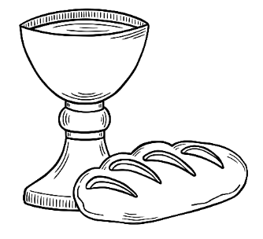
Communion for all
An all-age Communion service to gather the whole community in a simple and joyful way, with the meal shared from picnic bags enjoyed side by side. Inspired by the call of the fishermen—ordinary people invited into something extraordinary—to remind everyone that faith begins where we are and grows when we come together. Young and old alike were welcomed, fed, and sent out with a shared sense of purpose and belonging.

Keep your eyes on the Synod website as that information will soon be there as well as there will be the opportunity to apply for grants to help subsidise transport to THE BIG DAY OUT.

Tickets are still available here: https://www.tickettailor.com/events/theunitedreformedchurchyorkshireprovincetrustltd/2067409
Booking closes at 9am on Tuesday 5th May 2026.
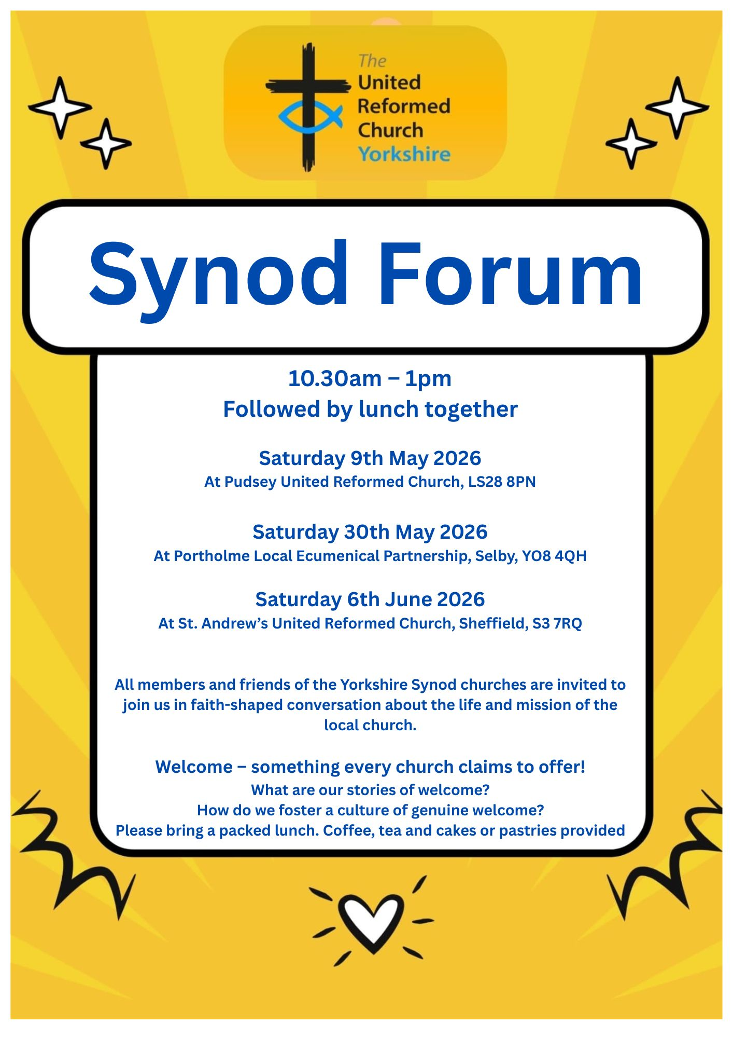
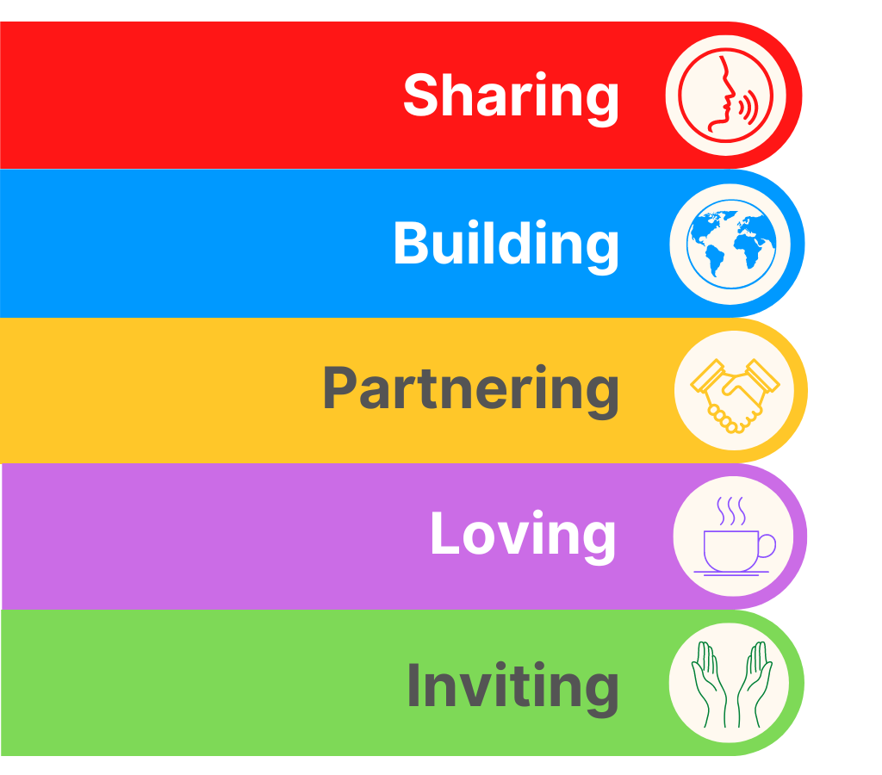

SYNOD FORUMS 2026
This is a reminder that the first of three Synod Forums for 2026 is coming up very soon on
𝐒𝐚𝐭𝐮𝐫𝐝𝐚𝐲 𝟗𝐭𝐡 𝐌𝐚𝐲 𝐚𝐭 𝐏𝐮𝐝𝐬𝐞𝐲 𝐔𝐧𝐢𝐭𝐞𝐝 𝐑𝐞𝐟𝐨𝐫𝐦𝐞𝐝 𝐂𝐡𝐮𝐫𝐜𝐡, 𝐋𝐒𝟐𝟖 𝟖𝐏𝐍,
followed by:
𝐒𝐚𝐭𝐮𝐫𝐝𝐚𝐲 𝟑𝟎𝐭𝐡 𝐌𝐚𝐲 𝐚𝐭 𝐏𝐨𝐫𝐭𝐡𝐨𝐥𝐦𝐞 𝐋𝐨𝐜𝐚𝐥 𝐄𝐜𝐮𝐦𝐞𝐧𝐢𝐜𝐚𝐥 𝐏𝐚𝐫𝐭𝐧𝐞𝐫𝐬𝐡𝐢𝐩, 𝐒𝐞𝐥𝐛𝐲, 𝐘𝐎𝟖 𝟒𝐐𝐇,
and on
𝐒𝐚𝐭𝐮𝐫𝐝𝐚𝐲 𝟔𝐭𝐡 𝐉𝐮𝐧𝐞 𝐚𝐭 𝐒𝐭 𝐀𝐧𝐝𝐫𝐞𝐰'𝐬 𝐔𝐧𝐢𝐭𝐞𝐝 𝐑𝐞𝐟𝐨𝐫𝐦𝐞𝐝 𝐂𝐡𝐮𝐫𝐜𝐡, 𝐒𝐡𝐞𝐟𝐟𝐢𝐞𝐥𝐝, 𝐒𝟑 𝟕𝐑𝐐.
The Forums are opportunities for fellowship and good conversation and the conversations will be faith-shaped around fostering a culture of genuine welcome. You are free to choose the date and venue that is best for you, and each will run from 10.30am – 1pm. Please do stay and share a ‘bring-your-own lunch’ and continue the conversations.
We hope these events will be a chance for those with Synod roles to hear from local churches so that we can support and encourage one another. The Synod Forum is your place to have your voice heard, and to help shape the priorities of the Synod.

TALKING ABOUT…

The next Talking About session is at the end of next month and is designed to address a particularly relevant issue that affects us as Christians.

On Thursday 28th May come and join the URC’s Faith in Action teaming trying to understand and address the growing phenomena of Christian Nationalism.

To book your place visit: www.bit.ly/T4lkingAbout


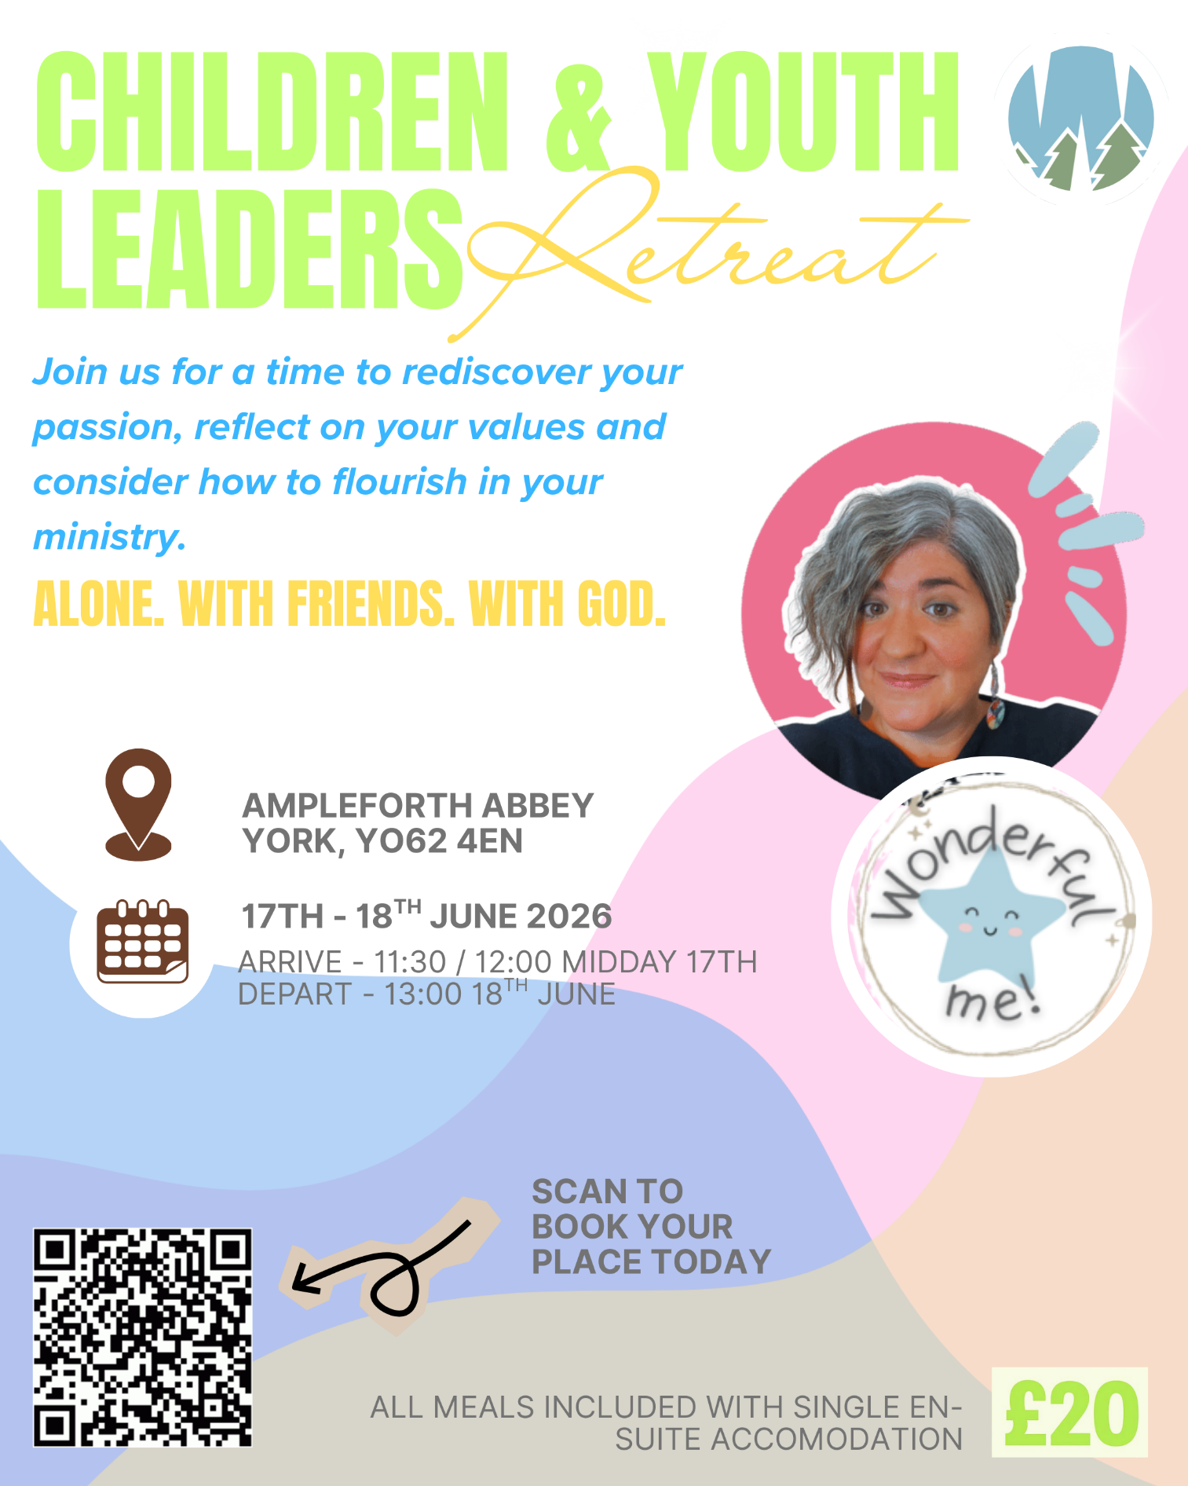



Yorkshire Synod Discipleship Development Small Grant Fund 2026
The Synod is pleased to let you all know that it has received confirmation that it has a pot of £4000 to grant to those wishing to apply to the Yorkshire Synod Discipleship Development 2026. Currently we have been able to grant about half of what has been allocated to us, and we would love to be able to offer grants to enable us to use all of what Yorkshire Synod has received.

1. Who is eligible to apply? Committed members or adherents, including children and young people, of a congregation within the United Reformed Church who are exercising, or want to exercise, a form of lay ministry or community service whether expressed within or beyond their local church. The DDF is not open to Ministers of Word and Sacraments and CRCWs, as there are other designated funds available for those groups.

2. How much is available? Up to £300 per applicant per calendar year, although the Synod may agree to more than this according to the local context and circumstances.

3. What can this money be used for? The purposes for which the funding is provided are defined by creativity and vocation, in line with the URC's discipleship development strategy. Be bold, take risks. The funding exists to help you to follow Jesus. You might be helped in this by courses (at any level) at any of the URC Resource Centres for Learning or from other learning providers, or you may have ideas on resourcing discipleship development in other people. You may need funds to cover the costs of travel, materials or books. All you have to do is make a case to your local church meeting and submit the application form to the Synod Convenor of Ministries for consideration and, if appropriate, authorisation.

4. How are applications made? Having gained your church meeting's endorsement, applications are to be made on the designated form, well before the spending is due to start. Backdated applications will not normally be accepted. Application forms are obtainable from the Synod Convenor of Ministries via the Synod Office at office@urcyorkshire.org.uk and should be sent back for authorisation before being passed to the synod finance office.

5. How are grants paid? Grants authorised by the Convenor of Synod Ministries
are paid by a Synod finance officer by reimbursement to you when you have given proof of what you've spent. Contact your Synod Convenor of Ministries for discussion if you need something funded directly on your behalf, rather than waiting for re-imbursement.

If anyone wants to discuss an application before submitting it please contact the Convenor of the Yorkshire Ministries Committee, Kath Lonsdale at kathlonsdale@talktalk.net.
Remember this is for any age of lay person in our churches to apply for so please discuss with your young people as well as adults.

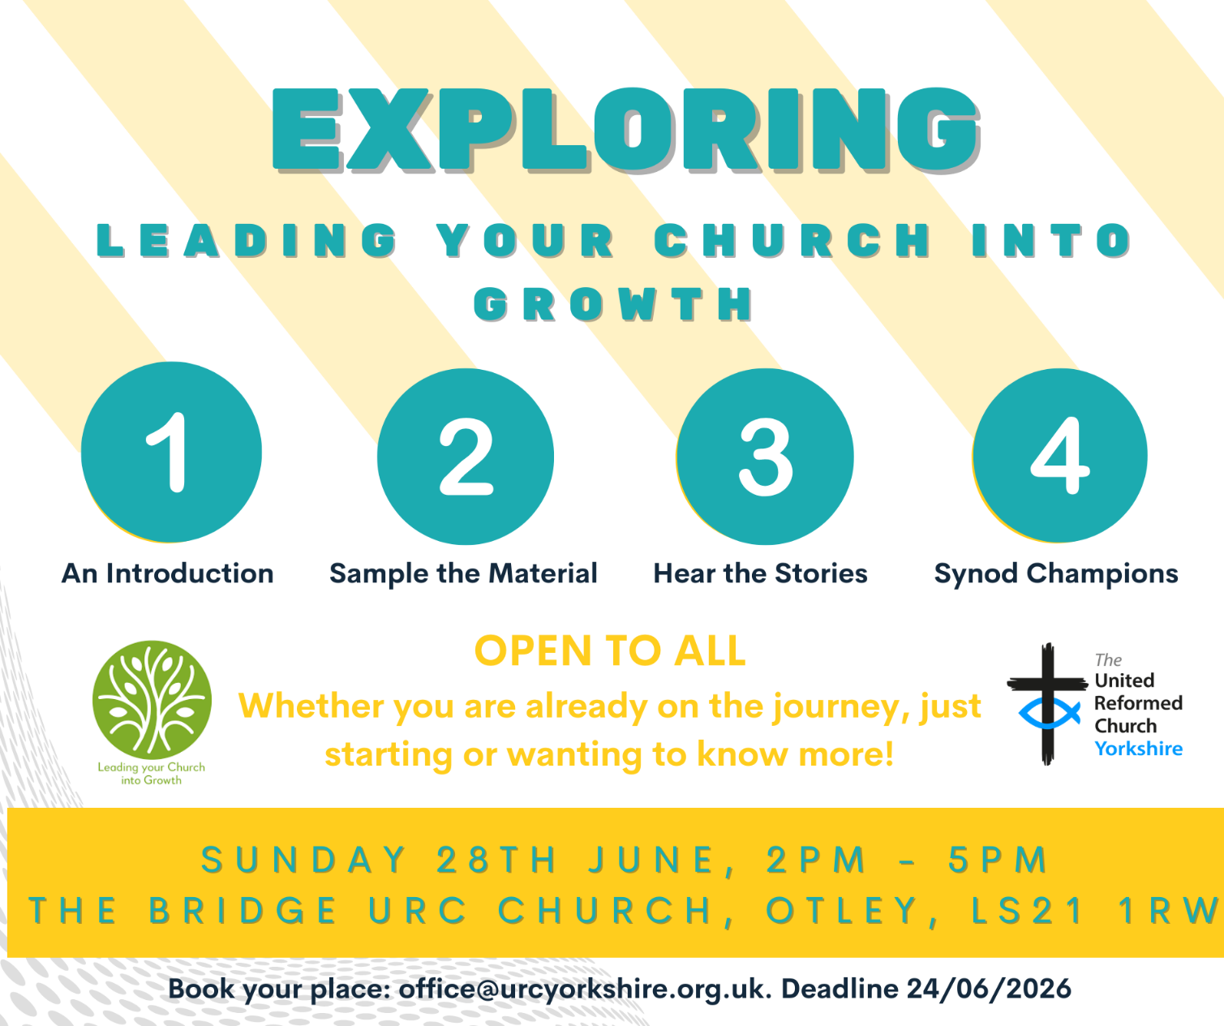



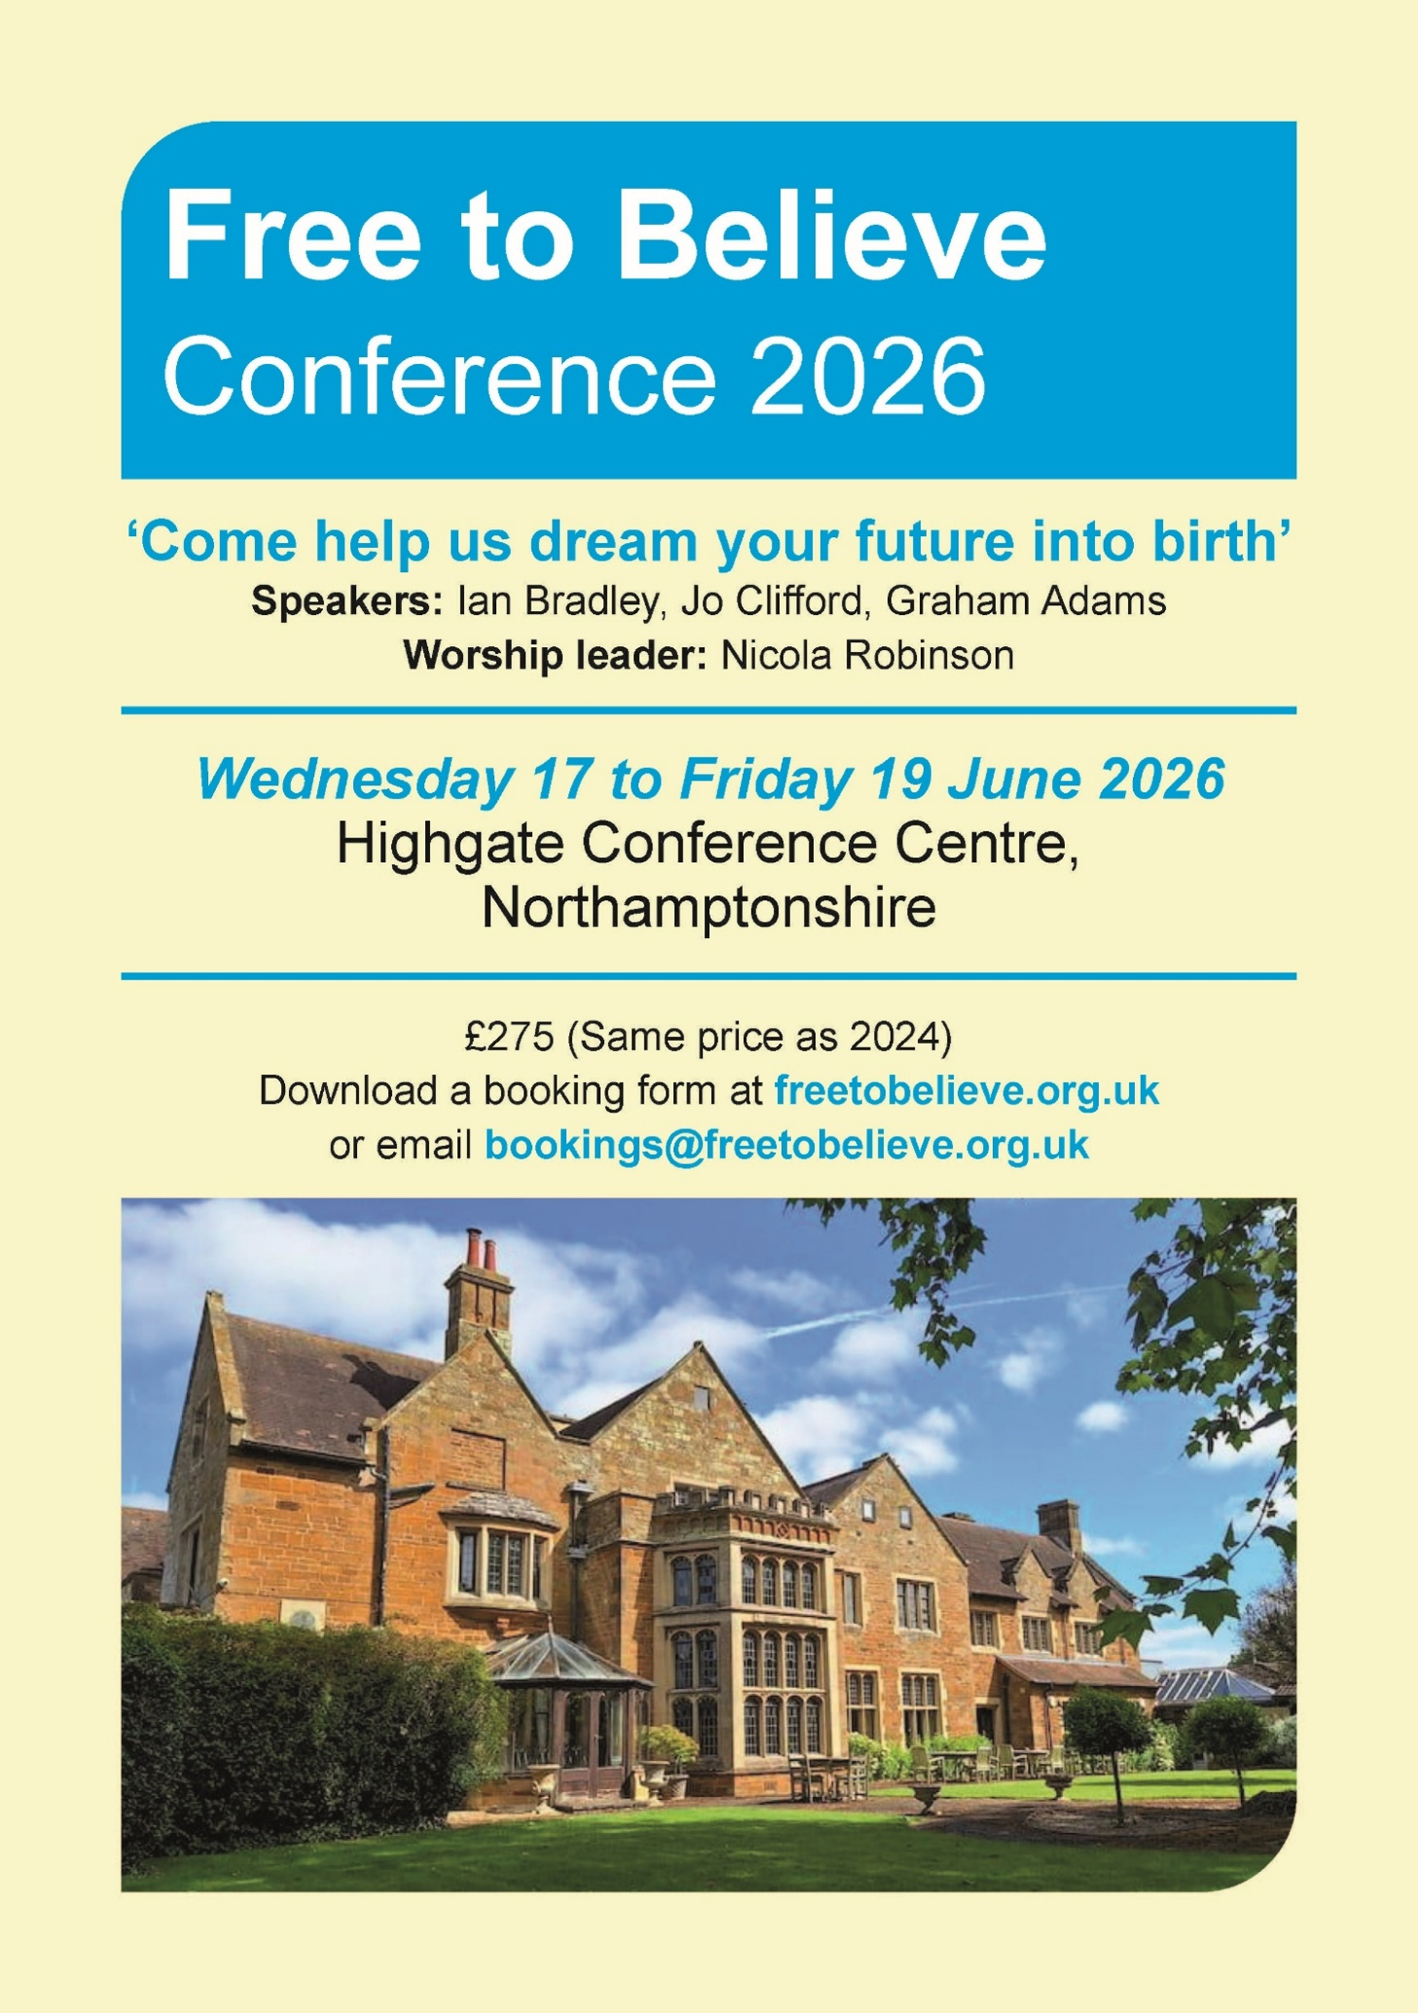
For more information, please visit the Free to Believe website at https://freetobelieve.org.uk/conferences.html


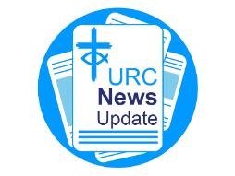
NEWS FROM THE DENOMINATION
The URC’s News Update is a regular e-newsletter that keeps you informed about the latest news and events.
To receive this popular newsletter, please visit the https://urc.org.uk/news-updates-sign-up-form/ page on the URC website and follow the links. If you just want to dip in and catch up on what is going one, that’s fine and you can
read and print recent editions of our e-newsletter by visiting the URC News Update page at https://urc.org.uk/urc-news-update/ .

Submit your photographs for the 2027 URC Calendar

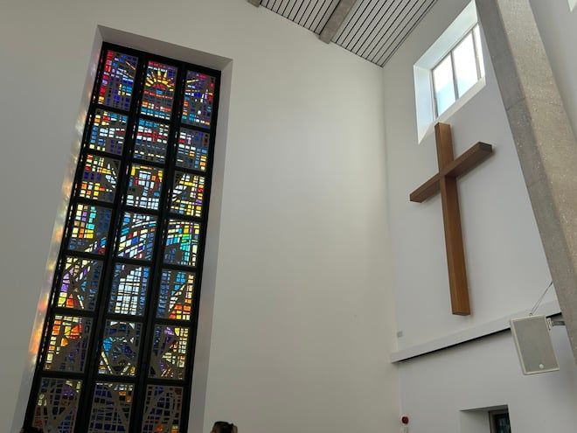
The 2027 United Reformed Church Calendar is titled ‘Transparent as glass’ and will feature stained glass windows and glass sculptures from our churches and Local Ecumenical Partnerships.

Glass has been used in churches since the 7th century for visual storytelling and religious education, acting as colourful “picture books” for congregations to learn Bible stories and for Christian teaching. Stained glass also creates a sacred atmosphere by focussing light for worship and enhancing our churches’ architectural beauty.

We invite you to send in your photos of large and small windows, as well as any sculptures made from, or including, glass. Please include the name of the church and the photographer. You can email your image(s) to the URC Press Office, pressoffice@urc.org.uk.

Please note that for all photos submitted, the photographer is granting the URC permission to use the photographs in print and digitally. The deadline for submitting your photos is June 5 2026.

The calendar will be available on the URC Bookshop from August and is once again generously supported by Edwards Insurance.

Safeguarding News
For more details please contact either Emma Pearce at emma.pearce@urc.org.uk or our own Carrie Kaunda at carrie.kaunda@urc.org.uk

The Safeguarding team are available seven days a week and 365 days a year as the inbox is monitored at weekends. This inbox is not monitored continually but concerns will be responded to within 24 hours. If you need immediate support, please contact the Police or your Local Authority Duty Safeguarding Team. All contact details for these services MUST be displayed in your churches.
Further details can be found on the Yorkshire website at https://urcyorkshire.org.uk/safeguarding/ or email your query to safeguarding.1and4@urc.org.uk.
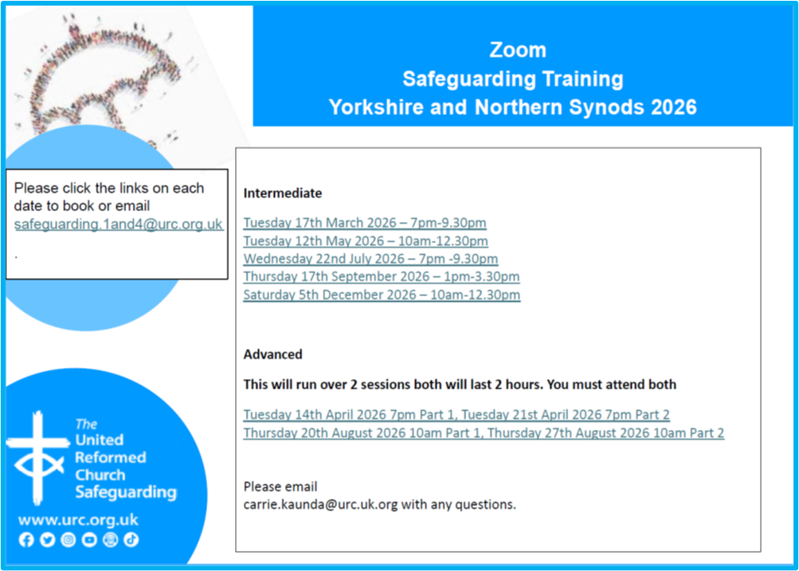

AND FINALLY

N.O.W. THAT’S WHAT I CALL MUSIC!
The NOW Mission & Care Group held a ‘Get Together’ on Saturday 25th April at Bilton Grange URC for what was billed as a day for ‘Creating Community and opening our hearts to God’. Led by Rev Mike Leigh an Anglican vicar who also practices as a Creative Singing Practitioner, over forty members from all eight of the churches in the Group attended for an excellent day.
Members learnt songs from around the world – and sounded quite good to say that there was a real mixture of people, some who would not claim to be good singers!
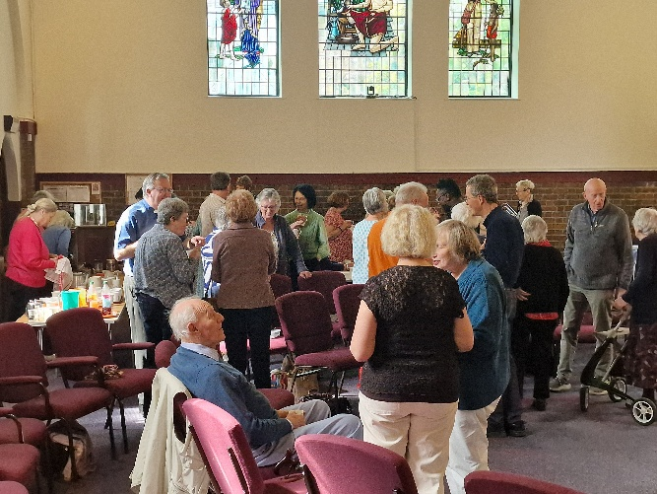
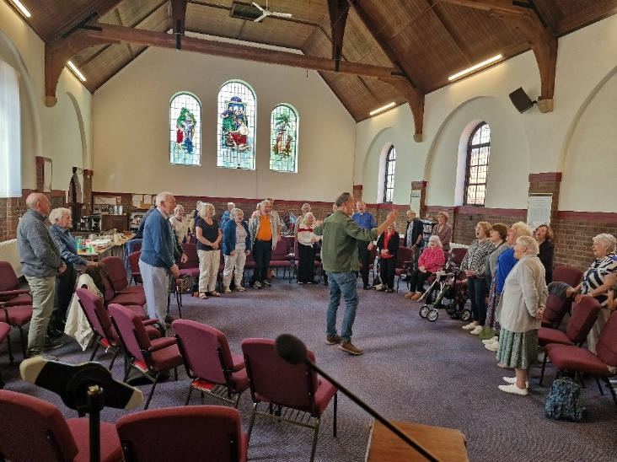
The feedback at the end was universally positive, and many expressed the view that they had been moved by the experience and all felt the day had helped to cement the growing relationships between the eight churches.

If you have a good news story from your part of the Synod or something that you feel reflects the work of Synod and which inspires others as we move into 2026, drop me a line at clerk@urcyorkshire.org.uk and I’ll make sure it hits the back page!!

You can also keep an eye on all our social media platforms for news; on the website at Home - URC Yorkshire Synod, at United Reformed Church in Yorkshire - Home | Facebook and Wilderness URC Yorkshire - Home | Facebook, the YouTube page at URC Yorkshire - YouTube and the Twitter (X) page at URC in Yorkshire (@URCYorkshire) / Twitter.

