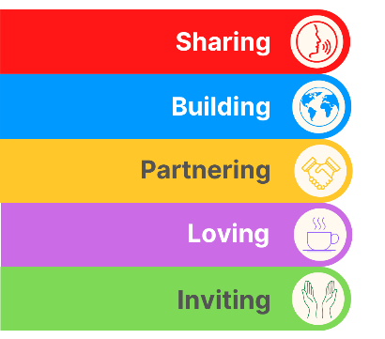
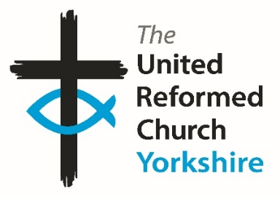
Yorkshire Synod Briefing
Number 174

14th May 2026

Here Comes the Summer
This coming weekend, for me at least, marks the start of the full on Synod Summer. I hope that as many of you as possible have signed up to go to the Synod’s BIG DAY OUT, being held at the Yorkshire Sculpture Park. All the activities can be found in this issue of the Briefing, and I know that there is a team of willing volunteers all ready and willing to help you enjoy the day as you “Let Your Soul Sing and Praise”. Although the office is no longer taking bookings, I’m told that there will be tickets available on the day. So follow the signs for the main entrance and be guided to where the Big Day Out welcome and registration desk is located at “The Learning Centre”. I hope that in the next Briefing, due out on 4th June, there will be stories and pictures showcasing the day which I’m sure will inspire you to come along to next year’s event.

This summer sees our Moderator, Revd Jamie Kissack, embarking on his Sabbatical. This gift is given to all our ministers and Jamie will be embarking on his on June 8th and will return spiritually refreshed on 22nd September. I hope you can join me in wishing Jamie well and look forward to his return at the beginning of Autumn.

Whilst we have not yet recruited a new Moderator’s PA in succession to Sally who retired last month, in the short term the existing office staff are providing cover. Anne Ward and Claire Preest will be covering the Moderator’s PA role between them: Anne will be overseeing the paperwork for Moderators’ Meetings and Introductions etc, whilst Claire will be supporting Jamie in arranging his diary. Both Anne and Claire will have access to the email accounts of moderator@urcyorkshire.org.uk and moderatorpa@urcyorkshire.org.uk. However, during Jamie’s Sabbatical (which begins on 8th June), the moderator@urcyorkshire.org.uk will have an out-of-office message and will not be responded to. Therefore, if you have any enquiries relating to Jamie’s role before or during his Sabbatical, please use the moderatorpa@urcyorkshire.org.uk (Sally’s old e-mail address) before the end of May.

Please continue to send invitations to your events, your stories and pictures in to me, and I’ll continue to advertise and share them throughout 2026, either here in The Briefing or on the Synod website at https://urcyorkshire.org.uk/. This time I am missing an “And Finally” story, so please send something in so that I can showcase your church around the Synod. They may even end up in https://urc.org.uk/our-news-stories/latest-news/ which is always worth a read and has the opportunity to sign up for regular URC’s news updates.
So, if you have any news of welcoming people into Church, stories of celebration and mission, please let me know by dropping me a line at clerk@urcyorkshire.org.uk and I’ll showcase it in the next edition, due out on the website only on 4th June 2026.
Tim Crossley
Yorkshire Synod Clerk

BIG DAY OUT ACTIVITIES
Here are some of the other activities that will be happening on the Big Day Out:

The Fisherman’s Tale from 4Front Theatre


We are delighted that 4Front Theatre are returning to the Yorkshire Sculpture Park to perform another of their truly magnificent shows. Last year they had us all laughing and singing, from the toddlers to the teenagers to the old-timers, everyone got caught up in the show about Jesus’ timeless parable tales. This year they will bring us The Fisherman’s Tale. ‘The Fisherman’s Tail is a show not to be missed. It is a hearty all-age musical; about four humble fishermen whose everyday lives are blown out of the water when they are caught up in the whirlwind of Jesus’ life and miracles. With lots of catchy original tunes, this new take on the life and miracles of Jesus will guarantee to put the wind in your sails.’

Big Praise & Sing

Alex Walker will lead us in this experiment to blend karaoke and open mic! Come along and request some of your favourite songs and pray that Alex knows the tunes. Have a go at singing, playing and dancing along to a mixture of worship songs and hymns.

Assembly Bangers

Take a deep breath as Simon and Caroline lead us in non-stop singing of all those old School Assembly favourites.
Put some “oil in your lamp”, colours in your day and maybe even “dance…wherever you may be” (with a few surprise entries into our all-time favourites list, perhaps).
Don’t just sing but rediscover your joyful child-like trust in “Jesus’ love… (it’s) very wonderful!”

Outofthebox Storytelling

Wisdom. Wonder. Wellbeing. For people of all ages. Listening to stories with our hearts and playfully exploring what they mean to us.


Communion for all
An all-age Communion service to gather the whole community in a simple and joyful way, with the meal shared from picnic bags enjoyed side by side. Inspired by the call of the fishermen—ordinary people invited into something extraordinary—to remind everyone that faith begins where we are and grows when we come together. Young and old alike were welcomed, fed, and sent out with a shared sense of purpose and belonging.

Tickets are available on the day. Go to the main entrance and head down to the Welcome and Registration Desk where the Synod Team will be based.
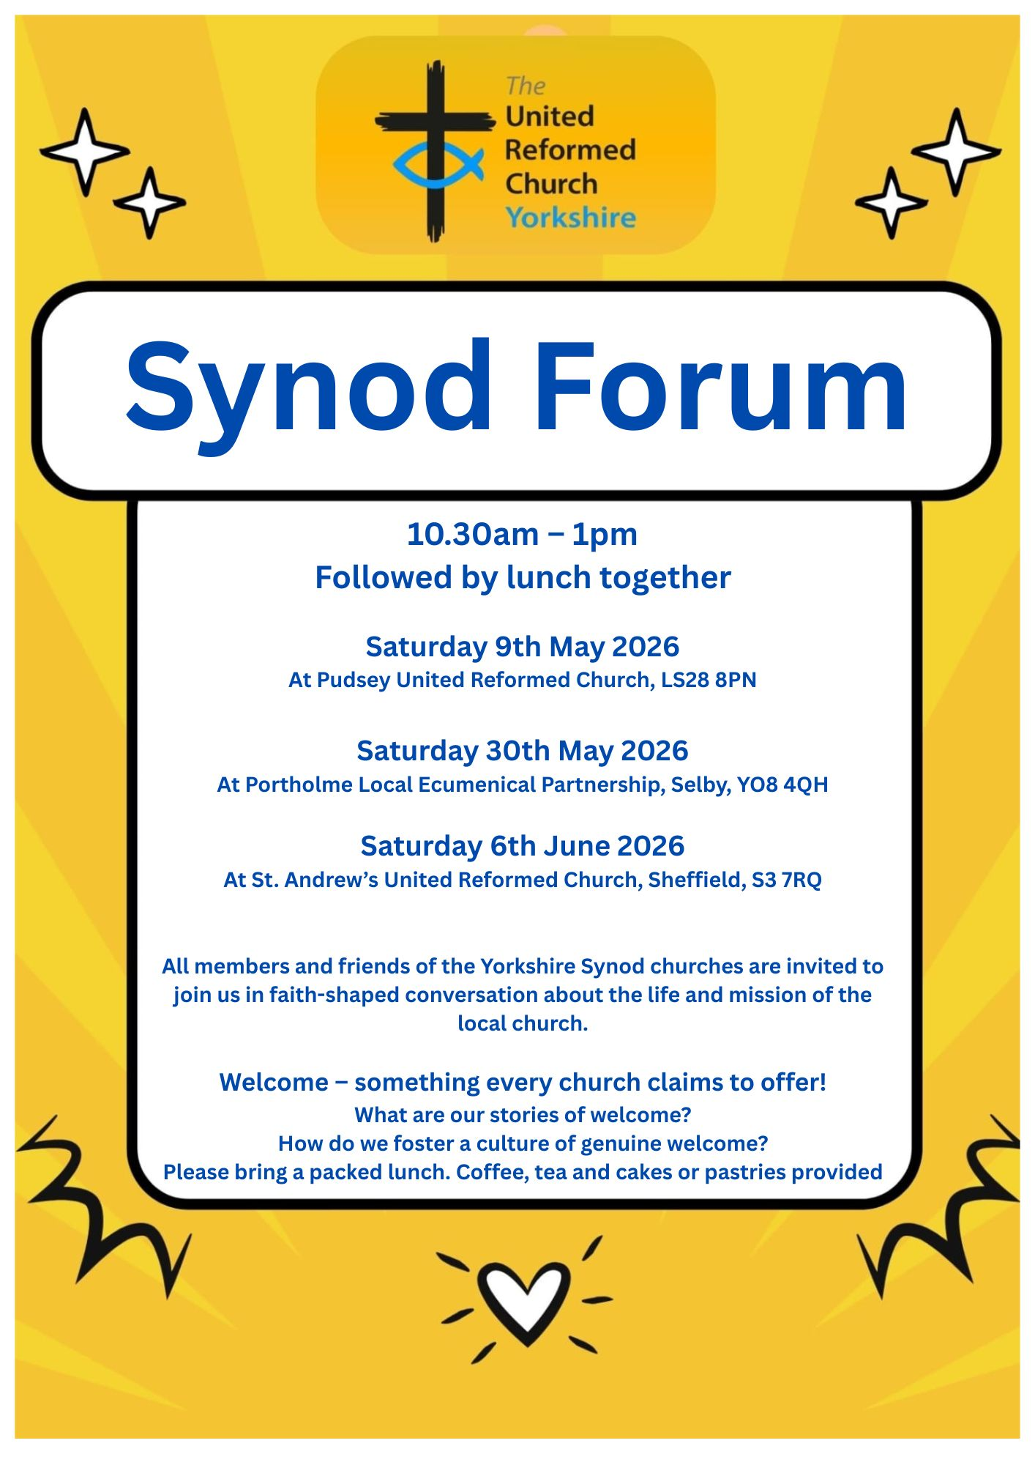
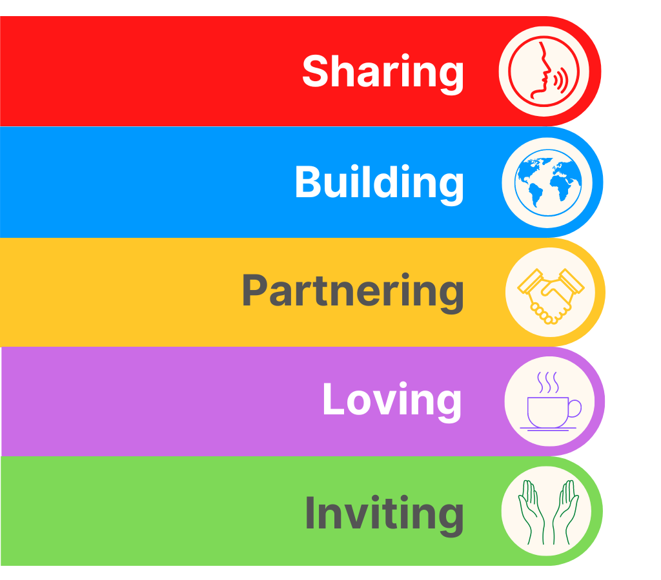
SYNOD FORUM REFLECTION

Churches are like custard!

There are lots of things that I don’t know about churches and lots of things that are frustrating but there are also lots of times when I delight in things I hear. Having never been to a Synod Forum I took the opportunity to go to the one being held in Pudsey URC on Saturday 9th of May.
Excitement, trepidation, apprehension are just a few words I would use to describe how I was feeling as I walked through the doors. A few familiar faces made me feel less anxious and the warm welcome I received relaxed me quite quickly.
The gathering began with an opening prayer and reflection led by Synod Moderator Jamie Kissack. Then we discussed and reflected on whether our churches are truly welcoming. We as Christians often think we are, but are we really? Do we hold on to the past as ‘that’s the way we’ve always done it’? Do we resist change?
I was particularly struck when Jamie said ‘churches are like custard, if you don’t stir them then a skin forms’. We need to change to continue to grow – to avoid becoming cold, sluggish, congealed and unappetising! For me the idea of an impenetrable skin is not hard to imagine. I don’t want to picture my church being covered in a thick, yukky skin preventing anyone from coming in and experiencing God’s Love. Are we prepared to keep looking hard at everything we do to ensure we are inclusive?
In small groups we looked at short bible passages, exploring how each passage could help churches become more welcoming. My group discussed ways in which we could show our commitment to inclusivity, including by:
- Smiling
- Being authentic
- Talking to people but more importantly listening to them. Do you always sit with friends over coffee – could you talk to someone different from time to time? Equally it is important not to swamp or overwhelm new people with an overenthusiastic welcome from everyone – we need to find the balance that is right for each individual and one type of welcome does not fit all!
- offering gluten free bread as standard
- putting children at the front rather than tucking them away at the back
- making on screen images clear - not always having background images with text overlay
- removing jargon as it can be a barrier
Finally, we asked ourselves:
- Are we an inclusive church accepting everyone for who they are irrespective of age, race, gender, sexuality, wealth, status, etc?
- Do we take on roles that are necessary rather than finding excuses to do only the things we enjoy?
- Do we invite everyone to join us or do we decide who is in and who’s not?
I also found out a lot about the Yorkshire Synod - paid and volunteer team members shared information about their roles which was really interesting. They reminded us that their role is to help us as local churches and asked what we felt we needed from them. They took home many suggestions, including that they tell us more about what they do so that local churches know what we can ask for help with.
Apart from the image of churches being like custard I want to leave you with this thought: “every time a new person joins our church then we become a new church”.
I am really pleased that I made time to go to this event. If, like me, you have never been to one of these gatherings before please consider it. To get details of future meetings and of other events going in around our area, why not sign up for Synod’s news briefings at https://urcyorkshire.org.uk/latest-news/ .
Heather Thomson, Elder, St Andrew’s URC, Roundhay.

TALKING ABOUT…

The next Talking About session is at the end of next month and is designed to address a particularly relevant issue that affects us as Christians.

On Thursday 28th May come and join the URC’s Faith in Action teaming trying to understand and address the growing phenomena of Christian Nationalism.

To book your place visit: www.bit.ly/T4lkingAbout


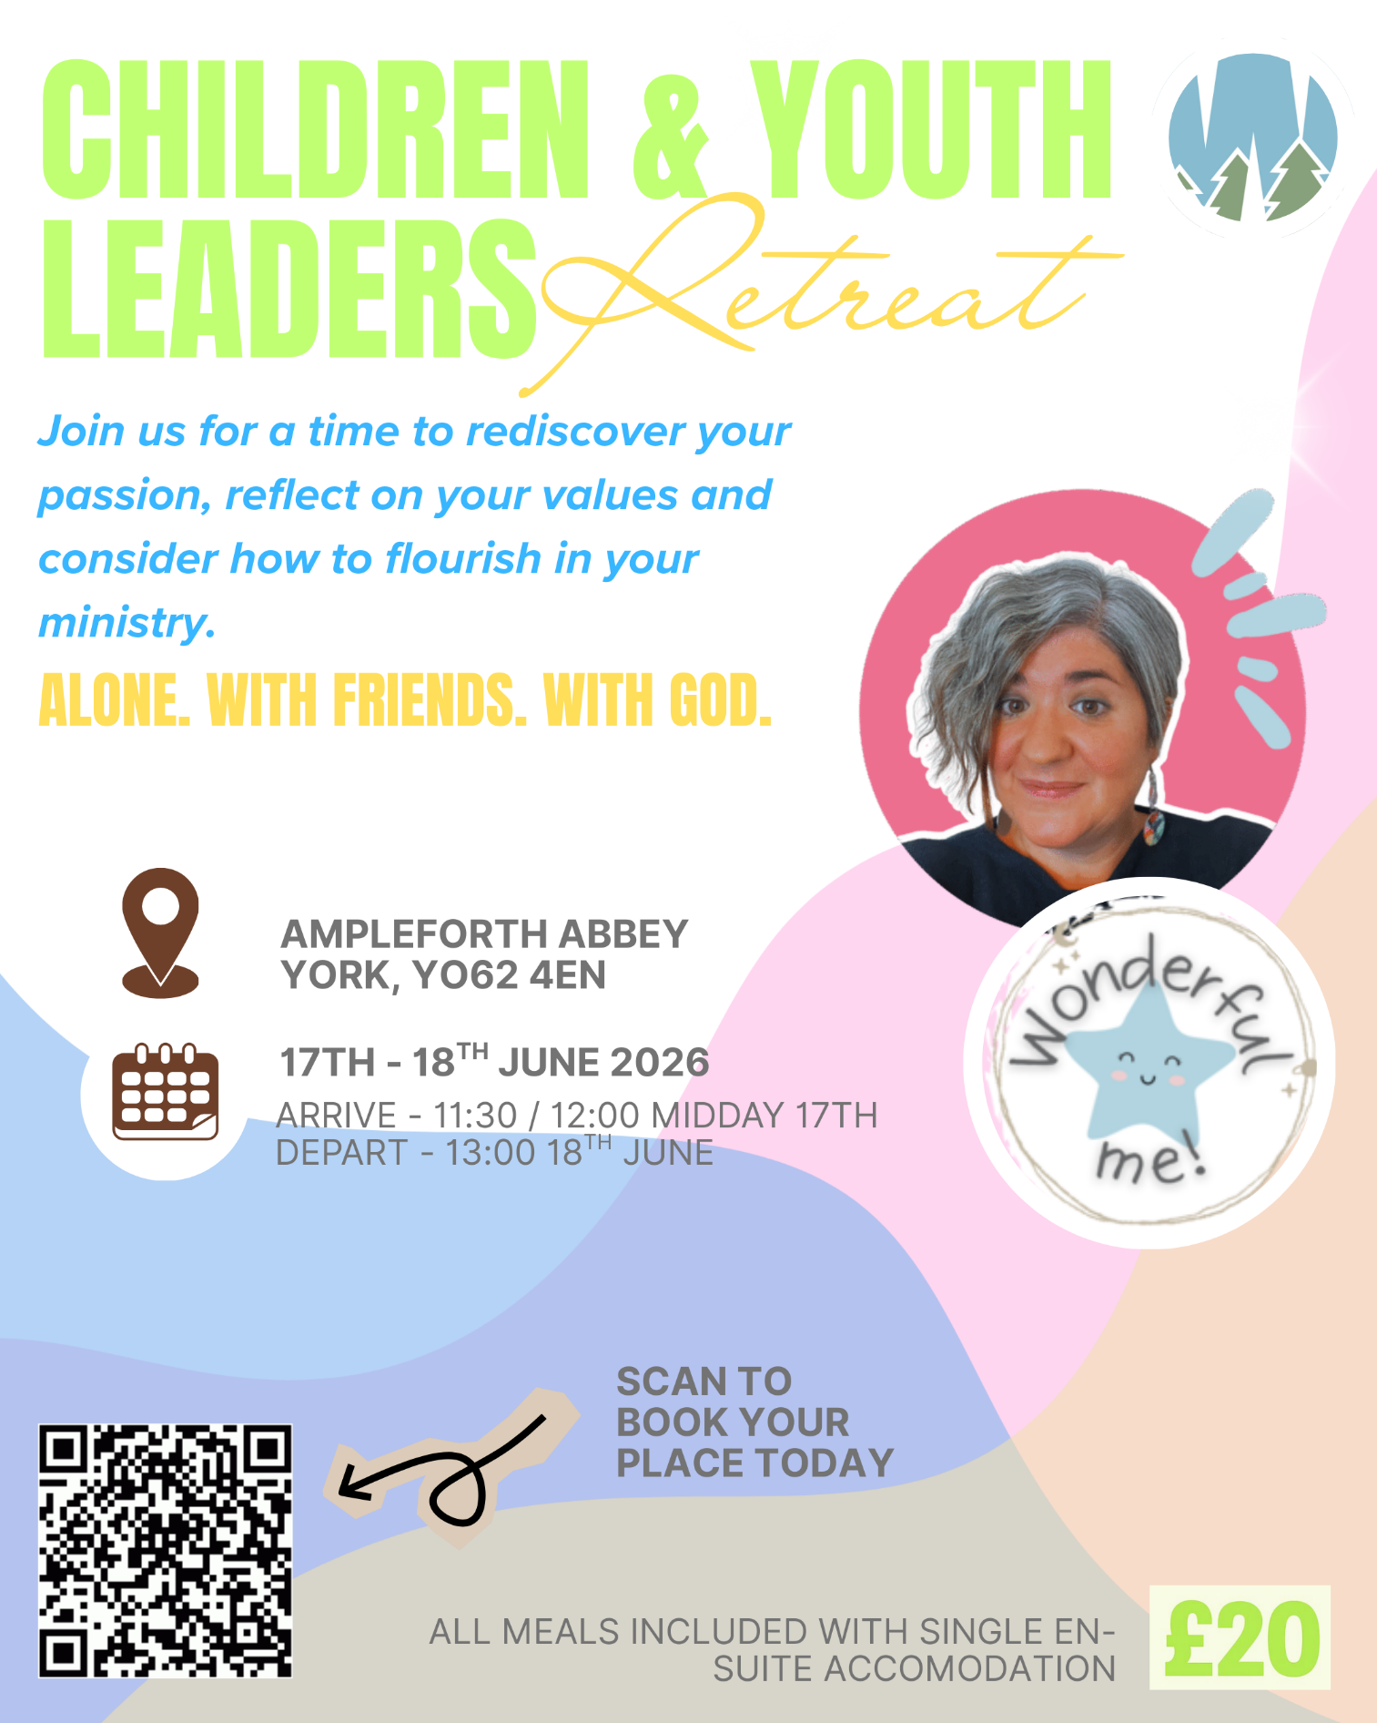



Yorkshire Synod Discipleship Development Small Grant Fund 2026
The Synod is pleased to let you all know that it has received confirmation that it has a pot of £4000 to grant to those wishing to apply to the Yorkshire Synod Discipleship Development 2026. Currently we have been able to grant about half of what has been allocated to us, and we would love to be able to offer grants to enable us to use the whole amount what Yorkshire Synod has been allocated.

1. Who is eligible to apply? Committed members or adherents, including children and young people, of a congregation within the United Reformed Church who are exercising, or want to exercise, a form of lay ministry or community service whether expressed within or beyond their local church. The DDF is not open to Ministers of Word and Sacraments and CRCWs, as there are other designated funds available for those groups.

2. How much is available? Up to £300 per applicant per calendar year, although the Synod may agree to more than this according to the local context and circumstances.

3. What can this money be used for? The purposes for which the funding is provided are defined by creativity and vocation, in line with the URC's discipleship development strategy. Be bold, take risks. The funding exists to help you to follow Jesus. You might be helped in this by courses (at any level) at any of the URC Resource Centres for Learning or from other learning providers, or you may have ideas on resourcing discipleship development in other people. You may need funds to cover the costs of travel, materials or books. All you have to do is make a case to your local church meeting and submit the application form to the Synod Convenor of Ministries for consideration and, if appropriate, authorisation.

4. How are applications made? Having gained your church meeting's endorsement, applications are to be made on the designated form, well before the spending is due to start. Backdated applications will not normally be accepted. Application forms are obtainable from the Synod Convenor of Ministries via the Synod Office at office@urcyorkshire.org.uk and should be sent back for authorisation before being passed to the synod finance office.

5. How are grants paid? Grants authorised by the Convenor of Synod Ministries
are paid by a Synod finance officer by reimbursement to you when you have given proof of what you've spent. Contact your Synod Convenor of Ministries for discussion if you need something funded directly on your behalf, rather than waiting for re-imbursement.

If anyone wants to discuss an application before submitting please contact the Convenor of the Yorkshire Ministries Committee, Kath Lonsdale at kathlonsdale@talktalk.net.
Remember this is for any age of lay person in our churches to apply for so please discuss with your young people as well as adults.
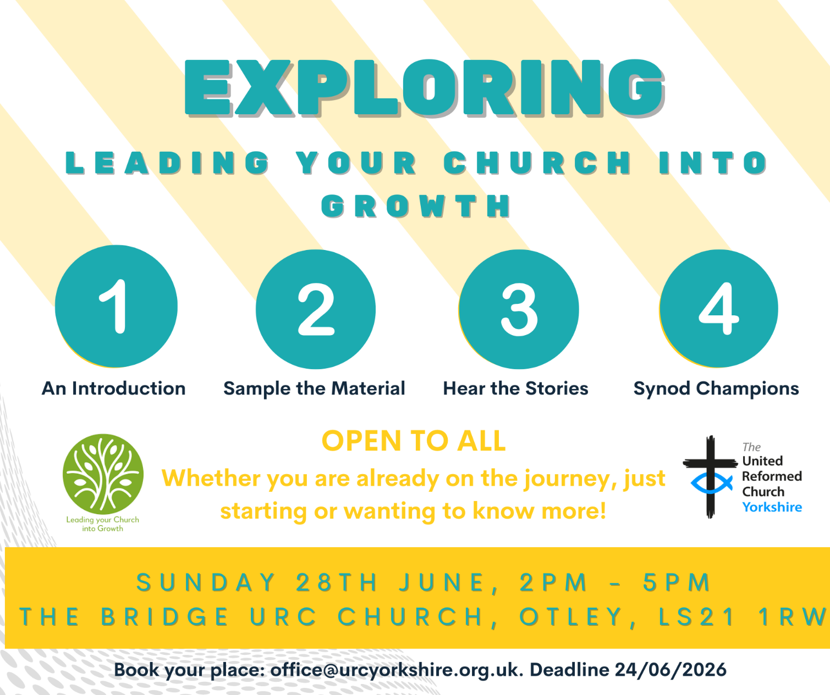

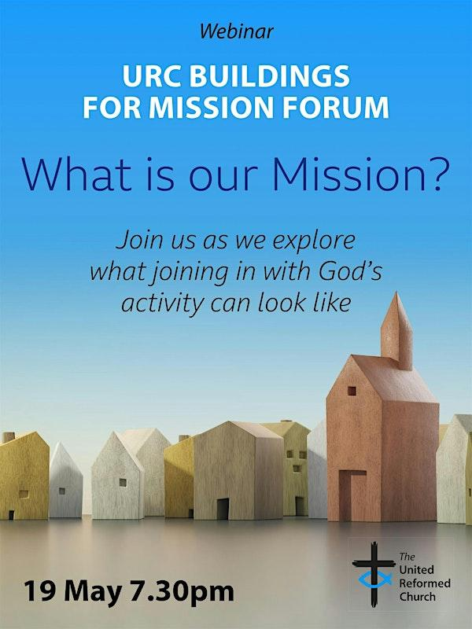
Buildings for Mission Forum Webinar
Tuesday 19 May 7.30pm
What is our Mission?
Join us as we explore what joining in with God’s activity can look like.
Register for the webinar here: https://www.eventbrite.com/cc/buildings-for-mission-forum-4814853?utm-campaign=social&utm-content=creatorshare&utm-medium=discovery&utm-term=odclsxcollection&utm-source=cp&aff=escb


Longcauseway Church ( United Reformed and Methodist) situated in the centre of Dewsbury, is looking to appoint a:
Church Community Project Leader and Premises Manager

37 hours per week, worked flexibly on a 3 year fixed contract

Salary: £27500 - £29000 pa, depending on qualifications/experience
(28 days holiday including Bank Holidays)
plus reasonable out of pocket expenses and travel expenses.
We are looking for an enthusiastic and committed individual to help us to further develop and implement our church’s mission through engaging and appropriate activities for all age groups with faith, hope and love for Dewsbury at their heart.
As well as being able to manage the day to day management of the church premises.
This post will require flexibility, including some evenings, weekends and Bank Holidays and it will be subject to an enhanced DBS check.
It is a Genuine Occupational Requirement for the post-holder to be a Christian.
Please contact the Church Secretary, Mrs Jo Hartley
email: churchsecretarylcw@outlook.com)
for a Job Description and Application Form.
Completed applications must be received by and Interviews will be arranged during the week beginning 29th June 2026.
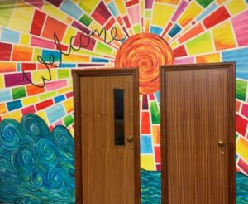

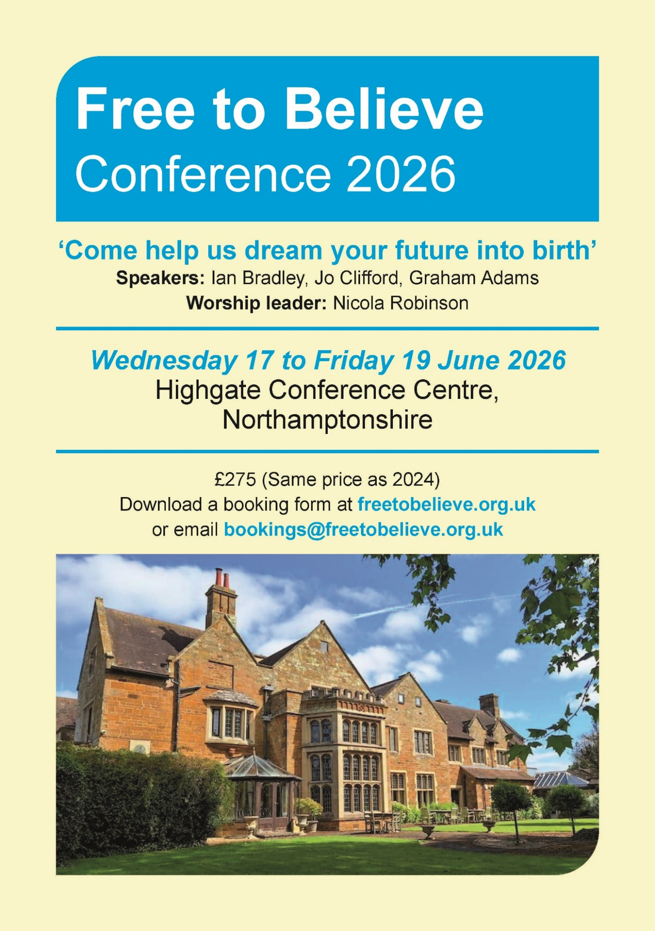
For more information, please visit the Free to Believe website at https://freetobelieve.org.uk/conferences.html
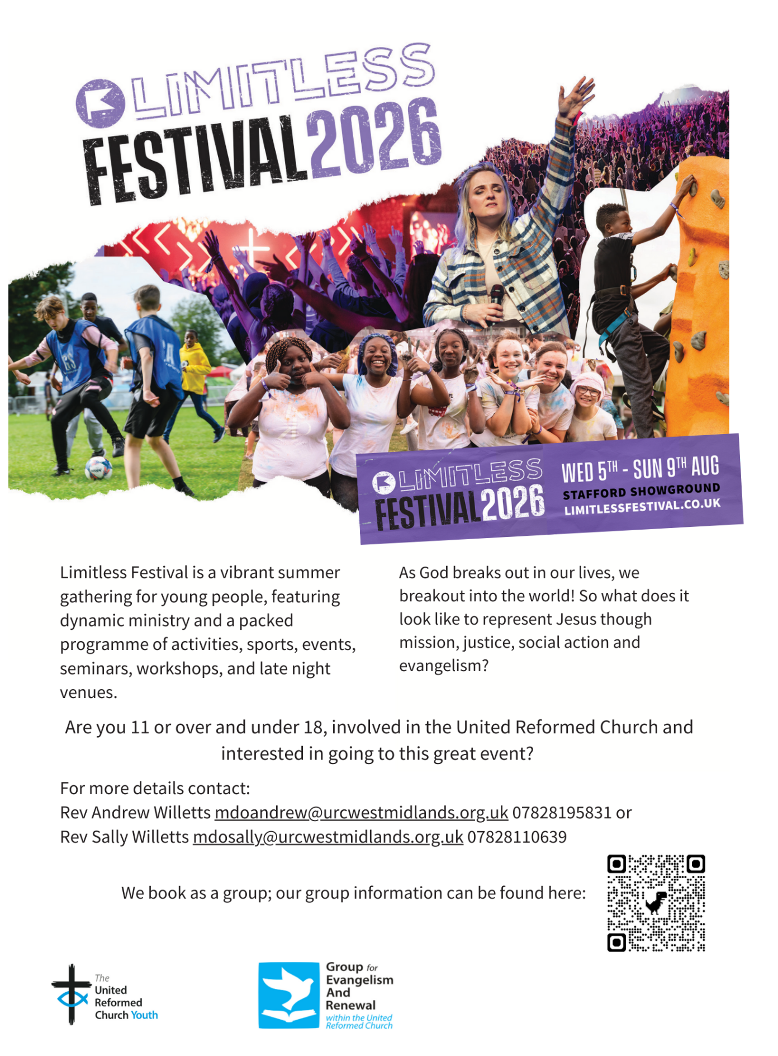


NEWS FROM THE DENOMINATION
The URC’s News Update is a regular e-newsletter that keeps you informed about the latest news and events.
To receive this popular newsletter, please visit the https://urc.org.uk/news-updates-sign-up-form/ page on the URC website and follow the links. If you just want to dip in and catch up on what is going one, that’s fine and you can
read and print recent editions of our e-newsletter by visiting the URC News Update page at https://urc.org.uk/urc-news-update/ .

Submit your photographs for the 2027 URC Calendar

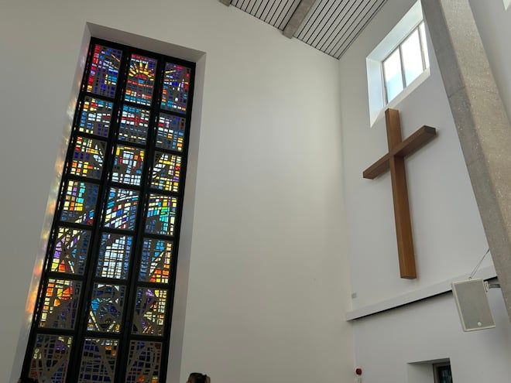
The 2027 United Reformed Church Calendar is titled ‘Transparent as glass’ and will feature stained glass windows and glass sculptures from our churches and Local Ecumenical Partnerships.

Glass has been used in churches since the 7th century for visual storytelling and religious education, acting as colourful “picture books” for congregations to learn Bible stories and for Christian teaching. Stained glass also creates a sacred atmosphere by focussing light for worship and enhancing our churches’ architectural beauty.

We invite you to send in your photos of large and small windows, as well as any sculptures made from, or including, glass. Please include the name of the church and the photographer. You can email your image(s) to the URC Press Office, pressoffice@urc.org.uk.

Please note that for all photos submitted, the photographer is granting the URC permission to use the photographs in print and digitally. The deadline for submitting your photos is June 5 2026.

The calendar will be available on the URC Bookshop from August and is once again generously supported by Edwards Insurance.

Safeguarding News
For more details please contact either Emma Pearce at emma.pearce@urc.org.uk or our own Carrie Kaunda at carrie.kaunda@urc.org.uk
The Safeguarding team are available seven days a week and 365 days a year as the inbox is monitored at weekends. This inbox is not monitored continually but concerns will be responded to within 24 hours. If you need immediate support, please contact the Police or your Local Authority Duty Safeguarding Team. All contact details for these services MUST be displayed in your churches.
Further details can be found on the Yorkshire website at https://urcyorkshire.org.uk/safeguarding/ or email your query to safeguarding.1and4@urc.org.uk.
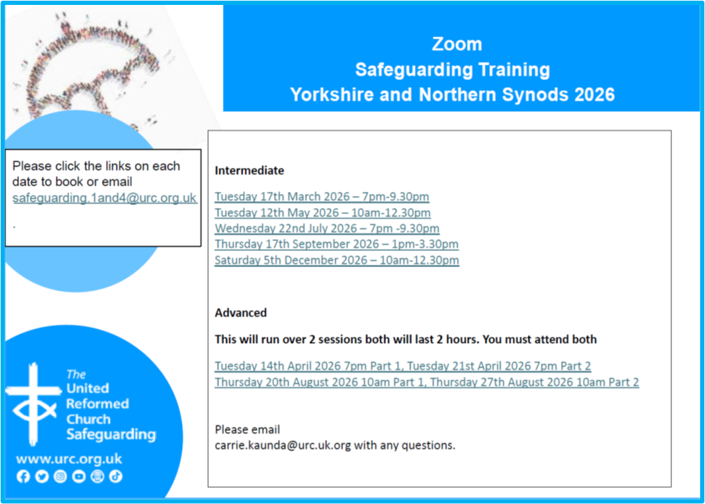

If you have a good news story from your part of the Synod or something that you feel reflects the work of Synod and which inspires others as we move into 2026, drop me a line at clerk@urcyorkshire.org.uk and I’ll make sure it hits the back page!!

You can also keep an eye on all our social media platforms for news; on the website at Home - URC Yorkshire Synod, at United Reformed Church in Yorkshire - Home | Facebook and Wilderness URC Yorkshire - Home | Facebook, the YouTube page at URC Yorkshire - YouTube and the Twitter (X) page at URC in Yorkshire (@URCYorkshire) / Twitter.

