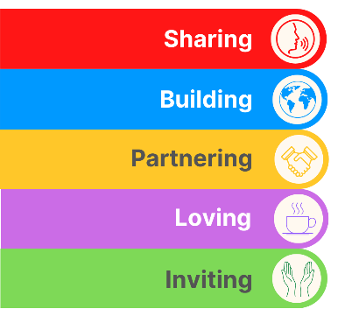
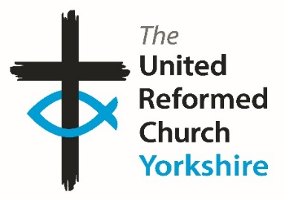
Yorkshire Synod Briefing
Number 175

4th June 2026

Summer is Here
I’ve recently come back off a week’s holiday, and unusually for the May half-term week, I have caught the sun. I also gather it was rather warm here in Yorkshire this past week or so as well, although fortunately for me the seas surrounding Cornwall tempered the intemperate temperatures. Happily, it didn’t spoil my enjoyment of a part of the world that many of us have visited and enjoyed.
Heat and flame crop up at this time of year in our Christian calendar with the incredible story of Pentecost telling how the Holy Spirit descended on the apostles in what seemed to be tongues of fire resting on each of them. Likewise we are urged in last week’s Lectionary to “make disciples of all nations, baptising them in the name of the Father and of the Son and of the Holy Spirit”. That fire the Spirit gives us I hope will help us make new disciples, sustain us through the summer and refresh us when we head away on our holidays over the next few months.
This leads me on to asking that you will join me in wishing our Moderator, Revd Jamie Kissack, a productive and fulfilling Sabbatical which begins this coming Monday, June 8th. This gift is offered to all our ministers and is there to enable spiritual refreshment. No doubt we will hear much of how that experience has renewed Jamie’s outlook after he returns 22nd September. Cover is in place and plans are already afoot at the Synod office to ensure that all questions can be answered whilst Jamie is away. In particular it is worth thanking Anne Ward and Claire Preest at Somerset House who will be covering the Moderator’s PA role between them. Anne will be overseeing the paperwork for Moderators’ Meetings and Introductions etc, whilst Claire will be monitoring the Moderator’s diary. Both Anne and Claire will have access to the moderatorpa@urcyorkshire.org.uk account. However, the moderator@urcyorkshire.org.uk e-mail address will have an out-of-office message and will not be responded to. Therefore, if you have any enquiries relating to Jamie’s role before or during his Sabbatical, please use the moderatorpa@urcyorkshire.org.uk e-mail address.

Please continue to send invitations to your events, your stories and pictures in to me, and I’ll continue to advertise and share them throughout 2026, either here in The Briefing or on the Synod website at https://urcyorkshire.org.uk/. This time there seems to be an emphasis on musical invitations and we have a homegrown “And Finally” story celebrating the dedication of our own Trust Secretary, Rachel Crawshaw. Please keep sending in the stories and invitations so that I can showcase your church around the Synod. They may even end up in https://urc.org.uk/our-news-stories/latest-news/ which is always worth a read and has the opportunity to sign up for regular URC’s news updates.
So, if you have any news of welcoming people into Church, stories of celebration and mission, please let me know by dropping me a line at clerk@urcyorkshire.org.uk and I’ll showcase it in the next edition, due out on the website only on 18^{h} June 2026.
Tim Crossley
Yorkshire Synod Clerk

Big Day Out Bonanza
Back in 16th May the Synod hosted The Big Day Out. It was a cracking day and for those who attended it will last long in the memory. The plan is to have a bigger and better report of what happened in the next issue, but to keep the memory fresh in the minds of those who attended and to encourage people to join the festivities at the next BIG DAY OUT, here’s a report from Pauline Hayley, an Elder at Westfield Wyke URC.
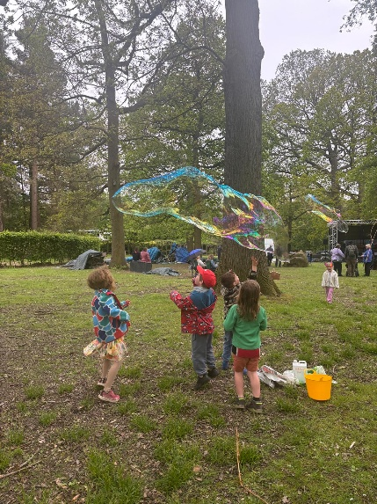
"Saturday 16th May was our BIG DAY OUT at Yorkshire Sculpture Park giving us the chance to meet with people from other churches within Yorkshire Synod. How lovely it was that Westfield were able to also take members from all the other churches in Wyke along with us.
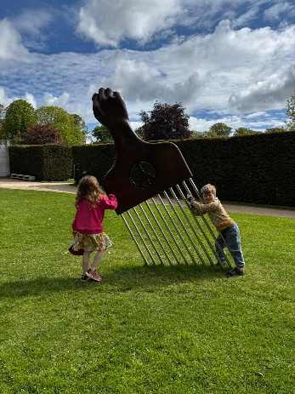
Activities and games were numerous and listening to the chatter in the cafe and watching people passing the window adorned with their creation sit seemed like everyone enjoyed joining in. I have to say that the things I loved the most were the assembly sing along and the magnificent production of The Fisherman's Tale by the 4 Front Christian theatre group. It captured the imagination of young and old alike and such a good way to remind us all of the important messages the New Testament gives us.
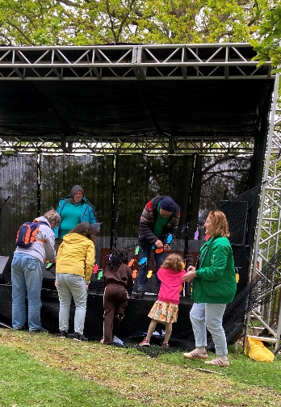
We rounded the day off with a communion with a difference sharing together in groups of 10 to partake in the sharing of wine and bread. Just as we said the final Amen the first spots of rain came down waiting to start to rain in earnest until we were on our way home.
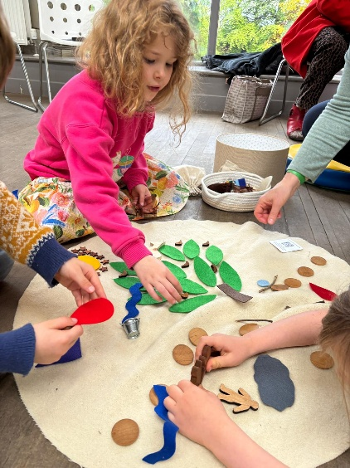
The organisation of the event was superb from beginning to end so well done all those involved in organising it."

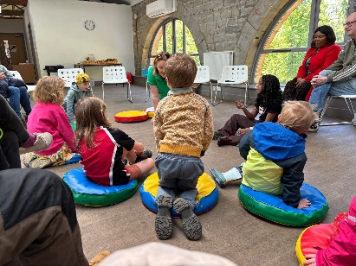
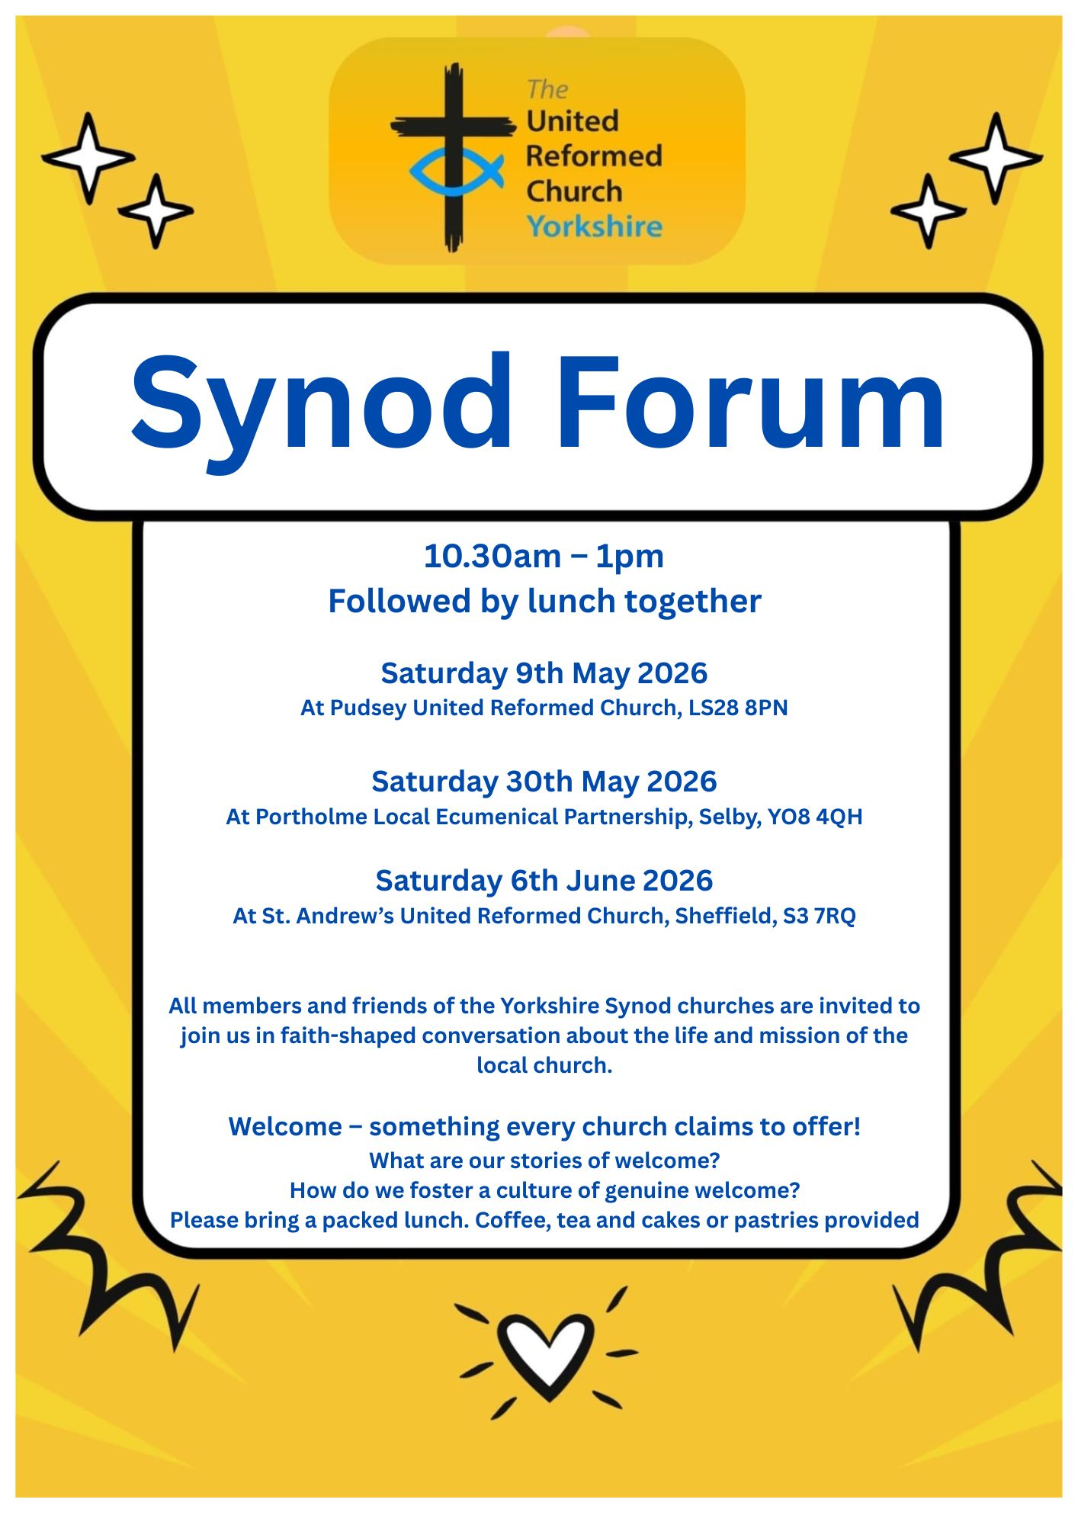
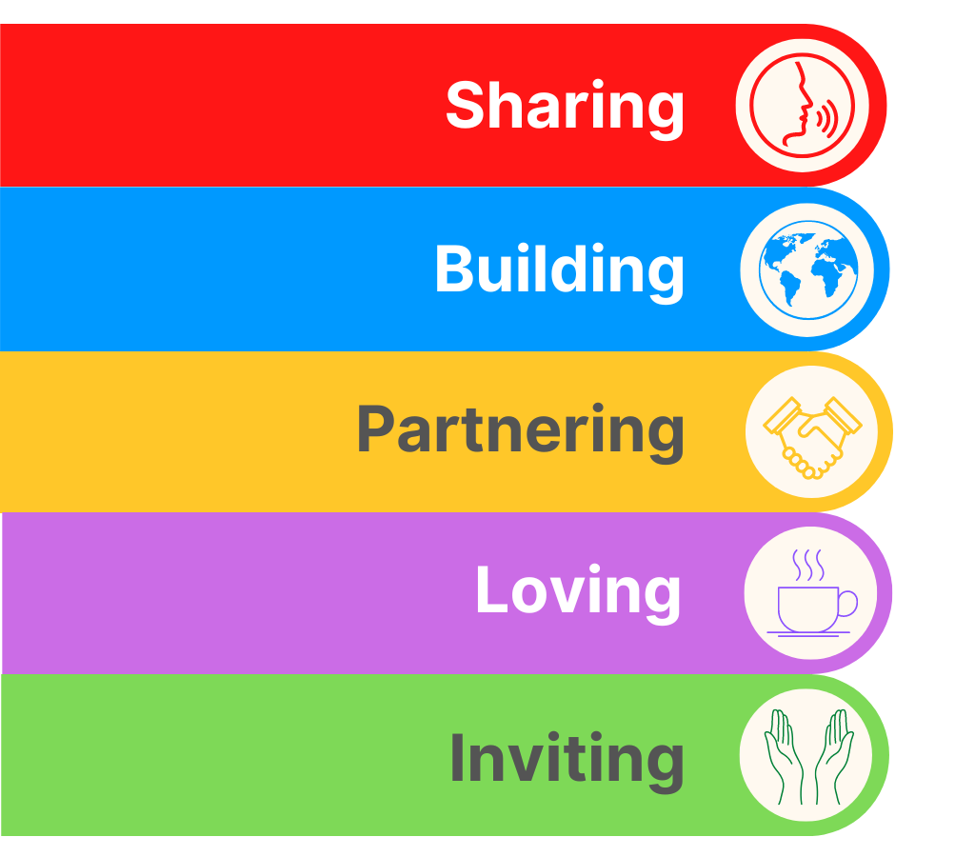
SYNOD FORUM REFLECTION
This Saturday sees the last of this year’s Synod Forums, so please read the reflection from the Pudsey event which is a nice taster of what is to come at St Andrew’s Sheffield.

Churches are like custard!

There are lots of things that I don’t know about churches and lots of things that are frustrating but there are also lots of times when I delight in things I hear. Having never been to a Synod Forum I took the opportunity to go to the one being held in Pudsey URC on Saturday 9th of May.
Excitement, trepidation, apprehension are just a few words I would use to describe how I was feeling as I walked through the doors. A few familiar faces made me feel less anxious and the warm welcome I received relaxed me quite quickly.
The gathering began with an opening prayer and reflection led by Synod Moderator Jamie Kissack. Then we discussed and reflected on whether our churches are truly welcoming. We as Christians often think we are, but are we really? Do we hold on to the past as ‘that’s the way we’ve always done it’? Do we resist change?
I was particularly struck when Jamie said ‘churches are like custard, if you don’t stir them then a skin forms’. We need to change to continue to grow – to avoid becoming cold, sluggish, congealed and unappetising! For me the idea of an impenetrable skin is not hard to imagine. I don’t want to picture my church being covered in a thick, yukky skin preventing anyone from coming in and experiencing God’s Love. Are we prepared to keep looking hard at everything we do to ensure we are inclusive?
In small groups we looked at short bible passages, exploring how each passage could help churches become more welcoming. My group discussed ways in which we could show our commitment to inclusivity, including by:
- Smiling
- Being authentic
- Talking to people but more importantly listening to them. Do you always sit with friends over coffee – could you talk to someone different from time to time? Equally it is important not to swamp or overwhelm new people with an overenthusiastic welcome from everyone – we need to find the balance that is right for each individual and one type of welcome does not fit all!
- offering gluten free bread as standard
- putting children at the front rather than tucking them away at the back
- making on screen images clear - not always having background images with text overlay
- removing jargon as it can be a barrier
Finally, we asked ourselves:
- Are we an inclusive church accepting everyone for who they are irrespective of age, race, gender, sexuality, wealth, status, etc?
- Do we take on roles that are necessary rather than finding excuses to do only the things we enjoy?
- Do we invite everyone to join us or do we decide who is in and who’s not?
I also found out a lot about the Yorkshire Synod - paid and volunteer team members shared information about their roles which was really interesting. They reminded us that their role is to help us as local churches and asked what we felt we needed from them. They took home many suggestions, including that they tell us more about what they do so that local churches know what we can ask for help with.
Apart from the image of churches being like custard I want to leave you with this thought: “every time a new person joins our church then we become a new church”.
I am really pleased that I made time to go to this event. If, like me, you have never been to one of these gatherings before please consider it. To get details of future meetings and of other events going in around our area, why not sign up for Synod’s news briefings at https://urcyorkshire.org.uk/latest-news/ .
Heather Thomson, Elder, St Andrew’s URC, Roundhay.

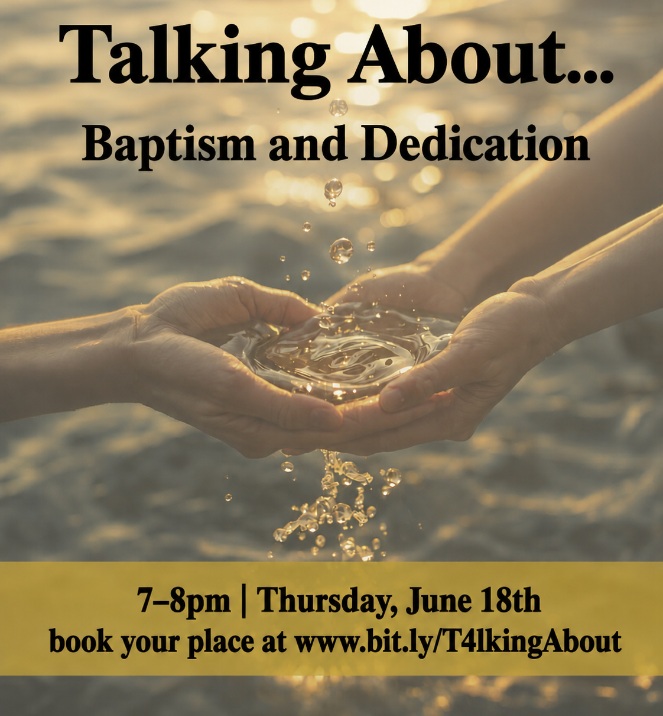
From babies to believers, Christenings to confirmations, a baptism is often the first display of commitment to following Jesus by an individual, or their parents. It is an event that universally brings a feeling of joy and goodwill to a local church congregation.
How can we make the most of this opportunity to share the sacrament of baptism with those who are new to church in a way that is welcoming, missional, and invitational, helping it become more than simply a service we provide, but an invitation into faith and community?
The United Reformed Children and Youth Team have been developing resources for infant and believer’s Baptism, as well as confirmation.
This is your chance to ask questions of those who developed the material, share thoughts, and reflect on what Baptism/Dedication/Confirmation might look like in your context.
BOOK YOUR PLACE AT www.bit.ly/T4lkingAbout
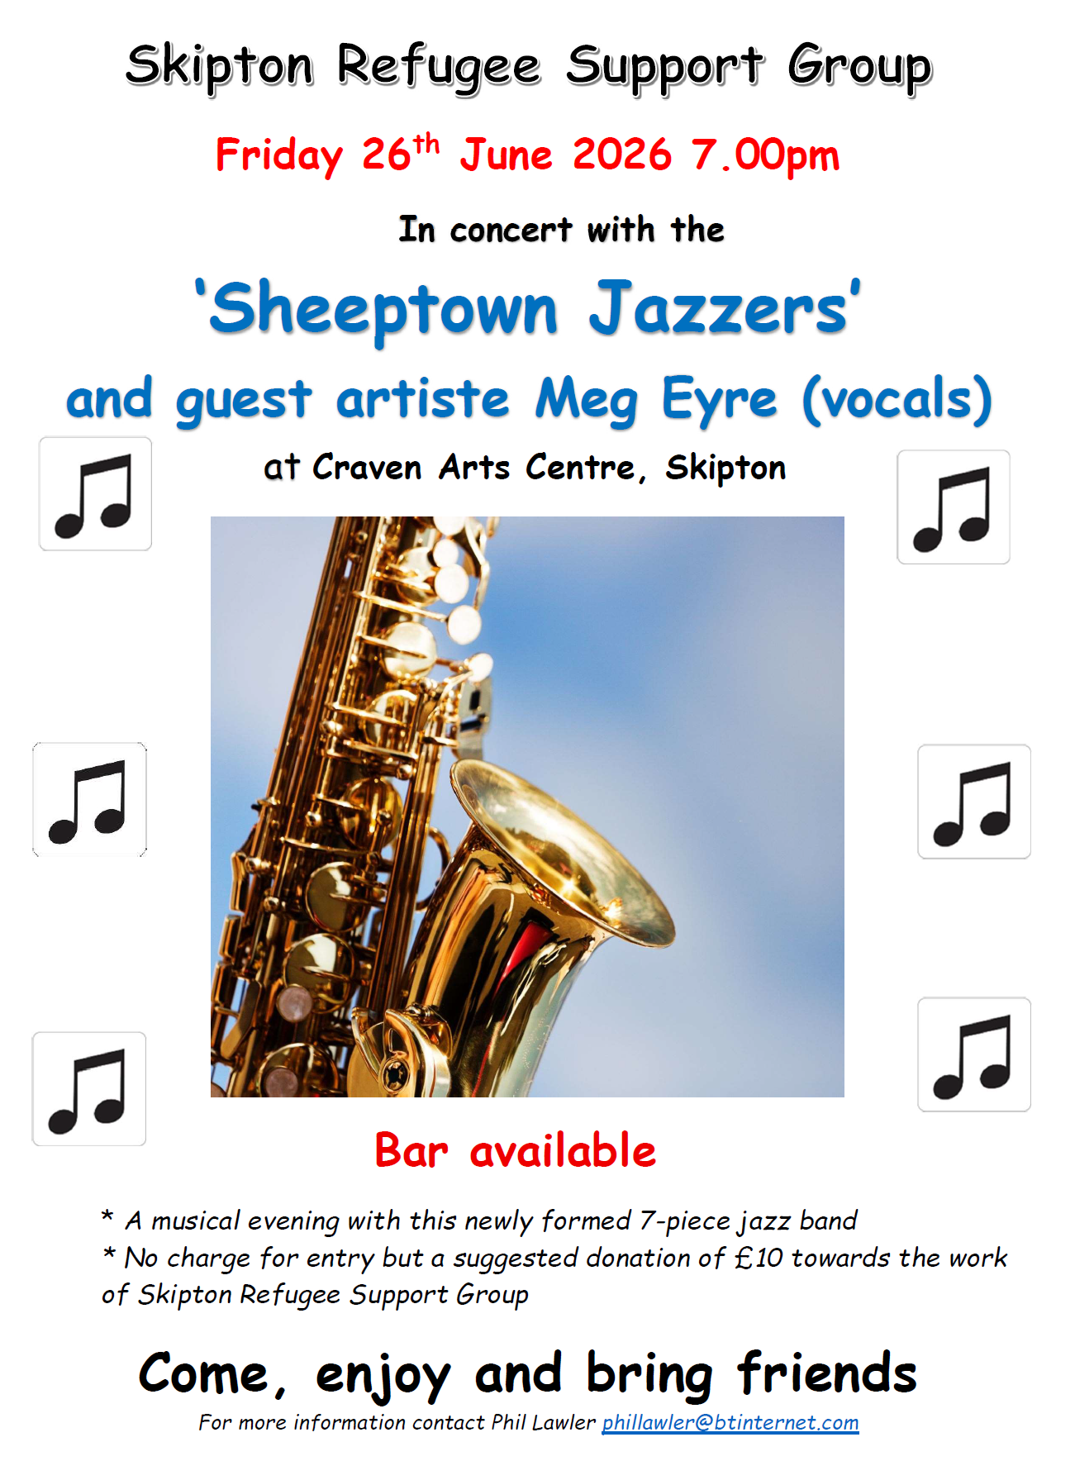
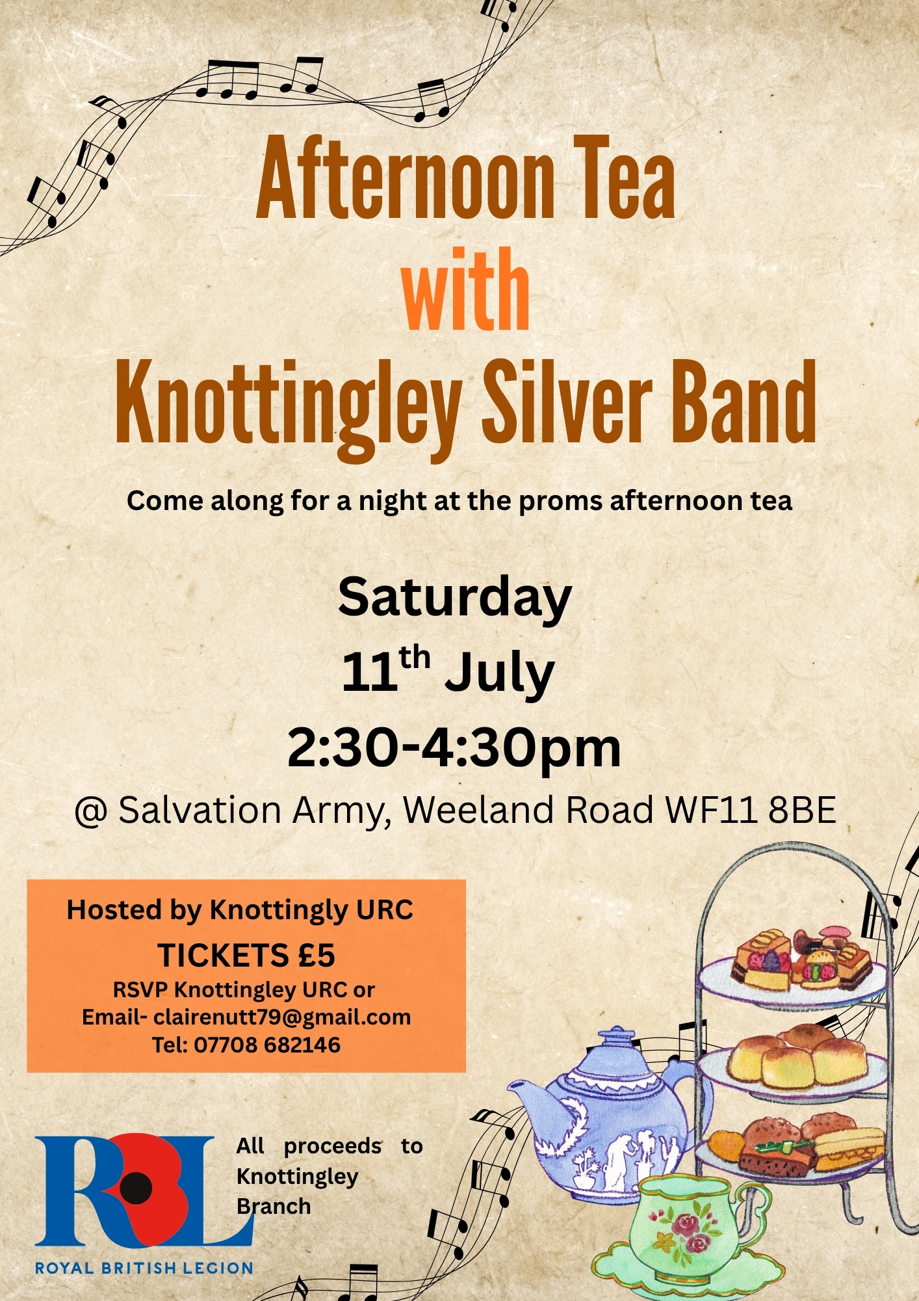

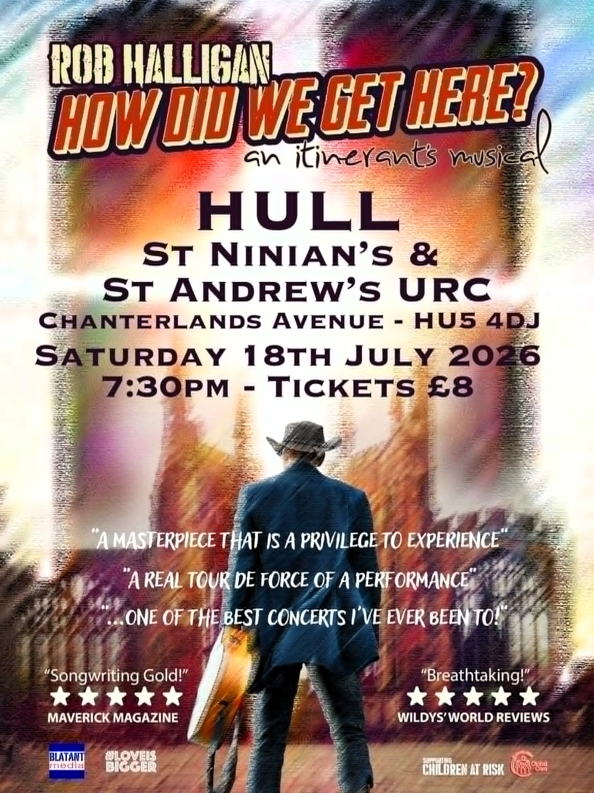

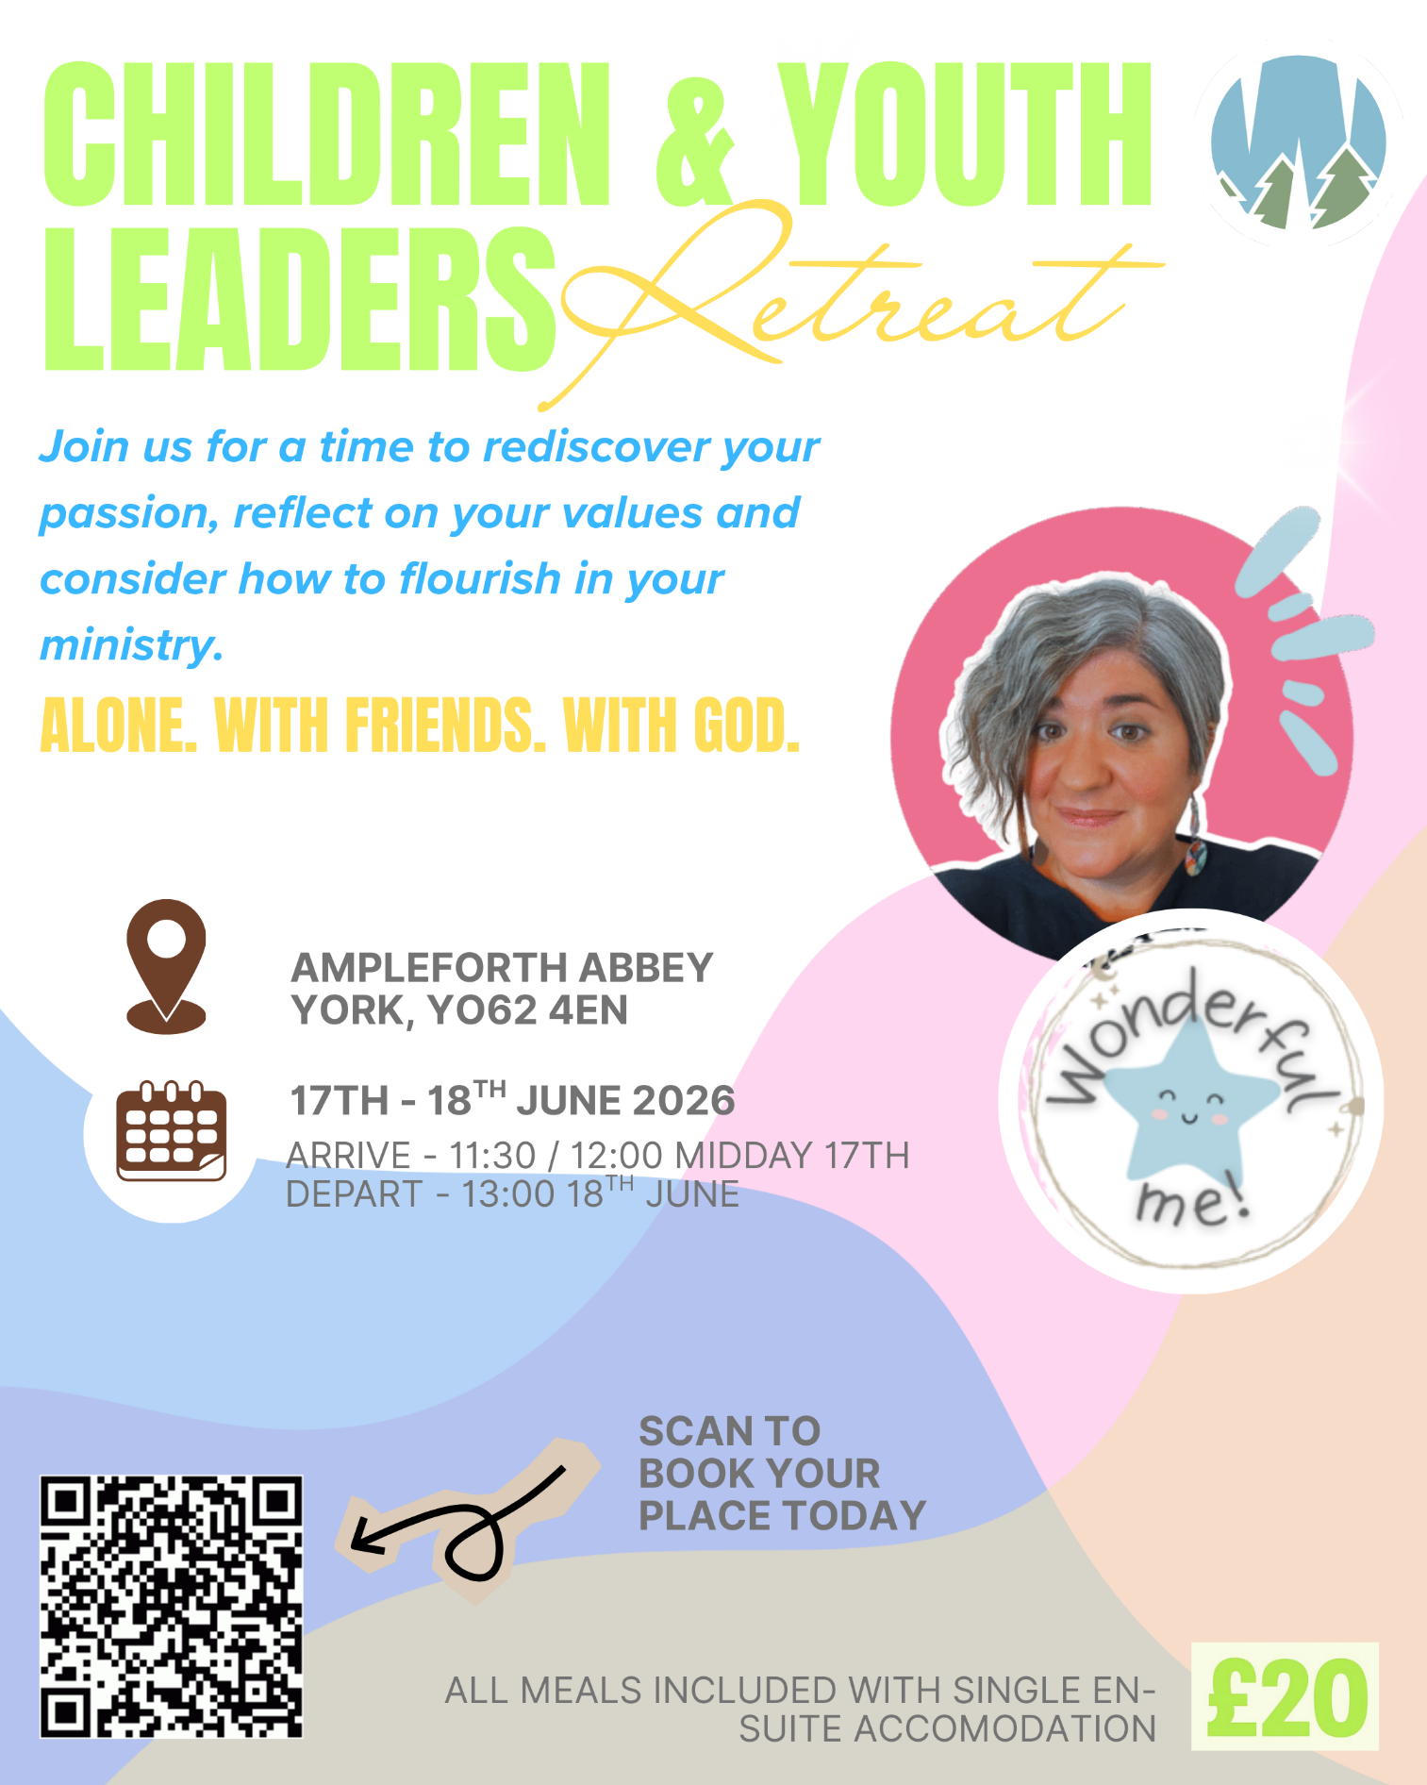



Yorkshire Synod Discipleship Development Small Grant Fund 2026
The Synod is pleased to let you all know that it has received confirmation that it has a pot of £4000 to grant to those wishing to apply to the Yorkshire Synod Discipleship Development 2026. Currently we have been able to grant about half of what has been allocated to us, and we would love to be able to offer grants to enable us to use all of what Yorkshire Synod has received.

1. Who is eligible to apply? Committed members or adherents, including children and young people, of a congregation within the United Reformed Church who are exercising, or want to exercise, a form of lay ministry or community service whether expressed within or beyond their local church. The DDF is not open to Ministers of Word and Sacraments and CRCWs, as there are other designated funds available for those groups.

2. How much is available? Up to £300 per applicant per calendar year, although the Synod may agree to more than this according to the local context and circumstances.

3. What can this money be used for? The purposes for which the funding is provided are defined by creativity and vocation, in line with the URC's discipleship development strategy. Be bold, take risks. The funding exists to help you to follow Jesus. You might be helped in this by courses (at any level) at any of the URC Resource Centres for Learning or from other learning providers, or you may have ideas on resourcing discipleship development in other people. You may need funds to cover the costs of travel, materials or books. All you have to do is make a case to your local church meeting and submit the application form to the Synod Convenor of Ministries for consideration and, if appropriate, authorisation.

4. How are applications made? Having gained your church meeting's endorsement, applications are to be made on the designated form, well before the spending is due to start. Backdated applications will not normally be accepted. Application forms are obtainable from the Synod Convenor of Ministries via the Synod Office at office@urcyorkshire.org.uk and should be sent back for authorisation before being passed to the synod finance office.

5. How are grants paid? Grants authorised by the Convenor of Synod Ministries
are paid by a Synod finance officer by reimbursement to you when you have given proof of what you've spent. Contact your Synod Convenor of Ministries for discussion if you need something funded directly on your behalf, rather than waiting for re-imbursement.

If anyone wants to discuss an application before submitting it please contact the Convenor of the Yorkshire Ministries Committee, Kath Lonsdale at kathlonsdale@talktalk.net.
Remember this is for any age of lay person in our churches to apply for so please discuss with your young people as well as adults.
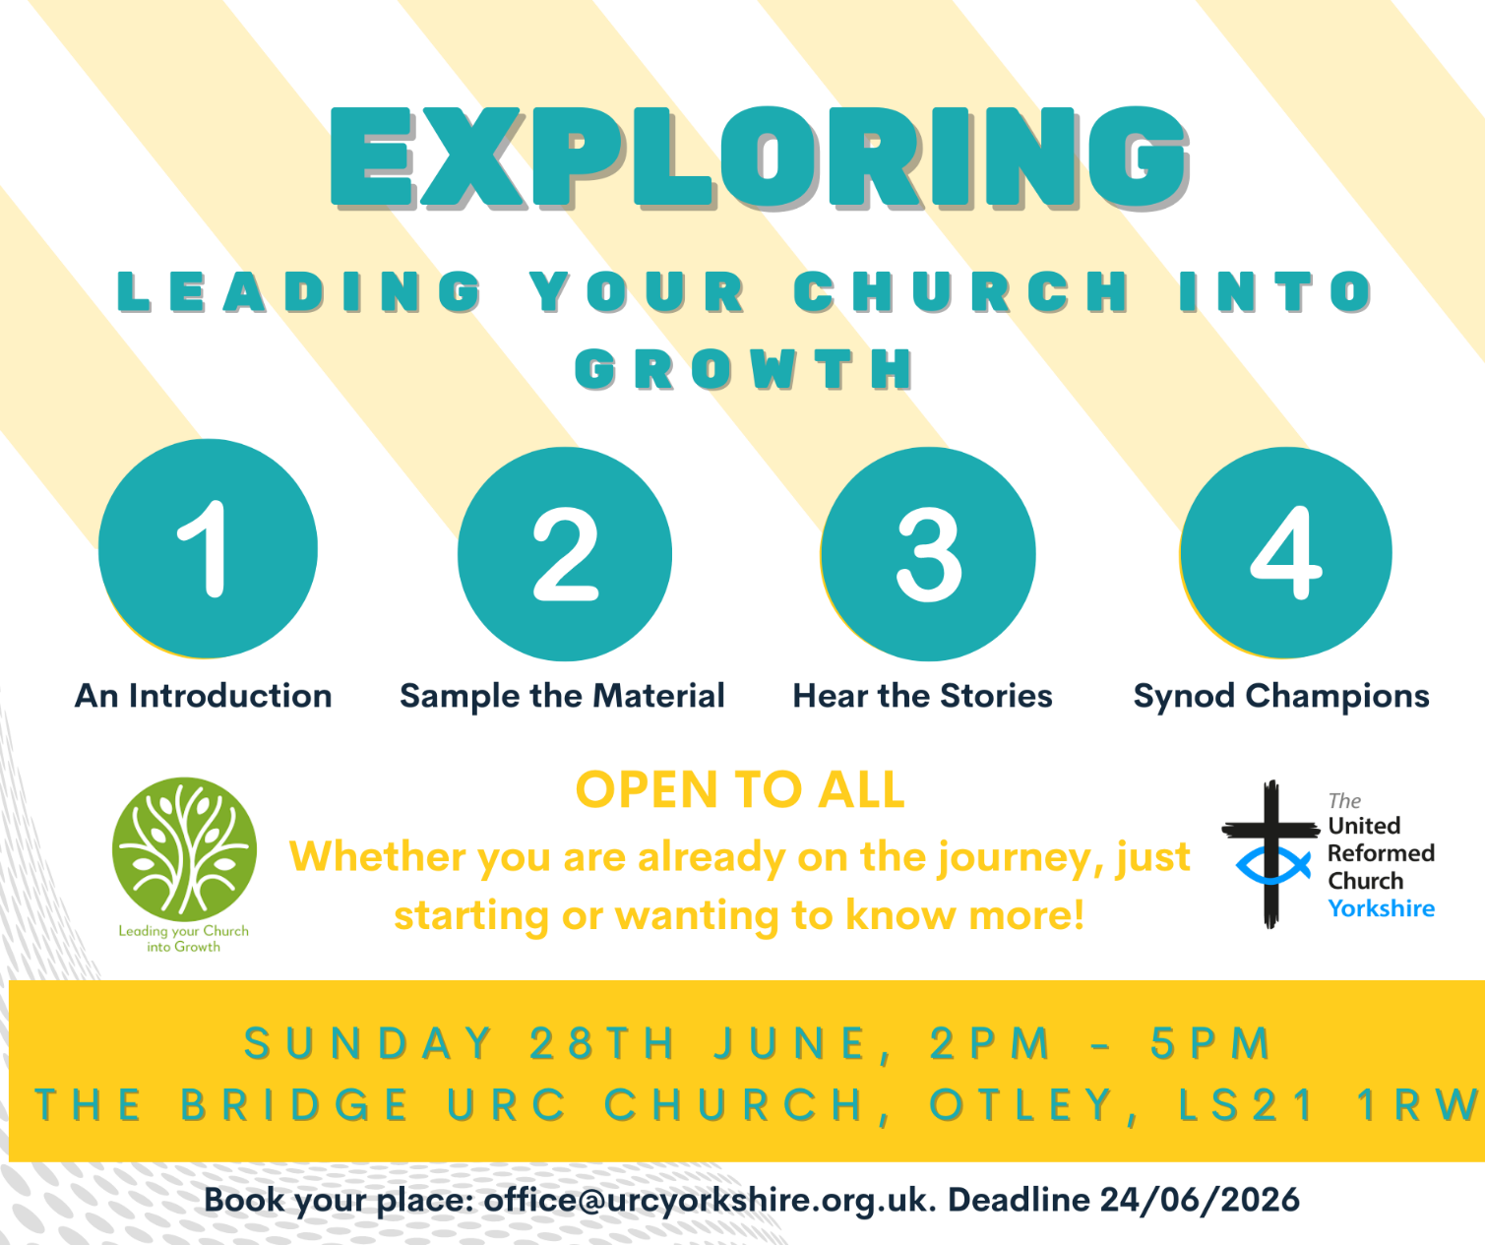

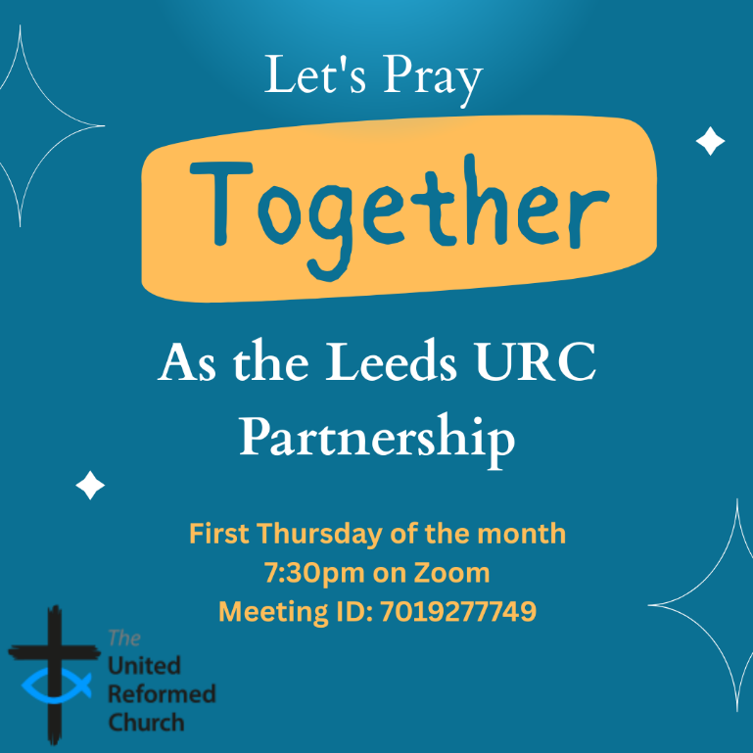
Leeds URC Partnership Prayers
Thursday, 4 June, 7:30pm.
A short time to pray together by reading the Bible and sharing the joys and challenges in our lives, churches, communities and world.
On Zoom:
https://us02web.zoom.us/j/7019277749

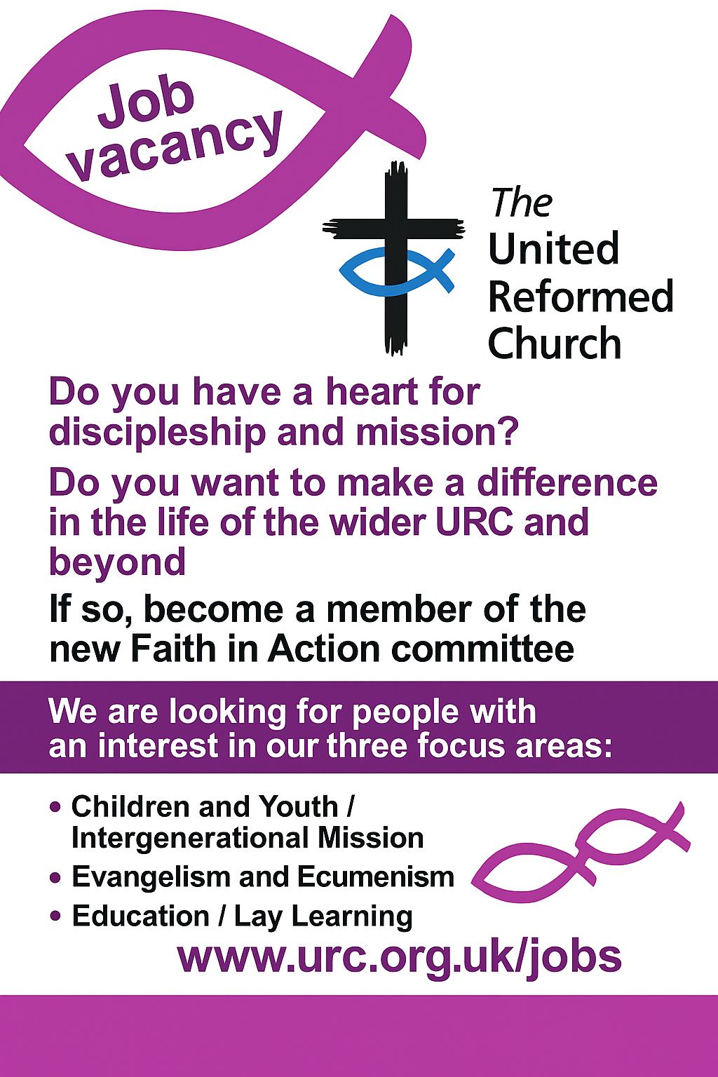
Longcauseway Church ( United Reformed and Methodist) situated in the centre of Dewsbury, is looking to appoint a:
Church Community Project Leader and Premises Manager

37 hours per week, worked flexibly on a 3 year fixed contract

Salary: £27500 - £29000 pa, depending on qualifications/experience
(28 days holiday including Bank Holidays)
plus reasonable out of pocket expenses and travel expenses.
We are looking for an enthusiastic and committed individual to help us to further develop and implement our church’s mission through engaging and appropriate activities for all age groups with faith, hope and love for Dewsbury at their heart.
As well as being able to manage the day-to-day management of the church premises.
This post will require flexibility, including some evenings, weekends and Bank Holidays and it will be subject to an enhanced DBS check.
It is a Genuine Occupational Requirement for the post-holder to be a Christian.
Please contact the Church Secretary, Mrs Jo Hartley
email: churchsecretarylcw@outlook.com)
for a Job Description and Application Form.
Completed applications must be received by and Interviews will be arranged during the week beginning 29th June 2026.
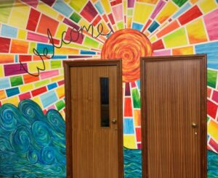

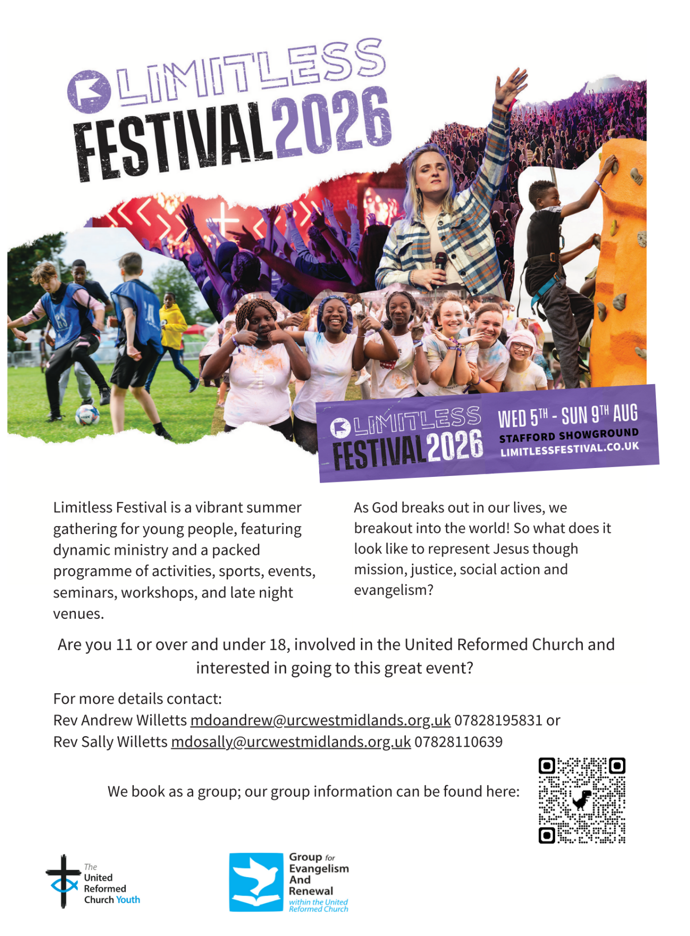

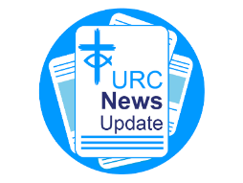
NEWS FROM THE DENOMINATION
The URC’s News Update is a regular e-newsletter that keeps you informed about the latest news and events.
To receive this popular newsletter, please visit the https://urc.org.uk/news-updates-sign-up-form/ page on the URC website and follow the links. If you just want to dip in and catch up on what is going one, that’s fine and you can
read and print recent editions of our e-newsletter by visiting the URC News Update page at https://urc.org.uk/urc-news-update/ .

The Synod is looking for people to join some of our key groups, especially the Children and Young People’s, the Property and the Financial Resources committees. These bodies guide the direction of Synod and without them Synod would find it hard to function. If you are able to take up a call to help Synod out, please contact the Synod Clerk at clerk@urcyorkshire.org.uk for more information.
Safeguarding News

The Safeguarding team are available seven days a week and 365 days a year as the inbox is monitored at weekends. This inbox is not monitored continually but concerns will be responded to within 24 hours. If you need immediate support, please contact the Police or your Local Authority Duty Safeguarding Team. All contact details for these services MUST be displayed in your churches
Further details can be found on the Yorkshire website at https://urcyorkshire.org.uk/safeguarding/ or email your query to safeguarding.1and4@urc.org.uk.

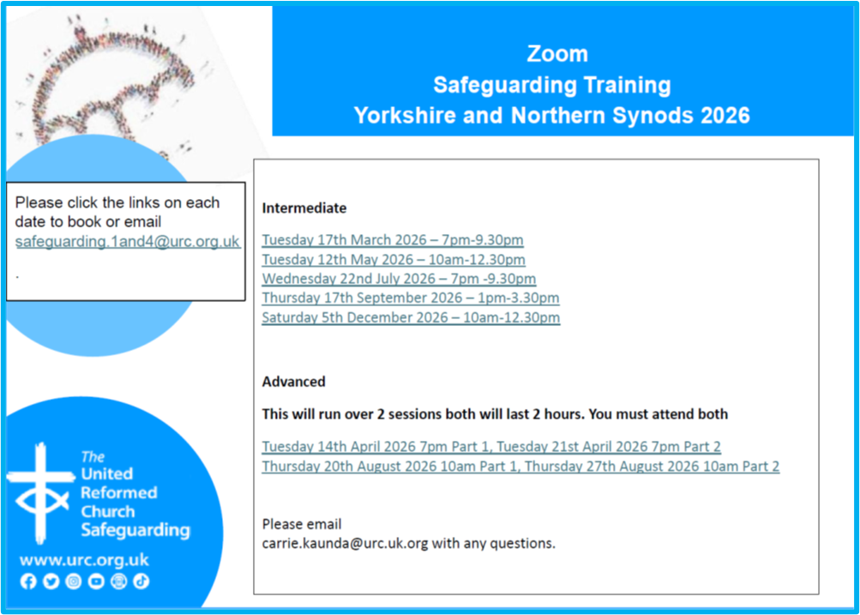

And Finally


Our brilliant Trust Secretary, Rachel Crawshaw, has another string to her bow. As well as guiding us all through the labyrinthine paths of the legal side of being part of the United Reformed Church in Yorkshire, she is an accomplished triathlete.On Sunday 17th May she took part in the “Outlaw Nottingham Half” event, which was held at Holme Pierrepoint in the Trent Valley east of Nottingham. It comprised a 1.2 mile open water swim, a 56 mile bike ride and then a 13.1 mile run. As you can see from the picture she finished strong and I’m told well under her target time.
I’m sure you will join me in congratulating her in achieving this goal and wish her well in any future events.

If you have a good news story from your part of the Synod or something that you feel reflects the work of Synod and which inspires others as we move into 2026, drop me a line at clerk@urcyorkshire.org.uk and I’ll make sure it hits the back page!!

You can also keep an eye on all our social media platforms for news; on the website at Home - URC Yorkshire Synod, at United Reformed Church in Yorkshire - Home | Facebook and Wilderness URC Yorkshire - Home | Facebook, the YouTube page at URC Yorkshire - YouTube and the Twitter (X) page at URC in Yorkshire (@URCYorkshire) / Twitter.

Matt 28 v19.

