
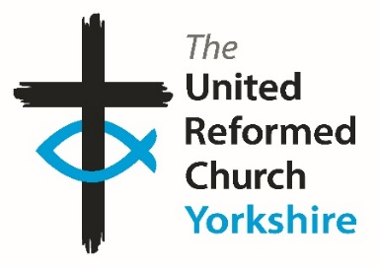
Yorkshire Synod Briefing
Number 176

18th June 2026

Summer is really Here
There seems to be a bit of a theme developing in the events I’ve been able to showcase this time; music and food, but as it isn’t Twelfth Night, I won’t quote the line that springs straight to mind, and sadly no prizes for those who do know what I’m talking about. However, that invitation being offered to join in the shared experiences of music and food together goes a long way to us being a Christian missional people. There will be many of you who could tell me how many times Jesus is recorded as eating with those he met and no doubt there will be some amongst you who could show how music underpinned the Psalms and the other poetry we have been gifted with in the Bible which all shows that Food and Music are no strangers to us as Christians. So we have Big Sings, Jazz, Silver Bands, Musicals and a Festival. We have Coffee Mornings and Afternoon Tea, and I would imagine that there will be refreshments available at the Festivals and the days events planned over the Summer. Enjoy them, connect with them and feel the Spirit working in you through them.
That certainly seemed to be the case with those who attended last month’s BIG DAY OUT. I’ve received more stories and feedback from those who attended, and I hope to offer a final opportunity to show some of your pictures next time – but only if you send them in to me at the usual clerk@urcyorkshire.org.uk e-mail address.
You will all now know that our Moderator, Revd Jamie Kissack, has begun his Sabbatical. He is due to return on 22nd September. Cover is in place as I mentioned last time, with Anne and Claire at Somerset House covering the Moderator’s PA role between them. However, the moderator@urcyorkshire.org.uk e-mail address now has an out-of-office message and will not be responded to. Therefore, if you have any enquiries relating to Jamie’s role during his Sabbatical, please use the moderatorpa@urcyorkshire.org.uk e-mail address.
Finally spare a thought for those who will be attending the upcoming URC General Assembly; not just the Yorkshire representatives, but all those from across our denomination who gather on 3rd July to help discern the way forward for the United Reformed Church. Details of all the papers and how you may want to watch the proceedings can be found by following this link https://urc.org.uk/general-assembly-assembly-executive-assembly-committees/general-assembly/ so I invite you to pray that they follow God’s guidance over the four days they meet.

Please continue to send invitations to your events, your stories and pictures in to me, and I’ll continue to advertise and share them throughout 2026, either here in The Briefing or on the Synod website at https://urcyorkshire.org.uk/. They may even end up in https://urc.org.uk/our-news-stories/latest-news/ which is always worth a read and has the opportunity to sign up for regular URC’s news updates.
So, if you have any news of welcoming people into Church, stories of celebration and mission, please let me know by dropping me a line at clerk@urcyorkshire.org.uk and I’ll showcase it in the next edition, due out on the website only on 2nd July 2026.
Tim Crossley
Yorkshire Synod Clerk

More from the Big Day Out
As mentioned in the last issue, back on 16th May the Synod hosted The Big Day Out. It was a cracking day and for those who attended it will last long in the memory. Happily, I’ve received some more comments and reports from those that attended, including from a couple of the churches who were able to provide transport through grants from the Synod Mission Fund.
Megan Tillbrook, the Synod’s Children and Youth Development Officer has collated attendees impressions of the day by using just one word which has been transformed into this word cloud
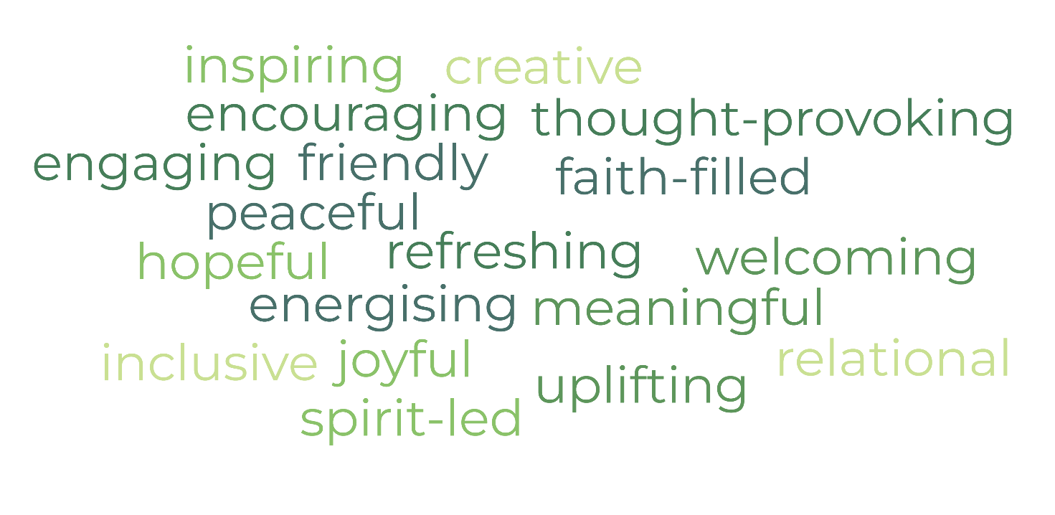

as well as inviting one liners on what the highlights were.

My highlight of the day was……………………..
“It was amazing me and my kids had a great day.”
“Watching the children engrossed in all activities.”
“Seeing so many people from different places having fun.“
“The beautiful grounds of the YSP.”
“The Fisherman’s Tale performance and the worship.”
“The play and art printing activity.”
“Being able to mix with people I don't see often in a sense of togetherness and spirit.”
“The friendship of people who attended, even if this was the first time we met. Something for everybody to take part in.”
“Walking around the lakes.”
“A big thankyou for making us all welcome and for all the planning and preparation.”
“This is the first time we have attended but already making plans for next year. We will encourage more people to join us.”

Unite Respect Connect (Huddersfield Pastorate)
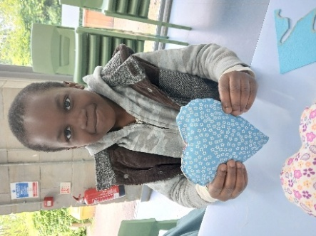
On Saturday 16th May 38 people from the Huddersfield pastorate area enjoyed a trip to the Yorkshire sculpture park for the Big Day Out. The group comprised Helen, our CRCW, 5 people from Waverley URC (2 of whom started attending the church’s coffee morning and since Easter have been attending worship), 5 people from Moldgreen URC and 9 adults and 17 children who attend our holiday activity sessions. Our holiday activity sessions started last summer and are run at both churches. Ages ranged from 18 months to people in their 80s. We originally had 42 people booked but unfortunately a few were sick on the day.
Everyone enjoyed the day and for families who don’t have transport they appreciated the opportunity to have a day out somewhere that wouldn’t normally be accessible to them. Our group included some families of other faiths and they appreciated the range of activities and did watch the play whilst having their lunch. We also saw it as a way of encouraging families to come and watch the play as we served the lunches from that field.
Helen Snashall, CRCW

Bilton Grange URC
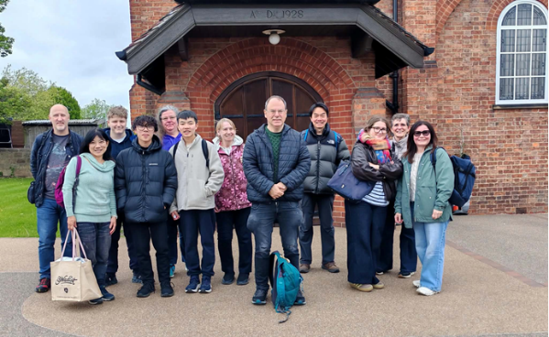
Pauline Calderwood, the BGURC Secretary writes that Bilton Grange are very grateful for the Synod Mission Fund grant we received that allowed 15 people to go on a minibus together to enjoy the Big Day Out.

Here are some of the comments we received:
- We had a great day at the Big Day Out. Many craft activities for the girls which they loved.
- A great walk and quiz - but the girls were upset they didn’t find all the sculptures and get a prize🥰 but much fun looking for them and taking photos.
- Nice to spend time with our group and join in with others.
- Much organization had gone into it - thanks to those organizing it.
- We had a lovely day out with friends and family.
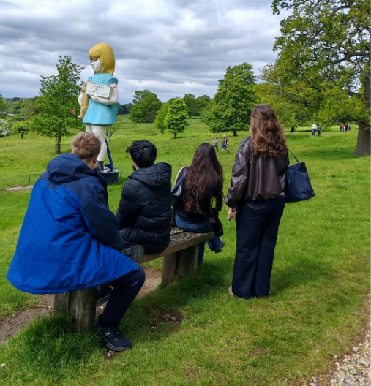
- Had a good day out, the children enjoyed themselves making several items and going on a treasure hunt around the statues.
- A very well organised event.
- We enjoyed the Big Day Out very much. The Sculpture Park was very big and beautiful.We loved the worship and communion. Matthew, Coco and Frankie enjoyed the challenge of Karlos’ Adventure Trail very much. They were very enthusiastic in finding all the Exhibits and tried their best in completing the answer sheet.
- We all have a great day! Thanks, Synod, for organising this wonderful event.


Good news! It’s not often these days that we get the opportunity to sing with a large crowd of worshippers, but that’s exactly what’s on offer on the first day of summer.
Mersey Synod’s Café Jam (who regularly visit Heckmondwike URC as you’ll see below) will be leading a BIG SING on Sunday 21st June at Albion United Reformed Church (Stamford Street East, Ashton-under-Lyne, OL6 6QQ). Starting with cake and hot drinks at 6pm, it will be an evening of singing a wide variety of hymns and songs – some old, some new, some lively, some quiet, some folk-style. With an interval at around 7.10pm with further cake and refreshments, the service will end at 8pm.
There is limited parking at the church, ample parking in the surrounding streets, and a nearby car park. Get your tickets today and invite friends, neighbours and family for the chance to celebrate our God in song together! Please book via the following link: https://bit.ly/3NmWod5
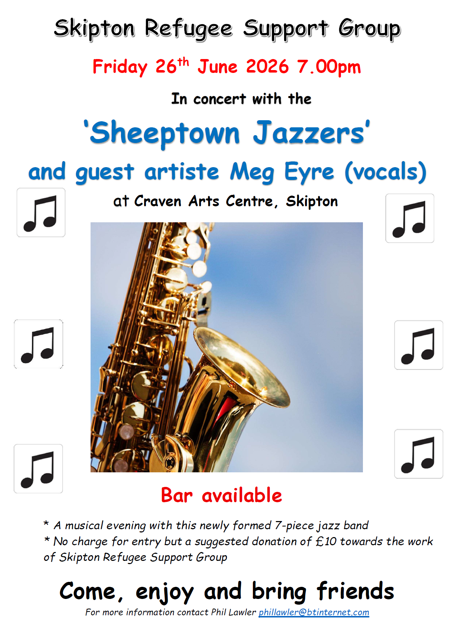

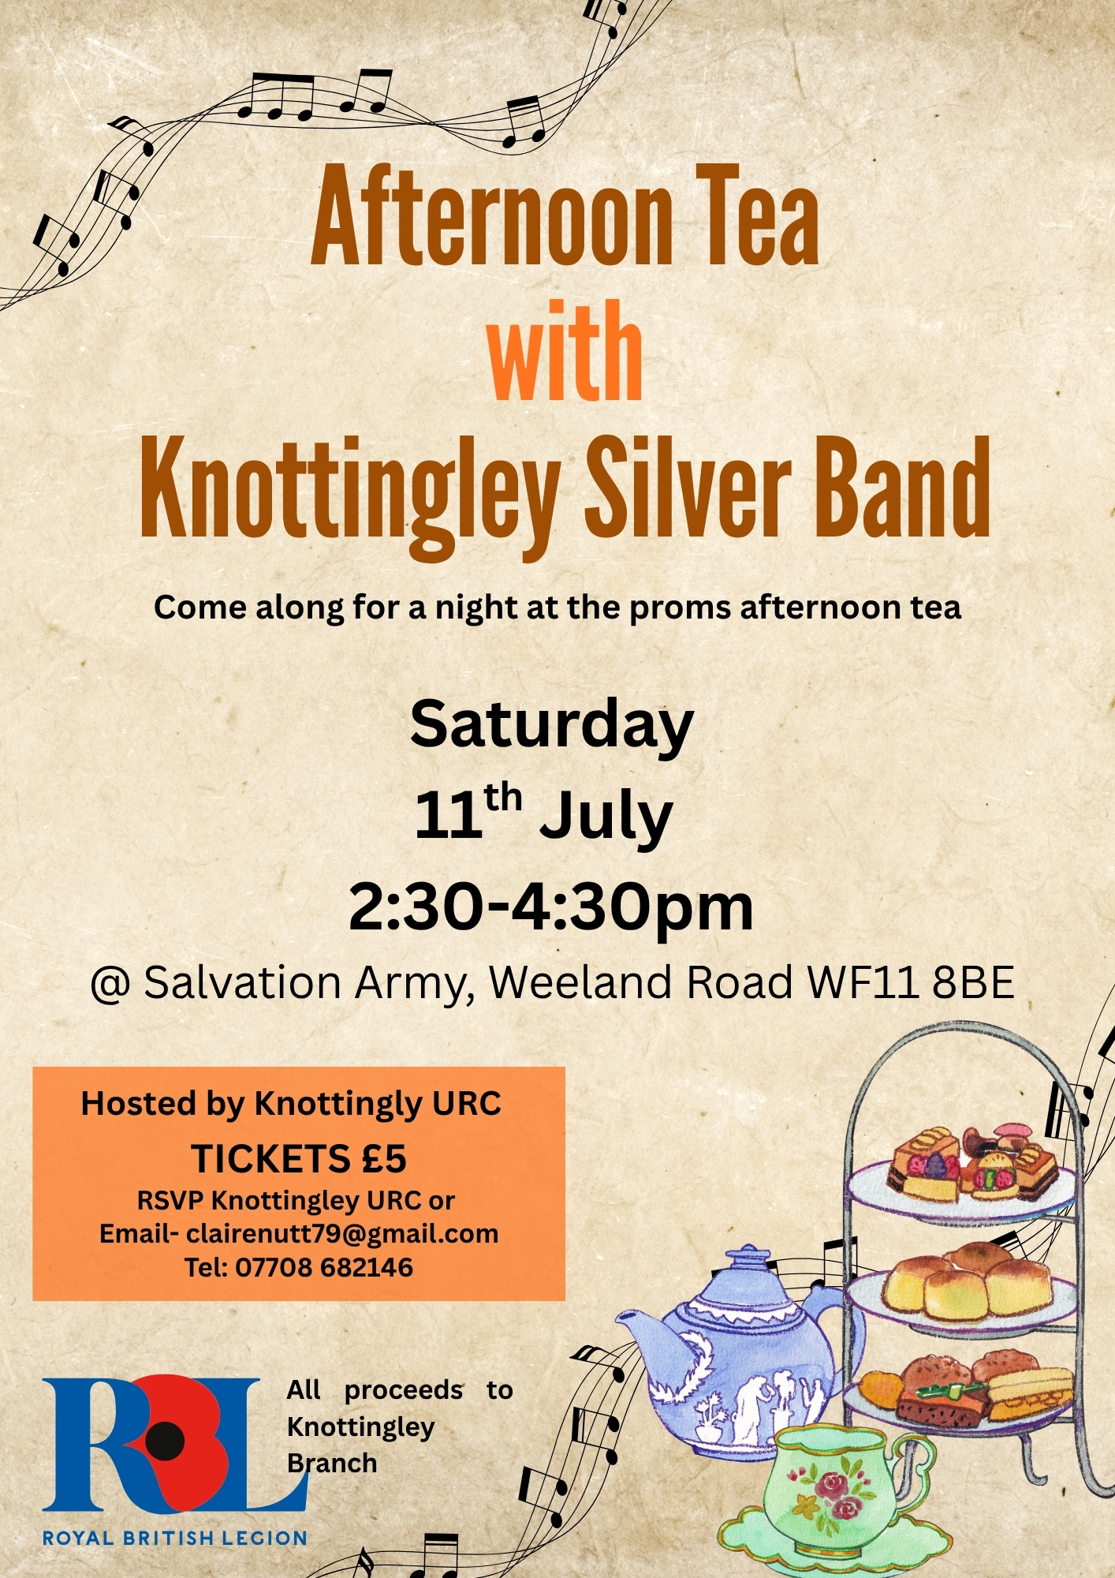

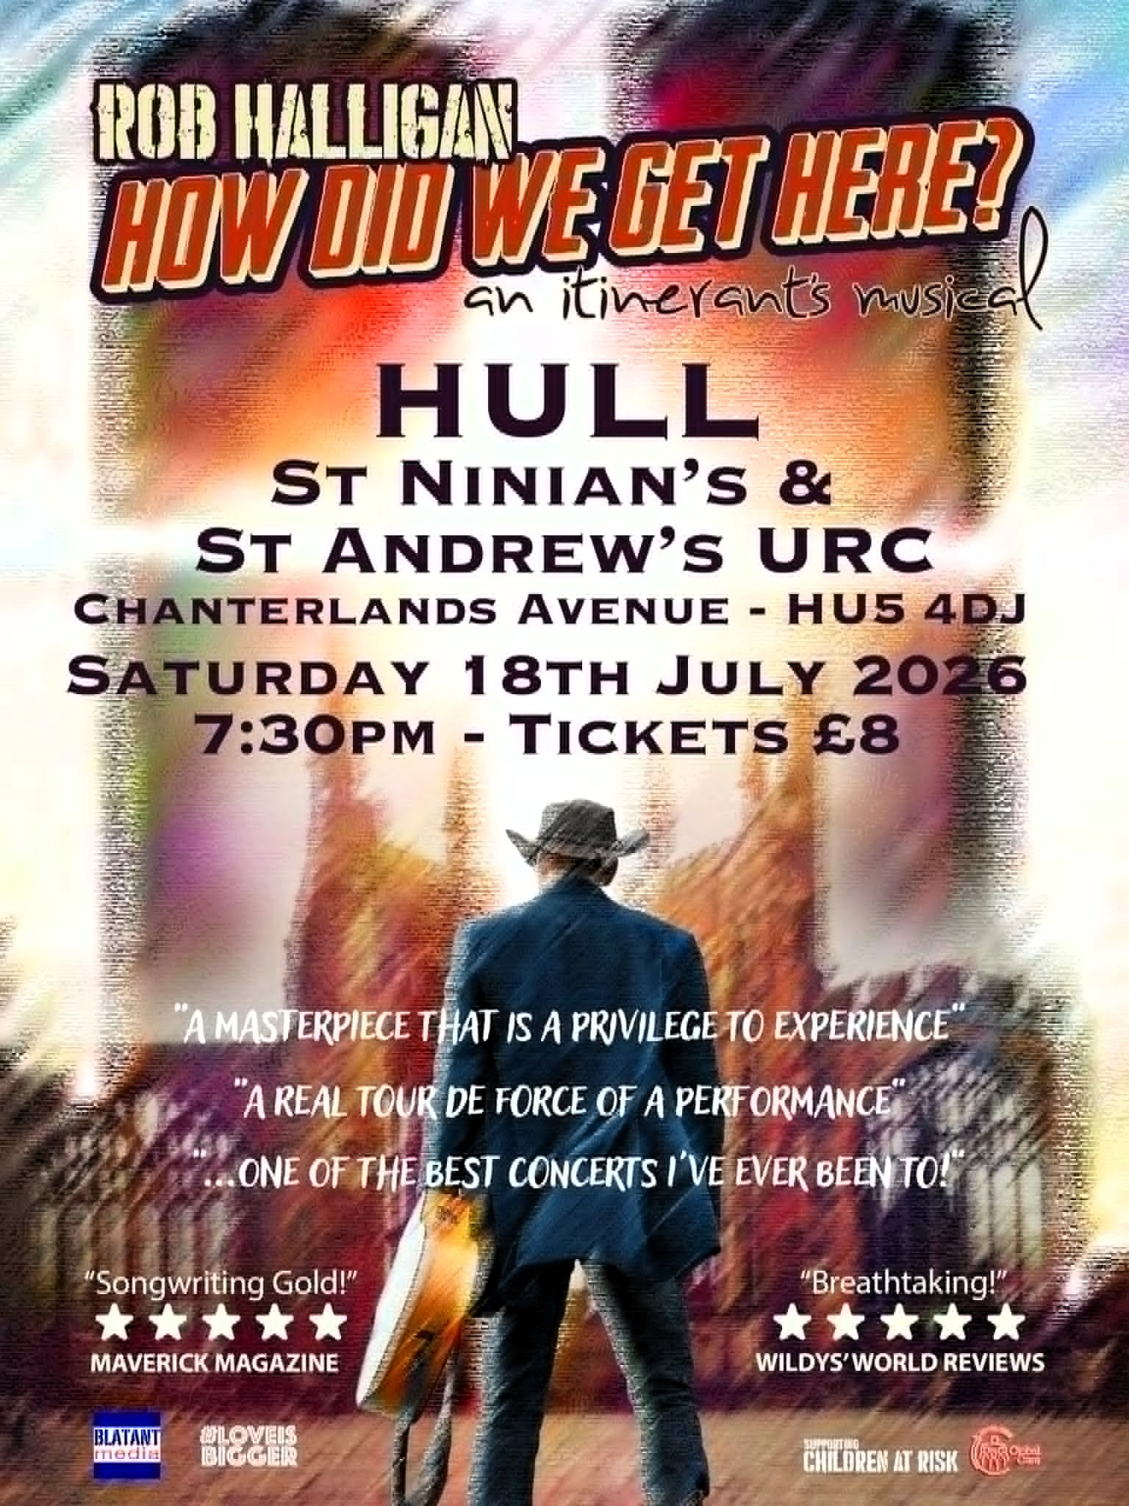


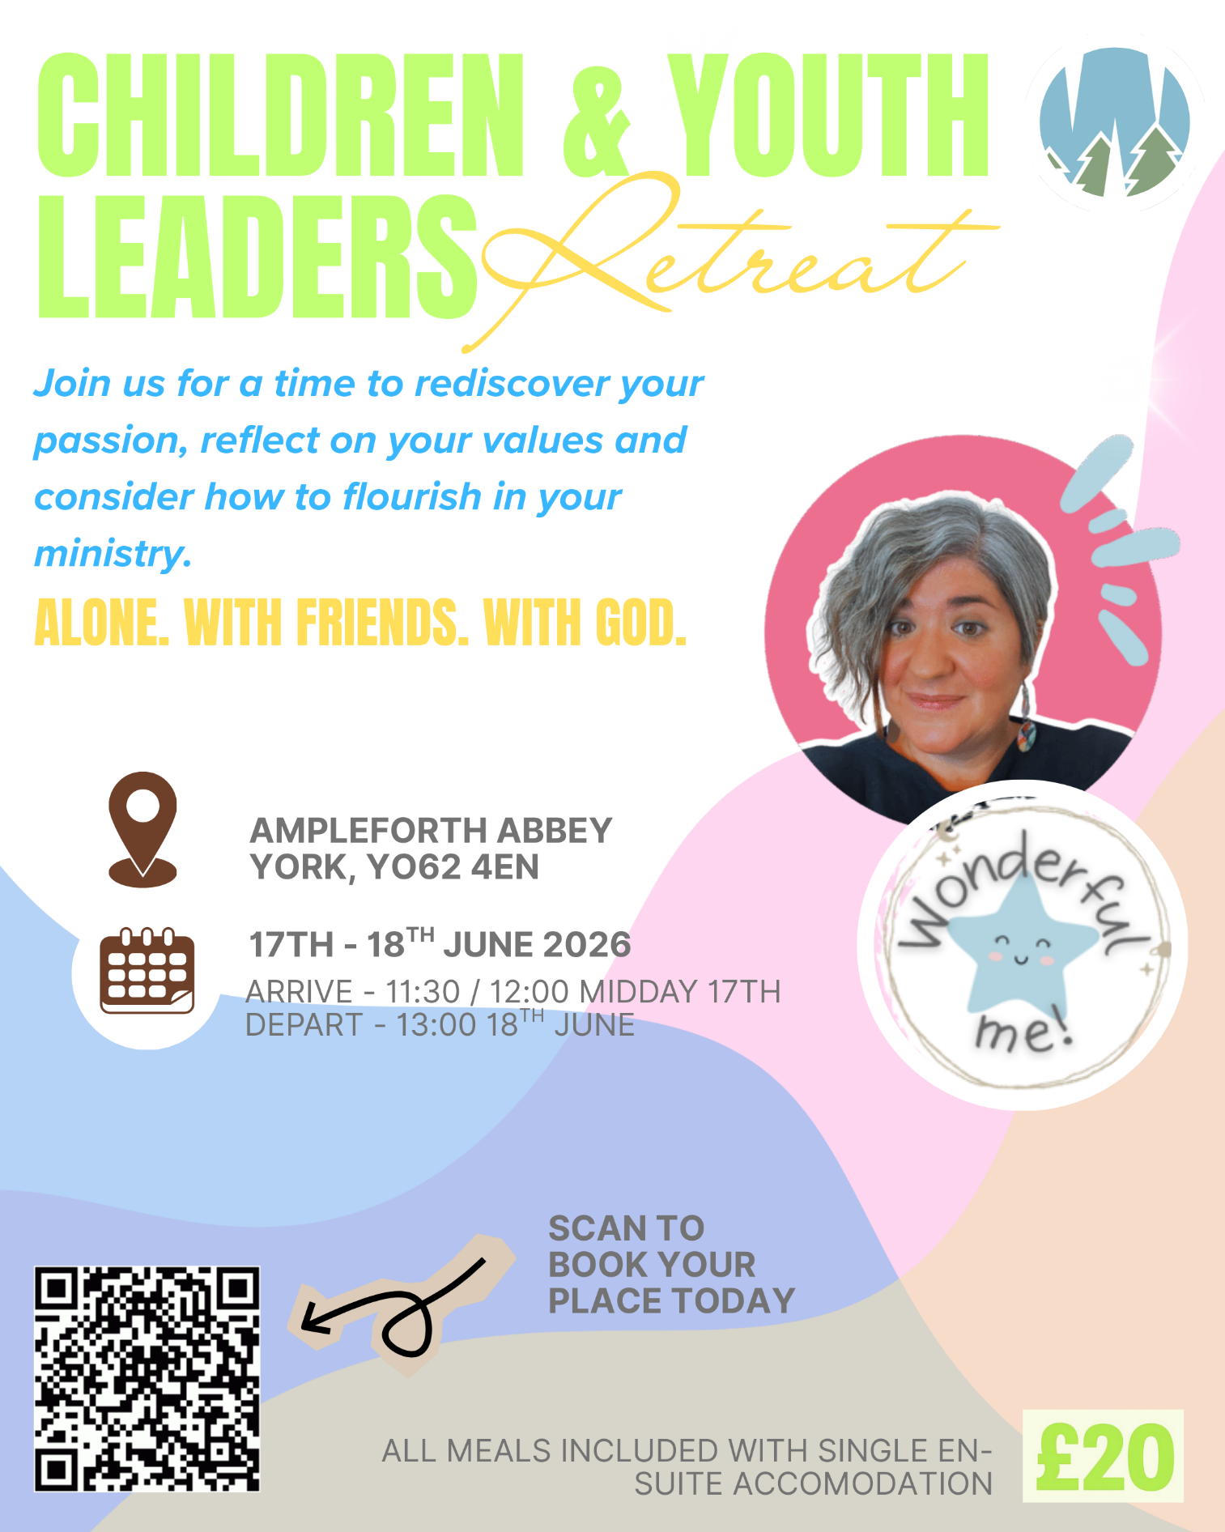



Yorkshire Synod Discipleship Development Small Grant Fund 2026
The Synod is pleased to let you all know that it has received confirmation that it has a pot of £4000 to grant to those wishing to apply to the Yorkshire Synod Discipleship Development 2026. Currently we have been able to grant about half of what has been allocated to us, and we would love to be able to offer grants to enable us to use all that Yorkshire Synod has received.

1. Who is eligible to apply? Committed members or adherents, including children and young people, of a congregation within the United Reformed Church who are exercising, or want to exercise, a form of lay ministry or community service whether expressed within or beyond their local church. The DDF is not open to Ministers of Word and Sacraments and CRCWs, as there are other designated funds available for those groups.

2. How much is available? Up to £300 per applicant per calendar year, although the Synod may agree to more than this according to the local context and circumstances.

3. What can this money be used for? The purposes for which the funding is provided are defined by creativity and vocation, in line with the URC's discipleship development strategy. Be bold, take risks. The funding exists to help you to follow Jesus. You might be helped in this by courses (at any level) at any of the URC Resource Centres for Learning or from other learning providers, or you may have ideas on resourcing discipleship development in other people. You may need funds to cover the costs of travel, materials or books. All you have to do is make a case to your local church meeting and submit the application form to the Synod Convenor of Ministries for consideration and, if appropriate, authorisation.

4. How are applications made? Having gained your church meeting's endorsement, applications are to be made on the designated form, well before the spending is due to start. Backdated applications will not normally be accepted. Application forms are obtainable from the Synod Convenor of Ministries via the Synod Office at office@urcyorkshire.org.uk and should be sent back for authorisation before being passed to the synod finance office.

5. How are grants paid? Grants authorised by the Convenor of Synod Ministries
are paid by a Synod finance officer by reimbursement to you when you have given proof of what you've spent. Contact your Synod Convenor of Ministries for discussion if you need something funded directly on your behalf, rather than waiting for re-imbursement.

If anyone wants to discuss an application before submitting, please contact the Convenor of the Yorkshire Ministries Committee, Kath Lonsdale at kathlonsdale@talktalk.net.
Remember this is for any age of lay person in our churches to apply for so please discuss with your young people as well as adults.
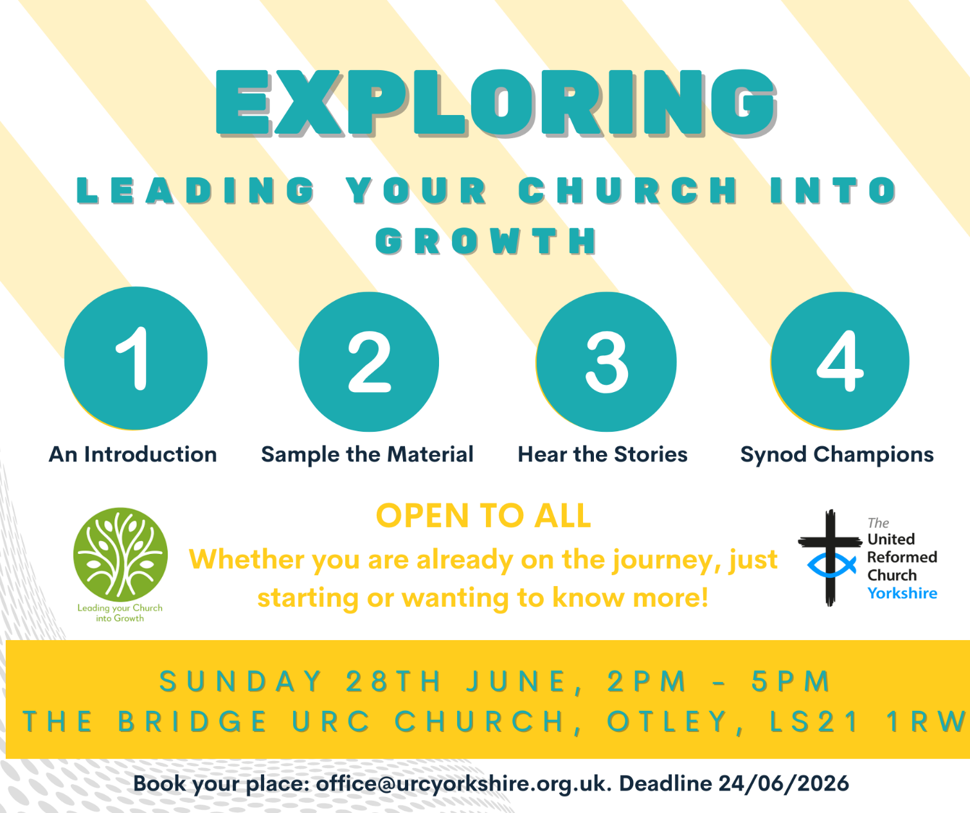

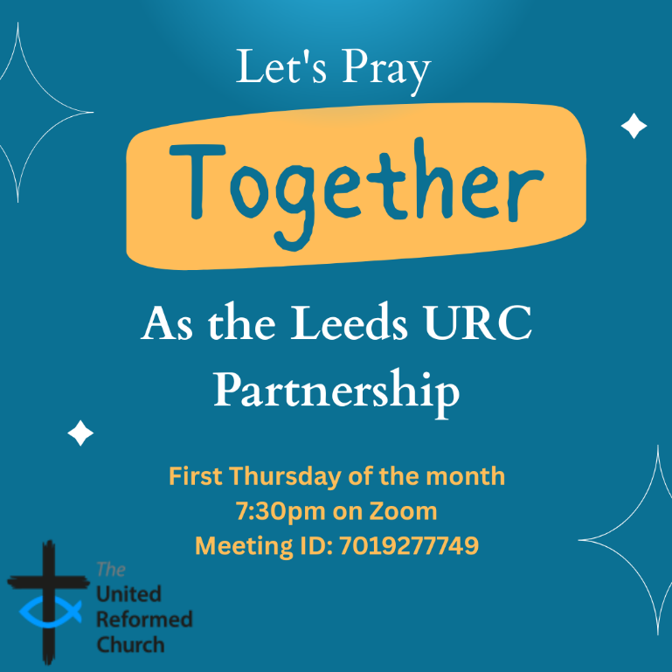
Leeds URC Partnership Prayers
Thursday, 2 July, 7:30pm.
A short time to pray together by reading the Bible and sharing the joys and challenges in our lives, churches, communities and world.
On Zoom:
https://us02web.zoom.us/j/7019277749

A Star in the East
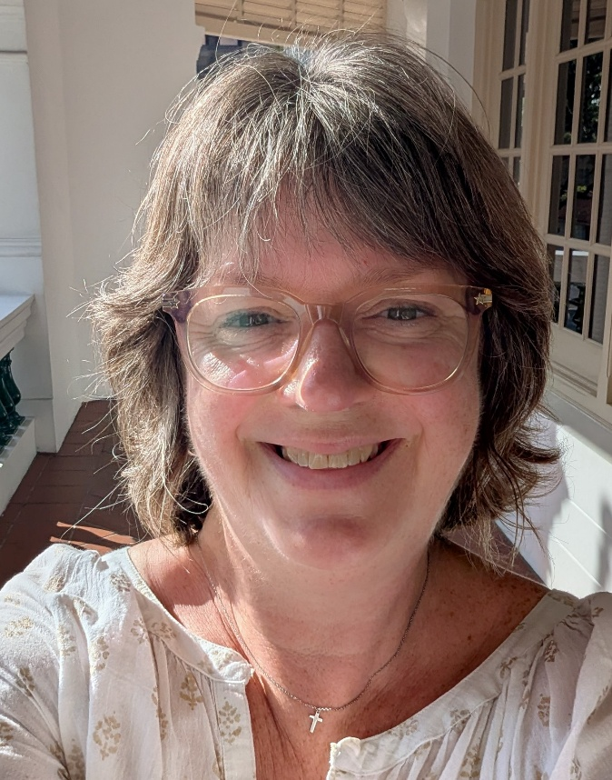
Although she officially started in early May, it’s great to be able to introduce the Synod’s new “Wilderness” worker, Katie Ogilvie, who will be based in and around the Hull Team of churches. Rather than me trying to do justice to he, here’s her own introduction to you:
Hi, I'm Katie!
After 25 years as a secondary school teacher, I've taken the leap into a role that feels like the natural home for everything I love — working with children, young people and families across our three congregations in Hull.
My faith has always been at the heart of how I live and what motivates me, and I'm so excited to bring that into this new adventure.
When I'm not here, you'll find me on our farm in East Yorkshire — home to ten (yes, ten!) alpacas, who are every bit as wonderful and ridiculous as you're imagining. I also love losing myself in a good film, playing the piano, and getting lost in a book. I can't wait to see where this Wilderness journey takes me, and I'm excited to see what the next four years will bring.

Holiday Club materials – and grants


This year’s URC Holiday Club materials from the Children, Youth and Intergenerational team (CYI) are available at Holiday Club Materials - United Reformed Church. With the theme Wisdom Quest, these are free, downloadable resources for those running holiday clubs for children aged 5–11. (Plus appendices for intergenerational, toddlers, 11–14s and vintage holiday clubs.)

Tying in with the CYI theme for the year, Wise Words, begin the quest of searching for God's wisdom, in words, actions and lives. Throughout the Bible we find words to live by, including the 'I am...' statements of Jesus. Explore some of these stories while thinking about how to share our wisdom with others.
Grants
The Children, Youth and Intergernational committee supports churches in running holiday clubs by offering a grant of either £50 or £100 towards the costs of resources, snacks, decorations, equipment etc. Apply at Children & Youth work grants - United Reformed Church


Longcauseway Church (United Reformed and Methodist) situated in the centre of Dewsbury, is looking to appoint a:
Church Community Project Leader and Premises Manager

37 hours per week, worked flexibly on a 3 year fixed contract

Salary: £27500 - £29000 pa, depending on qualifications/experience
(28 days holiday including Bank Holidays)
plus reasonable out of pocket expenses and travel expenses.
We are looking for an enthusiastic and committed individual to help us to further develop and implement our church’s mission through engaging and appropriate activities for all age groups with faith, hope and love for Dewsbury at their heart.
As well as being able to manage the day to day management of the church premises.
This post will require flexibility, including some evenings, weekends and Bank Holidays and it will be subject to an enhanced DBS check.
It is a Genuine Occupational Requirement for the post-holder to be a Christian.
Please contact the Church Secretary, Mrs Jo Hartley
email: churchsecretarylcw@outlook.com)
for a Job Description and Application Form.
Completed applications must be received by and Interviews will be arranged during the week beginning 29th June 2026.
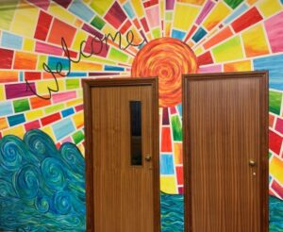

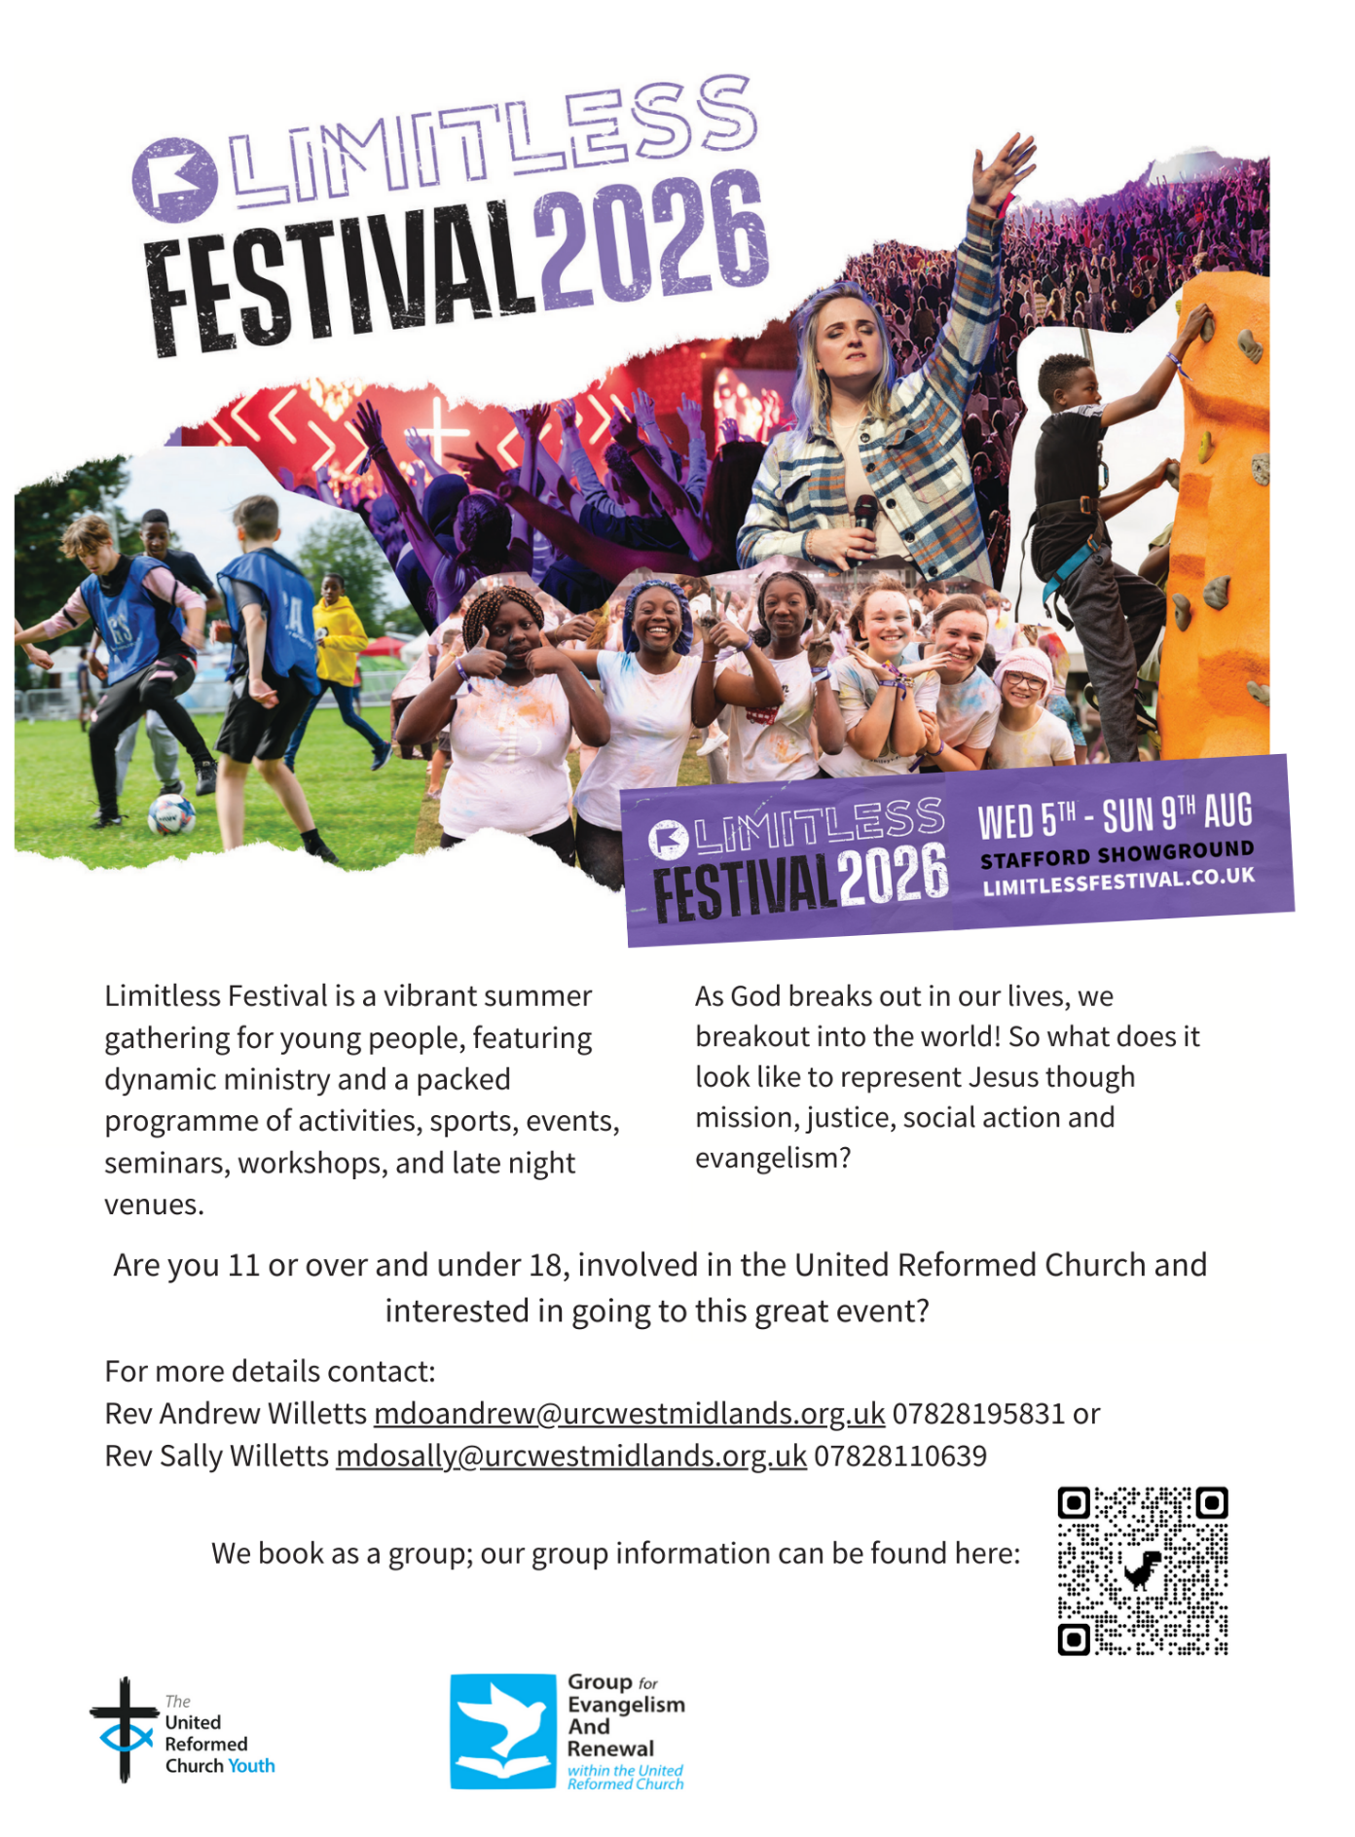

As well as the Joseph Crossley’s Almshouses now being open to people in Calderdale, Bradford and Kirklees as a place to live, they now have vacancies to join their team as Trustees. The Trustees must be practicing Christians in the same area of benefit, so opening the area of benefit also means we have opened the area we can draw Trustees from. They have vacancies for both a Pastoral Trustee, and a Finance and Property Trustee. They already have a team of 8 Trustees but are allowed to have up to 12. They also have a Treasurer and a Clerk, plus two employed wardens. The whole team are active protestant Christians.

If you have anyone in your churches who may be interested, please contact Mr Alan Kendall, the Chair of Trustees for the Joseph Crossley’s Almshouses, at alankendall1234@hotmail.com.

If you would like a copy of the flyer to distribute, please contact the Synod office at the usual address and we’ll be able to send a digital copy across for you to distribute locally. The open day is open to anyone – potential Residents, potential Trustees, people who are interested in old buildings or people who are interested in the history of Halifax, or just anyone who fancies a cheap day out with coffee and biscuits included!

No need to let them know you are coming. They will be there from 10am until 2pm, and they would love to see you there.

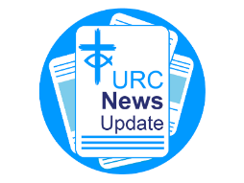
NEWS FROM THE DENOMINATION
The URC’s News Update is a regular e-newsletter that keeps you informed about the latest news and events.
To receive this popular newsletter, please visit the https://urc.org.uk/news-updates-sign-up-form/ page on the URC website and follow the links. If you just want to dip in and catch up on what is going one, that’s fine and you can
read and print recent editions of our e-newsletter by visiting the URC News Update page at https://urc.org.uk/urc-news-update/ .

Council for World Mission Sunday (19 July)

The Council for World Mission (CWM) marks CWM Sunday on 19 July, this year with the theme “Revisioning Mission”. Resources for worship and to share information about CWM have been prepared and can be found at https://www.cwmission.org/resources/publications/. In addition, you can view the General Secretary's Message for CWM Sunday 2026 - Council for World Mission (or use the YouTube link: https://youtu.be/lkNT_eC8E9U, which is also included in the liturgical and presentation materials).

The Synod is looking for people to join some of our key groups, especially the Children and Young People’s, the Property and the Financial Resources committees. These bodies guide the direction of Synod and without them Synod would find it hard to function. If you can take up a call to help Synod out, please contact the Synod Clerk at clerk@urcyorkshire.org.uk for more information.
Safeguarding News

The Safeguarding team are available seven days a week and 365 days a year as the inbox is monitored at weekends. This inbox is not monitored continually but concerns will be responded to within 24 hours. If you need immediate support, please contact the Police or your Local Authority Duty Safeguarding Team. All contact details for these services MUST be displayed in your churches
Further details can be found on the Yorkshire website at https://urcyorkshire.org.uk/safeguarding/ or email your query to safeguarding.1and4@urc.org.uk.

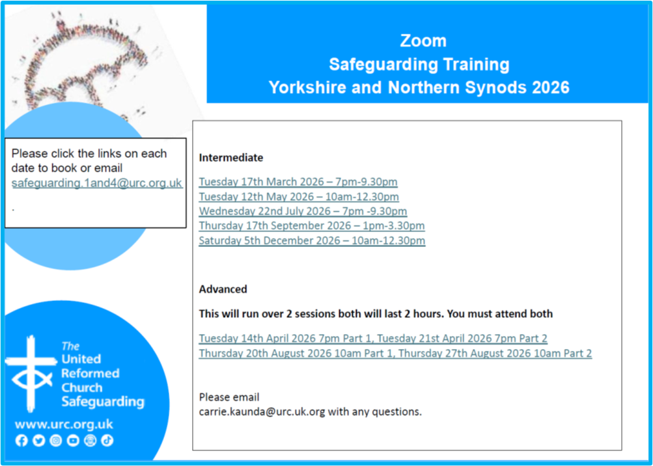

And Finally

Jamming Heckmondwike

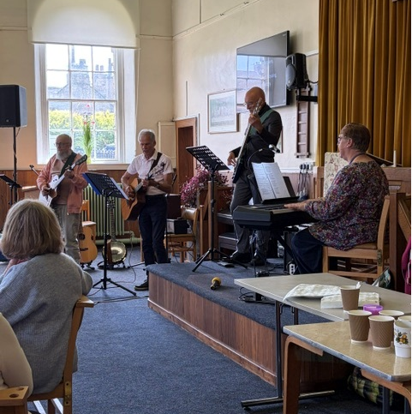
This headline isn’t an instruction to block the streets of Heckmondwike up with traffic nor to ask how the late great Bob Marley liked his donuts, but to showcase the talents that lie in the Mersey Synod. Janet, Heckmondwike URC’s secretary sent his across for us all to share:
“Last week Heckmondwike URC hosted a wonderful afternoon of praise and worship. The Merseyside synod worship group ‘Cafe Jam’ played a selection of familiar and new hymns. Friends from Norristhorpe URC and Longcauseway Church joined the Heckmondwike folk, who treated those at the event with a delicious selection of home made cakes in the interval.
A truly uplifting experience enjoyed by all who attended”

If you have a good news story from your part of the Synod or something that you feel reflects the work of Synod and which inspires others as we move into 2026, drop me a line at clerk@urcyorkshire.org.uk and I’ll make sure it hits the back page!!

You can also keep an eye on all our social media platforms for news; on the website at Home - URC Yorkshire Synod, at United Reformed Church in Yorkshire - Home | Facebook and Wilderness URC Yorkshire - Home | Facebook, the YouTube page at URC Yorkshire - YouTube and the Twitter (X) page at URC in Yorkshire (@URCYorkshire) / Twitter.

