
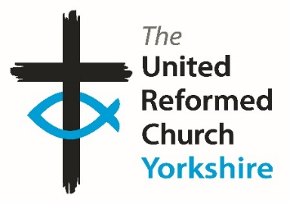
Yorkshire Synod Briefing
Number 177

2nd July 2026

Invitations, Celebrations, Visits and Farewells
This issue has a little bit of everything. As is usually the case there are plenty of invitations to events across the Synod over the summer, and an invitation to try to honour those in our churches who open them up visitors, or use them as places of connection, of support and of outward Christian activity. Look for the National Churches Trust logo and follow the links to their Volunteer Awards. We are also celebrating the recent wedding of our own Safeguarding Officer Carrie. She married Terry on 20th June, and when you reach the back page you’ll see how happy she and Terry are. Congratulations to both of them and may God give you many years together. Judy Rogers, our Racial Justice Advocate has sent in a great piece on the “DARE” visit to Trinity St Andrew’s Skipton. It’s a great partnership that crosses Synod boundaries, and more importantly the Yorkshire/Lancashire one!! Sadly though, we also say farewell to one of our churches, Northcliffe, Shipley, and one of their long-standing members, Tim Billingsley, has written a beautiful piece celebrating the life of the church and commending its legacy to future Christians.

Spare a thought for those who will be attending the upcoming URC General Assembly; not just the Yorkshire representatives, but all those from across our denomination who gather on 3rd July to help discern the way forward for the United Reformed Church. Details of all the papers and how you may want to watch the proceedings can be found by following this link https://urc.org.uk/general-assembly-assembly-executive-assembly-committees/general-assembly/ so I invite you to pray that they follow God’s guidance over the four days they meet.

You will all now know that our Moderator, Revd Jamie Kissack, has begun his Sabbatical. He is due to return on 22nd September. Cover is in place as I mentioned last time, with Anne and Claire at Somerset House covering the Moderator’s PA role between them. However, the moderator@urcyorkshire.org.uk e-mail address now has an out-of-office message and will not be responded to. Therefore, if you have any enquiries relating to Jamie’s role during his Sabbatical, please use the moderatorpa@urcyorkshire.org.uk e-mail address.

Please continue to send invitations to your events, your stories and pictures in to me, and I’ll continue to advertise and share them throughout 2026, either here in The Briefing or on the Synod website at https://urcyorkshire.org.uk/. They may even end up in https://urc.org.uk/our-news-stories/latest-news/ which is always worth a read and has the opportunity to sign up for regular URC’s news updates.
So, if you have any news of welcoming people into Church, stories of celebration and mission, please let me know by dropping me a line at clerk@urcyorkshire.org.uk and I’ll showcase it in the next edition, due out on the website only on 16th July 2026.
Tim Crossley
Yorkshire Synod Clerk
DARE visits Skipton to celebrate Refugee Week
On Sunday 28th June, Trinity St Andrews LEP in Skipton (TSA) welcomed members of the Darwen Asylum and Refugee Enterprise to Skipton to mark Refugee Week as they have done each year for the past 5 years.
This year Revd Daleen ten Cate, the Mission Enabler for the URC North-West Synod and Chair of DARE Trustees, led worship at TSA. She has been heavily involved in the running of DARE for many years and has recently been able to hand over the day to day running to the newly appointed Centre Manager Gemma Garcete, who helped by her daughter taught the congregation a song in Spanish and told of the amazing work that DARE does with over 350 clients who access their services on a weekly basis.
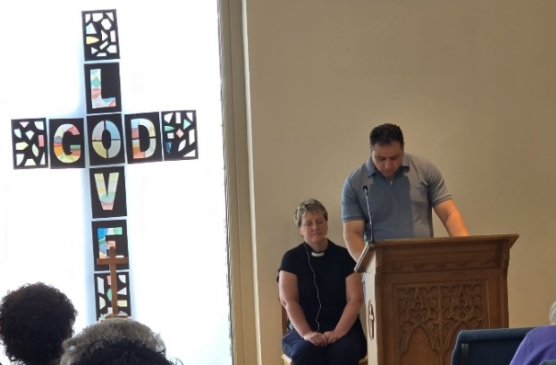
The theme of the service was ‘Courage’ and was attended by 34 members of the DARE family as well as over 50 members of TSA.
Various people read prayers and the lessons in their own languages (with translations in English on the screen). It was a joyous service remembering the courage of many people who seek Sanctuary in the UK and highlighted some of the individual stories of people who have been supported by DARE. As Daleen said in her address, “Courage is not always loud or dramatic. More often, it is found in the quiet, faithful acts of everyday life. It is taking one step in the right direction, day after day.”

Of particular interest to Skipton folk was the story of Deborah Kayembe who visited Skipton over 15 years ago and spoke of her experiences. Daleen recalled, “A young mother walked through the doors of DARE. She was heavily pregnant, carrying a toddler in her arms, with only a small French loaf for her family to eat. Moments later she collapsed in front of us. She was severely malnourished and was later diagnosed with hepatitis. She had fled persecution in the Democratic Republic of Congo. Today she is an internationally respected human rights lawyer and civil rights activist. In 2021 she became the 54th Rector of the University of Edinburgh—the first Black person and only the third woman to hold that prestigious office.”
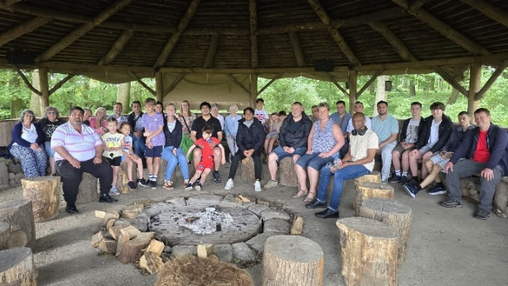
Daleen finished her address by saying , “These are only a few of the stories from DARE. There are many more. Many of those people are sitting here among us today. Despite unimaginable hardship they have chosen not simply to survive but to flourish. They have become case-workers, carers, nurses, teachers, volunteers and community leaders. They long to give back to the communities that have welcomed them.”

After the service the visitors and members of TSA drove to the Odyssey at Broughton Hall near Skipton. Here we were welcomed by the Outreach worker Jessica Penrose, and we shared a scrumptious lunch prepared by members of TSA. The children loved playing on the nets high up in the trees which was to them like a mini ‘Go Ape’.
We then walked around the rewilding area of this stately home with its board walk through the marshy area, saw thousands of trees newly planted on the hillside and the most exciting thing was the beaver enclosure (one of only 2 in Yorkshire). No beavers in sight as they are nocturnal and very shy, but plenty of evidence to see of beaver activity.

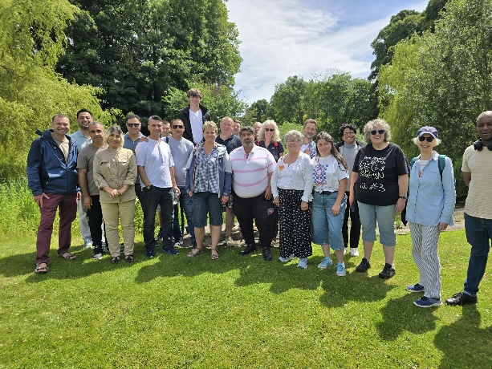
Daleen wrote to the DARE visitors:
A heartfelt thank you for each of you who attended today and for your beautiful messages. Knowing you all enriches my life and many others.”
​One visitor commented:
I wanted to thank you for organising this beautiful trip and for the opportunity to attend such a unique service, where I could hear and read the verses of the Bible in a different language. I would also like to thank Max and his family for taking the trouble to drive me to Skipton today.
​God bless you all.
Another said:
Today was a truly beautiful and peaceful day for me. I visited a church in Skipton, where I met kind and wonderful people. Together, we prayed and shared moments filled with faith and serenity.
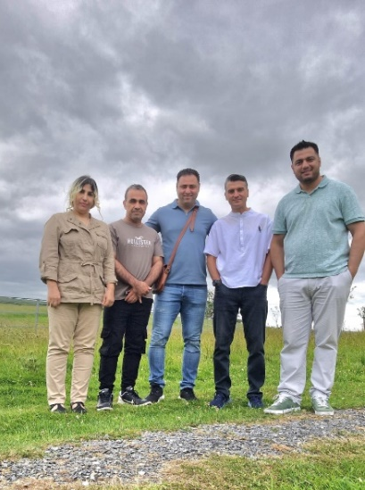
Afterwards, we enjoyed a meal together in a warm and friendly atmosphere. Then we went for a walk and talked about our cultures, our lives, and our experiences. These moments were incredibly meaningful and unforgettable to me.
Today, more than ever, I saw kindness, humanity, and beauty in people, and my heart is full of joy and gratitude. I sincerely thank everyone who accompanied us today. This day will always remain in my memory.
And another:
I had such a wonderful time being with all of you. At church, I couldn't understand much of what was being said, but there was one thing I understood very clearly: your kindness, warmth, and love. Understanding that doesn't require knowing English. It reminded me of a saying attributed to Cyrus the Great:
"Be like the rainfall upon everyone without asking whose field it is."
Thank you all for your love and hospitality. I will always remember it.

To watch the service see https://m.youtube.com/watch?v=Uhr96wx1uMY (starts 13 minutes in)
Such encounters are so powerful and meaningful.

Judy Rogers, URC Synod Racial Justice Advocate & a member at Trinity St Andrew’s, Skipton.


Dismantling and Decolonising Homophobia
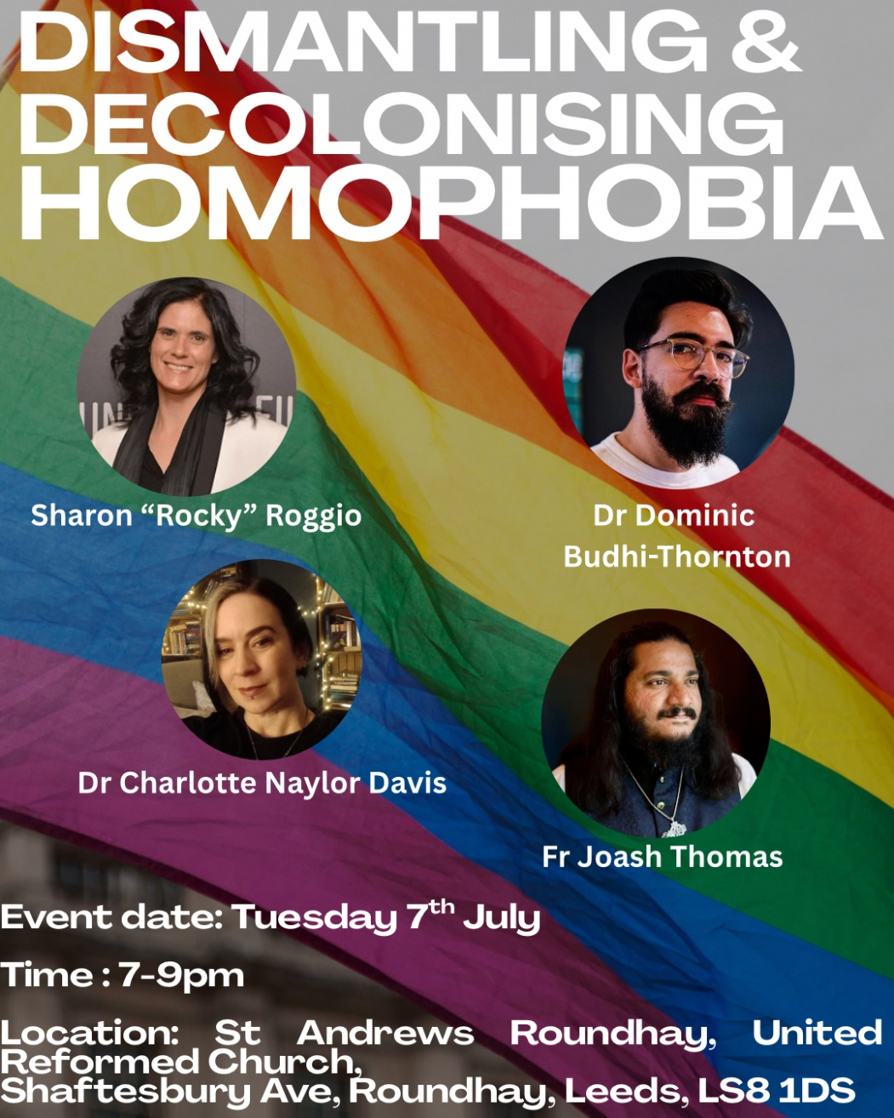
Building on the work of 1946 the movie (https://www.1946themovie.com/) join director Sharon Roggio and theologians Fr Joash Thomas and Dr Dom Budhi-Thornton for an insightful evening at St Andrew's URC, Roundhay on Tuesday 7th July between 7pm and 9pm, where our panel will explore how to break down and challenge homophobia through a decolonial lens.
Joined by local community theologian Dr Charlotte Naylor Davis, this is an opportunity to learn and consider ways forward for churches on these issues.
Come ready to engage, reflect, and connect over food and thought.

ACCESSIBILITY: We are keen to make this as accessible as possible in person, though due to resources we sadly won't be able to provide BSL translation. The building has a hearing loop, accessible access and a wheelchair accessible toilet but disability is wide and varied, so please contact me ahead of time with any access needs or accommodations to make sure that we adapt to help you be as comfortable as possible on the night.


We will work with you and try our best to accommodate everyone. We are happy to provide carer tickets if they are required.
If you require any more information, please contact Charlotte through the eventbrite organiser link or at cndrevive@gmail.com
https://www.eventbrite.co.uk/e/1992434858296?aff=oddtdtcreator
And finally, here is a QR code in case anyone wants that!

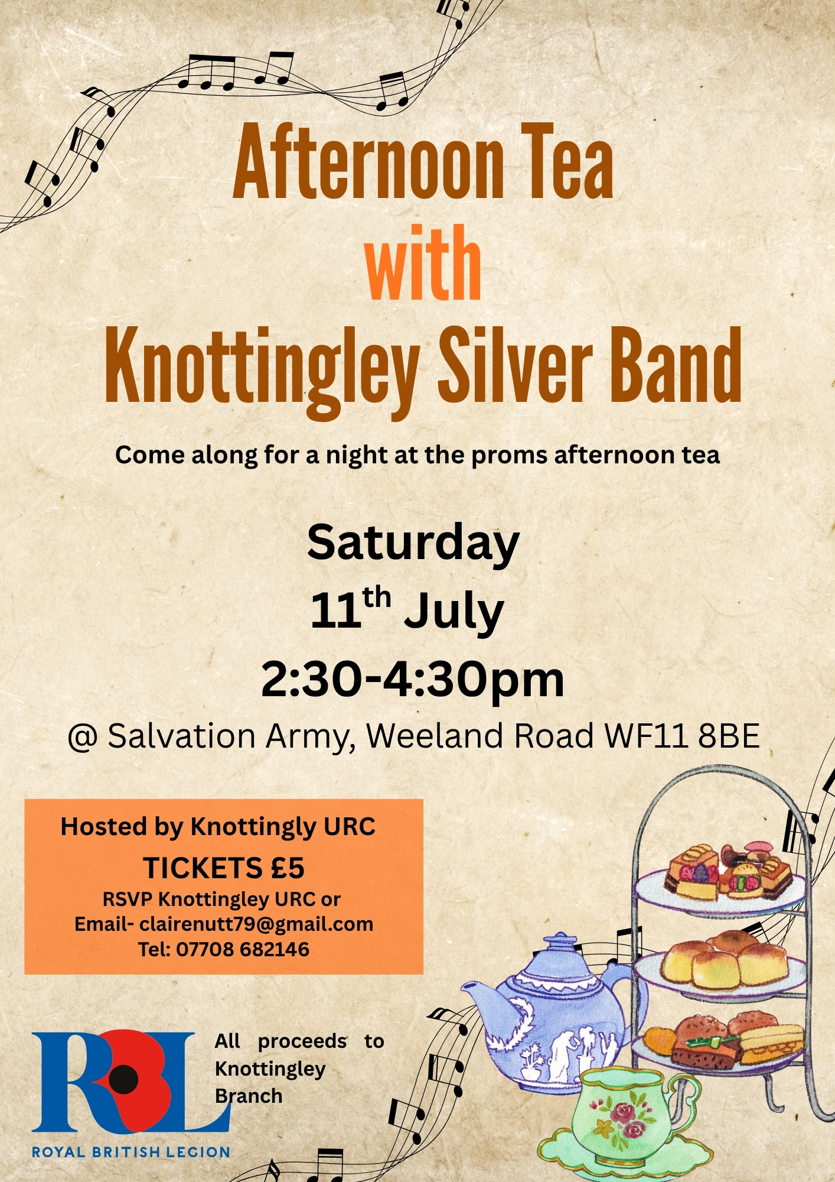


St Andrew’s Roundhay are planning to celebrate Yorkshire Day on 1st August with a summer barbecue which is open to everyone – church members, friends and the local community. There will be lots of activities for children and adults as well as lots of food and drinks.

We invite our friends from the URC to come and join the fun!

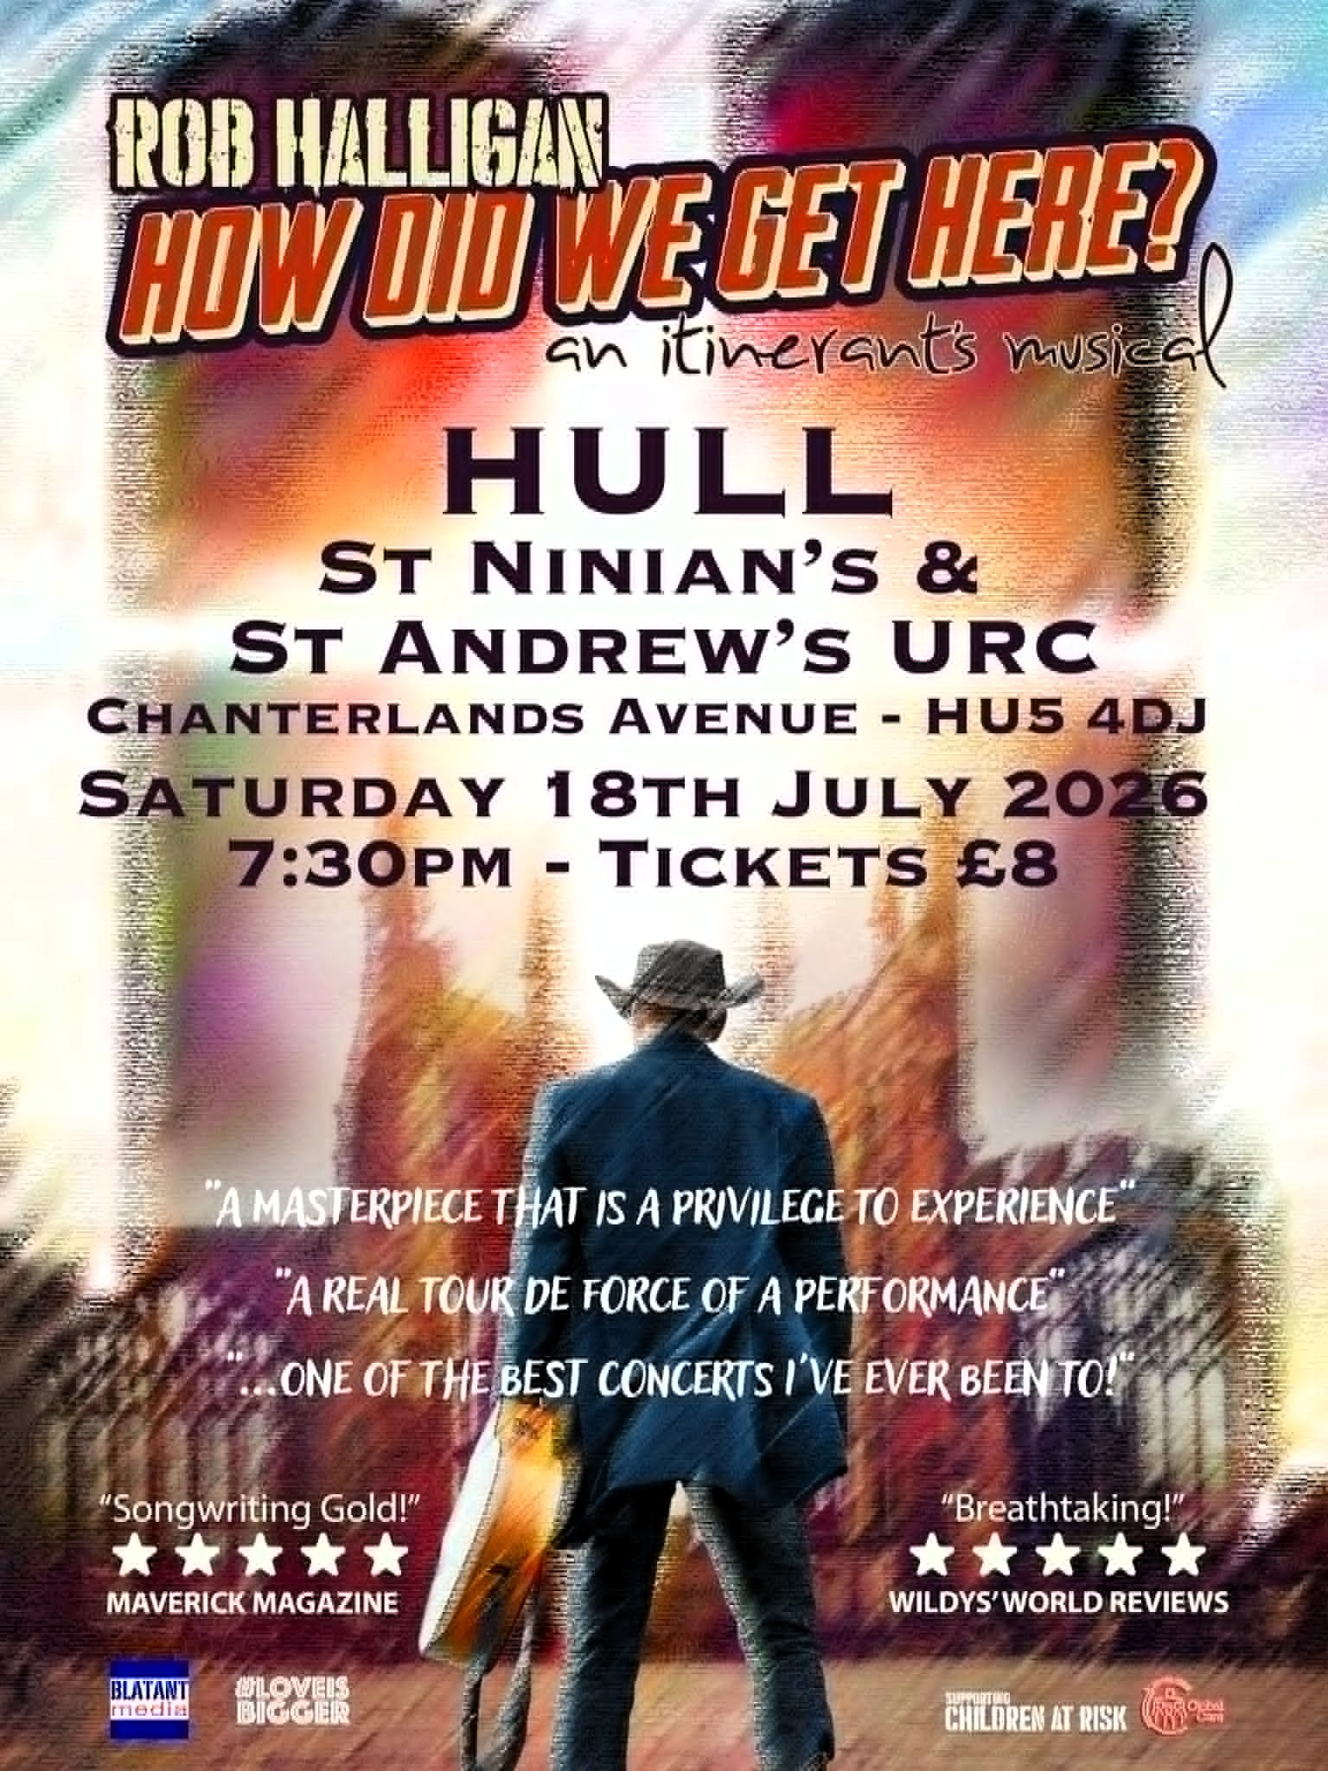



Yes, It’s Here
One of the first roll outs from the Church Life Review is this brand new Resources Hub for all our churches and volunteers to use. There are two ways into it, through the URC website, or directly using this link: https://urcresourceshub.org.uk/. Please take a bit of time to have a look, and if you have any feedback or any suggestions for what you may want it to hold, please contact me at clerk@urcyorkshire.org.uk and I’ll pass on your feedback.

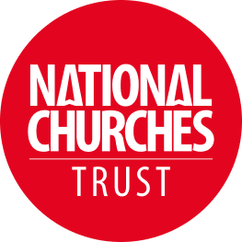

Church & Community Volunteers Awards
Every day, volunteers at churches, chapels and meeting houses across the UK are doing extraordinary things. You're caring for historic buildings, welcoming visitors, supporting local communities, and creating spaces where people can connect, belong and thrive. None of this happens without dedicated and passionate local people.
That's why the NCT awards celebrate the people and churches making a real difference. The NCT recognises how conservation, community use and visitor engagement work together: caring for historic buildings, opening them to visitors, and using them as places of connection, support and activity. From community cafés and foodbanks to events, tourism and heritage interpretation, volunteers help churches remain relevant and resilient.
We want to celebrate volunteers who help churches thrive by caring for and conserving the building and its heritage, using the space to support and strengthen local communities, welcoming visitors and sharing the church’s stories
Nominations for these awards are open now, with the closing date being Tuesday 11 August 2026 (midnight). Volunteers from any church, chapel or meeting house can be nominated.
Click here to download the guidelines and questions for this award and for more information use this link: https://www.nationalchurchestrust.org/impact/awards/volunteers2026?mc_cid=50f6e69e14&mc_eid=d9834dde1d



Celebrating the Mission and Ministry of Northcliffe Church, Shipley
Sunday 28th June saw the farewell service at Northcliffe Church, Shipley, which was a Local Ecumenical Partnership between Shipley United Reformed Church and Hall Royd Methodist Church. Northcliffe have prayed long and hard over the decision to call time, and that time was called at the end of June.
Tim Billingsley has kindly sent across his reflections of Northcliffe Church, covering it’s Congregational, Methodist and URC heritage, and I pray that you join Tim in his hope that the legacy of Northcliffe lasts for many more years to come.

“The Church is wherever God's people are praising,
knowing they're wanted and loved by their Lord.
The Church is wherever Christ's followers are trying
to live and to share out the good news of God.
Carol Rose Ikeler
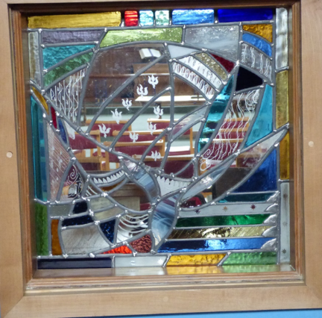
Carol Ikeler’s hymn, sings about a church without walls where God’s people try to live and to share the good news of God. This song has been a bit of an earworm for me over the last few weeks, with good reason. It is a reassurance that although worship in this space is ending in a very short while, the church of God known as Northcliffe will carry on.
I was reminded of a conversation I’d had with a local Iman, a chaplain at the Bradford magistrate’s court. Our discussion included what is worship and how we serve God. The Iman quoted a text that said something like, “All service, (service to God that is), all service is worship.” If we agree that all worship is praise then let’s consider how the people of Northcliffe and have been praising God.

Since both Methodist and Congregational Christians set up their tin tabernacles across the road from each other, God has been praised through successive years of often sacrificial service. God has been praised through uniformed organisations, boys and girls brigade, scouts , Guides, Brownies and Rangers. There have been youth clubs and a Toc H group. Generations of children have developed early language and social skills through pre-school groups. God was praised as these vital foundations were laid.
For over 80 years a continuous melody of praise has rung around this place as the Hall Royd band has nurtured young talent and brought pleasure to many.
The prime purpose of each congregation was to gather in worship and the mutual support we call fellowship. God has been praised by the open doors and welcoming hearts of his people. God has been praised as buildings were developed and improved to be safer and more inclusive and accessible. He has been praised as our toilets were twinned with latrines across the developing world.
In many quiet and uncelebrated ways, God has been and will continue to be praised.
The inclusive service, All together, moves next month to St Andrew’s in Undercliffe. We can be assured that this service, the making and developing of it, is praise, because, we find ourselves in a warm and thin space when we meet. It is praise indeed. God is so good.
Our links with and circuit wide promotion of the Immanuel Project is praise in deed, praise with sleeves rolled up. Praise indeed.
This a but a short sample of an endless list, much of which is lost to memory. Now as worship here ends and this farewell concludes. Our praises will continue as we find new ways to serve. Maybe to serve ourselves and our wellbeing and take a break for a while. We will praise as we seek a new congregation -- or not. We pray that God’s people known as Northcliffe church will continue to serve as the Spirit moves them and, in their service continue to be of the praising church.

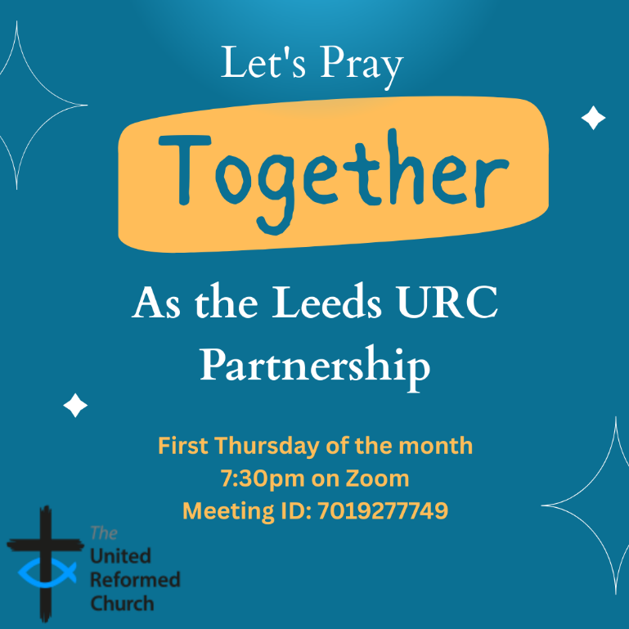
Leeds URC Partnership Prayers

Thursday, 2 July, 7:30pm.
A short time to pray together by reading the Bible and sharing the joys and challenges in our lives, churches, communities and world.
On Zoom:
https://us02web.zoom.us/j/7019277749

Yorkshire Synod Discipleship Development Small Grant Fund 2026
The Synod is pleased to let you all know that it has received confirmation that it has a pot of £4000 to grant to those wishing to apply to the Yorkshire Synod Discipleship Development 2026. Currently we have been able to grant about half of what has been allocated to us, and we would love to be able to offer grants to enable us to use all of what Yorkshire Synod has received.

1. Who is eligible to apply? Committed members or adherents, including children and young people, of a congregation within the United Reformed Church who are exercising, or want to exercise, a form of lay ministry or community service whether expressed within or beyond their local church. The DDF is not open to Ministers of Word and Sacraments and CRCWs, as there are other designated funds available for those groups.

2. How much is available? Up to £300 per applicant per calendar year, although the Synod may agree to more than this according to the local context and circumstances.

3. What can this money be used for? The purposes for which the funding is provided are defined by creativity and vocation, in line with the URC's discipleship development strategy. Be bold, take risks. The funding exists to help you to follow Jesus. You might be helped in this by courses (at any level) at any of the URC Resource Centres for Learning or from other learning providers, or you may have ideas on resourcing discipleship development in other people. You may need funds to cover the costs of travel, materials or books. All you have to do is make a case to your local church meeting and submit the application form to the Synod Convenor of Ministries for consideration and, if appropriate, authorisation.

4. How are applications made? Having gained your church meeting's endorsement, applications are to be made on the designated form, well before the spending is due to start. Backdated applications will not normally be accepted. Application forms are obtainable from the Synod Convenor of Ministries via the Synod Office at office@urcyorkshire.org.uk and should be sent back for authorisation before being passed to the synod finance office.

5. How are grants paid? Grants authorised by the Convenor of Synod Ministries
are paid by a Synod finance officer by reimbursement to you when you have given proof of what you've spent. Contact your Synod Convenor of Ministries for discussion if you need something funded directly on your behalf, rather than waiting for re-imbursement.

If anyone wants to discuss an application before submitting it please contact the Convenor of the Yorkshire Ministries Committee, Kath Lonsdale at kathlonsdale@talktalk.net.
Remember this is for any age of lay person in our churches to apply for so please discuss with your young people as well as adults.

Exciting Roles for URC Youth Members!!!!!!

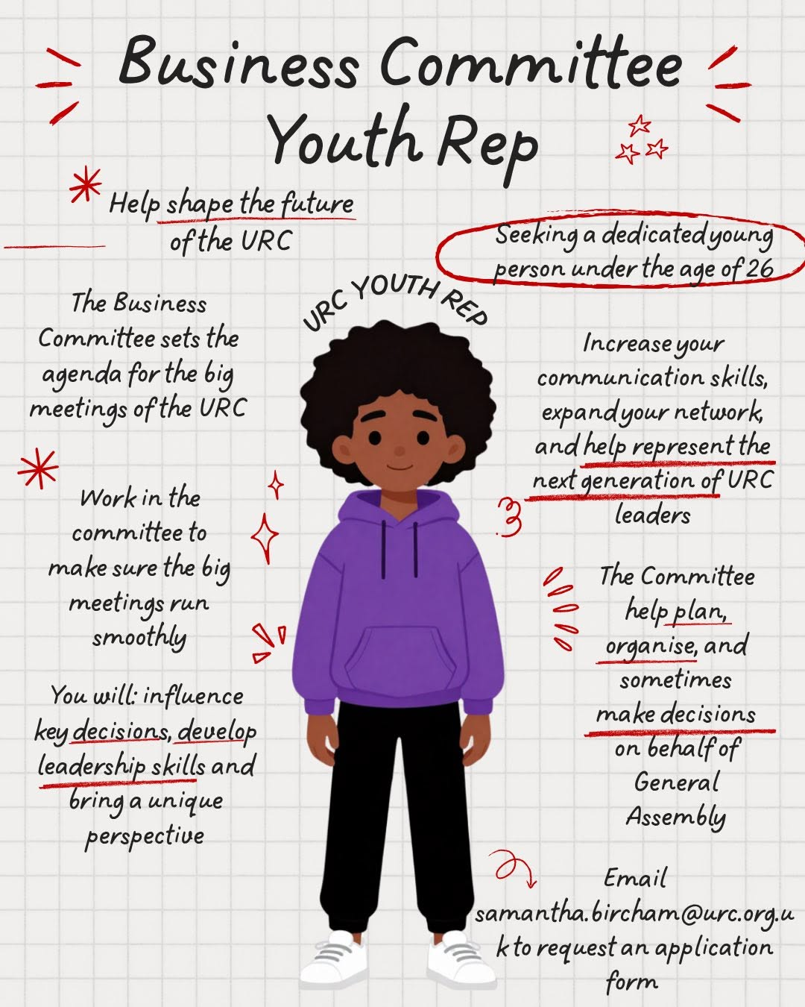
We seem to love committees in the URC and committees in the URC always love it when URC Youth help them in their selected areas through youth representation on that the committee!!
There are three Youth Rep roles which need to be filled and they are explicitly for under 26s.
In no particular order, the first is on the Business Committee, which primarily shapes the future of the URC. Second is on the Church Life Fund Committee which will determine the direction of the upcoming Church Life Fund. Thirdly on the Nominations Committee , whose role is to ensure that the voices on the URC’s committees are representative of the whole denomination.

Find out more on urc.org.uk/jobs/ or email Victoria Blunt, Convenor of Nominations Committee at victoria.blunt@urc.org.uk

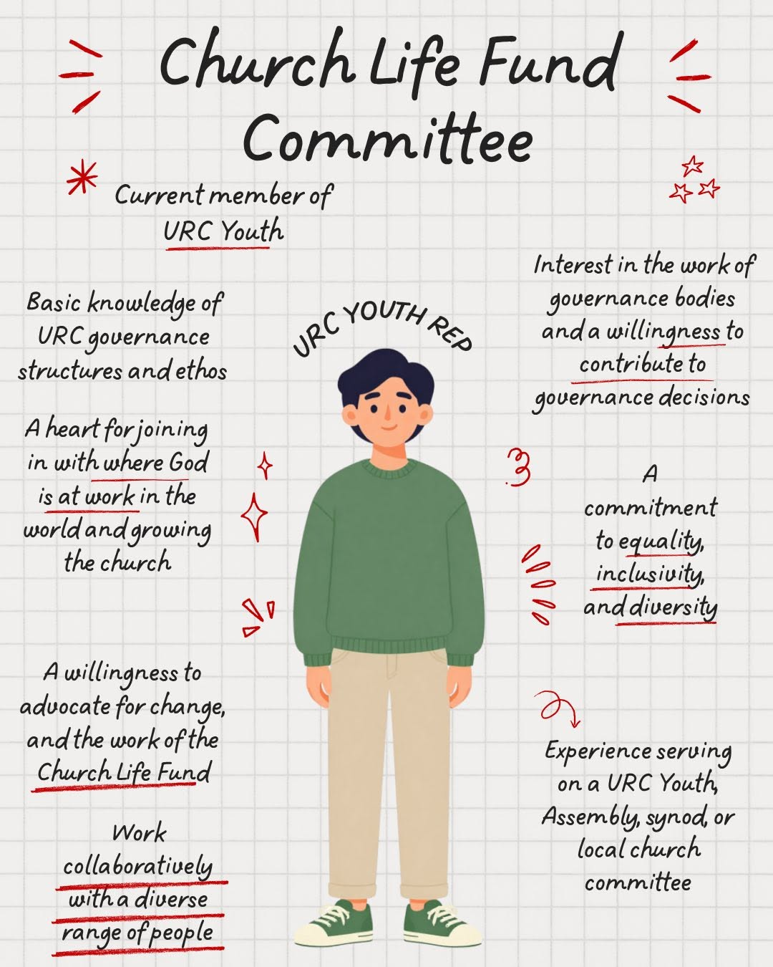
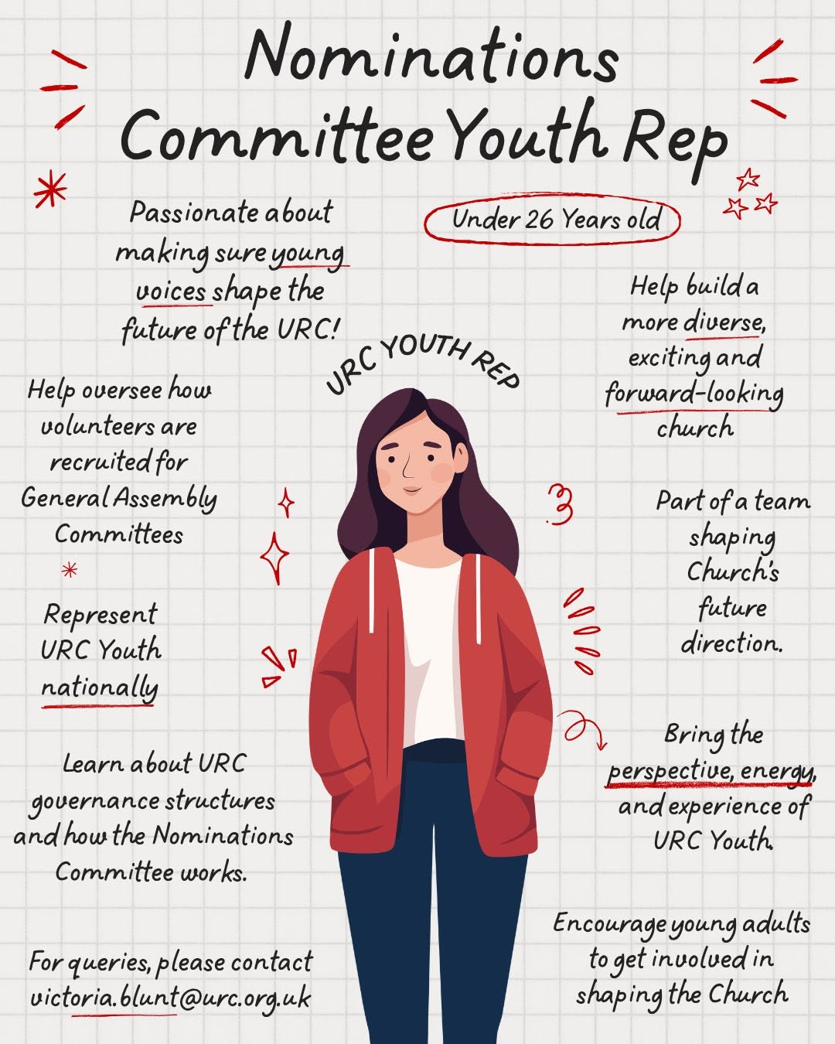


Holiday Club materials – and grants

This year’s URC Holiday Club materials from the Children, Youth and Intergenerational team (CYI) are available at Holiday Club Materials - United Reformed Church. With the theme Wisdom Quest, these are free, downloadable resources for those running holiday clubs for children aged 5–11. (Plus appendices for intergenerational, toddlers, 11–14s and vintage holiday clubs.)

Tying in with the CYI theme for the year, Wise Words, begin the quest of searching for God's wisdom, in words, actions and lives. Throughout the Bible we find words to live by, including the 'I am...' statements of Jesus. Explore some of these stories while thinking about how to share our wisdom with others.
Grants
The Children, Youth and Intergernational committee supports churches in running holiday clubs by offering a grant of either £50 or £100 towards the costs of resources, snacks, decorations, equipment etc. Apply at Children & Youth work grants - United Reformed Church



As well as the Joseph Crossley’s Almshouses now being open to people in Calderdale, Bradford and Kirklees as a place to live, they now have vacancies to join their team as Trustees. The Trustees have to be practicing Christians in the same area of benefit, so opening the area of benefit also means we have opened the area we can draw Trustees from. They have vacancies for both a Pastoral Trustee, and a Finance and Property Trustee. They already have a team of 8 Trustees, but are allowed to have up to 12. They also have a Treasurer and a Clerk, plus two employed wardens. The whole team are active protestant Christians.

If you have anyone in your churches who may be interested, please contact Mr Alan Kendall, the Chair of Trustees for the Joseph Crossley’s Almshouses, at alankendall1234@hotmail.com.

If you would like a copy of the flyer to distribute, please contact the Synod office at the usual address and we’ll be able to send a digital copy across for you to distribute locally. The open day is open to anyone – potential Residents, potential Trustees, people who are interested in old buildings or people who are interested in the history of Halifax, or just anyone who fancies a cheap day out with coffee and biscuits included!

No need to let them know you are coming. They will be there from 10am until 2pm, and they would love to see you there.

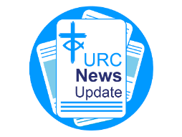
NEWS FROM THE DENOMINATION
The URC’s News Update is a regular e-newsletter that keeps you informed about the latest news and events.
To receive this popular newsletter, please visit the https://urc.org.uk/news-updates-sign-up-form/ page on the URC website and follow the links. If you just want to dip in and catch up on what is going one, that’s fine and you can
read and print recent editions of our e-newsletter by visiting the URC News Update page at https://urc.org.uk/urc-news-update/ .

Convenor of the URC Net Zero Task Group
Could you help lead the United Reformed Church (URC) in its commitment to reducing its carbon footprint?
The Convenor of the Net Zero Task Group (NZTG) has a key role in coordinating the work of the Net Zero Task Group to provide support, advice and encouragement to the whole of the URC, to help lead the denomination towards a net zero carbon future.
The URC is looking for a Convenor who will bring their own experience, drive and perspectives to the NZTG, while also releasing these in others within the task group. The Convenor should be a URC member (lay or ordained).
Closing Date 27 July 2026
More details and application form available here: https://urc.org.uk/jobs/#volunteer

Council for World Mission Sunday (19 July)

The Council for World Mission (CWM) marks CWM Sunday on 19 July, this year with the theme “Revisioning Mission”. Resources for worship and to share information about CWM have been prepared and can be found at https://www.cwmission.org/resources/publications/. In addition, you can view the General Secretary's Message for CWM Sunday 2026 - Council for World Mission (or use the YouTube link: https://youtu.be/lkNT_eC8E9U, which is also included in the liturgical and presentation materials).

The Synod is looking for people to join some of our key groups, especially the Children and Young People’s, the Property and the Financial Resources committees. These bodies guide the direction of Synod and without them Synod would find it hard to function. If you are able to take up a call to help Synod out, please contact the Synod Clerk at clerk@urcyorkshire.org.uk for more information.

Safeguarding News

The Safeguarding team are available seven days a week and 365 days a year as the inbox is monitored at weekends. This inbox is not monitored continually but concerns will be responded to within 24 hours. If you need immediate support, please contact the Police or your Local Authority Duty Safeguarding Team. All contact details for these services MUST be displayed in your churches
Further details can be found on the Yorkshire website at https://urcyorkshire.org.uk/safeguarding/ or email your query to safeguarding.1and4@urc.org.uk.

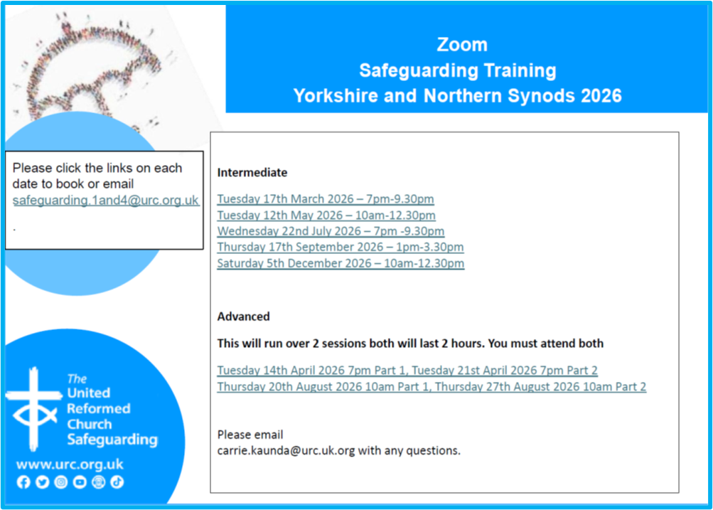

And Finally
Carrie’s Wedding


It’s not often that I can report on one of our members of staff getting married, but I can in this issue. On Saturday 20th June, our own Safeguarding Officer, Carrie, married Terry, and by the look of the pictures, it was a brilliant day.
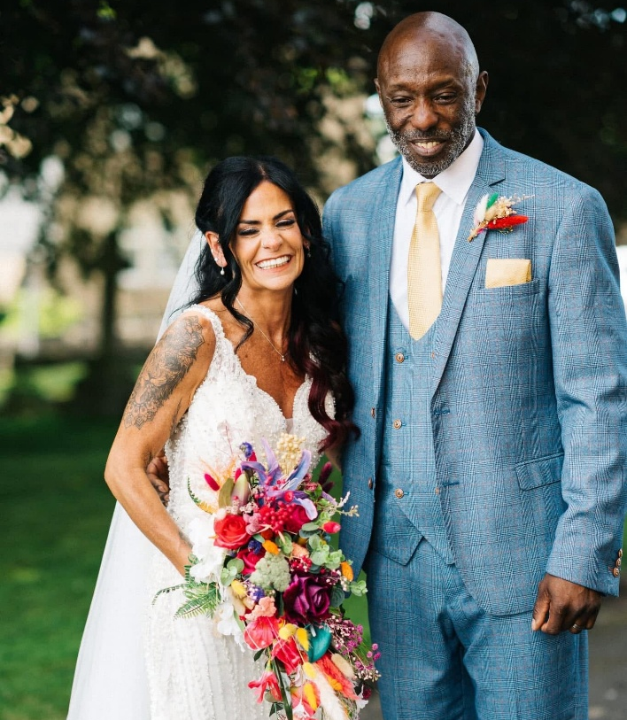



So please join us at the Synod Office in congratulating Carrie and welcoming Terry into the wider Synod family. It does mean though that you will have to update yours records as Carrie has changed her e-mail address to carriesolomon.yorkshire@urc.org.uk. The old e-mail will transfer through to the new, but not for long, so if you can update your records, that would be great.

If you have a good news story from your part of the Synod or something that you feel reflects the work of Synod and which inspires others as we move into 2026, drop me a line at clerk@urcyorkshire.org.uk and I’ll make sure it hits the back page!!

You can also keep an eye on all our social media platforms for news; on the website at Home - URC Yorkshire Synod, at United Reformed Church in Yorkshire - Home | Facebook and Wilderness URC Yorkshire - Home | Facebook, the YouTube page at URC Yorkshire - YouTube and the Twitter (X) page at URC in Yorkshire (@URCYorkshire) / Twitter.

