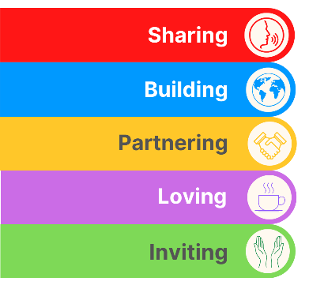
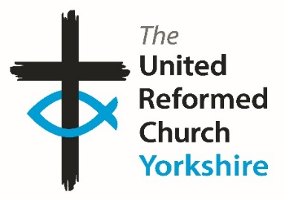
Yorkshire Synod Briefing
Number 178

16th July 2026

General Assembly Special
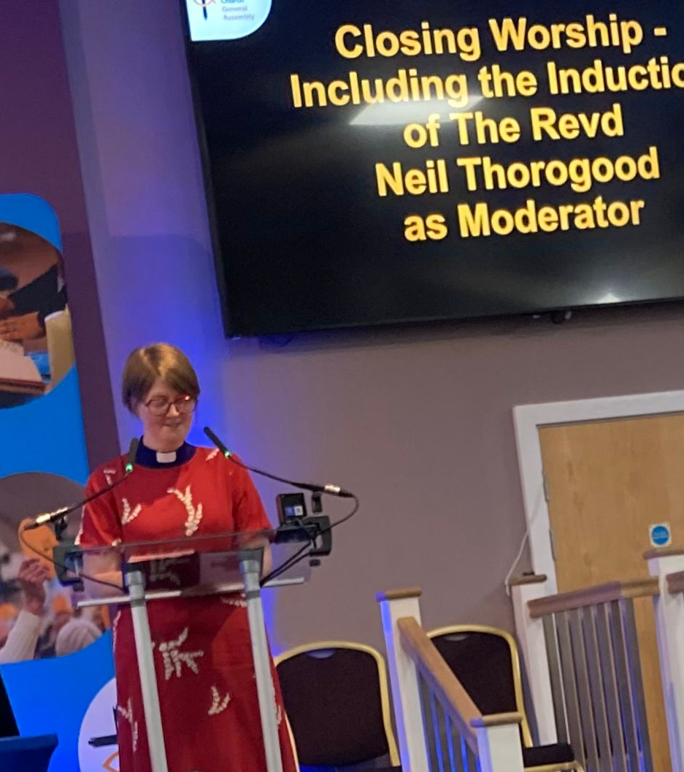
As you may have gathered, the 2026 meeting of the General Assembly of the United Reformed Church took place at the beginning of the month. 11 Yorkshire representatives attended, plus a few with very close Yorkshire connections, including the URC Youth Moderator, Kacie Hodgson and the new GA Moderator’s Chaplain, Revd Samantha Sheehan as well as a surprise visit from one of our own Yorkshire churches (see below). For those attending it was great to catch up with old friends and colleagues as well as an opportunity to meet new people from around the denomination. Rather than me giving chapter and verse on what happened over the weekend, these links take you straight into the daily summaries which can be found separately on the URC website.
Revd Samantha Sheehan leading GA's closing Worship
03 Jul 2026 - General Assembly 2026: day one round-up, 3 July
04 Jul 2026 - General Assembly 2026: day two round-up, 4 July
05 Jul 2026 - General Assembly 2026: day three round-up, 5 July
06 Jul 2026 - General Assembly 2026: day four round-up, 6 July
You can also watch the recorded livestream here: https://www.youtube.com/@URCUK/streams
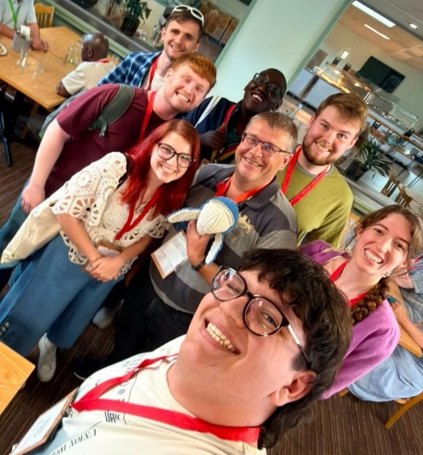
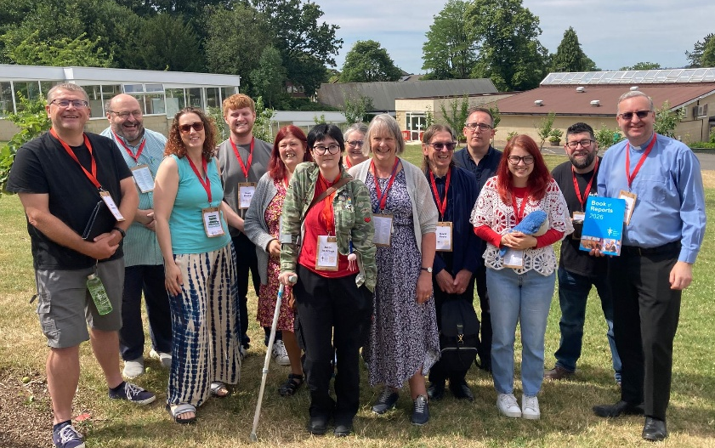
The Yorkshire reps: From L-R; Tim, John, Claire N, Noah (from Otley but moonlighting in Mersey Synod!!), Terri, Jason R, Claire W, Kath, David, Simon, Kacie, Johnny & Jason M.
URC Youth Moderator Kacie, with Tim the Clerk and Jeremy the URC Youth Mascot
Suffice to say that the pictures here give an idea of the weekend’s activities not being wholly business based, and I encourage those who would like to join the Yorkshire team for the 2027 General Assembly to contact the Clerk as soon as possible.

Community Project Awards.
Recently the community work being done in our Yorkshire churches has been rewarded by the receiving of Community Project Awards sponsored by the insurance company Congregational; St Andrew’s Skipton, Wilsden and St Andrew’s Roundhay have all recently received awards, and this year it was great to see that the Children’s and Youth Project at Stag Community Church, Rotherham, was named as one of the winners. This longstanding young people’s work has become a renewed focus for the church and it was great that Lu Hunt, the lead worker and their Minister, Revd Matt Stone could travel to General Assembly to collect the award. The associated video can be found by following this link, which will also take you all the 2026 winners videos, as well as previous years winners: https://urc.org.uk/your-church/church-local-and-global/community-project-awards/
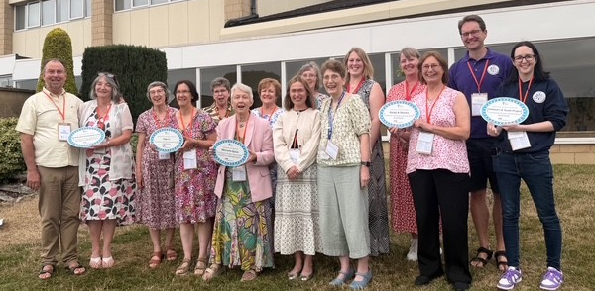
Revd Matt Stone and Lu Hunt (1st & 2nd right) from Stag Community Church with their fellow 2026 Project Award winners
You will all now know that our Moderator, Revd Jamie Kissack, is on Sabbatical. He is due to return on 22nd September. Cover is in place with Anne and Claire at Somerset House covering the Moderator’s PA role between them. However, the moderator@urcyorkshire.org.uk e-mail address now has an out-of-office message and will not be responded to. Therefore, if you have any enquiries relating to Jamie’s role during his Sabbatical, please use the moderatorpa@urcyorkshire.org.uk e-mail address.
Just as an addition as we head into late July and August, some of our Somerset House staff will be taking their summer holidays, so please be aware that at times we may be less quick at responding to queries than during non-holiday periods.
Please continue to send invitations to your events, your stories and pictures in to me, and I’ll continue to advertise and share them throughout 2026, either here in The Briefing or on the Synod website at https://urcyorkshire.org.uk/. They may even end up in https://urc.org.uk/our-news-stories/latest-news/ which is always worth a read and has the opportunity to sign up for regular URC’s news updates.
So, if you have any news of welcoming people into Church, stories of celebration and mission, please let me know by dropping me a line at clerk@urcyorkshire.org.uk and I’ll showcase it in the next edition, due out on the website only on 30th July 2026.
Tim Crossley
Yorkshire Synod Clerk


St Andrew’s Roundhay are planning to celebrate Yorkshire Day on 1st August with a summer barbecue which is open to everyone – church members, friends and the local community. There will be lots of activities for children and adults as well as lots of food and drinks.

We invite our friends from the URC to come and join the fun!

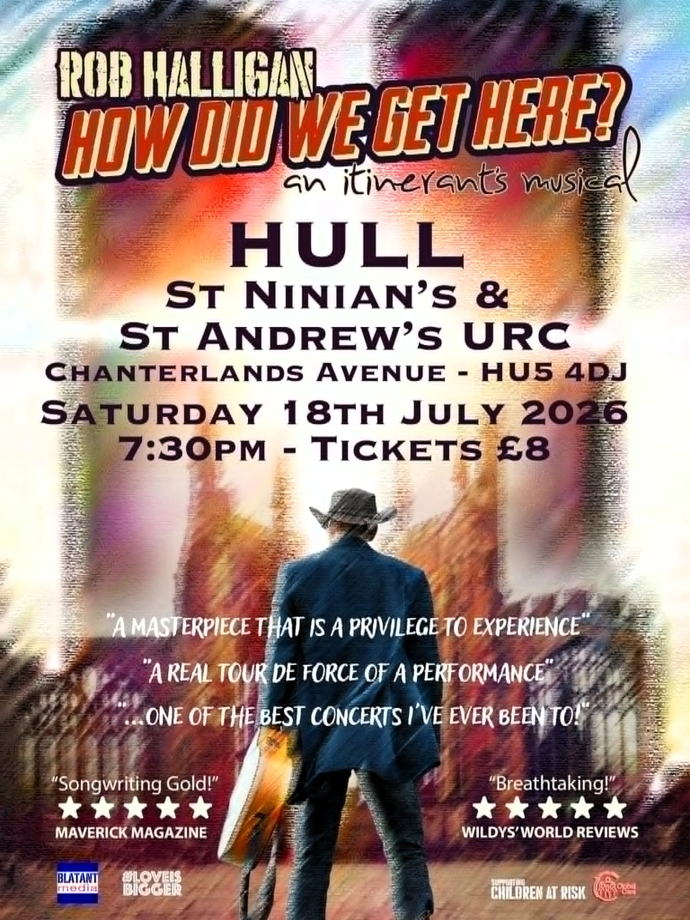

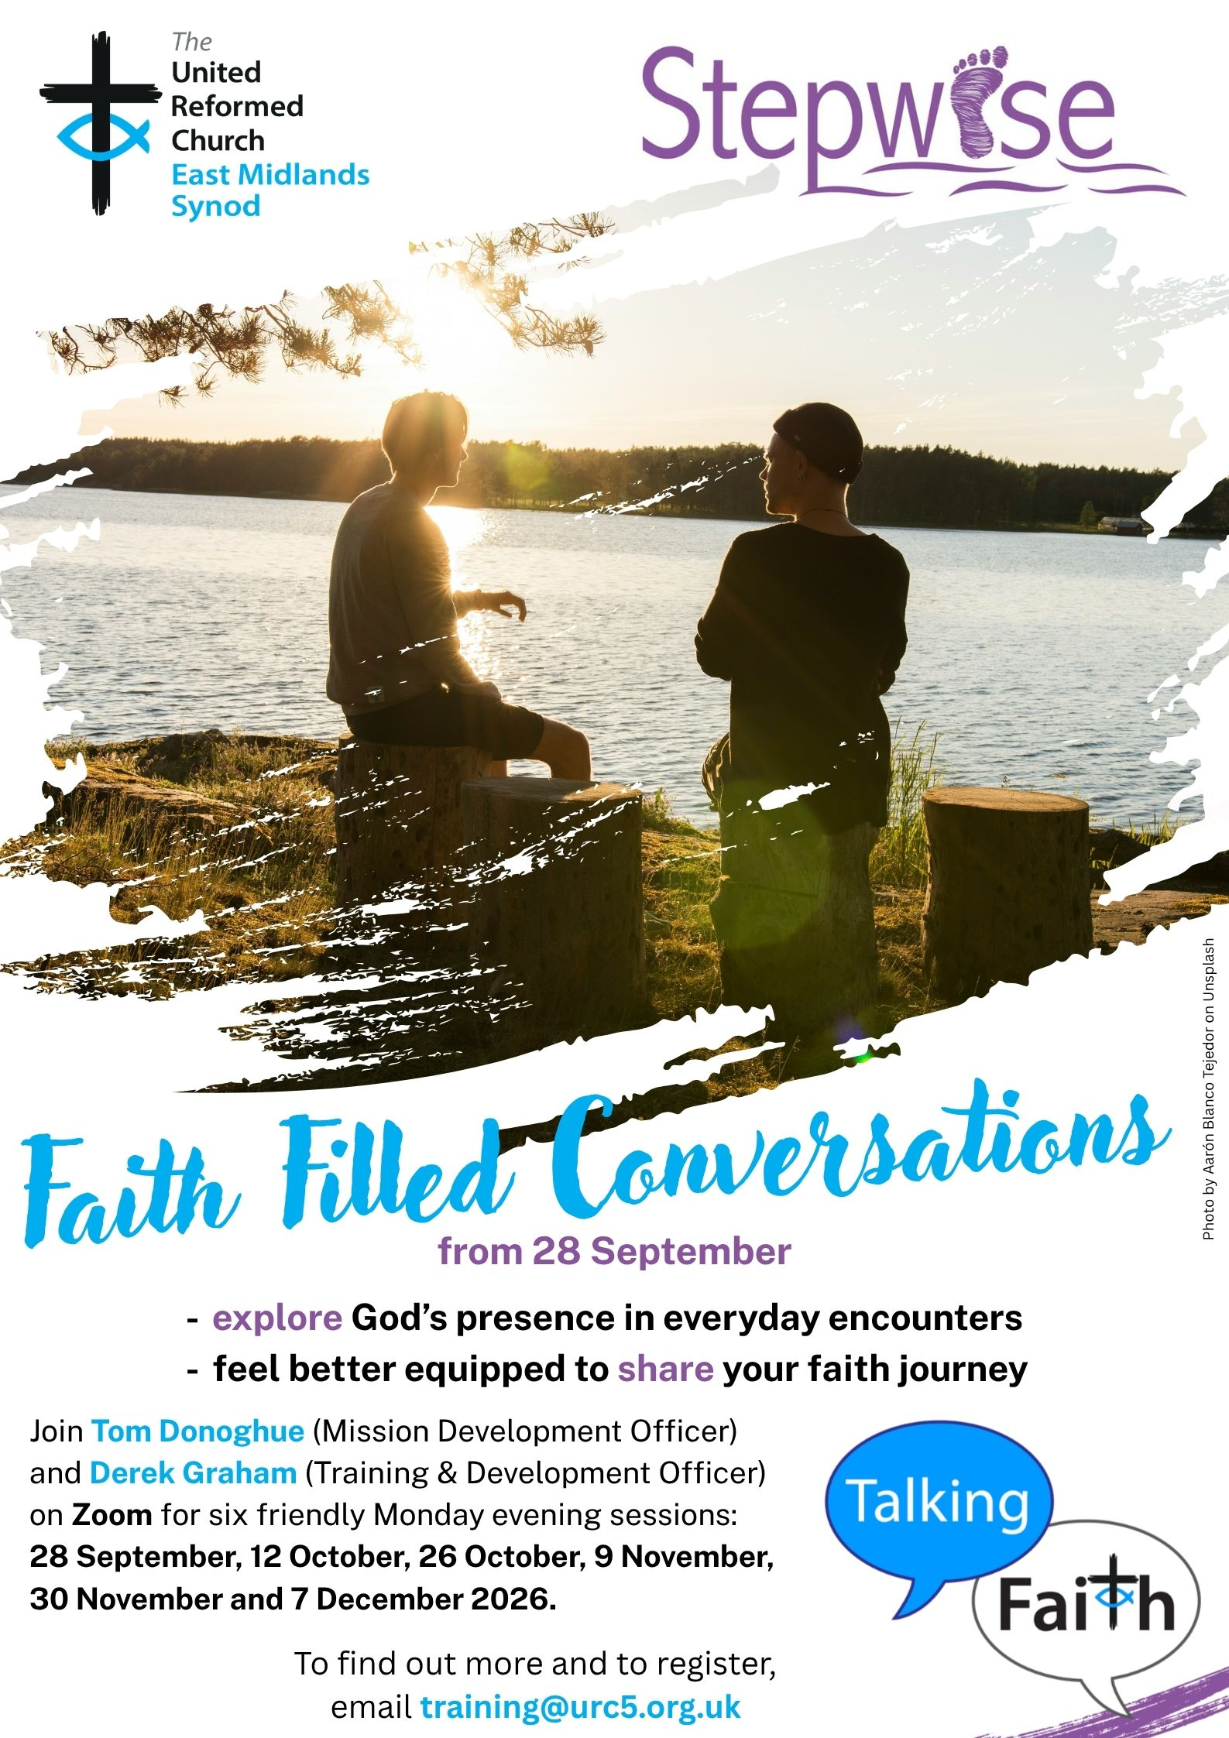

Yes, It’s Here:
The URC’s Resources Hub
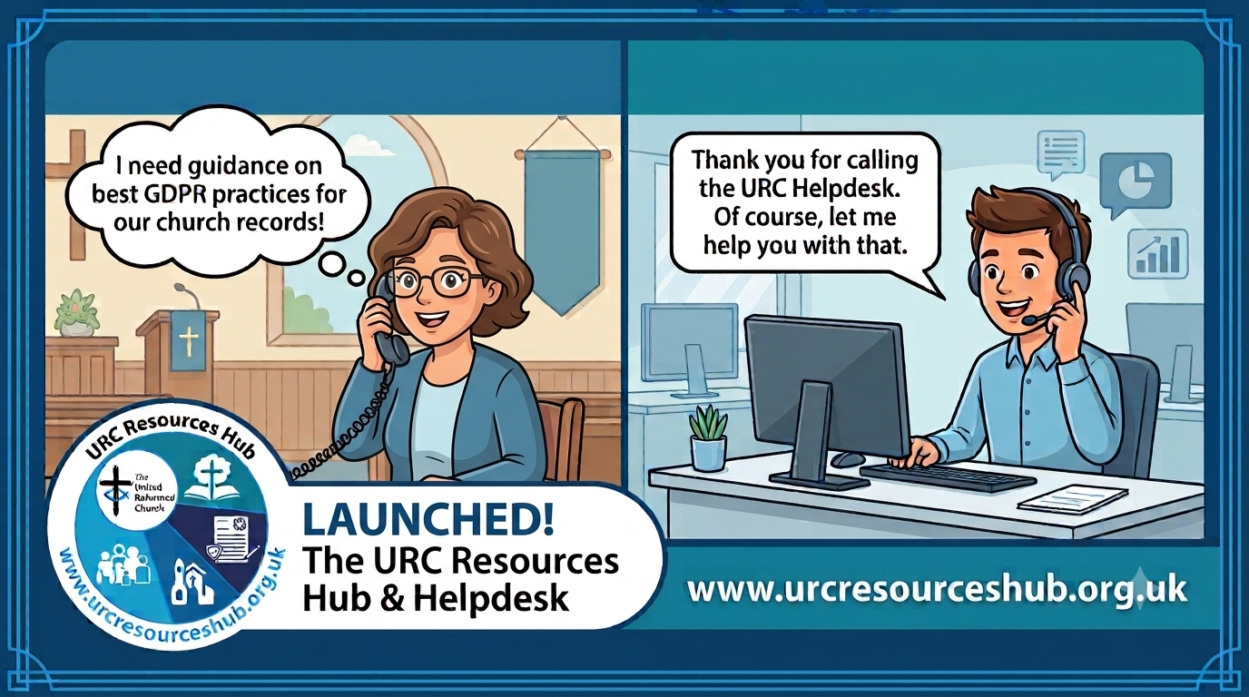
One of the first roll outs from the Church Life Review is this brand new Resources Hub for all our churches and volunteers to use. There are two ways into it, through the URC website, or directly using this link: https://urcresourceshub.org.uk/. Please take a bit of time to have a look, and if you have any feedback or any suggestions for what you may want it to hold, please contact me at clerk@urcyorkshire.org.uk and I’ll pass on your feedback.

There will be more resources being uploaded to the resource over the next few months. The next tranche will be documents covering governance and finance, so keep an eye out on announcements here, in the URC’s regular News Update circulars and in Reformed magazine.

It’s not too late to ask that the team behind the hub add items which you may want. If you know of any resources which you feel may benefit all our churches, drop the Clerk a line at clerk@urcyorkshire.org.uk and he’ll contact the team putting the Resource Hub together.

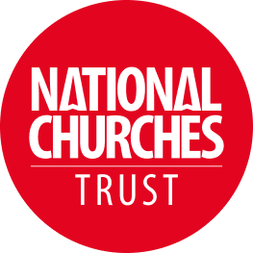

Church & Community Volunteers Awards
Every day, volunteers at churches, chapels and meeting houses across the UK are doing extraordinary things. You're caring for historic buildings, welcoming visitors, supporting local communities, and creating spaces where people can connect, belong and thrive. None of this happens without dedicated and passionate local people.
That's why the NCT awards celebrate the people and churches making a real difference. The NCT recognises how conservation, community use and visitor engagement work together: caring for historic buildings, opening them to visitors, and using them as places of connection, support and activity. From community cafés and foodbanks to events, tourism and heritage interpretation, volunteers help churches remain relevant and resilient.
We want to celebrate volunteers who help churches thrive by caring for and conserving the building and its heritage, using the space to support and strengthen local communities, welcoming visitors and sharing the church’s stories
Nominations for these awards are open now, with the closing date being Tuesday 11 August 2026 (midnight). Volunteers from any church, chapel or meeting house can be nominated.
Click here to download the guidelines and questions for this award and for more information use this link: https://www.nationalchurchestrust.org/impact/awards/volunteers2026?mc_cid=50f6e69e14&mc_eid=d9834dde1d


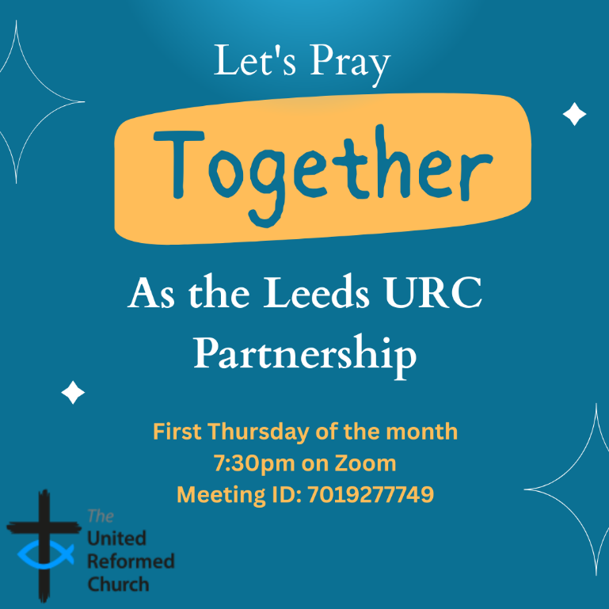
Leeds URC Partnership Prayers

Thursday, 6 August, 7:30pm.
A short time to pray together by reading the Bible and sharing the joys and challenges in our lives, churches, communities and world.
On Zoom:
https://us02web.zoom.us/j/7019277749

Yorkshire Synod Discipleship Development Small Grant Fund 2026
The Synod is pleased to let you all know that it has received confirmation that it has a pot of £4000 to grant to those wishing to apply to the Yorkshire Synod Discipleship Development 2026. Currently we have been able to grant about half of what has been allocated to us, and we would love to be able to offer grants to enable us to use all of what Yorkshire Synod has received.

1. Who is eligible to apply? Committed members or adherents, including children and young people, of a congregation within the United Reformed Church who are exercising, or want to exercise, a form of lay ministry or community service whether expressed within or beyond their local church. The DDF is not open to Ministers of Word and Sacraments and CRCWs, as there are other designated funds available for those groups.

2. How much is available? Up to £300 per applicant per calendar year, although the Synod may agree to more than this according to the local context and circumstances.

3. What can this money be used for? The purposes for which the funding is provided are defined by creativity and vocation, in line with the URC's discipleship development strategy. Be bold, take risks. The funding exists to help you to follow Jesus. You might be helped in this by courses (at any level) at any of the URC Resource Centres for Learning or from other learning providers, or you may have ideas on resourcing discipleship development in other people. You may need funds to cover the costs of travel, materials or books. All you have to do is make a case to your local church meeting and submit the application form to the Synod Convenor of Ministries for consideration and, if appropriate, authorisation.

4. How are applications made? Having gained your church meeting's endorsement, applications are to be made on the designated form, well before the spending is due to start. Backdated applications will not normally be accepted. Application forms are obtainable from the Synod Convenor of Ministries via the Synod Office at office@urcyorkshire.org.uk and should be sent back for authorisation before being passed to the synod finance office.

5. How are grants paid? Grants authorised by the Convenor of Synod Ministries
are paid by a Synod finance officer by reimbursement to you when you have given proof of what you've spent. Contact your Synod Convenor of Ministries for discussion if you need something funded directly on your behalf, rather than waiting for re-imbursement.

If anyone wants to discuss an application before submitting it please contact the Convenor of the Yorkshire Ministries Committee, Kath Lonsdale at kathlonsdale@talktalk.net.
Remember this is for any age of lay person in our churches to apply for so please discuss with your young people as well as adults.

Exciting Roles for URC Youth Members!!!!!!

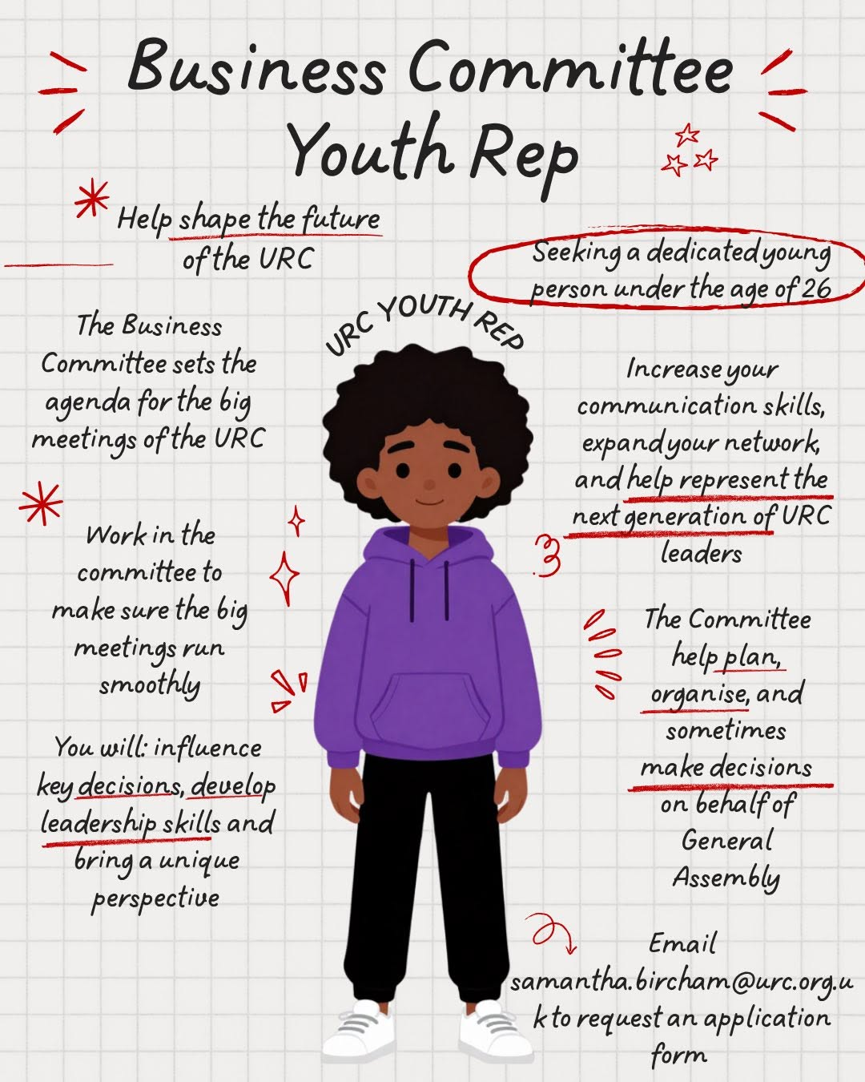
We seem to love committees in the URC and committees in the URC always love it when URC Youth help them in their selected areas through youth representation on that the committee!!
There are three Youth Rep roles which need to be filled and they are explicitly for under 26s.
In no particular order, the first is on the Business Committee, which primarily shapes the future of the URC. Second is on the Church Life Fund Committee which will determine the direction of the upcoming Church Life Fund. Thirdly on the Nominations Committee , whose role is to ensure that the voices on the URC’s committees are representative of the whole denomination.

Find out more on urc.org.uk/jobs/ or email Victoria Blunt, Convenor of Nominations Committee at victoria.blunt@urc.org.uk

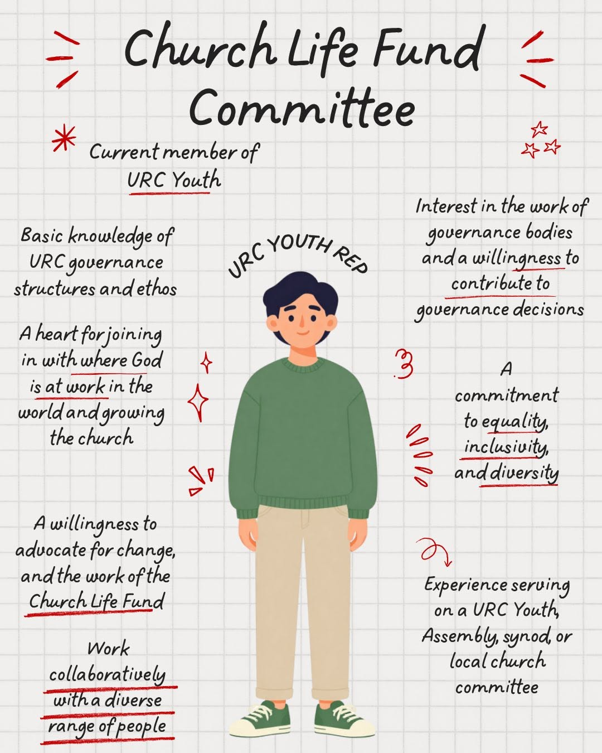
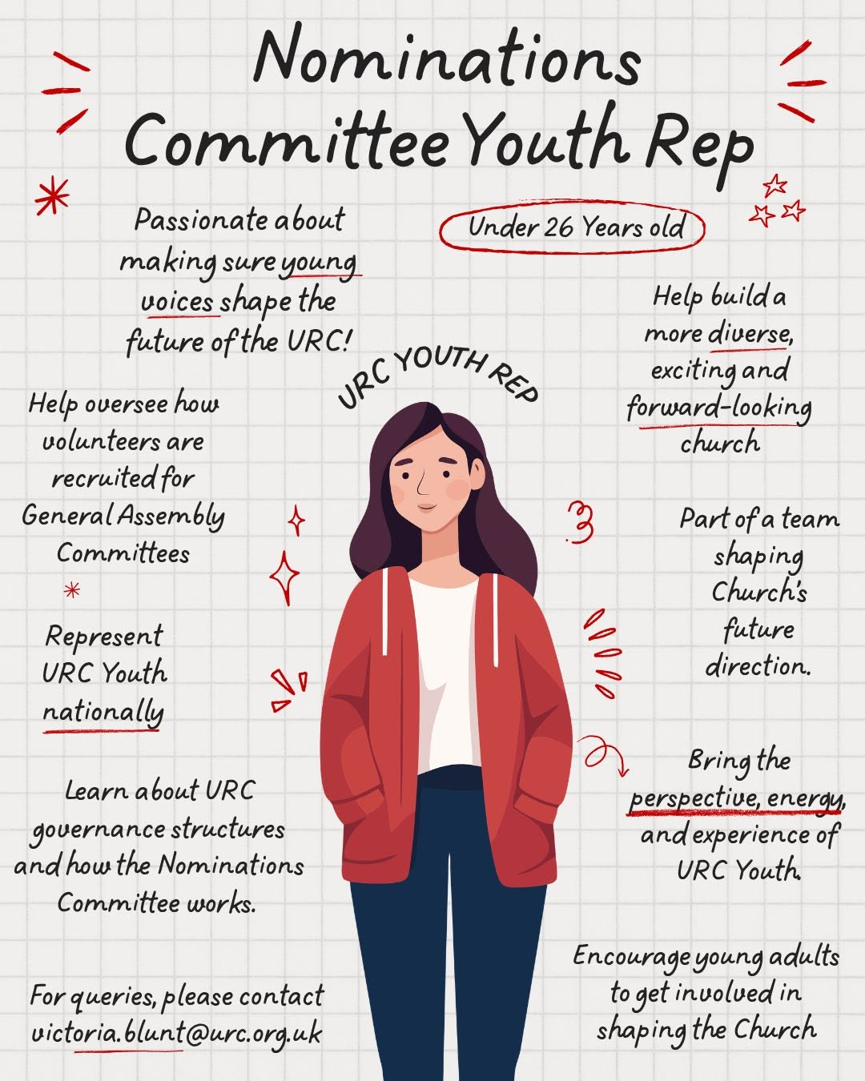


Holiday Club materials – and grants

This year’s URC Holiday Club materials from the Children, Youth and Intergenerational team (CYI) are available at Holiday Club Materials - United Reformed Church. With the theme Wisdom Quest, these are free, downloadable resources for those running holiday clubs for children aged 5–11. (Plus appendices for intergenerational, toddlers, 11–14s and vintage holiday clubs.)

Tying in with the CYI theme for the year, Wise Words, begin the quest of searching for God's wisdom, in words, actions and lives. Throughout the Bible we find words to live by, including the 'I am...' statements of Jesus. Explore some of these stories while thinking about how to share our wisdom with others.
Grants
The Children, Youth and Intergenerational committee supports churches in running holiday clubs by offering a grant of either £50 or £100 towards the costs of resources, snacks, decorations, equipment etc. Apply at Children & Youth work grants - United Reformed Church

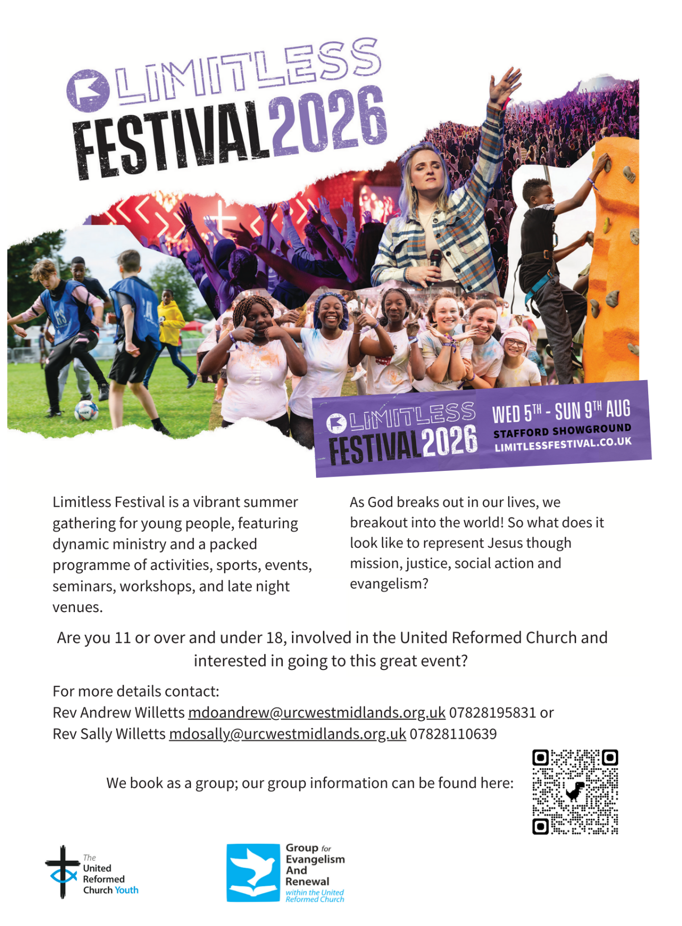

As well as the Joseph Crossley’s Almshouses now being open to people in Calderdale, Bradford and Kirklees as a place to live, they now have vacancies to join their team as Trustees. The Trustees have to be practicing Christians in the same area of benefit, so opening the area of benefit also means we have opened the area we can draw Trustees from. They have vacancies for both a Pastoral Trustee, and a Finance and Property Trustee. They already have a team of 8 Trustees, but are allowed to have up to 12. They also have a Treasurer and a Clerk, plus two employed wardens. The whole team are active protestant Christians.

If you have anyone in your churches who may be interested, please contact Mr Alan Kendall, the Chair of Trustees for the Joseph Crossley’s Almshouses, at alankendall1234@hotmail.com.

If you would like a copy of the flyer to distribute, please contact the Synod office at the usual address and we’ll be able to send a digital copy across for you to distribute locally. The open day is open to anyone – potential Residents, potential Trustees, people who are interested in old buildings or people who are interested in the history of Halifax, or just anyone who fancies a cheap day out with coffee and biscuits included!

No need to let them know you are coming. They will be there from 10am until 2pm, and they would love to see you there.

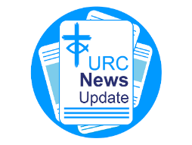
NEWS FROM THE DENOMINATION
The URC’s News Update is a regular e-newsletter that keeps you informed about the latest news and events.
To receive this popular newsletter, please visit the https://urc.org.uk/news-updates-sign-up-form/ page on the URC website and follow the links. If you just want to dip in and catch up on what is going one, that’s fine and you can
read and print recent editions of our e-newsletter by visiting the URC News Update page at https://urc.org.uk/urc-news-update/ .

Convenor of the URC Net Zero Task Group
Could you help lead the United Reformed Church (URC) in its commitment to reducing its carbon footprint?
The Convenor of the Net Zero Task Group (NZTG) has a key role in coordinating the work of the Net Zero Task Group to provide support, advice and encouragement to the whole of the URC, to help lead the denomination towards a net zero carbon future.
The URC is looking for a Convenor who will bring their own experience, drive and perspectives to the NZTG, while also releasing these in others within the task group. The Convenor should be a URC member (lay or ordained).
Closing Date 27 July 2026
More details and application form available here: https://urc.org.uk/jobs/#volunteer

Council for World Mission Sunday (19 July)

The Council for World Mission (CWM) marks CWM Sunday on 19 July, this year with the theme “Revisioning Mission”. Resources for worship and to share information about CWM have been prepared and can be found at https://www.cwmission.org/resources/publications/. In addition, you can view the General Secretary's Message for CWM Sunday 2026 - Council for World Mission (or use the YouTube link: https://youtu.be/lkNT_eC8E9U, which is also included in the liturgical and presentation materials).

The Synod is looking for people to join some of our key groups, especially the Children and Young People’s, the Property and the Financial Resources committees. These bodies guide the direction of Synod and without them Synod would find it hard to function. If you are able to take up a call to help Synod out, please contact the Synod Clerk at clerk@urcyorkshire.org.uk for more information.

Property Committee News
Our erstwhile Property Officer, Jane Bunyan will be on leave between 31st August and 4th September this year which means that the usual dates for property applications into Synod are having to change. Usually the deadline for applications to be considered at the September meeting is 31st August, but for this meeting that deadline has been brought forward. Therefore, any property applications for either works or Synod Mission Fund grants (property stream) will need to be in by Friday 21st August 2026. Partial or incomplete submissions will be held over until the November meeting.
Churches may wish to note that applications for grant funding support have been brought into line with the Synod Mission Fund. So, before they can be considered, we will be asking more questions regarding mission and compliance. Full details of these can be found in sections H, I and J of the supporting notes to the form, which is downloadable from here https://urcyorkshire.org.uk/wp-content/uploads/2026/05/Synod-Mission-Fund-Grant-Application-Form.docx
If you have any questions, please contact Jane at property@urcyorkshire.org.uk or the Clerk at clerk@urcyorkshire.org.uk.

And Finally
Jubilee Celebrations

Each year at General Assembly, the United Reformed Church honours its Jubilee Ministers. These are Ministers whose ordination was 50, 60, 70 or more years ago. We are blessed in Yorkshire Synod to have been able to celebrate two Jubilee Ministers this year, both of whom were ordained in 1966, and both of whom are members at Trinity St Andrew’s in Skipton.
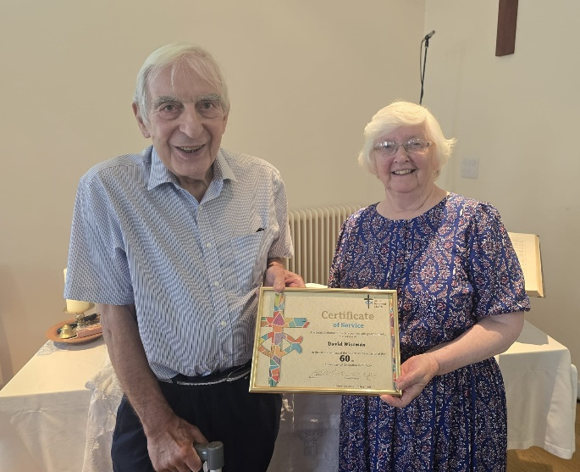
The first is Revd David Batchelor, who on being ordained first served in Madagascar through CCWM (Congregational Council for World Mission), and then later in Guisborough, Eston, Southport, Eastcote and Hale.
The second, and pictured here with his wife Margaret, is Revd David Wiseman, who was ordained into Workington then served at Poulton-le-Fylde, Wigan, Bournmouth and Rochdale.
Congratulations to both Davids on reaching this milestone, thank you for your service to the Congregational and United Reformed Churches and may our prayers from Synod keep you for many more years to come.

If you have a good news story from your part of the Synod or something that you feel reflects the work of Synod and which inspires others as we move into 2026, drop me a line at clerk@urcyorkshire.org.uk and I’ll make sure it hits the back page!!

You can also keep an eye on all our social media platforms for news; on the website at Home - URC Yorkshire Synod, at United Reformed Church in Yorkshire - Home | Facebook and Wilderness URC Yorkshire - Home | Facebook, the YouTube page at URC Yorkshire - YouTube and the Twitter (X) page at URC in Yorkshire (@URCYorkshire) / Twitter.

