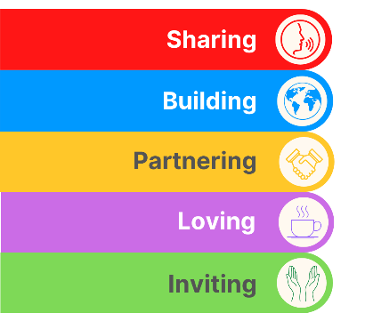
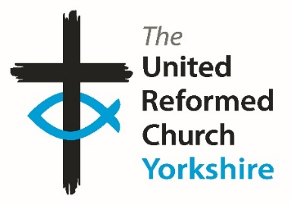
Yorkshire Synod Briefing
Number 179

30th July 2026

A Time for Everything


“For everything has its season, and for every activity under heaven its time:” Many of you will recognize this snippet from Ecclesiates 3:1 and I’m sure it resonates with you as it does with us here at Synod. This is especially so in the coming month as it sees many of us heading on our holidays, especially those who have school aged children, and this will have an effect on the Synod Office in Morley. As well as yours truly taking a fortnight at the end of the month, several other members of staff will be taking well earned breaks before the unofficial start of the meetings year in September. We have also taken this relatively quiet time to upgrade some of the electrics at Synod office, so this Thursday and Friday and next Thursday and Friday will see the Synod Office power free……… This all will mean that the speed in which the team get back to any general queries may not be as quick as usual, but rest assured, Synod remains dedicated to serving all our churches. I know that the URC doesn’t do church years as such (apart from the liturgical year starting on Advent Sunday), but with many of us tied to academic calendars and many of our churches tied into the Methodist Church’s year as part of their LEP arrangements, the start of September sees the Synod’s wheels start turning. So August then will see many of the Synod team getting a bit of rest and recouperation, and as you will see from the events already being line up for the autumn, they will be ready for the work to bring God’s Kingdom ever closer.

One thing we haven’t been in July is quiet. You will have read the stories from General Assembly – they are still on the URC website at https://urc.org.uk/general-assembly-assembly-executive-assembly-committees/general-assembly/ and in this issue you’ll see that the recent Lay Preachers’ Weekend was a great success. Not only that, but we have had news of an ursine picnic in Wyke!!!

So, if you have any news of welcoming people into Church, stories of celebration and mission, please let me know by dropping me a line at clerk@urcyorkshire.org.uk and I’ll showcase it in the next edition, due out on the website only on 13th August 2026.
Tim Crossley
Yorkshire Synod Clerk

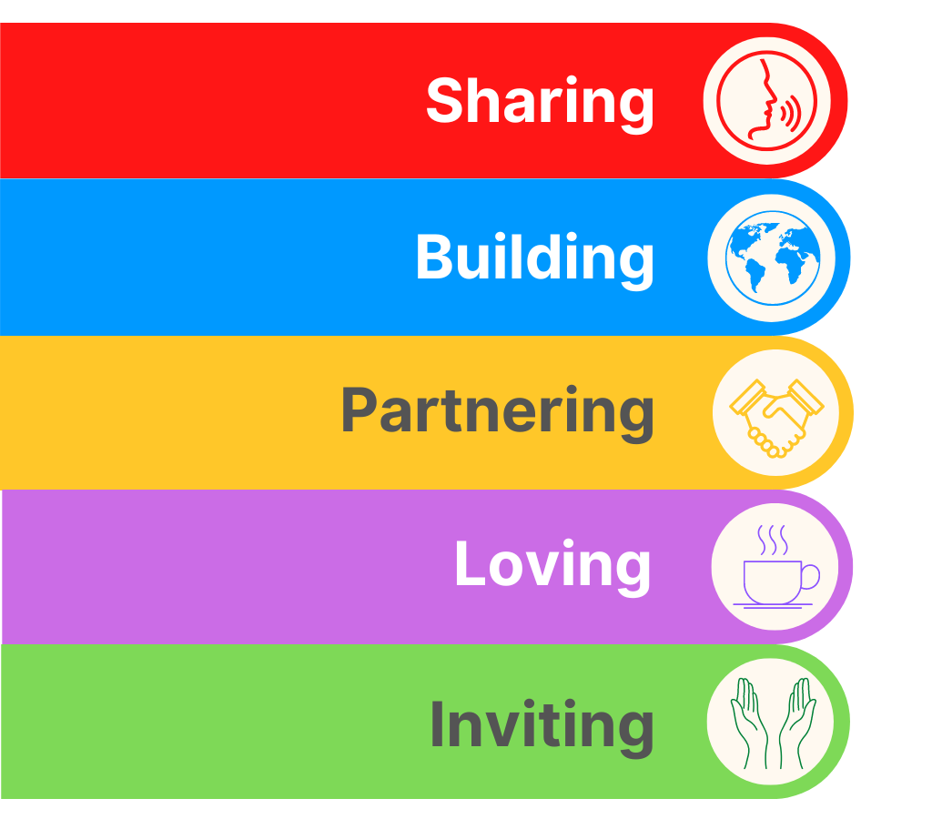
Lay Preachers Weekend
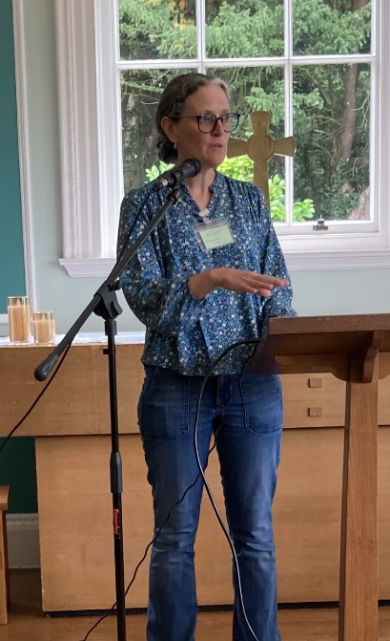
At the recent Lay Preachers’ Weekend, held at Wydale Hall near Scarborough, Dr Alison Gray from Westminster college led the weekend on how to preach on the Psalms. In doing so she both inspired those attending as well as challenged them in equal parts. They were also blessed in that Alison offered to play the piano for the three acts of worship, helped by Sue Pickering of Ardeen Road URC, Doncaster, on the violin, who came to the conference for the first time.
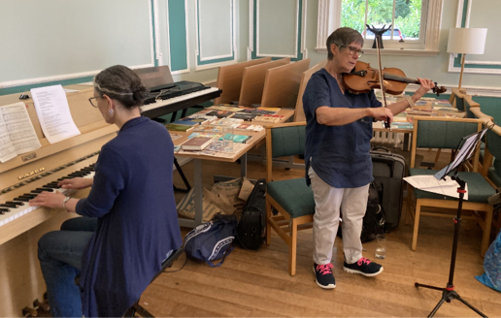
Psalm 133 says "how good and pleasant it is when God's people live together in unity." Margaret Preece from Hornsea shared with us after we studied this psalm amongst others and has paraphrased it, succinctly summing up the whole time spent together in fellowship and in learning:

"How good and pleasant it is to be with my Christian friends this weekend.
How good and pleasant to pray together,
praise God together and learn together.
This is unity, this is God's will,
to work and play together in this special place
as God's children in unity."

The Lay Preachers offered a big thank you to Alison, to Revd Jason McCullagh, to Jon Steel and the to the planning group which consisted of Rod Morrison, Anne Dale, Jill Fletcher, Kath Lonsdale and all who attended for making this another fruitful Synod weekend. Keep your eyes open for details of next year’s annual conference at Wydale from 9th to 11th July 2027.

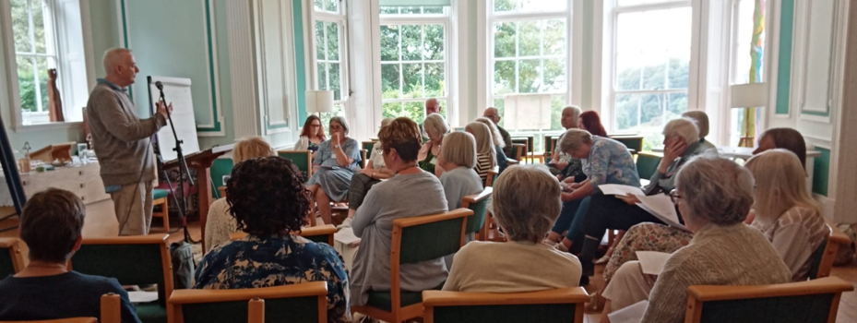
Exciting Roles for URC Youth Members!!!!!!

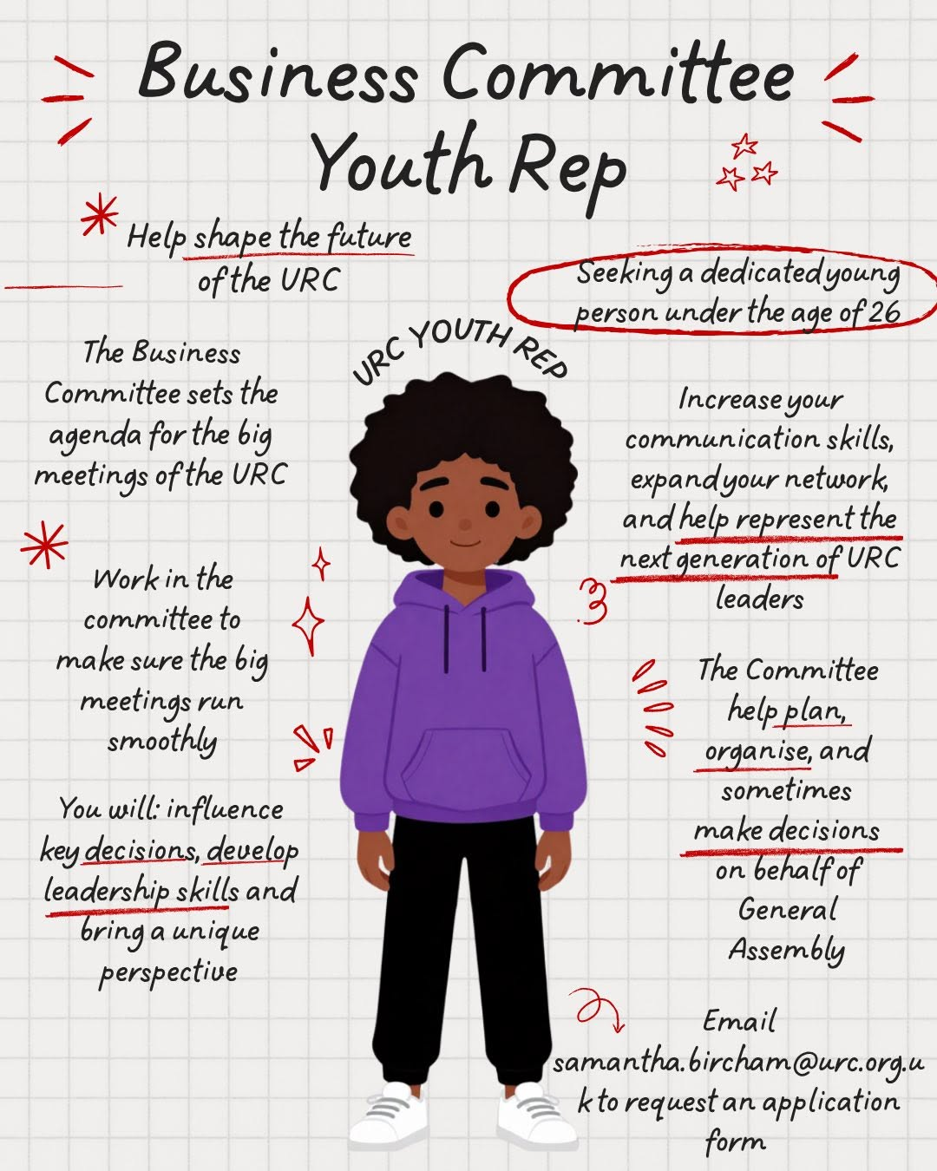
We seem to love committees in the URC and committees in the URC always love it when URC Youth help them in their selected areas through youth representation on that the committee!!
There are three Youth Rep roles which need to be filled and they are explicitly for under 26s.
In no particular order, the first is on the Business Committee, which primarily shapes the future of the URC. Second is on the Church Life Fund Committee which will determine the direction of the upcoming Church Life Fund. Thirdly on the Nominations Committee , whose role is to ensure that the voices on the URC’s committees are representative of the whole denomination.

Find out more on urc.org.uk/jobs/ or email Victoria Blunt, Convenor of Nominations Committee at victoria.blunt@urc.org.uk

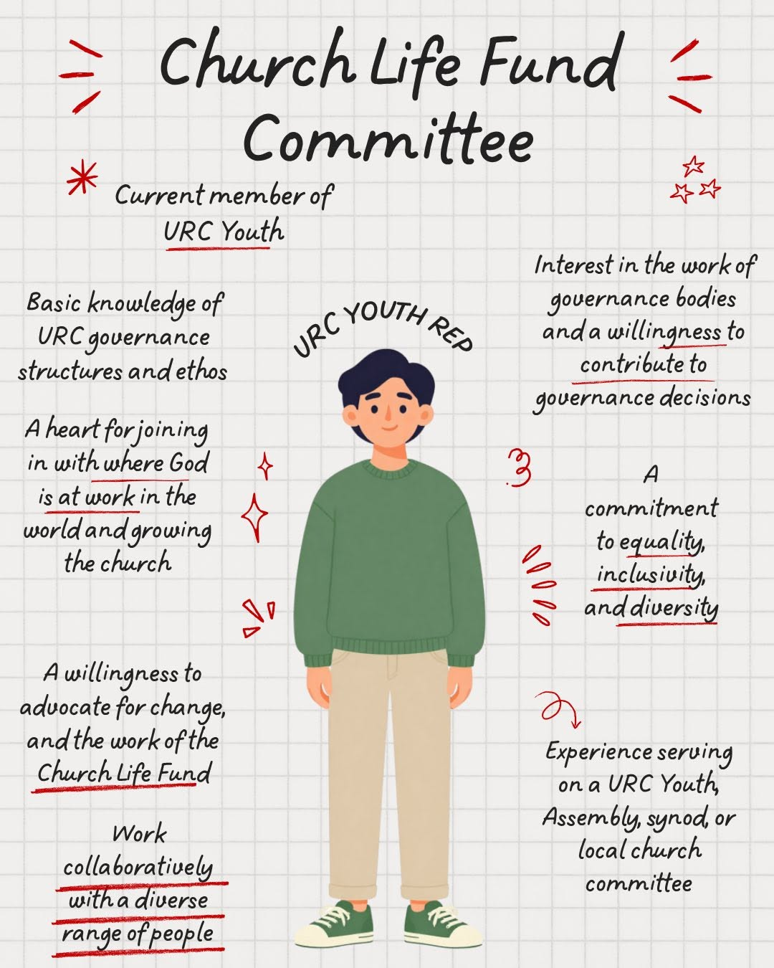
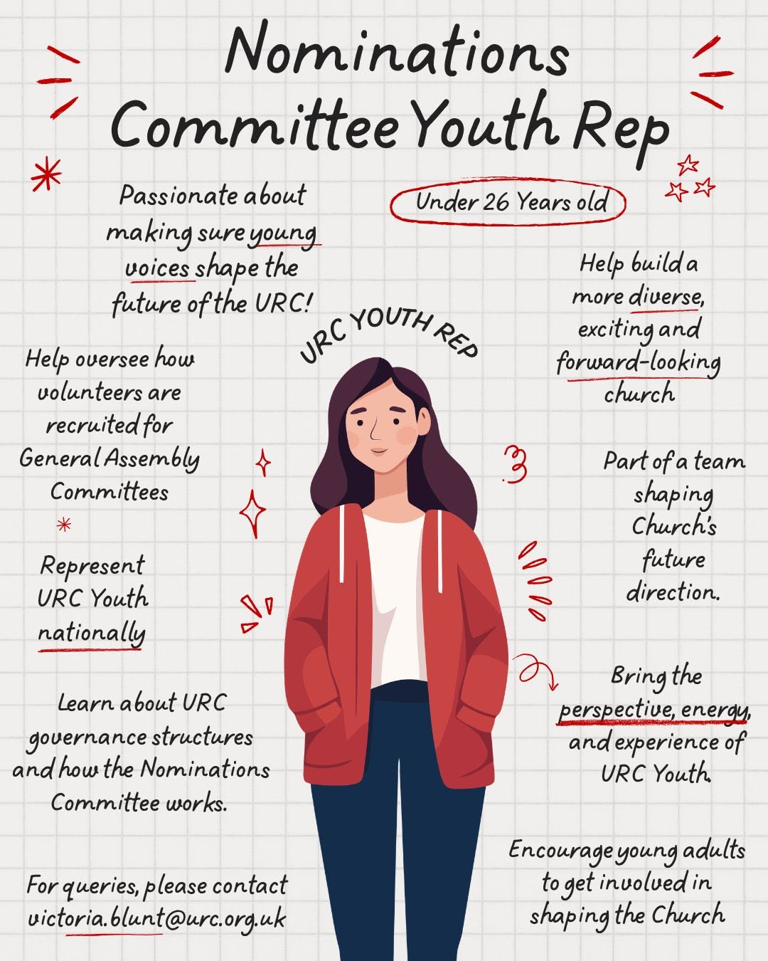


Holiday Club materials – and grants

This year’s URC Holiday Club materials from the Children, Youth and Intergenerational team (CYI) are available at Holiday Club Materials - United Reformed Church. With the theme Wisdom Quest, these are free, downloadable resources for those running holiday clubs for children aged 5–11. (Plus appendices for intergenerational, toddlers, 11–14s and vintage holiday clubs.)

Tying in with the CYI theme for the year, Wise Words, begin the quest of searching for God's wisdom, in words, actions and lives. Throughout the Bible we find words to live by, including the 'I am...' statements of Jesus. Explore some of these stories while thinking about how to share our wisdom with others.
Grants
The Children, Youth and Intergenerational committee supports churches in running holiday clubs by offering a grant of either £50 or £100 towards the costs of resources, snacks, decorations, equipment etc. Apply at Children & Youth work grants - United Reformed Church

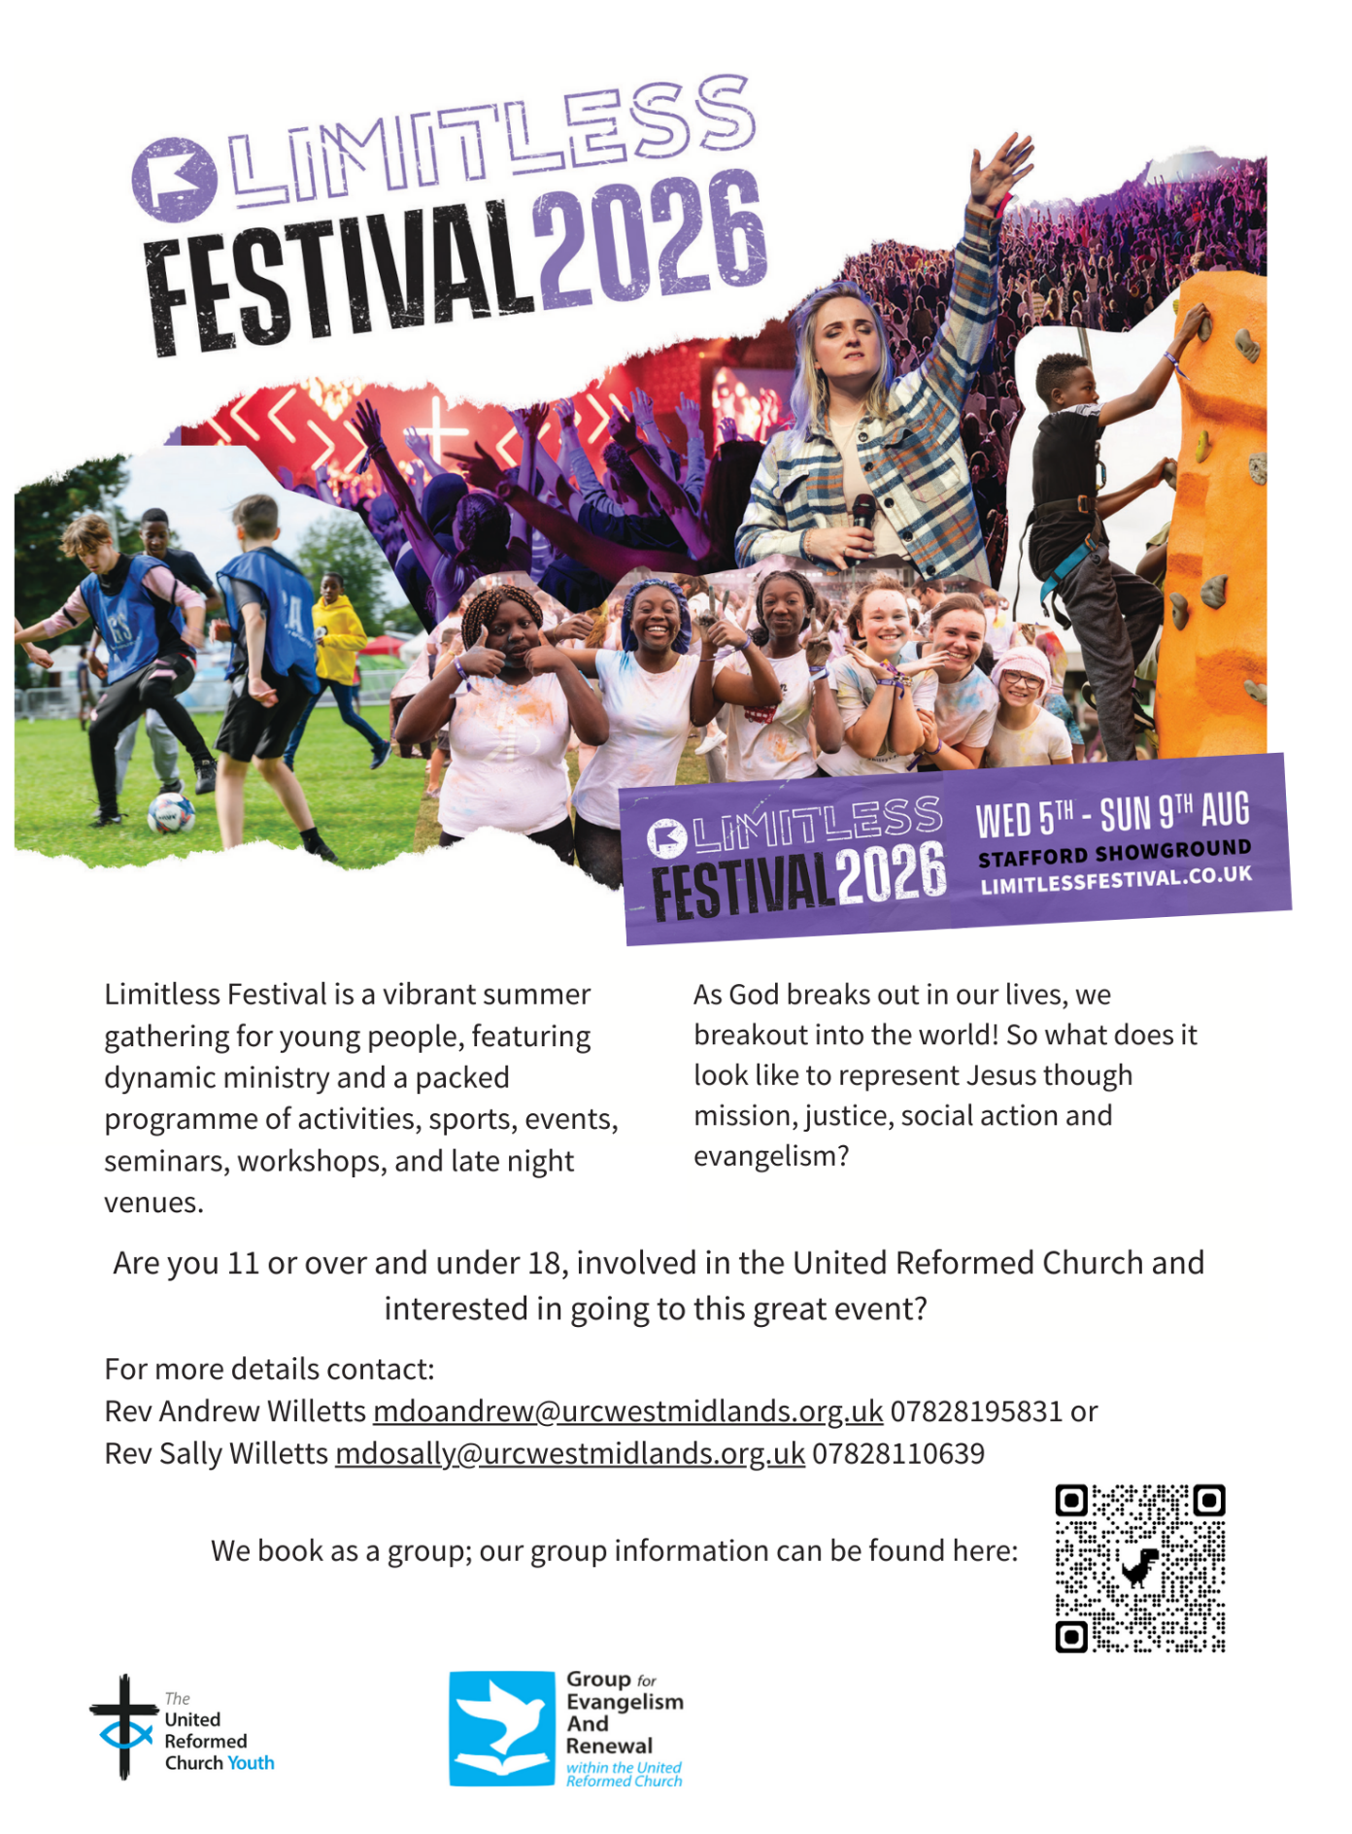


St Andrew’s Roundhay are planning to celebrate Yorkshire Day on 1st August with a summer barbecue which is open to everyone – church members, friends and the local community. There will be lots of activities for children and adults as well as lots of food and drinks.
We invite our friends from the URC to come and join the fun!

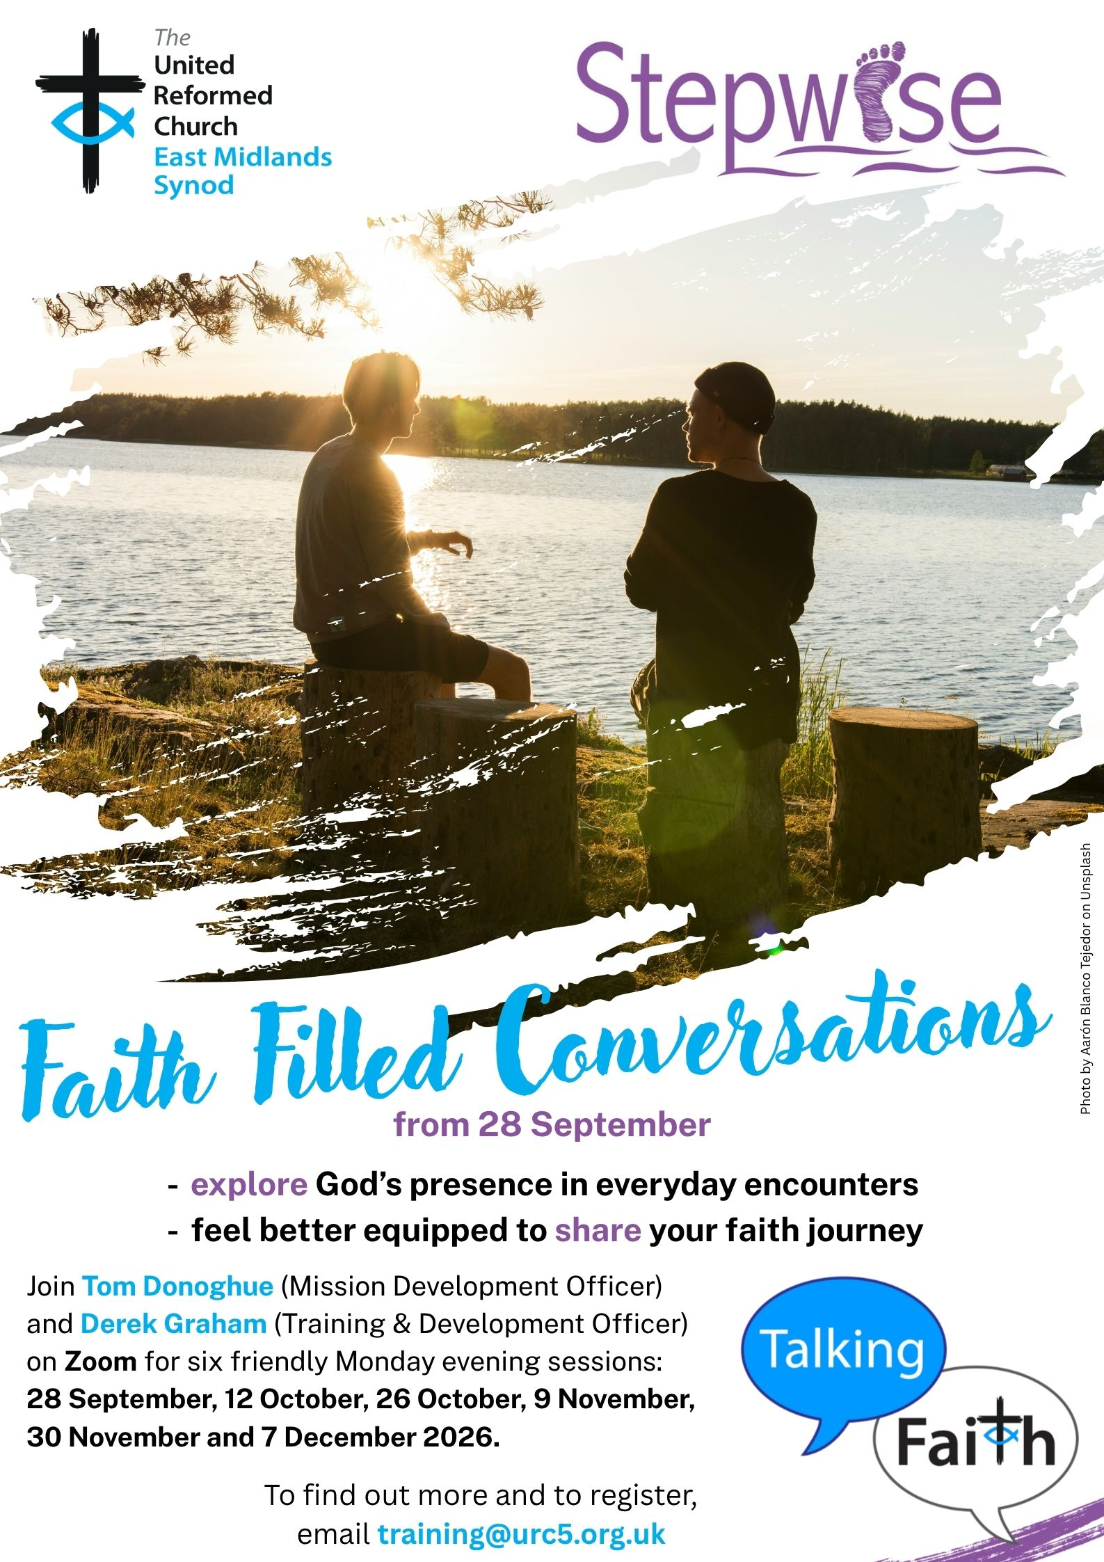

Yes, It’s Here:
The URC’s Resources Hub
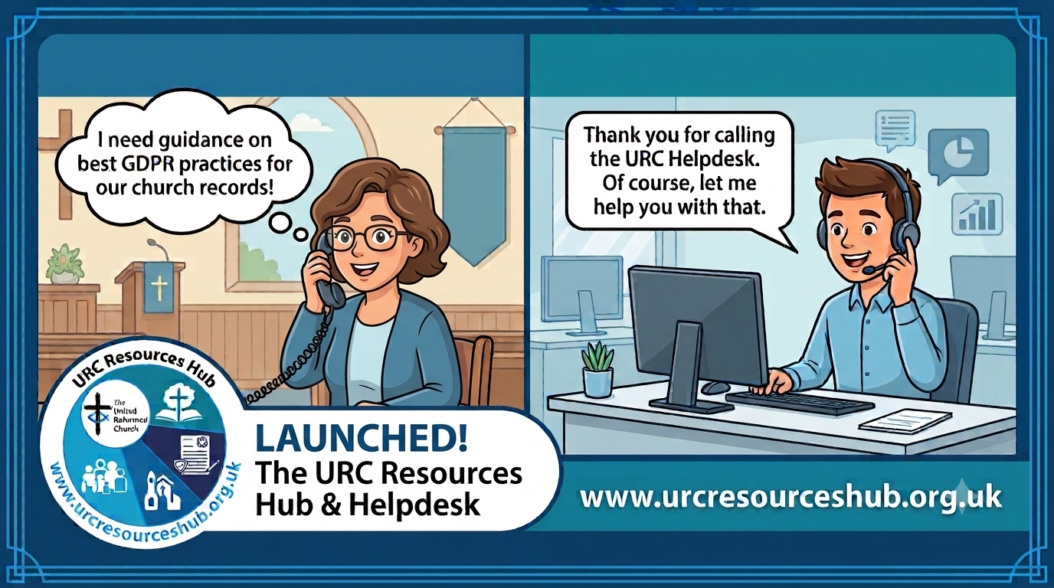
One of the first roll outs from the Church Life Review is this brand new Resources Hub for all our churches and volunteers to use. There are two ways into it, through the URC website, or directly using this link: https://urcresourceshub.org.uk/. Please take a bit of time to have a look, and if you have any feedback or any suggestions for what you may want it to hold, please contact me at clerk@urcyorkshire.org.uk and I’ll pass on your feedback.

There will be more resources being uploaded to the resource over the next few months. The next tranche will be documents covering governance and finance, so keep an eye out on announcements here, in the URC’s regular News Update circulars and in Reformed magazine.

It’s not too late to ask that the team behind the hub add items which you may want. If you know of any resources which you feel may benefit all our churches, drop the Clerk a line at clerk@urcyorkshire.org.uk and he’ll contact the team putting the Resource Hub together.

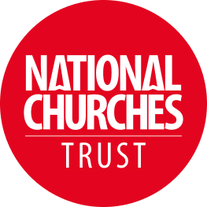

Church & Community Volunteers Awards
Every day, volunteers at churches, chapels and meeting houses across the UK are doing extraordinary things. You're caring for historic buildings, welcoming visitors, supporting local communities, and creating spaces where people can connect, belong and thrive. None of this happens without dedicated and passionate local people.
That's why the NCT awards celebrate the people and churches making a real difference. The NCT recognises how conservation, community use and visitor engagement work together: caring for historic buildings, opening them to visitors, and using them as places of connection, support and activity. From community cafés and foodbanks to events, tourism and heritage interpretation, volunteers help churches remain relevant and resilient.
We want to celebrate volunteers who help churches thrive by caring for and conserving the building and its heritage, using the space to support and strengthen local communities, welcoming visitors and sharing the church’s stories
Nominations for these awards are open now, with the closing date being Tuesday 11 August 2026 (midnight). Volunteers from any church, chapel or meeting house can be nominated.
Click here to download the guidelines and questions for this award and for more information use this link: https://www.nationalchurchestrust.org/impact/awards/volunteers2026?mc_cid=50f6e69e14&mc_eid=d9834dde1d


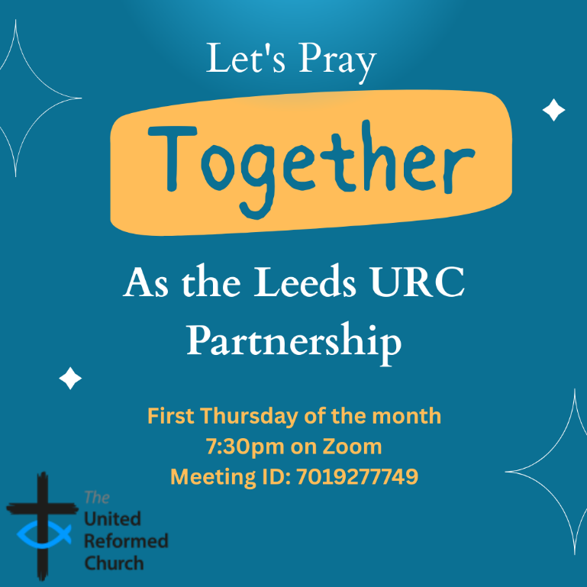
Leeds URC Partnership Prayers

Thursday, 6 August, 7:30pm.
A short time to pray together by reading the Bible and sharing the joys and challenges in our lives, churches, communities and world.
On Zoom:
https://us02web.zoom.us/j/7019277749

Yorkshire Synod Discipleship Development Small Grant Fund 2026
The Synod is pleased to let you all know that it has received confirmation that it has a pot of £4000 to grant to those wishing to apply to the Yorkshire Synod Discipleship Development 2026. Currently we have been able to grant about half of what has been allocated to us, and we would love to be able to offer grants to enable us to use all of what Yorkshire Synod has received.

1. Who is eligible to apply? Committed members or adherents, including children and young people, of a congregation within the United Reformed Church who are exercising, or want to exercise, a form of lay ministry or community service whether expressed within or beyond their local church. The DDF is not open to Ministers of Word and Sacraments and CRCWs, as there are other designated funds available for those groups.

2. How much is available? Up to £300 per applicant per calendar year, although the Synod may agree to more than this according to the local context and circumstances. Currently we have funding available for 4 more grants this calendar year.

3. What can this money be used for? The purposes for which the funding is provided are defined by creativity and vocation, in line with the URC's discipleship development strategy. Be bold, take risks. The funding exists to help you to follow Jesus. You might be helped in this by courses (at any level) at any of the URC Resource Centres for Learning or from other learning providers, or you may have ideas on resourcing discipleship development in other people. You may need funds to cover the costs of travel, materials or books. All you have to do is make a case to your local church meeting and submit the application form to the Synod Convenor of Ministries for consideration and, if appropriate, authorisation.

4. How are applications made? Having gained your church meeting's endorsement, applications are to be made on the designated form, well before the spending is due to start. Backdated applications will not normally be accepted. Application forms are obtainable from the Synod Convenor of Ministries via the Synod Office at office@urcyorkshire.org.uk and should be sent back for authorisation before being passed to the synod finance office.

5. How are grants paid? Grants authorised by the Convenor of Synod Ministries
are paid by a Synod finance officer by reimbursement to you when you have given proof of what you've spent. Contact your Synod Convenor of Ministries for discussion if you need something funded directly on your behalf, rather than waiting for re-imbursement.

If anyone wants to discuss an application before submitting it please contact the Convenor of the Yorkshire Ministries Committee, Kath Lonsdale at kath.lonsdale@outlook.com (please note the new e-mail address).
Remember this is for any age of lay person in our churches to apply for so please discuss with your young people as well as adults.

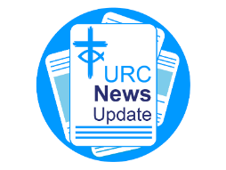
NEWS FROM THE DENOMINATION
The URC’s News Update is a regular e-newsletter that keeps you informed about the latest news and events.
To receive this popular newsletter, please visit the https://urc.org.uk/news-updates-sign-up-form/ page on the URC website and follow the links. If you just want to dip in and catch up on what is going one, that’s fine and you can
read and print recent editions of our e-newsletter by visiting the URC News Update page at https://urc.org.uk/urc-news-update/ .

!!! WANTED !!!
The Synod is looking for people to join some of our key groups, especially in the Property, the Financial Resources and Children and Young People’s committees. These bodies guide the direction of Synod and without them Synod would find it hard to function. If you are able to take up a call to help Synod out, please contact the Synod Clerk at clerk@urcyorkshire.org.uk for more information.

Property Committee News
Our erstwhile Property Officer, Jane Bunyan will be on leave between 31st August and 4th September this year which means that the usual dates for property applications into Synod are having to change. Usually the deadline for applications to be considered at the September meeting is 31st August, but for this meeting that deadline has been brought forward. Therefore, any property applications for either works or Synod Mission Fund grants (property stream) will need to be in by Friday 21st August 2026. Partial or incomplete submissions will be held over until the November meeting.
Churches may wish to note that applications for grant funding support have been brought into line with the Synod Mission Fund. So, before they can be considered, we will be asking more questions regarding mission and compliance. Full details of these can be found in sections H, I and J of the supporting notes to the form, which is downloadable from here https://urcyorkshire.org.uk/wp-content/uploads/2026/05/Synod-Mission-Fund-Grant-Application-Form.docx
If you have any questions, please contact Jane at property@urcyorkshire.org.uk or the Clerk at clerk@urcyorkshire.org.uk.

NEWS FROM BEYOND THE DENOMINATION

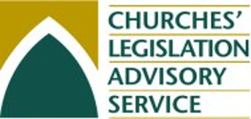
It’s not often that I have to send messages in the Briefing like this, but there have been a few matters to do with compliance that all our churches need to be aware of. An organisation the Synod subscribes to is the Churches’ Legislation Advisory Service (CLAS). CLAS serves all churches in the UK and sends regular updates on matters legal etc. This month we have received a circular advising us of several legal updates.

Data Protection
The new legal requirements are now in force under which all organisations that process personal data must provide data-subjects with a clear mechanism for raising data protection complaints, acknowledge receipt within 30 calendar days, investigate them appropriately and communicate the outcome.

Employment – Working or volunteering in regulated activity with children
The update coming into force on 1 September 2026 is the removal of the "supervision exemption" from the definition of regulated activity with children in England. This change was made by the Crime and Policing Act 2026 and primarily affects volunteers rather than paid staff.
Key changes
Until 31 August 2026, an unpaid volunteer who teaches, trains, instructs, cares for, or supervises children may not be considered to be carrying out regulated activity if he or she is appropriately supervised by someone who is already in regulated activity.
FROM 1 SEPTEMBER 2026, THE SUPERVISION EXEMPTION WILL BE REMOVED.
- Supervision no longer prevents a volunteer's role from being classed as regulated activity.
- If the volunteer's role meets the normal frequency ("period") rules, it is regulated activity regardless of whether or not the volunteer is supervised.
Who is affected?
The main group affected is volunteers in schools, colleges, childcare settings and providers, and other organisations working with children.

Protecting built Heritage
On 13 July, the Commons Culture, Media and Sport Committee published its Third Report of Session 2026-27: Protecting built heritage. Specifically on the care and maintenance of listed places of worship, it notes in the Introduction that:
“Recent changes to support schemes, including the replacement of the Listed Places of Worship Grant Scheme with the Places of Worship Renewal Fund, represent a significant shift in approach. While directing funds towards areas of socio-economic need has merit, reliance on area-based indicators risks disadvantaging places of worship of high historic and architectural significance outside these areas and could overlook the wider community value and reach of such sites.”
The Synod team (as well as the denomination) is keeping a close eye on this as it will have an effect on the way in which repairs to listed buildings are funded.

If you would like a copy of the circular sent by CLAS, please contact the Clerk at clerk@urcyorkshire.org.uk and if there are any queries regarding the changes in regulated activities and safeguarding, please contact the Safeguarding team at safeguarding.1and4@urc.org.uk

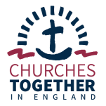


You and your church are invited to join The National Conversation to have ‘your say’ on the future our country.
The National Conversation is a chance for everyone to contribute ideas about how to shape a more united future for England. It has been launched by the Independent Commission on Community and Cohesion. This is a non-partisan, time-limited commission tasked with uncovering a vision for the future.
The Commission wants to hear from churches because it knows that we are on the frontline of community life. We see the pressures on families and young people, the impact of economic insecurity and cultural change, the tensions and misunderstandings between different groups — and the deep desire many people still have for belonging, meaning and hope. As trusted places where people of all backgrounds come together, churches have a view of connection and division like no other.
Churches Together in England General Secretary, Bishop Mike Royal, urged Christians to take part. He said: “The voice of the church is as important as any other voice. Make sure, as a church leader, you have your say in The National Conversation.”

How to take part
Your church or Churches Together group can participate in The National Conversation in two ways.

Invite your congregation and people in your networks to fill in a short online survey designed and run independently by Nuffield College, University of Oxford.
You can either
Share this link (this is a special link for churches; other sectors have different links)
(The survey should take around 10 minutes)
Or you could host a community conversation. This would involve bringing people together for a short, guided discussion about what connects and divides us. The National Conversation provides the guide, discussion prompts and a simple way to feed back.

This is a great opportunity for churches to draw on their relationships within local communities and convene people across difference, helping to shape the conversation about the kind of country we want to be.
Both the survey and the feedback from the community conversations need to be submitted by 31 August 2026.

Findings will inform an independent report, published at the end of 2026, with recommendations for government, public service providers, businesses, civil society organisations and the church.

Please share this invitation with your networks. The National Conversation has prepared a series of resources to make sharing easier.

And Finally
Wyke’s Teddy Bears’ Picnic

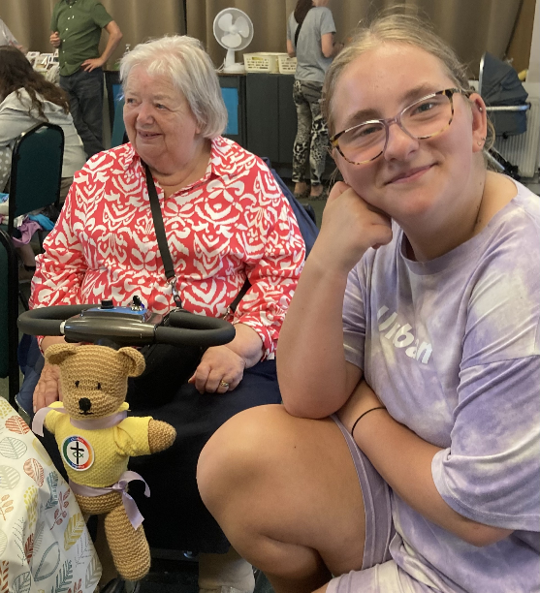
As you will have seen mentioned on page 1 of this time’s Briefing, there was an ursine flavour to an event in Wyke last weekend. Kath Lonsdale, the Secretary at Westfield URC, writes to tells us that the whole community had a wonderful time at the Wyke churches together community teddy bear's picnic.
Unfortunately they did have to move inside the community church as all the outside games were blowing about on Wyke Green, but that worked well as folk used their picnic rugs or the tables already out in the hall and they were able to use the big carpet area for the giant dominoes, connect 4, noughts and crosses and throw a bean bag game; not to mention the ball pool that went down a treat for those able to get in it.
The room was full with people of all ages from babies to 90 year olds and folk were sharing picnic food with those who had not brought any.
Pictured here is Billy the Synod bear enjoying his picnic and transport courtesy of Pauline Haley and Imogen acting as his minder and agent.

If you have a good news story from your part of the Synod or something that you feel reflects the work of Synod and which inspires others as we move into 2026, drop me a line at clerk@urcyorkshire.org.uk and I’ll make sure it hits the back page!!

You can also keep an eye on all our social media platforms for news; on the website at Home - URC Yorkshire Synod, at United Reformed Church in Yorkshire - Home | Facebook and Wilderness URC Yorkshire - Home | Facebook, the YouTube page at URC Yorkshire - YouTube and the Twitter (X) page at URC in Yorkshire (@URCYorkshire) / Twitter.

