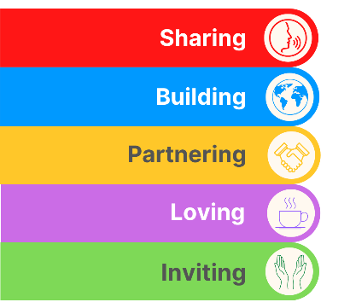
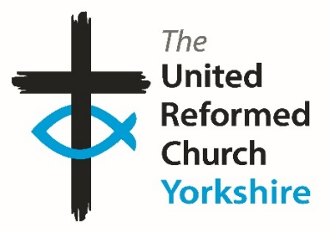
Yorkshire Synod Briefing
Number 180

3rd September 2026

Autumn Invitations
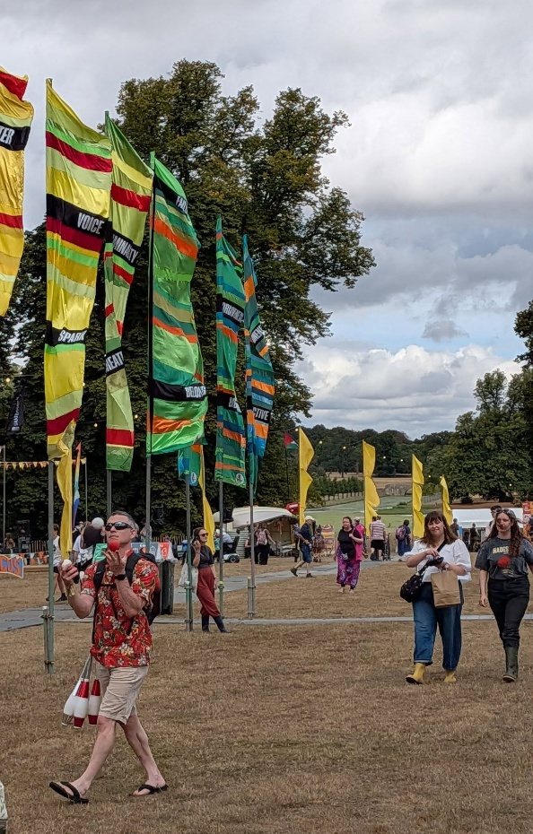
Firstly I’d like to apologise for not getting the 13th August edition of the Briefing published. Unfortunately I had a period off work which then led straight into my own summer holiday, so I’d like to take this opportunity to thank the Synod staff team for covering while I was away during August. I hope you can join me in saying thank you to them and how much we appreciate what the team do for all of us in Yorkshire Synod.
It’s a relatively short Briefing this time, mainly as we are still savouring a very busy and hopefully relaxing summer. As you will have seen there have been quite a few events over the last couple of months around the Synod and I know that quite a few folk from the Synod’s Wilderness team attended the recent Greenbelt Festival at Boughton Hall in Northamptonshire. You can find out more by visiting the Wilderness Facebook page at https://www.facebook.com/share/1FAi9PV8Gs/
Although reports of the activities over the summer haven’t been coming in too quickly, there are still plenty of things to do this coming September. The invitations keep coming in so please take a look and if you can join in. Even Synod is quite busy over the next couple of months. Not only have we the Autumn Synod meetings on the evening of Thursday 8th October on the Zoom conferencing platform and on Saturday 10th October at Moldgreen URC in Huddersfield, but we have a couple of new faces joining the ministerial team. On 26th September Ed Lyne will be ordained and inducted into the Leeds partnership at Wigton Moor URC and then on 3rd October Revd Simon Helme will be indicted into Christchurch Ilkley. I’m sure that you will offer a warm Yorkshire welcome to Ed and Simon as they begin their time in God’s Own Country.

So, if you have any news of welcoming people into Church, stories of celebration and mission, please let me know by dropping me a line at clerk@urcyorkshire.org.uk and I’ll showcase it in the next edition, due out on the website only on 17th September 2026.
Tim Crossley
Yorkshire Synod Clerk

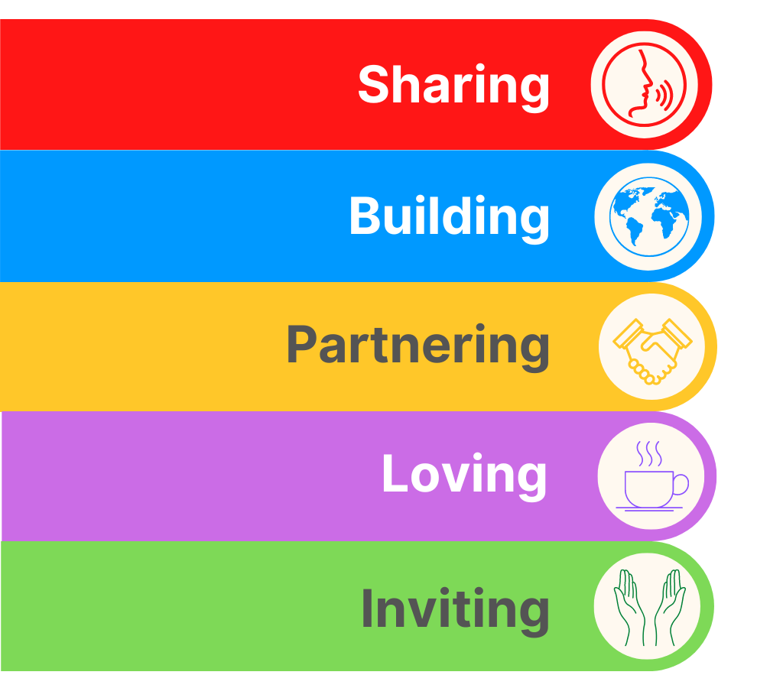
Exciting Roles for URC Youth Members!!!!!!

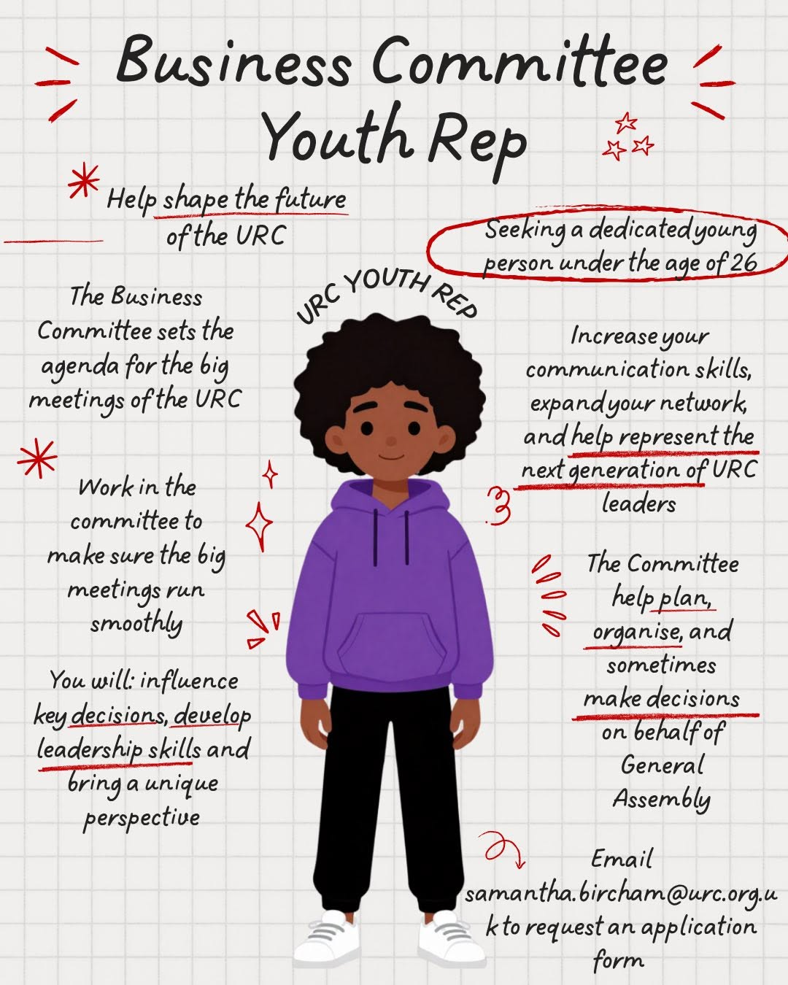
We seem to love committees in the URC and committees in the URC always love it when URC Youth help them in their selected areas through youth representation on that the committee!!
There are three Youth Rep roles which need to be filled and they are explicitly for under 26s.
In no particular order, the first is on the Business Committee, which primarily shapes the future of the URC. Second is on the Church Life Fund Committee which will determine the direction of the upcoming Church Life Fund. Thirdly on the Nominations Committee , whose role is to ensure that the voices on the URC’s committees are representative of the whole denomination.

Find out more on urc.org.uk/jobs/ or email Victoria Blunt, Convenor of Nominations Committee at victoria.blunt@urc.org.uk

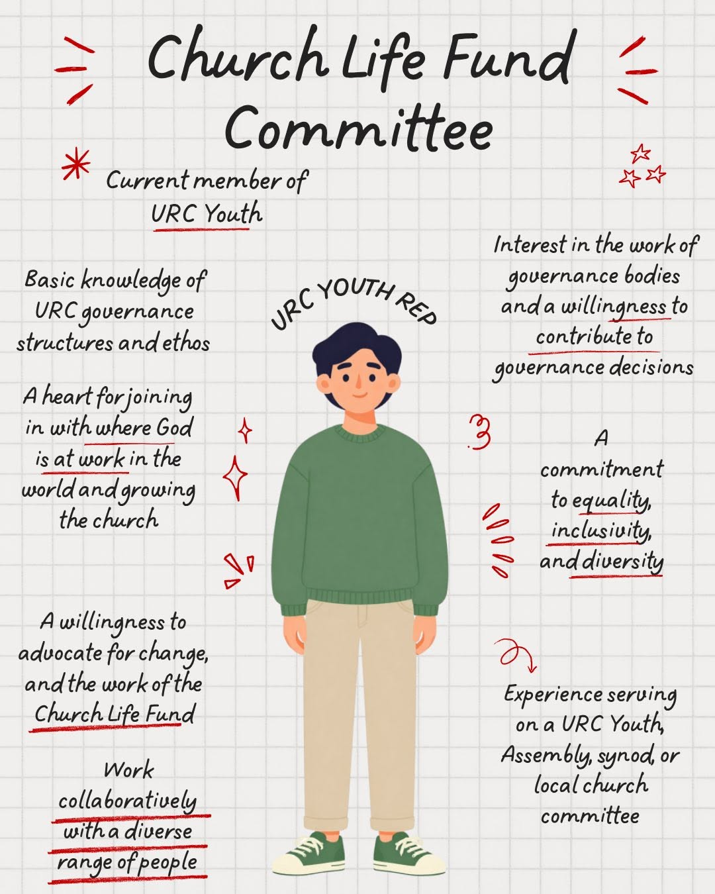
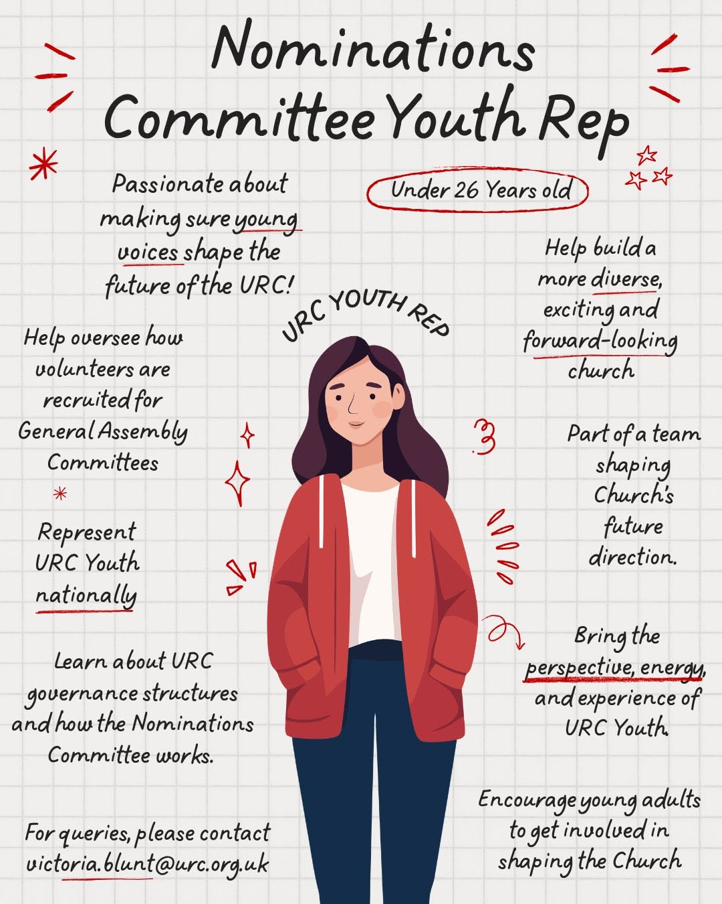

To book, please click here Mental Health First Aid Training Booking Form or contact Carrie Solomon at carriesolomon.yorkshire@urc.org.uk


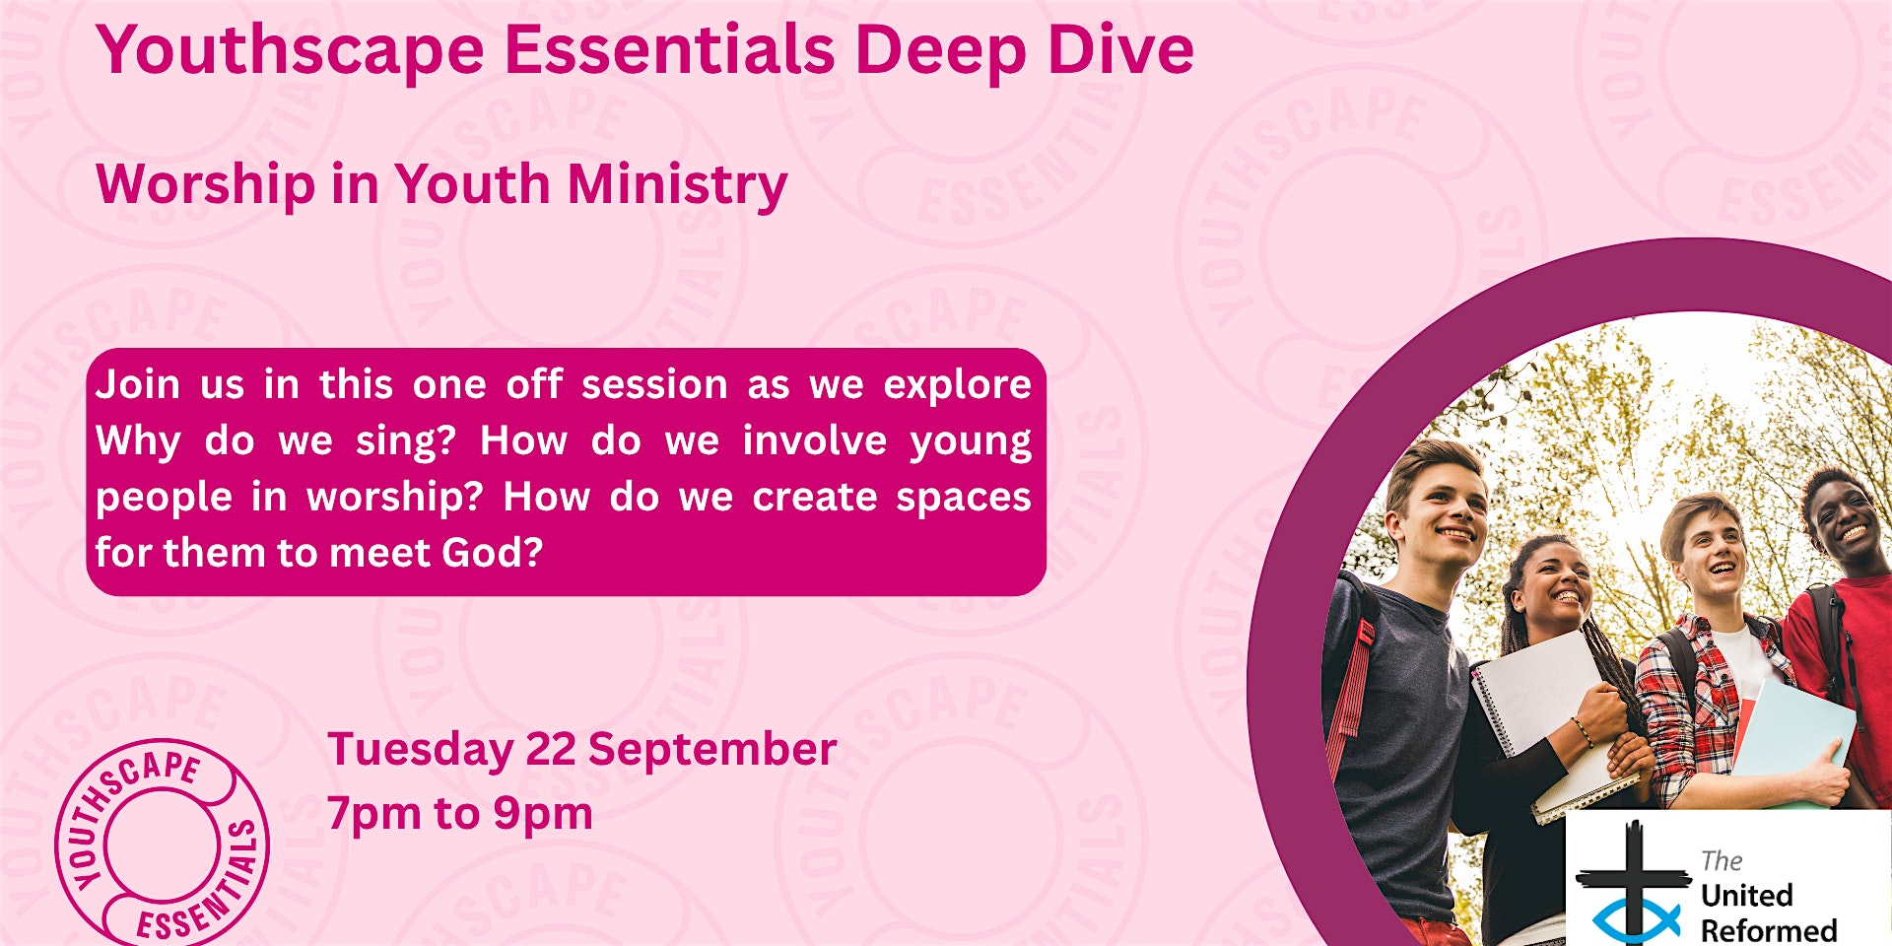
Youthscape Deep Dive - Worship
Tuesday, 22 September 2026 from 19:00 to 21:00 (United Kingdom Time)
Get my tickets
https://www.eventbrite.co.uk/e/youthscape-deep-dive-worship-tickets-1997696258285?aff=ebemoffollowpublishemail&ref=eemail&utm_campaign=following_published_event&utm_content=follow_notification&utm_medium=email&utm_source=eventbrite

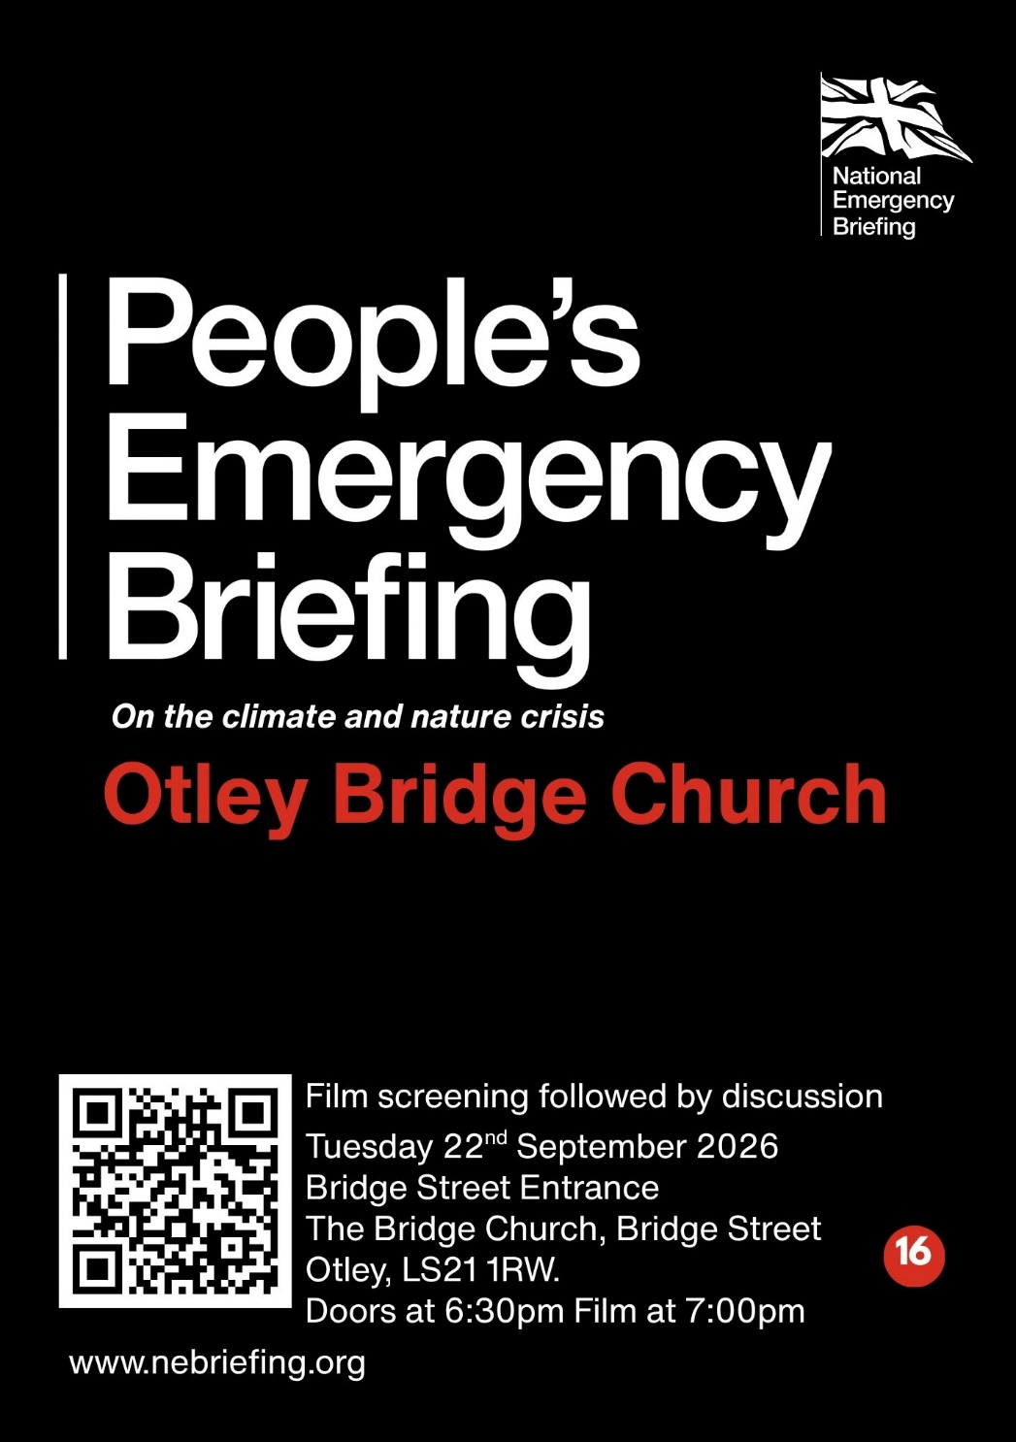
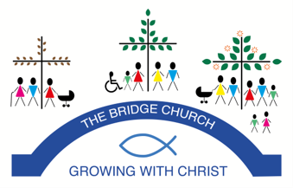
The Bridge Church in Otley is inviting you to attend a local screening of the People’s Emergency Briefing film on the threats to British life from ongoing damage to nature and to our climate on Tuesday 22nd September 2026.

There is no need to pre-book as the film will be shown in the sanctuary of the Bridge Church where there is plenty of room.

The film features footage from last November’s National Emergency Briefing, bringing together leading UK experts in climate science, food security, health, economics, national security and nature.

It presents a calm, evidence-based overview of how the climate and nature crisis is affecting everyday life in Britain - and what the science says about risks and responses.

The initiative is explicitly non-partisan and supported by a wide range of organisations, including the Church of England, National Trust, WWF, the Royal Meteorological Society and many others.
Faith communities have long traditions of stewardship, care for the vulnerable, and intergenerational responsibility. We believe this is an important moment for thoughtful, compassionate local dialogue.
Following the 50-minute film, we will host a structured discussion about what this means for our community.

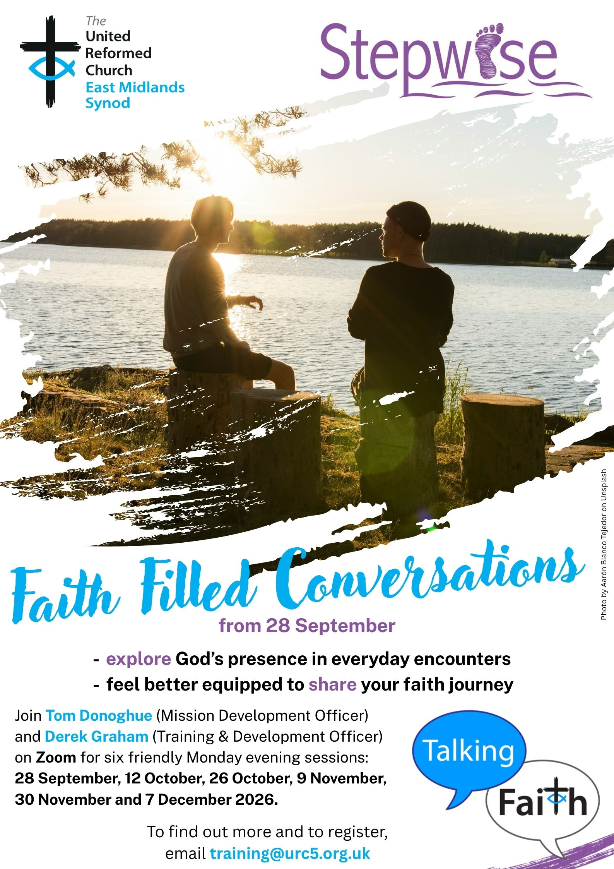

In Person Safeguarding Training
Autumn 2026

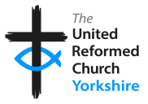
Friday 18th September 10.00am-12.30pm

Foundation and Intermediate Combined Training
Emmanuel Church
Forest School Room Thorpe Drive, Waterthorpe S20 7JU

Thursday 24th September 12.30-3.00pm
Foundation and Intermediate Combined Training Norrsithorpe URC
Norristhorpe Ln, Liversedge WF15 7AR

Thursday 24th September 7.00pm-9.00pm
Foundation and Intermediate Combined Training
Zion URC, Cottingham
201 Hallgate, Cottingham HU16 4BB

Wednesday 30th September 6.30pm-8.00pm Intermediate Training
Stag Community Church Wickersley Rd, Rotherham S60 4JN

Thursday 1st October 9.30am-2.30pm
Advanced Training Sheffield Central URC
Norfolk St, Sheffield S1 2JB

Please email safeguarding.1and4@urc.org.uk for details of how to sign up for these important courses.

Yes, It’s Here:
The URC’s Resources Hub
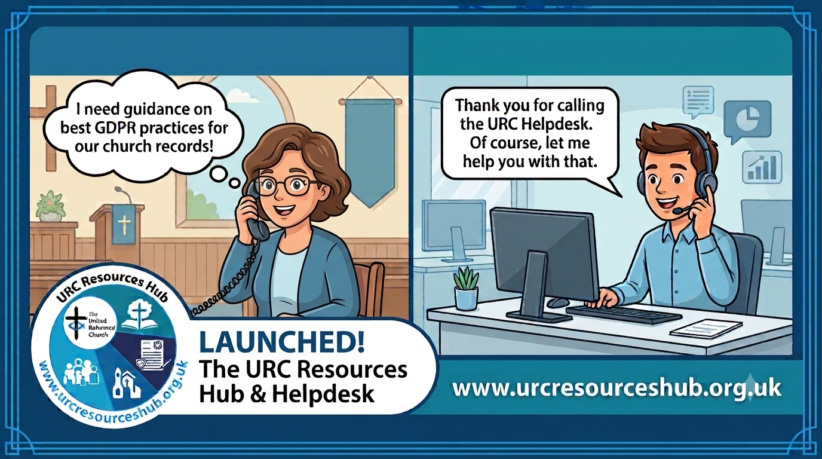
One of the first roll outs from the Church Life Review is this brand new Resources Hub for all our churches and volunteers to use. There are two ways into it, through the URC website, or directly using this link: https://urcresourceshub.org.uk/. Please take a bit of time to have a look, and if you have any feedback or any suggestions for what you may want it to hold, please contact me at clerk@urcyorkshire.org.uk and I’ll pass on your feedback.

There will be more resources being uploaded to the resource over the next few months. The next tranche will be documents covering governance and finance, so keep an eye out on announcements here, in the URC’s regular News Update circulars and in Reformed magazine.

It’s not too late to ask that the team behind the hub add items which you may want. If you know of any resources which you feel may benefit all our churches, drop the Clerk a line at clerk@urcyorkshire.org.uk and he’ll contact the team putting the Resource Hub together.


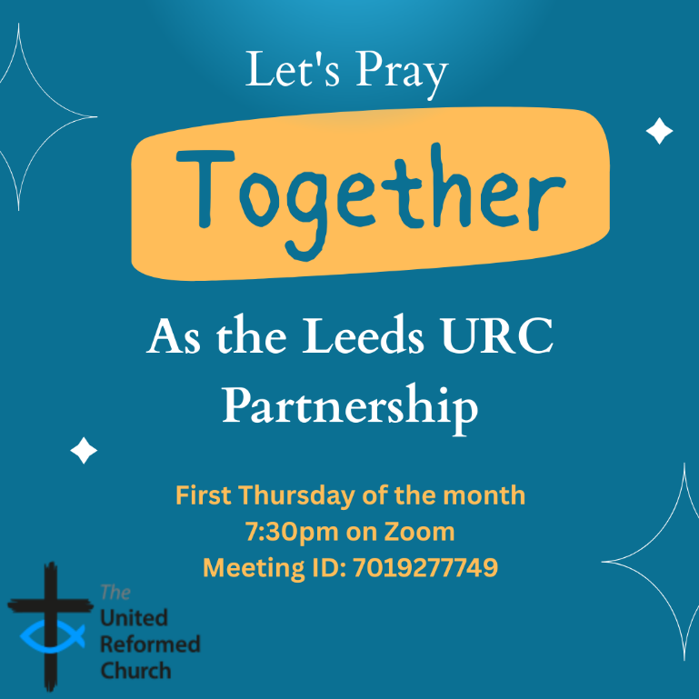
Leeds URC Partnership Prayers

Thursday, 3rd September, 7:30pm.
A short time to pray together by reading the Bible and sharing the joys and challenges in our lives, churches, communities and world.
On Zoom:
https://us02web.zoom.us/j/7019277749

!!! WANTED !!!
The Synod is looking for people to join some of our key groups, especially in the Property, the Financial Resources and Children and Young People’s committees. These bodies guide the direction of Synod and without them Synod would find it hard to function. If you are able to take up a call to help Synod out, please contact the Synod Clerk at clerk@urcyorkshire.org.uk for more information.

Yorkshire Synod Discipleship Development Small Grant Fund 2026
The Synod is pleased to let you all know that it has received confirmation that it has a pot of £4000 to grant to those wishing to apply to the Yorkshire Synod Discipleship Development 2026. Currently we have been able to grant about half of what has been allocated to us, and we would love to be able to offer grants to enable us to use all of what Yorkshire Synod has received.

1. Who is eligible to apply? Committed members or adherents, including children and young people, of a congregation within the United Reformed Church who are exercising, or want to exercise, a form of lay ministry or community service whether expressed within or beyond their local church. The DDF is not open to Ministers of Word and Sacraments and CRCWs, as there are other designated funds available for those groups.

2. How much is available? Up to £300 per applicant per calendar year, although the Synod may agree to more than this according to the local context and circumstances. Currently we have funding available for 4 more grants this calendar year.

3. What can this money be used for? The purposes for which the funding is provided are defined by creativity and vocation, in line with the URC's discipleship development strategy. Be bold, take risks. The funding exists to help you to follow Jesus. You might be helped in this by courses (at any level) at any of the URC Resource Centres for Learning or from other learning providers, or you may have ideas on resourcing discipleship development in other people. You may need funds to cover the costs of travel, materials or books. All you have to do is make a case to your local church meeting and submit the application form to the Synod Convenor of Ministries for consideration and, if appropriate, authorisation.

4. How are applications made? Having gained your church meeting's endorsement, applications are to be made on the designated form, well before the spending is due to start. Backdated applications will not normally be accepted. Application forms are obtainable from the Synod Convenor of Ministries via the Synod Office at office@urcyorkshire.org.uk and should be sent back for authorisation before being passed to the synod finance office.

5. How are grants paid? Grants authorised by the Convenor of Synod Ministries
are paid by a Synod finance officer by reimbursement to you when you have given proof of what you've spent. Contact your Synod Convenor of Ministries for discussion if you need something funded directly on your behalf, rather than waiting for re-imbursement.

If anyone wants to discuss an application before submitting it please contact the Convenor of the Yorkshire Ministries Committee, Kath Lonsdale at kath.lonsdale@outlook.com (please note the new e-mail address).
Remember this is for any age of lay person in our churches to apply for so please discuss with your young people as well as adults.

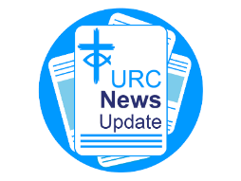
NEWS FROM THE DENOMINATION
The URC’s News Update is a regular e-newsletter that keeps you informed about the latest news and events.
To receive this popular newsletter, please visit the https://urc.org.uk/news-updates-sign-up-form/ page on the URC website and follow the links. If you just want to dip in and catch up on what is going one, that’s fine and you can
read and print recent editions of our e-newsletter by visiting the URC News Update page at https://urc.org.uk/urc-news-update/ .

And Finally
Adam crosses over to The Crossing

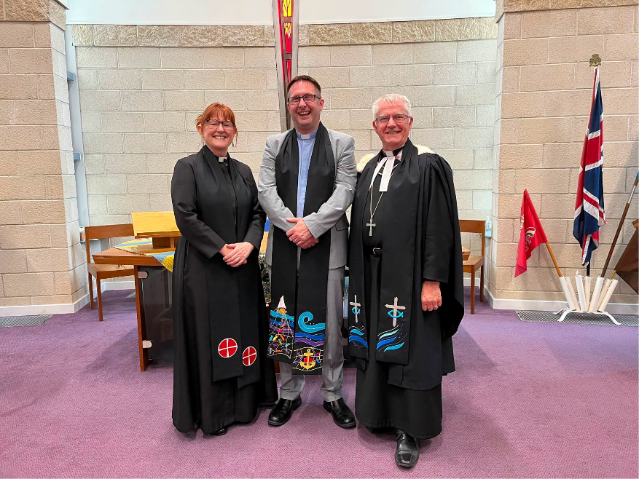
News has reached Synod Towers that one of our home-grown ministers, Revd Adam Woodhouse (whose Christian roots are firmly enshrined in South Bradford) has again crossed the Synod boundary, this time into East Midlands. Representatives from Holme and Westfield Wyke URC’s went to Adam’s recent induction into The Crossing Church (URC/Methodist) in Worksop, Nottinghamshire to support him. Adam had been the youth worker at Westfield and Holme before being called to stipendiary ministry and both churches have continued to regularly pray for him and support his ministry journey. Greeting Adam are on the right Revd Geoffrey Clarke, the East Midlands Moderator and on the left Revd Vicky Atkins, District Chair Sheffield Methodist District.

If you have a good news story from your part of the Synod or something that you feel reflects the work of Synod and which inspires others as we move into 2026, drop me a line at clerk@urcyorkshire.org.uk and I’ll make sure it hits the back page!!

You can also keep an eye on all our social media platforms for news; on the website at Home - URC Yorkshire Synod, at United Reformed Church in Yorkshire - Home | Facebook and Wilderness URC Yorkshire - Home | Facebook, the YouTube page at URC Yorkshire - YouTube and the Twitter (X) page at URC in Yorkshire (@URCYorkshire) / Twitter.

