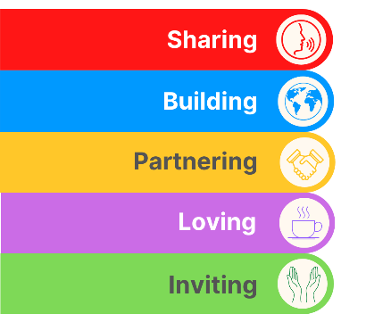
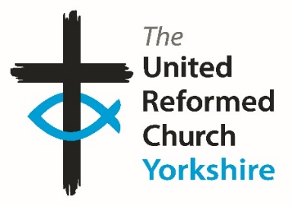
Yorkshire Synod Briefing
Number 180

17th September 2026

More Autumn Invitations
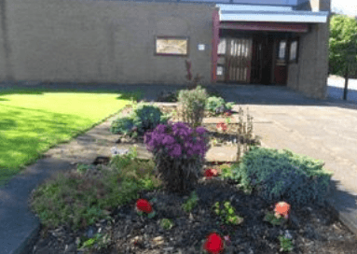
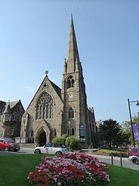
Synod is quite busy over the next couple of months with plenty of meetings and projects in the pipeline. The best thing about this busyness is that we have a couple of new faces joining the ministerial team. On 26th September Ed Lyne will be ordained and inducted into the Leeds Partnership at Wigton Moor URC and then on 3rd October Revd Simon Helme will be indicted into Christchurch Ilkley. I’m sure that you will offer a warm Yorkshire welcome to Ed and Simon as they begin their time in God’s Own Country.
Wigton Moor URC
We are building up to this year’s Autumn Synod meetings on the evening of Thursday 8th October on the Zoom conferencing platform and on Saturday 10th October at Moldgreen URC in Huddersfield.

The Saturday Synod meeting will see the return of an official welcome desk at synod. You will be met by a member of the synod team, a member of Moldgreen URC and others who will be pleased to see you. Here you will be given a name tag, an opportunity to get orientated with the building and receive information about the day. There will also be an opportunity to have a look at the new ‘Yorkshire Synod Spotlight’ noticeboard. Here you will find ideas, stories, and information about what is happening across our beautiful and faithful churches. If you have anything that you would like to include on the notice board for others to see and take inspiration from, please send this to megancyp@urcyorkshire.org.uk. Not only that, but your church representatives will be able to help guide Synod as we constantly look to bring God’s Kingdom closer.
Christchurch, Ilkley
Finally there are moves afoot to bring the Synod website more up to date. We will be using it to bring more stories and news items, as well as being a place where we can offer resources to help churches and individuals work more effectively for the Kingdom. So please start sharing more so that we can share and please keep your website as up to date as you can. As ever we can source help for churches at Synod, contact us at the usual office@urcyorkshire.org.uk address for more details.
If you have any news of welcoming people into Church, stories of celebration and mission, please let me know at clerk@urcyorkshire.org.uk and I’ll showcase it in the next edition, due out on the website only on 1st October 2026.
Tim Crossley
Yorkshire Synod Clerk
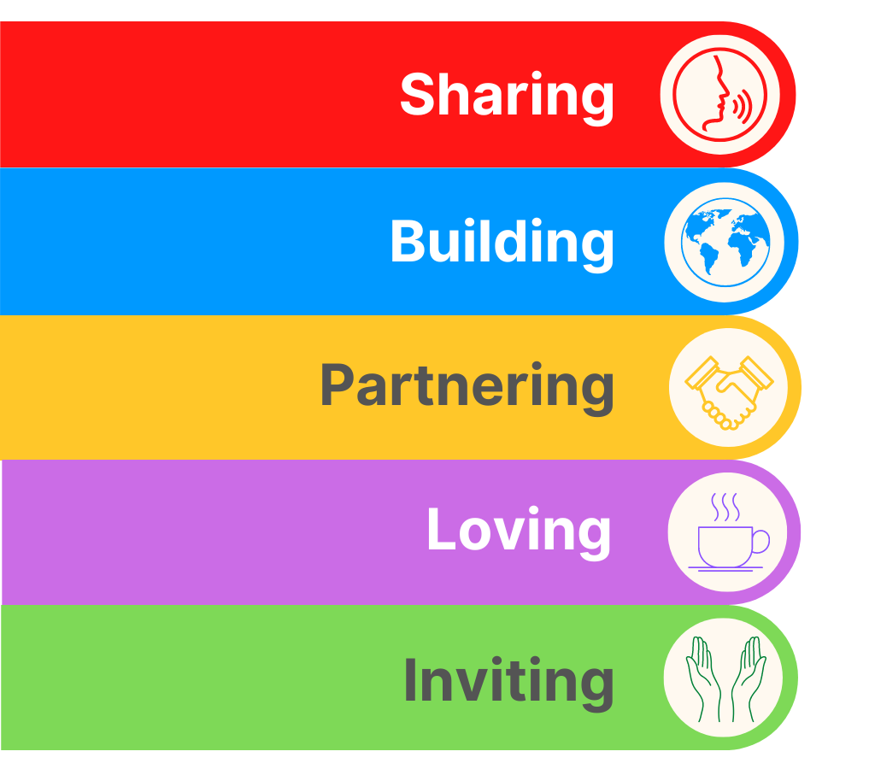


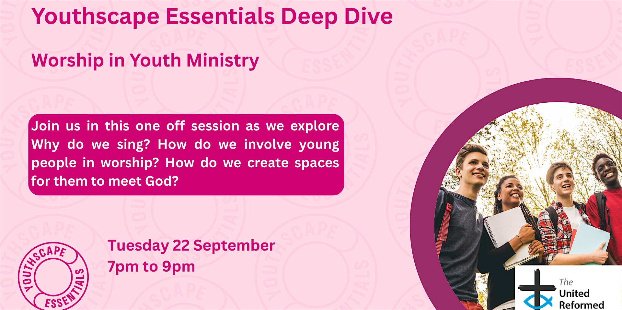
Youthscape Deep Dive - Worship
Tuesday, 22 September 2026 from 19:00 to 21:00 (United Kingdom Time)
Get my tickets
https://www.eventbrite.co.uk/e/youthscape-deep-dive-worship-tickets-1997696258285?aff=ebemoffollowpublishemail&ref=eemail&utm_campaign=following_published_event&utm_content=follow_notification&utm_medium=email&utm_source=eventbrite


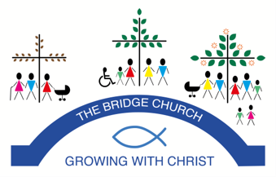
The Bridge Church in Otley is inviting you to attend a local screening of the People’s Emergency Briefing film on the threats to British life from ongoing damage to nature and to our climate on Tuesday 22nd September 2026.

There is no need to pre-book as the film will be shown in the sanctuary of the Bridge Church where there is plenty of room.

The film features footage from last November’s National Emergency Briefing, bringing together leading UK experts in climate science, food security, health, economics, national security and nature.

It presents a calm, evidence-based overview of how the climate and nature crisis is affecting everyday life in Britain - and what the science says about risks and responses.

The initiative is explicitly non-partisan and supported by a wide range of organisations, including the Church of England, National Trust, WWF, the Royal Meteorological Society and many others.
Faith communities have long traditions of stewardship, care for the vulnerable, and intergenerational responsibility. We believe this is an important moment for thoughtful, compassionate local dialogue.
Following the 50-minute film, we will host a structured discussion about what this means for our community.

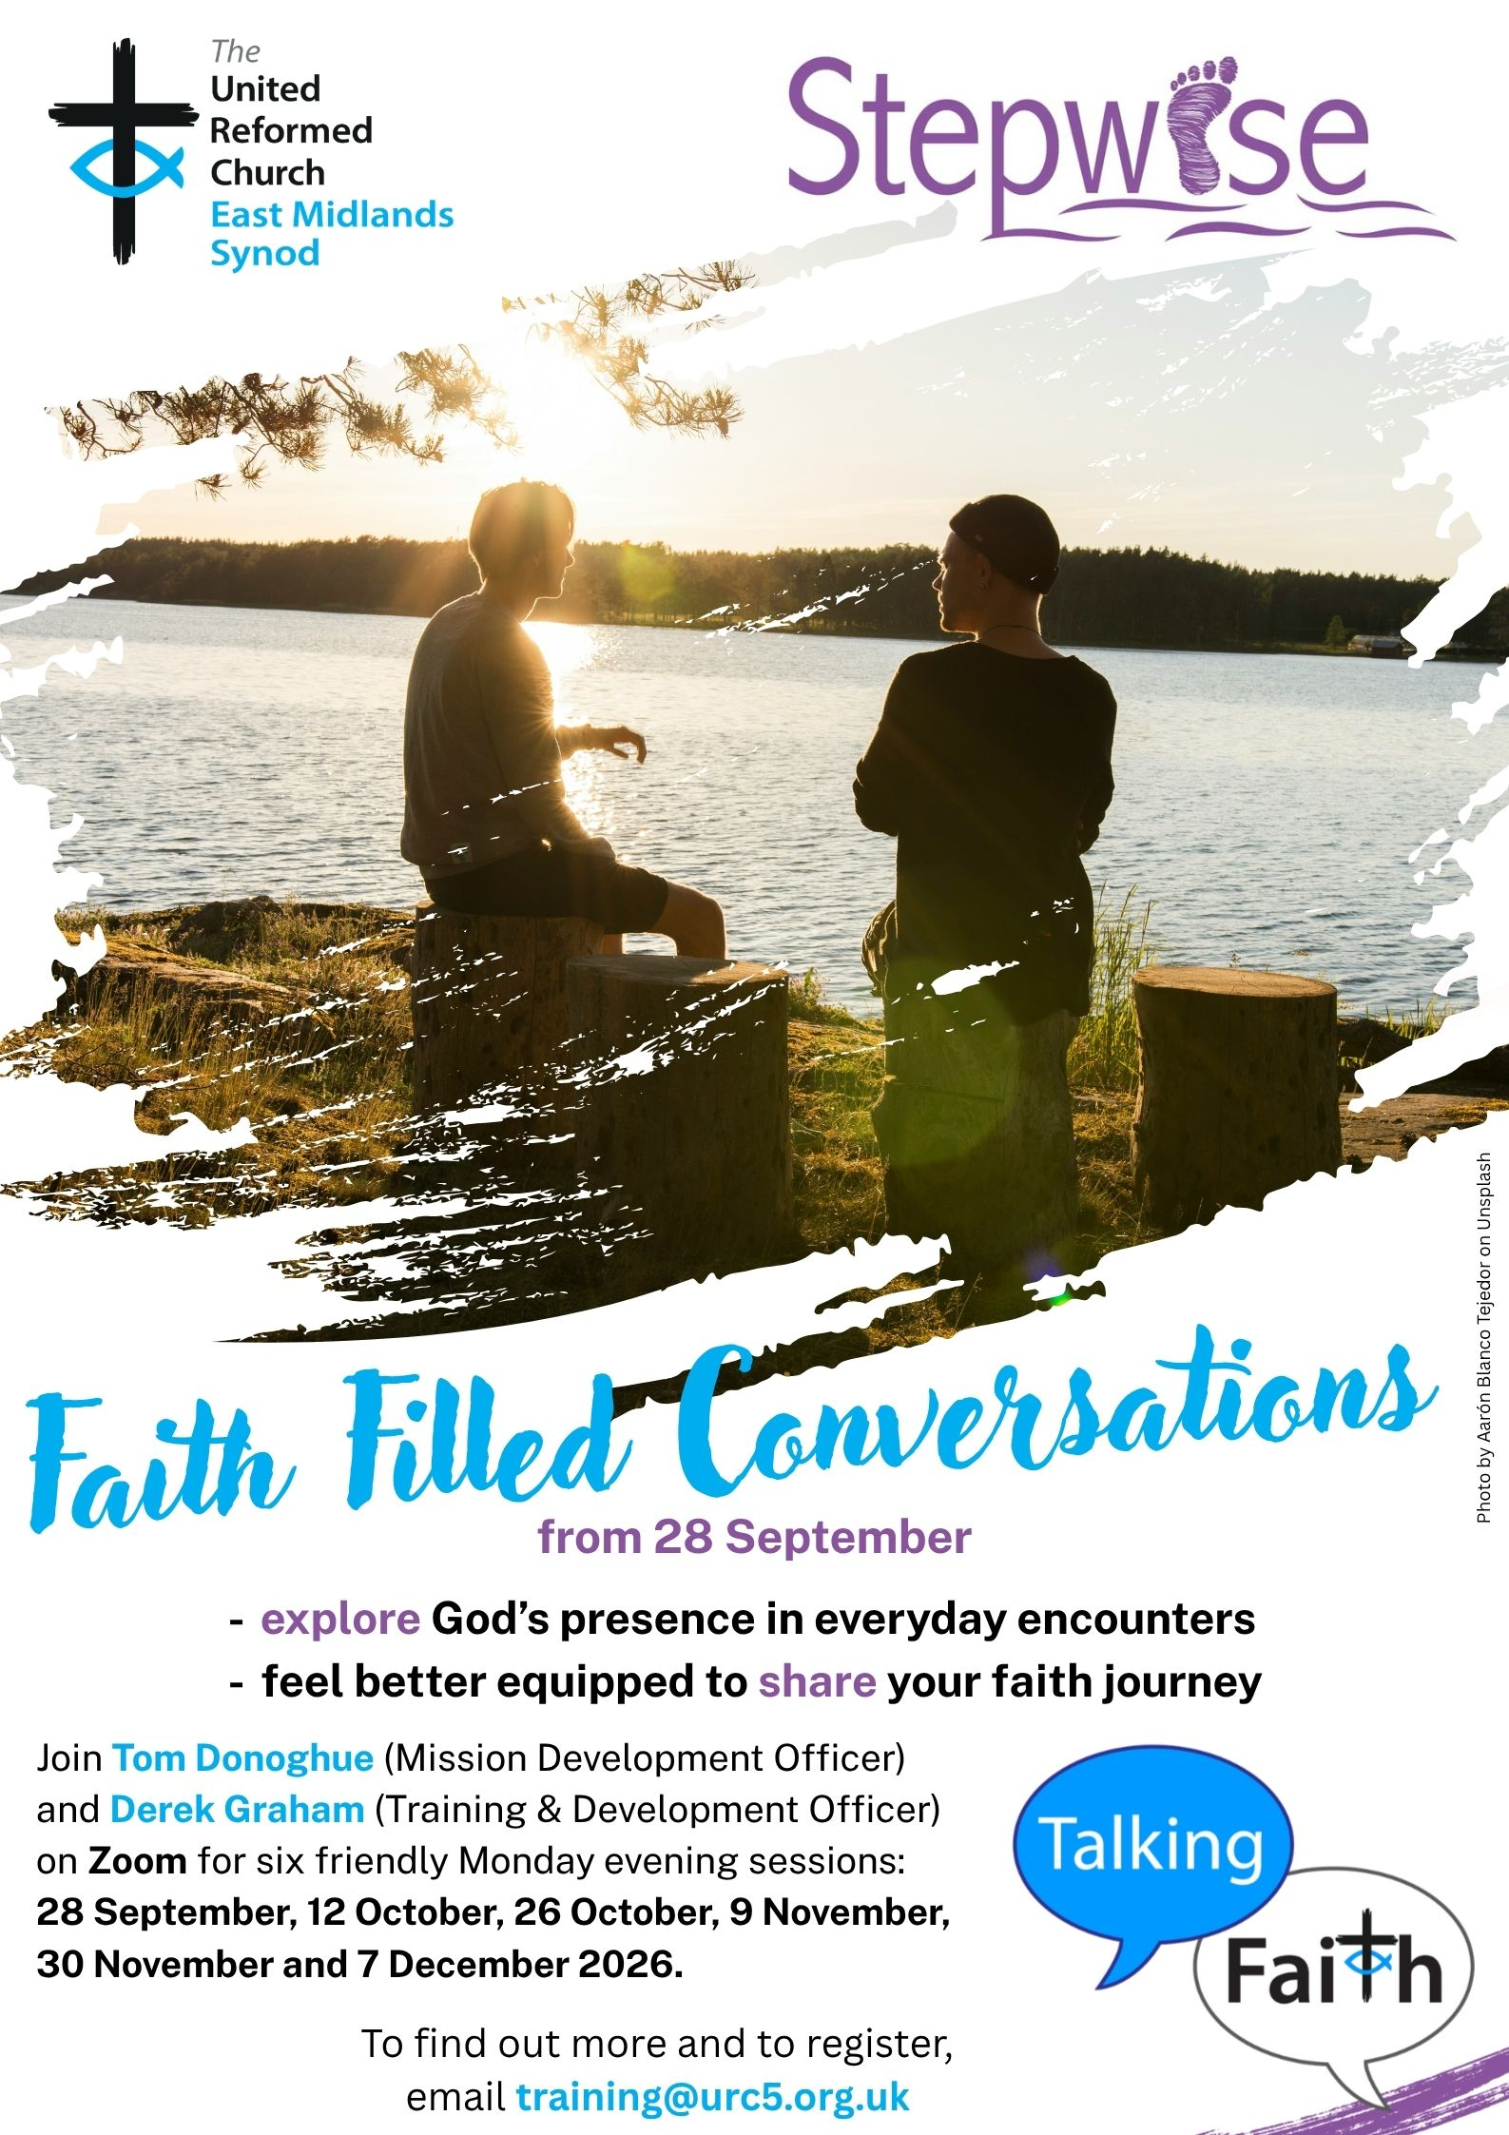
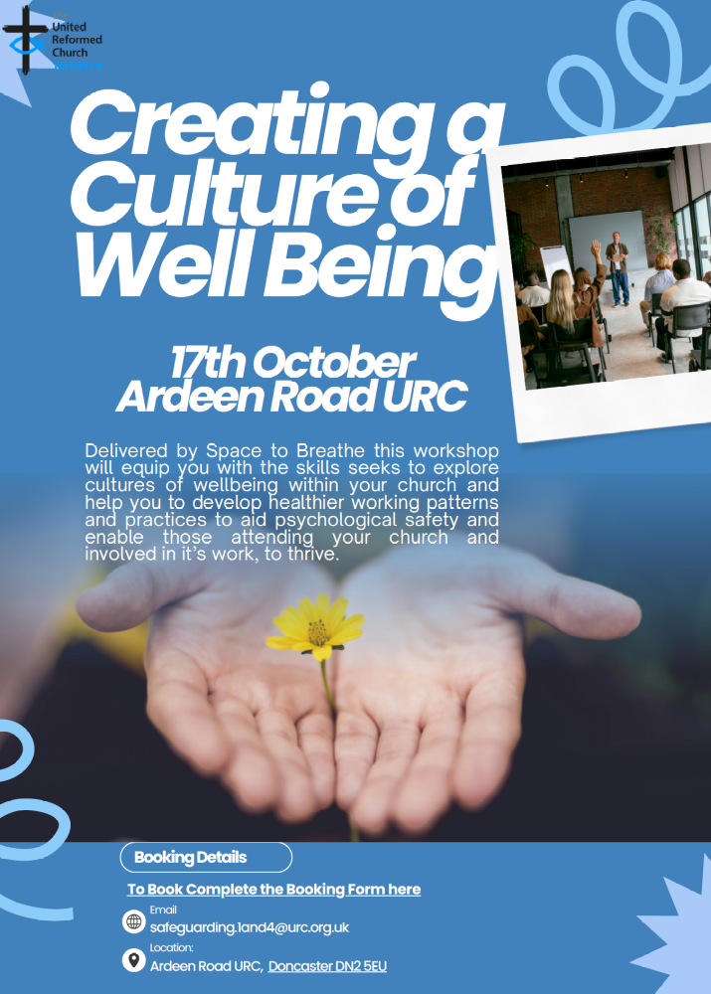
For more information contact Carrie Solomon at safeguarding.1and4@urc.org.uk
and to book click here: https://tinyurl.com/2szfafc8

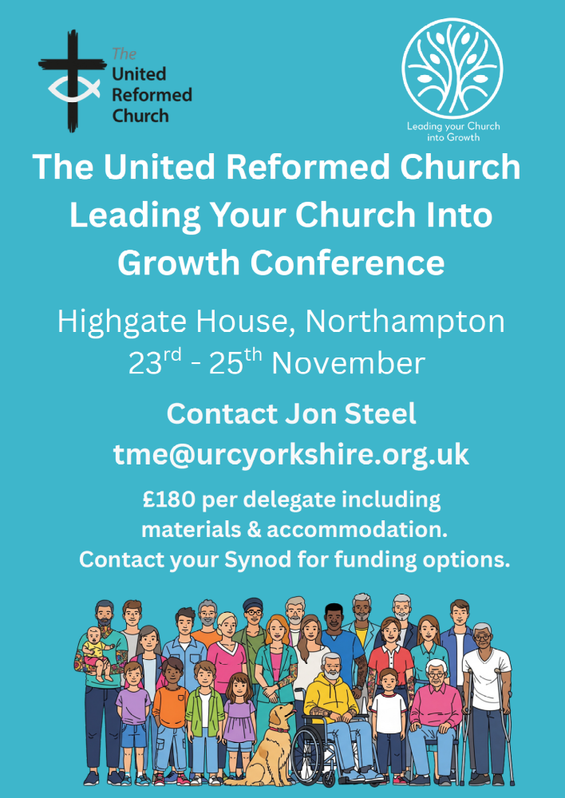

In Person Safeguarding Training
Autumn 2026


Friday 18th September 10.00am-12.30pm

Foundation and Intermediate Combined Training
Emmanuel Church
Forest School Room Thorpe Drive, Waterthorpe S20 7JU

Thursday 24th September 12.30-3.00pm
Foundation and Intermediate Combined Training Norristhorpe URC
Norristhorpe Ln, Liversedge WF15 7AR

Thursday 24th September 7.00pm-9.00pm
Foundation and Intermediate Combined Training
Zion URC, Cottingham
201 Hallgate, Cottingham HU16 4BB

Wednesday 30th September 6.30pm-8.00pm Intermediate Training
Stag Community Church Wickersley Rd, Rotherham S60 4JN

Thursday 1st October 9.30am-2.30pm
Advanced Training Sheffield Central URC
Norfolk St, Sheffield S1 2JB

Please email safeguarding.1and4@urc.org.uk for details of how to sign up for these important courses.

URC Advent Resources
Usually if I see Christmas related things before 1st December I get the hump (geddit?). However I’m making an exception for this: What if every family connected to your church had a simple, meaningful way to journey through Advent together?


The URC Family Advent Resource is designed to help families to explore the Christmas story in their own homes, creating special moments together throughout the season and making faith part of the everyday excitement of Advent.
💛Copies are just £2 each. We have a limited number available so order ASAP with Megan, Melloney or Katie.
It’s a simple way to:
✨ Encourage families in their faith
✨ Equip parents and carers to explore Advent at home
✨ Help children engage with the Christmas story
✨ Show families that your church is thinking of and praying for them this Christmas
Whether you’re looking for a gift for every family or a resource to support your church’s Advent ministry, this could be a lovely way to bless the families in your community.
Email megancyp@urcyorkshire.org.uk to secure your packs

Judy Rogers, the Yorkshire Synod’s Racial Justice Advocate has asked that your attention is drawn to the Churches Together in Britain & Ireland’s (CTBI) resources for this year’s Black History Month (BHM).
This year marks the 39th anniversary of BHM in Britain. It was first organised in 1987, led by Ghanaian analyst and community activist Akyaaba Addai-Sebo, with the aim of recognizing the contributions of Black communities and promoting a more inclusive understanding of British history. From a Christian perspective, BHM is an excellent way of celebrating the way God has enabled Black women, men and children to use their God-given giftings to revitalise the Church in this country. Please follow this link for some excellent resources from CTBI:
https://ctbi.org.uk/wp-content/uploads/2026/08/Black-History-Month-Resources-for-churches-2026.pdf
and please share with us at Synod how you have marked Black History Month in your church.

!!! WANTED !!!
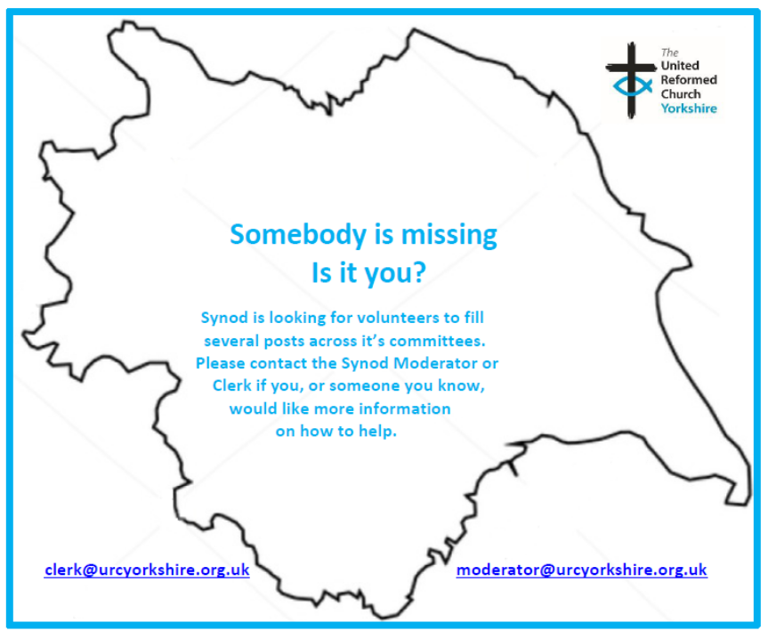
The Synod is looking for people to join some of our key groups, especially in the Property, the Financial Resources and Children and Young People’s committees. These bodies guide the direction of Synod and without them Synod would find it hard to function. If you can take up a call to help Synod out, please contact the Synod Clerk at clerk@urcyorkshire.org.uk for more information.

Yes, It’s Here:
The URC’s Resources Hub
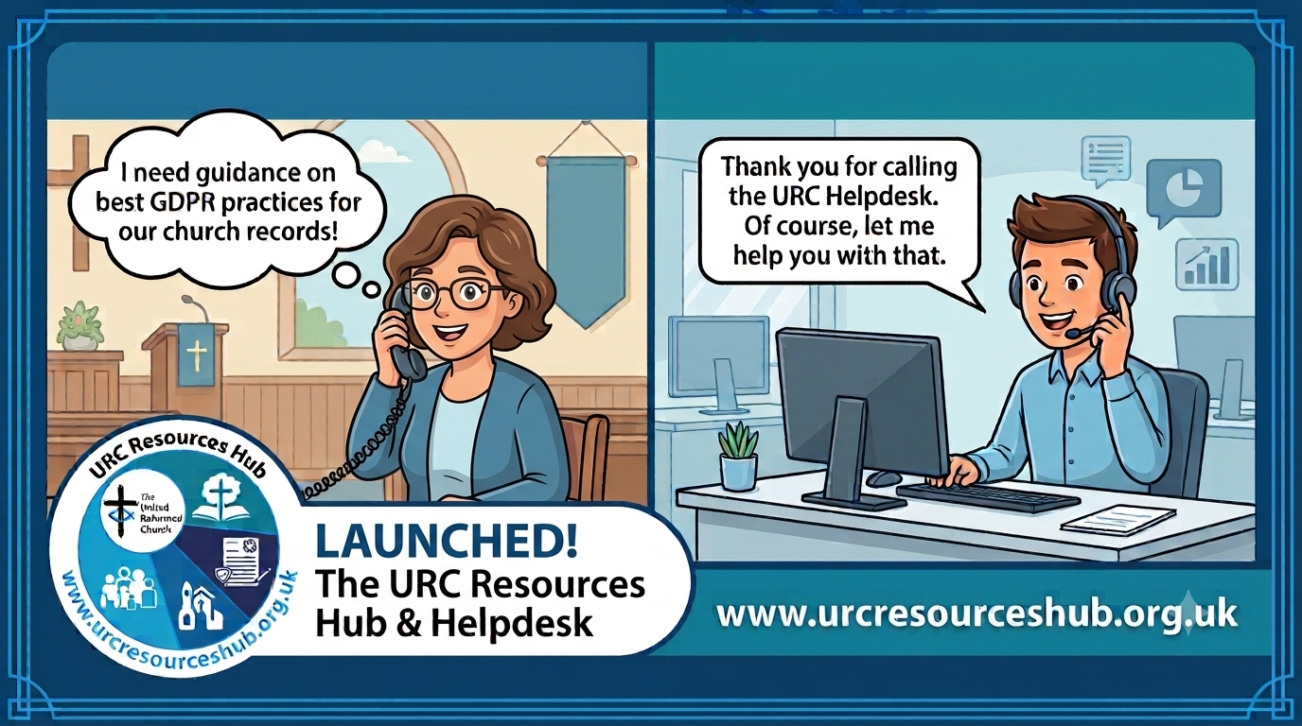
One of the first roll outs from the Church Life Review is this brand-new Resources Hub for all our churches and volunteers to use. There are two ways into it, through the URC website, or directly using this link: https://urcresourceshub.org.uk/. Please take a bit of time to have a look, and if you have any feedback or any suggestions for what you may want it to hold, please contact me at clerk@urcyorkshire.org.uk and I’ll pass on your feedback.

There will be more resources being uploaded to the resource over the next few months. The next tranche will be documents covering governance and finance, so keep an eye out on announcements here, in the URC’s regular News Update circulars and in Reformed magazine.

It’s not too late to ask that the team behind the hub add items which you may want. If you know of any resources which you feel may benefit all our churches, drop the Clerk a line at clerk@urcyorkshire.org.uk and he’ll contact the team putting the Resource Hub together.

URC Response to “Martyn’s Law”
A recent addition to the Resource Hub is in relation to Martyn’s Law [Terrorism (Protection of Premises) Act 2025], which received its Royal Assent in April 2025 and concerns premises hosting events that exceed 200 people being required to consider how they would respond to a terrorist incident. This legislation is coming into force in April 2027; therefore we want to give all local URC’s the opportunity to be prepared for this change. Therefore, the Resources Hub now has some useful guidance notes for local churches on what the law entails and gets them to begin thinking about the practical next steps. The guidance notes can be found here; https://urcresourceshub.org.uk/martyns-law-guidance/
We would also like to take this opportunity to invite churches to join a free webinar on Thursday 22nd October 2026 at 1pm which is being done in partnership with the Community Security Trust (CST). This session is designed to help local churches, trustees, elders, ministers and church officers understand their responsibilities under the new legislation and what steps they may need to take to comply. Further details of this event can now be found on our new ‘Learning’ page on the Hub here; https://urcresourceshub.org.uk/learning-development/, as well as the link to register for the event.
I would be very grateful if you could send both links to all churches within your Synod to make them aware of these changes, even if they are unlikely to fall under the ‘scope’ of the new law. If you could also pop further details about the upcoming webinar in your Synod newsletter and on your websites, I would also be incredibly grateful.

Looking for a Good Home
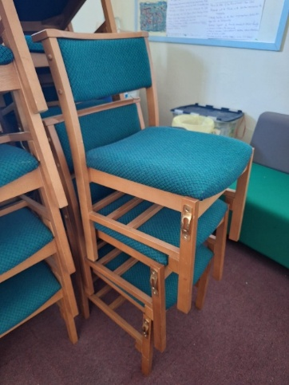
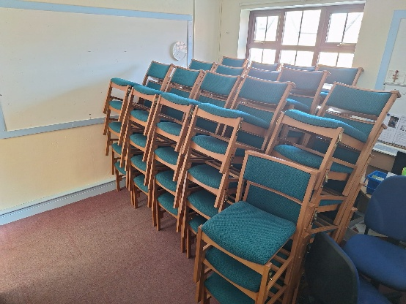
68 Chairs are surplus to requirements at St Andrew's Roundhay. The chairs are in good condition, easily stackable and can be set up as individual chairs or linked together, as per the two pictures.
If you would like them, St Andrew’s is happy to donate them – or to accept a donation towards their outreach work! However, if anyone is interested they will need to arrange collection.
For more information, please contact St Andrew’s directly via Lewis.Murray@standrews.cc

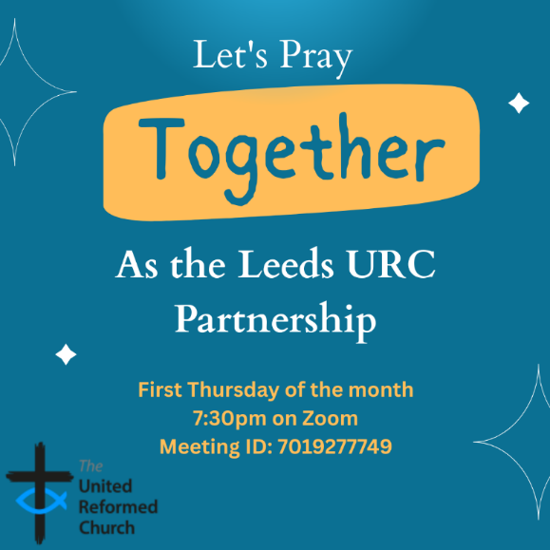
Leeds URC Partnership Prayers
Thursday, 1st October, 7:30pm.
A short time to pray together by reading the Bible and sharing the joys and challenges in our lives, churches, communities and world.
On Zoom:
https://us02web.zoom.us/j/7019277749



Yorkshire Synod Discipleship Development Small Grant Fund 2026
The Synod is delighted to share that there is still funding available from the £4,000 allocated to support applications to the Yorkshire Synod Discipleship Development Fund 2026.
To date, we have awarded only half of the funds available to us, and we would love to see the remainder put to good use. We therefore warmly encourage anyone considering applying to do so. By making full use of this funding, we can ensure that the entire allocation received by the Yorkshire Synod benefits individuals and communities before the end of the year.

1. Who is eligible to apply? Committed members or adherents, including children and young people, of a congregation within the United Reformed Church who are exercising, or want to exercise, a form of lay ministry or community service whether expressed within or beyond their local church. The DDF is not open to Ministers of Word and Sacraments and CRCWs, as there are other designated funds available for those groups.

2. How much is available? Up to £300 per applicant per calendar year, although the Synod may agree to more than this according to the local context and circumstances. Currently we have funding available for 4 more grants this calendar year.

3. What can this money be used for? The purposes for which the funding is provided are defined by creativity and vocation, in line with the URC's discipleship development strategy. Be bold, take risks. The funding exists to help you to follow Jesus. You might be helped in this by courses (at any level) at any of the URC Resource Centres for Learning or from other learning providers, or you may have ideas on resourcing discipleship development in other people. You may need funds to cover the costs of travel, materials or books. All you have to do is make a case to your local church meeting and submit the application form to the Synod Convenor of Ministries for consideration and, if appropriate, authorisation.

4. How are applications made? Having gained your church meeting's endorsement, applications are to be made on the designated form, well before the spending is due to start. Backdated applications will not normally be accepted. Application forms are obtainable from the Synod Convenor of Ministries via the Synod Office at office@urcyorkshire.org.uk and should be sent back for authorisation before being passed to the synod finance office.

5. How are grants paid? Grants authorised by the Convenor of Synod Ministries
are paid by a Synod finance officer by reimbursement to you when you have given proof of what you've spent. Contact your Synod Convenor of Ministries for discussion if you need something funded directly on your behalf, rather than waiting for re-imbursement.

If anyone wants to discuss an application before submitting it please contact the Convenor of the Yorkshire Ministries Committee, Kath Lonsdale at kath.lonsdale@outlook.com (please note the new e-mail address).
Remember this is for any age of lay person in our churches to apply for so please discuss with your young people as well as adults.

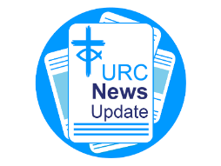
NEWS FROM THE DENOMINATION
The URC’s News Update is a regular e-newsletter that keeps you informed about the latest news and events.
To receive this popular newsletter, please visit the https://urc.org.uk/news-updates-sign-up-form/ page on the URC website and follow the links. If you just want to dip in and catch up on what is going one, that’s fine and you can
read and print recent editions of our e-newsletter by visiting the URC News Update page at https://urc.org.uk/urc-news-update/ .

And Finally
TSA at SKIPTON PRIDE

On the Saturday 8th August, Pride came to Skipton and members of the Trinity St Andrews Pride group ran a stall at the event which was centred on the Canal Basin in the town. It was a truly joyous event when the group gave out hundreds of rainbow decorated buns, kids enjoyed decorating jars and putting on rainbow transfers and they had lots of amazing conversations. The organisers of the event said how much they appreciated our church being at Pride since many people present had experienced trauma because of the way a church had treated them in the past.

To complete the weekend, on the Sunday evening following, Trinity St Andrew’s welcomed Rev Nicola Robinson to preach at our Pride Praise service. She shared with us some of her own story and her experience with the Pride Church in Leeds.
One of the Trinity St Andrew’s lay preachers, Jane Jolly wrote about her first experience at Pride:
“I have never previously been on the rota of helpers for the Trinity St. Andrew's church stall at Skipton Pride but have usually visited it in the past. Who would have thought that the words "Would you like a Bun? They're free." could lead to so many varied and often meaningful conversations and sometimes to prayer as well? These conversations revealed how the presence of a Christian church at this event made people feel welcomed, accepted and loved. I wish I had been part of this witness to God's love for all before.”
Trinity St Andrew’s Pride Group members Judy, Molly & Judith.
Photo credit Stephen Garnett.
Skipton Pride 2027 can’t come around quickly enough.

If you have a good news story from your part of the Synod or something that you feel reflects the work of Synod as we move into the last quarter of 2026, drop me a line at clerk@urcyorkshire.org.uk and I’ll make sure it hits the back page!!

You can also keep an eye on all our social media platforms for news; on the website at Home - URC Yorkshire Synod, at United Reformed Church in Yorkshire - Home | Facebook and Wilderness URC Yorkshire - Home | Facebook, and the YouTube page at URC Yorkshire - YouTube

