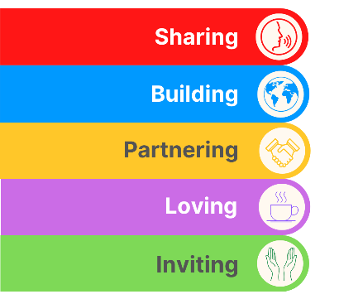
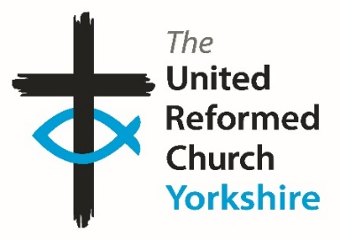
Yorkshire Synod Briefing
Number 182

1st October 2026

TALKING MONEY, TALKING MISSION
In the last issue of the Briefing I mentioned that we are building up to this year’s Autumn Synod meetings on the evening of Thursday 8th October on the Zoom conferencing platform and on Saturday 10th October at Moldgreen URC in Huddersfield.
However there has been a change in the date of the evening session.
The new date for the evening session is now Thursday 29th October.

This change doesn’t affect the Saturday session at Moldgreen URC, and hopefully by now all Representatives and Church Secretaries will have received notice and a link to the meeting’s literature. What it does mean is that Synod Representatives will be able to participate more fully in the General Assembly led consultation on the future of the denomination’s Maintenance of the Ministry Fund. This is the primary resource which underpins the ministerial work of the URC and all churches and Synods have been asked to engage in the consultation. This is why it is so important that as many churches as possible are represented at both these meetings.
The Saturday Synod meeting will see the return of an official welcome desk at synod. You will be met by a member of the synod team, a member of Moldgreen URC and others who will be pleased to see you. Here you will be given a name tag, an opportunity to get orientated with the building and receive information about the day. There will also be an opportunity to have a look at the new ‘Yorkshire Synod Spotlight’ notice board. Here you will find ideas, stories, and information about what is happening across our beautiful and faithful churches. If you have anything that you would like to include on the notice board for others to see and take inspiration from, please send this to megancyp@urcyorkshire.org.uk. Not only that, but your church representatives will be able to help guide Synod as we constantly look to bring God’s Kingdom closer.

Before that we will be celebrating the second of our inductions this autumn, this time at Christchurch, Ilkley, on Saturday 3rd October at 2.30pm. There we will welcome Revd Simon Helme into the church there and not only will Simon be working with the Wharfedale and Aireborough Methodist Circuit, but as a URC minister, he will be part of the wider Synod team. I’m sure that Synod will be as warm in its welcome as it has been with Revd Ed Lyne, whose ordination and induction last Saturday is covered in this issue’s back page.

If you have any news of welcoming people into Church, stories of celebration and mission, please let me know at clerk@urcyorkshire.org.uk and I’ll showcase it in the next edition, due out on the website only on 15th October 2026.
Tim Crossley
Yorkshire Synod Clerk
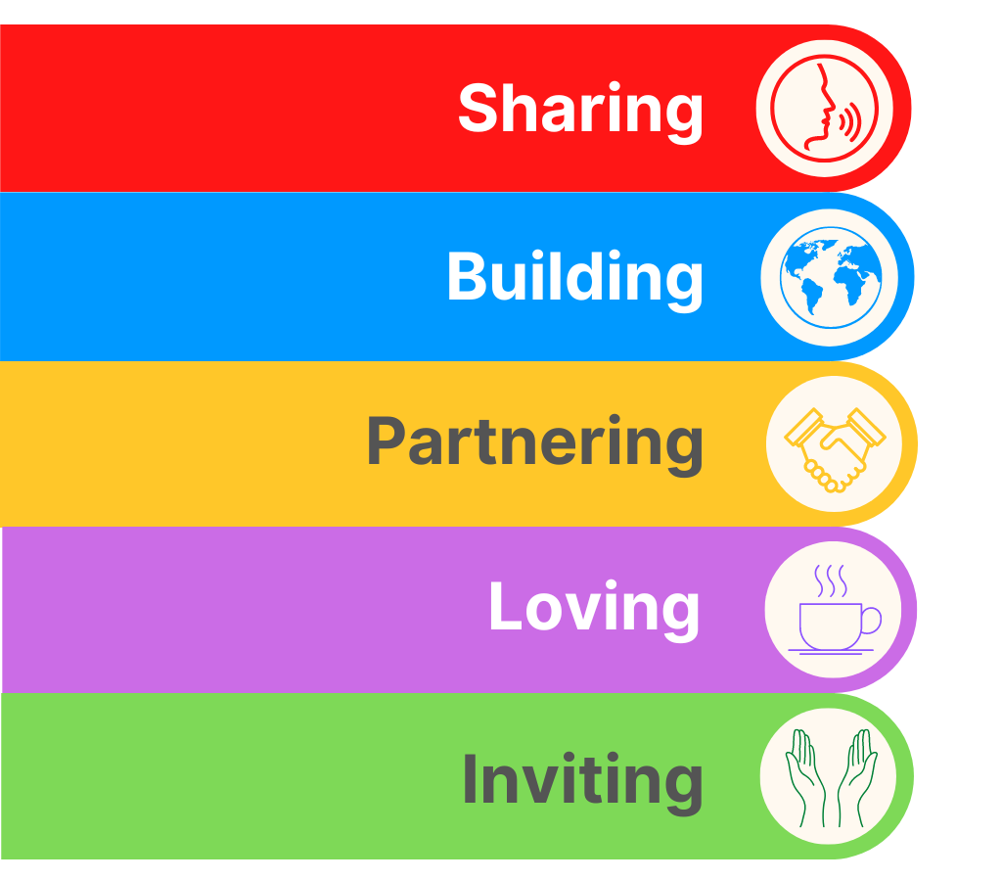
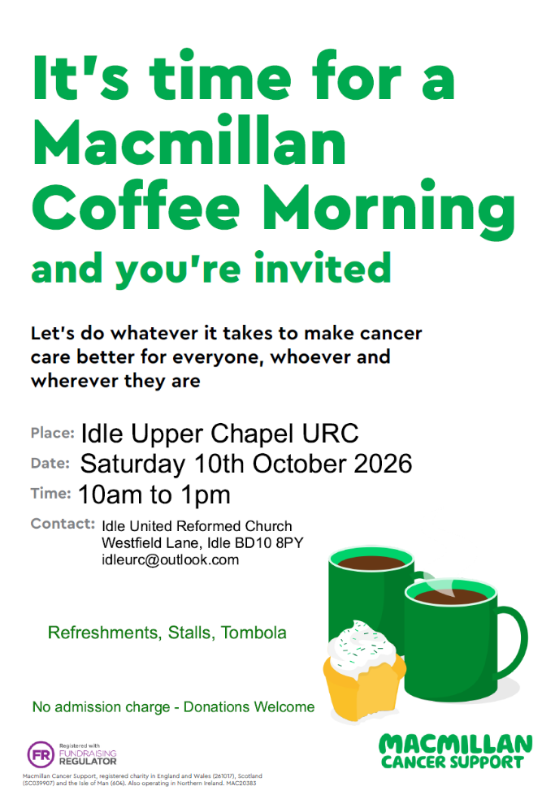
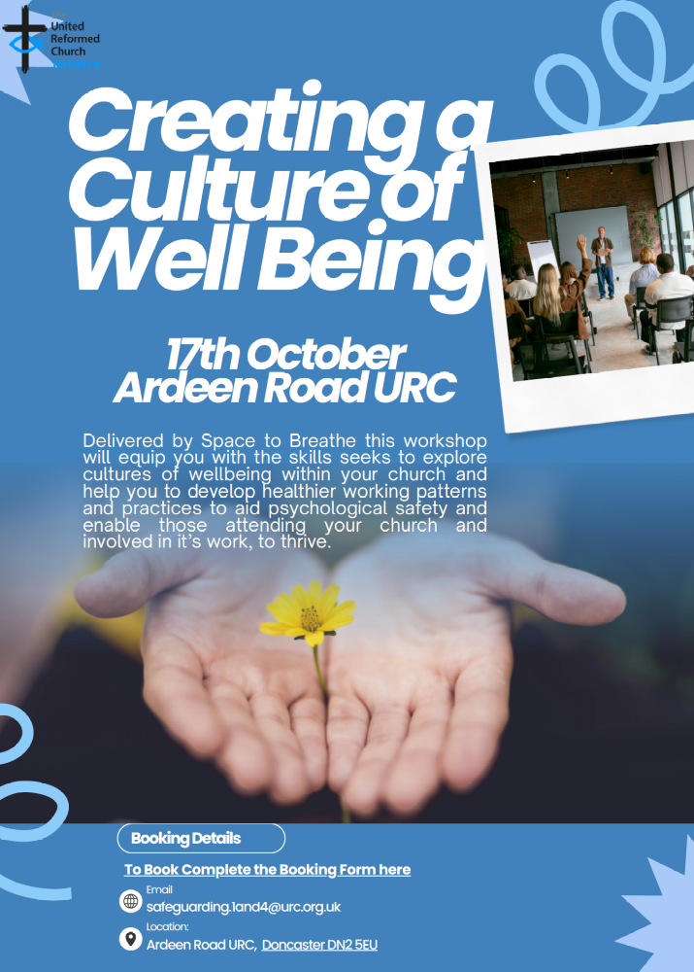
For more information contact Carrie Solomon at safeguarding.1and4@urc.org.uk
and to book click here: https://tinyurl.com/2szfafc8

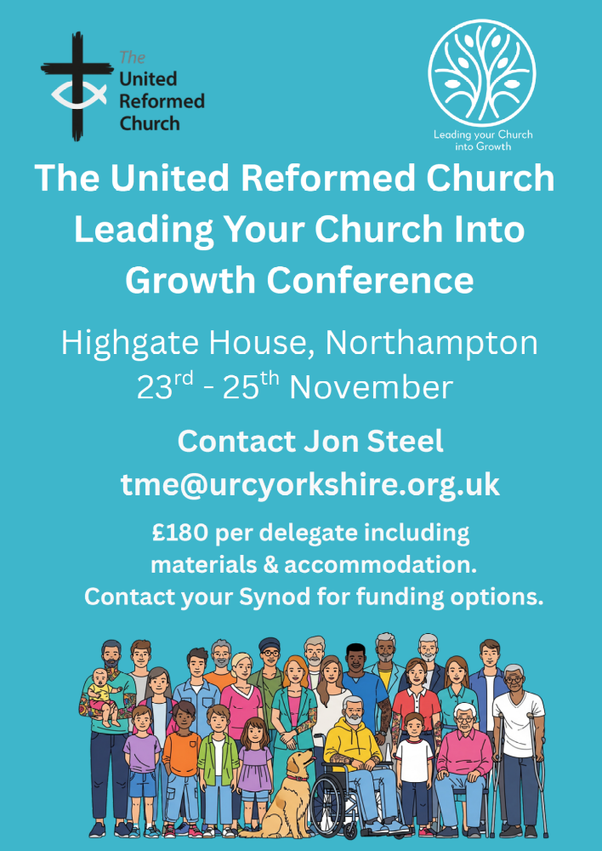


Contact megancyp@urcyorkshire.org.uk to book your place!
https://urc.org.uk/.../chil.../urc-youth/urc-youth-assembly/

Lay Worship Leaders’ Weekend

"Date for the Diary"

9th – 11th July 2027
(Friday teatime to Sunday lunch)

at Wydale Conference Centre, Brompton by Sawdon near Scarborough www.wydale.org

We are very pleased that Revd John Proctor has agreed to be our main speaker
at the annual 2027 conference.
Look out for theme information in January 2027.

This weekend will again be paid for by Synod and grants so you will only need to cover your travel costs.

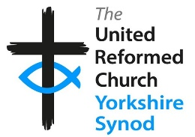
To register your place, contact:
office@urcyorkshire.org.uk or 0113 289 8490.

For any queries, contact Kath at
kath.lonsdale@outlook.com
01274 315 203 or 07759 525 936


Judy Rogers, the Yorkshire Synod’s Racial Justice Advocate has asked that your attention is drawn to the Churches Together in Britain & Ireland’s (CTBI) resources for this year’s Black History Month (BHM).
This year marks the 39th anniversary of BHM in Britain. It was first organised in 1987, led by Ghanaian analyst and community activist Akyaaba Addai-Sebo, with the aim of recognizing the contributions of Black communities and promoting a more inclusive understanding of British history. From a Christian perspective, BHM is an excellent way of celebrating the way God has enabled Black women, men and children to use their God-given giftings to revitalise the Church in this country. Please follow this link for some excellent resources from CTBI:
https://ctbi.org.uk/wp-content/uploads/2026/08/Black-History-Month-Resources-for-churches-2026.pdf
and please share with us at Synod how you have marked Black History Month in your church.

!!! WANTED !!!
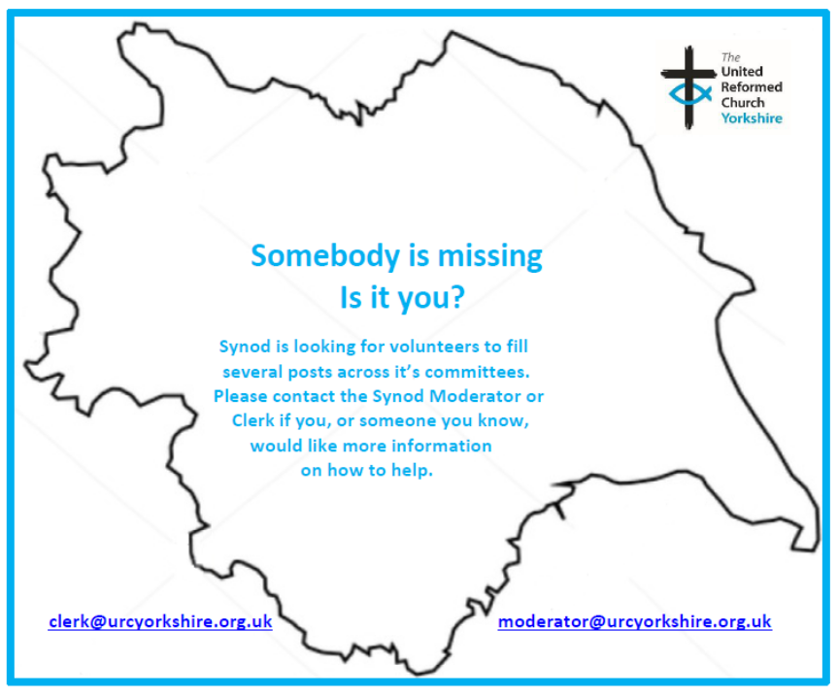
The Synod is looking for people to join some of our key groups, especially in the Property, the Financial Resources and Children and Young People’s committees. These bodies guide the direction of Synod and without them Synod would find it hard to function. If you are able to take up a call to help Synod out, please contact the Synod Clerk at clerk@urcyorkshire.org.uk for more information.

Yes, It’s Here:
The URC’s Resources Hub
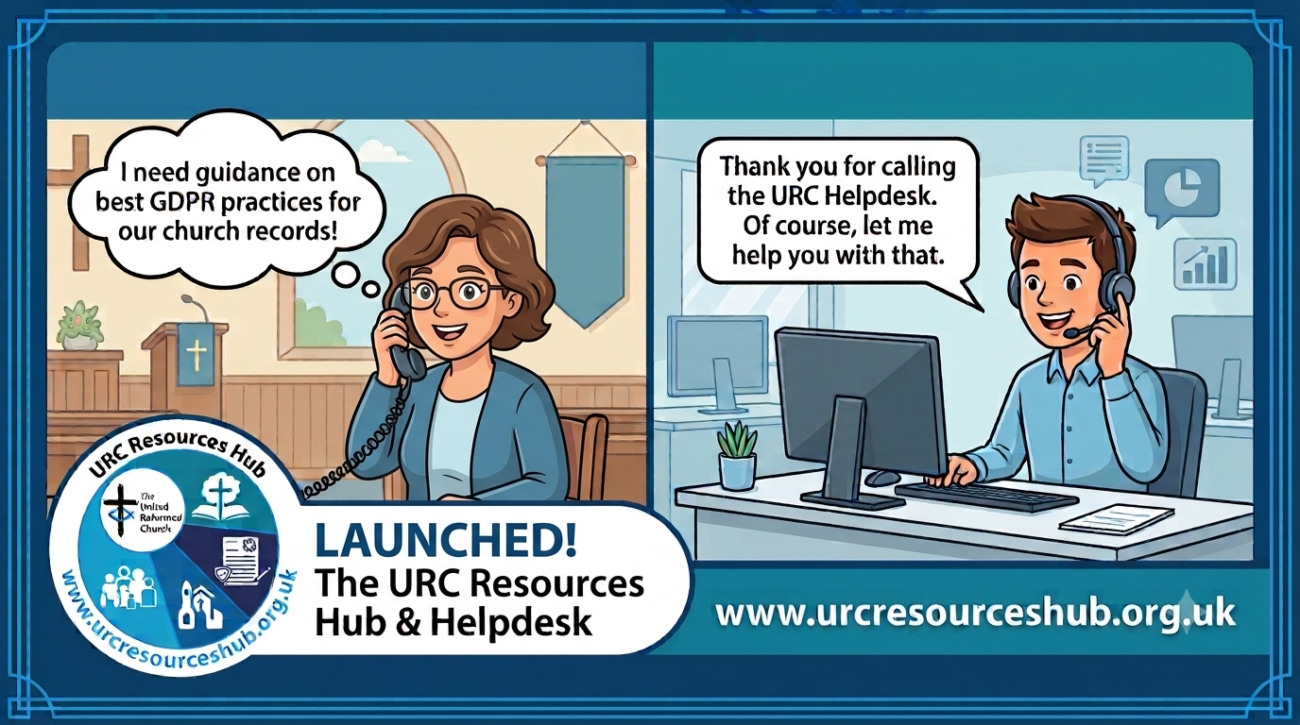
One of the first roll outs from the Church Life Review is this brand new Resources Hub for all our churches and volunteers to use. There are two ways into it, through the URC website, or directly using this link: https://urcresourceshub.org.uk/. Please take a bit of time to have a look, and if you have any feedback or any suggestions for what you may want it to hold, please contact me at clerk@urcyorkshire.org.uk and I’ll pass on your feedback.

There will be more resources being uploaded to the resource over the next few months. The next tranche will be documents covering governance and finance, so keep an eye out on announcements here, in the URC’s regular News Update circulars and in Reformed magazine.

It’s not too late to ask that the team behind the hub add items which you may want. If you know of any resources which you feel may benefit all our churches, drop the Clerk a line at clerk@urcyorkshire.org.uk and he’ll contact the team putting the Resource Hub together.

URC Response to “Martyn’s Law”
A recent addition to the Resource Hub is in relation to Martyn’s Law [Terrorism (Protection of Premises) Act 2025], which received its Royal Assent in April 2025 and concerns premises hosting events that exceed 200 people being required to consider how they would respond to a terrorist incident. This legislation is coming into force in April 2027, therefore we want to give all local URC’s the opportunity to be prepared for this change. Therefore, the Resources Hub now has some useful guidance notes for local churches on what the law entails and gets them to begin thinking about the practical next steps. The guidance notes can be found here; https://urcresourceshub.org.uk/martyns-law-guidance/
We would also like to take this opportunity to invite churches to join a free webinar on Thursday 22nd October 2026 at 1pm which is being done in partnership with the Community Security Trust (CST). This session is designed to help local churches, trustees, elders, ministers and church officers understand their responsibilities under the new legislation and what steps they may need to take to comply. Further details of this event can now be found on our new ‘Learning’ page on the Hub here; https://urcresourceshub.org.uk/learning-development/, as well as the link to register for the event.
I would be very grateful if you could send both links to all churches within your Synod to make them aware of these changes, even if they are unlikely to fall under the ‘scope’ of the new law. If you could also pop further details about the upcoming webinar in your Synod newsletter and on your websites, I would also be incredibly grateful.

Looking for a Good Home
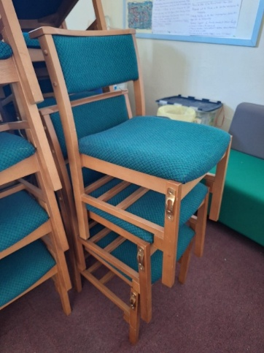
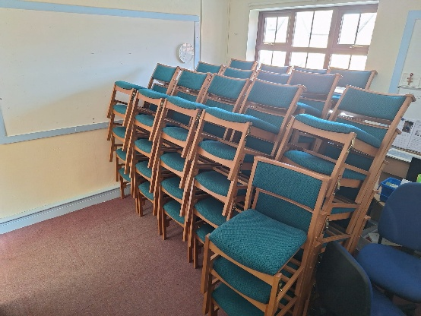
68 Chairs are surplus to requirements at St Andrew's Roundhay. The chairs are in good condition, easily stackable and can be set up as individual chairs or linked together, as per the two pictures.
If you would like them, St Andrew’s is happy to donate them – or to accept a donation towards their outreach work! However if anyone is interested they will need to arrange collection.
For more information, please contact St Andrew’s directly via Lewis.Murray@standrews.cc

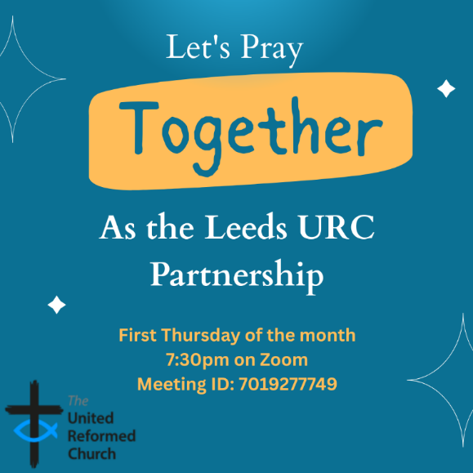
Leeds URC Partnership Prayers
Thursday, 1st October, 7:30pm.
Thursday 5th November, 7:30pm.
A short time to pray together by reading the Bible and sharing the joys and challenges in our lives, churches, communities and world.
On Zoom:
https://us02web.zoom.us/j/7019277749



Yorkshire Synod Discipleship Development Small Grant Fund 2026
The Synod is pleased to let you all know that it still has some of the pot of £4000 to grant to those wishing to apply to the Yorkshire Synod Discipleship Development 2026. Currently we have been able to grant half of what has been allocated to us, and we would love to be able to offer grants to enable us to use all of what Yorkshire Synod has received by the end of the year.

1. Who is eligible to apply? Committed members or adherents, including children and young people, of a congregation within the United Reformed Church who are exercising, or want to exercise, a form of lay ministry or community service whether expressed within or beyond their local church. The DDF is not open to Ministers of Word and Sacraments and CRCWs, as there are other designated funds available for those groups.

2. How much is available? Up to £300 per applicant per calendar year, although the Synod may agree to more than this according to the local context and circumstances. Currently we have funding available for 4 more grants this calendar year.

3. What can this money be used for? The purposes for which the funding is provided are defined by creativity and vocation, in line with the URC's discipleship development strategy. Be bold, take risks. The funding exists to help you to follow Jesus. You might be helped in this by courses (at any level) at any of the URC Resource Centres for Learning or from other learning providers, or you may have ideas on resourcing discipleship development in other people. You may need funds to cover the costs of travel, materials or books. All you have to do is make a case to your local church meeting and submit the application form to the Synod Convenor of Ministries for consideration and, if appropriate, authorisation.

4. How are applications made? Having gained your church meeting's endorsement, applications are to be made on the designated form, well before the spending is due to start. Backdated applications will not normally be accepted. Application forms are obtainable from the Synod Convenor of Ministries via the Synod Office at office@urcyorkshire.org.uk and should be sent back for authorisation before being passed to the synod finance office.

5. How are grants paid? Grants authorised by the Convenor of Synod Ministries
are paid by a Synod finance officer by reimbursement to you when you have given proof of what you've spent. Contact your Synod Convenor of Ministries for discussion if you need something funded directly on your behalf, rather than waiting for re-imbursement.

If anyone wants to discuss an application before submitting it please contact the Convenor of the Yorkshire Ministries Committee, Kath Lonsdale at kath.lonsdale@outlook.com (please note the new e-mail address).
Remember this is for any age of lay person in our churches to apply for so please discuss with your young people as well as adults.

NEWS FROM THE DENOMINATION
The Ever Joyful Banner Project
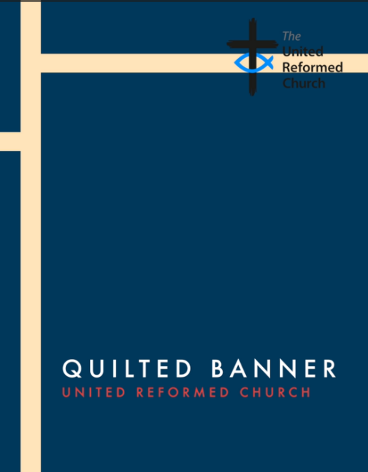
Our own Revd Samantha Sheehan, who is currently serving as the Chaplain to this year’s General Assembly Moderator is organising a denominational wide project called the "Ever Joyful" patchwork banner. You could almost call it the Great URC Sewing Bee……………
She is already very grateful for your support in this and has already received a number of emails from folk requesting their packs following the article in the URC News Update earlier this month.
The packs have been put together with everything a congregation needs to get started - the fabric square, instructions and return envelope – and each church’s pack will be sent to the Synod Office. This means that they will be available to collect at our Saturday Synod meeting, being held on October 10th at Moldgreen URC in Huddersfield.
At the meeting we will be showing a short video (3 minutes) to explain the project and which invites local congregations to share in decorating a fabric square. The links to this video is here as well:
Ever Joyful or https://drive.google.com/file/d/1C30CqIh6_Td7sISGfUICxkARzSD9jJBt/view to download from a Google Drive or from YouTube here Ever Joyful or https://www.youtube.com/watch?v=lnr9Vcn1OJc

We have given the deadline of 1st Dec for the patches to be returned, so Samantha and the Ever Joyful Banner team are very grateful to Northern Synod for being willing to receive them all. If folk miss this deadline, squares can be received up until the Assembly Executive meeting at the beginning of February. Although they do wish for as many as possible to come back by December giving them as much time as possible to create the banner before General Assembly 2027.

For more information please contact Samantha at Rev.S.Sheehan@gmail.com

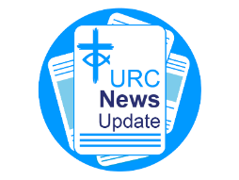
The URC’s News Update is a regular e-newsletter that keeps you informed about the latest news and events.
To receive this popular newsletter, please visit the https://urc.org.uk/news-updates-sign-up-form/ page on the URC website and follow the links. If you just want to dip in and catch up on what is going one, that’s fine and you can
read and print recent editions of our e-newsletter by visiting the URC News Update page at https://urc.org.uk/urc-news-update/ .

And Finally
Ordination and Induction at Wigton Moor
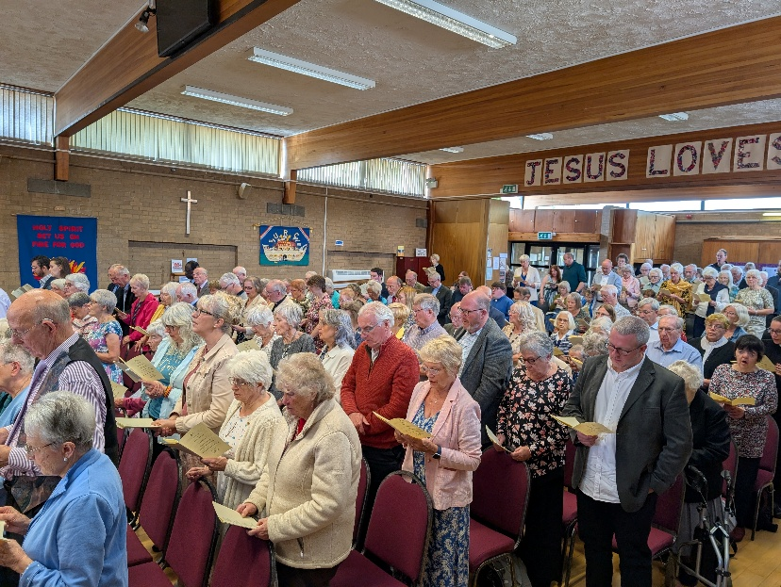
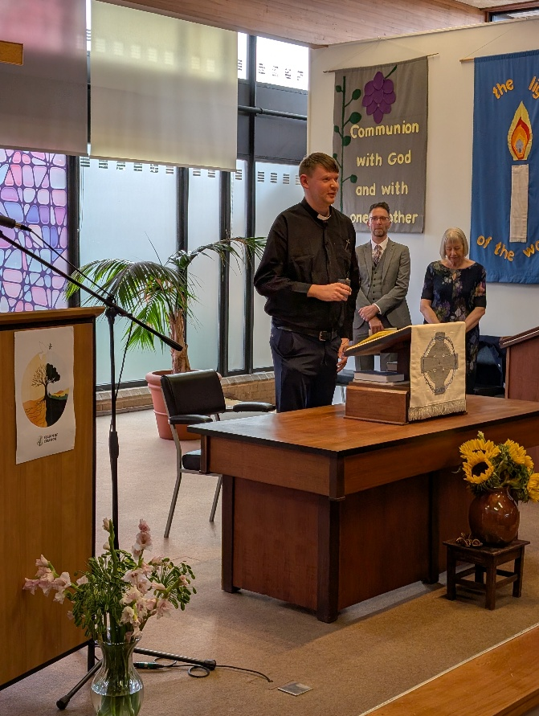
Last Saturday, September 26th September, saw Wigton Moor URC full to capacity to celebrate the ordination of Edward Lyne and his induction into the Leeds partnership. The service, led by the Yorkshire Synod Moderator, Revd Jamie Kissack, with contributions from Revd Dr Graham Adams of Luther King Theological College and Mrs Sheana Dudley (seen here pictured with Ed), was one which was both steeped in the traditions of the United Reformed Church and a celebration of Ed’s call into ministry. To have the church packed without a free seat in the house was testament to how Ed has been received into the Leeds partnership and shows the support he has had from his family and friends through his faith journey.
All of us here welcome Ed into the Yorkshire Synod and look forward to accompanying him of his continung journey as a Minister of Word and Sacraments in the United Reformed Church.

If you have a good news story from your part of the Synod or something that you feel reflects the work of Synod as we move into the last quarter of 2026, drop me a line at clerk@urcyorkshire.org.uk and I’ll make sure it hits the back page!!

You can also keep an eye on all our social media platforms for news; on the website at Home - URC Yorkshire Synod, at United Reformed Church in Yorkshire - Home | Facebook and Wilderness URC Yorkshire - Home | Facebook, and the YouTube page at URC Yorkshire - YouTube

