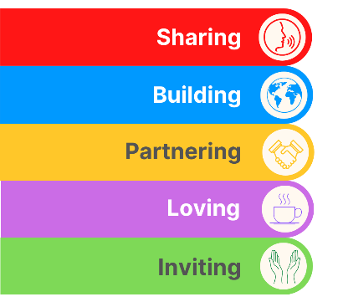
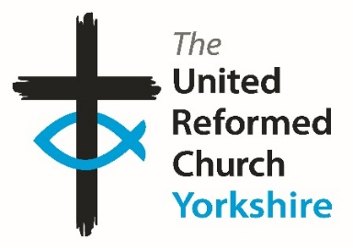
Yorkshire Synod Briefing
Number 183

15th October 2026

AUTUMN SYNOD SPECIAL
TALKING MONEY, TALKING MISSION
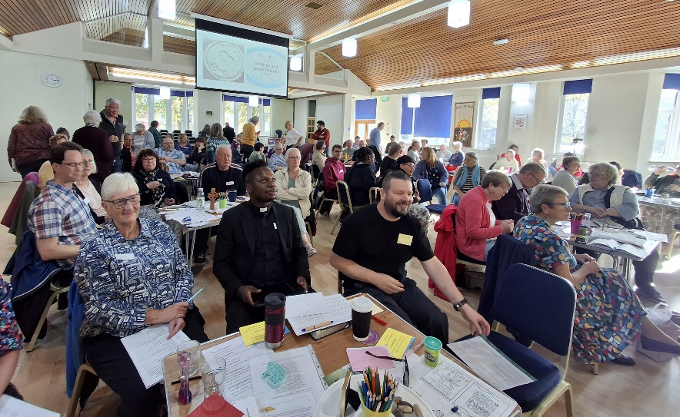
This issue of the Briefing finds us sat between the “in person” part of this Autumn’s Synod meeting and the “online” session scheduled for a fortnight’s time. Last Saturday saw Yorkshire church representatives gather at Moldgreen URC in Huddersfield to worship, learn and deliberate together on matters Mission and matters Money. On the evening of Thursday 29th October Synod reconvenes to continue that conversation with feedback on what was discussed in Moldgreen and to discern how we move forward into 2027 and beyond.
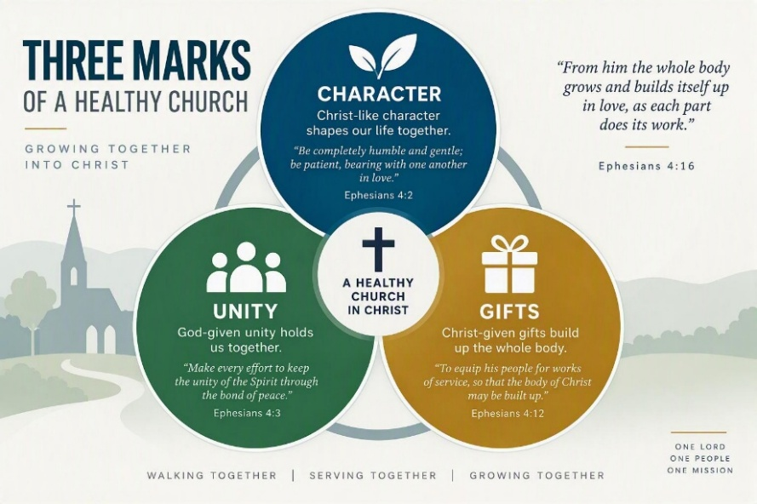
At Moldgreen worship was led by the Synod Directed Ministries team, with the offer that their expertise is available across the Synod. By using the theme of Three Marks of a Healthy Church, the scene was set for how we can use our character, gifts and unity in Christ to grow our churches. So the day was set, with the meeting getting to grips with how we work together to resource spiritually and financially, in the knowledge that this is as much a denomination wide conversation as it is a Synod one.
Our outgoing Treasurer, Simon Copley, led the way by leading an initial conversation on how ministry in the URC is funded through the Maintenance of the Ministry Fund (MMF), including videos from the denomination’s General Secretary, John Bradbury, and the MMF consultation team. These can be found here https://youtu.be/4i7SUc2irdc and here https://youtu.be/CfJpqBoQLg0. Simon asked the Synod meeting to engage and consider five conversations; seeing the fruits of the MMF in our own context, our assumptions about the MMF, what kind of Church does the MMF enable us to become, what responsibilities does that place upon different parts of the church – Synods, Churches and General Assembly, and what other themes and observations come to us? Hopefully more feedback will come when Synod reconvenes on 29th October.
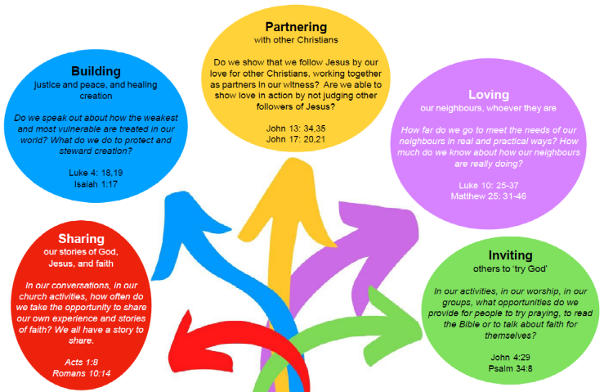
Following on from that, our new Training and Missional Enabler, Jon Steel, introduced the idea of church Missional Living Documents; a means to develop the gifts we know are within our churches which can be used to develop a proactive missional culture. This work is being developed across all our churches and as it does there is an open invitation to be part of that work. Keep an eye on https://urcyorkshire.org.uk/mission/ as this begins to grow.

Synod also heard of the work of our Wilderness Project, run through Megan Tillbrook, our Children and Youth Development Officer. This year we are supporting Emily and Leo in their work at St Andrew’s Roundhay and were treated to a video showcasing what they have done to develop and enhance Christ’s work in north Leeds.
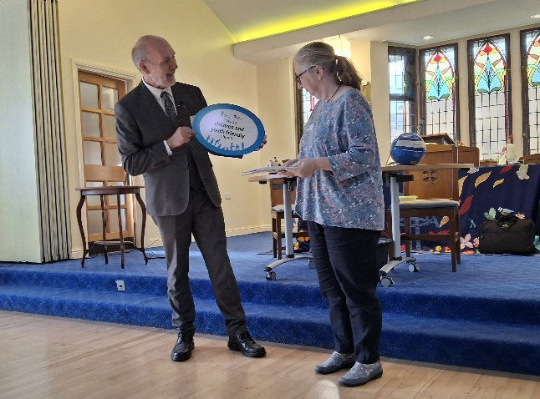
We were also treated to the presentation to Shiregreen URC of their Children and Youth Friendly Church Award. Here we see our Moderator, Jamie handing the award to Youth worker Tracey Winfrow. Children and Youth work at Shiregreen has snowballed in recent years and it is great to see that the hard work put in by the church has not gone unnoticed. For more information on how to engage with the Children and Youth Friendly Church Scheme, visit the https://urc.org.uk/your-church/family-friendly-church/children-and-youth-friendly-church-scheme/ page on the URC website and contact Megan at megancyp@urcyorkshire.org.uk.

Somewhere else where the work of outreach is succeeding is at Moldgreen itself, where Helen Snashall, the Church Related Community Worker, who leads the Unite, Respect, Connect Project. This project, working in the community in and around Moldgreen and Dalton in south -east Huddersfield. The church buildings at Moldgreen have never been busier and the ethos of outreach now includes Waverley URC in north Huddersfield, as we learnt from watching their video, which can be accessed here https://www.youtube.com/watch?v=N115mYab6Vg.

If you have any news of welcoming people into Church, stories of celebration and mission, please let me know at clerk@urcyorkshire.org.uk and I’ll showcase it in the next edition, due out on the website only on 5th November 2026.
Tim Crossley
Yorkshire Synod Clerk
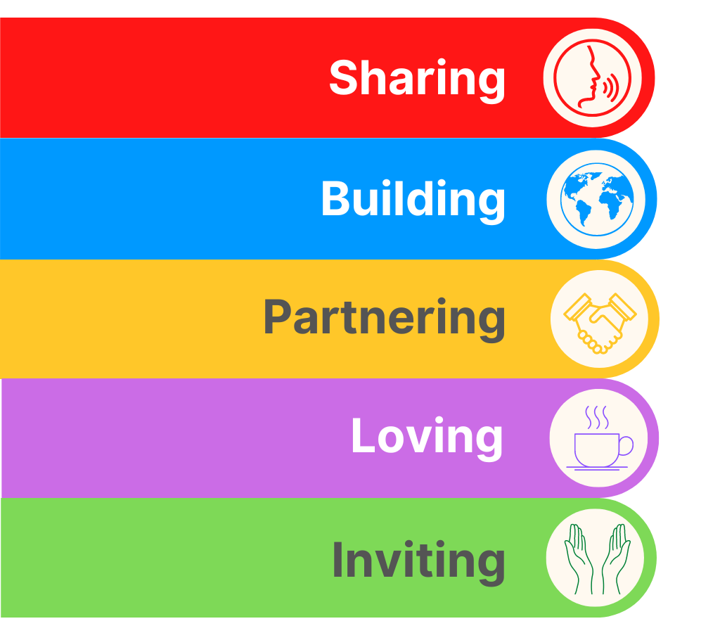
The Ever Joyful Banner Project

Hopefully by now, every church in Synod will have received a special envelope from our own Revd Samantha Sheehan, who is currently serving as the Chaplain to this year’s General Assembly Moderator. She is organising a denominational wide project called the "Ever Joyful" patchwork banner. You could almost call it the Great URC Sewing Bee……………
She is already very grateful for your support in this and has already received a number of emails from folk requesting their packs following the article in the URC News Update earlier this month.
The packs have been put together with everything a congregation needs to get started - the fabric square, instructions and return envelope – and each church’s pack will be sent to the Synod Office. Thank you to all those who collected their envelopes (and other church’s envelopes) at our Saturday Synod meeting on October 10th at Moldgreen URC in Huddersfield. Those that were not collected have been posted out to the relevant church secretary so there shouldn’t be an excuse not to be aware of the project.
At the meeting we showed a short film (3 minutes) to explain the project and which invites local congregations to share in decorating a fabric square. If you missed it, or if you want to watch it again, these are the links to this video:
Ever Joyful or https://drive.google.com/file/d/1C30CqIh6_Td7sISGfUICxkARzSD9jJBt/view to download from a Google Drive or from YouTube here Ever Joyful or https://www.youtube.com/watch?v=lnr9Vcn1OJc

We have given the deadline of 1st Dec for the patches to be returned, so Samantha and the Ever Joyful Banner team are very grateful to Northern Synod for being willing to receive them all. If folk miss this deadline, squares can be received up until the Assembly Executive meeting at the beginning of February. Although they do wish for as many as possible to come back by December giving them as much time as possible to create the banner before General Assembly 2027.

For more information please contact Samantha at Rev.S.Sheehan@gmail.com


To sign up, all you have to do is visit the Yorkshire Synod website at
https://urcyorkshire.org.uk/
scroll to the foot of the page and fill in your name and e-mail address.
It’s as simple as that!!
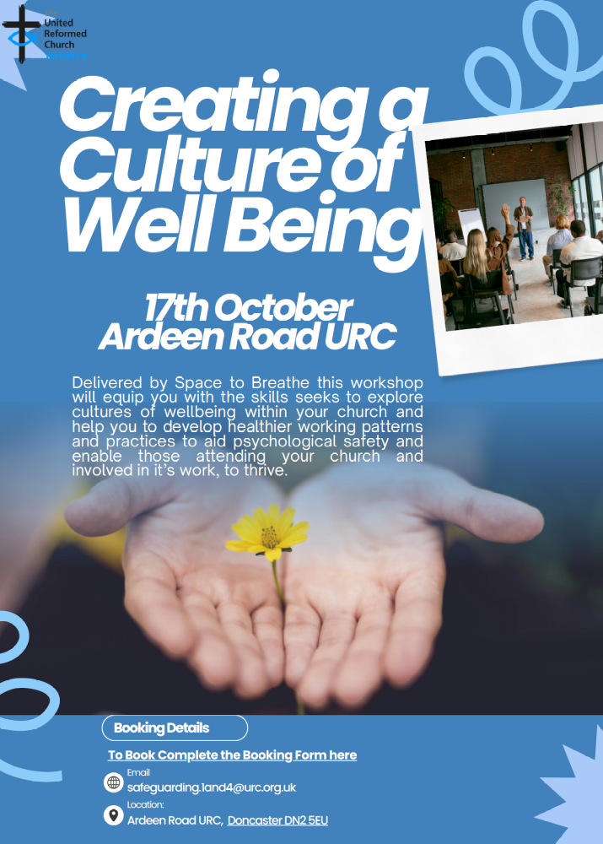
For more information contact Carrie Solomon at safeguarding.1and4@urc.org.uk
and to book click here: https://tinyurl.com/2szfafc8
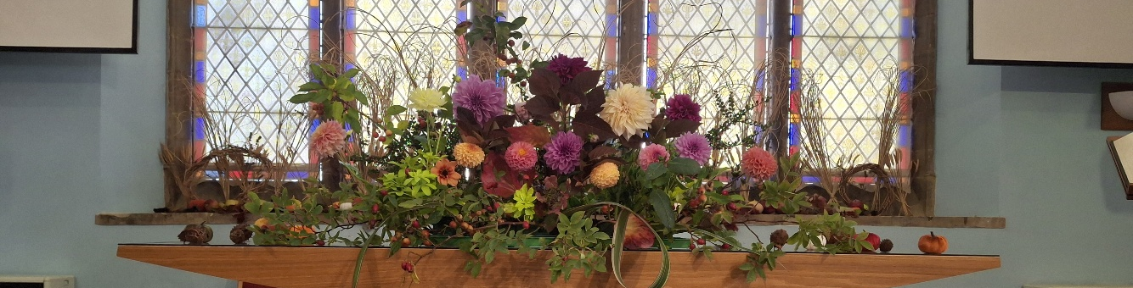

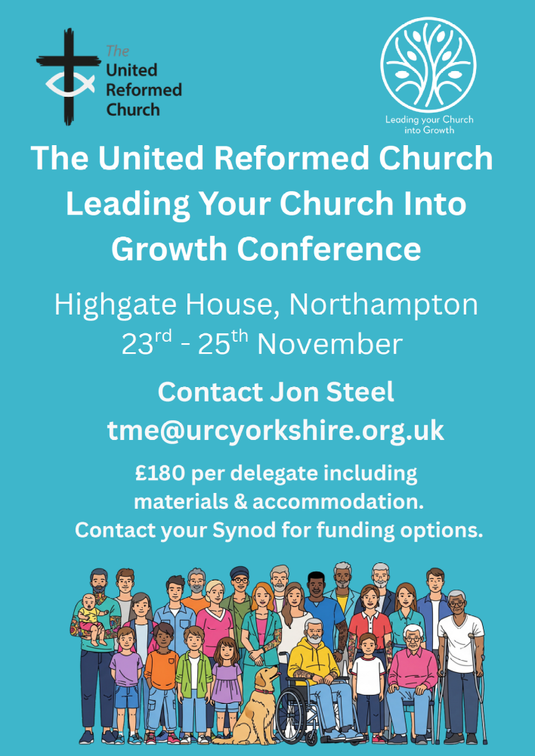


Contact megancyp@urcyorkshire.org.uk to book your place!
https://urc.org.uk/.../chil.../urc-youth/urc-youth-assembly/

Lay Worship Leaders’ Weekend

"Date for the Diary"

9th – 11th July 2027
(Friday teatime to Sunday lunch)

at Wydale Conference Centre, Brompton by Sawdon near Scarborough www.wydale.org

We are very pleased that Revd John Proctor has agreed to be our main speaker
at the annual 2027 conference.
Look out for theme information in January 2027.

This weekend will again be paid for by Synod and grants so you will only need to cover your travel costs.

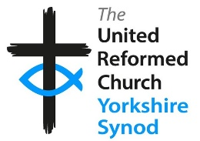
To register your place, contact:
office@urcyorkshire.org.uk or 0113 289 8490.

For any queries, contact Kath at
kath.lonsdale@outlook.com
01274 315 203 or 07759 525 936


Judy Rogers, the Yorkshire Synod’s Racial Justice Advocate has asked that your attention is drawn to the Churches Together in Britain & Ireland’s (CTBI) resources for this year’s Black History Month (BHM).
This year marks the 39th anniversary of BHM in Britain. It was first organised in 1987, led by Ghanaian analyst and community activist Akyaaba Addai-Sebo, with the aim of recognizing the contributions of Black communities and promoting a more inclusive understanding of British history. From a Christian perspective, BHM is an excellent way of celebrating the way God has enabled Black women, men and children to use their God-given giftings to revitalise the Church in this country. Please follow this link for some excellent resources from CTBI:
https://ctbi.org.uk/wp-content/uploads/2026/08/Black-History-Month-Resources-for-churches-2026.pdf
and please share with us at Synod how you have marked Black History Month in your church.

!!! WANTED !!!
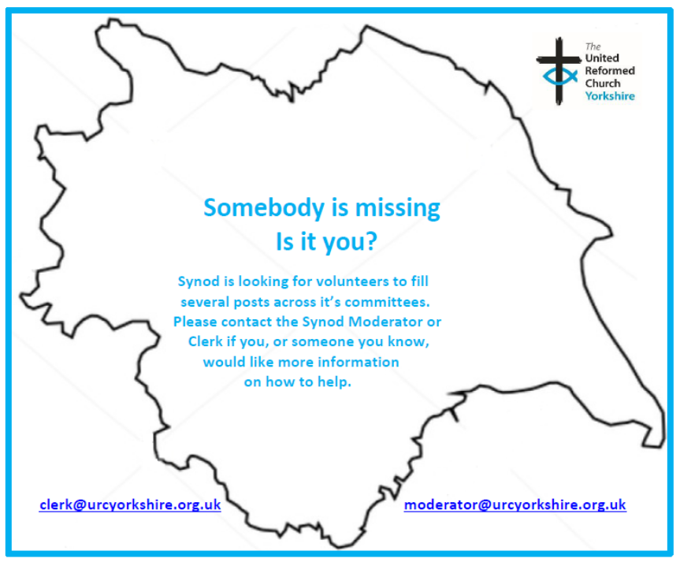
The Synod is looking for people to join some of our key groups, especially in the Property, the Financial Resources and Children and Young People’s committees. These bodies guide the direction of Synod and without them Synod would find it hard to function. If you are able to take up a call to help Synod out, please contact the Synod Clerk at clerk@urcyorkshire.org.uk for more information.

Yes, It’s Here:
The URC’s Resources Hub
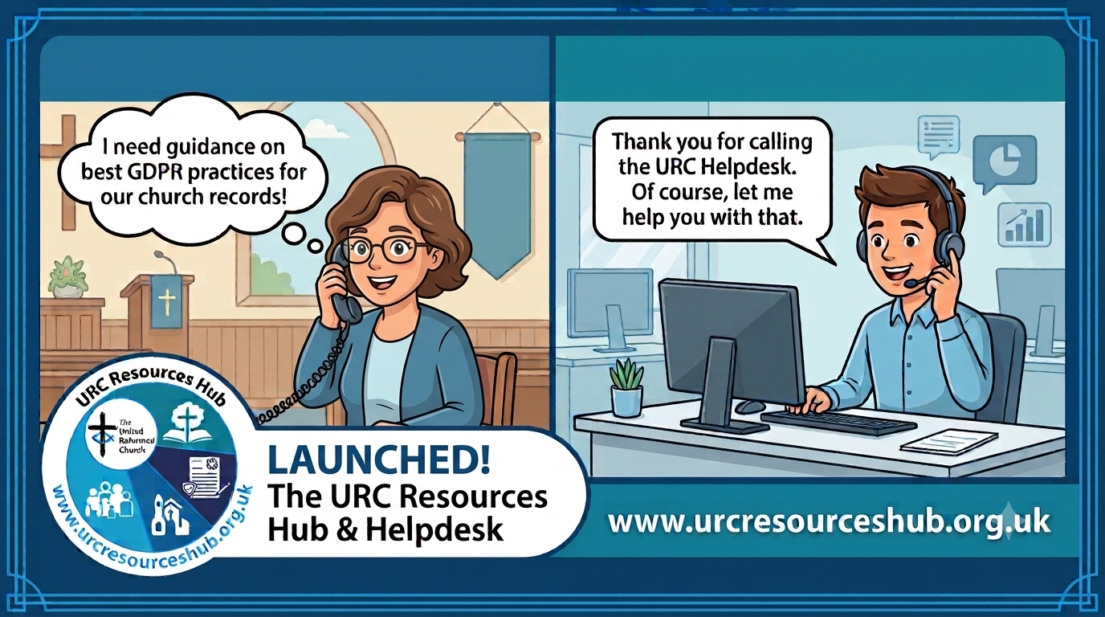
One of the first roll outs from the Church Life Review is this brand new Resources Hub for all our churches and volunteers to use. There are two ways into it, through the URC website, or directly using this link: https://urcresourceshub.org.uk/. Please take a bit of time to have a look, and if you have any feedback or any suggestions for what you may want it to hold, please contact me at clerk@urcyorkshire.org.uk and I’ll pass on your feedback.

There will be more resources being uploaded to the resource over the next few months. The next tranche will be documents covering governance and finance, so keep an eye out on announcements here, in the URC’s regular News Update circulars and in Reformed magazine.

It’s not too late to ask that the team behind the hub add items which you may want. If you know of any resources which you feel may benefit all our churches, drop the Clerk a line at clerk@urcyorkshire.org.uk and he’ll contact the team putting the Resource Hub together.

URC Response to “Martyn’s Law”
A recent addition to the Resource Hub is in relation to Martyn’s Law [Terrorism (Protection of Premises) Act 2025], which received its Royal Assent in April 2025 and concerns premises hosting events that exceed 200 people being required to consider how they would respond to a terrorist incident. This legislation is coming into force in April 2027, therefore we want to give all local URC’s the opportunity to be prepared for this change. Therefore, the Resources Hub now has some useful guidance notes for local churches on what the law entails and gets them to begin thinking about the practical next steps. The guidance notes can be found here; https://urcresourceshub.org.uk/martyns-law-guidance/
We would also like to take this opportunity to invite churches to join a free webinar on Thursday 22nd October 2026 at 1pm which is being done in partnership with the Community Security Trust (CST). This session is designed to help local churches, trustees, elders, ministers and church officers understand their responsibilities under the new legislation and what steps they may need to take to comply. Further details of this event can now be found on our new ‘Learning’ page on the Hub here; https://urcresourceshub.org.uk/learning-development/, as well as the link to register for the event.
I would be very grateful if you could send both links to all churches within your Synod to make them aware of these changes, even if they are unlikely to fall under the ‘scope’ of the new law. If you could also pop further details about the upcoming webinar in your Synod newsletter and on your websites, I would also be incredibly grateful.

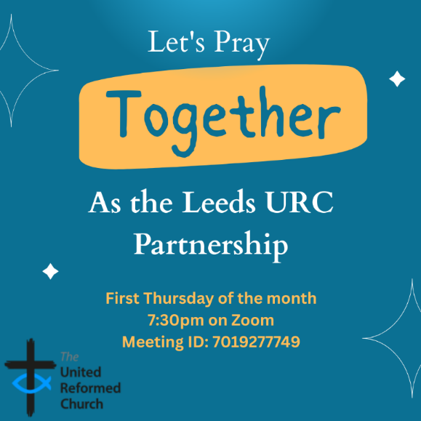
Leeds URC Partnership Prayers

Thursday 5th November, 7:30pm.
A short time to pray together by reading the Bible and sharing the joys and challenges in our lives, churches, communities and world.

On Zoom:
https://us02web.zoom.us/j/7019277749

NEWS FROM THE DENOMINATION

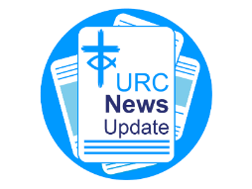
The URC’s News Update is a regular e-newsletter that keeps you informed about the latest news and events.
To receive this popular newsletter, please visit the https://urc.org.uk/news-updates-sign-up-form/ page on the URC website and follow the links. If you just want to dip in and catch up on what is going one, that’s fine and you can
read and print recent editions of our e-newsletter by visiting the URC News Update page at https://urc.org.uk/urc-news-update/ .



Yorkshire Synod Discipleship Development Small Grant Fund 2026
The Synod is pleased to let you all know that it still has some of the pot of £4000 to grant to those wishing to apply to the Yorkshire Synod Discipleship Development 2026. Currently we have been able to grant half of what has been allocated to us, and we would love to be able to offer grants to enable us to use all of what Yorkshire Synod has received by the end of the year.

1. Who is eligible to apply? Committed members or adherents, including children and young people, of a congregation within the United Reformed Church who are exercising, or want to exercise, a form of lay ministry or community service whether expressed within or beyond their local church. The DDF is not open to Ministers of Word and Sacraments and CRCWs, as there are other designated funds available for those groups.

2. How much is available? Up to £300 per applicant per calendar year, although the Synod may agree to more than this according to the local context and circumstances. Currently we have funding available for 4 more grants this calendar year.

3. What can this money be used for? The purposes for which the funding is provided are defined by creativity and vocation, in line with the URC's discipleship development strategy. Be bold, take risks. The funding exists to help you to follow Jesus. You might be helped in this by courses (at any level) at any of the URC Resource Centres for Learning or from other learning providers, or you may have ideas on resourcing discipleship development in other people. You may need funds to cover the costs of travel, materials or books. All you have to do is make a case to your local church meeting and submit the application form to the Synod Convenor of Ministries for consideration and, if appropriate, authorisation.

4. How are applications made? Having gained your church meeting's endorsement, applications are to be made on the designated form, well before the spending is due to start. Backdated applications will not normally be accepted. Application forms are obtainable from the Synod Convenor of Ministries via the Synod Office at office@urcyorkshire.org.uk and should be sent back for authorisation before being passed to the synod finance office.

5. How are grants paid? Grants authorised by the Convenor of Synod Ministries
are paid by a Synod finance officer by reimbursement to you when you have given proof of what you've spent. Contact your Synod Convenor of Ministries for discussion if you need something funded directly on your behalf, rather than waiting for re-imbursement.

If anyone wants to discuss an application before submitting it please contact the Convenor of the Yorkshire Ministries Committee, Kath Lonsdale at kath.lonsdale@outlook.com (please note the new e-mail address).
Remember this is for any age of lay person in our churches to apply for so please discuss with your young people as well as adults.

Harvest Celebrations at Swanland

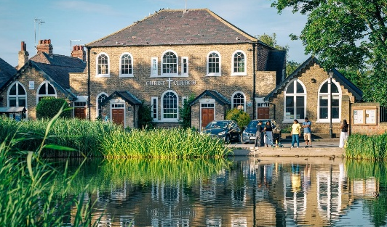
News has reached Synod of the incredible Harvest celebrations that have taken place at Christ Church Swanland. Their Harvest collections last week brought in a vast amount of food donations, a total of sixty bags and two crates - all full to the brim – all of which have been taken to their local food bank for distribution.

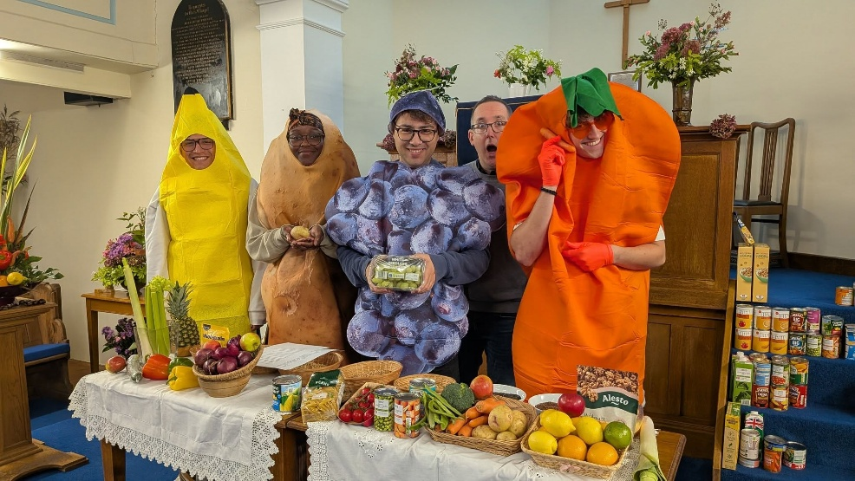
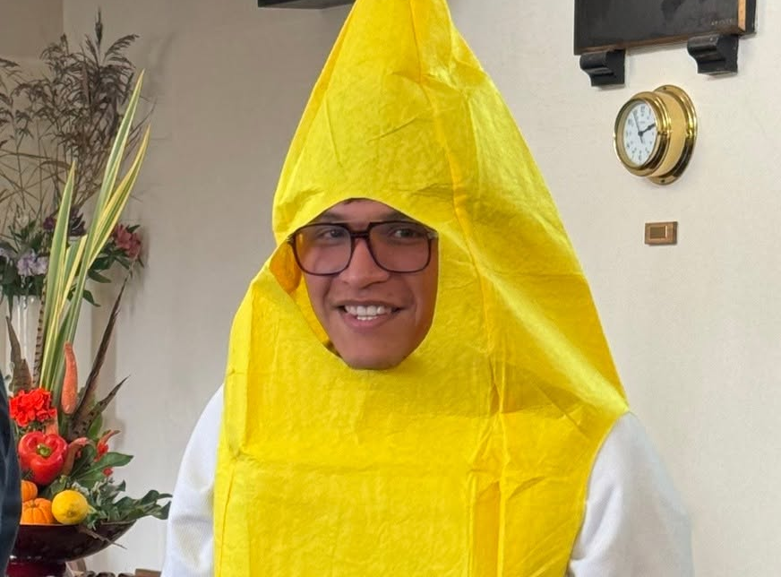
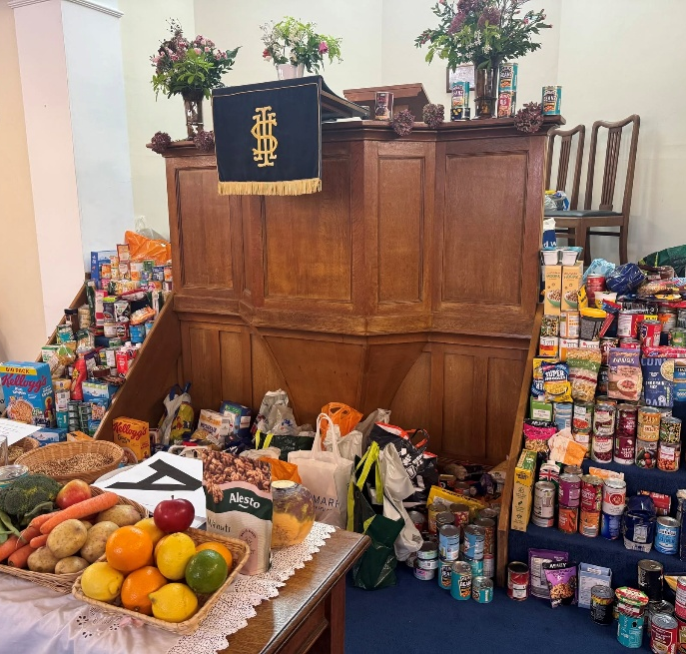
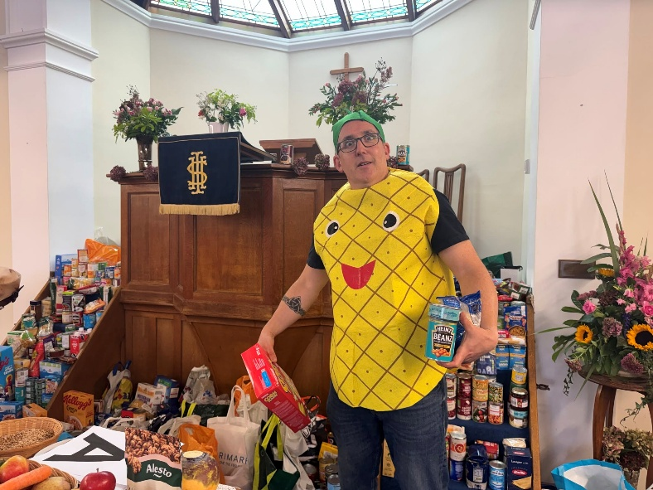
As well as the children from Swanland Primary we were delighted to be joined by some very helpful fruits and vegetables - thanks for all your help guys!
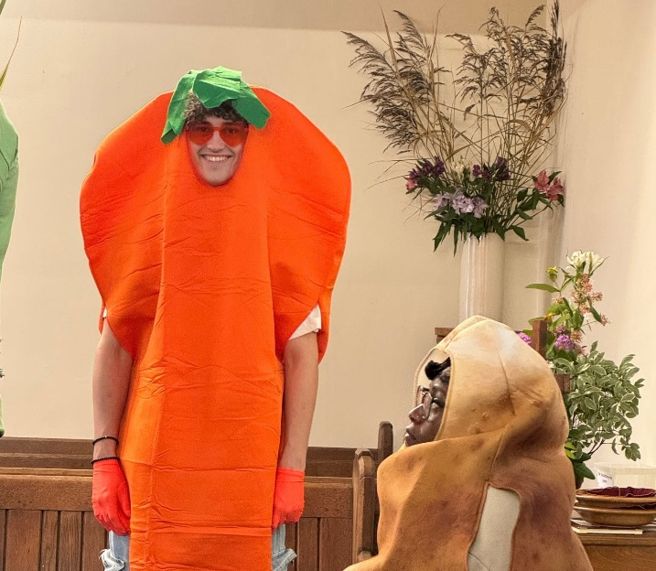

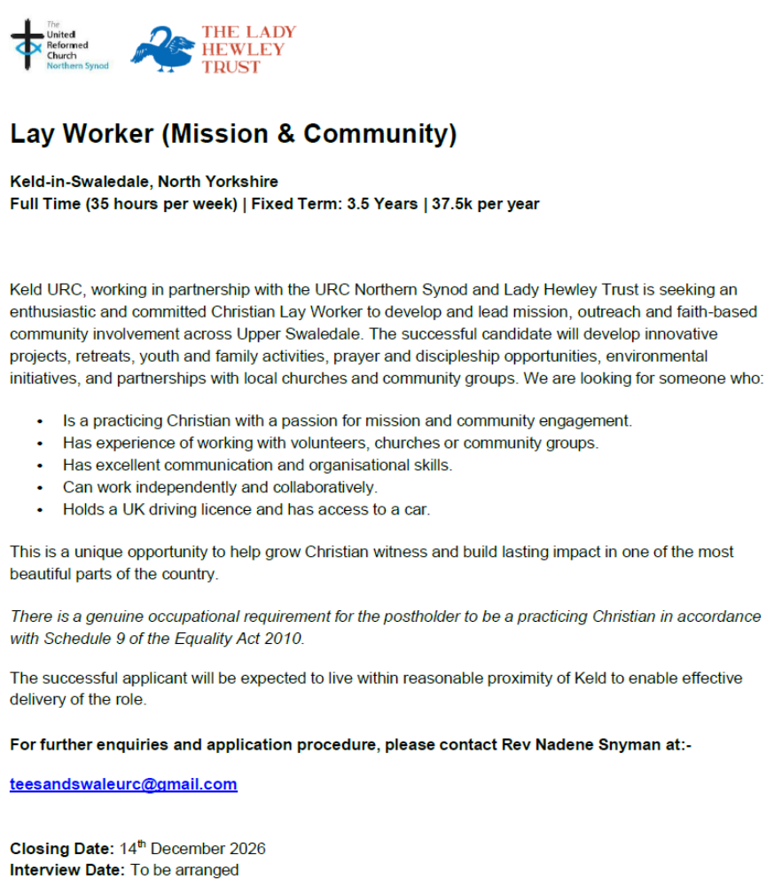

And Finally
A New Face at Christchurch, Ilkley

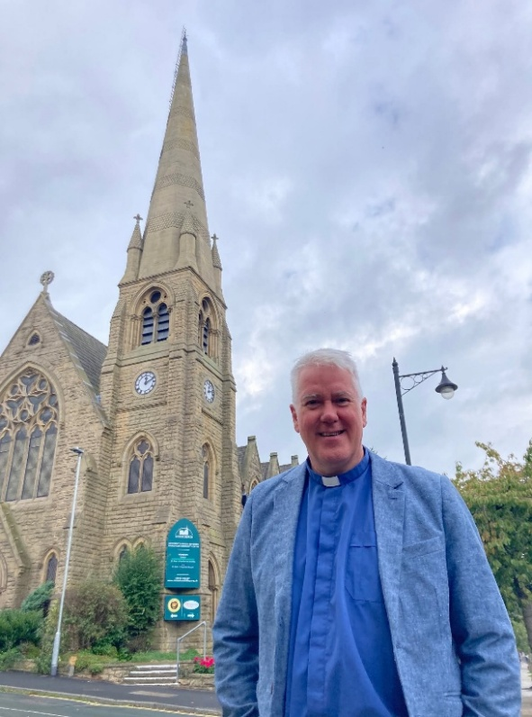
A couple of Saturdays ago (3rd October) Christchurch Ilkley had the great pleasure of being able to induct Revd Simon Helme into his new post. Simon had anwered the call offered by Ilkley where he will be embedded into both the life of the Synod and the local Wharfedale and Aireborough Methodist Circuit.
Simon and his wife Debbie have come from Dursley in Gloucestershire where they served at Dursley Tabernacle for 25 years, although Simon himself is from Burnley. He says “coming back up north I am already dropping my ‘h’s and my wife is demanding subtitles. We got through passport control and have a work visa for Yorkshire for seven years!
“I see the energy and power of the present church community, their great enthusiasm, faith and inclusivity and desire for the church to make a difference in this community. They are very open, questioning and progressive in their Christian faith.
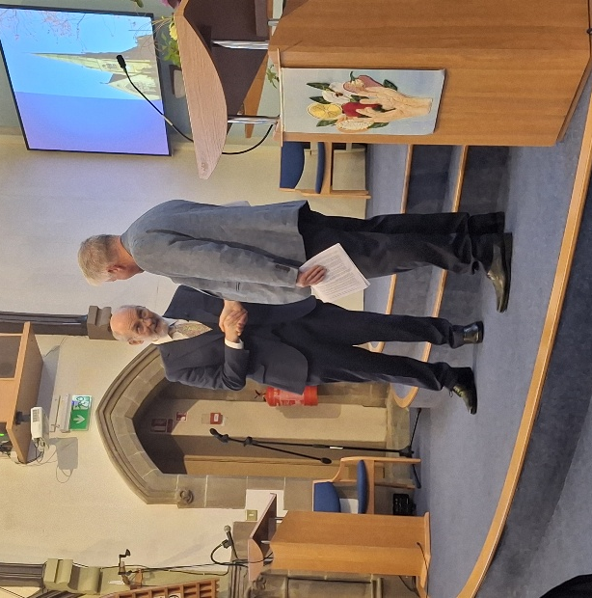
I will be trying to encourage growth and a sense of belonging among the 20-40s age range. Working with Michael Johnston our Youth, Children and Families Worker, we are also looking at how we can offer provision for children in our Sunday morning worship to make Christchurch a place where you can bring your family and have a positive faith filled and fun filled time (those two aspects are not necessarily mutually exclusive!). I’m looking forward to what the next seven years may bring.”
All of us here welcome Simon and Debbie into the Yorkshire Synod and look forward to accompanying him of his continung journey as a Minister of Word and Sacraments in the United Reformed Church.

If you have a good news story from your part of the Synod or something that you feel reflects the work of Synod as we move into the last two months of 2026, or even things that are to happen in 2027, drop me a line at clerk@urcyorkshire.org.uk and I’ll make sure it hits the back page!!

You can also keep an eye on all our social media platforms for news; on the website at Home - URC Yorkshire Synod, at United Reformed Church in Yorkshire - Home | Facebook and Wilderness URC Yorkshire - Home | Facebook, and the YouTube page at URC Yorkshire - YouTube

